5CO03 Professional behaviors and valuing people.

Sarah Angharad Mary Barnes

Task 1 - Word Count excluding Questions used as headings to sections denoted in bold.
2216
Task 2 - Word Count
1201

Task 1
1- Define the term professional and explain what it means to be a ‘people professional’. (AC 1.1)
Stevenson (2010) defines professional as a ‘person competent or skilled in a particular activity’. People professionals are skilled in people, so they are able to inspire, influence and guide people. The CIPD (2022a) profession map sets an international benchmark for people professionals to utilise in order to drive change, ensure good decisions and to confidently act at an elite level within your role. Being a people professional focuses on developing and enhancing behaviours that shift focus, is impactful and adds value to the decision-making processes. The people profession is multi-disciplinary and combines multiple areas such as learning & development (L&D), recruitment, talent management and organisational development (OD) to name a few (CIPD,2020a).
This profession is a holistic view of people practices, prioritising employees experience. CIPD (2020a) frames the role as a ‘professional field of work and expertise’ and aims for an expert impactful contribution to organisational values and strategic goals. Essentially the role of people professional is all about the human capital of the organisation, recognising the skills of each employee and how it shapes the workforce, by building inclusion and diversity into the workforce and promoting employee wellbeing whilst also focusing on the more numerical datasets around people analytics (Learndirect, 2023). The people profession needs to be at the core of the organisation to drive change, create agility, influence transformation and strategy whilst navigating complex situations and support navigation of the uncertain times.
2- Explore how the role of a people professional (either a generalist or a particular specialist) is evolving and the priorities this raises for continuing professional development (CPD) (AC 3.1)
The role of the people professional is shaped by the organisations need. Generalist people professionals need to be agile in order to respond effectively to an ever-changing role, whether tackling grievances or helping to develop job roles. The key to achieving the best outcomes is understanding how to form solutions and is centred around the relationships created throughout the organisation (CIPD, 2022b). Continuous professional development will ensure that people professionals draw from the best available up to date evidence and thus be able to influence the best decisions through critical analysis and thought.
The need to change, adapt and respond to demands has become more apparent in recent years especially in light of the COVID-19 pandemic. The continuous professional development of our organisations is vital for its continued growth. Some areas to focus on digital, technological, and internal changes (such as models, processes, and structures) are key influential trends for people practices developing continuously to shape a future workplace (CIPD, 2021).
To ensure impactful development people professionals can structure their CPD by using the CPD cycle. This highlights seven stages to help structure, identify and measure the learning experience and create greater insight (CIPD 2022e). The focus of CPD is the benefit it brings to all different aspects of people practices and capturing experiences and the benefits of these to apply them to the ever-changing environment that we operate and work in, boosting confidence and professionalism.

3- Discuss the concept of ‘ethical values’, and how at least three ethical values that you hold personally, impact (or could impact) on your work as a people professional. (AC 1.2)
Ethical values are front and centre of professionalism; as people professionals there is unique access to employees throughout the employee lifecycle which supports the embedding of ethical behaviours and values (CIPD, 2022c). One’s own values, prior encounters, beliefs and interests will influence judgements, hence the importance to be self-aware to ensure integrity and objectivity is maintained when exercising professional ethics to make sure it is not unintentionally swayed by your personal views (ACCA, no date).
CIPD (2019) research report Rotten Apples, bad barrels and sticky situations identifies five key areas of persuasion that may influence and sway behaviours: individuals, organisation climate & culture, leaders, situations and communication, training, and codes of conduct.
The ‘bad apples’ focus on individuals and how their behaviours influence those around them both in positive and negative ways. No one human is the same as the other; whilst there may be similarities in cultural influence, one’s opinion is their own. By recognising individual differences and holding the ethical principles of equality, fairness and respect positive cultures can be fostered, confidence within teams and individuals can be built and engagement will be higher among the workforce. Fostering these active states of mind will help to combat the personality traits of Machiavellianism which are high risk for unethical behaviours and help to empower employees to feel confident in challenging unethical behaviours (CIPD, 2019a). The ‘bad barrels’ analogy focuses on the wider picture of organisational culture, climate, and the influence of the leadership roles within the business. If strong social norms exist within departments, organisations or teams, the culture is harder to influence; these norms provide insight into what is deemed acceptable whether it is ethical or not.
In addition to core values of equality, respect and fairness by showing empathy, and understanding a number of situational factors can be identified and where possible mitigated. Understanding how personal circumstance, lack of interest from monotonous roles and reduced engagement from unrealistic goals impact on behaviours and contribute to prospect of unethical behaviour impacting people professionals.

4 - Explain why it is essential for people professionals to contribute confidently to discussions, and ways of doing this that are (AC 1.3):
⦁ informed
⦁ clear
⦁ engaging.
People professionals are expected to be able to influence and drive strategies throughout the organisation, clear communication and contribution to discussions are imperative to this influence. Good communications can help repair broken trust and reinvigorate the drive to behave ethically; it can help breed a sense of common purpose when multiple cultures have merged and drives consistency in behaviours (CIPD, 2022c). People professionals need to be able to influence others to fulfil their role effectively; through transparency of actions, recognising & owning mistakes and being part of the resolution, they build relationships with and increases engagement of the workforce (CIPD, 2022d). HR disrupted (2022a) indicated that regardless of having an executive or board position the notion that this affect the credibility or influence is erroneous. The ability to contribute confidently and influence others is not tied to positional power but by building relationships. Through passion, internal organisational knowledge and business acumen coupled with confidence and common-sense leaders can be truly influential (HR Disrupted, 2022a).
The skills to communicate clearly and confidently are skills that develop and continually improve over time and practice; one usually becomes more effective and convey messages and affect change more confidently as we become more practised (Taylor and Woodhams, 2022a). It is imperative that people professionals are able to contribute in order for them to perform in their roles effectively; a key aspect to do this confidently is through the correct level of assertiveness. One critical difference that separates assertive behaviours and aggression is that assertive behaviour is the rational ability to uphold and present views whilst ensuring respect of others’ views and rights are maintained.
An effective people professional will be able to challenge as and when it is correct to do so, whilst considering French and Ravens (1959) six forms of power to ascertain the best way to tailor their approach and effectively influence the situation. In doing so they can make complex information accessible for organisations by making it clear, jargon free and understandable to help drive change, decisions and enable progress.

5- Discuss when and how to raise concerns when issues such as organisational policies or leadership approaches conflict with ethical values or legislation. (AC 1.4)
The ability for employees to be able to voice concerns, provide feedback and express opinions is fundamental to ensuring good working practices and quality in changing work methods (CIPD, 2022f). There are many ways in which employees can raise concerns whether it be formal, informal or through speaking up / whistleblowing.
Whistleblowing is the process whereby employees highlight concerns or wrongdoing of an organisation; for it to be protected under the 1998 legislation the Public Interest Disclosure Act 1998 (PIDA) the information provided must be grounded in fact not just opinion (CIPD, 2021e). As whistleblowing is often seen negatively due to the anxiety around repercussions of raising such concerns, the importance of branding whistleblowing into a more positive light to take away this anxiety. By making it into speaking up and focusing on the power of the employee’s voice, it turns what can be seen as destructive or critical to the organisation into a constructive safe way for concerns to be raised (CIPD, 2019b). The legal framework of PIDA is intended to incentivise employers to foster the culture of speaking up, promotes employee voices and creating a safe environment where the employees feel safe to speak up (Taylor and Woodhams, 2022b).
As everyone has different experiences and views; we see differing situations in varying lights, as such reactions to these situations differ. This diversity of knowledge can present great collaborative working environment, however at times it can also present conflict through misunderstanding and personality clashes (CIPD, 2020c). When conflict is managed effectively it can goals can be reached, when it is manged poorly it can result in ethical and/or legal conflicts. When business practices include behaviours that some find unacceptable the ethical conflicts can arise. As with differing opinions, the views of which behaviours are acceptable and ethical can vary; providing that people professionals develop business relationships based on mutual trust, respect, and confidence along with the principles of equality, diversity and inclusion are championed the ability to challenge effectively in either a formal or informal manner is more effective (Taylor and Woodhams, 2022a).
6- Provide a robust argument for ethical people practice that is supported by academic theory and details both the business and human benefits of people at work feeling included, valued and fairly treated. (AC 2.1)
Ethical people practice develops a highly engaged and motivated workforce; it helps employees fell their organisation values them and will treat them fairly. To understand the benefit of employee wellbeing and motivation we review motivational theories developed by Maslow, McLelland and the EACH model presented by HR Disrupted.
Maslow suggests there are five levels of human needs that explain how people are motivated described in the style of a pyramid. People start at the bottom of the hierarchy and as on need is met it no longer stands as a motivational factor (BBC, 2023). Maslow describes the five levels of needs of physiological, security, recognition, esteem, and accomplishment. Physiological needs are all related to personal survival, the second level is security, not just physical security but the need for people to be round familiarity rather than the unknown. The third level considers the social nature of humans, belonging. This leads to the fourth level of Maslows’ theory which is the need for recognition and esteem; finally personal accomplishment (Pichère, Cadiat and Probert, 2015). McLelland’s theory however focuses on the characteristics of the people and proposes that there are three motivators that affect people regardless of culture, age or gender; one of which will be dominant: Achievement, power and affiliation (Mindtools, 2022a). Under each of the three motivators are behavioural traits which we will explore briefly, being strong independent whilst taking calculated risks describe the dominant factor of the achievement motivator; conversely, wanting to be part of a team, collaboration and more risk adverse personalities are often deemed to have affiliation as the primary motivator and finally if power is the main motivator, competition, control, and influence are the clear behaviours. When people professionals couple these theories with an approach to treating employees as adults, consumers, and human beings (EACH Model) it improves performance allows ownership by the employee whilst recognising that one size doesn’t fit all (HR Disrupted, 2023a).
When employees feel they are included in decision making process, are part of an ethical organisation which focuses on fairness along with equality and embracing differences in cultural backgrounds the performance, engagement and worker wellbeing is heightened thus reducing absenteeism and turnover whilst increasing efficiency. When employees feel valued and safe the organisation, employees, and wider team benefit.

7- Drawing on your own or a hypothetical example of providing a people practice solution to meet a particular need or introducing a new policy or initiative, describe:
⦁ strategies for designing the solution/initiative so that it will be inclusive
⦁ strategies for checking that, when in practice, the solution/initiative engages and meets the needs of all those it is aimed at. (AC 2.2)
When implementing new strategies, initiatives, and policies effectively the need to ensure a diverse and inclusive group are engaged in the planning and designing as well as the implementation.
Inclusion and diversity often are seen as interchangeable, however are distinct attributes that should always been in consideration when designing, implementing, and reviewing initiatives and solutions (CIPD, 2021c).
During COVID-19 we have had to implement a solution of working that is a hybrid of office and home working to ensure that staff were kept safe, but the service demands were met. Some team member either were not able to, or did not want to work from home for multiple reasons, conversely some team members needed the flexibility to be able to care for dependants. The solution produced need to cater for all parties without adversely impacting ay one dimension as to be equitable. The focus being fair and equitable, but not necessarily taking a consistent view across all as what works for one, may not for the other recognising the diverse nature of our workforce (CIPD, 2021c).
When this strategy was being agreed the initial phase was to gather intelligence from stakeholders. To ensure that this is done in a way to ensure all areas of the workforce are included in the process of design, surveys were distributed both electronically and also paper versions to ensure those with less or no access to IT equipment were able to participate and inform the discussion.
For any implementation or Implementation of processes or systems, an evaluation of how the process was rolled put along with an assessment of whether the implemented process has actually met the needs and purpose it was intended in an inclusive manner. Feedback should be gathered to understand what well, what could have gone better and to understand ‘lessons learned’, this could be one via employee surveys which can ask specific questions to enable measurement against the strategic aims (CIPD, 2022h). When the employee voice is heard and initiatives implemented meet their needs, productivity increases as does employee wellbeing resulting in a decline in attrition and absence rates (CIPD, 2022f).
Task 2
Activity 1:
To assess my own performance against the five core behaviours of the CIPD profession map, I reflected on the behaviours and answered the self-assessment as honestly as possible. To ensure that reflections and useful meaning full action plans are produced as a result of undertaking such assessments it is imperative to get feedback. Obtaining feedback can help mitigate the risk of being overly self-critical and can highlight areas you may have missed (Taylor and Woodhams, 2022a).
Feedback needs to be well rounded and honest. By asking a direct report, a peer, and my manager to review the same self-assessment but to answer it as an assessment of how I present in the core areas to them and to provide should they wish any additional feedback for inclusion for me to reflect on; I have used the model of 360-degree feedback to gain a more complete picture (CIPD, 2022g).
Please refer to Appendix 1 for the self-assessment and feedback received.
Activity 2:
To understand the best approach to selecting from the recommended development areas; I have utilised the VARK Assessment to better understand which learning style I am most In line with. Whilst understanding your preference will allow for better planning, as many people do branch over multiple styles it is good to vary between visual, auditory, reading/writing, and kinesthetic modes of learning (MindTools, 2022b). Whilst the CIPD self-assessment provides a plethora of recommendations, I have limited the number of selections based on my VARK learning style (reading/writing being the highest followed by kinesthetic) to actions to research and consider putting into practise as well as resources to delve into and read.
When planning a personal development plan (PDP) or any project, to create an effective plan for success comprises of five elements making the goals SMART (Specific, measurable, achievable, relevant, and time-bound). The benefits of setting your goals in this way is ensure it is attainable whilst being engaging and presenting a challenge helping to keep the goal in focus (Forbes, 2023).
I have chosen specific resources and actions from the recommendations provided that I feel would benefit my own learning along with being able to develop my team that has recently expanded and been through numerous changes and are at risk of change fatigue. By focusing on coaching models, inclusive learning, and the best strategies to promote learning & development I can help the team welcome new staff and help each member achieve their goals whilst maintaining wellbeing.
Please refer to Appendix 2 for the selected items in my learning plan.
Activity 3:
To ensure that one is making the best use of development activities it is key to take some time to reflect on the experience. To make reflective practise more structured and easier to retain and revisit, they can be written down.
There are several models of reflective cycles, being conscious of differences and similarities between the models will help understanding of the core concepts and enables exploration of deeper reflective processes (Open Learn, 2023).
Taylor and Woodhams (2023a) refers to reflective cycle model developed by Smith which can help understanding how events are experienced. The cycle consists of five stages; experience, feelings, what happened, analysis and action plan. You can begin reflecting at any point of the cycle.
Over the last 12 months, there has been a lot of change in working environment, resulting in the need to develop rapidly and effectively. Three areas I have been reflecting on where I have formally or informally undertaken development activities are, commencing level 5 CIPD, been given the opportunity to temporarily act up into a higher role and the expansion and development of my team.

CIPD level 5 reflections
The experience so far has been difficult, yet exciting. I have completed the first two modules and have found that practical application of the theory is key to making this learning experience key; it is allowing me to widen my skillset and thinking.
It has brough out several different emotions as I progress through each module, usually starting with unease and worry largely centred in self-doubt.
The results of the modules marked have thankfully reflected the effort and time spent on researching, reading, and absorbing the themes and topics of these modules.
Following the results, I have spent time analysing how I approached each stage to then formulate an action plan based on the constructive feedback issued on marking and actively listening to other reflections of their experience. The key to listening and reflecting on good feedback to challenge your assumptions and assessments of the situation and ensue they are accurate. The question repeatedly ask myself at throughout my analysing is what I would do differently (Taylor and Woodhams, 2022a)?
Following the key stage of analysis, I made an action plan for how to approach the next assignment to maximise results and reduce pressure of deadlines.
Temporary promotion
I the last six months there has been temporary changes within the team to cover long term absence, as a result some opportunities were presented for employees to develop their skills and portfolio experience by acting into a more senior role to support the temporary structure.
I felt very flattered that my manager proposed that I should consider one of these opportunities, my primary emotion was trepidation, the feeling of hope as I had the support from my management and belief from them that I was suitable to do this; whilst feeling daunted by the prospect of potentially letting the team down. I was successful and I am almost halfway through the initial twelve-month period.
Taking the time to reflect and analyse how the role has changed the way I work, how I have been able to expand the team and make more impact through effectively influencing decisions that are being made which may impact the team has enable to increase the staff morale and wellbeing. The main challenge I have found is delegating more responsibility to my direct reports and managing the conflict between team members.
From this reflection, I have planned to undertake a team assessment through colour works, Belbin team roles or similar assessments in order to ascertain and to develop my own and the teams understanding of what personalities are in the team and the best methods of communication depending on what personality role they are.
Team expansion and development
I have found that in expanding the team and by helping members in the process be able to try and in some cases be successful in obtaining promotions has embedded the practice of succession planning and continuous development.
We have been successful in appointing three new posts at differing grades into the intelligence teams. Whilst expanding the team and seeing internal promotions occur, I have been keen to ensure that the psychological safety for my team is maintain through the period of change (HR Disrupted, 2023b).
Through the evaluation of this development process, I have been able to critically evaluate both my own methods as well as the senior member of my team’s approach to recruitment, induction and training the new recruits. This development has been crucial to building team moral and engaging the staff as well as employee experience. My key aim is to ensure I can recognise and also help combat change fatigue should this present given the number of changes faced by the team in a short space of time (HR Disrupted, 2022b).

Appendix 1: Self-Assessment and Feedback from Manager, peer, and direct report.

Self-Assessment:
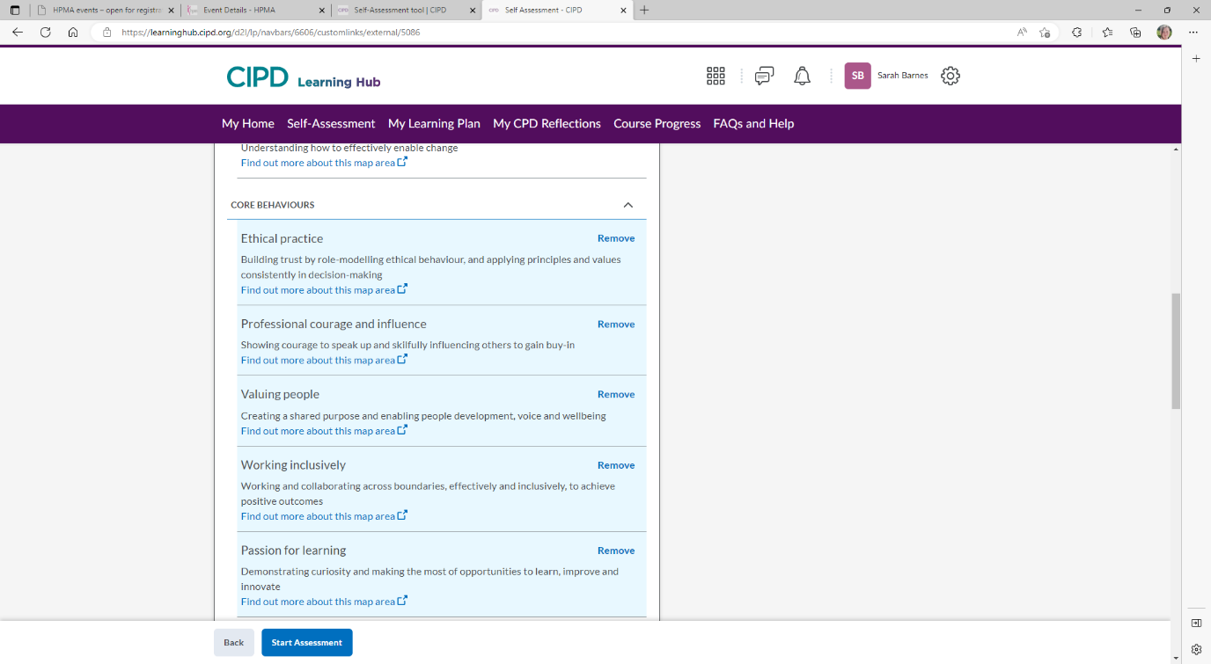
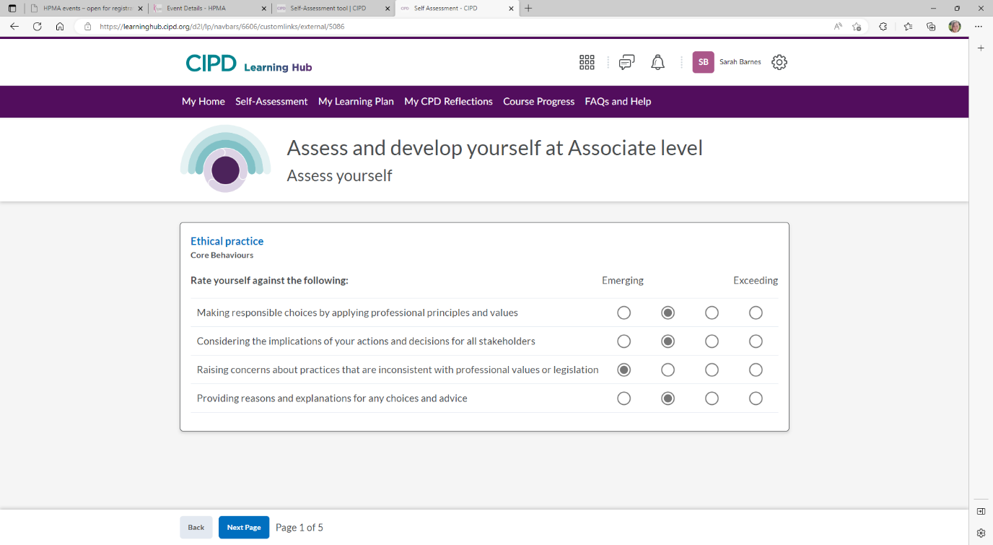
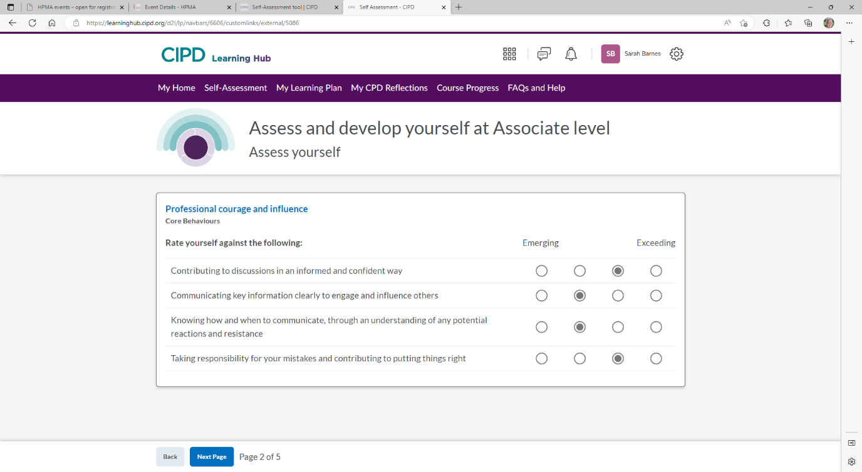
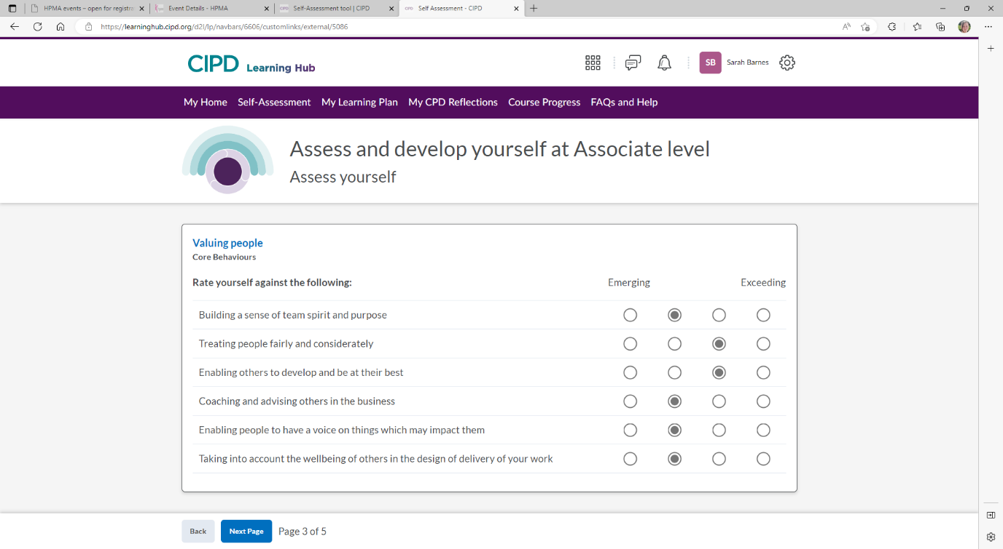
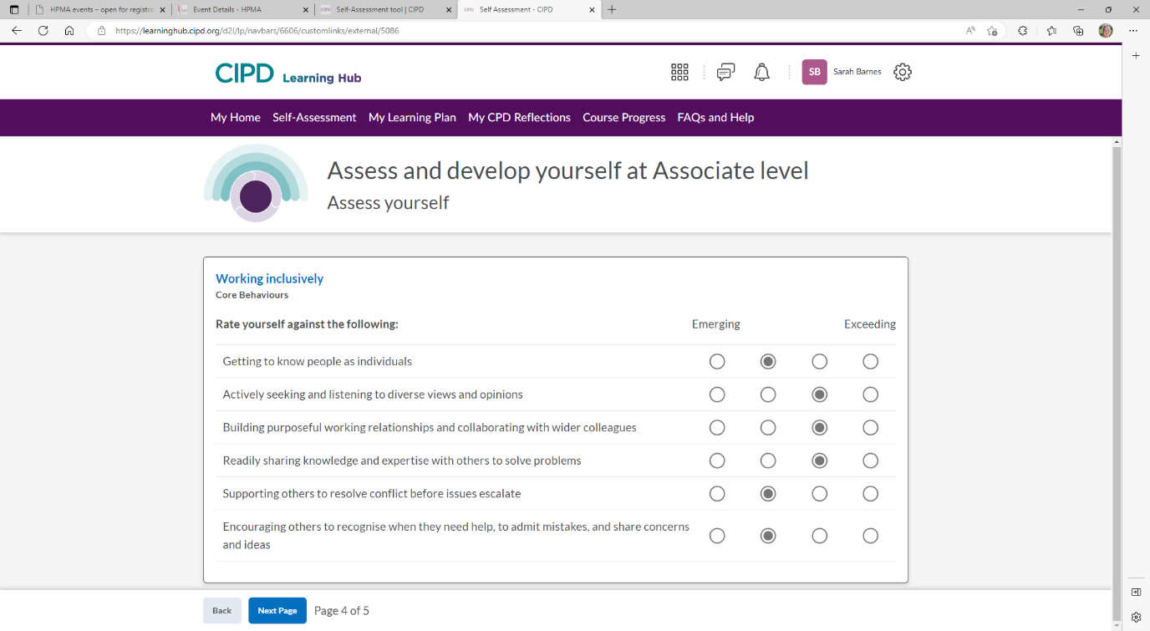
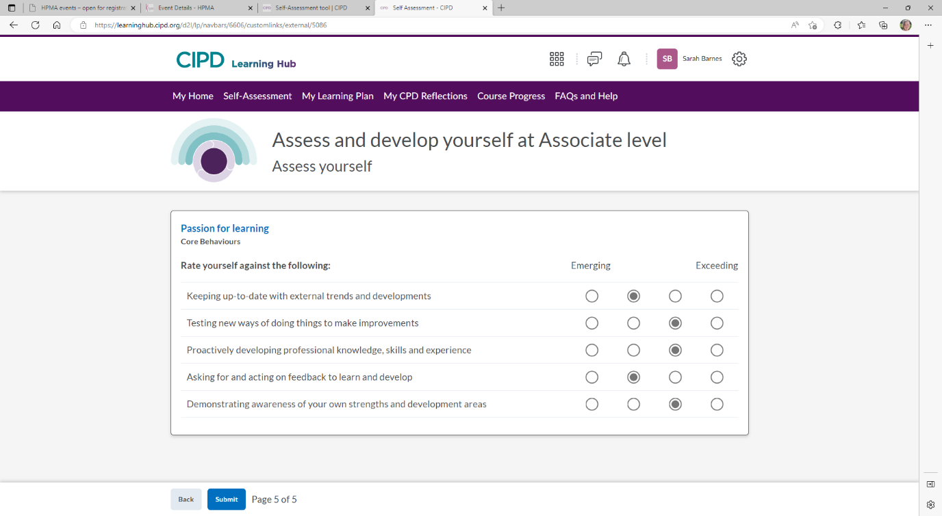

Feedback from Manager: 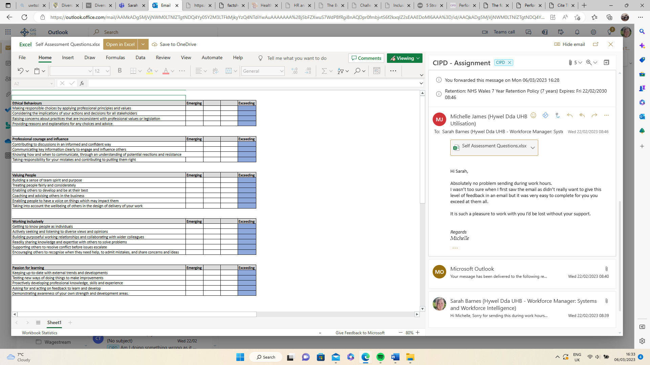

Feedback from Peer:
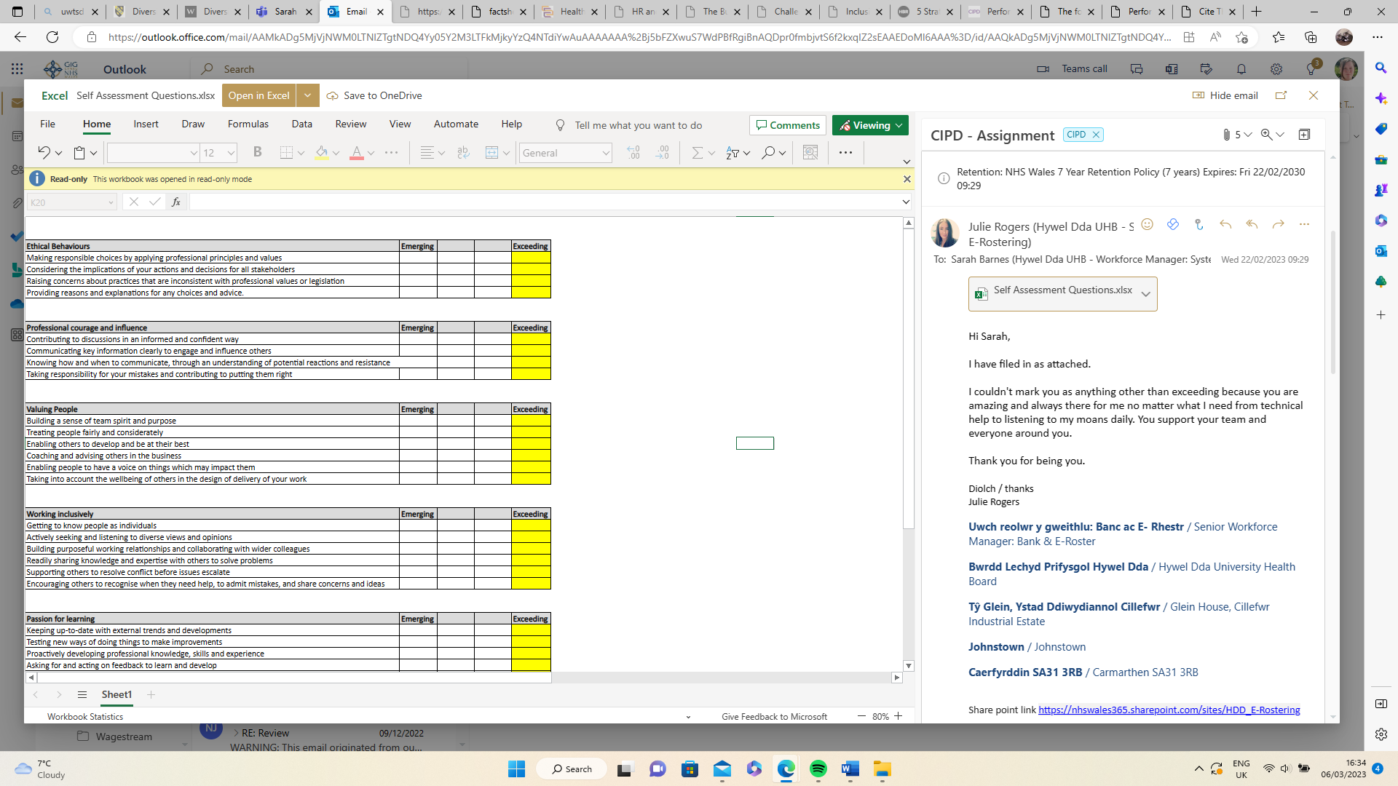

Feedback from direct report:
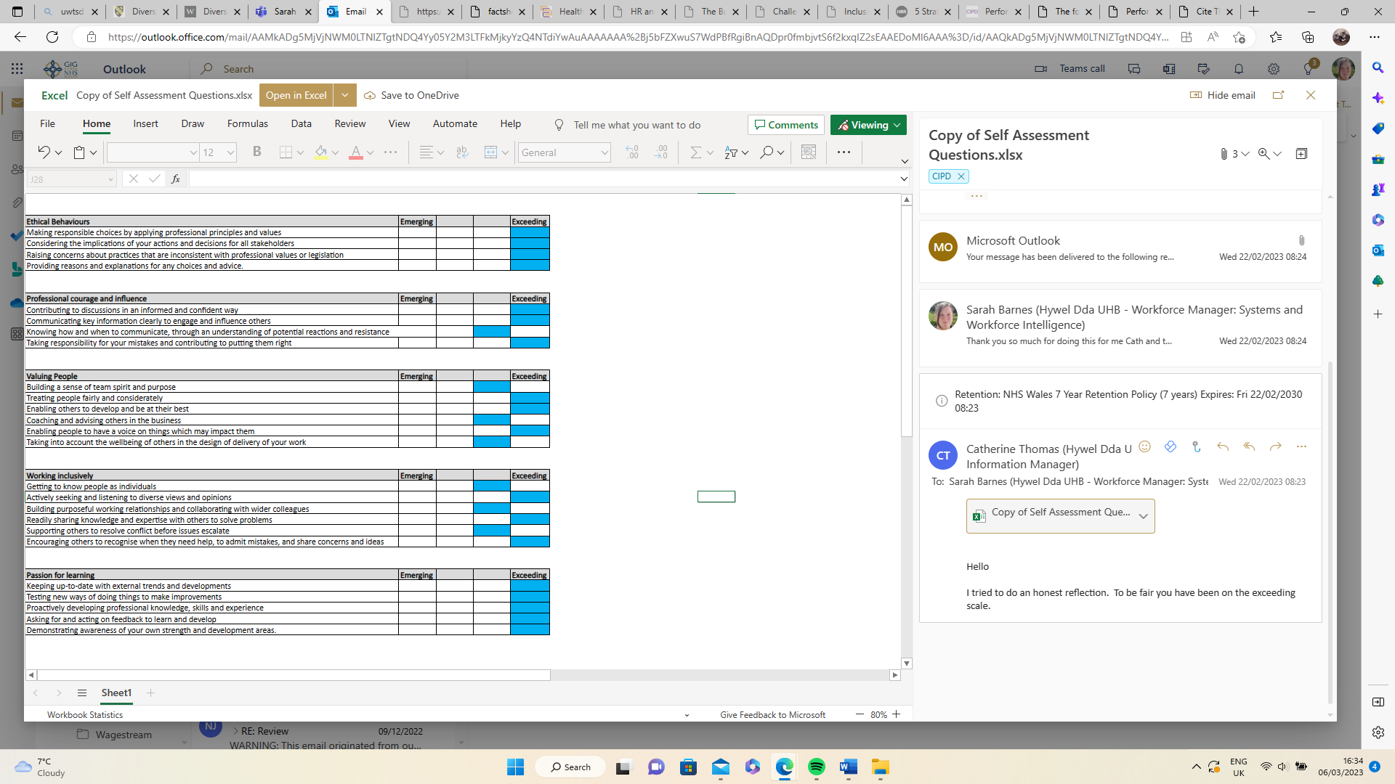

Appendix 2: My Learning Plan
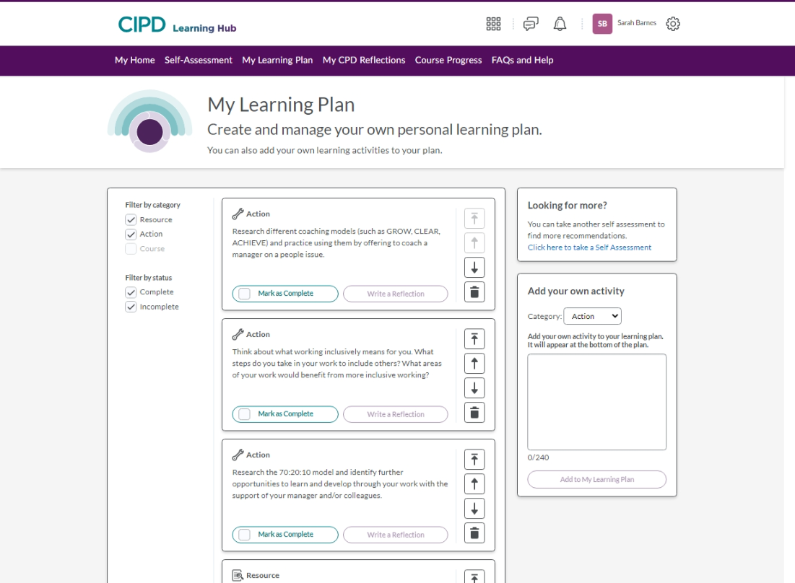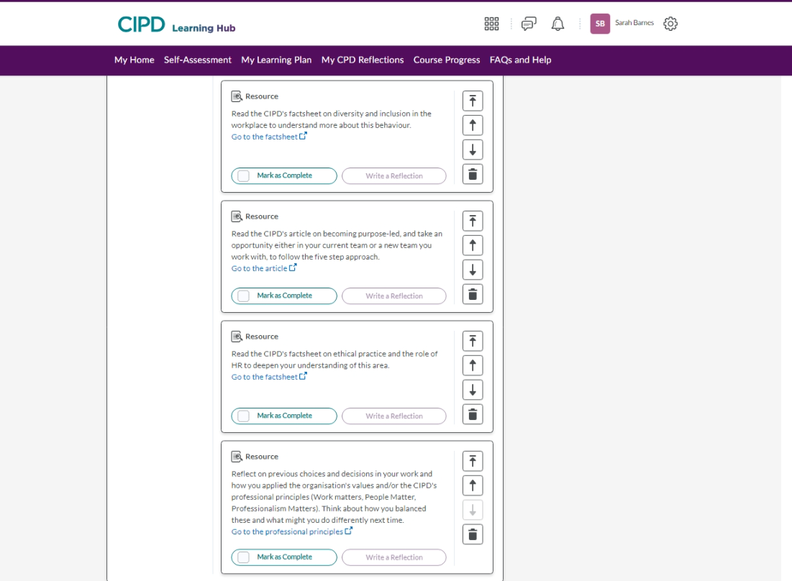
Bibliography:
ACCA (no date) What is ethics? Available at: https://www.accaglobal.com/gb/en/about-us/regulation/ethics/what-is-ethics.html (Accessed: 2002/2023)
Bazzichelli, T. 2021. Whistleblowing for Change: Exposing Systems of Power and Injustice. Bielefeld: transcript Verlag. https://doi.org/10.1515/9783839457931
BBC (2023) Motivation and Leadership. Available at: https://www.bbc.co.uk/bitesize/guides/zkt8xyc/revision/4 (Accessed: 04/03/2023).
CIPD (2019a) ROTTEN APPLES, BAD BARRELS AND STICKY SITUATIONS. 7788. Available at: https://www.cipd.co.uk/Images/unethical-behaviour-in-the-workplace_report-2_tcm18-57022.pdf (Accessed: 09/02/2023).
CIPD (2019b) Creating Ethical Workplaces [Podcast] 04 June. Available at: https://www.cipd.co.uk/podcasts/ethical-workplaces (Accessed: 01/03/2023).
CIPD (2020a) Why we call it the people profession. Available at: https://peopleprofession.cipd.org/insights/articles/why-people-profession (Accessed: 07/02/2023).
CIPD (2020b) People Profession 2030 A collective view of future trends. 8073. Available at: https://www.cipd.co.uk/Images/people-profession-2030-report-compressed_tcm18-86095.pdf (Accessed: 09/02/2023).
CIPD (2020c) Managing conflict in the modern workplace. 7968. Available at: https://www.cipd.co.uk/Images/managing-conflict-in-the-workplace-2_tcm18-70655.pdf (Accessed: 26/02/2023).
CIPD (2021a) People Profession 2030: how people managers will play a central role in the future world of work. Available at: https://peopleprofession.cipd.org/insights/articles/people-managers-central-role-future-world-work (Accessed: 19/02/2023).
CIPD (2021b) Whistleblowing Q&As Available at: https://www.cipd.co.uk/knowledge/fundamentals/emp-law/whistleblowing/questions (Accessed: 26/2/2023).
CIPD (2021c) Inclusion and diversity in the workplace Available at: https://moodle.uwtsd.ac.uk/pluginfile.php/558556/mod_resource/content/1/Inclusion%20and%20diversity%20at%20work.pdf (Accessed: 04/3/2023).
CIPD (2022a) Explore the Profession Map. Available at: https://peopleprofession.cipd.org/profession-map (Accessed: 04/02/2023).
CIPD (2022b) HR generalist roles. Available at: https://www.cipd.co.uk/careers/career-options/hr-roles (Accessed: 11/02/2023).
CIPD (2022c) Ethical practice and the role of people professionals. Available at: https://www.cipd.co.uk/knowledge/culture/ethics/role-hr-factsheet (Accessed: 16/02/2023).
CIPD (2022d) Professional courage and influence. Available at: https://peopleprofession.cipd.org/profession-map/core-behaviours/professional-courage-influence (Accessed: 18/02/2023).
CIPD (2022e) The CPD Cycle. Available at: https://www.cipd.co.uk/learn/cpd/cycle (Accessed: 20/02/2023).
CIPD (2022f) Employee Voice. Available at: https://www.cipd.co.uk/knowledge/fundamentals/relations/communication/voice-factsheet (Accessed: 27/02/2023).
CIPD (2022g) Performance Reviews. Available at: https://www.cipd.co.uk/knowledge/fundamentals/people/performance/appraisals-factsheet#111981. (Accessed: 06/03/2023).
CIPD (2022h) Employee communication. Available at: https://www.cipd.co.uk/knowledge/fundamentals/relations/communication/factsheet. (Accessed: 12/03/2023).
De Wet, J., Wetzelhütter, D., Bacher, J. (2019). Revisiting the trans-situationality of values in Schwartz's Portrait Values Questionnaire. Quality & Quantity, 53(2), 685–711.
Ferdman, B.M. and Deane, B.R. (2013) Diversity at Work: The Practice of Inclusion. 1st edn. New York, NY: Wiley. Available at: https://doi.org/10.1002/9781118764282. (Accessed: 10/03/2023)
Forbes (2023) The Ultimate Guide to S.M.A.R.T. Goals. Available at: https://www.forbes.com/advisor/business/smart-goals/ (Accessed: 08/03/2023).
French, J.R.P. and Raven, B. (1959). 'The Bases of Social Power.' In 'Studies in Social Power, Cartwright, D.,' pp.150-167. Ann Arbor, MI: Institute for Social Research. Available at: http://www.communicationcache.com/uploads/1/0/8/8/10887248/the_bases_of_social_power_-_chapter_20_-_1959.pdf. Accessed 29/01/2023.
Havard Business review (2020) ‘5 Strategies for Creating an Inclusive Workplace ‘Available at: https://hbr.org/2020/01/5-strategies-for-creating-an-inclusive-workplace (Accessed: 06/03/2023).
HR Disrupted (2022a) REALLY INFLUENTIAL HR. 4th September 2022. Available at: https://disruptivehr.club/really-influential-hr/ (Accessed: 23/02/2023).
HR Disrupted (2022b) TACKLING CHANGE FATIGUE. 23rd July 2022. Available at: https://disruptivehr.club/tackling-change-fatigue/ (Accessed: 12/03/2023).
HR Disrupted (2023a) THE DISRUPTIVE HR EACH MODEL. Available at: https://disruptivehr.com/each-hr-diagnostic/?__hstc=231547264.f4316ccdaf25df96ddcbd5b2d80c9dea.1672934494572.1677172692858.1677522073854.16&__hssc=231547264.6.1677687710327&__hsfp=2583587100 (Accessed: 04/03/2023).
HR Disrupted. (2023b) FOUR ESSENTIALS FOR MANAGING CHANGE. 5th February 2023 Available at: https://disruptivehr.club/four-essentials-for-managing-change/ (Accessed: 12/03/2023).
Knoppen, Desirée & Saris, Willem. (2009). Evaluation of the Portrait Values Questionnaire using SEM: A New ESS Proposal.
Learndirect (2023) Why Human Resources Became the ‘People Profession. Available at: https://www.learndirect.com/pillar/why-human-resources-became-the-people-profession (Accessed: 07/02/2023)
Marchington, M. et al. (2021) Human resource management at work: the definitive guide. Seventh edition. London, United Kingdom ;: Kogan Page.
Megginson, D. and Whitaker, V. (2007) Continuing professional development. Second edition. London: Chartered Institute of Personnel and Development.
Mick Marchington, 2008. Where next for HRM? Rediscovering the heart and soul of people management. Institute of Employment Studies. Available at: https://www.employment-studies.co.uk/system/files/resources/files/wp20.pdf (Accessed: 10/03/2023)
Mindtools (2022a) McClelland's Human Motivation Theory. Available at: https://www.mindtools.com/aznjntj/mcclellands-human-motivation-theory (Accessed: 04/03/2023).
MindTools (2022b) VAK Learning Styles. Available at: https://www.mindtools.com/ak6cyjn/vak-learning-styles (Accessed: 07/03/2023).
Open Learn (2023) 4 Models of reflection – core concepts for reflective thinking. Available at: https://www.open.edu/openlearn/mod/oucontent/view.php?id=51386&section=4 (Accessed: 12/03/2023).
Pichère, P., Cadiat, A.-C. and Probert, C. (2015) Maslow’s hierarchy of needs. Translated by C. Probert. Namur: Lemaitre Publishing.
Roche, W.K., Teague, P., and Colvin, A.J. (2014) The Oxford handbook of conflict management in organizations. Edited by W.K. Roche, P. Teague, and A.J. Colvin. Oxford: Oxford University Press.
Schwartz SH, Melech G, Lehrnami A, Burgess S, Harris M, Owens V. 2001. Extending the cross-cultural validity of the theory of basic human values with a different method of measurement. Journal of Cross-Cultural Psychology 32:519-42.
Schwartz, S.H., Cieciuch, J., Vecchione, M., Davidov, E., Fischer, R., Beierlein, C., Ramos, A., Verkasalo, M., Lönnqvist, J.-E., Demirutku, K., Dirilen-Gumus, O., & Konty, M. (2012). Refining the theory of basic individual values. Journal of Personality and Social Psychology, 103, 663-688.
Stevenson, A. (2010) Oxford dictionary of English. 3rd ed. / edited by Angus Stevenson. Oxford: Oxford University Press.
Taylor, S. and Woodhams, C. (2022a) Studying human resource management: a guide to the study, context and practice of HR. Third edition. Edited by S. Taylor and C. Woodhams. London: KoganPage.
Taylor, S. and Woodhams, C. (2022b) Human resource management: people and organsiations. Third edition. Edited by S. Taylor and C. Woodhams. London: KoganPage.

