Comparison of Two Hospitality Organisations Report



Name: Sophie Edmunds
Student Number: 2100303
Module Title: Financial Management for the Hotel Industry
Module Number: BMIH5007
Lecturer’s Name: Dale Clark

Word Count: 2,030

Table of Contents:

Executive Summary……………………………………………… 3

Introduction to the report and the two organisations……… 4
- Hilton
- Accor International
Financial Management of Hilton and Accor International…. 4-7
- Total Revenue
- Market Position
- Growth Potential
- Financial Commitment to CSR
Recommendations & Conclusion……………………………….7

Tables/Chart References………………………………………….8-9

References…………………………………………………………..10-12

Executive Summary

This report has analysed the financial management of Hilton and Accor International with considerable differences in their total revenue. The information reviewed has evidently revealed the detrimental impact the Covid-19 Pandemic had on both organisations, but mainly affecting the recovery for Accor.
Additionally, the report found notable similarities in the direction the companies partake with their corporate social responsibility and invest significant amounts towards funds and initiatives.
They have close positioning within their market and strategize their portfolio of brands across a range of markets and target audiences. Although, the report found that Hilton has a stronger brand recognition and is situated much higher in the largest companies by market cap compared to Accor.
Furthermore, Accor and Hilton have defined their potential growth towards the future that align with both organisation’s framework, such as planning to expand in China and increasing the pipeline of hotels and rooms to be opened over the 2023/24 period and beyond.
Finally, the report concluded with a recommendation for an opportunity for Hilton to grow their marketing strategy in the future with the suggestion of introducing travel influencers to utilize their positive cash flow recovery and place a focus on future objectives. There is a recommendation for Accor to place focus on outsourcing services like housekeeping with the objective to recover their total revenue and reduce labour costs.

Introduction
The purpose of this report is to make a comparison of two hospitality organisations; Hilton and Accor International and provide a background into their corporates and their approach to financial management. The research will be critically analysed and evaluated in relation to informational requirements of management and the observation of total revenue (TR), market positioning, any potential for growth, plus Hilton and Accor’s financial commitment to Corporate Social Responsibility (CSR) with the application of industry examples and academic theory.
After the research has been analysed and compared between the two companies, a recommendation will be made for both businesses upon any opportunities for growth or potential for outsourcing, then the report will be concluded.
To begin with, the first Hilton hotel to open was in 1925 by Conrad Hilton in Texas, US (Hilton, 2023). According to Hilton (2023) they are one of the most recognised and respected brands in the world. The article by Hilton (2023), continues to say the company own and lease over “7,000 properties in 123 countries and territories, with 19 distinct brands.”
Accor is a company that was discovered by two friends, Paul Dubrule and Gérard Pélisson (Accor, 2023). The article continues to say they “opened their first Novotel in 1967” in France. Their vision of hotels has developed over 5,300 properties in 110 countries with over 40+ hotel brands (Accor, 2023).
Total Revenue of Hilton Hotels (Hilton Worldwide Holdings Inc.) and Accor International (AC.PA.)
Firstly, the report will look at the total revenue of Hilton. Total revenue is an important indicator of the amount of money a business produces from the sales of products or services during a fixed period (Rodrigue, 2022).
According to Yahoo! Finance (2023), the organisation has accumulated a growth in revenue. It is worth noting that the period of 2019-20 was majorly impacted by the Covid-19 Pandemic which can explain the loss of $5,145,000 in the space of one year. However, despite that, they still earned a profit of $4,307,000 in 2020 compared to $9,452,000 in 2019. Since then, their profits have been gradually increasing and is predicted to be $8,165,000 for the 12-month period of 2022. Therefore, the company has recovered rather rapidly. (See table (a) on pg. 9)
Next, Accor’s TR will be analysed. In comparison to Hilton, Yahoo! Finance (2023) statement shows Accor International suffered a negative net income loss of $2,428,000 in the period of 2019-20. Even though Accor still earned a positive cash flow of $1,621,000 in 2020, it’s a significant drop compared to $4,049,000 in 2019. (See table (b) on pg. 9). Unlike Hilton, Accor’s total revenue has made slow progress in recovery, but is rising year on year with a predicted TR of $3,105,000 in the 12-month period of 2022.
From the statistics, management in both organisations can reflect upon this information with the use of forecasting on balance sheets (Fridson, 2011, pg. 28). These balance sheets are valuable when presenting to primary investors in a company (Arnold, 2012, pg. 8). TR is also important for the management’s understanding of what Arnold (2012, pg. 2) says is clarity of “day to day management”, creating “long term plans” and knowing how to not only “advance in their careers” but to build a plan of financial success for the organisation’s future.
Market Position
It is worth noting that Hilton is placed fourth in the “largest hotel companies by market cap” with $40.33B (Companies Market Cap, 2023) and Accor is situated fourteenth with a market cap of $8.54B (see table (d) for reference, on pg. 8).
Hilton is a global hospitality brand that ranked the leading hotel brand in the world in 2020. Statista (2021) say by region, European Hilton hotels had an average RevPAR of $93.71. According to Weinstein (2022), post-covid saw an improved performance for Hilton, with a “continued strength in leisure travel.” The CEO reported “diluted earnings of $1.26 per share and a net income of $346 million. The adjusted EBITDA was $732 million” with both totals exceeding the high end of guidance. The article by Weinstein continues saying by September 2022, Hilton approved development during its third quarter, adding nearly 13,000 new rooms to their portfolio.
Accor is another global hospitality brand which reported its European EBITDA fell by €1.2 billion in 2021, RevPAR was down by 73% in the last three months of 2020 and net income was at a loss for the year just under €2 billion compared to a net profit of €485 million in in 2019. There was a loss per share of €7.71 against earnings (Cole, 2021). Though, management insisted in Weinstein’s article that “Accor is ideally positioned to benefit from the recovery and press ahead.”
In a conducted analysis by Moth (2013), they looked into multiple hotel brands framework from “the purchase journey, personalisation and mobile.” Hilton scored 81% and Accor 78% (See table (c), on pg. 8). This framework investigated the effectiveness and brand awareness the organisations had at the time. Hilton provided its potential guests with a general search for the site on Google, whereas Accor “only offered search tools for users to find a location for a hotel.” Additionally, Hilton’s website had an effective search tool, which were informative, displayed images and provided descriptions of the room and facilities. Moth mentions this can improve the user experience during the booking process and Hilton came on top during the purchase stages, closely followed by Accor which provided “a well formatted summary page, clear details of the price and room package.”
With 19 brands, over 1.07 million hotel rooms now in 2023 (Hilton, 2023), (Statista, 2020), Hilton’s marketing strategy is comprised of individual strategies aimed to reach potential guests at any demographic from budget to luxury worldwide (Talbot, 2019). Similarly, Accor has 40+ hotel brands with an estimated 780,000 rooms segmented to tailor to multiple demographics (Accor Group, 2023). Unlike Hilton, in an article by Saunders (2022), Accor doesn’t have a stronger brand recognition “but is growing fast and is gaining ground on the competition.”
Likewise, to Hilton, Accor International have a robust marketing strategy. However, despite the similarities, from the perspective of financial management and Total Revenue, both hotels are figuring out how to manage with inflation and have faith in pricing power to pull them through the cost-of-living crisis (Jorden, 2022). With the majority of Hilton’s properties in the US (Statista, 2022) and Accor with the highest number of their hotels in Southern Europe (Statista, 2022) the information from these brands consequent from the macro-scale factors within the countries they operate within, that can affect their revenue, marketing strategies and position (Papadopoulos and Martín, 2011, pg. 132).
Growth Potential
In this section, the growth potential of Hilton and Accor will be compared. Lebaux (2012) describes “growth potential is an organisation’s future ability to generate later profits, expand its workforce and increase population.”
With information from Seeking Alpha (2022) Hilton Worldwide Holdings Inc. has shown “rapid growth in revenue”. From the statistics in the previous section, Hilton is pushing forward with expansion plans and sustained a 5.6% net unit growth from 2021 (Stories from Hilton, 2022). Hilton (2021) planned to open 2,670 more hotels and a pipeline of 408,000. According to O’Neil (2023) the company forecasts in the first quarter of 2023 a “net income of $1.38 billion to $1.45 billion”, to push RevPAR “between 4 and 8% on a comparable and currency-neutral basis.” They aim to sign at least “one hotel per day” and introduced a new brand to the company. Hilton management are expecting a shift in consumer spending and pricing power to support the growth of their organisation (O’Neil, 2023).
Meanwhile, in the article by Weinstein (2022), Accor International “confirmed its forecast of 3.5% net network growth” in 2022. Accor Group (2022) shared its growth and development pipelines where Accor opened nearly 300 hotels in 2021 and 41,000 rooms. Like Hilton, they are planning on opening a further 1,200+ properties and 200,000 rooms and what Hospitality Net (2022) says is to “bounce back to pre-pandemic levels.” Davies (2022) states that Accor’s profit forecast from 2022 is estimated between €550-610 million. However, Accor is expecting a decrease in their RevPAR in 2023 and they aim EBITDA will return to a positive margin into 2024 once inflation pressures ease (Fitch Ratings, 2022).
Although Accor’s net growth rate is smaller than Hilton’s, they are still financially performing strong and what both hotel companies have in common is that they are both planning on growing their hotels in China. Accor aims to expand in China by 20%, as well as refurbishing existing buildings to coincide with the ESG initiatives and signing at least one new hotel per day (O’Neil, 2022), (Accor Group, 2022).
Financial Commitment to Corporate Social Responsibility (CSR)
According to Orlando, et al. (2020), they state that CSR shows “activities have been responsively introduced to achieve stakeholders needs and standards.” Corporates must now have CSR in the “core of their innovative strategies.” This involves sustainable social performances that align with the company’s framework.
Hilton (2023) has a strategic “travel with purpose” environmental, social and governance responsibility. They pledge to resource, operate and grow sustainably and to “pave the way to a net zero future”, and have started with their water and waste programmes. Socially, Hilton is committed to fostering opportunities for people within their company and for their ‘Team Members’ communities. Hilton (2023) continue to mention that they are focused on “the pursuit of Diversity, Equity & Inclusion, and to the protection of human rights.” Hilton (2019, pg. 7) stated, “since 2014, Hilton have invested more than $3.2 million in disaster relief and resiliency efforts.” This shows Hilton takes a serious approach to supporting the countries they operate within which benefits their stakeholders and aims to improve the social and environmental issues impacting their areas, as well as boosting the reputation of Hilton’s brand.
Similarly, Accor Group (2023) are focused on limiting its “carbon footprint and impact on the planet.” Accor actively seek and respond to travellers’ concerns about CSR and state their commitment to the WATCH program that “combats the sexual exploitation of minors.” Accor’s financial commitment to their CSR revolves around the guests and making them feel welcome and to increase authentic experiences for their guests and staff (Estis, 2018). Moreover, Accor Group (2021, pg. 19) supported and helped people through the Covid-19 Pandemic, “Accor and its Board of Directors allocated a 25% of the dividend towards their creation of the ‘ALL Heartist Fund’”. This fund assisted people going through financial and physical distress to access healthcare, keep their homes and pay for children’s school fees. Accor honoured 98,000 requests which amounted to more than €31 million (Accor, 2023).
It is apparent that both organisations are devoted to taking responsible action for social and environmental objectives which align with governance of the countries they operate within. Both companies have invested significant amounts to bolster the financial commitment to put staff and guests first and support their surrounding communities.
Recommendations & Conclusion
It may be evident that Hilton and Accor International are similar in their financial approaches in market positioning, growth potential, and CSR, however, they contrast considerably when reflecting on their Total Revenue.
A recommendation that can be suggested for Accor can help them attempt to lower costs in order to increase their revenue is by outsourcing services within their hotels like Housekeeping. According to eZee Absolute (2022), there is a “drop of 25% labour costs when housekeeping services were outsourced.” Not only that, but it continues to report that there is a “consistent quality” with outsourcing housekeeping staff and can be one approach Accor could adopt to recover from financial loss and maintain a reputable brand image.
On the other hand, Hilton could find another opportunity of growth to improve their marketing strategy and positioning further, by reaching out to travel influencers on social media like Instagram and TikTok. This is becoming a growing trend that can be an effective way to target your audience like millennials and Gen-Z, in which the influencers can create content and deliver the company’s message to potential travellers while pressing on relevant social and environmental solutions Hilton is committed to addressing (eHotelier, 2019).

Tables/Chart References

( d ) Chart of Companies Market Cap. Information from: [https://companiesmarketcap.com/hotels/largest-hotel-companies-by-market-cap/]
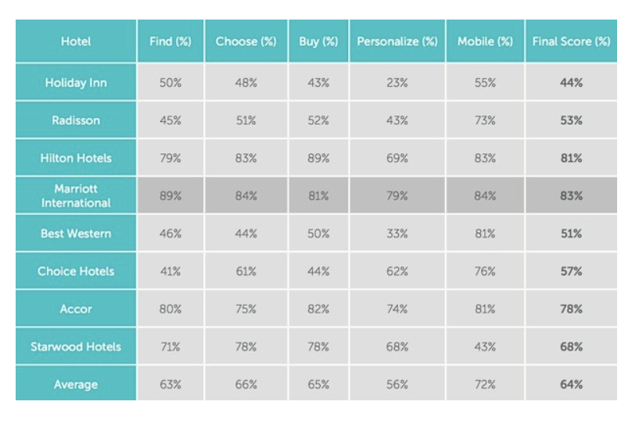
(c) Website Analysis Framework (Moth, 2013) [https://econsultancy.com/marriott-edges-out-hilton-and-accor-in-hotel-site-ux-survey/].
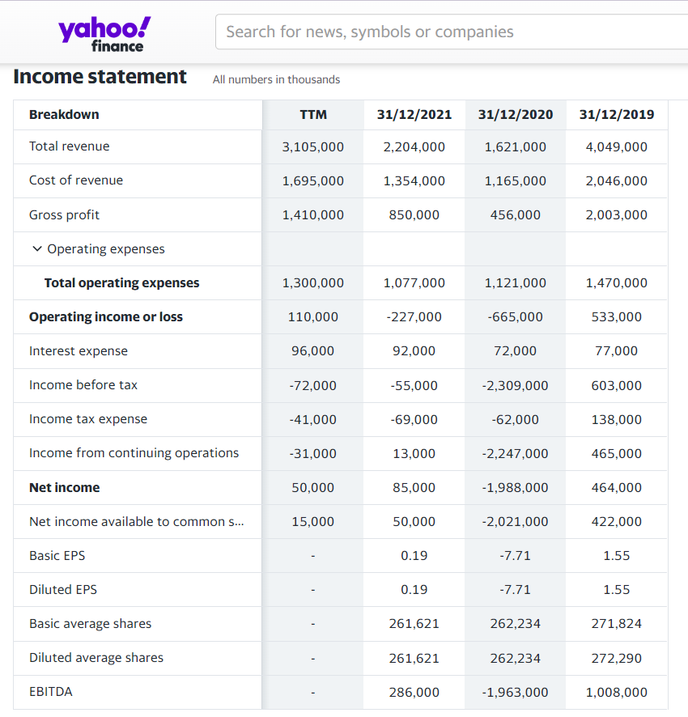
(b) Accor (AC.PA) Income Statement (Yahoo! Finance 2023) [https://uk.finance.yahoo.com/quote/AC.PA/financials?p=AC.PA]
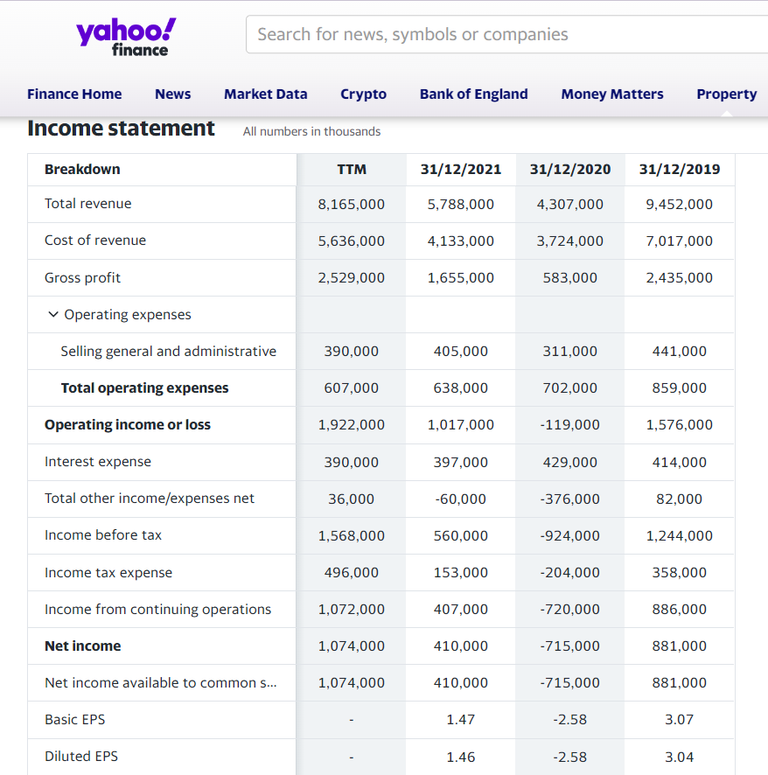
- Hilton Worldwide Holdings Inc. Income Statement (Yahoo! Finance, 2023) [https://uk.finance.yahoo.com/quote/HLT/financials?p=HLT]
References
Accor Group (2023) About Us. Available at: [https://group.accor.com/en/group/who-we-are/about-us] (Accessed on: 27/01/2023).
Accor Group (2023) Who we are. Available at: [https://group.accor.com/en/group/who-we-are/our-history] (Accessed on: 27/01/2023).
Accor Group (2022) Accor advances its global development strategy. Available at: [https://group.accor.com/en/Actualites/2022/03/global-development-strategy-openings-signings] (Accessed on: 10/02/2023).
Accor Group (2021) 2021 Integrated Report. Available at: [https://group.accor.com/-/media/Corporate/Investors/Documents-de reference/ACCO_RI_2021_MEL_EN_300322.pdf] (Accessed on: 13/02/2023).
Accor Group (2023) Environment & CSR. Available at: [https://group.accor.com/en/hotel-development/Optimise-your-costs/Environment-and-CSR] (Accessed on: 13/02/2023).
Arnold, G. (2013) Corporate financial management. 5th ed. Harlow, England ;: Pearson.
Brown, C. and Nwagbara, U. (2019) Corporate social responsibility and strategic market positioning for organizational success. Edited by C. Brown and U. Nwagbara. Hershey, Pennsylvania: Business Science Reference.
Cole, R. (2021) Accor’s losses extend to the EBITDA line. Hospitality Investor. Available at: [https://www.hospitalityinvestor.com/content/accor-s-losses-extend-to-ebitda-line] (Accessed on: 09/02/2023).
Companies Market Cap (2023) Largest Hotel Companies by Market Cap. Available at: [https://companiesmarketcap.com/hotels/largest-hotel-companies-by-market-cap/] (Accessed on: 10/02/2023).
Davies, P. (2022) Accor Lifts annual profit guidance after summer rebound. Travel Weekly. Available at: [https://travelweekly.co.uk/news/tourism/accor-lifts-annual-profit-guidance-after-summer-rebound] (Accessed on: 10/02/2023).
eZee Absolute (2022) Outsourcing Your Hotel Housekeeping: The Ultimate Guide for Hoteliers. Available at: [https://www.ezeeabsolute.com/blog/outsourcing-hotel-housekeeping/#:~:text=Outsourced%20housekeeping%20is%20exactly%20what,services%20and%20are%20reaping%20benefits.] (Accessed on: 13/02/2023).
eHotelier (2019) Hotel business growth: Top 5 industry trends to adopt right now. Available at: [https://insights.ehotelier.com/insights/2019/01/30/hotel-business-growth-top-5-industry-trends-to-adopt-right-now/] (Accessed on: 13/02/2023).
Estis, R. (2018) What it means to be a heartist: The Accor Hotels Journey. Available at: [https://ryanestis.com/leadership/what-it-means-to-be-a-heartist-the-accorhotels-journey/#:~:text=AccorHotels%20sees%20a%20%E2%80%9CHeartist%C2%AE,signs%20of%20this%20cultural%20transformation.] (Accessed on: 13/02/2023).
Fitch Ratings (2022) Fitch Affirms Accor S.A. at ‘BB+’ Outlook Stable. Available at: [https://www.fitchratings.com/research/corporate-finance/fitch-affirms-accor-sa-at-bb-outlook-stable-02-11-2022#:~:text=%2D%20Revenue%20increasing%20by%202.0%25%20in,21%25%2D22%25%20by%202025.] (Accessed on: 10/02/2023).
Fridson, M.S. and Alvarez, F. (2011) Financial Statement Analysis: A Practitioner’s Guide. 4th ed. Hoboken: Wiley.
Hilton (2019) Hilton 2019 Corporate Responsibility Report. Available at: [https://cr.hilton.com/wp-content/uploads/2020/04/Hilton-2019-CR-Report.pdf] (Accessed on: 13/02/2023).
Hilton (2023) The Story of Hilton. Available at: [https://stories.hilton.com/history] (Accessed on: 27/01/2023).
Hilton (2023) Our Brands. Available at: [https://www.hilton.com/en/corporate/#:~:text=In%20fact%2C%20with%207%2C000%20properties,for%20every%20budget%20and%20occasion.] (Accessed on: 27/01/2023).
Hilton (2023) Travel with Purpose. Available at: [https://esg.hilton.com/#:~:text=arrow_forward%20Learn%20more-,Social%20Impact,the%20protection%20of%20human%20rights.] (Accessed on: 13/02/2023).
Hospitality Net (2022) Accor advances its global development strategy. Available at: [https://www.hospitalitynet.org/news/4109465.html] (Accessed on: 10/02/2023).
Jorden, R. (2022) Hilton and Accor See Revenues Surge. Skift. Available on: [https://skift.com/2022/10/27/hilton-and-accor-see-revenues-surge/] (Accessed on: 01/02/23).
Lebeaux, R. (2012) Growth Potential. TechTarget. Available at: [https://www.techtarget.com/searchcio/definition/growth-potential#:~:text=Growth%20potential%20is%20an%20organization's,its%20workforce%20and%20increase%20production.] (Accessed on: 10/02/2023).
Moth, D. (2013) Marriott edges out Hilton and Accor in hotel site UX survey. Available at: [https://econsultancy.com/marriott-edges-out-hilton-and-accor-in-hotel-site-ux-survey/] (Accessed on: 06/02/2023).
O’Neil, S. (2022) Hilton and Accor Plan for Major Hotel Development in China. Available at: [https://skift.com/2022/04/22/hilton-and-accor-plan-for-major-hotel-development-in-china/] (Accessed on: 10/02/2023).
O’Neill, S. (2023) Hilton Sees Signs of Pandemic’s Pent-Up Demand Moderating in 2023. Skift. Available at: [https://skift.com/2023/02/09/hilton-sees-signs-of-pandemics-pent-up-demand-moderating-in-2023/#:~:text=The%20company%20forecast%20that%20in,have%20recessions%20damper%20travel%20demand.] (Accessed on: 10/02/2023).
Orlando, B., Hlioui, Z., and Yousfi, O. (2022) Corporate Social Responsibility, CSR and Innovation: Two Sides of the Same Coin. (edited. By B.) London, UK: IntechOpen.
Papadopoulos, N. and Martín Martín, O. (2011) ‘International market selection and segmentation: perspectives and challenges’, international marketing review, 28(2), pp. 132–149. Available at: [https://doi.org/10.1108/02651331111122632] .
Rodrigue, E. (2022) What is Total Revenue? , blog by HubSpot. Available at: [https://blog.hubspot.com/sales/total-revenue] (Accessed on: 31/01/2023).
Saunders, T. (2022) The dark horse of the hotel world: Why it’s time to pay attention to Accor. The Points Guy. Available at: [https://thepointsguy.com/news/accor-hotel-growth/] (Accessed on: 09/02/2023).
Seeking Alpha (2022) Hilton Worldwide Has A High Capacity To Accommodate More Growth Prospects. Available at: [https://seekingalpha.com/article/4521113-hilton-worldwide-high-capacity-accommodate-growth] (Accessed on: 09/02/2023).
Statista (2021) Global market size of the hospitality industry 2020-2021. Available at: [https://www.statista.com/statistics/1247012/global-market-size-of-the-hospitality-industry/] (Accessed on: 06/02/2023).
Statista (2022) Number of Hiton Worldwide Holdings hotels 2013-21, by region. Available at: [https://www.statista.com/statistics/297754/number-of-hilton-worldwide-hotels-by-geographical-region/] (Accessed on: 01/02/2023).
Statista (2022) Number of Hilton Worldwide Holdings hotel rooms 2009-2021. Available at: [https://www.statista.com/statistics/247301/number-of-hilton-worldwide-hotel-rooms/] (Accessed on: 01/02/2023).
Stories from Hilton (2022) Hilton Celebrates Growth and Development Milestones as Company Prepares for a New, Reinvigorated Era of Travel. Available at: [https://stories.hilton.com/releases/hilton-celebrates-growth-embraces-new-travel-era] (Accessed on: 10/02/2023).
Talbot, P. (2019) Inside Hilton’s Marketing Strategy. Available at: [https://www.forbes.com/sites/paultalbot/2019/05/23/inside-hiltons-marketing-strategy/?sh=bd5a09c1be98] (Accessed on: 06/02/2023).
Weinstein, J. (2022) HILTON, WYNDHAM, ACCOR EARNINGS REFLECT ONGOING RECOVERY. Available at: [https://hotelsmag.com/news/hilton-wyndham-accor-earnings-reflect-ongoing-recovery/] (Accessed on: 06/02/2023).
Yahoo! Finance (2023) Accor SA (AC.PA) Income Statement. Available at: [https://uk.finance.yahoo.com/quote/AC.PA/financials?p=AC.PA] (Accessed on: 27/01/2023).
Yahoo! Finance (2023) Hilton International Worldwide Inc. (HLT) Income Statement. Available at: [https://uk.finance.yahoo.com/quote/HLT/financials?p=HLT] (Accessed on: 21/01/2023).

