

BA International Hotel Management

Module Title: Hotel Placement Research Project
Module code: BMIH6008
Assignment Title: Hotel Research Project

Project Title: “Understanding the role of housekeeping services in creating guest satisfaction and positive guest experience in Cross Hands Hotel”.

Student Name: Sezen Mustanova
Student ID: 2210266

Declaration
I hereby declare that the research project entitled “Understanding the role of housekeeping services in creating guest satisfaction and positive guest experience in Cross Hands Hotel” is my original work and has been developed independently under the guidance of my teacher. All the information and sources are authentic and properly referenced by me. I ensure that this work has not been submitted earlier for any other academic purposes. I affirm that the whole task complies with institutional guidelines and ethical standards. Any assistance received during the research has been clearly stated in this part. I take full responsibility for the authenticity and content of the work efficiently.

Acknowledgement
I significantly thank my mentor for their potential instructions, and endorse throughout this work. I am also grateful to my colleagues and others for their systematic review and enhancement. Special thanks to my respondents, who generously gave their time and provided valuable information. This effectively makes the work possible, and I appreciate the resources offered by the institution. It was highly vital for the accomplishment of this study, and I extend sincere thanks to my family or friends for their constant support. This also efficiently motivates me during the completion of the journey.

Abstract
Housekeeping services are the main pillar in a hospitality industry in the United Kingdom. This action assists in providing a quality services to its guests. The Cross Hands Hotel is a popular hotel in the UK that provides exceptional experiences to its consumers. It has generated a huge revenue from its broader customer base. This research project has chosen a topic entitled as “Understanding the role of housekeeping services in creating guest satisfaction and positive guest experience in Cross Hands Hotel” that assists in gaining new insights from diverse sources. This study has different sections including Introduction, methodology, literature review, findings and analysis and conclusions. In the first section ‘Introduction’ has elaborated a background of the study. Aim, questions and objectives have also been presented in this part. Overview of the case study and rational of the project have been explained in this portion. The second portion ‘Literature Review’ have discussed three objectives from different books, journals and articles. This part assists in understanding the subject effectively with the help of different authors. A theoretical framework has been mentioned to implement the strategies to minimise the problems. The Methodology portion has been described as the choices of conducting research systematically. It assists in identifying the findings and ensures the validity and reliability of the project. Research strategy, methods and data collection choices have been mentioned in this report. The researcher has evaluated secondary and thematic data analysis to gather outcomes from the existing resources. The key findings have been explored to recommend some strategies to reduce the issues. In this part, the representation of several themes based on the objectives have been described. The discussion portion have elaborated some valuable insights with relation of the literature review. Maintaining operations effectively and investing in training may be an effective solution for the study. Implications, limitations and valuable key findings have been explored in this portion. Some recommendations that assist in mitigating the problems have also been described effectively.
Table of Contents
Chapter 1: Introduction 7
1.1 Background of the project 7
1.2 Project Aim and Objectives 7
1.3 Research questions 7
1.4 Overview of the case study 8
1.5 Project rationale 8
Chapter 2: Literature review 10
2.1 Identification of several techniques of housekeeping for offering a better service to the visitors of the hotel sector 10
2.2 Various barriers to guest satisfaction and housekeeping approaches in the hotel sector 11
2.3 Various techniques to address the challenges regarding the housekeeping approaches and offer a better experience to guests in the hotel sector 12
2.4 Theoretical Framework 13
2.5 Literature gaps 14
Chapter 3: Research Methodology 15
3.1 Research Onion 15
3.2 Research Philosophy 15
3.3 Research Approach 16
3.4 Research Design 16
3.5 Research Strategy 16
3.6 Research Method 16
3.7 Data collection 17
3.8 Data Analysis 17
3.9 Time-Horizon 17
3.10 Ethical Considerations 17
3.11 Alternative Research Methodology 17
Chapter 4: Findings and Discussion 19
4.1 Findings and Analysis 19
4.2 Discussion 28
Chapter 5: Conclusion and Recommendations 33
5.1 Conclusion 33
5.2 Recommendations and Practical Strategies 36
References 39
Appendix 49
Gantt Chart 49

Chapter 1: Introduction

1.1 Background of the project
“Housekeeping” is very important in the hospitality industry for shaping how guests feel (BBC, 2025). Among the main things that satisfy guests and improve a hotel's rating are being clean and making visitors feel at ease. There are over 1 million housekeepers in the "UK hotel sector" and 51% of the total cleaning staff work as part time workers (British Cleaning Council , 2022). In a competitive market, hotels must meet customer demand. Similar to many other places, the Cross Hands Hotel should keep its housekeeping practices up-to-date and help create a positive guest experience. This research will analyse the ways housekeeping can increase guest satisfaction and protect the hotel's reputation and recurring customers.

1.2 Project Aim and Objectives
Aim
To understand the role of housekeeping services in improving guest satisfaction at Cross Hands Hotel.
Objectives
1. To identify several practices of housekeeping to offer better services to the guests of Cross Hands Hotel.
2. To analyse the challenges of housekeeping practices and guest satisfaction in Cross Hands Hotel.
3. To evaluate the strategies to overcome the challenges related to housekeeping services and offer a positive experience to the customers in the Cross Hands Hotel.

1.3 Research questions
1. What housekeeping practices are currently implemented at Cross Hands Hotel to enhance guest services?
2. What are the main challenges faced by Cross Hands Hotel in managing housekeeping operations and achieving guest satisfaction?
3. What strategies can be adopted by the hotel to overcome the challenges and maximise positive guest experience?

1.4 Overview of the case study
Cross Hands Hotel is a traditional hotel located near the border of London and Wales. This is the place for tourists, business travellers and people from nearby to come and enjoy the convenience of modern life mixed with the local countryside. It was a posting house in the 14th century and in 1981, Queen Elizabeth II visited and stayed there (greenekinginns, 2025). 21 rooms are in the hotel and it has all a guest might need, including dining, accommodation and hosting events, in addition to expert cleaning services by the housekeeping team. Since guests are expecting more these days, the hotel has worked on both service and how it runs. Yet, the hospitality industry has experienced a number of problems, including a rise in demand at certain times of year, shortages of workers and uneven cleaning (Statista, 2024). This research will critically evaluate the case study to get accurate and vast insights about the hotel’s “housekeeping conditions” to propose proper recommendations.

1.5 Project rationale
“Housekeeping” is becoming more critical to hospitality success and “customer satisfaction”, thus, this project matters a great deal (Kalgi and Hire, 2024). The turnover rate of the UK hotel industry was £22.99 in 2022 which was a rise from 2021 (Statista, 2024). Since cleanliness plays a big role in guest mindset and loyalty, boosting housekeeping will make Cross Hands Hotel more famous. Looking at the current practices and drawing out challenges gives it a chance to design effective solutions that support new trends in customer expectations (Plummer, 2021). Furthermore, the results will provide useful information for management to change policies, train staff and plan services. Results from the study can guide changes in housekeeping to improve how guests stay and secure a reliable flow of business.

Chapter 2: Literature review

2.1 Identification of several techniques of housekeeping for offering a better service to the visitors of the hotel sector
Housekeeping plays a crucial role in the hospitality sector in offering various services to visitors. The overall satisfaction and comfort of customers are also highly dependent on this aspect in the business. Various practices also help this position to make the service better.
Proper cleaning and hygiene
As per Mangco and Andales (2023), the maintenance of hygiene is one of the major practices to make the overall service of the hotel sector better. The major responsibility of companies regarding this sector is to keep the entire environment comfortable and clean. Thus, in this approach, housekeeping plays a significant role. This journal has been created through the application of descriptive surveys. Additionally, it primarily focused on the housekeeping area of the particular sector. These aspects make the resource relevant to this specific objective. Similarly, Alcalde-González et al. (2021) depicted that clean rooms and environment are the key to success in this industry. The resource’s 40 semi-structured interviews have played a vital role in making it relevant to the objective.
Personalised room setup
Ojino et al. (2022) highlighted the personalisation activities in this particular sector to substantiate the plan properly. Various technologies help companies achieve their goals in the market. Rule-based reasoning and ontology are the key elements to organise the rooms in the industry. Both qualitative and quantitative methods have been used in this article to make it more effective regarding the subject. Çeltek (2024) also mentioned similar facts in the article regarding the practice. A smart hotel with advanced technologies is an effective strategy to customise the entire environment of the sector. This article has been conducted with the help of a secondary qualitative technique, which is the positive side of this resource.
Proper communication and response
According to Singgalen (2024), effective communication and rapid problem-solving through a proper response play a significant role in offering better services to guests. Various case studies and guest reviews have been assessed in this article to generate the outcome of this topic. Additionally, its industry-specific information is properly aligned with the particular goal. Ma'fiyah and Sumardiono (2023) also focused on the English language to communicate with guests. This factor helps foreigners understand the proper facts regarding their queries. The use of a qualitative case study approach regarding the specific industry has made it relevant to the topic.

2.2 Various barriers to guest satisfaction and housekeeping approaches in the hotel sector
Guests are the main stakeholders of this sector to earn a large amount of money in the market. However, the housekeeping factor comes with several challenges during operation.
Staff shortage and high turnover rate
As per Gaspani and Recchi (2024), the entire business market faced a huge staff crisis during the ‘COVID-19’ pandemic period. This crisis prevents companies from utilising proper guest satisfaction strategies in operations. A higher employee turnover is also a major reason for this challenge. Croes et al. (2025) focused on a similar practice to the above-mentioned article. The negative work environment and high stress in the job role drive employees towards resigning.
High room occupancy and time constraints
A proper housekeeping service needs a certain time, which is affected during the peak season. According to Chela-Alvarez et al. (2021), there was a high demand for rooms during this period, which creates barriers to effective services. Customer satisfaction is also affected through this practice. Adanse et al. (2024) have also discussed a similar factor, where difficulties in the peak seasons are highlighted. A survey through a random sampling method has been performed in this article to create proper results. Additionally, the response of 60 hotels and 480 individuals has made the topic relevant to this objective.
Communication gaps
Rudchenkov and Volkova (2021) prioritised communication gaps as the major barriers in the sector. Various gender-related issues also intensified this factor significantly in the particular industry. Singgalen (2025) has stated the same type of fact in the article. Customers' preferences during their journey make operations complicated for companies. The outcome of this journal has been generated through the help of a qualitative thematic analysis, which is a positive side of this resource.

2.3 Various techniques to address the challenges regarding the housekeeping approaches and offer a better experience to guests in the hotel sector
All the issues regarding the particular area of this business will be mitigated through some strategies. Companies should apply them to substantiate their plan effectively.
Investment in staff training
Jerez-Jerez (2025) analysed that guests’ expectations are changing rapidly day by day. Organisations should focus on proper employee training to understand these trends and offer a better service to customers. Suárez-Fernández et al. (2025) also prioritised this sector to mitigate the issue. Upskilling in water savings and other CSR activities will satisfy customers properly.
Adoption of advanced technology
Buhalis et al. (2024) depicted that organisations should utilise various digital equipment to make their services effective. A 360-degree review of the entire operations and improvement areas is also performed through this practice. The resource has applied a thematic analysis method to offer the result. This outcome is also properly aligned with the objective. Mercan et al. (2021) highlighted the same area, where the article focused on AI technology to substantiate the plan properly.
Enhancement of communication
Communication is one of the vital practices in the hotel industry to offer proper services to guests. As per Leung (2022), organisations should invest a huge amount of money in ICT to mitigate the issues properly. The journal’s assessment of various case studies makes it relevant to this objective. Carvalho and Ivanov (2024) also conducted a thematic analysis in the journal to generate the results from the subject. According to this resource, the implication of ChatGPT will streamline the process effectively.

2.4 Theoretical Framework
Expectancy Theory
It has been elaborated by Filipova (2023) that the scope of Vroom’s Expectancy theory is responsible for demonstrating a framework that explains on the way individuals make suitable choices. A derivation can be made that motivation based on ‘expectation’ of the guests is elaborated in this particular theoretical model. According to Beasley and Beasley (2023), suitable advantages are subject to be earned by the suitable use of this theory. It is responsible for developing a perception-based view on the operations to establish a relationship between performance, rewards and efforts. The management of the chosen organisation is also subject to gaining a better understanding of the factors that drive customer satisfaction and ensuring their implementation.
Expectancy-Disconfirmation Theory
Schiebler et al. (2025) have been responsible for describing the content of this particular theoretical framework as being based widely on perceived performance and individual expectations. The core is known to suggest that the results of outcomes are measured in the form of satisfaction gained as a comparison. It is conducted between the ‘perceived performances’ of the customers on the provided service with their respective prior expectations. This particular theory is responsible for understanding the relationship between customer satisfaction rates influenced by the expectations that are exhibited, in the views of Cai and Chi (2021). With the suitable application, this framework is beneficial in optimising the predictive capabilities through the suitable assessment of the needs and wants of the target audience.

2.5 Literature gaps
The above-mentioned literature review has presented the objectives properly through the application of different journals, articles, and books from Google Scholar. Additionally, the main purpose of this investigation has been fulfilled in this section. However, there are some uncovered areas in this chapter, which have created gaps. As per Mangco and Andales (2023), the current hospitality industry utilises several techniques in the workplace to make its housekeeping approach better. Personal room setup and hygiene are some vital parts of this approach. The lack of implementation technique of these strategies in the workplace is one of the major gaps. Additionally, there is a mention of some challenges regarding the implementation process in the particular sector. Croes et al. (2025) highlighted that staff shortage and high room occupancy are the key players in this area. However, there are some other barriers in society which has not been covered in this part. According to Jerez-Jerez (2025), investment in worker training and advanced technology are the major strategies to mitigate the issues. The lack of their integration technique has also created a gap.

Chapter 3: Research Methodology

3.1 Research Onion
This significant framework effectively offers a constructive structure for outlining the methodology portion (Saunders et al., 2012). It instructs individuals through different phases, such as from ‘philosophy’ to data gathering techniques. This assures clarity, progressiveness, and methodological rigour in the complete work (BRM, 2025). Effective following of different layers can help individuals to adhere their strategy with objectives.
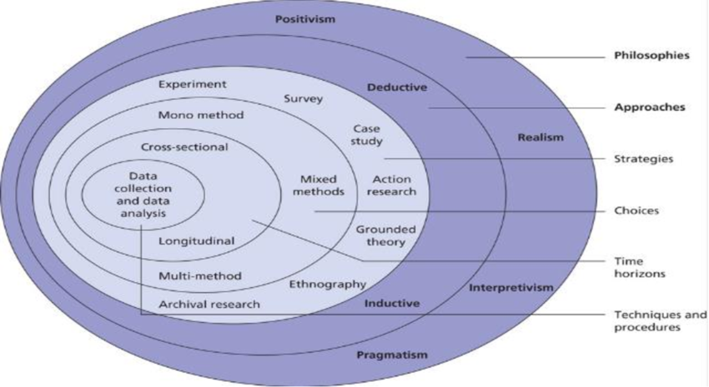
Figure: Research Onion
Source: (BBC, 2025)

3.2 Research Philosophy
This is a significant belief configuration, which instructs, the procedure knowledge is enhanced (Mbanaso et al., 2023). Out of three procedures, there has been usage of the ‘interpretivism’ procedure, which efficiently helps to explore complicated attributes and meanings. It permits informed and qualitative information (Bergmann, 2023). Although this is generalised, it relies on context and might restrict the capability to implement findings widely.

3.3 Research Approach
This is the complete plan and process for performing a study, from presumptions to methods. The ‘Inductive’ method has been utilised as it enables theory to emerge from information. It also caters for scalability and explains comprehension of trends (De Oliveira, 2023). However, this might generalise, and can take more time to perform.

3.4 Research Design
This is the constructive plan that depicts the procedure for the interpretation of data. Out of two different methods, there has been usage of ‘Exploratory design’, as it assists in recognising patterns. This also creates insights and clarifies the problems during the presence of limited insights (Mulisa, 2022). Although its limitations involve a shortage of conclusive outcomes, and restricted generalisability due to unstructured data gathering procedures.

3.5 Research Strategy
This is the complete plan that guides the procedure objectives are addressed (Johannesson et al., 2021). A ‘case study’ method has been utilised for this work, as it provides a clear comprehension of complicated challenges within actual-life contexts. Although they have drawbacks, such as restricted generalisability and problems with redundant findings across various configurations.

3.6 Research Method
This is the particular technique utilised to gather and interpret data at work (Veal, 2006). A ‘mono method’ has been utilised, as it streamlines data gathering and also assures continuation. Although it restricts different perceptions, which decreases the depth and breadth of insights. This depends on a single data source or strategy, which impacts the validity of the outcome (Walliman, 2021).

3.7 Data collection
This is the constructive procedure of collecting insights to address study questions, with inspection of the hypothesis. ‘Secondary data’ gathering has been implemented, as it saves time and cost by utilising present insights. This might have constraints, such as outdated information, significant bias, and restricted control over data standards (Dzwigol, 2022).

3.8 Data Analysis
This is the method of arrangement, with significant interpretation from gathered data. ‘Qualitative analysis’ has been used here, as it offers informed insights into different experiences. Thematic analysis has been performed here, however, this can take more time. It has been difficult to generalise the impact of bias in evaluation (Urcia, 2021).

3.9 Time-Horizon
This refers to a complete period during which information is gathered in the work. ‘Cross-sectional’ procedure has been used here, as it encompasses information at a single point in time. This also permits rapid assessment of patterns and connections. It is price-effective, although this cannot track transformations over time (Williamson, 2021).

3.10 Ethical Considerations
Ethical factors in the study ensure individuals’ rights and confidentiality. This involves explained consent, which overcomes any kind of damage (Cottrell, 2014). It also maintains credibility in information reporting, which fosters trust or integrity throughout the procedure. The Data Protection Act of 2018 and GDPR have been utilised in this work. This assists in the effective accomplishment of the study (Gov.UK, 2025).

3.11 Alternative Research Methodology
The longitudinal method can be applied for this, which includes the acquisition of data from similar subjects over an expanded time frame. This strategy permits for analysing transformations and patterns over time (Nickerson, 2022). It also permits clear insights into the casualty and the extended-term impacts of variables. Online data netnography can also be used, as it is increasingly suitable for individuals to supervise authentic responses. The implementation of this offers understanding of actual-time contexts of patterns.

Chapter 4: Findings and Discussion

4.1 Findings and Analysis
Objective 1: Housekeeping practices to offer better guest services at Cross Hands Hotel
Theme 1: Key housekeeping services of Cross Hands Hotel
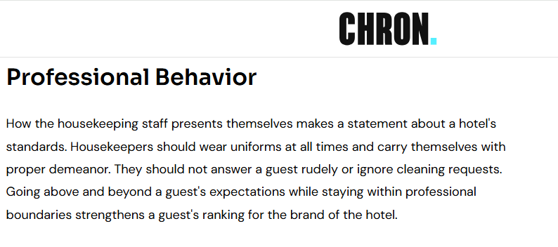
Figure: “Professional conduct” as a part of housekeeping activities
Source: (Petrick, 2025)
Cross Hands Hotel staff are responsible for keeping the environment tidy, cosy and pleasant for all guests. One main service includes daily cleaning of rooms in a professional way where the team dusts, vacuums, sanitises all surfaces and changes the used toiletries and towels (Petrick, 2025). It guarantees that the rooms are clean and smell good in the way guests hope for. Every evening, the staff at the hotel comes to prepare the room for guests to enjoy a peaceful sleep. They get the facility of laundry and dry cleaning during a long visit. Hotels regularly keep lobbies, corridors and restrooms spotless to help their image and keep them clean (Widiastini et al., 2024). Staff working in housekeeping are taught both how to clean and how to follow safe practices, including handling chemical products and managing infectious waste. A major service given is being prompt when guests ask for extra pillows, blankets or quick room cleaning. To be sustainable, Cross Hands Hotel prefers eco-friendly cleaners and focuses on the "professional conduct" of the staff. After the managers provide the services, housekeeping services make sure that each area meets the necessary quality standards before guests occupy the room (Aguilar-Escobar et al., 2021). Checking, inspecting and exchanging information regularly using these tools makes sure the housekeeping team is efficient. All of these services work together to ensure guests have a pleasant time and stay loyal and satisfied (Collis and Hussey, 2014).
Theme 2: Impact of the housekeeping services on guest satisfaction
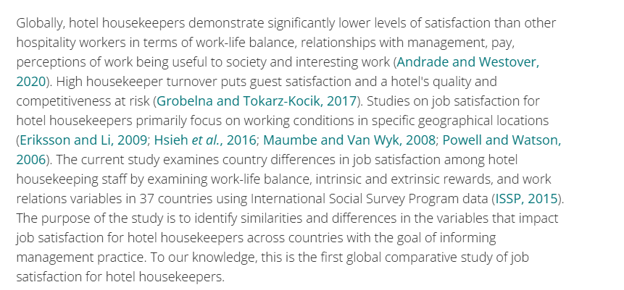
Figure: Importance of “housekeeping” in satisfying customers
Source: (Andrade et al., 2021)
The hotel's housekeeping is a major factor in making guests satisfied. Impressions of guests are often deepest when they notice a hotel's cleanliness upon arrival. According to the scholar's review, high turnover rates of housekeepers reduce the "customer satisfaction" rate (Andrade et al., 2021). Thus, it is understood that housekeeping plays a significant role in impressing guests. Maintaining rooms and public spaces at high levels shows that attention is given to every detail which improves guests’ comfort. People often appreciate and relax more when everything in their hotel appears spotless and healthy (Baquero et al., 2022). A quick answer to any specific needs and a perfectly clean washroom contributes to how good the service seems. When the rooms are kept fresh and tidy, guests are left with a reliable view of the hotel. Poor housekeeping makes guests unhappy, gives them reasons to write negative reviews and can bring guest issues to the reception desk (Buell, 2021). Having a clean business often makes customers more loyal and more likely to visit again. Nowadays, many people post about their experiences on the internet and where the accommodations are clean is talked about a lot in reviews. As a result, proper housekeeping practices improve how guests feel and also refine the hotel’s online reputation and its place among competitors (Twum et al., 2023). Besides, Cross Hands Hotel ensures its staff are courteous and helpful, all the while keeping everything discrete and professional which allows the hotel to give guests a more personal feel.
Objective 2: Challenges of housekeeping practices and guest satisfaction in Cross Hands Hotel
Theme 1: Challenges faced by the hotel in managing housekeeping practices
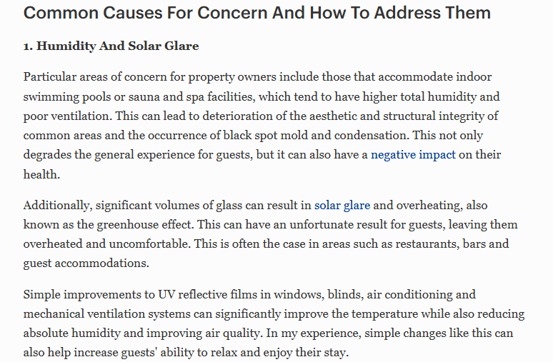
Figure: Examples of some common worries regarding “housekeeping activities”
Source: (Ratcliffe, 2023)
The source depicts common challenges for the property owners including maintaining indoor accommodation and a simple example is given in this (Ratcliffe, 2023). It proves that all the little things or families matter to guests and thus, giving detail focus to those sometimes become difficult for companies. Running good “housekeeping operations” is difficult for the Cross Hands Hotel. A big challenge is keeping service quality high as the number of people in the hotel goes up or down. At times of strong demand, housekeeping cannot keep up with all the work, making some jobs not done properly. In contrast, when demand for services drops, letting go of employees to save money can mean fewer and poorer services. A high number of departures from the housekeeping team can affect continually good service and cost the company extra for training (Brunot, 2025). Finding and keeping people with skills proves challenging, as everyone is paid very little and the work is tough which lowers the motivation and work outputs. Differences in communication between the front desk and housekeeping can lead to minor problems or delays such as not learning about late guests or what they require. Also, keeping up with new "health and safety rules", particularly after COVID-19 ends, needs regular employee training and the use of more resources, putting budget limits to the test (Lloyd, 2023). The hotel must handle guest requests when it comes to sustainability since while some expect new towels each day, others expect environmentally responsible practices.
Theme 2: Challenges in satisfying guests
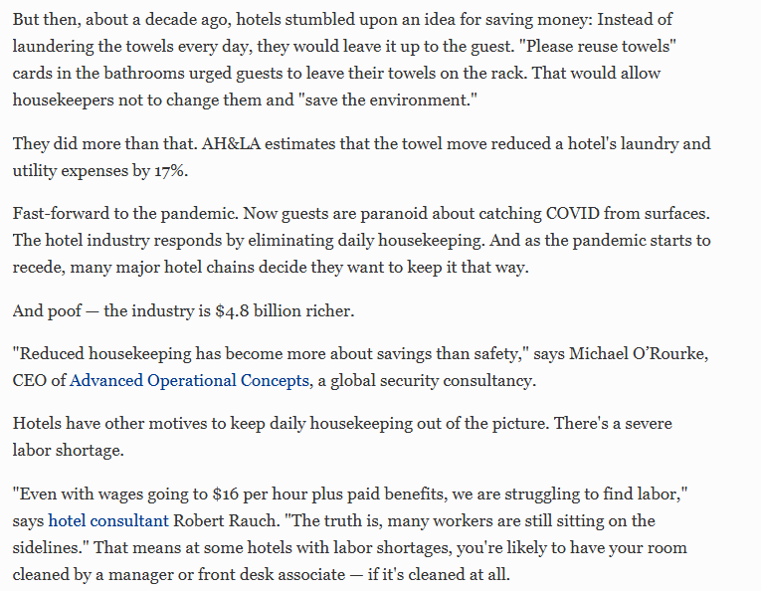
Figure: Difficulties in satisfying visitors due to poor housekeeping
Source: (Elliott, 2021)
Some challenges are present in the guest satisfaction area as well and due to labour shortage as well as budget constraints, many hotels compromise their housekeeping services. This results in guest dissatisfaction and during the pandemic situation, it became a serious concern (Elliott, 2021). In this condition, sometimes managers or people from other departments have to clean rooms which are not actually part of their job. Similarly, many issues at Cross Hands Hotel arise from the differing demands of guests, obstacles to operation and inadequate communication. A major problem is that guest likes can vary so much as some want attention and care, however, others want to stay isolated and uninterrupted. Finding a good mix between personal care and set rules might be complicated for staff in housekeeping (Dempsey, 2023). While there is a language gap between guests and housekeepers, it may cause misunderstandings or requests being missed. Other problems can be caused by faulty equipment such as vacuum cleaners not working or not having enough fresh linen. It can also be difficult to ensure guests do not think the housekeepers are neglecting them. Even though Wi-Fi performance, noise and room temperature cannot really be improved by housekeeping, housekeepers must still manage such complaints when cleaning guest rooms (Moreno-Perdigon et al., 2021). Not all staff training makes a difference as a poorly-handled situation can let down the work done by housekeeping.
Objective 3: Strategies to overcome the challenges and offer a positive experience to the customers in the Cross Hands Hotel
Theme 1: Strategies to overcome the challenges faced related to housekeeping services
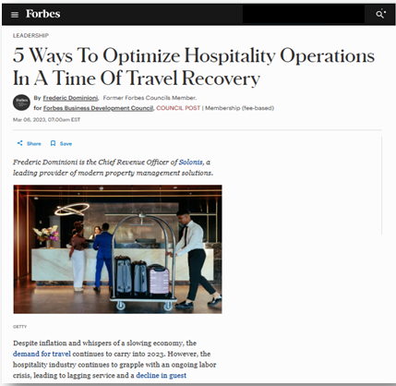
Figure: "5 Ways To Optimize Hospitality Operations In A Time Of Travel Recovery"
Source: (Dominioni, 2023)
Through the analysis of the above content collected from the journal named Forbes, which was created by Federic Dominioni, it has been found that suitable strategies can be recommended. It has been identified that there are many methods and techniques that can be implemented to reduce the potential issues, focusing on standardisation. The management of the organisations operating in the hotel industry of the United Kingdom is suggested to maintain suitable cleaning procedures in the different areas of operations. It is known to ensure a consistent level of cleanliness, which also contributes towards increased brand popularity. Another suitable strategy is identified to be the leverage of technology (IoT) in the form of different features, such as smart devices and automation, to improve functioning and build competition. The introduction of chatbots and artificial intelligence in different activities will contribute towards increasing efficiency and organisational performance. It is also subject to play a crucial role in filling the gaps experienced by the management due to the lack of expertise and skilled expertise in the different operations (PrecisionFM, 2024). A positive impact will be made on strengthening the digital infrastructure of the Cross Hands Hotel, which is known to reduce the issues related to data privacy and security concerns. Maintaining transparency within the organisational premises of this particular hotel is going to essentially improve customer relationships and contribute towards enhanced brand awareness. Other aspects, such as personalisation of the services, will be essentially suitable for improving the guests’ sense of security and belonging, leading to a positive influence on its marketing positions.
Theme 2: Strategies to offer a positive experience to the customers in the Cross Hands Hotel
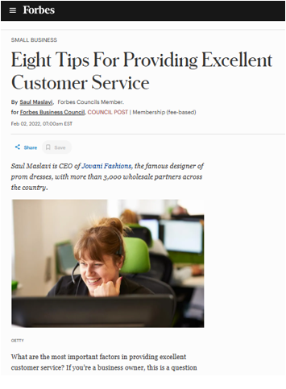
Figure: "Eight Tips For Providing Excellent Customer Service"
Source: (Maslavi, 2022)
It has been found from the information collected based on this blog that the management of the selected organisation should apply suitable approaches to create a positive guest experience. One of the primary methods can be identified for the optimisation of customer services includes the improvement and personalisation of the facilities which are provided by the administration. Different aspects, such as personalised welcome amenities and individually-tailored operations for the target audience, will play a crucial role in enhancing the satisfaction rates. Another recommendation is subject to the implementation of measures and methods which ensure effective maintenance of cleanliness and hygiene, as it improves brand awareness. The establishment of suitable training programs and workshops that contribute towards staff training and empowerment helps in identifying potential shortcomings and issues faced by the employees (Stylos et al., 2021). It is also responsible for creating a sense of value and belonging among the working individuals, which contributes towards improving the operational conditions within the Cross Hands Hotel. Drawing a relevance to the local communities and providing an authentic experience through suitable measures and methods will also be quite beneficial. An insightful instance relating to the provision of cultural activities in a particular place is ensured, tailored to the individual demands of the guests, increasing the overall engagement rates (Michalis, 2024). The guests are subject to collaborate with the local businesses that contribute towards enhancing the employment rates and improving the employment rates.

4.2 Discussion
Main discussions
Based on a structured methodology, the outcomes have been presented by the investigator. This context helps in obtaining information from diverse books, journals, websites and articles. The outcomes have declared that Cross Hands Hotel’s staff are involved in keeping the environment cosy, pleasant and tidy for all its visitors. The main services include daily cleaning of the rooms and ensuring that the rooms smell good. It prepares the accommodations and affirms that the guests' experiences are good. This action assists in delivering luxury and satisfaction to the consumers. Keeping lobbies, restrooms and corridors spotless clean helps the business in gathering a huge brand value among the customers. Promoting eco-friendly cleaning provides an exceptional experience to the customers. The housekeeping employees are responsible for maintaining quality services before the guests occupy the room. Using advanced tools helps the staff in checking, exchanging and inspecting information regularly. This action makes the work of the employees efficient and ensures a positive and satisfying environment in the United Kingdom. Similarly, Mangco and Andales (2023) have stated that he maintenance of hygiene is one of the major practices in the hospitality industry. Housekeepers play a vital role in ensuring positive guest experiences in a hotel. Ojino et al. (2022) have mentioned that the personalisation activities in this particular sector are essential for substantiating the plan properly. The outcomes also highlighted that these activities provide a high level of satisfaction to the consumers. It offers comforts and relaxation for the visitors. A quick answer to any particular needs and cleaned washrooms and rooms may contribute to the quality services. Having a clean business often makes customers more loyal and more likely to visit again. Gathering positive reviews in popular websites assists in attracting huge number of visitors towards the business. On the contrary, as per Singgalen (2024), rapid problem-solving and effective communication plays a significant role in offering better experiences to the customers. Communicating properly through English language attracts foreign guests towards the business. It assists to understand the visitors’ perspectives and minimise their issues effectively. Despite of various advantages, the organisation has faced several barriers while meeting the visitors’ satisfaction. The main issue of this context is to maintain indoor accommodation. It is difficult for the employees to maintain small things that creates difficulty in maintaining all operations effectively. Another common issue is keeping the service quality high. In the time of strong demand, the quality may not be up to the mark that faces criticism. The Cross Hands Hotel also faces issues while finding skilled staff for the business. Hiring efficient and talents in the organisation are challenging for the company as it requires proper training. Lack of proper training, the business has faced quality-related issues in the business. Similarly, according to Gaspani and Recchi (2024), after the pandemic situation, the organisation has faced skill shortages in the United Kingdom. This action stops from marinating quality services for the customers. Chela-Alvarez et al. (2021) have declared that A proper housekeeping service needs a certain time, which is affected during the peak season. Additionally, the customer satisfaction is also affected by these activities and face criticisms. On the contrary, as per Rudchenkov and Volkova (2021), communication gap is an important gap in the hospitality sector. It has created misunderstandings and lower the service quality. Chela-Alvarez et al. (2021) have described some other barriers to this process. Time constraints and a lack of proper response are the key players in this aspect. Theme 2 has also focused on the same area to offer a proper outcome regarding the assessment. Budget constraints and labour shortage have been mentioned in the particular part. This aspect prevents companies from applying the strategy during higher demand. These challenges also negatively affect the overall customer satisfaction in the business. Additionally, they should take some actionable steps to address them easily. Buhalis et al. (2024) discussed some strategies in the workplace to mitigate the challenges properly in the third objective. These factors play a vital role in supporting companies during their operations. The application of advanced technology and proper investment in staff training will be the major approaches in this section. Similarly, Theme 1 of the third goal has highlighted these areas. The utilisation of proper technology is a major sector in this area. Companies will achieve their goals through this process in the market. Contrarily, this practice has prioritised transparency, which is not pointed out in the literature review. Additionally, there is also another theme regarding the objective in the process. This factor is also a portrayal of the same field. Some major strategies to address the issues in the hotel sector the highlighted area of this portion. Carvalho and Ivanov (2024) analysed in the literature review that organisations should improve their communication processes to offer a better experience to customers. The issues regarding the response delay will be solved through this approach. Theme 2 in this segment has pointed out personalisation and community engagement as the key players of the factor. This is a contradiction of the above-mentioned part, which reflects the variety of solutions in the workplace. Some other sectors, such as hygiene and cleanliness, will play a vital role in maintaining the process. Companies should utilise these elements to substantiate their plan in the market.
Implications
‘The implications of the study’ is referred to as the potential impact of the findings beyond the results on different areas such as practice, theory, policy and further research (Page et al., 2022). It is essential for explaining what a work’s findings mean and contribute to the wider field of knowledge. There are mainly two types of implications including theoretical and practical. The ‘practical implications’ are explained as real-world examples and consequences of the outcomes (Benlian et al., 2022). It primarily focuses on the results that can be utilised in improving practices, policies and real-life outcomes. This context is beneficial for making any critical decisions based on the applications. It provides concrete and specific suggestions or recommendations on a particular issue. In this section, the outcomes will develop the housekeeping services effectively. The ‘theoretical implications’ are described as the potential influence of the findings of a study on existing theories (Hornikx et al., 2024). It highlights the key areas which need to be improved by generating new aspects. This context will assist an organisation in introducing frameworks and gaining evidence-based knowledge. It can develop the existing theories or generate a new model to solve the issues. Additionally, the implications are essential for avoiding repetitive outcomes of the results.
Limitations
The outcomes have been arranged by a structured methodology which represents the choices of a researcher. The individual has taken a secondary thematic analysis to deliver results to a specific issue. For this reason, the investigator has faced some issues while gaining results based on the chosen methods. These approaches provide a huge number of datasets that increase the confusion (Gonzalez, 2022). It has also created concerns about the reliability and validity of the findings. On the other hand, sorting the results based on the questions and objectives are crucial limitation for the study. It has developed barriers while preparing the study effectively. It is suggested that the investigator may choose primary data that helps to conduct the survey (Richardson et al., 2023). This action assists in generating current and real-life solutions to the problem. It also assists in knowing different perspectives of a group of people (Kara, 2023). The researcher can choose the mixed method with both primary and secondary information analysis. This action helps in preparing more valuable and critical results based on the assumptions (Guetterman et al., 2021). It can permit an investigator to gain scientific perspectives and decrease the confusion effectively.
Valuable Areas
The main and valuable areas of these findings are the hospitality industry and housekeeping services. The organisation has faced several challenges while meeting guest satisfaction. Mainly, managing indoor accommodations and running good housekeeping has increased concern about losing customer satisfaction in the business. Due to improper management, the services have been hampered and the employees may not keep up with the work. Generating the findings, this sector is facing huge barriers while offering positive experiences to its guests in the Cross Hands Hotel. Highlighting some solutions to the challenges may help mitigate the issues. Focusing on standardisation, the company can develop its operations effectively. Maintaining suitable cleaning processes will be an effective way to reduce the problems.

Chapter 5: Conclusion and Recommendations

5.1 Conclusion
There has been a significant description of the analysis portion, and the way it fosters objectives.
Procedure through which the findings are addressed with objectives
The analysis portion of this study has described the different housekeeping procedures at Cross Hands Hotel. It plays a vital role in transmitting superior client services by sustaining a clean and comfortable culture. Different employees assure regular room cleaning through procedures, such as dusting and sanitisation of services. This effectively guarantees that various rooms foster the client’s expectations for cleanliness. Different evening arrangements additionally optimise customers’ comfort by building a comfortable resting environment. Extended-term guests receive advantages from services, such as laundry or dry-cleaning. Whereas, people regions, such as lobbies, corridors, are daily maintained to leverage the hotel’s reputation. Housekeeping staff receive development procedures, with secure management of chemicals and hazardous waste. It effectively encompasses different health and security measures. Active responses to client requests for extra amenities result in the team’s dedication to a positive customer experience. ‘Viability’ has been incorporated into housekeeping by utilising environment-friendly cleaning items. This significantly displays contemporary travel inclinations, and different managers address standard control by daily inspection of rooms. There has been communication within the teams to ensure consistent meetings of excellent standards. The effect of these services on customer experience is highly significant, as cleanliness is frequently one of the primary factors. Effective attention to different details in rooms and people spaces optimises client comfort. It results in different positive experiences, trustworthiness, and the hotel’s image is also empowered through positive reviews. Again, hygiene factors have been one of the significant fundamentals in the contemporary virtual age. Moreover, professional attributes of housekeeping staff cater for a discreet culture, which also involves an individualised touch to the client’s experience. Hence, Cross Hands Hotel’s apprehensive housekeeping procedures, from security cleaning and compliance to sustainability, have been the key fundamentals. A cohesive operational structure assures that customers receive comfortable accommodations. It also optimises client experience and the hotel’s competitive positioning.
The organisation has faced different operational challenges in retaining effective services related to housekeeping. Continuous customer experience, with efficient management of services, has been the primary challenge. Reduced occupancy might build potential pressure in employee layouts. This efficiently decreases the quality and can also build different barriers. Minimised salaries and the requirement of physical labour create a negative effect on staff motivation. Misunderstanding between the hotel and front-end employees creates a potential delay. This reduced the customer experience, and efficient maintenance of sustainability poses significant barriers. This changes various anticipations of guests with time, and a low budget also negatively affects. Different individuals endorse environment-friendly procedures, and this creates pressure to maintain a suitable balance. Assorted customer anticipations also create problems in different operations of the establishment. Another primary barrier is the language barrier with customers. It creates misunderstandings, and limited resources also cause difficulties in service delivery Various guests value attentiveness, whereas others are inclined towards confidentiality. This makes it difficult to customise services efficiently. Language difficulties between clients and housekeepers result in miscommunication, while restricted resources create barriers in service delivery. Customers might misinterpret housekeeping restrictions as neglecting factors, and issues, such as reduced Wi-Fi connections, are frequently directed. This creates significant pressure, and apart from employee training, poorly managed situations can still create damage to customer experiences. Hence, these have addressed the procedure that Cross Hands Hotel must steer different operational and communication-connected issues to sustain excellent standards in housekeeping. These efforts have been vital for attaining sustained client experience and service standards.
Effective mitigation of issues in housekeeping requires the execution of different measures. Cross Hands Hotel can apply various critical measures to increase its effectiveness. Generalising cleaning processes across various operations has been highly crucial to sustain continuous cleanliness, with an increase in brand image. Leveraging the usage of technology, such as IoT devices, mechanisation, chat support, and AI can simplify activities. It has also created chances for compensation in skill shortages, with an enhancement in service performance. Lucidity in operations caters to client trust, whereas individualised services optimise the client’s sense of trustworthiness. Building a more positive client experience needs the hotel to prioritise enhancement in customer service through personalised provisions. Daily employee training and empowerment through different workshops have also been effective in recognising operational gaps. Moreover, integrating regional culture fundamentals into the customer experience, such as community-navigated activities, can offer a more generalised stay. Partnerships with regional businesses also endorse local employment. Hence, these approaches are objectified at enhancing operational efficiency and client experience at Cross Hands Hotel.

5.2 Recommendations and Practical Strategies
Employee Training and Development
One of the most essential suggestions that can be implemented within the organisational premises of Cross Hands Hotel is the establishment of training sessions and workshops (Simonis, 2023). It will be essential for identifying the core negative traits and the shortcomings that are faced by the management due to the inefficient workforce and their activities. The administration is subject to fostering guest specifications to improve the hands-on training experience for the individuals who are currently working within the grounds of the selected organisation (Lee et al., 2021). Recognition and appreciation need to be provided to increase the operational efficiency for the development of the infrastructure and system.
Introducing Technological Advancement
There are various features and techniques which including automation, Artificial Intelligence (AI) and Internet of Things (IoT), which can be responsible for driving engagement and functioning (Bonfanti et al., 2021). Through the implementation of suitable strategies such as schedule management and inventory control, the management of the Cross Hands Hotel is subject to increasing its functionality to ensure optimised satisfaction. With the application of smart cleaning devices and communication technology, the administration can aim to increase the operational efficiency and productivity level (Giannoukou, 2024). Reducing the operational costs and mitigating the potential challenges which are experienced due to a lack of abilities from the employees.
Focusing on Hygiene and Cleanliness
Another recommendation will be suggested for being applied within the organisational premises of the selected business in the United Kingdom for creating a positive guest experience. Highlighting the action of housekeeping as a priority, the functions need to be focused on cleanliness and hygiene within the grounds of the Cross Hands Hotel. Initiation of standardised protocols and measures is subject to integration that ensures the provision of suitable cleaning techniques and methods (Limna and Kraiwanit, 2023). Thus, the management of the hotel organisation will be able to attract the hygiene-conscious customers and drive the market position within the operating business market of the hospitality sector.
Ensuring Open Communication with Stakeholders
Fostering clear communication and similar techniques by the administration of the chosen business will be quite helpful in understanding the needs and wants of the guests. Through this particular recommendation, an optimised level of information conveying is ensured, leveraging the use of multiple channels and digital platforms (Iyelolu et al., 2024). Thus, a positive influence is made on the internal communication processes and helps maintain a smooth flow of work through the provision of accurate information. Active soliciting of feedback and planning of the processes are other advantages that can be experienced through this suggestion (Puh and Bagić Babac, 2023).
Implementing KPIs and Metrics
The suitable application of essential metrics and measures such as Net Promoter Score (NPS), Guest Satisfaction Scores (CSAT), and the time taken to tend to guest requests will be quite helpful (Ameur et al., 2023). With the extensive usage of these metrics and methods, the management of the Cross Hands Hotel will be able to gain a better insight into the employee performance. It is also going to be quite essential in identifying the potential lacking aspect and scope for development and growth, which promotes the brand's presence (Rita et al., 2022). The administration will also be able to promote their performance levels to a greater scope and establish a proper tracking system of employee performance within the organisational premises. This is going to be quite helpful in analysing the data related to the operations on a regular basis.
Providing Personalised Services
Collecting the essential information related to the guests’ preferences and requirements is needed to be identified and implemented for the creation of tailored services (Colmekcioglu et al., 2022). The offering of customised amenities and loyalty programs will be helpful in increasing the rate of guest satisfaction among the target market in the United Kingdom. It is also subject to gaining a competitive advantage compared to other similar businesses and enhancing its brand awareness (Polat et al., 2024). Another set of benefits which can be gained by the management Cross Hands Hotel is improved loyalty and increased revenue generation.

References
Adanse, J., Khayiya, R. and Maranga, V., (2024). Influence of optimal room occupancy strategies on revenue maximisation during slack periods in selected 3-to 5-star hotels in Ghana. Research in Hospitality Management, 14(1), pp.57-69.
Aguilar-Escobar, V.G., Garrido-Vega, P., Majado-Márquez, J. and Camuñez-Ruiz, J.A., (2021). Hotel room cleaning: Time study and analysis of influential variables in a Spanish hotel. Journal of Industrial Engineering and Management, 14(3), pp.645-660.
Alcalde-González, V., Mozo, A.G. and Bustos, A.V., (2021). No clean rooms, no hotel business: Subversion tactics in Las Kellys’ struggle for dignity in hotel housekeeping. Annals of Tourism Research, 91, p.103315.
Ameur, A., Hamdi, S. and Ben Yahia, S., (2023). Sentiment analysis for hotel reviews: A systematic literature review. ACM Computing Surveys, 56(2), pp.1-38.
Andrade, M.S., Miller, D. and Westover, J.H., (2021). Job satisfaction factors for housekeepers in the hotel industry: a global comparative analysis. International Hospitality Review, 35(1), pp.90-108.
Baquero, A., (2022). Customer and employee satisfaction in hotels. Journal of Hospitality and Tourism Issues, 4(2), pp.69-83.
BBC, (2025). Conducting research - methodology. [Online]Available at: https://www.bbc.co.uk/bitesize/guides/z9rn3k7/revision/3 [Accessed 24 May 2025].
BBC, (2025). Hospitality outlets. [Online] Available at: https://www.bbc.co.uk/bitesize/guides/zkj2cqt/revision/1#:~:text=Hospitality%20outlets-,Within%20the%20hospitality%20industry%20there%20are%20many%20outlets%20that%20provide,the%20bedrooms%20and%20public%20areas. [Accessed 24 May 2025].
Beasley, C. and Beasley, B.W., (2023). Expectancy Theory, Diversity, and the Nonprofit Board. Journal of Nonprofit Education & Leadership, 13(1).
Benlian, A., Wiener, M., Cram, W.A., Krasnova, H., Maedche, A., Möhlmann, M., Recker, J. and Remus, U., (2022). Algorithmic management: bright and dark sides, practical implications, and research opportunities. Business & Information Systems Engineering, 64(6), pp.825-839.
Bergmann, J., (2023). Research philosophy, methodological implications, and research design. In At Risk of Deprivation: The Multidimensional Well-Being Impacts of Climate Migration and Immobility in Peru (pp. 57-89). Wiesbaden: Springer Fachmedien Wiesbaden.
Bonfanti, A., Vigolo, V. and Yfantidou, G., (2021). The impact of the Covid-19 pandemic on customer experience design: The hotel managers’ perspective. International Journal of Hospitality Management, 94, p.102871.
British Cleaning Council, (2022). THE CLEANING, HYGIENE AND WASTE INDUSTRY. [Online] Available at: https://www.bics.org.uk/wp-content/uploads/2023/06/RR-2022.pdf [Accessed 24 May 2025].
BRM, (2025). The Essence of Research Philosophy. [Online]Available at: https://research-methodology.net/research-philosophy/#google_vignette [Accessed 24 May 2025].
Brunot, T., (2025). Housekeeping Human Resource Issues. [Online] Available at: https://smallbusiness.chron.com/housekeeping-human-resource-issues-73599.html [Accessed 27 May 2025].
Buell, R. W., (2021). Elevate Employees, Don’t Eliminate Them. [Online] Available at: https://hbr.org/2021/09/elevate-employees-dont-eliminate-them [Accessed 26 May 2025].
Buhalis, D., Efthymiou, L., Uzunboylu, N. and Thrassou, A., (2024). Charting the progress of technology adoption in tourism and hospitality in the era of industry 4.0. EuroMed Journal of Business, 19(1), pp.1-20.
Cai, R. and Chi, C.G.Q., (2021). Pictures vs. reality: roles of disconfirmation magnitude, disconfirmation sensitivity, and branding. International Journal of Hospitality Management, 98, p.103040.
Carvalho, I. and Ivanov, S., (2024). ChatGPT for tourism: applications, benefits and risks. Tourism review, 79(2), pp.290-303.
Çeltek, E., (2024). Unmanned smart hotel: applications and examples. Worldwide Hospitality and Tourism Themes, 16(5), pp.611-626.
Chela-Alvarez, X., Bulilete, O., García-Buades, M.E., Ferrer-Perez, V.A. and Llobera-Canaves, J., (2021). Perceived factors of stress and its outcomes among hotel housekeepers in the Balearic Islands: A qualitative approach from a gender perspective. International Journal of Environmental Research and Public Health, 18(1), p.52.
Collis, J and Hussey, R (2014), Business Research, A Practical Guide for Undergraduate and Postgraduate Students, Palgrave, London.
Colmekcioglu, N., Dineva, D. and Lu, X., (2022). “Building back better”: the impact of the COVID-19 pandemic on the resilience of the hospitality and tourism industries. International Journal of Contemporary Hospitality Management, 34(11), pp.4103-4122.
Cottrell, S., (2014). Dissertations and project reports : a step by step guide. New York: Pallgrave.
Croes, R., Padrón-Ávila, H., Rivera, M. and Renduchintala, C., (2025). A triadic model of job retention and turnover dynamics in the hospitality industry. International Journal of Contemporary Hospitality Management, 37(3), pp.700-721.
De Oliveira, B., (2023). Participatory action research as a research approach: Advantages, limitations and criticisms. Qualitative Research Journal, 23(3), pp.287-297.
Dempsey, J., (2023). Hospitality sector 'anxious' over summer staffing. [Online] Available at: https://www.bbc.com/news/business-66021588 [Accessed 27 May 2025].
Dominioni, F., (2023). 5 Ways To Optimize Hospitality Operations In A Time Of Travel Recovery. [Online] Available at: https://www.forbes.com/councils/forbesbusinessdevelopmentcouncil/2023/03/06/5-ways-to-optimize-hospitality-operations-in-a-time-of-travel-recovery/ [Accessed 24 May 2025].
Dzwigol, H., (2022). Research methodology in management science: Triangulation. Virtual Economics, 5(1), pp.78-93.
Elliott, C., (2021). Daily Hotel Housekeeping May Be History. Here’s Who Will Pay For It. [Online] Available at: https://www.forbes.com/sites/christopherelliott/2021/06/30/daily-hotel-housekeeping-may-be-history-heres-who-will-pay-for-it/ [Accessed 27 May 2025].
Filipova, A.A., (2023). Expectancy theory in organizations. In Global Encyclopedia of Public Administration, Public Policy, and Governance (pp. 4604-4612). Cham: Springer International Publishing.
Gaspani, F. and Recchi, S., (2024). Job quality and health conditions in the hotel industry: the case of housekeeping workers. International Review of Sociology, 34(1), pp.156-178.
Giannoukou, I., (2024). Revolutionizing hospitality: Strategic integration of innovation management embracing technological innovation for enhanced customer experiences. Technium Business and Management, 7, pp.24-39.
Gonzalez, E.J., (2022). Secondary Analysis of Large-scale Assessment Databases: Challenges, Limitations and Recommendations. In International Handbook of Comparative Large-Scale Studies in Education: Perspectives, Methods and Findings (pp. 1-32). Cham: Springer International Publishing.
Gov.UK, (2025). The UK's data protection legislation. [Online]Available at: https://www.gov.uk/data-protection [Accessed 24 May 2025].
greenekinginns, (2025). About our hotel. [Online] Available at: https://www.greenekinginns.co.uk/hotels/gloucestershire/cross-hands-hotel [Accessed 24 May 2025].
Guetterman, T.C., Fàbregues, S. and Sakakibara, R., (2021). Visuals in joint displays to represent integration in mixed methods research: A methodological review. Methods in Psychology, 5, p.100080.
Hornikx, J., van Meurs, F. and Tenzer, H., (2024). Foreign languages in advertising: Theoretical implications for language-related IB research. Journal of International Business Studies, 55(2), pp.270-279.
Iyelolu, T.V., Agu, E.E., Idemudia, C. and Ijomah, T.I., (2024). Improving customer engagement and crm for smes with ai driven solutions and future enhancements. International Journal of Engineering Research and Development, 20(8), pp.1150-1168.
Jerez-Jerez, M.J., (2025). A study of employee attitudes towards AI, its effect on sustainable development goals and non-financial performance in independent hotels. International Journal of Hospitality Management, 124, p.103987.
Johannesson, P., Perjons, E., Johannesson, P. and Perjons, E., (2021). Research strategies and methods. An introduction to design science, pp.41-75.
Kalgi, D. and Hire, J., (2024). Vital Role of Housekeeping in Organisations other than Hotels. Current Scenario in Science and Technology, Environment, Agriculture, Health, Water Resources, Social Science, Literature & Industrial, p.95.
Kara, H., (2023). Primary data collection: creative methods. In Research and Evaluation for Busy Students and Practitioners (pp. 155-172). Policy Press.
Lee, S.H., Yun, J.J., Díaz, M.M. and Duque, C.M., (2021). Open innovation through customer satisfaction: A logit model to explain customer recommendations in the hotel sector. Journal of Open Innovation: Technology, Market, and Complexity, 7(3), p.180.
Leung, R., (2022). Development of information and communication technology: from e-tourism to smart tourism. Handbook of e-Tourism, pp.23-55.
Limna, P. and Kraiwanit, T., (2023). The role of chatgpt on customer service in the hospitality industry: An exploratory study of hospitality workers' experiences and perceptions. Tourism and hospitality management, 29(4), pp.583-592.
Lloyd, H., (2023). Quantifying Housekeeping Challenge and Conservation Need. Heritage, 6(4), pp.3757-3776.
Ma'fiyah, I. and Sumardiono, S., (2023). English Language Needs for Hotel Service and ESP Program: The Case of Hospitality Vocational Secondary School. Journal of Innovation in Educational and Cultural Research, 4(3), pp.429-437.
Mangco, C.A. and Andales, N., (2023). Assessing Hygenic Practices, Sanitation Procedures of Housekeeping Department Perceived by Hotels-Motels Housekeeping Heads. Interdisciplinary Social Studies, 2(8), pp.2186-2193.
Maslavi, S., (2022). Eight Tips For Providing Excellent Customer Service. [Online] Available at: https://www.forbes.com/councils/forbesbusinesscouncil/2022/02/02/eight-tips-for-providing-excellent-customer-service/ [Accessed 25 May 2025].
Mbanaso, U.M., Abrahams, L. and Okafor, K.C., (2023). Research philosophy, design and methodology. In Research Techniques for Computer Science, Information Systems and Cybersecurity (pp. 81-113). Cham: Springer Nature Switzerland.
Mercan, S., Cain, L., Akkaya, K., Cebe, M., Uluagac, S., Alonso, M. and Cobanoglu, C., (2021). Improving the service industry with hyper-connectivity: IoT in hospitality. International Journal of Contemporary Hospitality Management, 33(1), pp.243-262.
Michalis, B., (2024). 11 Hotel Strategies to Attract Customers. [Online] Available at: https://www.canarytechnologies.com/post/hotel-strategies-attract-customers [Accessed 25 May 2025].
Moreno-Perdigon, M.C., Guzman-Perez, B. and Mesa, T.R., (2021). Guest satisfaction is independent and affiliated to chain hotels. International Journal of Hospitality Management, 94, p.102812.
Mulisa, F., (2022). When does a researcher choose a quantitative, qualitative, or mixed research approach?. Interchange, 53(1), pp.113-131.
Nickerson, C., (2022). Interpretivism paradigm & research philosophy. Simply Sociology, 5, pp.1-16.
Ojino, R., Mich, L. and Mvungi, N., (2022). Hotel room personalization via ontology and rule-based reasoning. International Journal of Web Information Systems, 18(5/6), pp.369-387.
Page, M.J., Moher, D. and McKenzie, J.E., (2022). Introduction to PRISMA 2020 and implications for research synthesis methodologists. Research synthesis methods, 13(2), pp.156-163.
Petrick, J., (2025). Hotel Housekeeping Rules. [Online] Available at: https://work.chron.com/hotel-housekeeping-rules-22847.html [Accessed 26 May 2025].
Plummer, R., (2021). 'A hotel without linen is not a hotel'. [Online] Available at: https://www.bbc.com/news/business-58465953 [Accessed 25 May 2025].
Polat, E., Çelik, F., Ibrahim, B. and Gursoy, D., (2024). Past, present, and future scene of influencer marketing in hospitality and tourism management. Journal of Travel & Tourism Marketing, 41(3), pp.322-343.
PrecisionFM, (2024). Cleaning Facilities management and How to Overcome Them. [Online] Available at: https://www.precisionfm.co.uk/7-key-challenges-in-cleaning-facilities-management-and-how-to-overcome-them/ [Accessed 24 May 2025].
Puh, K. and Bagić Babac, M., (2023). Predicting sentiment and rating of tourist reviews using machine learning. Journal of hospitality and tourism insights, 6(3), pp.1188-1204.
Ratcliffe, J., (2023). Trouble In Paradise: How Hotels And Guest Houses Can Improve Their Facilities. [Online] Available at: https://www.forbes.com/councils/forbesbusinesscouncil/2023/08/16/trouble-in-paradise-how-hotels-and-guest-houses-can-improve-their-facilities/ [Accessed 26 May 2025].
Richardson, J.L., Moore, A., Bromley, R.L., Stellfeld, M., Geissbühler, Y., Bluett-Duncan, M., Winterfeld, U., Favre, G., Alexe, A., Oliver, A.M. and van Rijt-Weetink, Y.R., (2023). Core data elements for pregnancy pharmacovigilance studies using primary source data collection methods: Recommendations from the IMI ConcePTION project. Drug Safety, 46(5), pp.479-491.
Rita, P., Ramos, R., Borges-Tiago, M.T. and Rodrigues, D., (2022). Impact of the rating system on sentiment and tone of voice: A Booking. com and TripAdvisor comparison study. International Journal of Hospitality Management, 104, p.103245.
Rudchenkov, V.N. and Volkova, N.V., (2021). Senior customer satisfaction in hospitality: Peculiarities and challenges by gender. In Gender and Tourism (pp. 55-74). Emerald Publishing Limited.
Saunders, M., Lewis, P. and Thornhill, A., (2012). Research Methods for Business Students, FT/Prentice Hall: Harlow.
Schiebler, T., Lee, N. and Brodbeck, F.C., (2025). Expectancy-disconfirmation and consumer satisfaction: A meta-analysis. Journal of the Academy of Marketing Science, pp.1-22.
Simonis, L., (2023). Customer experiences for senior guests: challenges and opportunities for the hospitality industry.
Singgalen, Y.A., (2024). Hotel Customer Satisfaction: A Comprehensive Analysis of Perceived Cleanliness, Location, Service, and Value. Journal of Business and Economics Research (JBE), 5(3), pp.352-369.
Singgalen, Y.A., (2025). Tourist Preferences at Hotel and Resort Based on Review Data. Journal of Business and Economics Research (JBE), 6(1), pp.179-190.
Statista, (2024). Main challenges expected by accommodation businesses over the next six months in Europe as of March 2024. [Online] Available at: https://www.statista.com/statistics/1358403/challenges-expected-accommodation-europe/ [Accessed 24 May 2025].
Statista, (2024). Turnover of hotel and similar accommodation businesses in the United Kingdom from 2008 to 2022. [Online] Available at: https://www.statista.com/statistics/558099/hotel-business-turnover-uk-united-kingdom/ [Accessed 25 May 2025].
Stylos, N., Fotiadis, A.K., Shin, D.D. and Huan, T.C.T., (2021). Beyond smart systems adoption: Enabling diffusion and assimilation of smartness in hospitality. International Journal of Hospitality Management, 98, p.103042.
Suárez-Fernández, S., Zapico, E. and Boto-García, D., (2025). Water-saving strategies at hotels: which are more effective?. Current Issues in Tourism, 28(7), pp.1135-1154.
Twum, K.K., Kosiba, J.P.B., Hinson, R.E., Gabrah, A.Y.B. and Assabil, E.N., (2023). Determining mobile money service customer satisfaction and continuance usage through service quality. Journal of Financial Services Marketing, 28(1), pp.30-42.
Urcia, I.A., (2021). Comparisons of adaptations in grounded theory and phenomenology: Selecting the specific qualitative research methodology. International journal of qualitative methods, 20, p.16094069211045474.
Veal, A J., (2006). Research Methods for Leisure and Tourism, 3rd Ed, Financial Times/ Prentice Hall.
Walliman, N., (2021). Research methods: The basics. Routledge.
Widiastini, N.M.A., Santiara, I.M. and Rahmawati, P.I., (2024). Analysis Operational Efficiency Strategy and Improvement of Hotel Housekeeping Communication System. Jurnal Manajemen Pelayanan Hotel, 8(2), pp.338-353.
Williamson, T., (2021). The philosophy of philosophy. John Wiley & Sons.

Appendix

Gantt Chart
Factors | 1st week | 2nd week | 3rd week | 4th week | 5th week | 6th week | 7th week | 8th week
Topic selection
Aim and objectives
Literature review
Research Methodology
Qualitative Analysis
Discussion
Conclusion
Submission

