

From Source to Coast:
How much influence did the Belize River Valley have with the wider political ecosystem of Mesoamerica?
Kai Conan Barkla

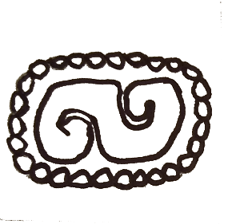
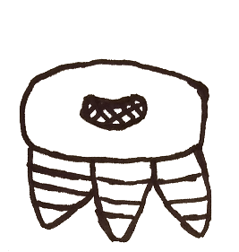
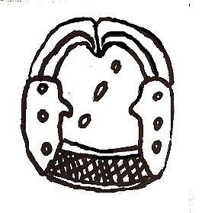

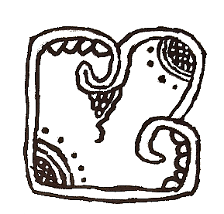

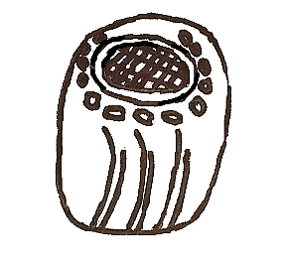
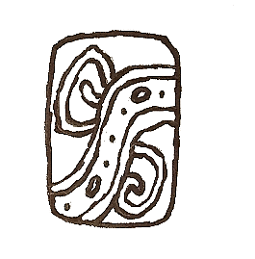

Contents

Acknowledgements 3
List of Figures 4

List of Maps 4

Introduction 5
Chapter 1) Freshwater Salt and Fluid Stone: Trade in the Belize River Valley 10
1.1) Introduction to Ancient Maya trade 10
1.2) The Belize River as a conduit of trade 10
1.3) The Belize River Valley as a producer of tradable goods 12

1.4) Discussion 16
Chapter 2) Flowing as One: Culture and Religion within the Belize River Valley 17
2.1) Introduction to Maya Culture, Architecture and Cosmology 17
2.2) Cahal Pech: A Preclassic trend setter? 18
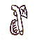
2.3) Discussion 20
Chapter 3) Fighting the Current: Conflict and War in the Belize River Valley 21
3.1) Introduction to Ancient Maya Warfare 21
3.2) Set in Xunantunich’s stones: The Naranjo wars and Caracol’s shadow 21
3.3) Naranjo and Komkom against Yaxha, allied stratagem
in Classic period warfare 27

3.4) Discussion 30
Summary & Conclusion 31
Reference List 33

Acknowledgments
My first thanks go to my kith and kin, who had to put up with my obsessions and niche interests, encouraging me to pursue what I enjoy best.
I am forever grateful to the Belize Valley Archaeological Reconnaissance (BVAR) project for providing an excellent first experience working with a culture that I have been passionate about for a long time. Both the staff and the colleagues I worked with in the summer of 2019 were an absolute pleasure to work with. I will never forget them - one and all. Many thanks go to John Walden who generously agreed to help in the production of this piece.
As my final year of UWTSD Lampeter draws to a close, I would also like to give thanks to the staff members of the university who have guided me and my peers throughout a lifechanging stage in my life that I’ll never forget.
Equal thanks should go to Claude and Louise Belanger, Elizabeth Graham and Jim from the local wine shop who all gave invaluable counsel and assistance in getting me to Belize in the first place. I cannot stress how kind it was to assist a stranger out of nowhere. Their part was, no matter how small, was worth leagues to me.
Finally, yet certainly no less heartfelt, I wish to thank the gods of Belize, who kept me safe and well while I was guest in their lands.

Cover Art. Barkla K. 2019.

List of Figures (In order of appearance)
Figure 1: Timeline of mentioned settlements within the Belize River Valley area or otherwise mentioned in text. Barkla K. 2019.
Figure 2 (a & b): Sketches of obsidian artefacts found at Cahal Pech. After Awe J. & Healy P.F. 1994. ‘Flakes to Blades? Middle Formative Development of Obsidian Artifacts in the Upper BelizeRiver Valley’, in Latin American Antiquity. Vol. 5, No. 3.
Figure 3: Fragments of ceramics at Baking Pot. Barkla K. 2019.
Figure 4a: A ballcourt from Caracol. Barkla K. 2019.
Figure 4b: A ballcourt at Tikal. Burchell S. 2010. https://commons.wikimedia.org/wiki/File:Central_ballcourt,_Tikal_02.jpg#filelinks Accessed 04/02/2020.
Figure 5a: Reconstruction drawing of Structure 14. Aimers J. 2000. ‘Preclassic Round Structures of the Upper Belize River Valley’, in Latin American Antiquity. Vol. 11, No. 1.
Figure 5b: Basic example of a butterfly symbol commonly found at Teotihuacan. Barkla K. 2019.
Figure 6: Jaina Figurine. Aleto T. 2007. https://commons.wikimedia.org/wiki/File:Jaina_Figurine_2_(T_Aleto).jpg Accessed 04/05/2020.
Figure 7: Cahal Pech Figurine head. After May N.P., DeLance L. & Awe J.J. 2019. ‘The Middle Preclassic Figurines from Cahal Pech, Belize Valley’, in Ancient Mesoamerica. Vol. 30.
Figure 8: Northwardly view from Castillo, Xunantunich. Barkla K. 2019.
Figure 9: ‘K2206’ Kerr J. 1999. http://research.mayavase.com/kerrmaya_list.php?_allSearch=&hold_search=&vase_number=2206&date_added=&ms_number=&site=&x=0&y=0 Accessed 01/05/2020.
Figure 10: Diagram demonstrating hypothesised political relationships between polities (mentioned in text) of the Late Classic Period. Barkla K. 2019 containing edited elements from Davies D. 2018.
Figure 11(a): Panel 3, (b): and where it can be found in its contemporary location in relation to Structure A9, Xunantunich, Belize. Barkla K. 2019.
Figure 12: Altar 23, Caracol, Belize. Barkla K. 2019
Figure 13: ‘K1229’ Kerr J. 1998. http://research.mayavase.com/kerrmaya_hires.php?vase=1229 Accessed 24/01/2020.
Figure 14: Bonampak Murals, captives tend to wounded hands. Latin American Studies No Date. http://www.latinamericanstudies.org/bonampak/Room-2_1.jpg Accessed 03/02/2020.
List of Maps (In order of appearance)
Map 1: Map of the Belize River Valley and its context within the Yucatan Peninsula. Barkla K. 2019.
Map 2: Simple map demonstrating possible trade routes as discussed in text, note that some trade goods are not shown on map due to too wide a distribution or a lack of physical evidence. Barkla 2019, with adapted elements from Wikipedia Commons (2020), Learning Geography (2020), IAOS (2019), Galuzzi (2006), Marty (2020).
Map 3: Simplified map demonstrating the positioning of major powers during the conflicts of the western lowlands during the Late Classic period. Barkla K. 2019 containing edited elements from Davies D. 2018 & Kerr J. 1998.
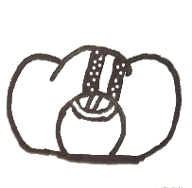
Introduction
The Belize river is the throbbing artery of the nation that shares its name, made up by its two main tributaries, the Mopan and Macal rivers. In the current era the Belize, Mopan and Macal are picturesque waterways that the occasional kayaking tourist circuits, but one and a half millennia ago they would have been the equivalent to highways. Major centres such as Cahal Pech, Baking Pot and Lower Dover can be found all along the river valley and no doubt controlled, protected and contributed to the trade that passed up and downstream. Where the rivers flowed settlements flourished, as they do today. Artistic styles and innovations blossomed across the width and breadth of Mesoamerica. Turbulent times too, for lumbering jungle giants clashed in the heart of the Maya world and the tendrils of their interests found their way across Mesoamerica. How did the communities in the Belize River Valley contribute their agency to the ever shifting and dynamic world of ancient Mesoamerica?
The pioneers of Maya archaeology are arguably Frederick Catherwood and John L. Stephens whose exploits in the jungles of Central America captured the imaginations of archaeologists and historians in Europe and America (Houk 2015:6). Crucially Catherwood and Stephens correctly attributed the cultural remains to the native Maya (Coe & Houston 2015:24-25); something that is still inconceivably in debate today (Haslip-Viera et al. 1997). J. Eric Thompson, a considerable name in early Maya studies, especially linguistics (Coe & Houston 2015:30, Coe & van Stone 2015:7) also made a foray into Belize operating at multiple sites across the region (Houk 2015:7). The latter half of the 1900s saw the excavations of Belizean sites such as Barton Ramie and Lamanai by Gordon Willey and David M. Pendergast respectively (Houk 2015:8, Willey 2004:15-24, Pendergast 1981). The Belize government and culture understands this wealth of its cultural heritage and maintains a keen patronage of archaeology (Coe & Houston 2015:305). As such the Belizean Maya sites have been graced with an extraordinary tradition of annual excavation projects (Chase & Garber 2004:13). Alas, as Houk (2015:3-5) notes, the eastern lowlands of the Maya area (including much of Belize) are relatively out of the limelight in favour of the seemingly more dramatic chronicles of the central lowlands. This is largely due to the lack of surviving texts in this area, and Belizean Maya sites tend to be smaller than the tourist hotspots of Chichen Itza and Tikal (p.3). This does not mean that history did not occur there; a wealth of material evidence proves contrary to this (p.3) as will be demonstrated in this dissertation. Indeed, many sites in Belize record some of the longest occupations in the Mesoamerican area (Chase & Garber 2004:8) such as Lamanai (Houk 2015:210-211, Pendergast 1981:96) and Cahal Pech (Awe 2000, Healy et al. 2004:103-105) from the Preclassic period to the Terminal Classic and even beyond. The elites of these sites had power, that is certain, but how much power did they possess and how did they exert this power? In other words, politics.
Politics in Maya studies have drawn keen interest as a gateway into a period of intrigue and war; studies into ancient Maya politics - including this one - can draw their lineage from scholars such as Thomas Barthel, Joyce Marcus, Richard Adams and Peter Mathews (Martin and Grube 2000:18); building upon one another these scholars brought into focus the divided factions of the Maya – a model we recognise today, away from Sylvanus Morley’s model of a single empire (Coe & Houston 2015:274). From the waning days of the 20th century and the early 2000s, interest rose in the mechanics of Maya politics with the works of Stephen Houston and Takeshi Inomata laying the foundation for Classic period Maya politics (Jackson 2013:4). Simon Martin and Nikolai Grube’s Chronicle of the Maya Kings and Queens (2000) presented the politics of the ancient Maya through the deeds of the rulers in a timeline of all the major Maya polities, illustrating the dramatic nature of the Classic period. Sarah Jackson (2013) also follows a similar style of singling out historical characters, instead Jackson shines light on those who are usually forgotten in history: the courtiers and officers of the palace while also explaining the possible roles of their positions. While it is invaluable to bring such figures and their livelihoods to life, this paper is not concerned with the mechanics of the Maya court but instead the wider implications of the courts. Mary and John Pohl (Pohl & Pohl 1994), argued that the ancient Maya were plagued with destabilising power-grabs and vacuums in the hierarchy, to the degree that even marriages and alliances merely worsened the conflict (pp.144,152). Lucero (1999:213) counters this by pointing out that if the Maya social systems were so unstable, then why did the culture and its mechanics survive for so long? Eventually the discussion of ancient Maya politics will lead to the topic of models: hypotheses regarding the systems that the Maya used to govern themselves, whether systems were centralised or decentralised; nuclearised or galactic in settlement plan. I highly agree with Lucero’s words of caution regarding models (1999:213), that the Maya inhabited such a diverse environment that likely different cities had different systems in place to adequately suit the physical elements in a location. In his book on political structure, de Montmollin (1989:xviii-10) begins on a highly reflective preface and chapter on models and typologies and the pitfalls that can occur when applying models or analogies to ancient societies. That is not to suggest that models do not have their place in political anthropology/archaeology, it allows for the standardisation of knowledge that avoids pedantic ‘to-and-fro’ to flood discussions. Models also have a use in allowing some connection to the layman, who may be dissuaded from engaging in Maya studies due to a tangle of theories and counter-theories. Additionally, models should not be ignored as just a tool of simple understanding, for they may contain an argument that supports a convincing theory – regardless of possible generalisations that may not fit every case study exactly. For example, the theory that the ancient Maya leaned more towards a decentralised, somewhat Balkanised heterarchical form seems to have the highest academic consensus (Coe & Houston 2015:274-276, Walden et al. 2019:2). However, I will take this concept as a loose mindset rather than a rigid model or template as to avoid a biased interpretation of data in order to serve any model.
This dissertation will examine data such as physical remains, writings, architectural/urban patterns and ideological markers that suggests political influence sourced from the Belize River Valley [see Map 1] to other areas in Mesoamerica. This will be done by dividing politics into three elements: Trade, Culture, and Military, which all act as subjects for each of the chapters. All these elements dictate a polity’s dealing with internal and external actors, which is this paper’s focus: political interactions. This paper will also limit the time frame examined, although it would be interesting to look at a broader timescale, I have chosen the time periods of the Middle Preclassic (900 BC) to the Terminal Classic (1000 AD) [see Fig.1]. The Middle Preclassic is already a mysterious period for the Maya and only a handful of sites are establishing themselves. To go even further back is tempting pure speculation at an era still believed to be one of humble, localised subsistence farming by the early Maya (Coe & Houston 2015:49-60). On the other end of the bracket, at the end of the Terminal Classic, the Maya suffered a collapse and the foci of demographics in the Maya region moved away from the central lowlands (including the Belize River Valley, albeit affected later) towards the north of the Yucatan – making the Terminal Classic the end of many sites examined in this text and signalling a significant change in the Maya region (pp.174-198).
In the first chapter, I will be examining the economic influence that the polities of Belize River Valley may have had on the rest of Mesoamerica through trade, either as the gatekeeper of incoming foreign goods or as a producer of resources itself. In the second chapter I will be examining the cultural influences that the Belize River Valley may have exerted on other areas of Mesoamerica. Sporting some of the oldest sites in Mesoamerica, the area may well have been a forerunner in traditions seen in later periods. The third chapter will be dedicated to the influence that Belize River Valley sites may have had through martial activity in conflicts throughout the Mesoamerican world.
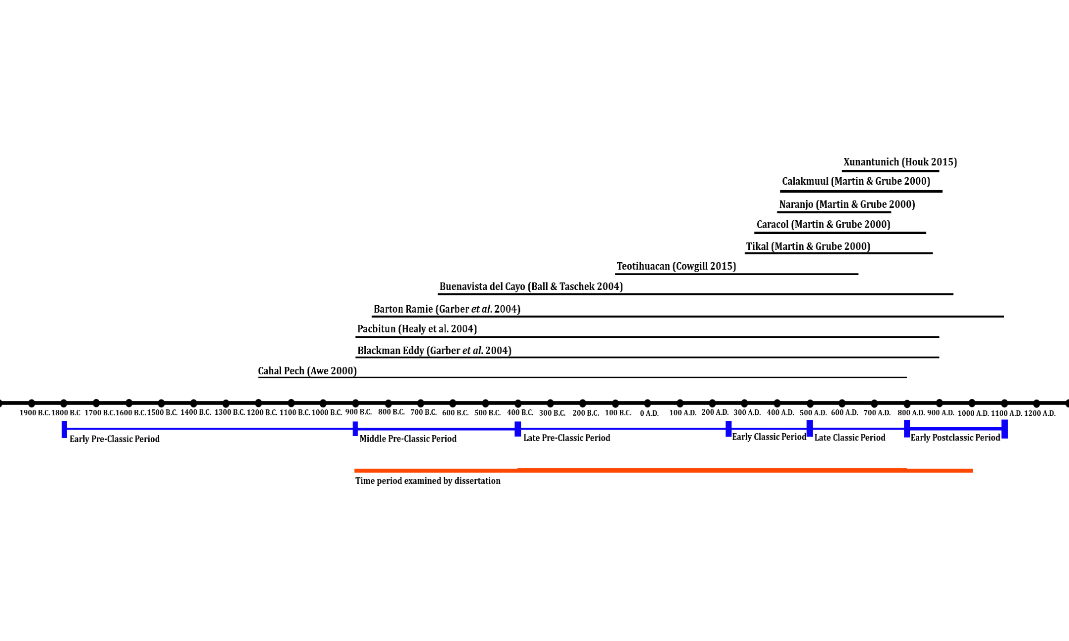
Figure 1: Timeline representing the theorised lifespan of mentioned settlements within the Belize River Valley or otherwise mentioned in the dissertation, Barkla 2019.
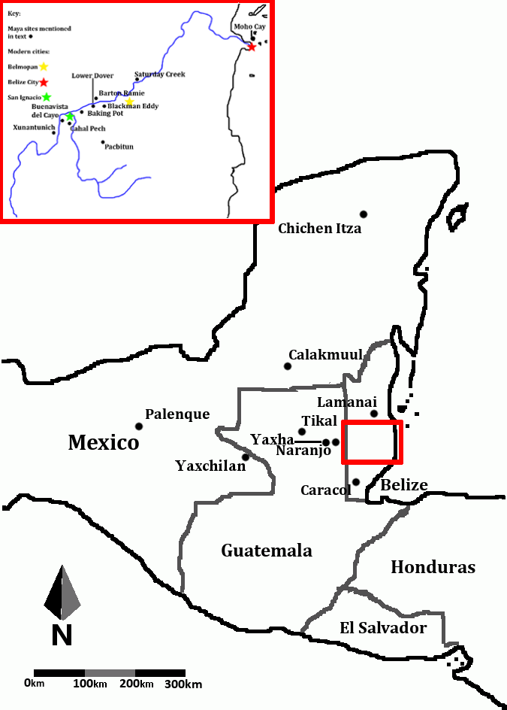
Map 1: Map of Belize River Valley within the context of the wider Maya area. Included are the location of major Maya archaeological sites or sites mentioned in text. (Barkla 2019)
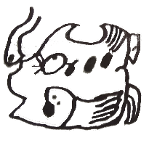
Freshwater Salt and Fluid Stone: Trade in the Belize River Valley
Introduction into ancient Maya trade
One does not have to look far to see what an ancient Maya market would have looked like, as the weekly people’s market in San Ignacio gives a good parallel to Pre-Colombian commerce: fresh fruits and vegetables, butchers cutting meat to sell, artisans with slate and greenstone carvings, jewellery and colourful textiles. Trade is well noted in the Contact period (Coe & Houston 2015:232-233, Tokovinine and Beliaev 2013:169-171). Spanish chroniclers were apparently very impressed with Maya commerce. It becomes far hazier when it comes to trade in the Classic period, even more so with the Preclassic. Although the exact routes and values of goods is hard to decipher, trade most certainly occurred in those eras as there are artefacts of non-local origin within the archaeological record: obsidian for example, was a vital material for nearly all Mesoamerican cultures that only came from a handful of quarries located in volcanic regions such as Central Mexico and Guatemala [see Map 2]. The Belize River Valley is no exception, as non-local goods have also been found in the sites of the valley too – and as will be discussed, possible Belize River Valley sourced items may have been found at other sites.
This chapter explores how trade through and from the Belize River Valley influenced the rest of Mesoamerica. Note that tributes and gifts, although an economic exchange, will not be discussed here. Although in their discussion of merchants, Tokovinine and Beliaev (2013) also discusses their role in royal tribute transactions and merchants were likely involved with the courts (p.194), tribute will not be discussed here. I believe that there must be a distinction between politically or diplomatically motivated acts of item transfer, and economically driven exchange either by the control of a ruling body or through individuals in the private sector. It is also important to mention that although the sites Moho Cay and Pacbitun are mentioned within this chapter, they are not considered Belize River Valley sites [see Map 1]; however, as will be demonstrated, I would argue that they are incorporated within the economic sphere of the Belize River Valley.
The Belize River as a conduit of trade
The demand for salt in the ancient Maya world was enormous, as would be expected for a people that relied on the inland farming of maize, beans, squash etc. and consumed very little in the way of high-sodium foods such as meats and certain fats (Coe & Houston 2015:23). Salt production facilities in the Maya region can be found in the northern lowlands and, more relevantly, along the Belize coast as well (McKillop 2002:1-3). While we know from Spanish sources that the northern Yucatan salt production was booming in the Postclassic (Coe & Houston 2015:232), McKillop argues that the centre of salt production for the Preclassic and Classic Maya was the Belize coast (2002:1,180, 2004:258). Given the convenience of proximity, the argument is strong. Salt likely entered the Belize River Valley (and likely the Hondo River too) and then reached the major sites of the Petén (in modern day Guatemala) [see Map 2]. Coe and Houston (2015:23) referring to Anthony Andrews’ work, notes that sites such as Tikal would have consumed approximately 130 tons of salt annually. Another important attribute of salt, not only as a component of a healthy diet, was its ability to preserve foods – in a tropical region, perhaps quite an important trait of the mineral. I argue that the ability to ‘stockpile’ both salt and salted foods would have given a polity great security: not only in terms of consumables for the populace but also transportable foods for campaigning warriors. The antibacterial nature of salt (Davies 2020) also translates into medicinal purposes for the mineral. We cannot truly know the extent of use, nor track the movements of salt trade entirely as it does not leave a clear archaeological trace. This said, specialised salt production facilities within the archaeological record of the Belize coast is a strong case for the mass production and movement of salt (McKillop 2002). Establishing that when it comes to salt, the Belize River Valley had both supply and demand – surely, the region must have prospered?
It was not just salt that flowed through the Belize River Valley. Moho Cay, located near the mouth of the Belize River acted as a trading hub for the valley (McKillop 2004:257) and found at the site were ceramics, jade, obsidian and maritime resources (pp.269-270). Even the latter may have been transported up the valley, as a midden found in Cahal Pech’s Tolok group revealed that marine fish had been transported more than 100 kilometres inland as early as the Preclassic (Healy et al. 2004:119). Cahal Pech is located conveniently at the start of the Belize River proper, where the Macal and Mopan rivers meet. I argue that because the elite were consuming these maritime imports as seen in the isotopic record (p.120), they had great control over the river trade and here we can see that it is a local power at Cahal Pech that controls trade rather that some patron-overlord in another city, at least in the Preclassic. We do see maritime resources such as shells at inland sites such as the multi-utility conch shell (Coe & Houston 2015:23), but these fish had to be transported upstream fresh, demonstrating a large amount of authority in the moving of high effort goods.
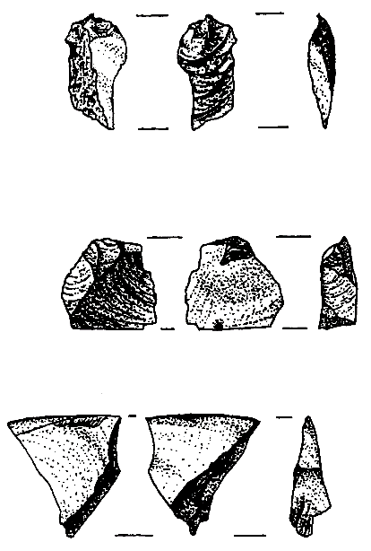
Obsidian, also found at Moho Cay, was another crucial material for the Maya to produce tool, ritual piece and weapon alike (Coe and Houston 2015:23). To understand how much control the Belize River Valley sites had over obsidian trade we could observe the patterns of obsidian found in the archaeological record. El Chayal, San Martin Jilotepeque and Ixtepeque are perhaps the most common sources of obsidian to the ancient Maya (Coe & Houston 2015:23, Stemp et al. 2011, Mendelsohn 2018). We know that from at least the Preclassic period, El Chayal and San Martin Jilotepeque were exporting chunks/cores of obsidian to sites local to the area (Mendelsohn 2018:641-642). So, do we find these cores in Belize River Valley sites, suggesting a midsection of the transition of obsidian via these centres to the rest of the Maya area? McKillop (2004:271) argues that the obsidian travelled from El Chayal, down the Motagua river up the Gulf of Honduras to Moho Cay where it is found in plentiful supply at the site (Healy et al 1984:416) where supposedly it would continue on inland [see Map 2]. In other sites there is no mention of obsidian cores [see Fig. 2], and only blades or flakes seem to be the obsidian artefacts commonly found in the archaeological record. I expect that as a highly valuable resource, the ancient Maya were unlikely to simply leave obsidian cores lying around for us to find in the archaeological record, let alone entire stores of it in depots. Instead we find it always processed and used either for practical or ritual purposes making it rather difficult to follow to stages of obsidian trade, therefore the hypothesis of the Belize River Valley as a gatekeeper of obsidian is still only a suggestion. It could be suggested however, that the riverbeds of the Belize, Mopan and Macal be examined for artefacts (and possibly remains of the canoes) with additional potential for marine archaeology off the coast of Belize in search of the same artefacts.
Figure 2 Left (a) and above (b): Sketches of obsidian artefacts found at Cahal Pech. After Awe & Healy 1994.
Considering that the Belize River Valley (including Moho Cay) was a major causeway for two of the most important resources of the Maya, both commoner and state, this alone must have exerted an enormous amount of influence. The East India Company gained a hefty amount of influence over British parliament from trading tea and spices which were in huge demand in Europe (Keay 1993), and so we can presume that the Belize River Valley had the same effect over much larger Maya polities. This is not to say that the Belize River Valley sites could exert too much pressure, for the Belize river was not the only route of trade. Tikal, for example, sits comfortably in the crossroads of the Belize, Hondo, San Pedro Martir and Salinas rivers (which is how I presume the city gained much of its power). Trade did occur on foot as well as by canoe (Tokovinine & Beliaev 2013), and although likely less profitable than riverine based trade, was a possibility should pre-existing trade routes fail. Nevertheless, the ability to embargo certain polities would have been no small consideration, requiring them to reorganise other, less profitable, trade routes by sending emissaries (also having to travel by foot or canoe). To a polity at war, a cut in military supplies such as obsidian and salt at exactly the wrong time could spell disaster – especially if the supplier decided to help the enemy instead. Just as Britain feared U-boat raids on merchant ships during the First and Second World Wars (Mason 2018, Calder 1969:69,267), perhaps the titans of Calakmuul and Tikal equally respected the humble island of Moho Cay. We must also consider the dangerous attention this may have gained the Belize River Valley, and it is possible that conflicts in the area were fuelled by desires to control the river trade, and this will be covered in the third chapter.
The Belize River Valley as a producer of tradable goods
The Belize River Valley was not just a conduit for resources but a producer as well. Lucero (2006:70) notes that both Saturday Creek and Barton Ramie experienced high amounts of rainfall annually, allowing for farmland ideal for growing cacao and cotton. Cacao has been argued as a form of currency for the Maya – a high value good at any rate. Textiles were commonly used as royal tribute by the Maya (Stone & Zender 2011:81, Pohl & Pohl 1994:155), additionally on a continent without wool or silk producing beasts: cotton was one of the only realistic textile sources. Lucero (2006:72-73) paints the lifestyle of these valley farmers as a ‘Free Market’ haven, with communities exchanging crops for lithics and ceramics with no elite interference as no ruler could control the natural sources of water (p.72). It even seems to be that commoners had the real agency in the situation, as elites compensated commoners who worked for them rather than extracting labour as tribute (pp.72,75). While I find it dubious that there was no hierarchy of some sort at Saturday Creek (p.73), it is interesting the amount of autonomy and wealth these farmers may have had – an ideal place to migrate to for an oppressed farmer. Thus, the Belize River Valley could have exerted pressure simply through its own geography, other sites would always be forced to reduce pressure on its labours lest they decided to flee to more autonomous zones.
The local Maya Mountains in Belize also produce a great many resources that are lacking in the non-mountainous lowlands that a great many Classic polities inhabited. The site of Pacbitun has a large quantity of skilled slate constructions and artworks (Healy et al. 1995, 2004). Slate has also been found in a large variety of sites such as Tikal, Palenque and Calakmuul (Healy et al. 1995:340), mainly as an elite item found in burials and caches – with one example found as far as Costa Rica (p.340). It is difficult to ascertain where these slate objects come from due to the material nature of slate (p.346), thus it is difficult to say for certain that slate was traded from the Belize River Valley. A strong indication of slate trade from Pacbitun however, is that the number of slate artefacts found at the site dramatically increases in the Terminal Classic (Healy et al. 1995:343), along with a specialised slate workshop operating in the same period (Healy et al. 2004:226). Healy et al. (1995:340) notes that slate artefacts appear more commonly in the Late Classic period. Combined with the frequency of Pacbitun slate around the same time this supports the theory that the site was the source of slate goods; the data suggests a rising demand for slate. It also seems as though Pacbitun may have enjoyed a monopoly of slate, as there seems to be few other obvious specialised slate production sites in the Maya area – though this may be due to early excavations in other sites. Unlike salt however, the position of slate in elite burials and caches suggests that slate artworks were to the Maya as sports cars and designer clothes are to contemporary markets: not just elite, elitist. What is of great interest is that caches at Pacbitun contained Pachuca (green obsidian) a resource that mainly comes from Central Mexico (Healy et al. 2004:216,217). Equally at Teotihuacan, located in Central Mexico, slate artefacts have been found as burial goods and pieces of artistry. Possibly this alludes to an exchange between Pacbitun and Teotihuacan? This connection, as yet, is still fairly weak, as much of the slate artefacts are in line with Teotihuacan ideology rather than Maya (Cowgill 2015:99,137). Still, Teotihuacan had to import its slate supply (pp.37,179), and it is curious to speculate whether the workshops at Pacbitun occasionally received a commission from the sprawling metropolis some 1210 kilometres away [see Map 2].
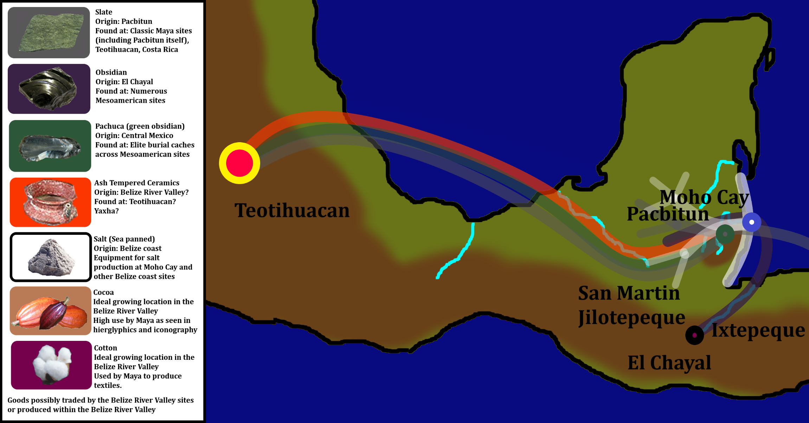
Map 2: Simple map demonstrating possible trade routes as discussed in text, note that some trade goods are not shown on map due to too wide a distribution or a lack of physical evidence. Barkla 2019, with adapted elements from Wikipedia Commons (2020), Learning Geography (2020), IAOS (2019), Galuzzi (2006)., Marty (2020)
Slate was not the only product mined at the Maya Mountains; the Maya Mountains possibly hold sources for jade as well as other greenstones which may have been used as fake jade by lesser elites (Lucero 1999:234). In terms of commoner goods, granite metates (maize grinders) were found at Moho Cay (McKillop 2004:270), vital in the production process of maize into consumable goods. There seems to be no evidence of obsidian in the Maya Mountains, however.
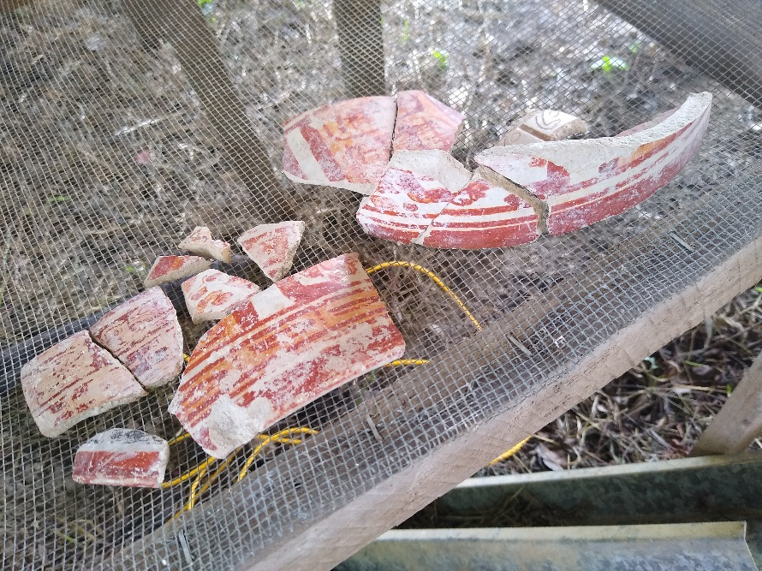
Belize River Valley sites such as Cahal Pech often exported ceramics to their neighbours in the Petén, as early as the Middle Preclassic (Ebert et al. 2019). There is also evidence that suggests trade in ceramics far from the Maya area. In Clayton’s (2005) paper on Maya pottery found at Teotihuacan, she noted that some of the ceramic finds had volcanic-ash temper, a signature feature of Petén and the Belize River Valley ceramics (pp.434-435)[see Fig. 3]. Though the likely origin of most of these ceramics are from the Petén due to the historical connections that Teotihuacan had with sites such as Tikal and possibly Calakmuul (Martin & Grube 2000:28-31, Clayton 2005:438-441), I still argue that there is a strong case for some of these ceramics coming from the Belize River Valley. The Valley of Mexico, where Teotihuacan is located, has poor clay sources (Cowgill 2015:77); compare this to the Belize Valley which has extremely good clay (Lucero 2006:71-73). Awe and Helmke (2012:67-68) argue that Xunantunich’s emblem glyph translates to Katyaatz Witz or ‘Clay-Bearing-Mountain’, and the site does indeed sit upon an “abundance of high-quality sources of clay” (p.68). If Xunantunich was trading ceramics with Teotihuacan, it must have been a very small chronological bracket for interaction, as Leventhal and Ashmore (2004:169) found no substantial evidence for occupation at Xunantunich before 600 AD. At this time Teotihuacan was already in a fatal decline (Cowgill 2015:chpt.9). Furthermore, this connection is even more strained: the majority of the Maya sherds found at Teotihuacan date to the early Classic period (Clayton 2005:442), rather than the Late to Terminal Classic time frame that Xunantunich seems to have occupied. The ‘Clay-Bearing-Mountain’ may have been worked on long before the site of Xunantunich (as we know it) had been built, as Preclassic structures and ceramics were found in excavations under the Castillo (Houk 2015:155-156). The clay did not have to originate from Xunantunich specifically, as the Belize Valley in general has good conditions for clay sources (Lucero 2006:71-73). We must consider, however, that this does not immediately suggest ceramics trade. Firstly, it may be that the ceramics were made locally by a Maya ethnic enclave within Teotihuacan (Clayton 2005:432). Additionally, the ceramics may not have been made by Maya: Clayton (p.438) argues that four sherds of an examined selection originated in the Pueblo region, with another two originating from the Veracruz area. However, these imitations of Maya ceramics suggest that not only were Maya style ceramics valuable, but influential enough to be imitated by other workshops in order to ‘cash in’ on a popular import. Clayton does not specify if these imitations are made with volcanic-ash temper or not, thus it cannot be said for certain that this is economic influence exerted by the Belize River Valley but is still a possibility to consider.
Figure 3: Fragments of ceramics at Baking Pot. Barkla 2019.
Discussion
There are many problems when considering trade in Mesoamerica, and this in turn problematizes the arguments I have presented in this chapter. Firstly, caution must be taken when considering the stages of exchange products/goods have been through. Considering the lack of draft animals, limited aquatic travel to oar-powered vessels and the weight of the goods transported, trade likely occurred in multiple stages. The pottery sherds, obsidian and jade we find may have travelled the breadth and width of Mesoamerica before reaching where it was found in situ – even this may not have been its final intended destination (with the exception of burial goods and caches): if one found the remains of Amazon packages in the ruins of a lorry depot, do we assume that the lorry depot was a powerful and rich polity? Secondly, as mentioned in the introduction, the distinction of trade, gifts and tribute is important. Non-local goods that we find may not have resulted in an economic exchange but a diplomatic action, perhaps even looted goods from a military attack. The third issue is far more important to the trajectory of this dissertation: the intent of trade and traders. What I mean by this is how much control did rulers have over merchants, and did they really use trade to gain influence over others? Of course, the Market does indirectly create influence through demand, but did political leaders use this to their advantage? Mendelsohn (2018:643) suggests that obsidian trade in the Guatemalan highlands operated separate of political influence.
While it is possible that the Belize River Valley sites had the power to stem the flow of strategically powerful resources and thereby cause havoc, yet for all that is known, this may have been unthinkably underhand in terms of ancient Maya morality. During the Sengoku Jidai in Japan: Uesugi Kenshin, upon hearing that his rival Takeda Shingen had lost his salt supply to embargos, sent over some of his own supply stating that he fought with swords, not salt (Clements 2010:170). Perhaps the Belize River Valley rulers held similar honour values. And what of merchants? If merchants were independent, then why should they care who buys their goods, what political motive might they have?
Nevertheless, the evidence at Moho Cay, Pacbitun and other sites within the Belize River Valley area demonstrates that the Belize River was a vital lifeline to the rest of the Maya area, transporting some of the most important and valued goods within the whole of Pre-Columbian America. The problems discussed above, while a cautionary warning when examining Mesoamerican trade, do not diminish the likelihood and significance of Belize River Valley trade. If a slate work passes through many hands, this may actually do Pacbitun’s slate industry a favour; the fame of the craft is spread out over a much wider area akin to advertisement – it also suggests that it had a real common value. Although what we consider trade goods may be tribute, it is important to note that tribute is likely based on socially valuable goods, therefore what is given in tribute is likely to be economically valuable. In the end, we are left at an impasse in Maya trade: the archaeological record leaves behind evidence of trade, and yet such economic transactions did not interest Maya scribes (Jackson 2013:9). As such it is clear that exchange occurred, yet hard to gauge the political potency of these transactions. Regardless of this, we can hypothesise the effects of the control and production of high-demand resources as I have done in this chapter; though we may never find definitive results, this does not mean that theories cannot be conceived on ancient Mesoamerican economical patterns and their effects on inter-polity relations.
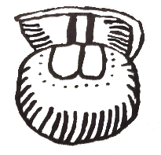
Flowing as One: Cultural influence from the Belize River Valley
Introduction to Maya Culture, Architecture and Cosmology
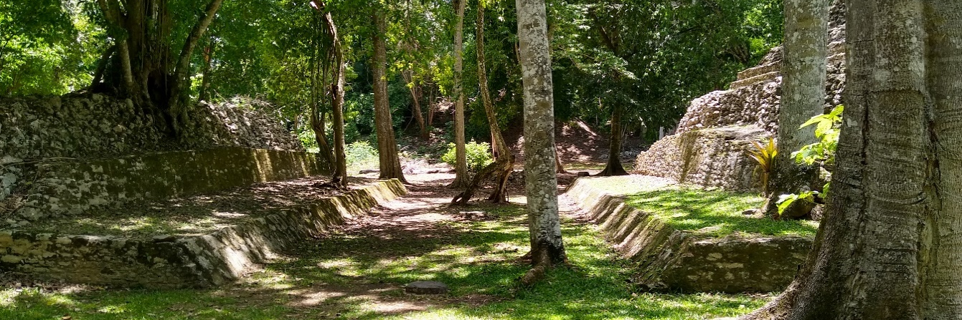
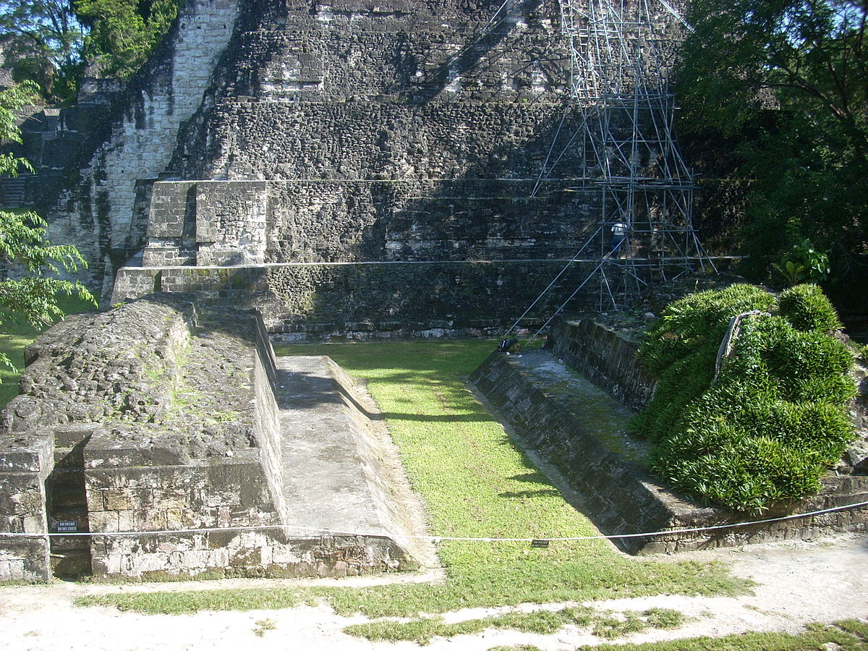
Strictly speaking, there is no singular Maya culture, and the Maya themselves have occupied far too great a timespan and too many diverse environments to make this the case. There are numerous linguistic variants of the Maya language (Houston & Coe 2015:26-31), from Yucatec which is spoken in much of the Yucatan peninsula to Wastek, a Maya enclave in central Mexico. From migrations of populations from other parts of Mesoamerica to the Spanish conquest to even the unlimited reach of the internet in the modern day, the Maya culture has changed from period to period – with the effects differing from one location to the next. Of course, there are many similarities that have persisted over distance and time: rituals that have survived the Catholic conversion (p.289), associations of the world with the maize plant (p.246) to the ballcourt which can be found in number all across the Mesoamerican world and even beyond (Houk 2015:37) [see Fig.4], which itself is laden with cosmological meaning. One of the most famous cultural aspects common across the Maya were the two calendars: the Tzolk’in and the H’ab (Coe & Houston 2015:63-68) which stand as an impressive testament to the mathematical and astronomical abilities the Maya possessed at their zenith. Houk (2015:33-39) presses home this point of uniqueness-with-affinity trait that Maya cities possess; terrain, local resources and strategic planning producing individuality.
Figure 4: Above (a): A ballcourt from Caracol, Barkla 2019. Below (b): A ballcourt at Tikal, Burchell 2010.
In this section, I will be examining the possibility that cultural traits found in the Belize River Valley may have influenced the urban planning, religious traditions and cultural traits of other Mesoamerican areas using the example of Cahal Pech. It is important to note that although features of Cahal Pech will be examined as arguments for cultural influence, it is understood other Belizean sites may exhibit these same features. Cahal Pech is solely used in the interest of focus and clarity.
Cahal Pech: A Preclassic trend setter?
Cahal Pech is perhaps one of the oldest Maya settlements, and more importantly has a long continuous occupation (Awe 2000, Houk 2015:70). Cahal Pech in the present day can be found watching over its inheritor, San Ignacio, where the Mopan and the Macal meet and become the Belize River. Long before the rise of the Classic period polities, Cahal Pech was already exhibiting cultural elements that Classic polities would later use in their artistic and architectural make-up. Could it be that the origin for some of the cultural traits we find in the Classic period can be found in the city of Cahal Pech? From the Middle Preclassic, Cahal Pech was already experiencing rapid construction projects (Horn et al. 2017), different groups expanded architecturally at different rates and with differing resources (pp.83-85) – perhaps suggesting a multi-ethnic population or even the development of a class-based system.
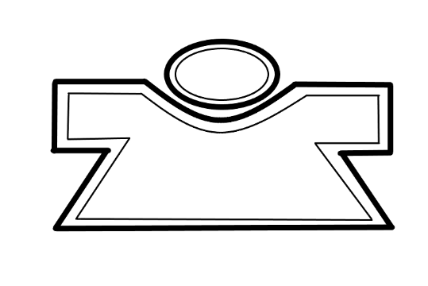
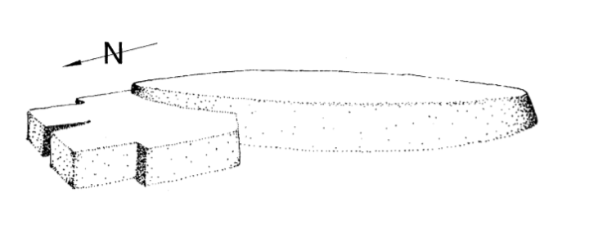
Some of the more unusual structures found in Cahal Pech’s archaeological record are round stone structures. Round structures are rarely found in Mesoamerican architectural archaeology (Aimers et al. 2000:79). Although this rarity may be due to the annually consistent and consecutive excavations at Cahal Pech and unlike other Maya structures, requires sub-surface excavations to find them (p.78). Multiple theories surround the nature of these stone platforms: from representations of the deity/culture hero K’ukulkan (a deity, it must be considered, that sprung into popularity in the Postclassic), to a hallmark of a simpler societal structure, sweat lodges, even to judiciary platforms (Aimers et al. 2000:80,82 Coe & Houston 2015:201,206). The round structures are also high reminiscent of so called ‘killing/gladiatorial stones’ that the Mexica/Aztecs used as a stage for a theatrical prelude to sacrifice (Clendinnen 1993:94, Aimers et al. 2000:82). This makes me wonder if the Maya practiced their own gladiatorial fights on these platforms, in boxing matches using stone weapons (Taube & Zender 2009). Eventually Aimers et al. (2000:82-83) settles that they were likely used for performances, whether dances or ancestor worship. It may be that like most public areas, these stone structures were used for a multitude of purposes. These structures seemed to have been phased out in the Classic period (p.79), possibly due to changes in cultural outlook (p.83), however it must be noted that round structures/areas may have continued in other shapes and forms such as wooden structures or even painted circles. It is possible that rectangular architecture became more prominent due to influence from Teotihuacan in the Classic period as suggested by Pasztory (pp.79-80). Although rectangular architecture appears at Cahal Pech much earlier than the Classic period (Healy et al. 2004, Aimers et al. 2000:74) there does seem to be perhaps a minor connection to the culture of Teotihuacan. A reconstruction of structure 14 at Cahal Pech has a curious resemblance to butterfly imagery found at Teotihuacan (Headrick 2003) [see Fig. 5], although a reconstruction can only speculate so far, this seems to be an opportunity to investigate structure 14 and other possible examples of butterfly iconography in non-Teotihuacan cultures.
Figure 5 Left (a): Reconstruction drawing of Structure 14, after Aimers 2000. Right (b): Basic example of a butterfly symbol commonly found at Teotihuacan, Barkla 2019.
As well as all the surface-based splendour that Cahal Pech has left behind, it is also within tombs that we find evidence of the Belize River Valley’s potential influence on other Maya cultures. Of these tombs, one of the most yielding finds was not that of human remains, but a monument that carried a human memory. This stela was found in a burial at Zopilote, the southern terminus group of Cahal Pech. The stela was believed to be dedicated to a person from the Late Preclassic (Awe 2013:36). The entombment of such lithic monuments is also found in Pacbitun and Caracol of which the later site’s buried stela exhibits an early Classic ruler (p.38). Could it be that Caracol was adhering to a Cahal Pech cultural trait? The carving itself is rather interesting and perhaps originates to a time before Maya hieroglyphics had developed or at least before it was the norm to apply it to such monuments, explaining the lack of inscriptions on the piece (Awe et al. 2009:182). Indeed, the monument may have even originated from Olmec or Olmec-styled artisans (pp.183-184). At around 400 BC the Olmecs would suffer a collapse to their civilisation (Coe & Houston 2015:61) putting it within the Late Preclassic time frame – an intriguing possibility that Cahal Pech was a multi-ethnic settlement that had an influx of Olmec refugees fleeing whatever catastrophe had struck their heartland. Another Late Preclassic burial is fascinating because its layout is very likely a metaphor of Maya cosmology drawing from tales such as the creation of the world and the Hero Twins as narrated in the Popol Vuh (Awe 2013:28-40). It is rather tantalising to consider that burials such as the legendary sarcophagus of Pakal I in Palenque, which is rich in iconography attaining to Maya ideology (Martin & Grube 2000:166-168, Coe & Houston 2015:159) can link all the way back to a burial practices that began in the Belize River Valley.
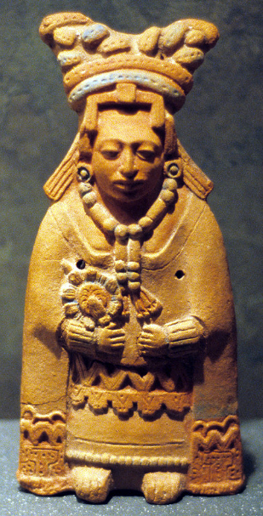
The clay figurines of Jaina island have been one of the most curious finds in Maya, perhaps Pre-Columbian in general, archaeology [see Fig. 6]. The purpose of these figurines is not entirely known: possibly depictions of real people or deities (Coe & Houston 2015:168). Similarly, clay-figurines are also found at Cahal Pech in vast troves dating from the Preclassic period (Healy et al. 2004:114) [see Fig 7]. That is not to say that Cahal Pech is alone in producing figurines in Preclassic Mesoamerica (Coe & Houston 2015:50-52), but the same scale and individuality of the figurines in both Jaina and Cahal Pech proves interesting. The difference in time is a strong argument against any connection, if we take the latest estimate of Jaina’s occupation and the invention of pigments found on the ceramic figurines (Muren 2004, Coe & Houston 2015:168): we are discussing a gap of nearly a thousand years. Not only that but the uses for both sets of figurines are still in doubt and cannot be said to have a similar role; Cahal Pech figurines may be linked to fertility or perhaps an animistic conduit to ancestor spirits (Healy et al. 2004:122). If the Jaina figures fulfilled this same ideological role, then perhaps one could suggest that Cahal Pech had cultural influence on the Maya of Jaina.
Figure 6: Jaina Figurine. Aleto 2007.
Discussion
It is important to complement a discussion on cultures, both past and present, with a warning towards the possible implications of arguments of cultural origin. Trying to discover the origin of cultural traits risks concepts of hierarchies of innovation; the enlightened civilisation versus the ignorant barbarian who learns the true way via the former. This is a simplified viewpoint that I believe will never help us learn and decipher the fluid motion of cultural traits and traditions throughout history as well as the modern world. I wish to apply this caution while in the discussion of Cahal Pech. Although I focus on the arguments that certain cultural elements were developed within the Belize River Valley settlements and radiated outwards, I by no means wish to suggest that this was a one way exchange nor that the Belize River Valley was an oasis of cultural élan when the rest of Mesoamerica’s regions were not developing their own distinct and vibrant identities – they clearly were.
Figure 7: Cahal Pech Figurine head. Photographed by DeLance, after May et al. 2019.
I do, however, wish to argue that the Belize River Valley may have contributed to the cultural mosaic of Mesoamerica. Though changed and adapted through their transitions, traditions originating from the Belize River Valley may well have distributed across the Maya world – perhaps beyond. It is admittedly difficult to measure the flow and invention of such an ineffable and incorporeal element; one is sure to notice the highly speculative nature of this chapter. Additionally, we must be aware that the large majority of artefacts of the Maya are likely non-existent in the archaeological record; weaving and woodwork being traditional crafts of the modern Maya are also tragically perishable – what wealth of material has been lost through time will forever haunt any research into ancient Maya culture. Nevertheless, this is not to deter future studies into ancient culture. Without understanding how ancient people lived and saw the world around them, the ruins that we study will remain forever that: ruins.
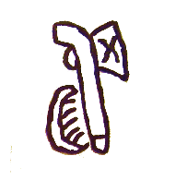
Fighting the Current: Conflict and War in the Belize River Valley
Introduction to ancient Maya Warfare
For all the stelae of warrior kings, murals of intense forest forays and hieroglyphic tales of conflict, very little is known about Classical Maya warfare. There is certainly enough evidence to say that warfare did occur in Maya history, indeed it is both frequent and visceral [see Fig 9]. The strategies, military philosophies, tactics or martial arts of the Maya, however, are not well known at all. The political implications of warfare are known: Calakmuul, which had been a major player in the Classical period was reduced to a downward spiral after a decisive clash with Tikal (Martin & Grube 2000:110-111); it could take just one defeat to be extinguished. Kings and Queens were expected to take noble captives, but they could be captured themselves, either to be sacrificed or made into vassals. For a weaker polity, it must have felt as if one was being hunted (an even grimmer metaphor when some rulers likened themselves to jaguars and snakes) – yet perhaps they braved the battlefield, finding solace in alliances or being ‘David’ in their battles against ‘Goliath’. In this chapter I wish to explore warfare in the Belize River Valley, and how the communities along the valley influenced wider political conflicts with the spear.
When it comes to warfare in the Belize River Valley, the lack of stone inscriptions (Houk 2015:3) makes the tracking of military endeavours in the region difficult. The lack of epigraphic records does not equate to less warfare – in fact, working on Webster’s hypothesis that warfare likely developed in areas of “high demographic potential” such as the Belize River Valley, Brown and Garber discuss what might be some of the earliest evidence of conflict in the Maya region at the site of Blackman Eddy (Brown & Garber 2003:91). Sites such Blackman Eddy, Cahal Pech and Xunantunich are all situated on strategically defensive areas (p.102) upon hilltops and/or flanked by rivers. The view from the Xunantunich’s Castillo is a sentinel’s paradise, and considering a ruler was expected to take part in warfare (Brown & Garber 2003:108, Martin & Grube 2000:16) it is likely that Maya rulers enjoyed high-altitude accommodation to fulfil the role of protector of the realm – both in a symbolic and practical manner [see Fig 8].
Set in Xunantunich’s stones: The Naranjo wars and Caracol’s shadow
In the Late Classic period, politics was defined by the clashing of two major powers in the Maya world: Calakmuul which may have been originally called Chiik Nab (Martin & Grube
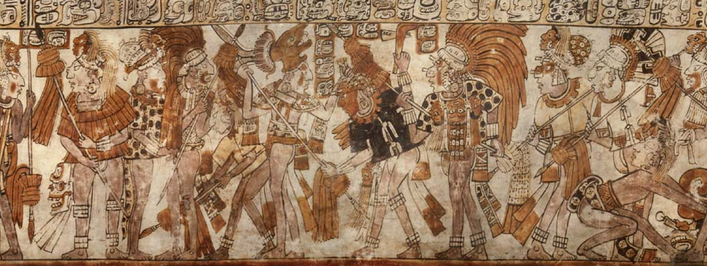
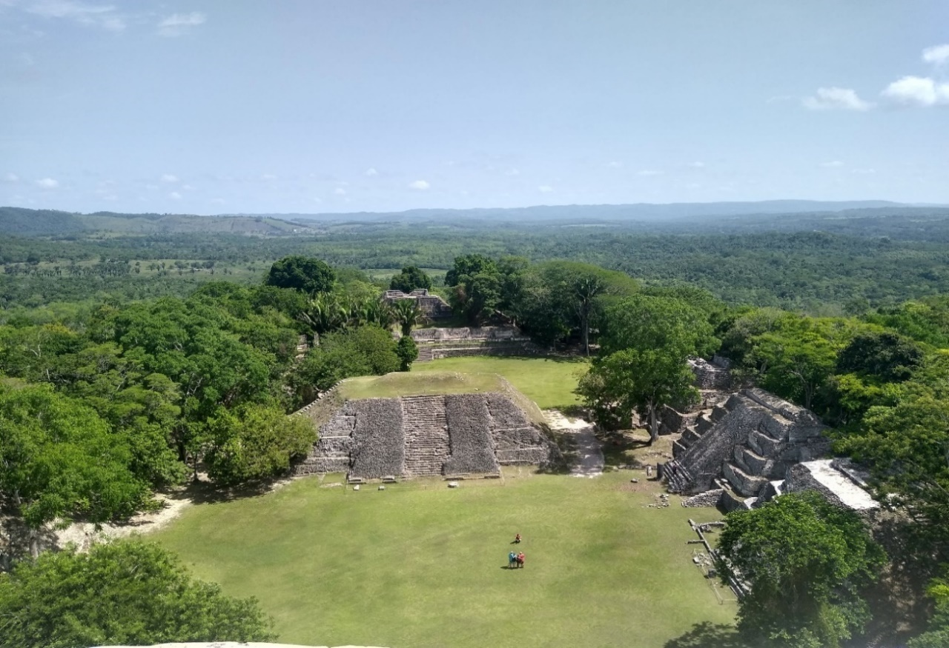
Figure 9: K2206. This vase gives us an invaluable yet limited view into Maya warfare, with equipment, arms and decoration of Maya warriors in full display in this battle scene, albeit stylised. Kerr 1999.
Figure 8: Northwardly view from Castillo, Xunantunich. With such a position a King or Queen would have ample view over not just his/her people, but also for incoming foes. Barkla 2019.
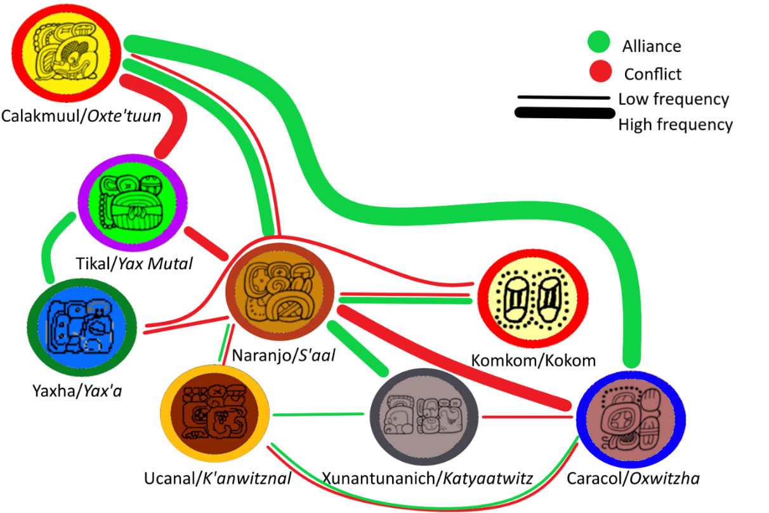
Figure 10: Diagram demonstrating hypothesised political relationships between polities (mentioned in text) of the Late Classic Period. Barkla 2019 containing adapted elements from Davies 2018.

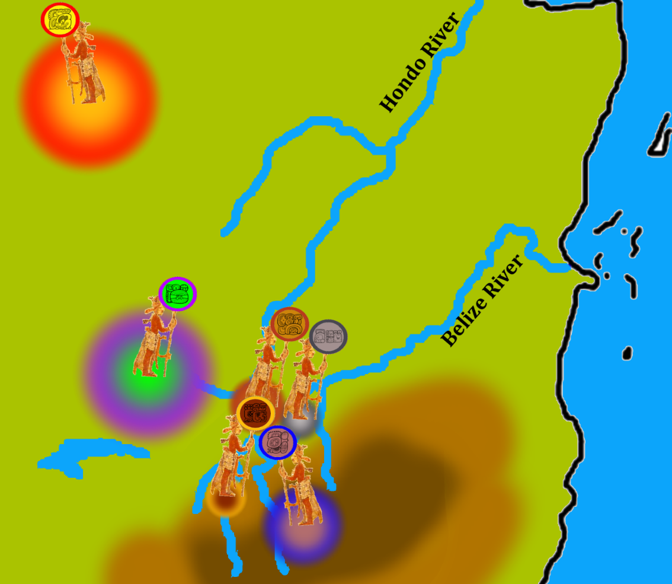
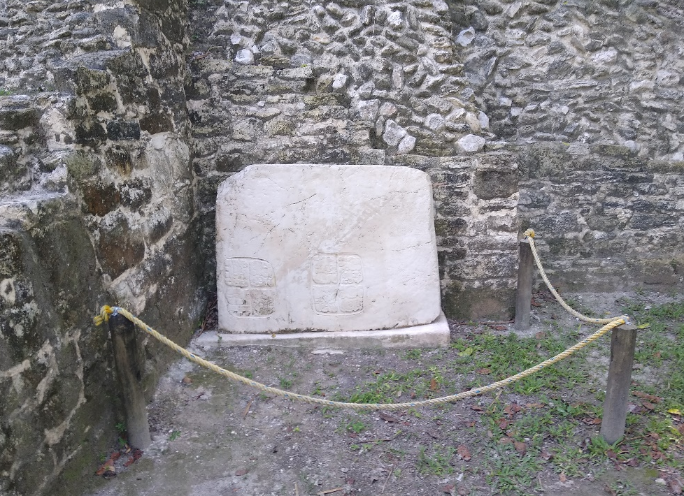
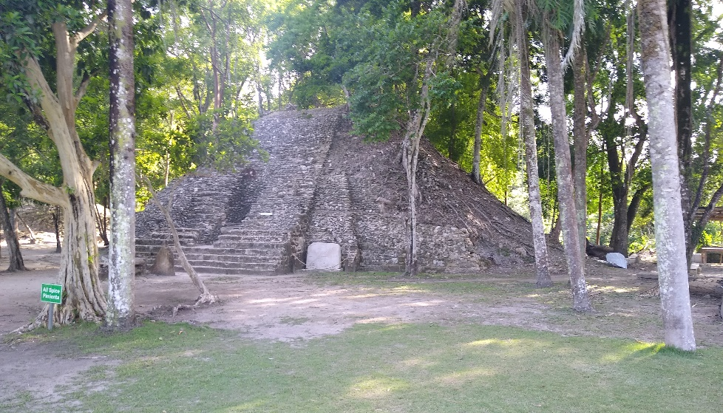
2000:104, Tokovinine 2007:20), and Tikal, traditionally called Yax Mutal (Martin & Grube 2000:30). Many kingdoms would define themselves by falling on one of these two sides – some by force, others by their own choice [see Fig. 10]. The shockwaves of this rivalry were felt no less in the Belize River Valley as two regional powers would also forge their own private rivalry – mimicking the clash between Tikal and Calakmuul in the west [see Map 3]. These two powers were Caracol/Oxwitzha (Martin & Grube 2000:85-99) and Naranjo/S’aal (pp.69-83), both these polities were under Kaan influence which makes this conflict more interesting as not even a common enemy could erode the friction between Caracol and Naranjo. The tactical importance of Calakmuul’s alliance with Caracol cannot be understated. Caracol’s location, in what is now southern Belize, opened a whole new front against Tikal’s domain, easing pressure on the main ‘frontlines’ of the war. Calakmuul had made a good choice in its ally: Caracol proved to be not only a committed ally, but a capable one too, scoring many victories in its history, especially against its rival Naranjo (Chase & Chase 2003:173). Naranjo had also come under the sway of Calakmuul in the rule of Aj Wosal (546 AD-615 AD?), creating an even more uncomfortable thorn in Tikal’s side. Naranjo would be surprisingly beset by both Caracol and Calakmuul, its old patron in the mid-7th Century AD (Martin & Grube 2000:71-72). The events surrounding this event are unclear, but it is possible that Calakmuul’s fury stemmed from disobedience of Naranjo’s lord at the time – possibly named K’uxaj (Tokovine 2007, Skidmore 2007). Calakmuul’s forces had fallen upon a weakened prey, for Caracol had waged two campaigns against Naranjo five years ago (Martin & Grube 2000:72). Though Calakmuul had brought Naranjo to heel, the Kaan dynasty could not make the wounds of Naranjo heal; Naranjo would inflict a vengeance so great it would put Caracol into dormancy (Martin & Grube 2000:95) but not without assistance, and Naranjo did not have to look far to find its ally: Xunantunich within the Belize River Valley.
Map 3: Simplified map demonstrating the positioning of major powers during the conflicts of the western lowlands during the Late Classic period. Barkla 2019 containing adapted elements from Davies 2018 & Kerr 1998.
How do we know that Xunantunich took part in the conflict against Caracol? In 2016, Panel 3 was found at Xunantunich at the base of structure A9 (Helmke & Awe 2016:4-5). This Panel is not just an isolated hieroglyphic structure but is part of a much larger hieroglyphic stairway from Caracol. This was the final piece of a puzzle regarding findings at Naranjo, in which a hieroglyphic staircase was found to describe Caracol’s victory over the city of Naranjo. Now the academic opinion is that Naranjo took the stairway as war booty when they defeated Caracol in 680 AD (Martin & Grube 2000:73, Helmke & Awe 2016:2), presumably hauled all the way back by freshly caught Caracol slaves. A large piece was missing from the complete stairway, even with a small fragment from Ucanal considered – until Panel 3 was found (Helmke & Awe 2016:3-4). The dividing of the stairway suggests a mutual military action against Caracol and may have been a glue that kept Xunantunich and Naranjo together; the memory of a common enemy and a common victory.
Figure 11(a): Panel 3, (b): and where it can be found in its contemporary location in relation to Structure A9 (b), Xunantunich, Belize. Barkla 2019.
Now here we must return to the original question: what can this tell us about the influence that the Belize River Valley had on the wider Mesoamerican world? Firstly, we must bear in mind that the attributing of this war trophy to both Naranjo and Xunantunich suggests an equal contribution of power to the conflict. Even if there was some hierarchical nature to the relationship between these two powers, with Naranjo as a suzerain to Xunantunich, the award of the war booty suggests an acknowledgement of importance to the engagement. It would also seem as though Naranjo was the initiator of the conflict and the head of the coalition with revenge as their casus belli, but this is not certain. We must also consider that Xunantunich may well have been the one to proposition Naranjo into a coalition – rather than the reverse. Caracol was an extremely belligerent and successful polity, Pohl and Pohl (1994:147) even state that as a result of military success its population had grown by 325% in about a century, greatly increasing its productive sectors. Perhaps Xunantunich felt threatened by Caracol and coerced Naranjo into an alliance using the chance for revenge as an incentive. As mentioned in the first chapter, the Belize River Valley may well have been an extremely lucrative asset economically. Perhaps Xunantunich felt it could not defend this asset by itself. Alternatively, Naranjo and Caracol may both have been vying for hegemony over the Valley and the wealth that comes with it.
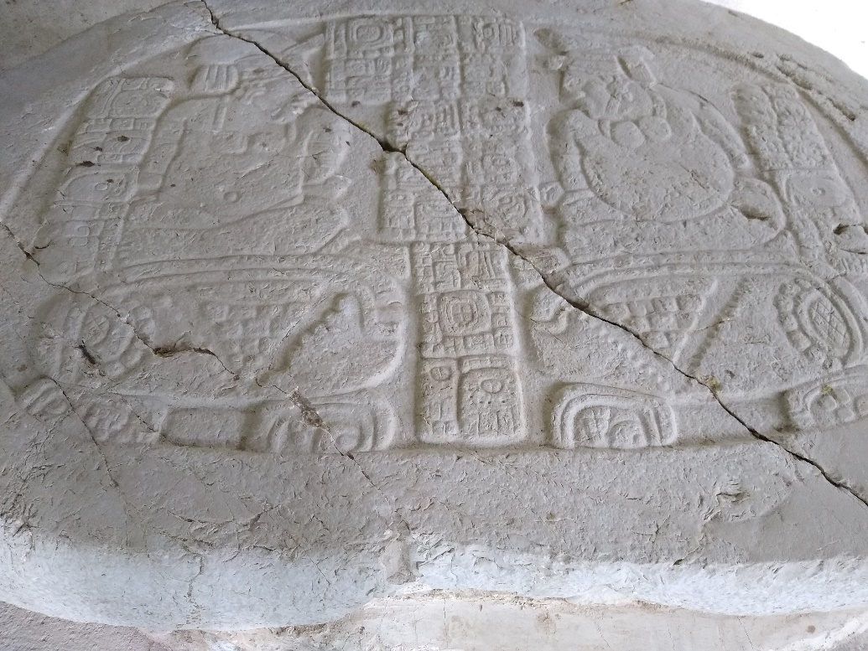
What is curious is that a piece of the stairway was also found at Ucanal: does this suggest that this was a triple alliance? Helmke and Awe (2016:2-3) do note that Ucanal was an ally of Naranjo at the same time, however it could be perceived in a much more morbid angle. Ucanal was an ally of Naranjo, however, Ucanal also tended to have wavering loyalties: Caracol in the early 9th century, built relations with Ucanal as seen in Altar 12 (Martin & Grube 2000:98-99). Even Altar 23 [see Fig 12], which shows the kings of B’ital and Ucanal captured by Caracol (Martin & Grube 2000:97), shows both individuals bound yet still wearing clothing and jewellery and seated in decent positions rather than the humiliating positions captives are usually shown in. Perhaps the piece of hieroglyphic stair in this example was a grizzly reminder of the consequence of siding against Naranjo, given to a rather dubious and untrusted ally.
Could the stairway at Xunantunich be the same, a threat veiled as a commendation? It is fair to say that we may never know what happened in the smouldering streets of Caracol after the battle was over and the allied forces came together for the debrief. What we can say is that Xunantunich did take part in one of the most crucial battles in the Classic period and for whatever reason, they took part of the hieroglyphic stair for themselves. The hieroglyphic narrative is one of Naranjo’s doubled defeat at the hand of Caracol in 626 AD and 631 AD (Helmke & Awe 2016:2), in many ways Xunantunich is entering the history of Naranjo by taking part in its vengeance and taking the hieroglyphic stairway – regardless of their relationship prior to the attack on Caracol, their very heritages had been woven together through a mutual pact.
Figure 12: Altar 23, Caracol, Belize. Barkla 2019
Naranjo and Komkom against Yaxha, allied stratagem in Classic period warfare
Naranjo seemed to enjoy a myriad of alliances for it would wage war again side by side with a kingdom from the Belize River Valley. Interestingly this conflict would take place in the dusk of the Classic period, the late 8th century AD. When many cities were already abandoned or declining, Naranjo clashed with its neighbour, the city of Yaxha. The victory over Yaxha was not only recorded at Naranjo, on Stela 12 but also on the Komkom Vase found at the site of Baking Pot (Helmke et al. 2018:82-85). The Komkom Vase demonstrates another point of view to the Naranjo-Yaxha conflict (pp.84-85), one that possibly shows the power that a Belize River Valley site could have on the political landscape. It also gives us a glimpse into the history of Yaxha, a city we know very little about (ironically, Yaxha is one of the Maya cities of which its original autonym has survived to the modern era). Naranjo neighboured Yaxha by roughly 20km – less than a day’s walk (Martin & Grube 2000:72. As such it is not surprising that the two cities may have become rivals due to regional competitiveness. Yet there are some ties between Yaxha and Tikal, possibly suggesting that Naranjo’s conflict against Yaxha may have been yet another proxy war orchestrated by Naranjo’s suzerain: the Kaan dynasty of Calakmuul – although it must be noted that at the time the Komkom Vase and Stela 12 were recounting, Calakmuul had suffered a defeat by the hands of Tikal and would be send into an irreversible decline (Martin & Grube 2000:111).
Something that is very interesting about the narratives of Naranjo Stela 12 and the Komkom Vase is the difference in dates that the same events occur (Helmke et al. 2018:84-85). For example, on Stela 12 it recounts that the location of Sak Suutz’a was put to puluuy (burned) on the 12th February 799 AD. However on the Komkom Vase this event occurred two days after on the 14th (p.56,84). Helmke, Hoggarth and Awe (2018:85-88) give various possibilities as to why these narratives vary from source to source; most interesting is the consideration that the differences reflect different experiences by Naranjo and Komkom during their campaign against Yaxha. Perhaps the differences in accounts is intentional as a representation of actual movements of the multiple allied forces acting under Naranjo, not as a single united body but as different elements using a multi-pronged offensive against their foes of the Yaxha domain. The differences in time are a possible consequence of the ‘fog of war’. Webster (2000:80) makes an important note on the nature on Maya warfare in that all supplies had to be carried by porters (who themselves had to eat and drink). Webster continues to say that this made prolonged sieges an unsustainable strategy. Referring to The Art of War by Sun Tzu (2014:28), sieges were draining affairs even to the Chinese of his period who had draft animals rather than human porters, and the famous military theorist advises against such commitments. Indeed, Naranjo’s campaign against Yaxha exhibits many of the strategies Sun Tzu approves of, rapid mobility and living off the supplies of one’s enemies (pp.24-25,61,103). Considering the issue of logistics in Maya warfare, an invading army could not afford to be bogged down in long, attrition-based conflicts. This is what we see in the movements of the Naranjo-allied forces: the time between separate engagements are often short; within the space of a week the forces attack four separate locations (Helmke et al. 2018:84). However, I theorise that these attacks were not decisive, but instead were harrying skirmishes to keep Yaxha and its allies from combining their strength. Puluuy is a commonly seen verb used on the Komkom vase and means to burn/set alight (Helmke et al. 2018, Webster 2000:92), and while this verb is perhaps used to represent a destructive campaign, I would argue that it equally invokes the chaotic nature of fire and therefore could equate to raiding actions. A recent discovery of the burnt site of Witzna (another victim of Naranjo) demonstrates that puluuy may be a term for a complete razing of a settlement in an act of total war (Powell 2020). I argue against this, as in a pre-gunpowder era without artillery, razing a city would have been a lengthy, perhaps impossible task. Instead: perhaps the Komkom forces were one of Naranjo’s allies tasked with tying down Yaxha’s allies and allowing Naranjo’s main attack on Yaxha to go unhindered while also raiding for much needed supplies.
Similar to the events of the Xunantunich-Naranjo alliance, Naranjo may have also desired to incorporate the Komkom into their own history: the decisive blow to Yaxha and the routing of its king K’inich Lakamtun (Martin & Grube 2000:82, Helmke et al. 2018:70-71) is dealt by an individual named Took Yas. Took Yas may be a relation to the mother of Kamal Xok, the owner of the vase, as he bears a similar emblem glyph to hers. Was the Komkom Vase a celebration of both a martial and marital alliance between Naranjo and the Komkom? A celebration that would be rather bitter when considering that although the current king of Naranjo, Itzamnaaj K’awiil, was the son of a Yaxha queen and yet he still marched against his mother’s city (Martin & Grube 2000:82) – furthermore, the Komkom themselves had been attacked by Naranjo, albeit around a hundred years ago in 696 AD (p.76). What is very curious is that this obligation of subject kingdoms to provide war support (not necessarily warriors) was commonly utilised by the later Mexica/Aztec, and later by their Spanish conquerors to create a snowballing cultivation of logistic and manpower strength (Oudijk & Restall 2007:42-47). It is curious to think that this tradition of vassal war contribution could trace back all the way to the Komkom, who proudly served their once conquerors with valour.
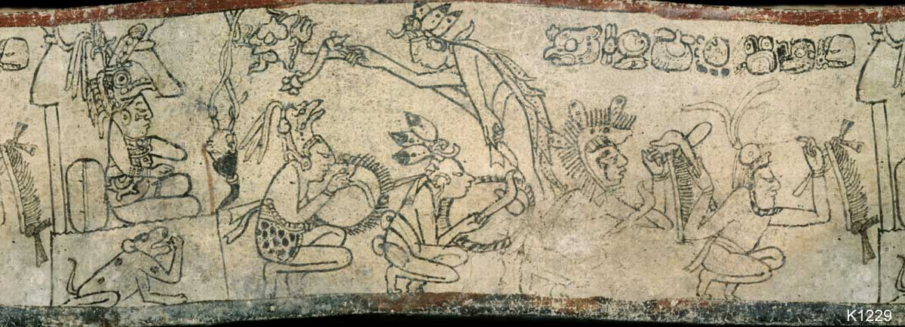
The Komkom were willing to fight for their allies’ honour and the Komkom Vase demonstrates they were proud of this, rather than being a grudging levy from a tyrannical overlord. We cannot know the full consequences of the actions of the Komkom on the wider Mesoamerican landscape, however there is some evidence that this was part a wider campaign against Tikal (Helmke et al. 2018:78-79), and the looming silhouette of the Classical titan is seen occasionally in Naranjo’s narrative (Martin & Grube 2000:82); the extent of Tikal’s involvement is as yet a mystery in the Naranjo-Yaxha conflict. It also appears that this war marked the end of Yaxha, as multiple constructions in the city came to a halt around the same time as the conflict (Rice & Rice 1980:447) Something of note is that around the area of Yaxha, a large amount of ceramics commonly associated with the Belize area were discovered (p.450). Rice and Rice (p.450) suggests that perhaps Yaxha had a relationship with the Belize area, furthering the complexities of the conflict’s context. This narrative is also noticeably void of Yaxha’s voice, for example we have no equivalent of The Aeneid or The Skye Boat song; a mournful yet hopeful tale of Yaxha’s refugee King. Perhaps Yaxha’s people also despised their king as much as Naranjo did, for he bears the name Lakamtun, an emblem glyph for yet another polity (Martin & Grube 2000:19) – a hated foreigner or beloved leader, we may never know. We shall conclude this section by mentioning how the Komkom concluded their episode: with a dance (Helmke et al. 2018:81) to celebrate the victory [see Fig 13]. How could we doubt the martial influence of Belize River Valley polities when the Komkom show a clear self-awareness of their own capabilities on the battlefield?
Figure 13: K1229. The dance mentioned in the Komkom Vase is perhaps translated as the ‘Frog-like-tortoise dance’ (Helmke et al. 81), perhaps this vessel (Kerr 1998) depicts this dance: with kitted warriors on their haunches.
Discussion
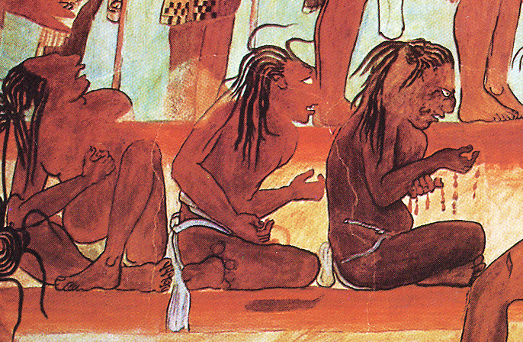
Within two case studies we have seen two victories claimed by Naranjo against Caracol and Yaxha – yet for their lack for mentioning them in its triumphs, Naranjo seems dependent on its allies. Both Xunantunich and Komkom had strong reasons not to engage in these conflicts: Xunantunich may well have made a powerful and dangerously close enemy in Caracol, and the Komkom seems to not have the historical rivalry with Yaxha that Naranjo did. And yet these two polities not only marched with their allies, but they also seemed to have performed with such valour that their victories are celebrated in war loot and a commendatory ceramic. It may even be that Naranjo sought allies in the Belize River Valley due to a continual martial tradition in the area. As mentioned in the introduction, sites such as Cahal Pech and Blackman Eddy show evidence of conflict within the Belize River Valley from the Preclassic period (Brown & Garber 2003:98-102). Even outside the valley, sites around the Belize area exhibit strong martial traditions: Cuello is the site of a mass sacrifice of 30 people, possibly of captured warriors (Houk 2015:2) and Caracol remained a strong military presence in the Maya area for much of the late Classic period. At Cahal Pech, a bowl containing the finger bones of several adults were found in a burial chamber (Awe 2013:37); if these were procured from unwilling victims, it then correlates to the Bonampak Murals in which the hands of captives are maimed (Coe & Houston 2015:150) [see Fig. 14]. Another burial at Cahal Pech also contained burnt human bones, possibly suggesting cannibalism (Healy et al. 2004:121). The nature/existence of cannibalism in Mesoamerica has long been debated, but what evidence we have suggests that cannibalism may have been an element within Mesoamerican warrior society (Houston et al. 2006:220) – an extreme fate of the war-fallen. This is of additional interest regarding the second chapter as it perhaps suggests that Belize River Valley sites may have been the birthplace of some Maya warrior traditions. At Baking Pot, a large amount of worked granite artefacts suggest mace heads or even bola weights (Aimers 2004:311): a hunting weapon used to catch animals or perhaps an aid for capturing enemies in the rout. It could also be argued that these were stones used as boxing weapons (Taube & Zender 2009:180-209), a common sport in Mesoamerica. During the Spanish conquest of the Yucatan, what we now know as Belize was home to the Maya nations of Chetumal and Dzuluinicob, who so fiercely resisted the Spanish encroachments that other Maya groups rallied to the area to escape the Spanish (Bolland 1993:162).
Figure 14: Bonampak Murals, captives tend to wounded hands. Latin American Studies No Date.
This raises the question: why did the Belize River Valley settlements not attain the same levels of success as polities such as Calakmuul, Naranjo, Caracol and Tikal if they were equally potent in the craft of warfare? Militarism does not always equate to expansiveness or hegemonic success. Perhaps this militarism was born from a need to guard the valuable territories of the Belize River Valley, with the area so economically potent as discussed in the first chapter of this text. The lack of stone inscriptions makes it difficult to see the true extent of military potency in the Belize area including that of the Belize River Valley sites (Houk 2015:3). Nevertheless, these stories from the ‘side characters’ of Maya conflicts also signifies something else: how many other victories boasted by such figures as Bird Jaguar IV of Yaxchilan (Martin & Grube 2000:130-133) were actually the produce of a collective effort? Indeed, the King was assisted by the ruler of La Pasadita in battle; La Pasadita has an entire lintel depicting their local hero (p.131).
What is interesting is that the late 6th century AD is a time of heightened warfare, but also of recognised camaraderie: at around this time, the production of the Bonampak murals suggest a strong patronage between Yaxchilan and Bonampak and the former’s celebration of their vassal’s victory (Martin & Grube 2000:136). All this said, we must also take into consideration the more sinister reasons – were the Belize River Valley sites coerced into conflict? Naranjo itself was chastised by Calakmuul in 631 AD (p.72), perhaps Naranjo attempted to replicate the web of hegemony that Calakmuul did: with a stern equilibrium of patronage and punishment (p.104). Equally, a cynical and nihilistic outlook on Maya military alliances can be similarly limited as it reduces the ancient Maya elite as ruthless machines, rather than living and breathing people who were capable of the human traits of gratitude and kindness. The Belize lowland cities may have been smaller than the Petén cities (Houk 2015:3), but they certainly were not shy of committing to conflicts with much larger states and by doing so shaped the history of the Maya.
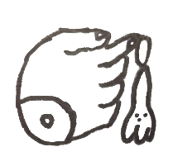
Summary & Conclusion
It was inevitable that the title of this paper should be inherently problematic: ‘How much influence did the Belize River Valley have with the wider political ecosystem of Mesoamerica?’ Can we truly measure influence and if so, then what challenges do we face when trying to quantify the unquantifiable in the shrouded past? It appears this inquiry is destined to spiral in speculation and hypotheses. Secondly comes the issue of the designation of region. The Belize River Valley area is only a region that modern Mesoamerican studies use for geographical clarity and it is unlikely it would have an equivalent to the ancient Maya, who likely divided territories in a different way. The boarders of Guatemala, Mexico and Belize may divide the Yucatan in the present; who knows what boundaries were drawn and redrawn in the shifting politics of the ancient Maya. However, I still argue for the concept of a political ecosystem, a meshwork of dynamic actors and reactors, with even the humblest agents shifting the balance. The Moon for example is only a fraction of Earth’s size and is deceptively distant from our world – and yet, its effect on Earth is awesome even through the void of space. Its effect on the tides, the light it grants or occasionally takes away, to the vast cultural weight it possesses across the world. Let us take this in mind when considering even the humblest settlements, that through its mere existence it may have influence on larger settlements.
Rome owed a large part of its greatness to Italian olive groves and North African grain shipments (Erdkamp 2013). A powerful Mediterranean force, yet one that was propped up by multiple communities across Europe, the Middle East and Africa. The iconic warrior elite of feudal Japan, the Samurai, sprung from conflicts with the Emishi (Indigenous North Japanese ethnicity) rather than a wholly (Yamato) Japanese development (Clements 2010:23-24) – small tribes had forever changed Japanese warfare and culture. Through this text I have aimed to encourage the same line of thought when it comes to Mesoamerica: that settlements, whether powerful or humble, shared an interdependent relationship with their neighbours. Whether by trade, culture or military action the Belize River Valley sites and their people demonstrate that they are not peripheral or a footnote to the Petén but are instead parts of a milieu and mesh of political interaction. It is unwise to completely disregard hierarchies and to suggest that every faction was equal in power, as history tells us otherwise. Clearly the inhabitants of the Belize River Valley lived within the shadow of their neighbours. Regardless, to look merely at the Tikals, Romes and the Chinas of this world is like focusing on solely jaguars, eagles and tigers – the understanding of ecosystems comes from a holistic perception. What is important in any ecosystem is the flow of energy; it cannot be made or destroyed, only transferred cyclically and indefinitely. I have demonstrated that we can also look at political systems in the same way, by looking at the flow of power and influence particularly from a perceived lower end of the hierarchal structure.
The rulers and inhabitants of the Belize River Valley could well have exploited the demand for valuable resources to gain political power and resource security. Culturally we may also argue that the Belize River Valley sites also helped pollinate traditions seen throughout Maya history. And finally, they may have influenced the history of Mesoamerica in the most direct form: in conflict. Through the architectural, iconographic and ethnographic data examined, it could well be argued that at certain times – even continually – the Belize River Valley sites had a profound connection with the rest of Mesoamerica. As do all rivers, the Belize River contributes its waters to the vast oceans that dominate our world, only to be fed themselves by rainwater, stolen from the sea. The settlements, people and their rulers within the valley of the Belize River have demonstrated themselves a part of a similar cycle: a circle of power and influence that comes and goes from source to coast.

References
Aimers J. 2004. ‘Terminal Classic to Postclassic in the Belize Valley’, in The Ancient Maya of the Belize Valley (editor: Garber J.F.). University Press of Florida, 15 Northwest 15th Street Gainesville, FL 32611-2079.
Aimers J.J., Powis T.G. & Awe J.J. Awe 2000. ‘Preclassic Round Structures of the Upper Belize River Valley’, in Latin American Antiquity.
Awe J. 2000. ‘Cahal Pech’, in Archaeology Magazine. https://archive.archaeology.org/online/features/belize/cahalpech.html [Accessed 19/11/2019].
Awe J.J. 2013. ‘Journey on the Cahal Pech time machine: an archaeological reconstruction of the dynastic sequence at a Belize Valley Maya polity’, in Research Reports in Belizean Archaeology. Vol.10
Awe J., Grube N. & Cheetham D. 2009. ‘Cahal Pech Stela 9: a Preclassic monument from the Belize Valley’, in Research Reports in Belizean Archaeology. Vol.6.
Ball J.W. & Taschek J.T. 2004. ‘Buenavista del Cayo’, in The Ancient Maya of the Belize Valley (editor: Garber J.F.). University Press of Florida, 15 Northwest 15th Street Gainesville, FL 32611-2079.
Brown M.K. & Garber J.F. 2003. ‘Evidence of Conflict during the Middle Formative in the Maya Lowlands: A View from Blackman Eddy, Belize’, in Ancient Mesoamerican Warfare (editors Brown M.K. & Stanton T.W.). AltaMira press, Walnut Creek, CA 94596.
Bolland O.N. 1993. ‘Belize: Historical Settings’, in Guyana and Belize: country studies (edited by Merrill T.). Headquarters, Department of the Army, DA Pam 550-82.
Calder A. 1969. The People’s War. Granada Publishing Limited, 3 Upper James Street, London W1R 4BP.
Chase D.Z. & Chase A.F. 2003. ‘Texts and Contexts in Maya Warfare’, in Ancient Mesoamerican Warfare (editors Brown M.K. & Stanton T.W.). AltaMira Press, Walnut Creek, CA 94596.
Chase A.F. & Garber J.F. 2004. ‘The Archaeology of the Belize Valley in Historical Perspective’, in The Ancient Maya of the Belize Valley (editor Garber J.F.). University Press of Florida, 15 Northwest 15th Street Gainesville, FL 32611-2079.
Clayton S.C. 2005. ‘Interregional Relationships in Mesoamerica: Interpreting Maya Ceramics at Teotihuacan’, in Latin American Antiquity. Vol.16, No.4.
Clements J. 2010. A Brief History of The Samurai: A new history of the warrior elite. Constable & Robinson Ltd., London W6 9ER.
Clendinnen I. 1993. Aztecs: an interpretation. Cambridge University Press, The Pitt Building, Trumpington Street, Cambridge CB2 1RP.
Coe M.D. & Houston S. 2015. The Maya (9th edition). Thames and Hudson Ltd, 181A High Holborn, London WC1V 7QX.
Coe M.D. & van Stone M. 2015. Reading the Maya Glyphs (2nd edition). Thames and Hudson Ltd, 181A High Holborn, London WC1V 7QX.
Cowgill G.L. 2015. Ancient Teotihuacan: Early Urbanism in Central Mexico. 32 Avenue of the Americas, New York, NY 10013-2473, USA.
Davies E. 2020. ‘Why does salt have antibacterial properties?’, Science Focus. https://www.sciencefocus.com/nature/why-does-salt-have-antibacterial-properties/ Accessed 23/04/2020.
Ebert C.E., Pierce D.E. & Awe J.J. 2019. ‘Preclassic ceramic economy in Belize: neutron activation analysis at Cahal Pech’, in Antiquity. Vol.93 No.371.
Erdkamp P. 2013. ‘The food supply of the capital’, in The Cambridge Companion to Ancient Rome. Cambridge University Press.
Garber et al 2004. ‘Archaeological Investigations at Blackman Eddy’, in The Ancient Maya of the Belize Valley (editor Garber J.F.). University Press of Florida, 15 Northwest 15th Street Gainesville, FL 32611-2079.
Haslip-Viera G., Ortiz de Montellano B. & Barbour W. 1997. ‘Robbing Native American Cultures: Van Sertima’s Afrocentricity and the Olmecs’. Current Anthropology Vol.38, No.3.
Headrick A. 2003. ‘Butterfly War at Teotihuacan’, in Ancient Mesoamerican Warfare (editors Brown M.K. & Stanton T.W.). AltaMira Press, Walnut Creek, CA 94596.
Healy P.F, McKillop H.I. & Walsh B. 1984. ‘Analysis of Obsidian from Moho Cay, Belize: New Evidence on Classic Maya Trade Routes’, in Science. Vol.255, No.4660.
Healy P.F. et al. 1995. ‘Pacbitun (Belize) and ancient Maya use of slate’. Antiquity Vol.69
Healy P.F. et al. 2004. ‘Cahal Pech: The Middle Formative Period’, in The Ancient Maya of the Belize Valley (editor: Garber J.F.). University Press of Florida, 15 Northwest 15th Street Gainesville, FL 32611-2079.
Healy P.F., Hohmann B, Powis T.G. 2004. ‘The Ancient Maya Center of Pacbitun’, in The Ancient Maya of the Belize Valley (editor: Garber J.F.). University Press of Florida, 15 Northwest 15th Street Gainesville, FL 32611-2079.
Helmke C. & Awe J. 2012. ‘Ancient Maya territorial organisation of Central Belize: confluence of archaeological and epigraphic data’, in Contributions in New World Archaeology. Vol.4.
Helmke C. & Awe J. 2016. ‘Death Becomes Her: An Analysis of Panel 3, Xunantunich, Belize’, in The PARI Journal. Vol.16, No.4.
Helmke C., Hoggarth J.A. & Awe J.J. 2018. A Reading of the Komkom Vase Discovered at Baking Pot, Belize. Precolumbia Mesoweb Press.
Horn III S.W., Garber J.F. & Awe J.J. 2017. ‘And now for something completely different: architectural variability as a signature of dynamic social relations at middle Preclassic Cahal Pech’, in Research Reports in Belizean Archaeology (Edited by Morris J. et al.). Vol.14.
Houk B.A. 2015. Ancient Maya Cities of the Eastern Lowlands. University Press of Florida 15 Northwest 15th Street Gainesville, FL 32611-2079.
Houston S., Stuart D. & Taube K. 2006. The Memory of Bones: Body, Being, and Experience among the Classic Maya. University of Texas Press, Austin TX 78713-7819.
Jackson S.E. 2013. Politics of the Maya Court: Hierarchy and Change in the Late Classic Period. University of Oklahoma Press, 2800 Venture Drive, Norman, OK 73069.
Keay J. 1993. The Honourable Company: A History Of The English East India Company. HarperCollinsPublishers, 77-85 Fulham Palace Road, Hammersmith, London W6 8JB.
Leventhal R.M. & Ashmore W. 2004. ‘Xunantunich in a Belize Valley Context’, in The Ancient Maya of the Belize Valley (editor Garber J.F.). University Press of Florida, 15 Northwest 15th Street Gainesville, FL 32611-2079.
Lucero L.J. 1999. ‘Classic Lowland Maya Political Organization: A Review’, in Journal of World Prehistory. Vol. 13, No. 2.
Lucero L.J. 2006. Water and Ritual: The Rise and Fall of Classic Maya Rulers. University of Texas Press, Austin TX 78713-7819.
Martin S. & Grube N. 2000. Chronicle of the Maya Kings and Queens. Thames and Hudson Ltd, 181A High Holborn, London WC1V 7QX.
Mason A. 2018. ‘The U-boat campaign that almost broke Britain’, Imperial War Museum. https://www.iwm.org.uk/history/the-u-boat-campaign-that-almost-broke-britain Accessed 31/1/2020.
McKillop H. 2002. Salt: White Gold of the Ancient Maya. University Press of Florid, 15 Northwest 15th Street Gainesville, FL 32611-2079.
McKillop H. 2004. ‘The Classic Maya Trading Port of Moho Cay’, in Classic Maya Provincial Politics: Xunantunich and Its Hinterlands (editors LeCount L.J & Yaeger J.). University of Arizona Press.
Mendelsohn R.R. 2018. ‘Obsidian sourcing and dynamic trade patterns at Izapa, Chiapas, Mexico: 100BCE–400CE’, in Journal of Archaeological Science: Reports. Vol.20.
de Montmollin O. 1989. The archaeology of political structure: Settlement analysis in a Classic Maya polity. Cambridge University Press, The Pitt Building, Trumpington Street, Cambridge CB2 1RP.
Muren G. 2004. ‘Jaina Standing Lady’. https://web.archive.org/web/20110717194058/http://umfa.verite.com/?id=NDg1 Accessed 30/1/2020.
Oudijk M.R. & Restall M. 2007. ‘Mesoamerican Conquistadors in the Sixteenth Century’, in Indian Conquistadors. University of Oklahoma Press, Norman, Publishing Division of the University.
Pendergast D.M. 1981. ‘The 1980 Excavations at Lamanai, Belize.’. Mexicon Vol.2.
Pohl M.E.D & Pohl J.M.D. 1994. ‘Cycles of conflict: political factionalism in the Maya Lowlands’, in Factional competition and political development in the New World (editors: Brumfiel E.M. & Fox J.W.). Cambridge University Press, The Edinburgh Building, Cambridge CB2 2RU.
Powell E.A. 2020. ‘Maya Total War’, Archaeology. https://www.archaeology.org/issues/366-2001/trenches/8242-digs-guatemala-witzna-fire Accessed 07/02/2020.
Rice D.S. & Rice P.M. 1980. ‘The Northeast Petén Revisited’, in American Antiquity. Vol.45, No.3.
Skidmore J. 2007. ‘An Updated Listing of Early Naranjo Rulers’, in The PARI Journal. Vol.7, No.4.
Stemp W.J., Graham E. & Goulet J. 2011. ‘Coastal Maya Obsidian Trade in the Late Postclassic to Early Colonial Period: The View From San Pedro, Ambergris Caye, Belize’, in Journal of Island & Coastal Archaeology. Vol.6, No.1.
Stone A. & Zender M. 2011. Reading Maya Art: A Hieroglyphic Guide to Ancient Maya Painting and Sculpture. Thames & Hudson Ltd., London.
Sun Tzu 2014. The Art of War (introduction by Cawthorne N.). Arcturus Publishing Ltd., London SE1 3HA.
Taube K. & Zender M. 2009. ‘American Gladiators: Ritual Boxing in Ancient Mesoamerica’, in Blood and Beauty: Organized Violence in the Art and Archaeology of Mesoamerica and Central America (editors Orr H. & Koontz R.). Cotsen Institute of Archaeology Press.
Tokovinine A. 2007. ‘Of Snake Kings and Cannibals: A Fresh Look at the Naranjo Hieroglyphic Stairway’, in The PARI Journal. Vol.7, No.4.
Tokovinine A. & Beliaev D. 2013. ‘People of the road: traders and travellers in ancient Maya Words and images’, in Merchants, Markets, and exchange in the Pre-Columbian World (editors Hirth K.G. & Pillsbury J.). Dumbarton Oaks, Trustees for Harvard University, Washington D.C.
Walden et al. 2019. ‘Modeling variability in Classic Maya intermediate elite political strategies through multivariate analysis of settlement patterns’, in Journal of Anthropological Archaeology. Vol.55.
Webster D. 2000. ‘The Not So Peaceful Civilization: A Review of Maya War’, in Journal of World Prehistory. Vol.14, No.1.
Willey G.R. 2004. ‘Retrospective’, in Classic Maya Provincial Politics: Xunantunich and Its Hinterlands (editors LeCount L.J & Yaeger J.). University of Arizona Press.

