Agent AI: AI Pathfinder

Student Name: Mathew Taylor

P Number: 149885

Module Title: Game Programming and Graphics

Assignment Title: OpenGL Based 3D Game

Module Lecturer’s Name: Gordon Dickers

Content
Table of Figures 2
Introduction 3
Algorithms 3
User Guide 3
Program Listing 4
whereCanIGo() 4
mazeSetup() 6
finalOutput() 7
main() 8
Testing 10
Images 11
References 13

Table of Figures
Figure 1 – Maze Selection 11
Figure 2 - Input Item to search for 11
Figure 3 - Maze Searched by AI with start position, AI position and the end point position output 12
Figure 4 - Output of the path the AI followed to find the item in the maze (see figure 1 for the rest of the maze above) 12

Introduction
This report will cover the algorithms implemented into the AI pathfinder. A brief user guide, the program listing, any testing that was undertaken during the development and screenshots of the final working product.

Algorithms
The main algorithm used in the AI pathfinder is the DFS (Depth First Search). The DFS starts at the root node and travels down a path, should it find a dead end, it will return to the last unexplored location[1]. The DFS is used in the AI pathfinder and handles all the locations for the AI to move to in the maze. When the AI has reached a dead end in the maze the top value on the stack will be popped off the stack, allowing the AI to return to a location with another unexplored path[2]. This algorithm is run until the item in the maze has been found[1].

User Guide
Upon running the AI pathfinder program, the user will be prompted with a choice of which maze they would like the AI pathfinder to search, the different maze options are listed above the input. The chosen maze must be input correctly (if the choice is “Maze.maz” then the user must input “Maze.maz”). Should the user input an incorrect choice, the console will ask the user to input the choice again.
Once the maze choice has been selected the user will be asked to input what item the AI pathfinder must search through the maze for. Both maze options currently only have “F” items in them but searching for other items will not crash the program, only return a message stating that the item could not be found.
During the search of the maze the AI character is represented as “@”, the paths the AI character travelled to that led to dead ends are represented with “o” and the direct path taken from the start to the item by the AI is represented by “x”. The start position is and “S” and the item currently in the maze is an “F”.

Program Listing

whereCanIGo()
The whereCanIGo function handles the checking of whether the AI can move up, down, left or right in the maze, this is dependent on where a space is in the maze.
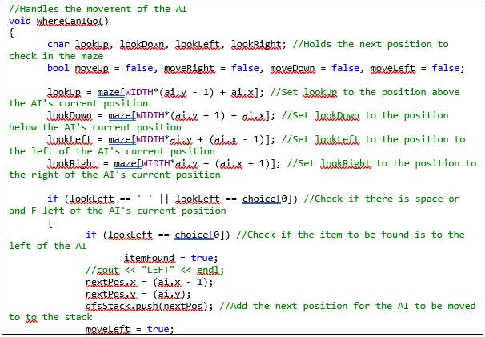
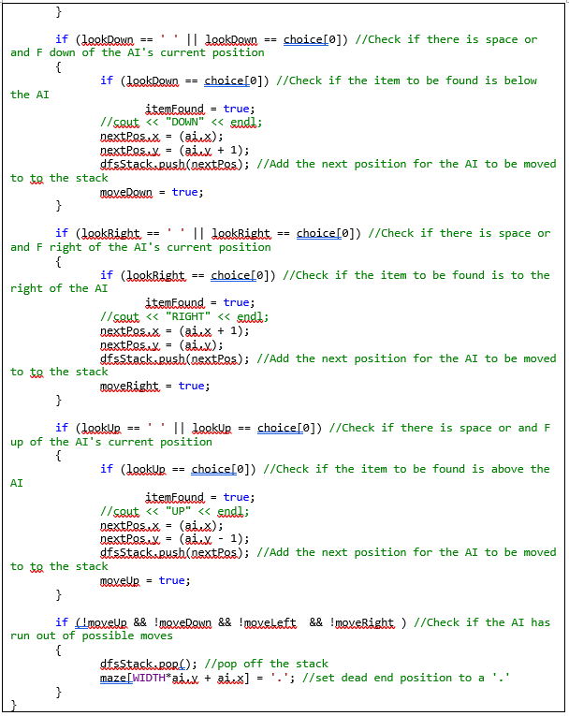

mazeSetup()
The mazeSetup function handles the inputs from the user and the initial generation of the maze by reading from the file containing the chosen maze. This function will set the start position of the AI.
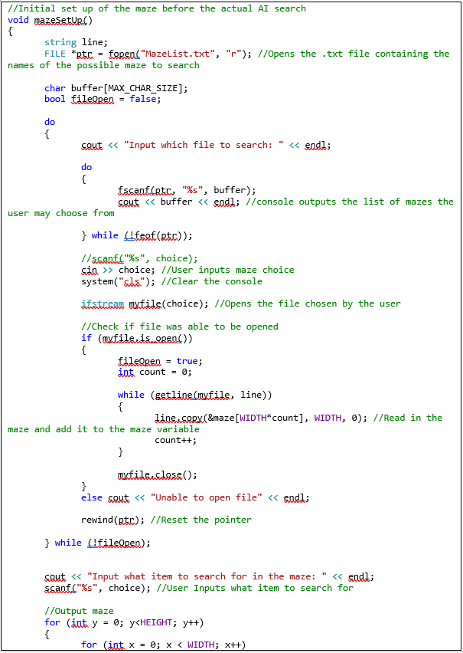
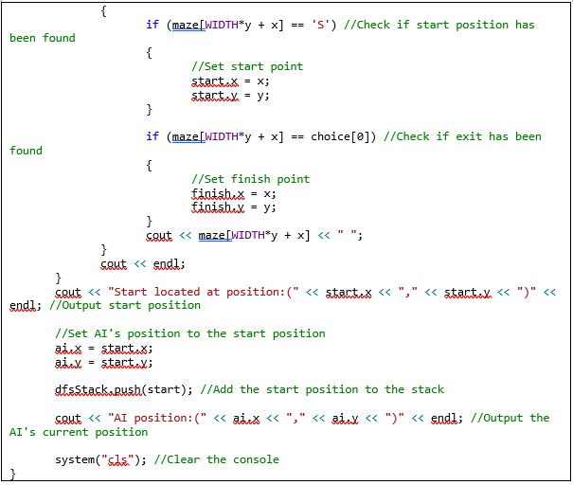

finalOutput()
The finalOutput function handles all the outputs after the search is complete. This function outputs whether the item has been found or not and if the item has been found, the location of the item. The last output is the path the AI took to get from the start position to the item.
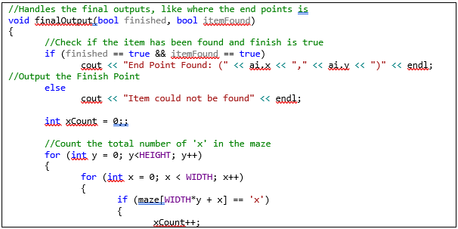
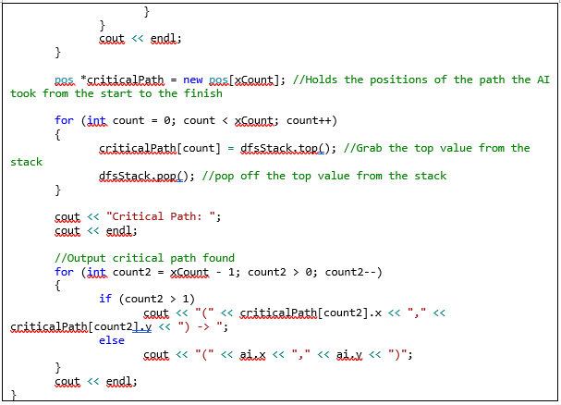

main()
The main handles the actual search algorithm and prints out the maze, while constantly clearing the console so the user can see the maze updating as the AI searches through it.
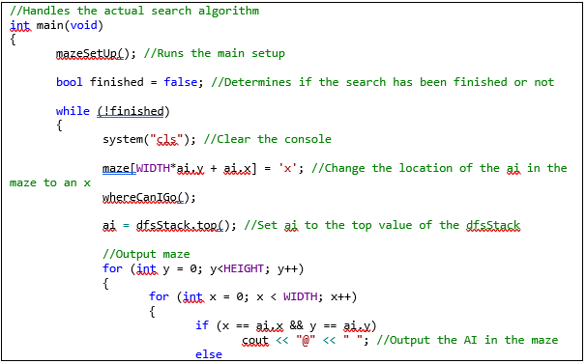
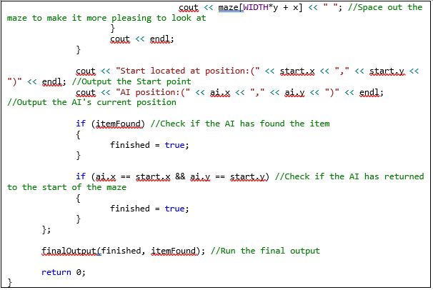

Testing
Test No. | Test Description | Expected Result | Actual Result | Pass/Fail
1 | Maze Selection. | Can choose different maze. | Can choose different maze. | Pass.
2 | Item Selection. | Can choose an item to find. | Can choose an item to find. | Pass.
3 | AI can movement in the maze. | AI can move up, down, left and right. | AI can move up, down, left and right. | Pass.
4 | AI will stay within the walls. | AI doesn’t travel through walls. | AI doesn’t travel through walls. | Pass.
5 | AI moves backwards if dead end is found. | AI moves backwards if dead end is found. | AI moves backwards if dead end is found. | Pass.
6 | AI can detect if the item to be found is next to it. | AI stops searching through the maze if item is next to it. | AI stops searching through the maze if item is next to it. | Pass.
7 | User inputs something other than one of the maze options. | Console outputs a message asking the user to input a choice again. | Console outputs a message asking the user to input a choice again. | Pass.
8 | User inputs an item that does not exist to find. | Console outputs message saying that the item couldn’t be found. | Console outputs message saying that the item couldn’t be found. | Pass.
9 | AI leaves a trail of x’s to show the path it’s taken. | User can see the x’s appear on screen as the AI moves. | User can see the x’s appear on screen as the AI moves. | Pass.
10 | AI leaves o’s when it reaches a dead end. | User can see the o’s appear on screen as the AI leaves a dead end. | User can see the o’s appear on screen as the AI leaves a dead end. | Pass.

Images
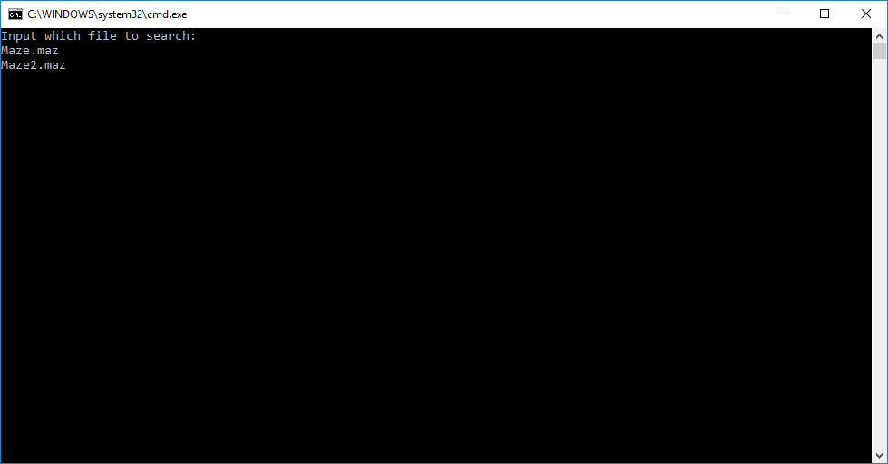
Figure 1 – Maze Selection
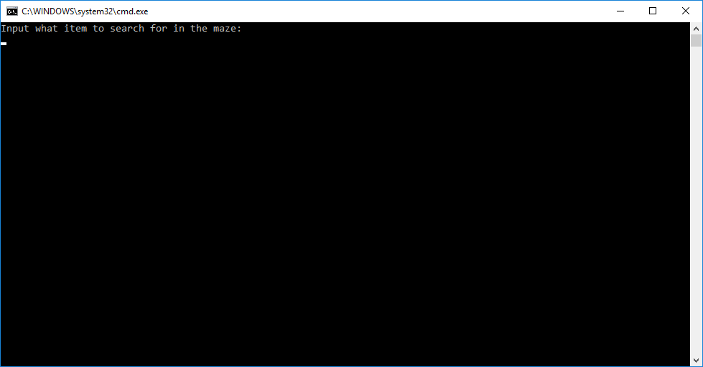
Figure 2 - Input Item to search for
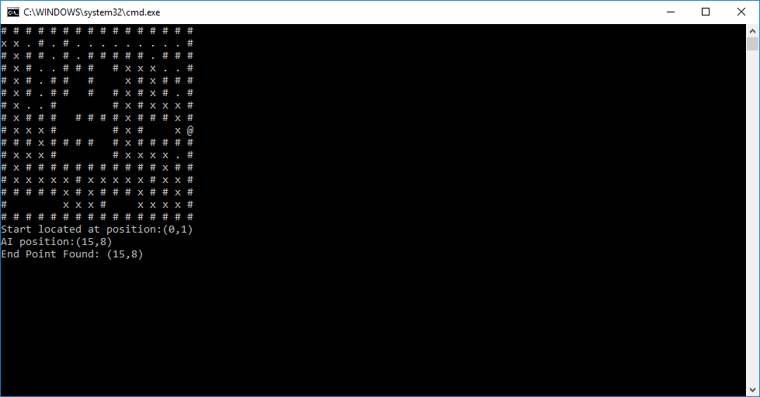
Figure 3 - Maze Searched by AI with start position, AI position and the end point position output
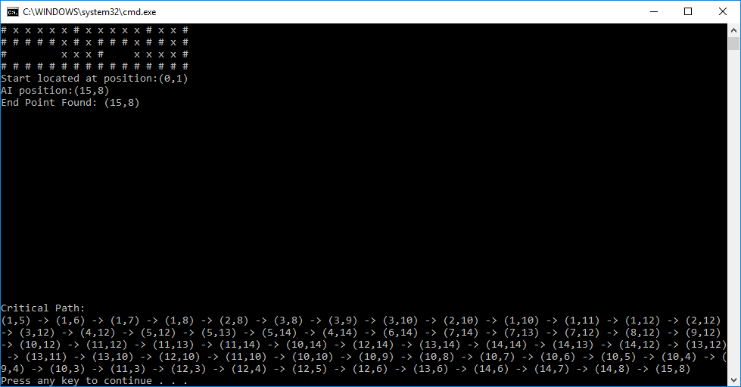
Figure 4 - Output of the path the AI followed to find the item in the maze (see figure 1 for the rest of the maze above)

References
[1] K. Moore and K. Jenkinson, “Depth-First Search (DFS) | Brilliant Math &amp; Science Wiki,” Brilliant, 2002. [Online]. Available: https://brilliant.org/wiki/depth-first-search-dfs/. [Accessed: 29-Mar-2018].
[2] L. L. Larmore, “DFS and BFS Algorithms using Stacks and Queues,” pp. 1–4.

