

LOCATION: Swansea | LLEOLIAD: abertawe
LEVEL 4 | LEFEL 4
EXAMINATION PERIOD | CYFNOD ARHOLIADAU
January 2024 | IONAWR 2024
MODULE CODE: ACDA4004
Micros Peripherals & Interfaces

Marking Scheme

ANSWER ALL QUESTIONS (marks add up to 50 in total)

- The following comprise a number of mnemonics from the PIC16F84 microprocessor instruction set. Give the meaning of what each mnemonic stands for and explain what the instruction actually does.

1 mark for stating what the mnemonic stands fo
1 mark for stating the meaning

  - RETURN : Return from Subroutine – loads the program counter with the address of the piece of code that initially called the subroutine
[2 Marks]
  - SLEEP Go into standby/sleep mode – enters a low power mode where most parts of the PIC are powered down.
[2 Marks]
  - ADDLW Add literal and W – takes a given literal value and adds it to the contents of the
[2 Marks]
  - BCF f, b Bit clear f. The bit, indicated to by the ‘b’ is cleared (set to zero) in the register pointed to by ‘f’
[2 Marks]
  - DECF Decrement F – the file register pointed to by the value ‘f’ is decremented by one.
[2 Marks]

- Provide circuit diagram sketches as well as written explanations, detailing two different hardware based methods of how you might solve or reduce the incidence of switch bounce for the input of a typical PIC microcontroller IO pin

5 marks for each method.
Examples would be:

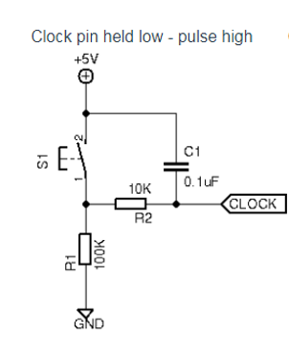

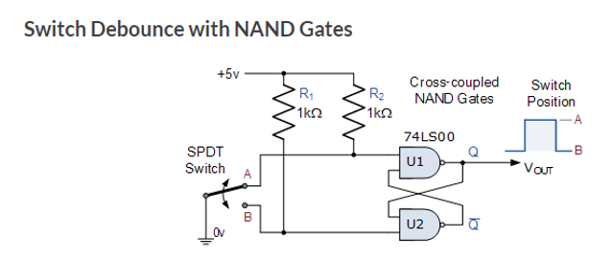

[10 Marks]

- Draw the logic symbol for an AND gate and provide the truth table for it.
[3 Marks]
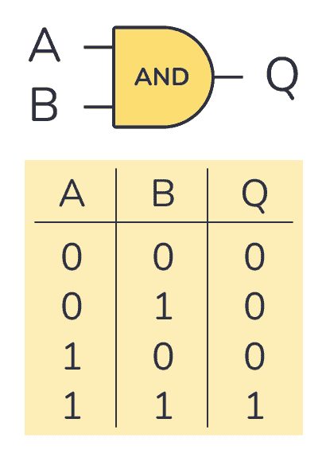

1.5 marks for the correct symbol, 1.5 marks for the truth table

- a) Produce a truth table for the following logic circuit, solving the states for the final ‘output’ block, but also showing all the intermediate nodes that were used in this final calculation. (7 marks)

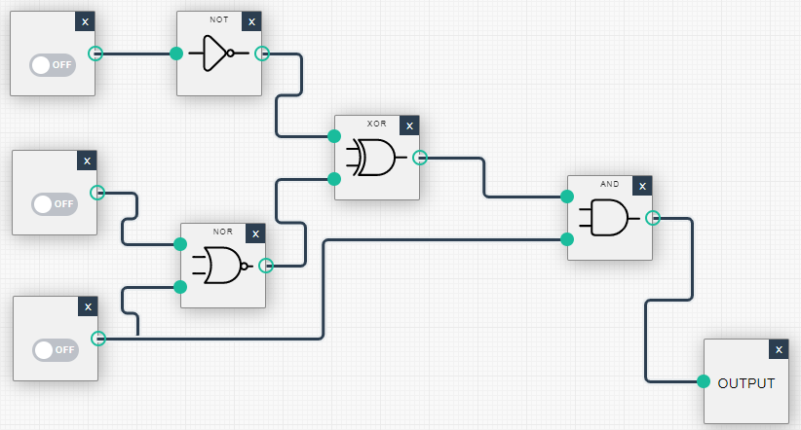

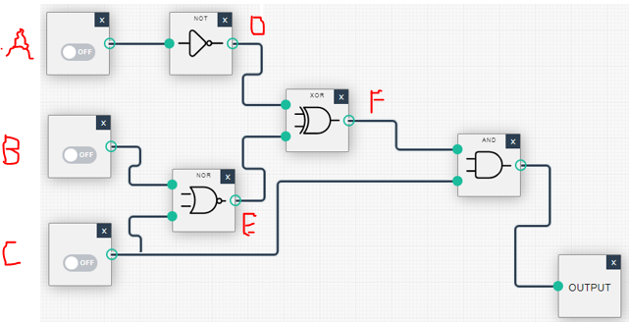

A b c d e f out
0 0 0 1 1 0 0
0 0 1 1 0 1 1
0 1 0 1 0 0 0
0 1 1 1 0 1 1
1 0 0 0 1 0 0
1 0 1 0 0 0 0
1 1 0 0 0 0 0
1 1 1 0 0 0 0

b) By visually inspecting the final truth table, suggest a far simpler logic diagram that would produce the same result. (3 marks)

One could use formal reduction methods, however observation shows that the output is only true when C is true and A is false (B does not affect the output)

Therefore we could simply use A and C inputs and produce:

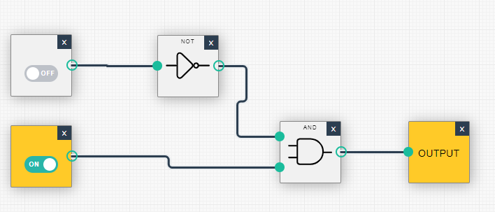

- Provide diagrams to show typical Harvard and Von Neumann processor architectures. Also state one advantage that each of the two types provides over the other.

4 marks each for the Harvard and Von Neumann diagrams
1 mark for each advantage (e.g. – Harvard – ability to fetch instructions and data simultaneously. Von Neumann – simpler bus structure as instructions and data share one bus)

Harvard
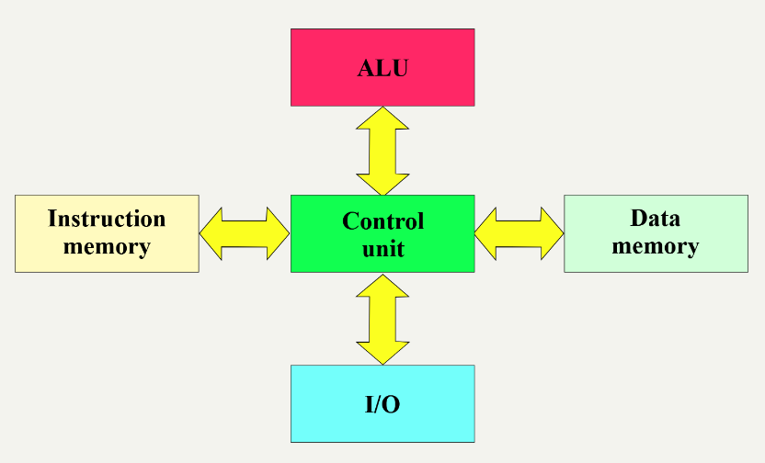

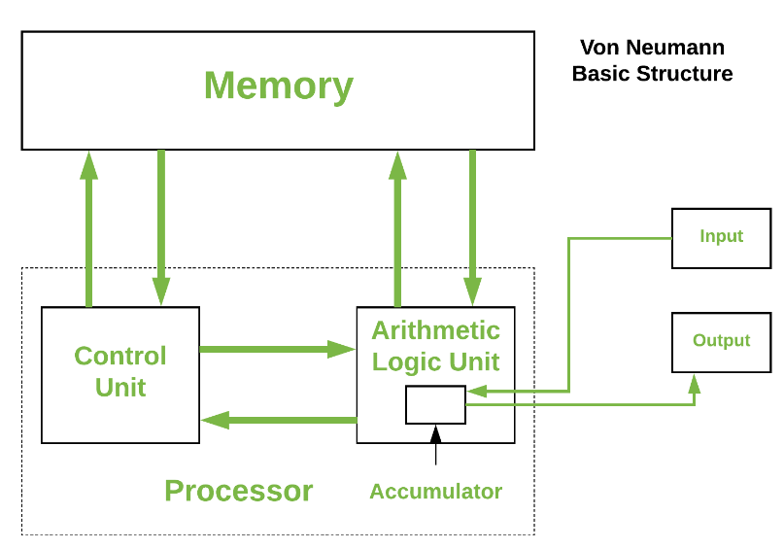

[10 Marks]

- BY using text and diagrams, explain the principle of how you can implement a simple DAC by using a single microcontroller output pin that produces a PWM digital signal.

To implement a simple digital-to-analog converter (DAC) using a single microcontroller output pin producing a PWM signal, you can utilize the principle of pulse-width modulation (PWM) combined with low-pass filtering.

The microcontroller generates a PWM signal on a single output pin. The duty cycle of this PWM signal is varied to represent different analog voltage levels.
Low-Pass Filtering
The PWM signal is passed through a simple RC (resistor-capacitor) low-pass filter circuit connected to the output pin.
Signal Averaging
The low-pass filter averages out the PWM pulses, producing an analog voltage level proportional to the PWM duty cycle.

3 marks for the description
2 marks for the smoothing circuit (LPF)
2 marks for a PWM diagram
[7 Marks]

Diwedd/End

