

University of Wales Trinity Saint David
School of Engineering

Engine performance characteristics
Calum McGowan Franklin
1803213
Motorsport Engineering/HNC/HND
Date 12/01/2020
Module code
M4X02196
Contents
A. List of figures 3
1. Introduction 4
Aims 4
2. Experimental procedure 5
Equipment 5
Method 5
3. Results 7
4. Analysis 8
5. Discussion 16
6. Conclusion 18
7. Evaluation 19
8. Appendices 20
9. Bibliography 22

List of figures
Table 1- Collected engine data for load (Nm), engine speed (rpm), fuel flow rate(l/min) and lambda value from idle through to 5500 rpm. For full table see appendix.
Table 2- Variables considered on the day of testing to collect baseline data.
Table 3- Derived data expressing values for load(N),Engine speed(rpm), fuel flow rate(l/min)(kgh/m)/(kg/H),lambda(mm³ ) torque(Nm), power(W), corrected power(W), fuel flow rate(kgh/m)/(kg/H), Specific fuel consumption(kg/kWh),Break mean effective pressure(Pa) and thermal efficiency(%).
Figure 1- Torque vs engine speed, test data and peak published value.
Figure 2- Brake power vs engine speed, test data and peak published value.
Figure 3- Specific fuel consumption vs engine speed.
Figure 4- Comparative data, Engine speed vs torque and power.
Figure 5- Comparative data, Engine speed vs torque and power.

Introduction
It is essential to perform several tests on an engine when trying to determine the performance characteristics of a motor vehicle. Typically, tests are carried out using either a chassis or engine dynamometer. The data collected from these tests can be used to calculate various engine attributes which can then enable exploration and enhance development. (Zammit,1996)
A dynamometer is a device used to determine the torque and/or power of an engine or machine by creating a resistive force. In the case of an eddy current dynamometer resistance is gained through an increase in amperage that in turn creates a larger magnetic field and thus more resistance against the rotational force exerted by the engine when using an engine dynamometer, or the whole powertrain system when using a chassis dynamometer. (Setra.com,2019)
An engine dynamometer operates by mounting an engine shaft into the dynamometer rotor. The rotor is then turned via engine force which is opposed by a calculated load acting against the rotor. As the load and torque arm are known variables, engine torque can be resolved. Engine speed is also monitored at the crank which enables Brake power to be determined.

Aims
This report will be analysing the characteristics of a Honda civic 1.6 d/b 2001 engine by using an eddy current dynamometer to collect baseline engine variables that will then be used to calculate further engine characteristics.

Experimental procedure
The following test was performed in lab room 019 in the UWTSD. The test was overseen by Abi and Mark. The results found are from group A.

Equipment
- DSG dynamometer

- Torque arm and calibration weights

- 2001 Honda Civic 1.6 v Tec d16 engine

- Software, Dataq pro v2 6xx.

Method
- In the console room, open data q v2 6xx software.
- Attach torque arm to dynamometer outer housing and add calibration weights.
- Calculate torque moment manually and compare this against the software value. Be aware that there may be a difference in the manually calculated torque moment and the software generated value, this may occur as the weights can have a different mass to that which is stated. In order to rectify this the weights must be weighed to confirm correlation.
- Calibration is zeroed.
- Safety checks must be considered before test sequence is initiated. This includes room doors, dynamometer coolant and fuel pump.
- Within the software several tests are optional. “Step test” will run the engine from a set RPM to another. “Manual test” will allow manipulation of load and rpm in real time. Test sequence will run a pre-determined imitation of conditions, used to mimic a track or journey, and a “sweep test” which runs the engine through the entire rev range.
- select “sweep test” and select the duration of test and load parameters.
- Start engine via console switch and allow to warm before beginning test.
- Begin test and allow engine to run through range before returning to idol.
- Raw data is collected and tabulated.

Results
Load | Dyno Speed | Fuel Flow Rate | Lambda
Newtons | rpm | l/min | Lambda
83.48864 | 1000 | 0.0704 | 1.269
85.13097 | 1050 | 0.0724 | 1.2682
87.82388 | 1100 | 0.0737 | 1.2674
90.0148 | 1150 | 0.0728 | 1.2667
92.04368 | 1200 | 0.0744 | 1.266
//////////////////////////////////////////////////////////////
88.54159 | 5300 | 0.3324 | 1.0508
87.596424 | 5350 | 0.3308 | 1.0504
86.396654 | 5400 | 0.3388 | 1.05
85.383374 | 5450 | 0.3438 | 1.05
84.611246 | 5500 | 0.3488 | 1.05
Table 1. Collected engine data for load (Nm), engine speed (rpm), fuel flow rate(l/min) and lambda value from idle through to 5500 rpm. For full table see appendix.

Analysis
In conjunction with the data collected within Table 1, other controlled variables to be determined are ; the radius of the torque arm, the ambient temperature for the day, the ambient pressure for the day, the bore and stroke of the engine being tested, fuel specific gravity and the calorific value of the fuel being used.
-Radius of torque arm. | 0.818775m
-Temperature on the day. | 21°
-pressure on the day. | 1.041 bar
-Engine bore and stroke. | 75x90mm
-calorific value of fuel used. | 45,800kj/kg
-fuel specific gravity. | 0.78kg/m^3
Table 2, Variables considered on the day of testing to collect baseline data.
With all controlled variables considered and the baseline engine data collected and tabulated from the eddy current dynamometer it is possible to determine further engine characteristics by using calculations derived from the known variables. This is demonstrated with calculations and graphs as follows.

Calculating Torque
$Torque$ is the twisting force of a rotating body. Calculated by a force exerted on a given point amplified by a distance perpendicular to the point of action. (khanaccademy, 2019)
$$Torque=WR$$
$W=load (N)$
$R=radius of torque arm (m)$

Calculating Brake power
$BP$ is calculated as the amount of work done in time, i.e. the amount of turning force through a given distance through a given time. In an engine that will be the result of engine torque and rotational speed (aboutmech.com,2016).
Therefore,
$$BP=\frac{2πNT}{60}$$
$BP \left(W\right)$
$N=engine revolutions per minute (rpm)$ $T=Torqu$e (Nm)
$$2π R= distance turned through.$$
$/60=$ conversion of minutes to seconds

Calculating corrected power
$Corrected power$ is calculated from the value obtained for $BP$ whilst considering temperature and pressure noted on the day of testing (dynomitedynamometer.com,2019).
$$Corrected power=\left(\frac{1.01325}{Pa}\sqrt{\frac{Ta}{293}} \right)BP$$
$1.01325=standard atmospheric pressure (Bar)$ $Pa=engine pressure (\frac{N}{m^{2}})$ $Ta=engine temperature (k)$
$293=standard temperature \left(k\right)$

Calculating S.F.C
Specific fuel consumption (SFC) is established to understand the amount of fuel used by an engine over a period of time and can be calculated using either the indicated power of an engine or the brake power (Autospeed.com,2019).

Typically calculated as shown;
$$S.F.C=\frac{Vx0.75x3600}{tx1000xBP}$$
$V=colume of fuel being measured \left(cc\right)$
$0.75=specfic gravity of the fuel and converts litres to kg$
$3600=converts fuel used per second to fuel used per hour$
$1000=converts fuel volume cc into litres$ (L)
$BP=Brake power (W)$

However, from the dynamometer test a value is already obtained for the volumetric fuel flow rate, expressed as litres per minute. To obtain $S.F.C$ in Kg/KWh the following calculations are to be made;
$Volumetric fuel flow rate$ (l/m) $*specific gravity of fuel=fuel flow rate$ (kg/m)
$Fuel flow rate$ (kg/m)$*60=fuel flow rate$ (kg/hour)
$fuel flow rate$(kg/hour) $÷BP\left(kW\right)=S.F.C$

Calculating B.M.E.P
I.M.E.P, indicated mean effective pressure is the average pressure across the piston throughout the duration of its combustion stroke and will require the same power input as for a complete cycle. This is a measure of the effectiveness of the combustion process and can be used to compare engines of different sizes (Epi.eng.com,2019).
I.M.E.P can be determined after calculating indicated power.
B.M.E.P is the mean effective pressure across the piston after all frictional losses have been considered and therefore is calculated from the brake power.
B.M.E.P is calculated as follows
$$B.M.E.P=\frac{BP*(60*2)}{LxAxNxn}$$
$L=engine stroke$ (m)
$A=piston area$ $(m^{2})$
$N=engine speed$ (r/m)
$n=number of cylinders$

Calculating thermal efficiency
Break thermal efficiency is the ratio of the output work performed by an engine to the input heat taken from the calorific value of the fuel used. Much of the heat energy from fuel is lost due to exhaust gasses, engine cooling and heat transfer (Zammit,2019).
Thermal efficiency can be taken from either the I.P, or the B.P which will include engine frictional losses. The B.P was used to determine thermal efficiency with the following calculations.
$$break thermal efficiency=\frac{(BP÷1000)}{SFC\left(\frac{kg}{sec}\right)*C.V}$$

Calculating piston area
The area of the piston is a necessary measurement in order to obtain values for B.M.E.P and I.M.E.P,
Piston area is calculated as follows;
$$A=\frac{πd^{2}}{4}$$
Or, with regards to the measurements taken;$$0.4418=\frac{π({0.75)}^{2}}{4}$$

Using the data tabulated from the dynamometer, the above calculations are used to generate the following table and graphs in Excel.
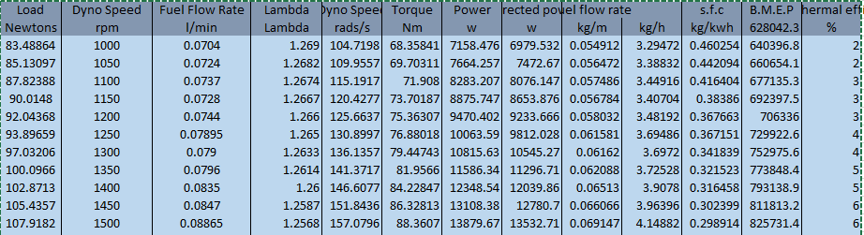
//////////////////////////////////////////////////////////////////////////////////////////////////////////
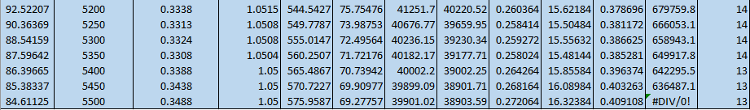
Table 3.Derived data expressing values for load(N),Engine speed(rpm), fuel flow rate(l/min)(kgh/m)/(kg/H),lambda(mm³) torque(Nm), power(W), corrected power(W), fuel flow rate(kgh/m)/(kg/H), Specific fuel consumption(kg/kWh),Break mean effective pressure(Pa) and thermal efficiency(%). For full table please see bibliography.
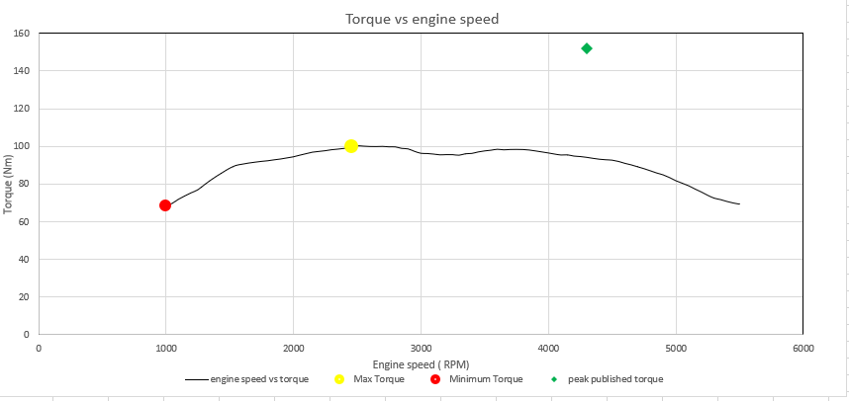
Figure 1. Torque vs engine speed, test data and peak published value.
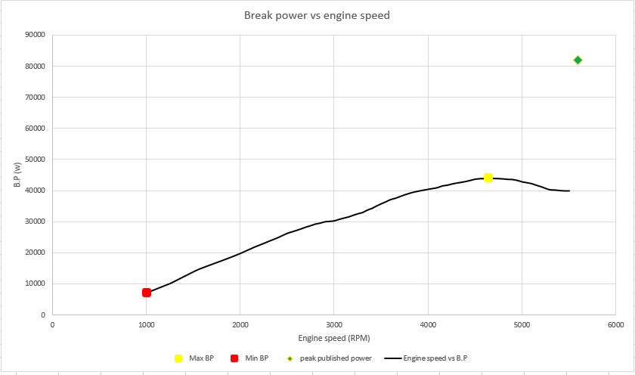
Figure 2. Brake power vs engine speed, test data and peak published value.

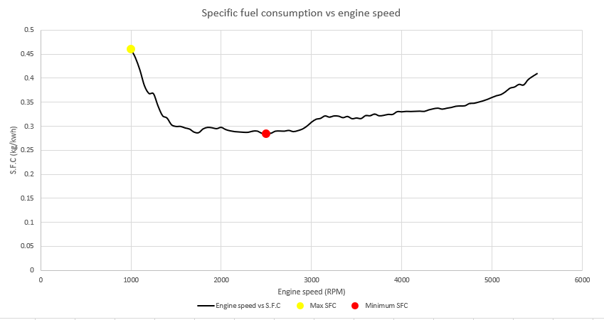
Figure 3. Specific fuel consumption vs engine speed.

Comparative data
The following graphs were examined for research purposes expressing engine speed against both torque and power. Figures 4 and 5 express similar trendlines to the values found on the Honda civic engine tested. Conclusively it can be deduced that the dynamometer testing and data found is accurate.
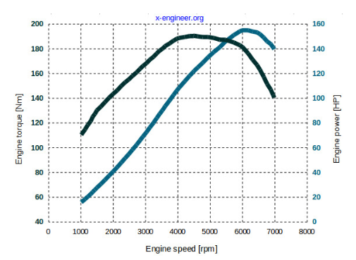
Figure 4. Comparative data, Engine speed vs torque and power for a Honda 2.0 si engine at full load. (x-engineer.org, 2019)
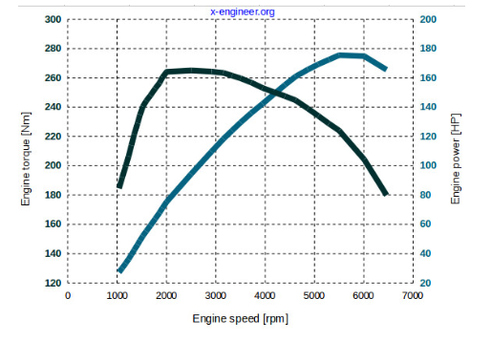
Figure 5. Comparative data, Engine speed vs torque and power for a Saab 2.0 T engine at full load. (x-engineer.org, 2019)

Discussion
Investigating the graphs from figures 1,2 and 3 it can be inferred that;
Torque increases with engine speed until reaching peak value of approximately 100Nm at 2500 rpm, following this the torque curve drops off due to a decrease in volumetric efficiency at higher engine speed. Volumetric efficiency being the measure of efficiency in filling the cylinders with fresh charge (Zammit,1996).
Brake power is relative to both engine speed and torque, as it is the measure of work done. Increasing either will give a greater power output. In figure 2 power increases with engine speed until it reaches peak value of approximately 45kW at 4700 rpm, following this the decline in brake power is due to a decrease in brake mean effective pressure (Zammit,1996). From Table 3 it is noted that the BMEP expresses similar values to the torque values expressed, depicting a relationship. This would be accurate as the torque value declines once reaching peak value as does the BMEP with both elements being contributing factors to brake power.
The peak published value for power shows a value of approximately 82kW at 4300 rpm expressing a difference of 37kW and the peak published torque expresses a difference of 50Nm from the torque values collected from testing. The reason for this could be due to the published values being taken from a de-restricted engine whilst the test results gathered are from a restricted model, the production of which was due to stringent Japanese emissions at the time of production. Another contributing factor could also be the condition of the test engine as the mileage is unknown and the service history is rudimentary.
Within figure 3 SFC expresses its lowest value of approximately 0.28 kg/kWh in mid rev range and shows its highest value of 0.46 kg/kWh at 1000 rpm which is almost replicated at 5500 rpm.
SFC increases in the low rev range due to the loss of energy of combustion as heat has more time to dissipate (Autospeed.com,2019). Also, at high engine speed the SFC will increase due to an increase in the frictional losses of the engine, this once again contributes to lose of combustion energy.
Interestingly, SFC expresses its lowest value at approximately 2500 rpm which is correlated with peak torque value. This is accurate as at peak torque the engines volumetric efficiency is best, this will in turn improve S.F.C.

Conclusion
Both torque and brake power increase with engine speed until reaching peak values after which both decrease rapidly. The decline in torque is a product of decreasing volumetric efficiency, similarly the decline in brake power is a result of reducing BMEP.
The results gathered demonstrate the relationship between torque and brake power and illustrate how brake power is a product of torque. The results also show that increasing torque will result in a larger power output.
SFC is at its lowest value in the mid rev range as this is when the engine performs most efficiently due to good BMEP and least frictional losses.

Evaluation
Overall the investigation was successful and supplied accurate data that could then be used to calculate derived data to investigate further engine characteristics. Comparing results found against similar investigations it is inferred that the data collected is accurate and the investigation was conducted correctly.
An improvement upon this study would be to conduct the tests on a recently serviced engine with new components and auxiliary lines to reduce any losses alongside recorded history as to be aware of any engine anomalies.

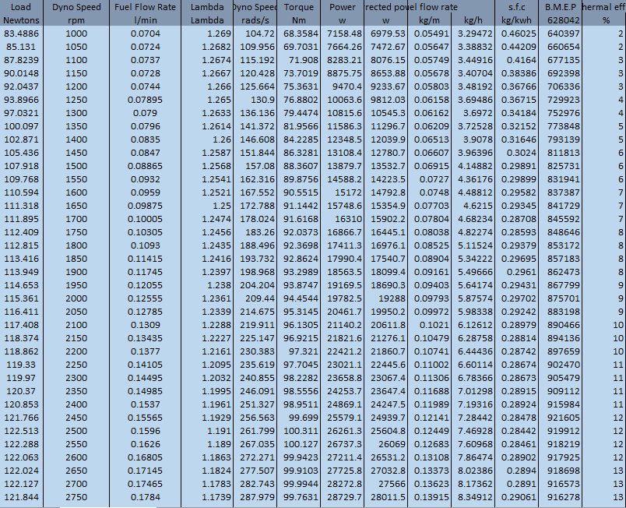
Appendices

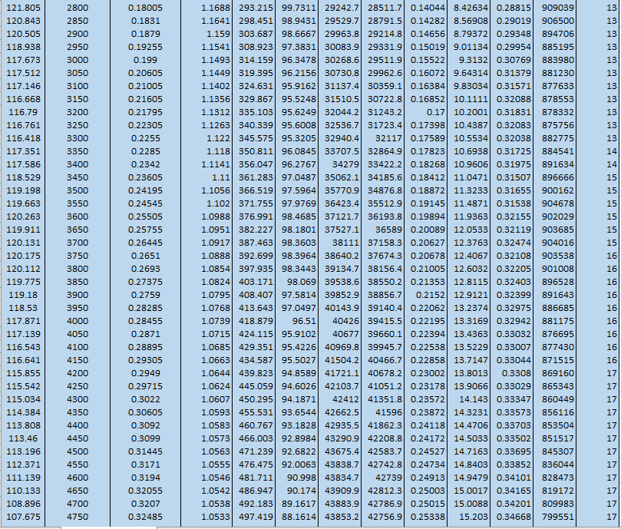
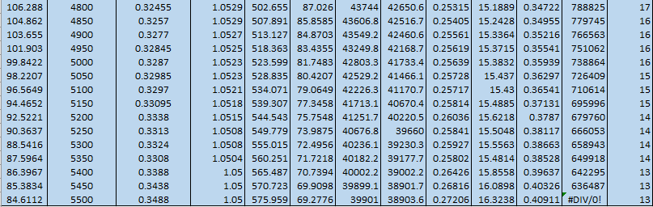

Bibliography

aboutmech.com. (2019). brake power of an ic engine. Available: http://www.aboutmech.com/2016/01/brake-power-of-ic-engine.html. Last accessed 17/12/2019.
autospeed.com. (2008). brake specific fuel consumption. Available: http://www.autospeed.com/cms/title_Brake-Specific-Fuel-Consumption/A_112611/article.html. Last accessed 4/1/2020.
dynomitedynamometer. (2000). corrected horsepower. Available: https://www.dynomitedynamometer.com/dyno-tech-talk/corrected-horsepower.htm. Last accessed 17/12/2019.
epi-eng.com. (2019). brake mean effective pressure. Available: http://www.epi-eng.com/piston_engine_technology/bmep_performance_yardstick.htm. Last accessed 11/12/2019.
khanacademy. (2019). torque and momentum. Available: https://www.khanacademy.org/science/physics/torque-angular-momentum/torque-tutorial/a/torque. Last accessed 15/12/2019.
setra.com. (2019). dynamomemeter testing. Available: https://www.setra.com/blog/test-and-measurement-dynamometer. Last accessed 15/12/2019.
x-engineer. (2019). power vs torque. Available: https://x-engineer.org/automotive-engineering/internal-combustion-engines/performance/power-vs-torque/. Last accessed 15/12/2019.
s j zammit (1987). motor vehicle engineering science. Harlow, United Kingdom: longman publishing.

