Can the variations in weather affect the real time noise results against modelled predictions?

Scott Ling

Ordinance, Munitions and Explosives Major Project Report.

Release Conditions
This document has been prepared for MOD and, unless indicated, may be used and circulated in accordance with the conditions of the Order under which it was supplied.
It may not be used or copied for any non-Governmental or commercial purpose without the written agreement of Dstl.

© Crown Copyright 2022
Defence Science and Technology Laboratory UK
Approval for wider use or release must be sought from:
Intellectual Property Department
Defence Science and Technology Laboratory
Porton Down, Salisbury, Wiltshire SP4 0JQ

This information is released for Defence purposes and whilst it does not attract a national Security Protective Marking, elements of the information may be of a sensitive nature and therefore the information is to be:
- Handled, used and transmitted with care.
- Basic precautions against accidental compromise, opportunist or deliberate attack are to be taken.
- Disposed of sensibly by destroying in a manner to make reconstruction unlikely.

Abstract
A series of bare cased firing experiments were conducted to obtain real-time data to compare against modelled acoustic data. Two charge heights were chosen by the author and used alongside a set amount of plastic explosive to be able to gain the data to carry out comparison work. The charge methods utilised during this experiment were; 0.5 kilograms, 1 kilograms and 2 kilograms. Acoustic sensors were deployed on the outer limit of the modelled noise forecast to obtain the real time decibels during the firings. Twenty four firings were conducted in total with the plastic explosive PE8 and using RP83 detonators.
The decibel readings as a result of these firings was used to compare against the predicted data. Existing work of this kind had never taken place prior to this experiment so there is no legacy data to run a more in-depth comparison with. The reliability of the acoustic modelling method could be further improved in future work by predicting the noise for buried charges and using the Meteorological data from the trials site location.
By carrying out these firings it is hoped to be able to achieve a better understanding of how the noise modelling works compared to real-time noise as well as the reliability of the modelling software against the meteorological conditions at the trial site.

Contents
Release Conditions 2
Abstract 2
Contents 2
1.Introduction 2
2.Background Research 2
3.Understanding how sound works. 2
4.Sound Waves 2
5.Wavelengths 2
6.Relationship between pressure and displacement 2
7.Modelling 2
8.Method for stemming 2
9.Personal protective equipment 2
10.Equipment and Material 2
11.Work description 2
12.Acoustic Noise sensors 2
13.LEQ 2
14.Lmax 2
15.Lmin 2
16.SEL 2
17.Peak 2
18.Paper work 2
19.Trials plan Amendments 2
20.List of Equipment 2
21.Trials Plan 2
22.Firing Order 2
23.Firing procedure 2
24.Misfires 2
25.Data 2
26.Local Met Data VS Larkhill Met Data 2
Met data for the 18-07-2022 2
Met Data for the 19-07-2022 2
Met Data for the 20-07-2022 2
27.Noise data results 2
20/07/2022 2
28.Analysis 2
29.Discussion 2
Failed sensor 2
Increase data set 2
Temperature 2
Improvements to instrumentation 2
Trials design improvements 2
31.Self-reflection 2
32.Bibliography 2
33.Abbreviations 2
34.Appendix 2
Heat Illness checklist 2

Introduction
The author of this dissertation had visions of carrying out this experiment to obtain data and understanding on how meteorological data is used to produce acoustic noise forecasting’s for the area and the location that the author works in on a day to day basis in the explosive industry. The experiment was carried out at trial site on the week commencing the 18th July 2022 during an unusually hot period of weather.
The aim of this project is to compare recorded results from sensors placed at various points around the range boundary with the predictions from the Met office. The current predictions are calculated at 2 metres above ground level, however a large proportion of the firings carried out on the range during trials are at a height of up to 1 metre above ground, ground level or buried.
The current Monet formula is unable to process predictions for buried charges so there will be no Modelled data to run a comparison against for the data obtained from the sensors placed around the Range.
Met office weather forecast will be obtained for the firing days this will enable a comparison of data to be carried out to see if there is any variables due to the weather conditions.

Background Research
Representations from area surroundings place of work and the occasional complaints from members of the public who inhabit the surrounding area of the author’s place of work have highlighted concerns over noise. For this reason it has been decided that explosive firings at the authors place of work will be restricted if there is an adverse risk that there will annoyance of the risk of structural damage caused. [1]
Experience within acoustic blast testing has indicated that the noise complaints were unlikely to occur if the impulsive noise level was below the rate of 120dB. The Meteorological office based at The Royal School of Artillery in Larkhill have developed and use a computer modelling software to model and predict the probable blast noise levels at various distances using a standard explosive source. [1]
Based on this experience and modified by local operating conditions the authors place of work use the noise prediction policy has been formulated. By using data supplied by the Meteorological Office at Larkhill no local built-up area will be subjected to an impulsive noise level of more than 129 dB from a single explosion on any of the authors working trial sites. This is further restricted in that where the predicted blast noise level is of the order of 125 dB or more repeated firings will be curtailed to one every 20 minutes. [1] [2]
The current blast noise prediction model used by the Larkhill Meteorological Office is based on radio-sonde ascents made at Larkhill at various times through the day. The sonde data is processed by computer and used to plot a series of isopleths of noise levels related to a standard source of 2.4 kg of PE8 explosive at a scale of 1:10 000. Copies of this diagram are then forwarded on to the author’s place of work and are available at 0800, 1000, 1200 and 1400 hours each day with each prediction being valid for the two hour period following the given times. [1] [3]
No noise limits have been set for buildings within the Establishment. If the forecasts suggest that excessive noise levels might be experienced (between 120 and 129 dB) at points within the HQ Building, and other areas of the authors work place, the trial site control building will ensure the electronic notice board at the main entrance to the Porton site displays Range activity.
The temperature and humidity can affect sound measurements. With a fixed temperature a decrease of in humidity could reduce the sound to a listener. Temperature and humidity affect although humidity changes slowly, this is a factor that affects measurement repeatability.
The sound is given off from an explosion will travel in all directions from the point of detonation. The further the blast travels away from the point of detonation it will become slower and the energy that is produced will also reduce this will then transfer to an acoustic wave. The blast wave is followed by a negative pressure wave once this has the past the final reaction from a detonation is a blast wind.
Carrying out explosive work within a confined environment a reflection from the confined area this will cause the blast wave to bounce back from the surfaces it comes into contact with.
During an explosion a chemical reaction takes place and generates high pressure outputs and hot gasses. The pressure difference between the gasses produces a shockwave, which in turn moves outwards from the source. The shock wave will consist of of an immediate increase in pressure, which will rapidly decrease. When the peak pressure increases during the reaction the speed of the shockwave will also increase.
When enough energy is transferred to a material it can cause an explosion which will then produce a large amount of energy and high volumes of gaseous products within a small time window. The energy of an explosive sound source is dominated by low frequencies especially at distances away from the source.

Understanding how sound works.
Acoustic attenuation is split down into four categories these are as follows:
- Sound attenuation
- Audio attenuation
- Wave attenuation
- Noise attenuation
The definition of attenuation is where there is a loss or reduction in the intensity of energy. To be able to understand how attenuation works an understanding of how soundwaves work is needed. [4] [5]

Sound Waves
Sound is known as a wave phenomenon, a sound wave has a longitudinal property where the molecules are displaced for a period of time and then returned to their original state. Objects that are vibrating will also produce a sound. The molecules within the object when vibrating in a back-and-forth motion will produce a given frequency.
A frequency of a wave is calculated and measured by how many complete oscillations are carried out during the back-and-forth vibrations this I measured per seconds. The unit that is used to describe this is expressed as Hertz. A hertz measures the frequency of the given cycle that has occurred. [6]

Wavelengths
A wavelength of a sound wave is described as the distance the sound travels within a cycle. The wave will repeat its patterns once in every cycle so a wavelength can also be referred to as the length it takes for the pattern to repeat. The speed of sound is referred as to how fast noise is passed between the molecules.
When measuring soundwaves these are recorded in Decibels, Sabin or Hertz. When looking or referring to attenuation any data taken from this is recorded in decibels. When there is a high amount of energy transferred through a section of the object per second this is referred to as the intensity of the sound wave. [7]
The higher the vibrations, the bigger the rate at which the energy is transferred through the object, when this occurs this will produce a higher intensity sound wave. The following unit ${Watts/Meter}^{2}$ is used to express the intensity of sound
A logarithmic scale will be used to measure sound intensity which is the decibel scale, this classifies a range for sound from 0-194dB. The intensity within sound will dissipate over time and distance, meaning the further away from the initial noise you the lower the sound reading will be. [8]
When the sound travels from its original source it will increase through the area. A sound wave that is a distance from a smaller source placed on a hard surface with no interference from surrounding objects will disperse in a hemispherical pattern. Once the source of the sound is suspended in the air it will disperse in a spherical pattern. During both these case the area is related to the square of the distance. [7]
The formula for hemisphere is as follows:
$$A=2πr^{2}$$
The formula for a sphere is as follows:
$$A=4πr^{2}$$
When using these formulas the area will quadruple with every doubling distance and this will result in an increase of a factor of 100 if the distance is increased by a factor of 10. [8]
Acoustically this will mean the sound level under these conditions will lower at a rate of 6db for every double distance from the source of the noise.
When using the decibel it can be and is defined as a unit of level power-like quantity during the tenth root of the logarithm. The decibel is the unit of level within the field of quantity when the bas of the logarithm is the 20th root of ten.

Below is the table explaining the logarithmic calculations for vibration levels a sound levels and their sub categories of acceleration and velocity for vibration and particle velocity and pressure for sound levels. [9]

 | Vibration Levels |  | Sound Levels
 | Acceleration : La | Velocity : Lv | Particle Velocity : Lv | Pressure : Lp
dB | ms⁻² | ms⁻¹ | ms⁻¹ | Pa, Nm⁻²
0 dB | 1 x 10⁻⁵ | 1 x 10⁻⁹ | 5 x 10⁻⁸ | 2 x 10⁻⁵
20 dB | 1 x 10⁻⁴ | 1 x 10⁻⁸ | 5 x 10⁻⁷ | 2 x 10⁻⁴
40 dB | 1 x 10⁻³ | 1 x 10⁻⁷ | 5 x 10⁻⁶ | 2 x 10⁻³
60 dB | 1 x 10⁻² | 1 x 10⁻⁶ | 5 x 10⁻⁵ | 2 x 10⁻²
80 dB | 0.1 | 1 x 10⁻⁵ | 5 x 10⁻⁴ | 0.2
100 dB | 1.0 | 1 x 10⁻⁴ | 5 x 10⁻³ | 2.0
Figure 1 Decibel reference level Table

The above table shows that 0dB is the baseline reference for each of the given parameters. The parameters given use the log of 20 formula for the given sound pressure levels.

The parameters that are given below use the log of 10 formula for the sound power levels.

Sound | Power Level, LW | Sound Intensity | Sound Energy Density
dB | Watts | Watts/m² | Joules/m³
0 dB | 1 x 10⁻¹² | 1 x 10⁻¹² | 1 x 10⁻¹²
20 dB | 1 x 10⁻¹⁰ | 1 x 10⁻¹⁰ | 1 x 10⁻¹⁰
40 dB | 1 x 10⁻⁸ | 1 x 10⁻⁸ | 1 x 10⁻⁸
Figure 2 Sound Exposure Table
Sound exposure (E) is the value of ${Sound pressure}^{2}$ measured during the stated period for the noise or timed event. The measurements are usually A-weighted this is in relation to a humans response.
Sound exposure is defined in the SI unit as ${Pa}^{2}s$ this is described as (Pascal-squared second). When using occupational noise exposure meter or otherwise known as noise dose meters record using the SI unit of ${Pa}^{2}h$ this is described as (Pascal-squared hour) and these record the noise levels throughout the working day.

Relationship between pressure and displacement
To be able to understand the relationship of pressure and displacement in an acoustic wave an instantaneous acoustic pressure will not generate a particle displacement. There is a delay during this process as the pressure will accelerate the particles until there are no particles left, this is where the max particulate velocity is found but displacement will carry on.

For sinusoidal displacement the figures have been acquired from the fluid of dynamics law. Fluid dynamics can be applied to equations as long as there is a minimum pressure in comparison to the ambient air pressure as well as the particle speed remaining below the speed of sound.

Particle displacement is linked to the speed and time using a frequency. Fluid dynamics has the equivalent pressure as of that as the speed of flow. Only by expanding the resting pressure for the current speed the actual pressure with remain as constant.

During maximum pressure there will be no particle speed and the same will be for particle displacement, this will also be the maximum of particle displacement. The displacement of this will be in phase with the pressure. [10]

Modelling
To carry out a noise forecast prediction atmospheric conditions are taken from by the release of a weather balloon at Larkhill meteorological office. During this flight the data is sent back to a system in which gives the information required to be inputted into the Monet noise software to provide an acoustic noise plot. Having received these noise plots the author or the authors colleagues will then be able to determine as to whether the size of charge can be fired by the TCO or whether the TCO will need to wait for the next two hour window.
The noise modelling will provide an acoustic map showing this will provide an image of the boundary which is the black line in the below image. The noise forecast is marked as a red circle if that is within the marked boundary line then the charge can be fired.
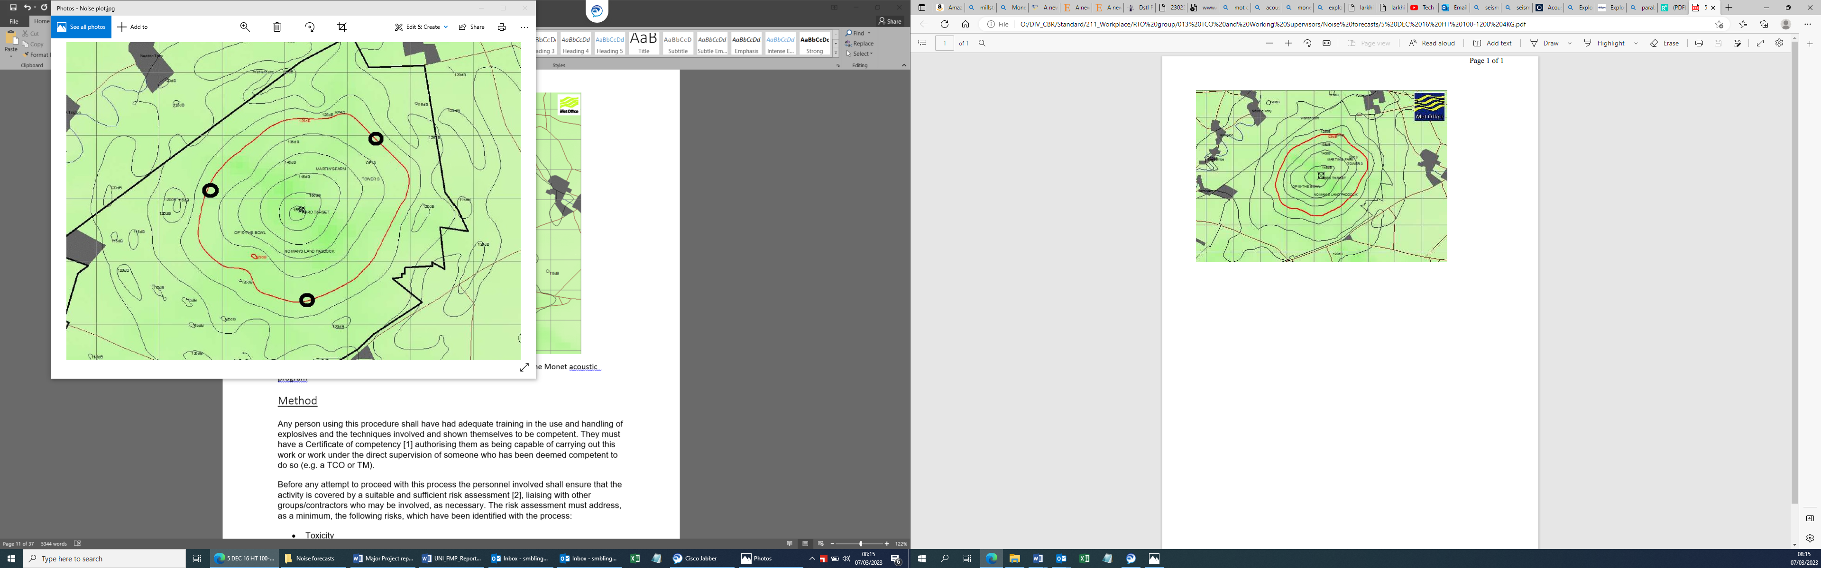
Figure 3 Modelled noise Forecast within the Boundary
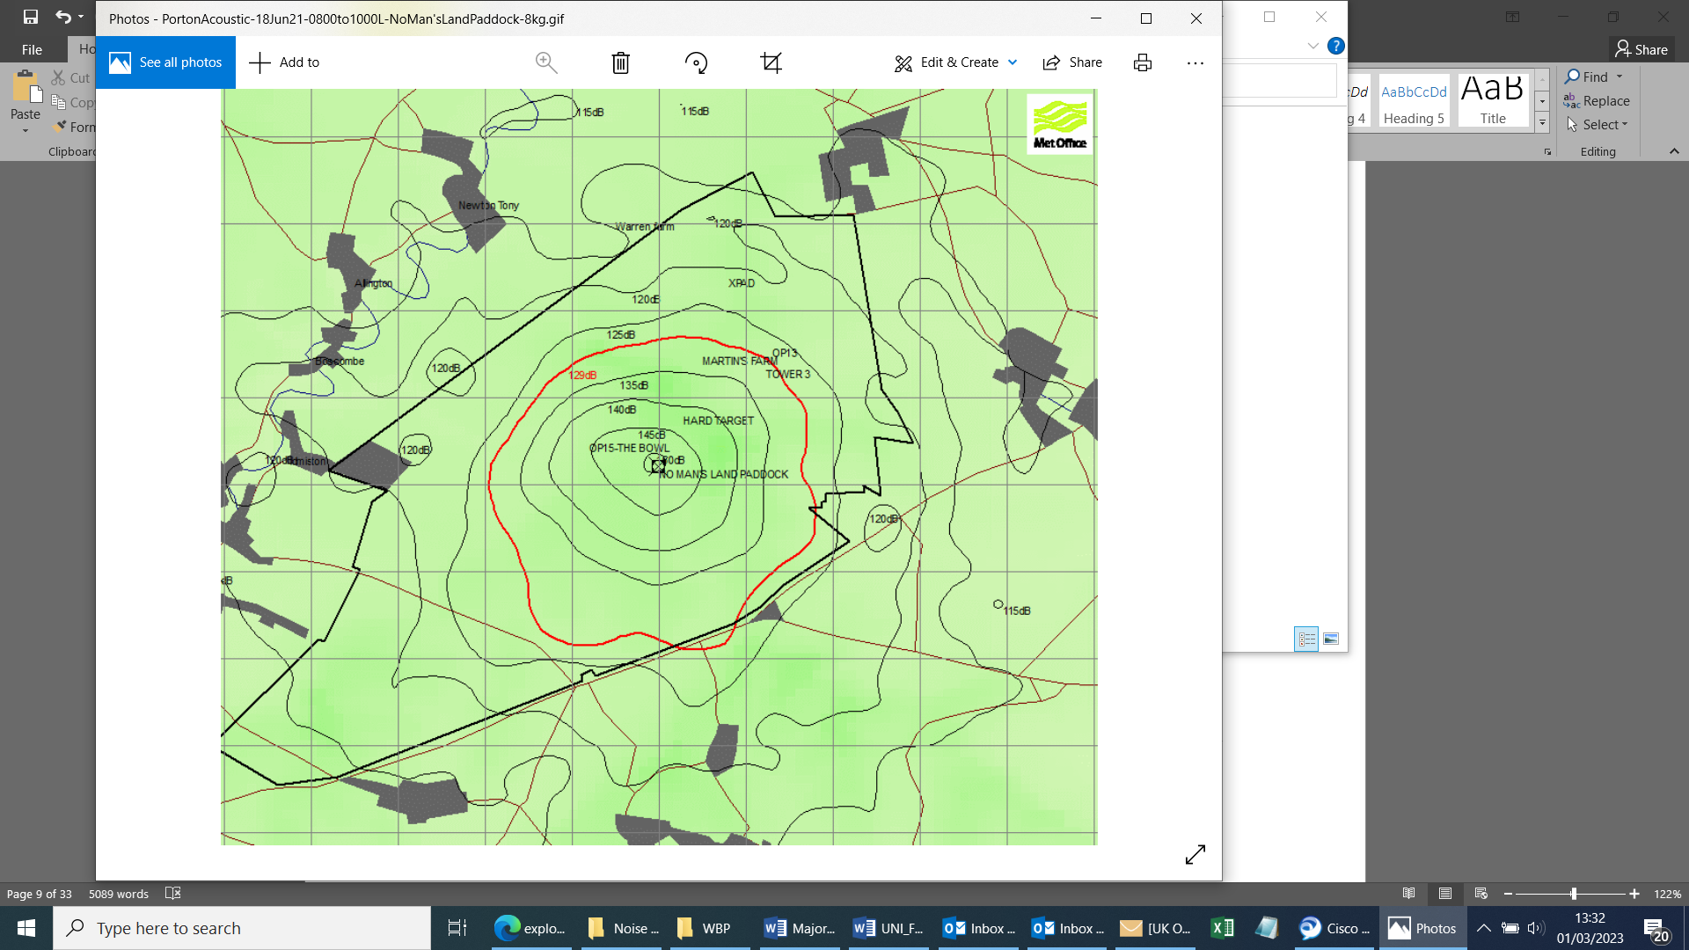
Figure 4 Modelled noise Forecast outside of the boundary
These modelling plots are obtained by inputting meteorological data into the Monet acoustic program. [11]

Method for stemming
Any person or persons carrying out the stemming procedure shall have had adequate training in the use and handling of explosives and the techniques involved and shown themselves to be competent. They must have a Certificate of competency [1] authorising them as being capable of carrying out this work or work under the direct supervision of someone who has been deemed competent to do so (e.g. a TCO or TM).
Before any attempt to proceed with this process the personnel involved shall ensure that the activity is covered by a suitable and sufficient risk assessment [2], liaising with other groups/contractors who may be involved, as necessary. The risk assessment must address, as a minimum, the following risks, which have been identified with the process:
- Toxicity
- Handling
- Compatibility.
Any relevant requirements as listed on the Management System under working with explosives must be met.

Personal protective equipment
All personnel shall be provided with PPE that is relevant to the specific tasks that will be carried out as stated in the risk assessment. The PPE required to carry out the charge preparation task is the use of nitrile gloves this is due to the PE8 having carcinogenic properties and when handling without the correct PPE could transfer into the skin of the handler.

Equipment and Material
Tools that may be required to assist when carrying out the stemming procedure:
- Stemming stick (Delrin)
- Wet wipe for cleaning down
- Detonator dibber
All materials used above must be non-sparking, compatible with the energetics and also need to have anti-static properties.

Work description
On entering the Trials Conducting Officers preparation area all personnel carrying out the work described below should be wearing the correct PPE as identified in the risk assessment associated to the task. All contraband will be left in the control room the list of contraband is as follows:
- Mobile phones
- Smart watches
- Smoking/vaping equipment
- Matches/lighters
Before starting the charge preparation the TCO will weigh the sticks of PE8 to confirm they are the correct weight for the firing. The charges were then configured by taping the required NEQ amount together
Given that the chosen explosive was PE8 and even though the firings were carried out during a heat wave it was necessary to knead the explosives by hand until it was more malleable prior to carrying out the charge configuration task.
Once the charge had been made a hole was dibbed into the PE8, this allowed the detonator to be pushed into the PE for the appropriate contact. Due to not using any type of manufactured charge casing there was no reason for compatibility testing and there was no storage restrictions associated with the charges, this was covered in the trials plan and risk assessment.
This project was carried out alongside other scheduled trials that had been booked on the author’s place of work. The cover area that was associated with this project restricted all unnecessary access to the locations of the sensors so these could not be interfered with or given false information or false noise readings by vehicles or personnel transiting past their locations. Decibel Meters (Norsonic 116) were used by the author and the following equipment and modelling was required:
- Tripods to mount Decibel readers
- Met office weather data
- Met office Noise model forecast
The data that is collected will be compared with the predicted Met office modelling to see if there are any differences between Modelling and real time data, the Met office weather data will then be analysed and compared with the real time data obtained.
The variables that need to be considered during the project duration, has the potential to have both positive and negative effects. These variable may have effects on the data that is recorded this could be as simple as “the wind blowing in a different direction”.
- Temperature
- Humidity
- Wind
- Surroundings (mitigation if there is a blast structure built around ground zero)
- Overall weather
- Measurement methods (Different brands of decibel readers)
- Charge size
- Locations (open area trials sites/enclosed trials sites)
- Type of Explosive (PE vs C4)

Acoustic Noise sensors
Nor sonic sensors where recommended to the author by an acoustic modelling team, however these were provided by an external company due to the acoustic team not being able to supply these due to current work load. [12]

The specifications for the norsonic Acoustic sensors are as follows:
- Statistics - Ln values - 0.1, 1, 5, 10, 50, 90, 95 and 99 % levels
- Selectable Statistics - free selection of Ln value with 0.1 dB resolution
- Level v time - electronic level recorder - various parameters and extensive period selection
- Parallel Measurements - Fast, Slow and Impulse
- Parallel Measurements - SPL, Leq, Lmax, Lmin, SEL and Peak levels
- Advanced L(t) - A and C weighted parameters, plus markers to highlight events with parallel time constants
- Extended memory - 250,000 values or more than 1,400 measurements
- RS-232 interface - for printer and PC use
- Large graphical display for L(t) and tables of results
- Pause with option to delete previous 10 seconds before continuing
- Detachable preamplifier for use with extension cables
- All meters, and calibrators are delivered with calibration certificates.

Once the author had received the acoustic sensors the calibration certificate was checked to ensure the calibration was in date prior to using. The sensor was delivered with a microphone a preamplifier, batteries and a windshield protector. Also included in the case was the Nor1020 software and cable to be able to convert the data which can be found further into this report. [12]
.
The nor116 sensor carries out a time function analysis. Having the ability to use this functions it means it is able to obtain slow as well as fast impulse measurements. The values that the sensors capture and a description are as follows: [12]

LEQ
The Leq or Equivalent Continuous sound level which receives and process the background noise when the acoustic sensor is being used. [12]
The nor116 sensors allows for fluctuations these fluctuations are stored within the internal memory of the sensor and once all of the measurements are collected it will then calculate the ‘average energy’ or LEQ value. The meter will convert the decibel value to sound pressure levels. Once this is done the sensor will then add the values together and then divide them by the number of samples that have been collected and will then finally convert this data back to decibels. [12]
This is where the Leq or equivalent continuous sound level meter comes in. This meter faithfully follows all the fluctuations, stores them in the machines internal memory and at the end of the measurement calculates an 'average energy' or Leq value. When we say average, this is not a simple arithmetic average because we are measuring in decibels which are logarithmic values. So our meter converts the dB values to sound pressure levels, adds them all up then divides by the number of samples and finally converts this equivalent level back to decibels. [12]
A high specification Leq sound level meter samples and will capture the noise levels at a rate of 16 samples a second.
Using this information this means the sensors that are used will collect 57600 samples in an hour. The calculations for this are as follows.
$$16x60x60=57600$$

Lmax
The Lmax is the maximum sound level, during the period of measurement and noise event. [12]

Lmin
The Lmin is the opposite of the Lmax and is the minimum sound level acquired during the period of measurement and sound event SEL. [12]

SEL
Sound exposure limit or (SEL) is the number equivalent of the total sound energy. For example a noise level of 70 dba lasting 1 second would have a SEL of 70 dba, however if the event lasted for 2 seconds this would then have a SEL of 73 dba. [12]

Peak
For a true peak value to be measured the acoustic receiver will need to be equipped with a peak detector, for the data to be obtained and analysed this would need to respond in less than 100µs (100 microseconds). However the response time for a class one meter is only 40µs (40 microseconds). [12]

Paper work
During the planning and organisation of the experiment the author was involved in the writing and reviewing of both the trials plan and risk assessment paper work, specifically the instrumentation for data retrieval as well as the arena section regarding the set-up and safe systems of work and the techniques and disciplines that will be used to conduct this experiment.
The author engaged with the trials manager who was requested by the author this is due to the author’s company’s policy and procedural requirements to have a trials manager associated to the trial.
Once the Author and the trials manager had established an authorised the correct safe systems of work a full review was carried out including members of the health and safety committee to achieve final sign off.
Once this sign off had occurred the paperwork was then submitted to the Trials conducting officer to formulate a Trials permit and submitted to the Authors management chain for approval and sign off. This is required prior to any task associated with the authors experiment can be carried out.

Trials plan Amendments

Additional information for control measure for hot weather conditions:
- A heat illness checklist has been completed and the work rate has been scored as a - Low rate task with occasional Medium activities. A WBGT will be used to monitor the temperatures if they are close to the Index upper limit as detailed in the company’s heat illness guidance document.

- Plenty of water will be available on site and regular breaks will be taken in the shade during hot spells

- Only high voltage firing packs to be used, low voltage will not be present.

- Fire risk due to hot weather- due to the increased temperatures on range the risk of fire is higher than normal. Mitigation on this within this trial is that the firings will be bare charge so no hot fragment risk, firings will be carried out in the middle of hard target and there will be a water bowser present on site during firings.

List of Equipment
Instrumentation
- Nor 116 Precision sound Analyser- Class 1
- Delboy Laptop
- Reynolds high Voltage firing pack
Energetics
- Plastic Explosives (PE8)
- RP83 High Voltage detonators
Consumables
- Wooden Hangman
- Tape
- String
- Sandbags
- Infrastructure
- Trials site
- Firing point
Software
- Nor data recording conversion software

Trials Plan
For this experiment the author composed a trials plan which explains the aims that the author wanted to achieve as well as all relevant safety information and a chain of command that highlighted the personnel on the experiment and what their roles would be.
A risk assessment was also authored that included all the hazardous associated with the task as well as any slips, trips and falls related risks all the way through to the hazards surrounding energetic materials. The trial was conducted on a Trial site where the author works and has previously carried out energetic work, which in the past has had meteorological data and negative noise forecasts effect and impact previous work.
The trial site that was used for this experiment is an open area concrete pad which allows the acoustic effects from a blast to travel towards the acoustic sensors without the interference of objects buildings and other landscape restrictions. During the firings the charge was located in the centre of the pad away from the over shadow off the control and allow for the prevailing air flow that is natural to this site carry the acoustic waves during the firings.
The experiment that the author carried out had two types of charge testing configuration, the first configuration was were the PE8 was placed horizontally at ground level on the pad with a sand bag protecting the pad this replicated firings that had been carried out in the past at ground level.
The second configuration was at the height of 600mm above the ground hung from a wooden hangman with the PE8 strung horizontally in a cradle formation this is due to firings being carried out a minimum of 600mm high so this replicated firings that would be carried out using pendine blocks underneath charge stands.
For the 600mm high charge configuration a wooden hangman was used due to the cost of pendine blocks it wasn’t a viable option to use these during the authors experiment. The wooden hangman were surplus to a previous package of work so these were readily available to the author.

Firing Order
Charge size | Charge Height
500 grams | Ground Level
500 grams | Ground Level
500 grams | Ground Level
500 grams | 600 mm above ground
500 grams | 600 mm above ground
500 grams | 600 mm above ground

Charge size | Charge Height
1 kilograms | Ground Level
1 kilograms | Ground Level
1 kilograms | Ground Level
1 kilograms | 600 mm above ground
1 kilograms | 600 mm above ground
1 kilograms | 600 mm above ground

Charge size | Charge Height
2 kilograms | Ground Level
2 kilograms | Ground Level
2 kilograms | Ground Level
2 kilograms | 600 mm above ground
2 kilograms | 600 mm above ground
2 kilograms | 600 mm above ground

Firing procedure
Below is the following firing procedure that will be carried out and executed during the activities of this experiment.
During firings, all personnel will be under hard cover in the Hard Target control room, having followed the firing procedure below:
- The Technical Lead/TM will ensure all data recorders are set up and working correctly.
- The assembled charge will be brought out for placement by the TCO.
- The Technical Lead or TM will go under cover after taking an image of the charge placement.
- When all staff are under cover, the safety link will inform the TCO via radio link.
- The TCO will place the detonator in the bare charge and take the final image of the charge prior to returning to the control room.
- The TCO will initiate the charge from the firing point in the control room.
- One charge has been initiated, the TCO will inform range control of the time of firing and charge size.
- The TCO will then clear the test area, allowing all staff to re-enter the area.

Misfires
In the event of a mis-fire during the firing the following procedure will be adhered to in line with the company’s policy.
- TCO will have direct control over the handling of any misfires.
- In the event of a misfire, at the discretion of the TCO, a second attempt may be made to initiate the device. If this fails, the TCO will inform range control that a misfire has occurred and ensure that all personnel remain under cover for 30 minutes.
- If still stable after 30 minutes the TCO will advance and check energetic materials and firing area.
- TCO will give the all clear only when they are satisfied that the misfire is stable and no further reaction is likely. TCO will then remove misfired item before allowing Trials staff to enter the firing area.
- The trials team and any visitors must obey all instructions and will only break cover once the all clear has been given by the TCO.

Data

Twenty four tests were carried out during the experiment, the tests were named shots for the purposes of working procedure and internal paperwork.
Date | Shot Number | Charge Size | Charge Height | Firing Time
18-07-2022 | Shot 1 | 500 grams | Ground | 10:53
18-07-2022 | Shot 2 | 500 grams | Ground | 11:07
18-07-2022 | Shot 3 | 500 grams | Ground | 11:16
18-07-2022 | Shot 4 | 500 grams | 600mm Above Ground | 11:30
18-07-2022 | Shot 5 | 500 grams | 600mm Above Ground | 11:44
18-07-2022 | Shot 6 | 500 grams | 600mm Above Ground | 11:57

Date | Shot Number | Charge Size | Charge Height | Firing Time
19-07-2022 | Shot 7 | 1 kilogram | Ground | 10:21
19-07-2022 | Shot 8 | 1 kilogram | Ground | 10:37
19-07-2022 | Shot 9 | 1 kilogram | Ground | 11:04
19-07-2022 | Shot 10 | 1 kilogram | 600mm Above Ground | 11:31
19-07-2022 | Shot 11 | 1 kilogram | 600mm Above Ground | 11:48
19-07-2022 | Shot 12 | 1 kilogram | 600mm Above Ground | 11:58

Date | Shot Number | Charge Size | Charge Height | Firing Time
20-07-2022 | Shot 13 | 500 grams | Ground | 12:17
20-07-2022 | Shot 14 | 500 grams | Ground | 12:26
20-07-2022 | Shot 15 | 500 grams | Ground | 12:37
20-07-2022 | Shot 16 | 500 grams | 600mm Above Ground | 12:48
20-07-2022 | Shot 17 | 500 grams | 600mm Above Ground | 13:00
20-07-2022 | Shot 18 | 500 grams | 600mm Above Ground | 13:14

Date | Shot Number | Charge size | Charge Height | Firing Time
20-07-2022 | Shot 19 | 2 kilogram | Ground | 14:33
20-07-2022 | Shot 20 | 2 kilogram | Ground | 14:43
20-07-2022 | Shot 21 | 2 kilogram | Ground | 14:53
20-07-2022 | Shot 22 | 2 kilogram | 600mm Above Ground | 15:08
20-07-2022 | Shot 23 | 2 kilogram | 600mm Above Ground | 15:21
20-07-2022 | Shot 24 | 2 kilogram | 600mm Above Ground | 15:34

Local Met Data VS Larkhill Met Data
In this section the Meteorological data that was obtained during the trial will be displayed to enable a visual understanding of the difference in data between the two sites to support and back-up that the Met data used from Larkhill to gain the noise forecasts for this trial site isn’t sufficient for the use by the end user. [2]
Located on the trial site is a met station called Davis met station this is used to give a local measurement of the met conditions it offers data for the following:
- Temperature
- Humidity
- Pressure
- Wind speed
The data samples were taken from the digital display prior to the firings being carried. [13]
Larkhill’s met data for the times of the firings have been included this allows the opportunity to see the difference between where the noise forecasts are predicted vs the area that the firings are being carried out in. These results will be analysed in the discussion section of this report.
The following data tables are for the firing days consisting of the 18th, 19th , and 20th of July and the each table is broken down into Larkhill’s Met data and the Met data taken from the trials site met station. [2] [13]

Met data for the 18-07-2022
Meteorological data | Davis Met station
Temperature | 27 °C
humidity | 45%
Pressure | 1002.0mbar
Wind speed | 11kmh⁻¹ South East

Meteorological data | Larkhill data
Temperature | 28 °C
Humidity | 45%
Pressure | 1020 mbar
Wind speed | 3.70 kmh⁻¹ South

Met Data for the 19-07-2022
Meteorological data | Davis Met station
Temperature | 28°C
Humidity | 32%
Pressure | 996.2mbar
Wind speed | 5 kmh⁻¹ South

Meteorological data | Larkhill Met data
Temperature | 33 °C
Humidity | 36%
Pressure | 1012mbar
Wind speed | 7 kmh⁻¹ South East

Met Data for the 20-07-2022
Meteorological data | Davis Met station
Temperature | 20 °C
Humidity | 83%
Pressure | 998.3mbar
Wind speed | 14 kmh⁻¹ South
Meteorological data | Larkhill Met data
Temperature | 18 °C
Humidity | 85%
Pressure | 1012mbar
Wind speed | 4.98 kmh⁻¹ West North West

Noise data results
The results were plotted in Microsoft Excel using the scatter graph function and a linear line of best fit, the resulting graphs can be seen
LOCATION ONE
19/07/2022
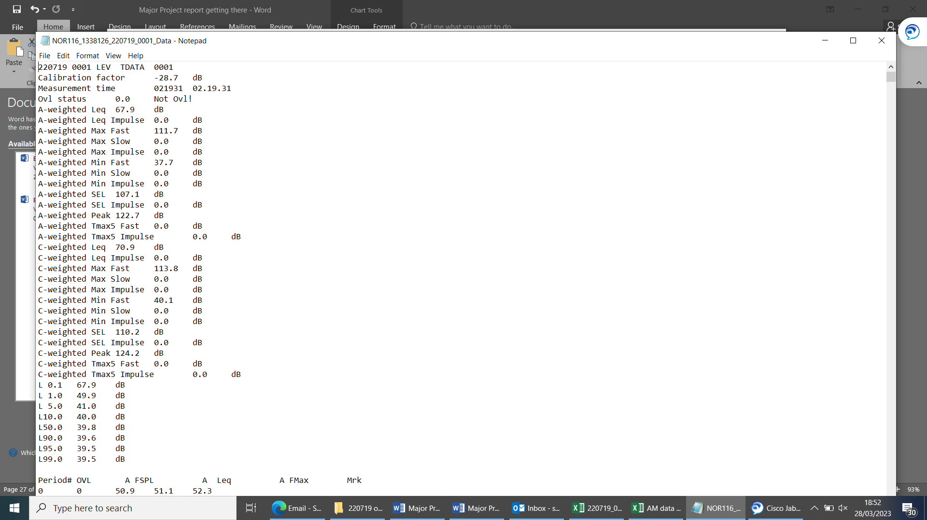
Figure 5-Location one sensor read out

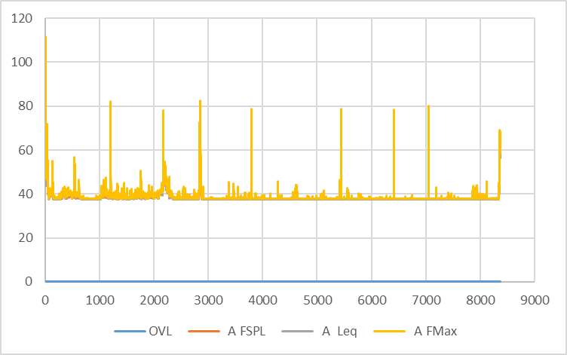
Figure 6- Overall graph

Figure 7- Breakdown of shots

Figure 8-Breakdown of shot

Figure 9-Break down of shot

Figure 10-Breakdown of shots

Figure 11-Breakdown of shot

20/07/2022
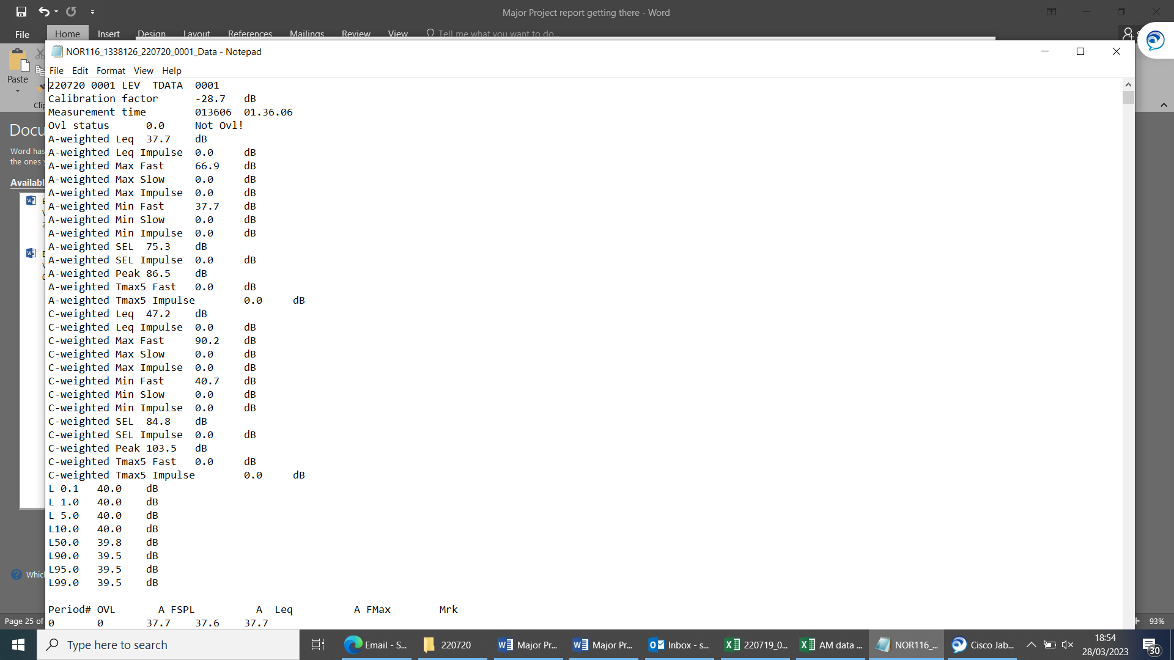
Figure 12- Main results
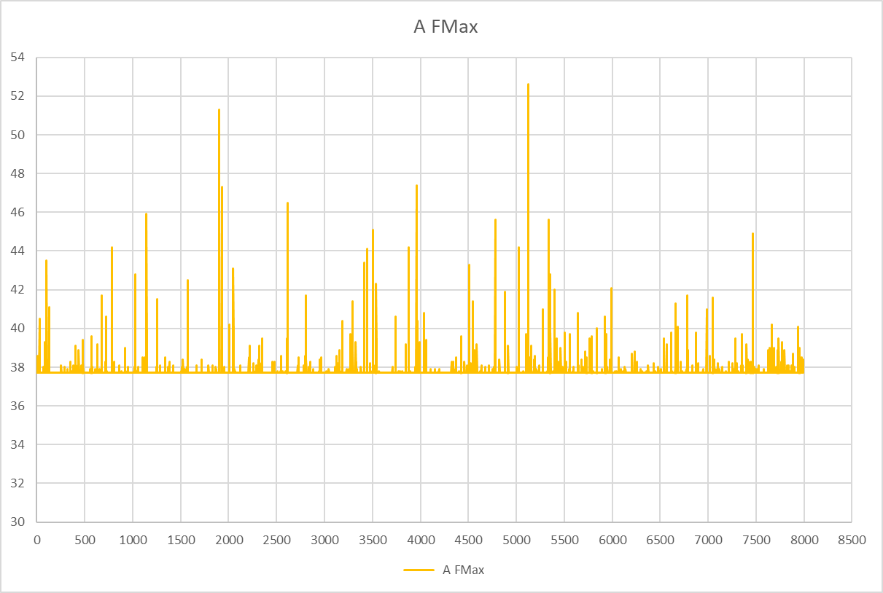
Figure 13-Main results graphed

Figure 14- Breakdown of shots

Figure 15-breakdown of shots

Figure 16- Breakdown of shots

Figure 17-breakdown of shots

Figure 18- Breakdown of shots

Location 2
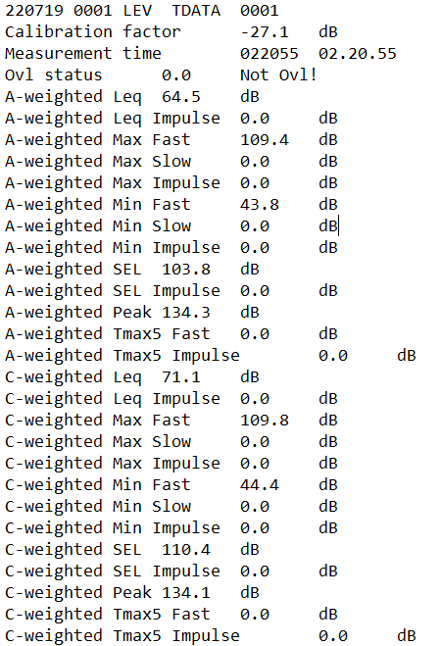
Figure 19-Location 2 main overview

Figure 20-Location 2 all shots over view

20/07/2023

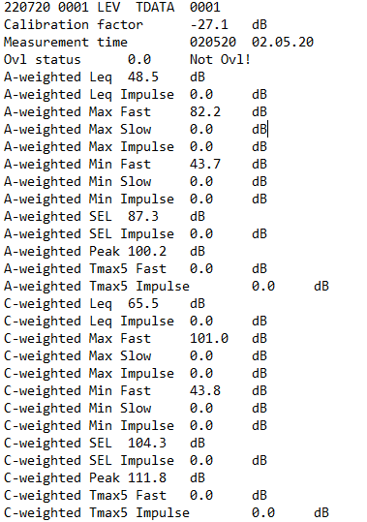
Figure 21-Main overview of sensor

Figure 22-graphed shots
Location 3
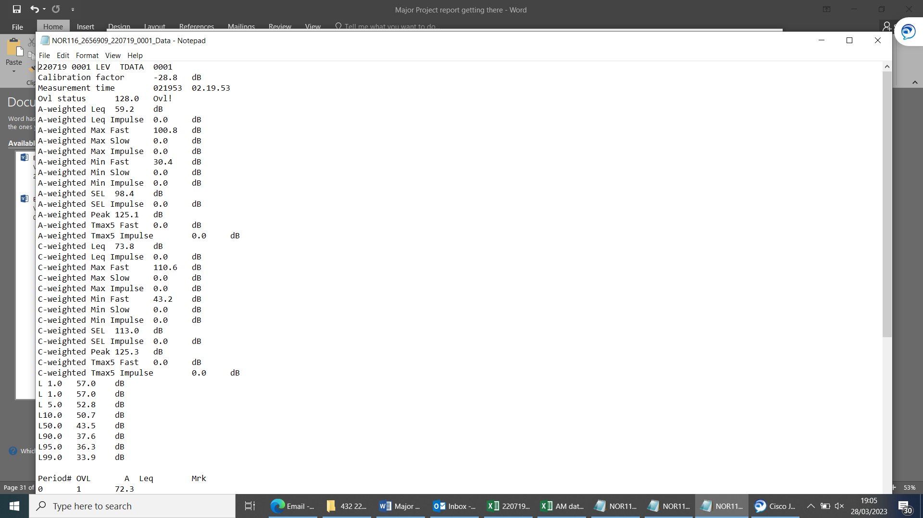

20/07/2022
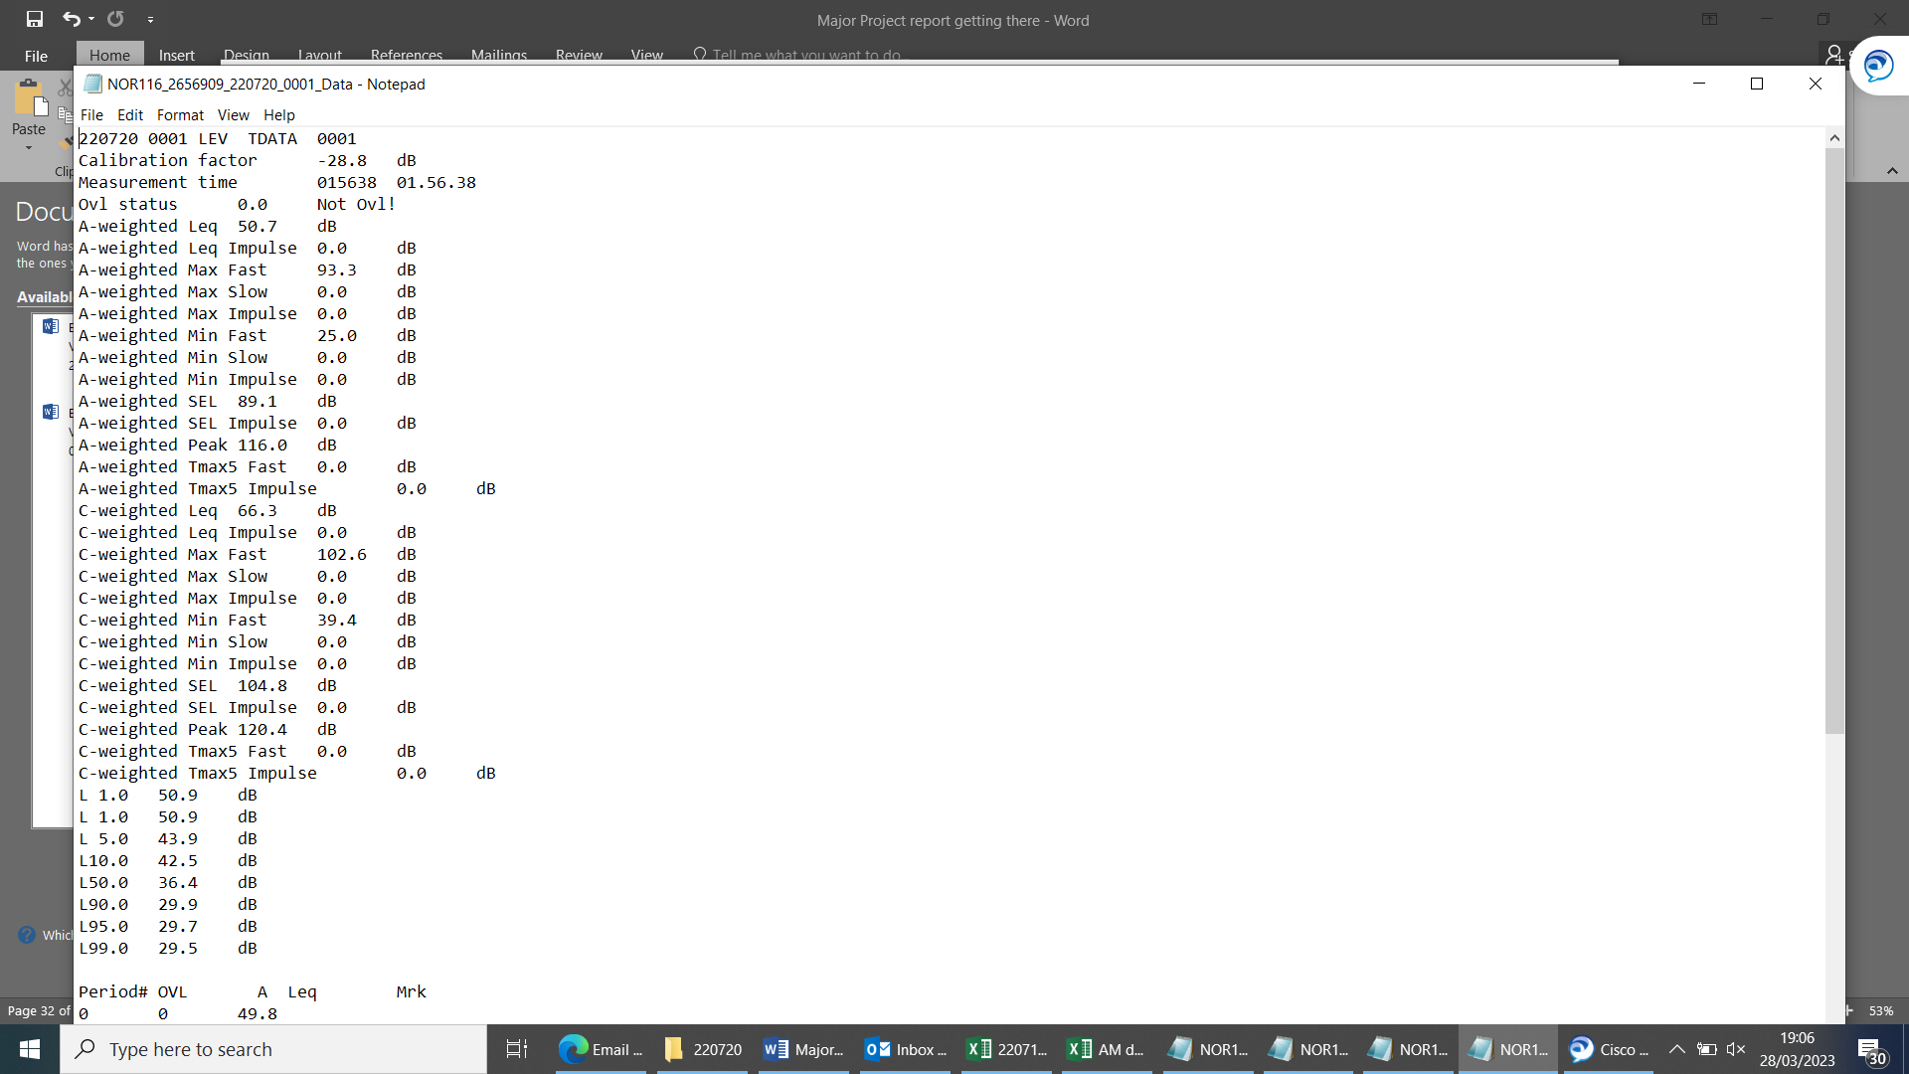

Analysis

From the data that has been received during this experiment it has given further thought of more investigation as to whether the modelled forecast using the meteorological data from the Met office is reliable.
The sensors that were placed at location 1 and location 2 were set-up to take a sample every 60 seconds during the time period that was selected. These time periods and samples have now been broken down into the firing times and graphed above for location one and two.
The sensors were placed on the red boundary line of the noise forecasted model which was forecasted to be 129dB during the firings. The predicted noise was not reflected in the results as the resultant figures that were obtained are considerably lower than that of the maximum predicted sound.
The sensor that was placed in location 2 would have been more likely to have received a higher peak pressure due to the wind direction during the firings.
Due to instrumentation failure the sensor that was positioned at location 3 only collected 26 samples in the two hour firing window. The max peaks that can be seen above in the data lists do not equate to the firing times during this experiment. Therefore this sensor has provided no data that can be analysed.

Discussion

Post the experiment has led to further brainstorming on different ways the experiment could be carried out in the future, by using lessons learned from the experiment the author has come up with additional ideas for the experiment.
These lessons learned are reflected below and broken down into sections with further descriptions on why these could and would improve the experiment.

Failed sensor
Post this experiment it was found that the sensor that was positioned at location three failed during the experiment.
These sensors were deployed on the given boundary and were left during the two hour firing window, this meant that due to the time constraints with the firings this information regarding the failed sensors wasn’t found out till after the experiment had finished.
There are multiple reasons as to why this sensor has failed the main reasoning for this is the sensors wasn’t correctly set-up in the run time to take measurements.

Increase data set
Further testing is required to increase data sets and gain a more reliable set and comparable data. The testing carried out was done so as a primary output to ascertain whether future experiments would be beneficial to support this test. Any further testing should be carried out as a standalone event to allow for more tests specific to the hypothesis to be attained.

Temperature
Tests were carried out on an outdoors range area during a heat wave. On the test days the firings were out in a 2 hour noise window in the morning due to there being restrictions imposed on the range do to the unforeseen high temperatures. This may have had an effect on the acoustic recordings due to the meteorological conditions being abnormal to the conditions normally seen in this country as well as at this trial location.

Improvements to instrumentation
Several improvements to instrumentation and measurement techniques were and have been identified during the post-trial discussions that have been held since the firings were conducted.
Further investigations would need to be carried to determine if the Met data that was collected from the trials site is different to that taken from the site of where the noise forecasts are issued.
It was found during the first set of firings the acoustic sensors were not as described by the company that provided them as they need to be programmed and set up for a continuous runtime. However following this issue it was spotted prior to the next stage of firings so this doesn’t reduce the possibility of lost data on further testing.
During the data analysis stages it was found that the acoustic sensors compressed to the sound that it recorded during the firing event which doesn’t give a true to form result.
Other acoustic sensors to consider using are:
- Resistive microphones
- Fibre-optic microphone
- Piezoelectric microphones
- Electret Microphones
- Solid-state Acoustic Detector

Trials design improvements
It was identified that if future experiments are carried out then an interest should be taken in the use of different explosive material.
It is recommended that future experiments should be conducted at various times of the year to obtain and data that can compared to different meteorological conditions with a wider variety such as:
- Cloudy day
- Wet day
- Windy day
- Variations of temperatures
For a more accurate modelled noise forecast the author would have liked to have inputted the data that was obtained from the trial site however due to time constraints and other work packages the author was working on this was unachievable.
- Conclusion
A work based project was successfully conducted to be able to obtain acoustic noise data during energetic firings. From the data that has been obtained it can be noted that there is a difference between the modelled noise predictions and those that were obtained during real time firings.
With these parameters it is possible to make some direct comparisons with other explosives to predict relative explosive power, gas production and TNT equivalence. Compared to other explosives such as TNT, C4, PE4 and RDX the material PE8 is found to be equivalent to RDX which is PE8’s main component [3].
The trial was conducted during an unusually hot spell which is not a true representation of the trial site that was used. This heat wave would have had an effect on the results obtained due to the atmospherically
PE8 was used during this experiment the author would have liked to achieve a wider data set using the following energetics:
- C4
- Rocket propelled grenades
- Pyrotechnic composites
- PE7
- HME Mixes
However due cost and time constraints this was not achievable this time round. By carrying out more firings this would support and provide evidence that the meteorological data taken from the trial site would need to be communicated to the Met office to give a true representation of the conditions at the trial site rather than the data obtained from the met office location being used.
By doing this it would improve the validity of the acoustic noise plots and the reliability of the acoustic forecasts.
Further research and work should be undertaken using a broader spectrum of acoustic noise sensors to provide a more stable and comparable data set.
The wooden hangman that were used for the firings worked well however due to the energetic properties they were destroyed after every shot which would add additional cost to the experiment, so in future if this work was to be further explored a recommendation to find a more suitable way of holding the above ground charge would need to be found.

Self-reflection
Upon reviewing the data obtained and reflecting on the way the project ran from cradle to grave, the author has time to reflect and come up with suggestions and recommendations that could be used if the work was carried again to be able to achieve a wider and more complex understanding of how acoustic noise modelling works.
Prior to the start of the experiment the author had clear aims and that he wanted to achieve during this project. However once the project had started there were certain aims and ideas that the author would not be able to complete due to circumstances outside of his control which have previously been highlighted in the discussion section of this report.
The project itself during the planning stages met all timed deadlines that the author had set and that all paperwork was authorised in good time prior to the experiment taking place, the delivery of the experiment did slip by a week this was due to the acoustic team within the organisation being unable to provide acoustic sensors which had previously been agreed.
Following on from this the author looked to an outside supplier for the fire of the acoustic sensors which were recommended and once a suitable provider was found there was a five day turn out from hiring to delivery.
The charge configuration was carried out by the Trials conducting officer the author would have liked these charges to have been moulded together to ensure that there was maximum contact between all energetic material during the firings.
The first set of 500 gram shots no data was achieved to the sensors not having the correct configuration which was down to the author not fully understanding the workings of the sensors and a communications issue between the author and the company that was used for hiring.
After the first set of firings the author set and run the sensors to cover the two hour noise window and set the run time to cover any additional issues that may have occurred during this window.
By setting the run time for this period this then meant the author had a considerable amount of data to work through up analysis which has hindered the findings of more reliable data.
The data that the author has obtained during this experiment would require further exploration into this subject due to the sensors compressing the acoustic noise so there isn’t a clear definition between the modelled data and the author’s data.
What can be highlighted from this experiment that there is a clear difference between the met data that is used at Larkhill and the difference of the data that was collected from the trial site prior to the firings being carried out.
Given the author formulated the project proposal as well as the delivering the project whilst executing the required safe systems of work required and formulating the project report this is in the authors eyes a completed development opportunity and a successful ending to nearing the finish of the five year OME degree.

Bibliography

[1] | P Gilbert, “CBR Range Operating Plan,” NA, NA, 2020.
[2] | Met Office, “Met Office weather forecast,” Met Office, na na na. [Online]. Available: https://www.metoffice.gov.uk/weather/forecast/gcnfb360d#?nearestTo=Porton%20(Wiltshire)&date=2022-01-12. [Accessed 11 01 2022].
[3] | Chemring Energetics UK, “PE8 Plastic Explosive,” [Online]. Available: https://www.chemring.com/~/media/Files/C/Chemring-V3/documents/energetics/PE8%20Plastic%20Explosive%20Iss%2013%20Nov%2020.pdf. [Accessed 28 October 2020].
[4] | R. O. N. J. M. Olsen, “A noise assessment and prediction system,” Semantic Scholar, NA NA NA. [Online]. Available: https://www.semanticscholar.org/paper/A-noise-assessment-and-prediction-system-Olsen-Noble/cfb2d63761427314527a97eb62b9212c9f28ea78#citing-papers. [Accessed 02 01 2022].
[5] | MOD Shoeburyness, “Acoustic Forecasting & Noise Monitoring,” Qinetiq, NA NA NA. [Online]. Available: https://www.qinetiq.com/en/shoeburyness/noise-management/acoustic-forecasting-and-noise-monitoring. [Accessed 29 12 2022].
[6] | a. C. F. M. W. S. a. M. B. Peter Gerstoft1, “Introduction to compressive sensing in acoustics,” 29 06 2018. [Online]. Available: https://asa.scitation.org/doi/10.1121/1.5043089. [Accessed 01 01 2023].
[7] | Comnoise, “Noise sources and their measurement,” NA NA NA. [Online]. Available: https://www.who.int/docstore/peh/noise/Comnoise-2.pdf. [Accessed 05 01 2022].
[8] | W. K. Blake, “Theory of sound and its Generation by Flow,” Mechanics of flow induced sound and vibration, vol. 1, no. second edition, 2017.
[9] | J. Kadis, “Acoustics: The study of sound,” CCRMA, 2015. [Online]. Available: https://ccrma.stanford.edu/~jay/subpages/Lectures/Lecture1-Acoustics.pdf. [Accessed 29 12 2022].
[10] | “Relation between pressure and particle displacement in an acoustic wave,” Physics, 15 06 2015. [Online]. Available: https://physics.stackexchange.com/questions/110102/relation-between-pressure-and-particle-displacement-in-an-acoustic-wave. [Accessed 16 12 2022].
[11] | Met Office, “New radar noise level estimator,” NA NA NA. [Online]. Available: https://www.metoffice.gov.uk/research/news/2019/new-radar-noise-level-estimator. [Accessed 13 01 2022].
[12] | Norsonic, “Using the sound level meter Nor-116,” NA NA NA. [Online]. Available: file:///C:/Users/Smbling/Downloads/6673357.pdf. [Accessed 16 12 2022].
[13] | Davis instruments, Davis , 2023. [Online]. Available: https://www.davisinstruments.com/pages/vantage-pro2. [Accessed 15 02 2023].
[14] | C. E. UK, “"PE8 Plastic Explosive,",” [Online]. Available: https://www.chemring.com/~/media/Files/C/Chemring-V3/documents/energetics/PE8%20Plastic%20Explosive%20Iss%2013%20Nov%2020.pdf.. [Accessed 2022 Nov 10].
[15] | A. R. K Kim, “Waveform inversion of acoustic waves for explosion yield estimation,” 27 06 2016. [Online]. Available: https://agupubs.onlinelibrary.wiley.com/doi/full/10.1002/2016GL069624. [Accessed 03 10 2022].
[16] | Study.com, “Standing wave definition,” Study.com, 13 03 2017. [Online]. Available: https://study.com/academy/lesson/standing-wave-definition-equation-theory.html. [Accessed 22 01 2023].

Abbreviations
PE- Plastic Explosives
TCO- Trials Conducting Officer
DB- Decibels
NEQ-Net Explosive Quantity
Kmh⁻¹-Kilometres per Hour
°C- Degrees Centigrade

Appendix

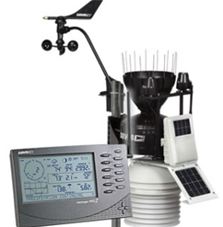
Figure 23 Local met station Stock image
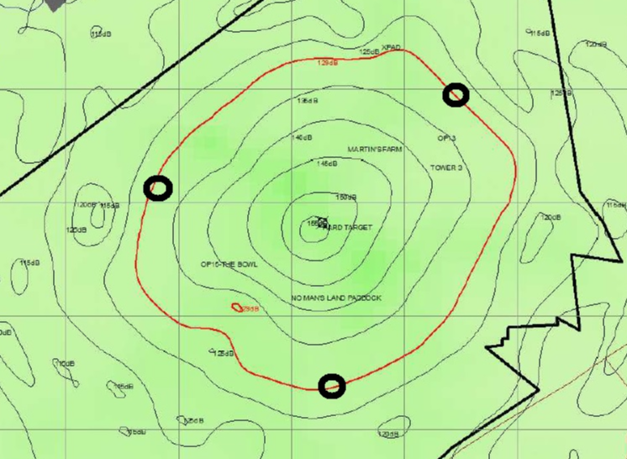
Figure 24 Black circles indicate the location of Acoustic Sensors
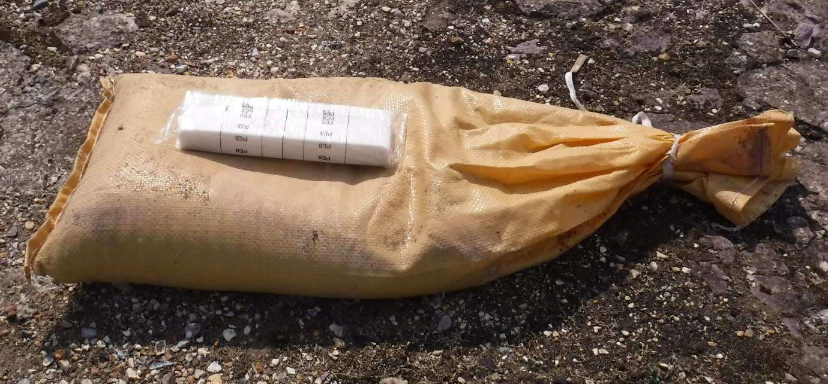
Figure 25 Charge set up for 500g firings
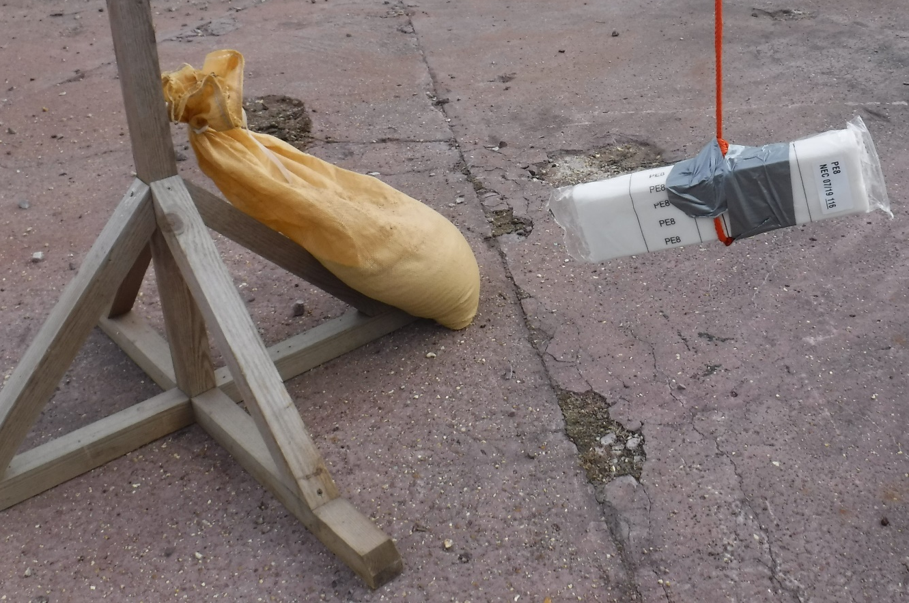
Figure 26 Configuration for 500g hanging charge

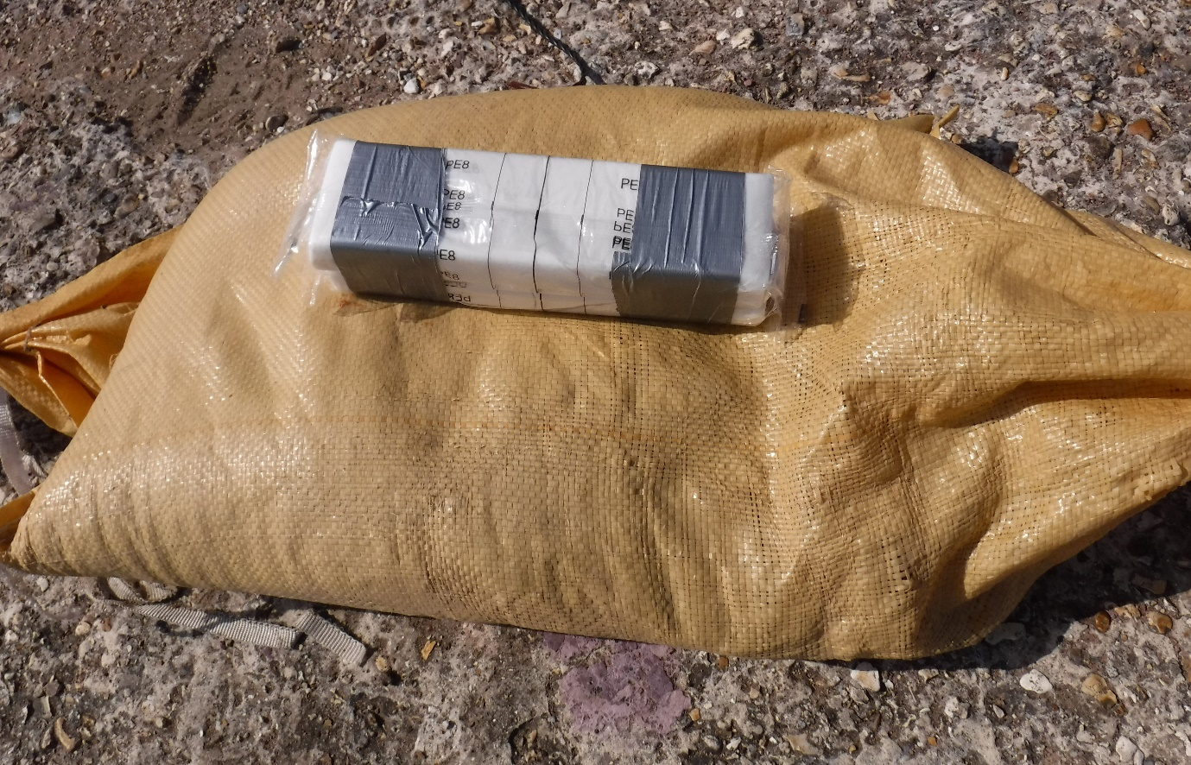
Figure 27 Configuration for 1 kilogram ground firing
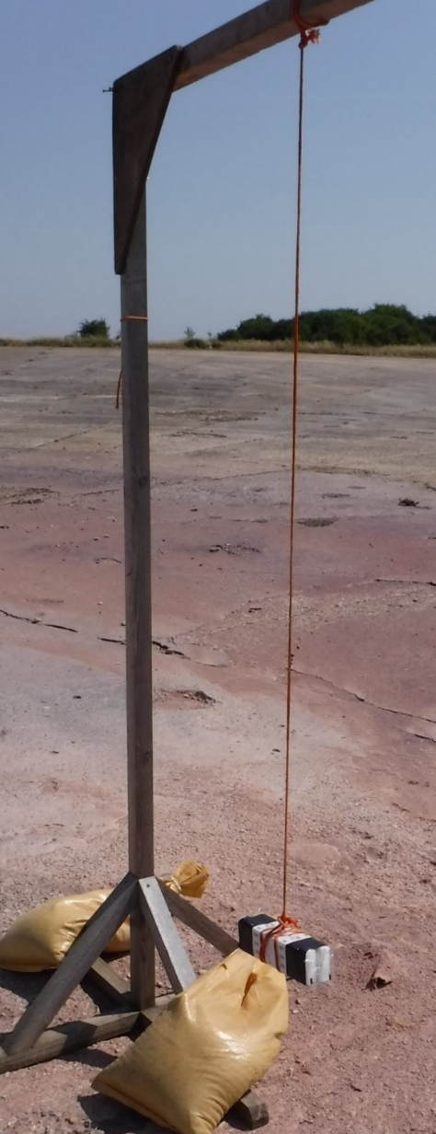
Figure 28 Configuration for 1 kilogram hanging charge
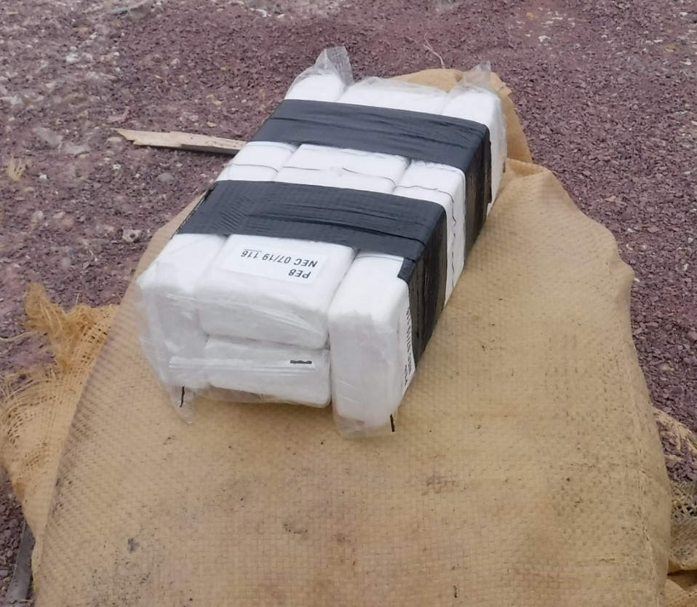
Figure 29 Configuration for 2 Kilogram ground Charge
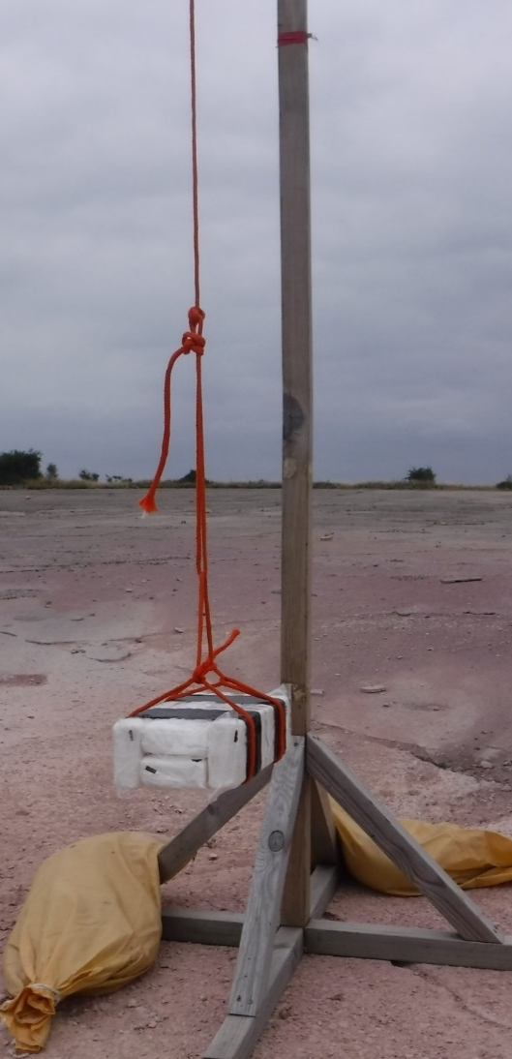
Figure 30 Configuration for 2 kilogram hanging charge
Heat Illness checklist
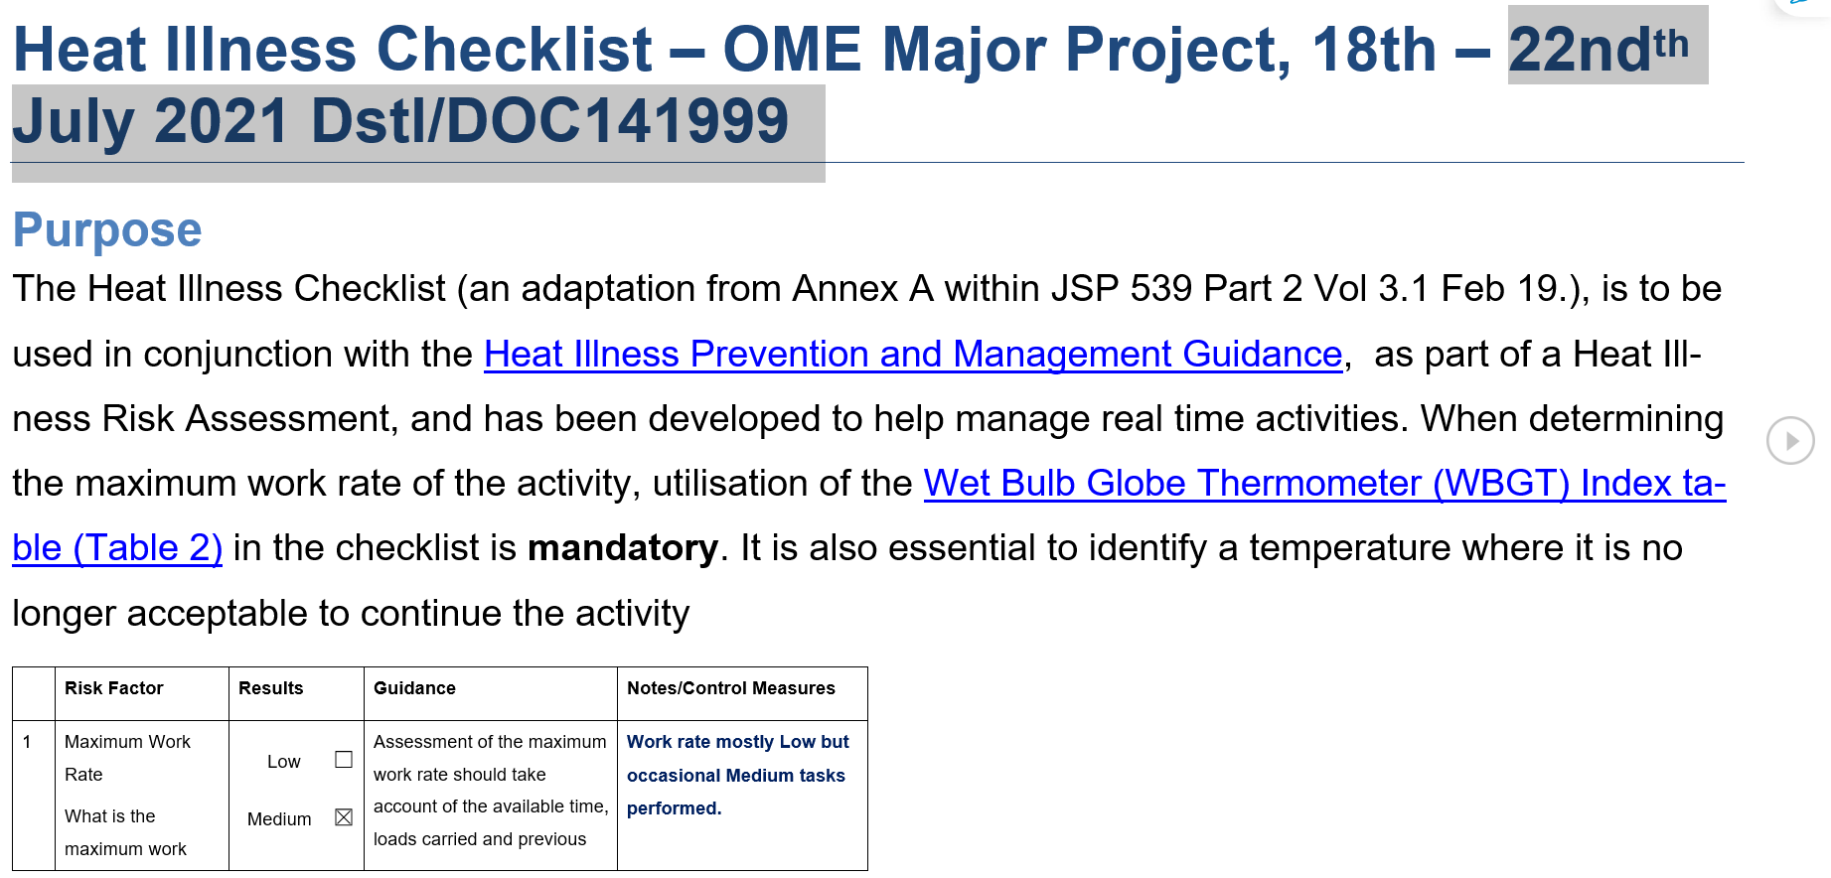
Figure 31 Heat Illness checklist Page 1
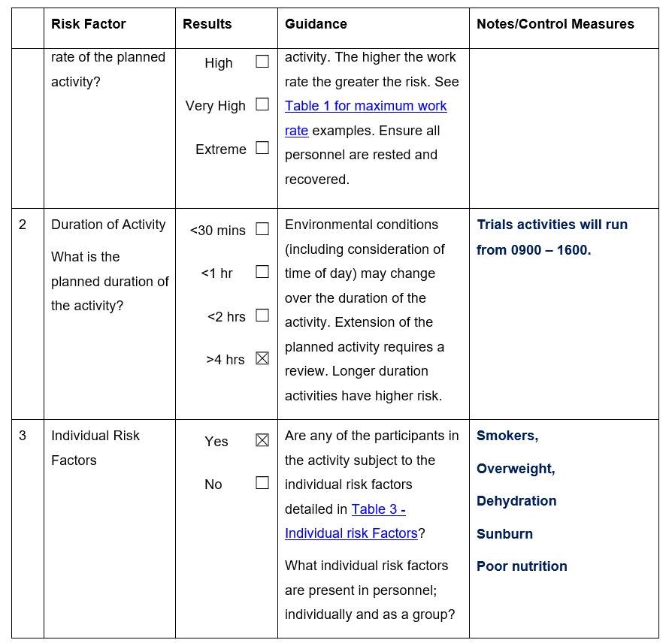
Figure 32 Heat illness checklist Page 2
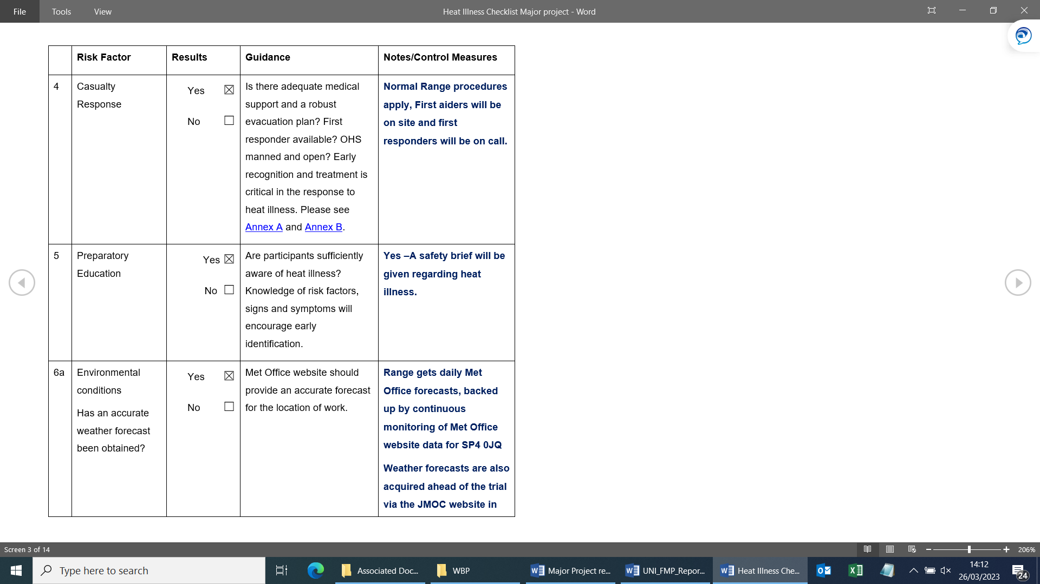
Figure 33 Heat illness checklist Page 3
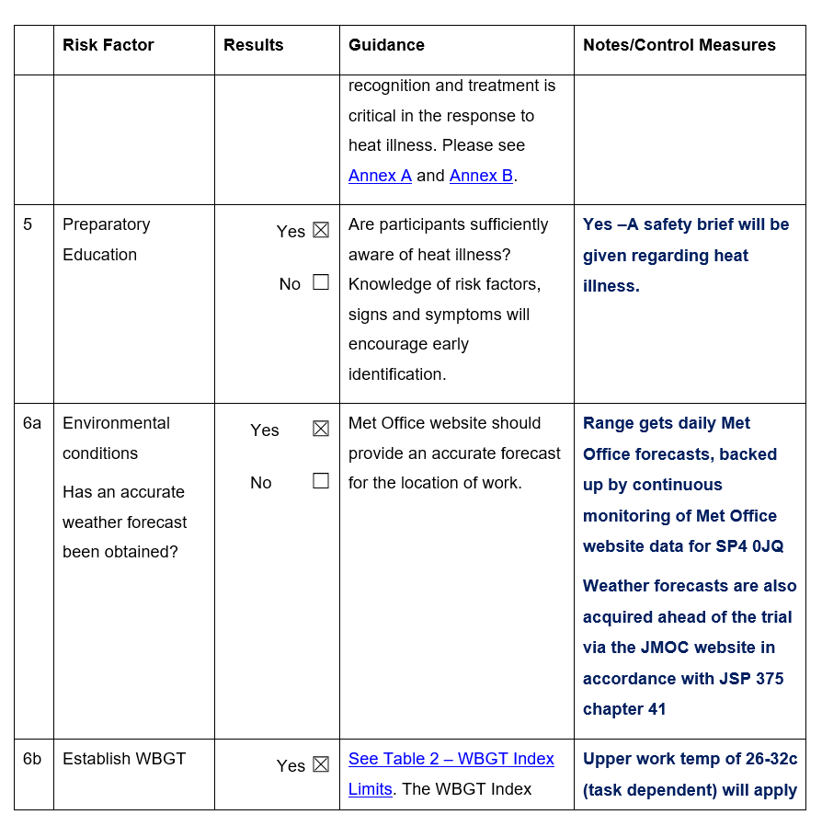
Figure 34 Heat Illness Page 4
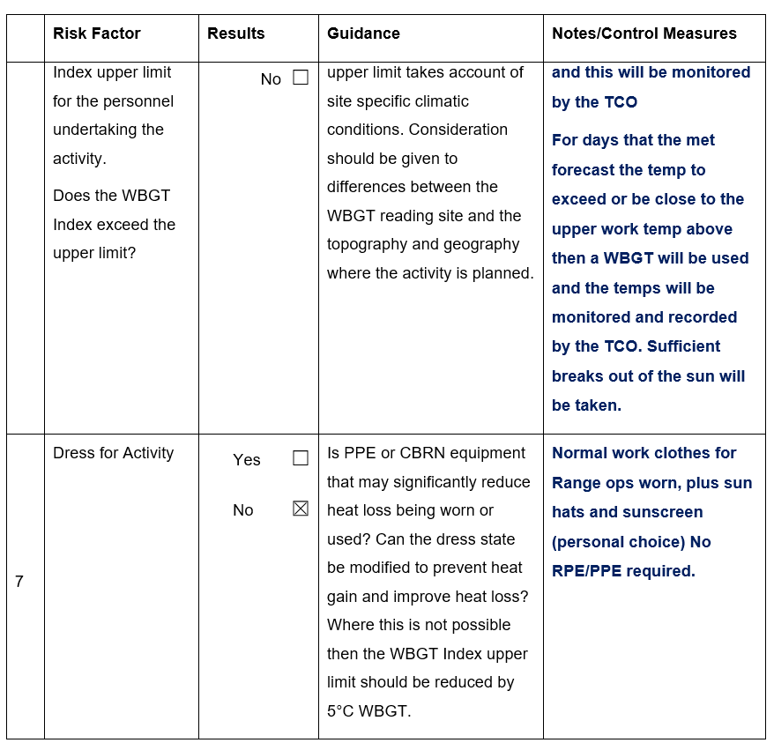
Figure 35 Heat Illness Page 5
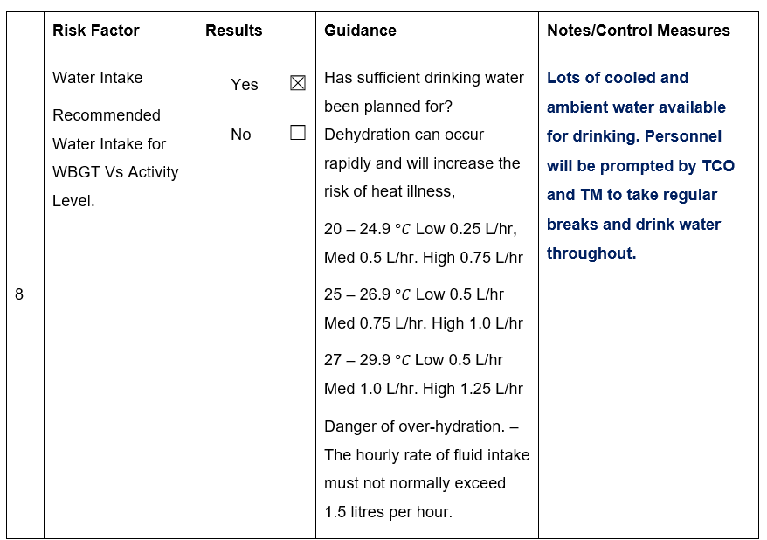
Figure 36 Heat Illness Page 6

Stemming Document
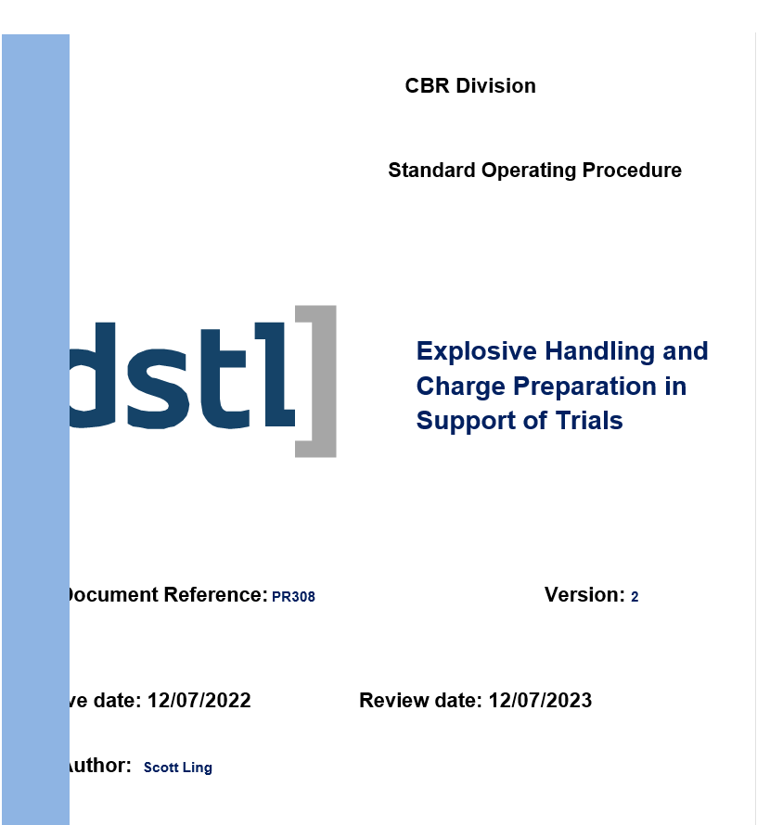
Figure 37 Stemming Document front cover
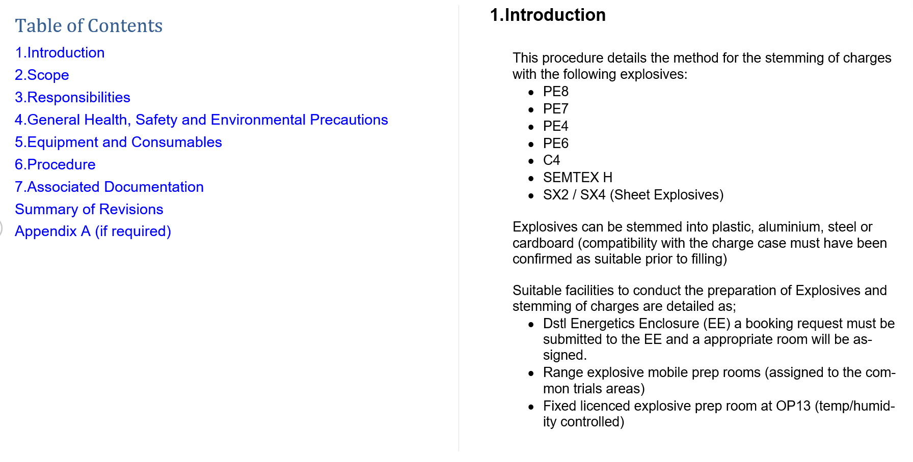
Figure 38 Stemming document Page 2 and 3
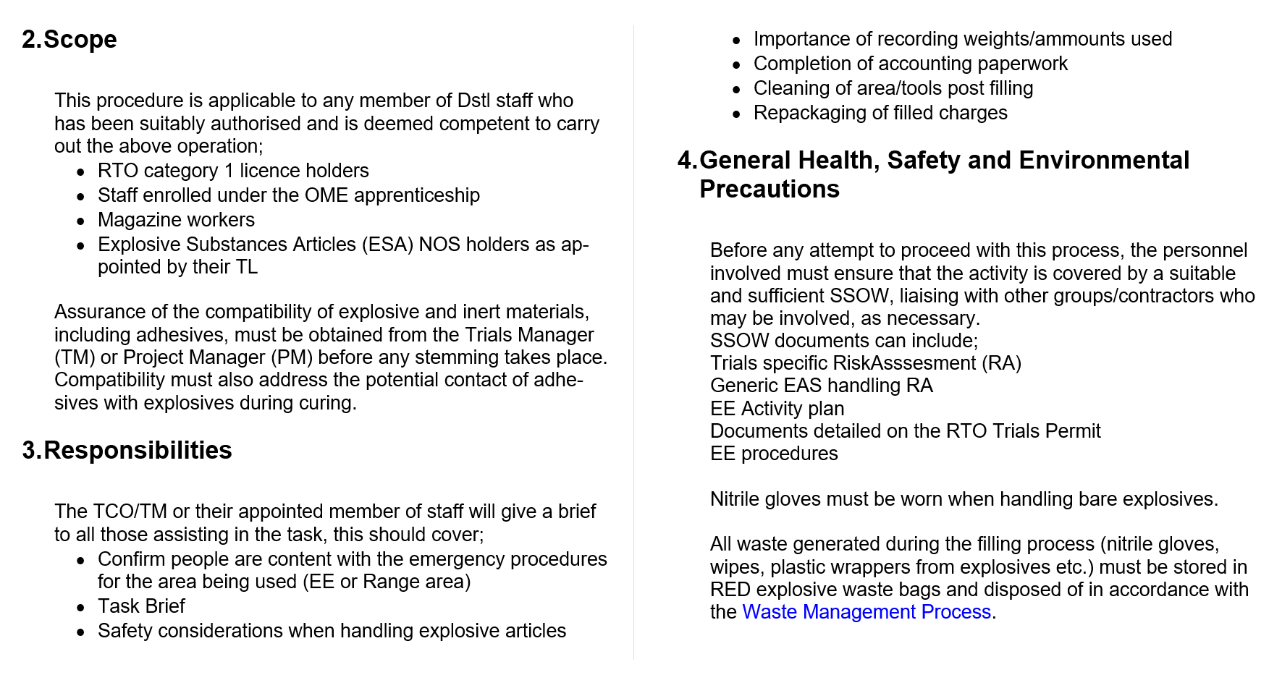
Figure 39 Stemming document Page 4 and 5
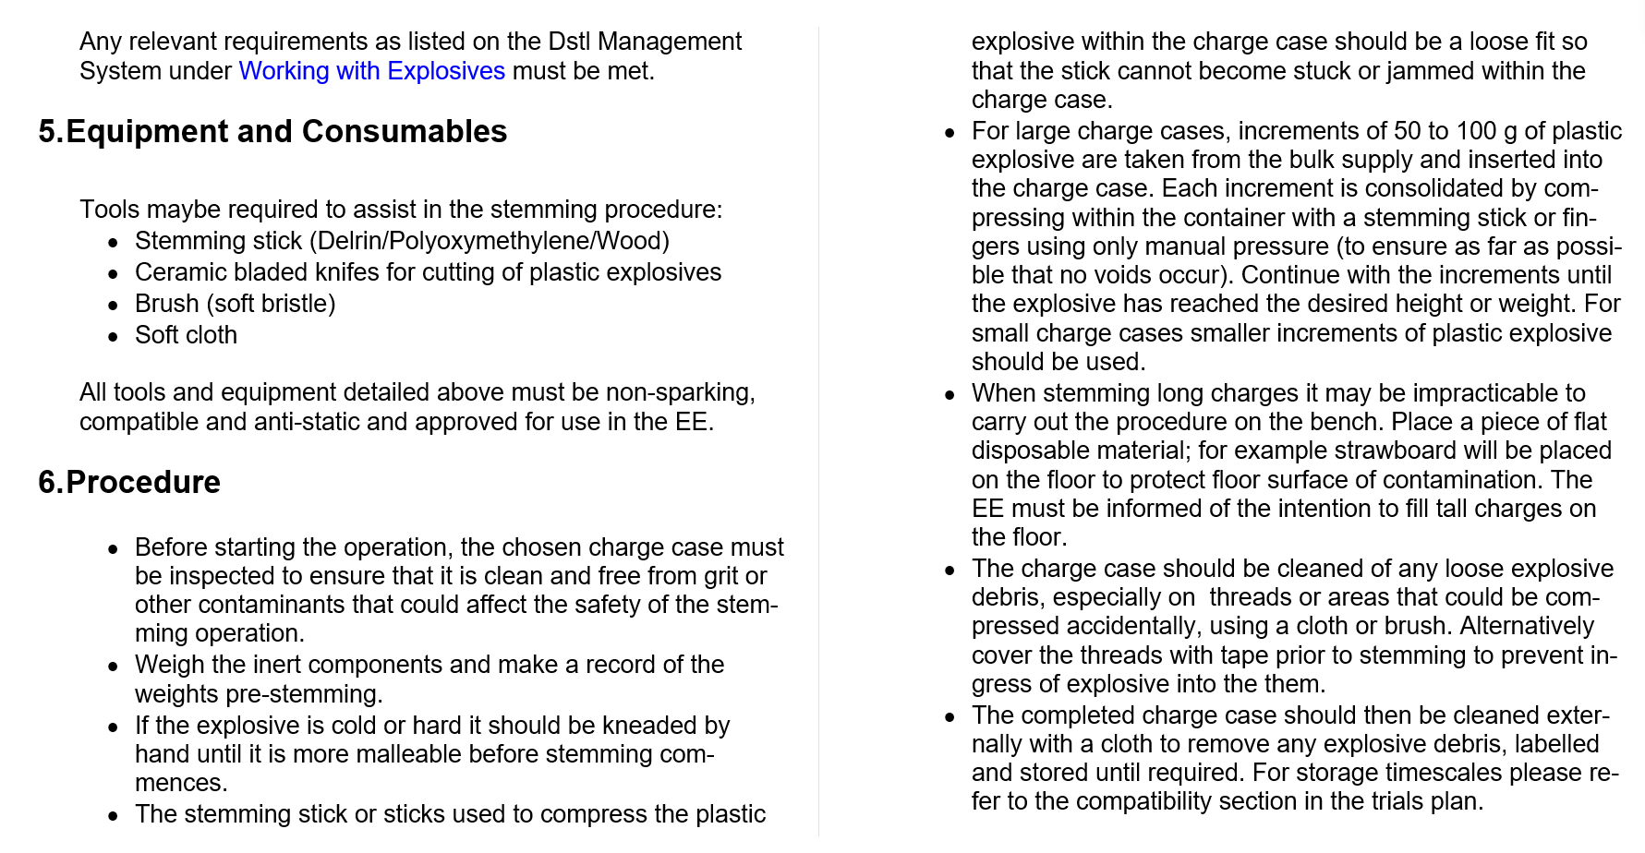
Figure 40 Stemming document page 6 and 7
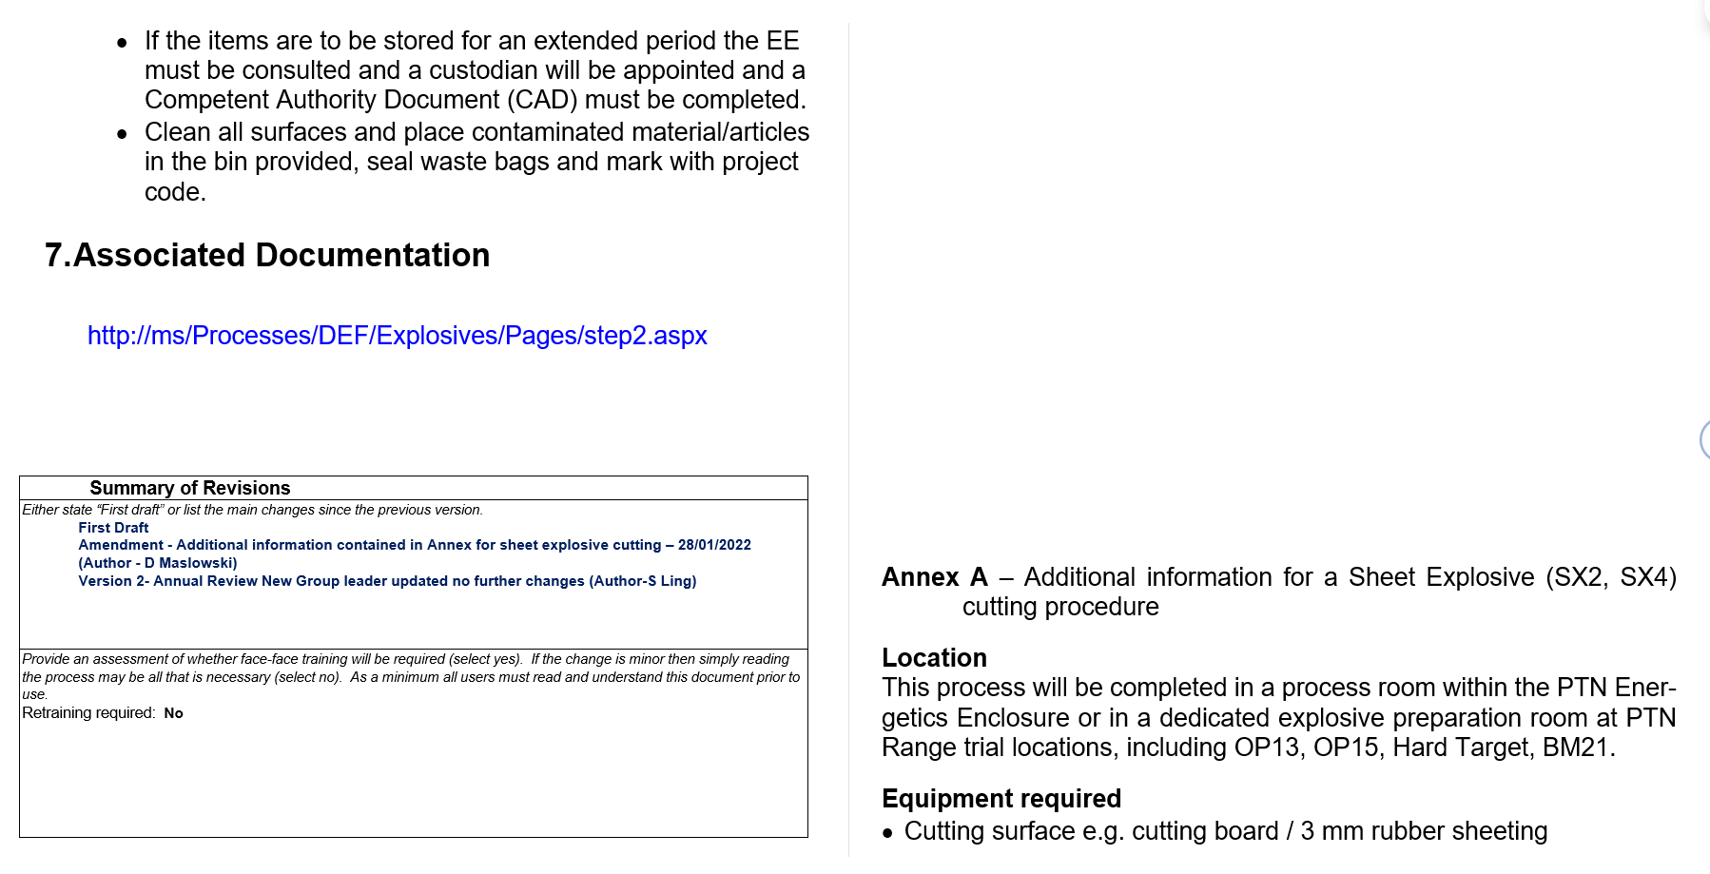
Figure 41 Stemming document 7 and 8
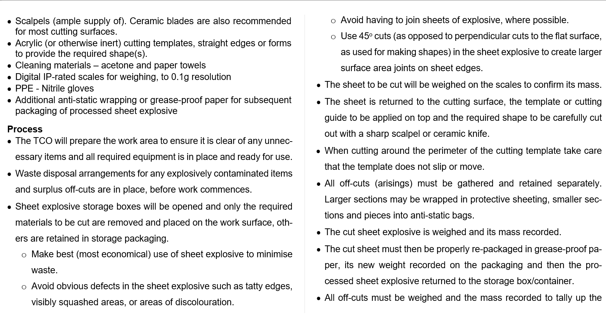
Figure 42 Stemming document pages 8 and 9
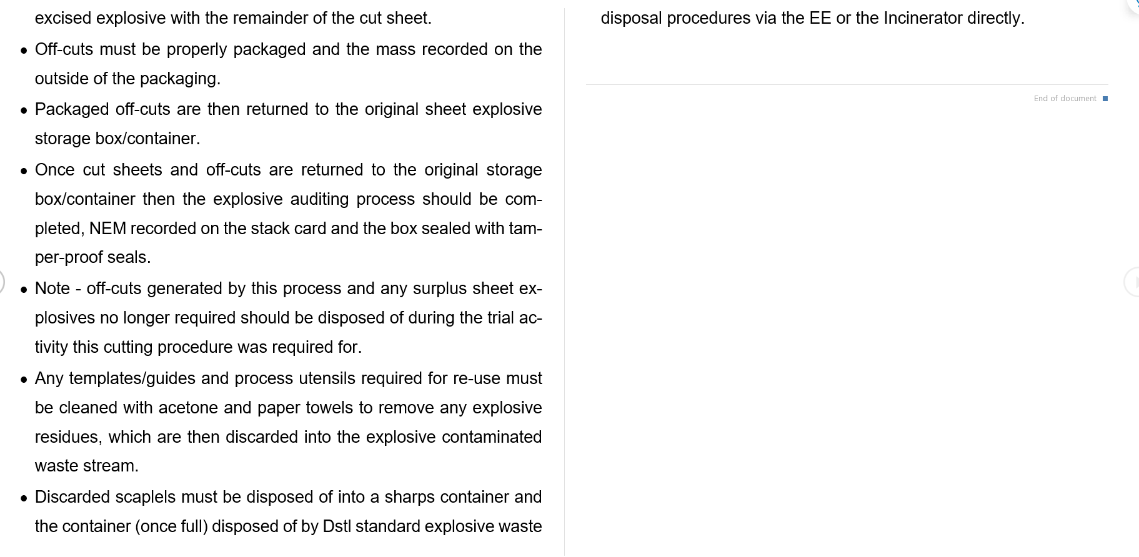
Figure 43 stemming document pages 10 and 11



