Andreea Cristina Velisaru.
Student id 2323535.
Lecture Raheela Shaikh.
Module code BMHP5015_BIRM.
Assignment Personal brand.

Cover page
Task 1 – Personal Brand........... 1.
Task 2 – Network Map and Rationale........2.
Task 3 – Blog.......................3.
Task 4 – NHS Equality, Diversity and Inclusion Quiz.....................4.
Task 5- A letter to myself...................5.
Task 6-Gantt chart..........................6.
Task 7-Making Changes-Report.................7.
Task 8-Self-reflection....................8.
Reference................................9.

Task 1 – Personal Brand
The way a person communicates their values, abilities, and professional identity to others is known as their personal brand being kind, strong, and able to function well under pressure are the cornerstones of my personal brand and are necessary for my professional aspiration of being a paramedic WHERE??. I want to be known for my ability to remain composed under pressure, interact with patients and coworkers in an effective manner, and show a commitment to delivering top-notch care. This identity reflects both my current self and the reputation I hope to establish in the workplace going forward.
I will concentrate on accumulating experience through clinical placements, emergency services volunteer work, and ongoing training in order to strengthen my personal brand. Developing a strong online profile would also enable me to connect with healthcare professionals and highlight my accomplishments, especially on sites like LinkedIn. Personal branding, according to Peters (1997), is about accepting accountability for how other people see you, which is essential in a competitive industry like paramedicine. Building my confidence and resiliency while continuously acting professionally will let me stand out to potential employers and establish my credibility. I may move closer to reaching my career goals by matching my brand to the requirements of the paramedic position.

Task 2 – Network Map and Rationale
Career, support, social, and community are the four main aspects of my network. Each contributes to my objective of becoming a paramedic. Lecturers, clinical placement supervisors, and practicing paramedics I encounter at professional gatherings or during training are all part of my career network. These relationships offer direction, career prospects, and role modelling. Family, close friends, and peers make up the support system, which provides motivation, emotional stability, and encouragement all of which are essential in a hard job. I may exchange knowledge and experiences with my students and professional organisations on social media sites like LinkedIn. The community network allows me to gain useful skills while contributing to society, such as through volunteering with nearby first aid organisations or emergency response teams.
Importantly, creating and sustaining these networks is crucial. According to Bourdieu (1986), job advancement can be directly impacted by social capital, or resources acquired through networks. Aspiring paramedics may benefit from this by learning more about NHS hiring procedures or receiving recommendations for positions. Furthermore, the strength of weak ties theory put forth by Granovetter (1973) emphasises how relationships outside of one's immediate circle frequently present new opportunities. I can build a network that promotes my well-being and my chances of finding work as a paramedic by striking a balance between professional connections and close, supporting relationships. Over time, my network has grown considerably, moving from primarily personal connections to a broader range of contacts that actively assist my professional objective of becoming a paramedic. There were less possibilities to learn about healthcare responsibilities and expectations in the past because my network lacked professional contacts. My network now consists of individuals who offer advice, criticism, and access to pertinent experiences, demonstrating a noticeable improvement in both scope and intent.
My current network's ability to strike a balance between professional growth and emotional support is one of its main advantages. But there are clear gaps, especially when it comes to strengthening relationships inside the EMS service. Granovetter (1973) asserts that these "weak ties" can be beneficial since they provide access to fresh knowledge and prospects. To reach these gaps, I want to engage more with professional platforms such as LinkedIn, attend NHS events, contact with practising paramedics, and participate in community-based health initiatives that offer meaningful interaction with experts.
My network will grow as I gain more self-assurance in striking up business discussions. According to NHS Health Careers (2023), networking is crucial for comprehending expectations in clinical professions, therefore growing my network will help me on my route to become a paramedic.
Me (Aspiring paramedic)
Volunteering
Organistions
family
Lecturers
Peers
Professional forums
First Aid Charities
Classmates
Placement supervisors
Local Health Groups
Practising Paramedics
Friends
Linkedin Groups

CURRENTLY
Career (orange)- lecturers, managers, and active paramedics green support from peers, family, and friends Social (purple)- professional forums, LinkedIn groups, and classmates Community (red)- volunteer work, neighbourhood health organisations, and first aid charities.

Task 3 – Blog
"Delayed Responses, Rising Demands: The Future of Paramedic Care"
Paramedics and Patients face a challenge with ambulance response times the increasing strain on ambulance response times has been one of the key issues paramedics in the UK have faced in recent years. Significant delays in emergency care have been caused by rising demand, a lack of staff, and longer hospital wait times. NHS England (2024) reports that category 2 response times (for diseases like heart attacks and strokes) are often significantly longer than the 18-minute target, placing a great deal of strain on paramedics and patients alike.
Understanding this topic is crucial for students and young people thinking about a career in paramedics. Paramedics on the front lines are regularly put in challenging circumstances where there is a greater demand than there are resources to meet. This can have an impact on staff wellbeing as well as patient results, resulting in tension, dissatisfaction, and burnout. But this difficulty also underlines how important paramedics are to the healthcare system. There has never been a greater need for paramedics who are resilient and skilled, which presents excellent career chances for individuals who are up to the challenge. The goal of initiatives like recruiting campaigns and funding for urgent community response teams is to support paramedic staff and speed up response times (NHS Confederation, 2023).
The key message is for prospective paramedics is to get ready for a challenging and fulfilling job. It will be crucial to cultivate resilience, teamwork abilities, and the capacity to remain composed under duress. Despite the current challenges, being a paramedic gives you the opportunity to directly affect people's lives, particularly during times of greatest need.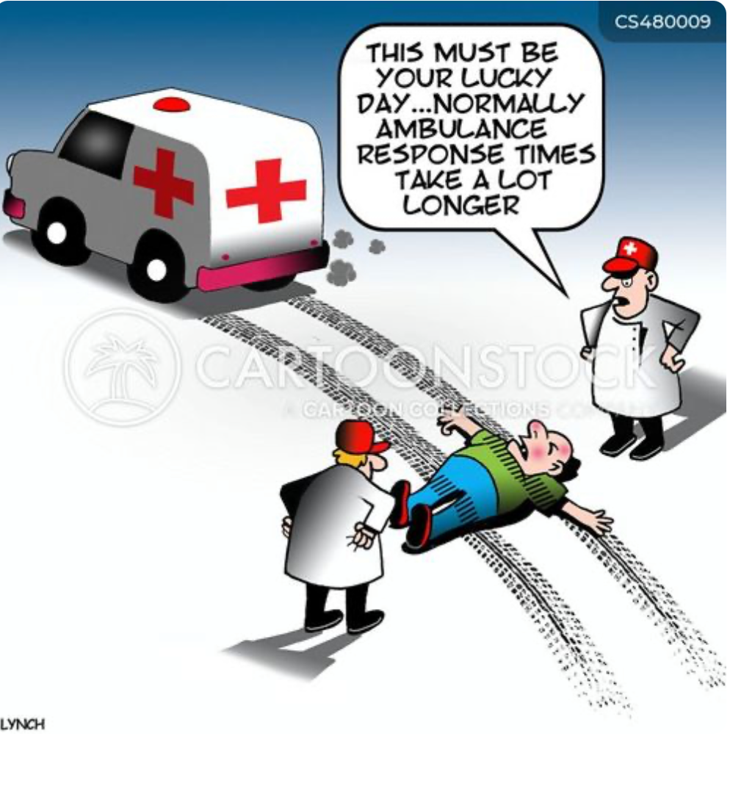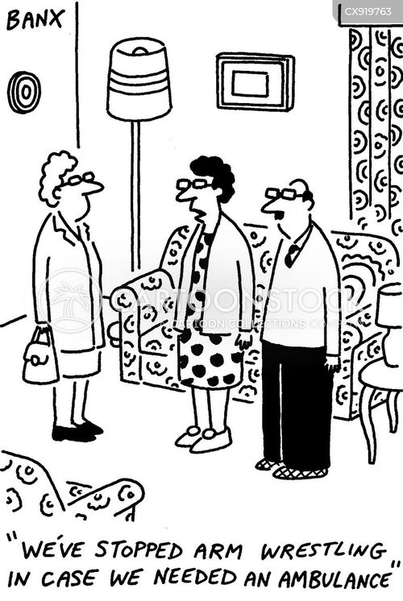
It is crucial to get ready for a challenging and fulfilling career if you are training to become a paramedic. You will succeed if you develop resilience, teamwork, and sound decision-making abilities. The benefits are as genuine as the challenges. There are few professions that let you directly save lives on a daily basis. Despite the headlines' emphasis on delays, keep in mind that every obstacle presents an opportunity for development, creativity, and change.

Task 4 – NHS Equality, Diversity and Inclusion Quiz
National initiatives to establish a more equitable, welcoming, and encouraging work environment throughout the NHS are outlined in the NHS Equality, Diversity, and Inclusion (EDI) Improvement Plan. Key points from the proposal are summarise followed in the question bellow.
1. What is the primary goal of the NHS Equality, Diversity and Inclusion Improvement Plan?
The main objective is to increase staff members sense of belonging and promote equality, diversity, and inclusion throughout the NHS workforce in order to improve employee satisfaction and retention (NHS England, 2023).
2. How does the NHS EDI Improvement Plan propose to tackle the gender pay gap?
According to NHS Employers (2023), it mandates that organisations evaluate pay disparities by protected characteristics, put Mend the Gap recommendations into practice, and hold boards accountable for progress.
3. What is meant by the term ‘intersectionality’ as used in the NHS EDI Improvement Plan?
According to NHS England (2023), intersectionality acknowledges that individuals have a variety of intersecting identities, such as race, gender, and disability, which collectively influence their experiences and disadvantages.
4. Why is it important for the NHS to create a psychologically safe work environment?
By empowering employees to speak up without fear, psychological safety enhances patient safety, welfare, and innovation (NHS England, 2023).
5. How does the NHS EDI Improvement Plan suggest improving the experience of internationally recruited staff?
In order to guarantee equitable treatment and career advancement, it encourages thorough induction, mentorship, and development programs (NHS Employers, 2023).
6. What role does leadership play in advancing EDI objectives according to the NHS Improvement Plan?
Leaders must utilise data to promote organisational transformation, model inclusive attitudes, and establish quantifiable EDI goals (NHS Employers, 2023).
7. Identify one way the NHS EDI Improvement Plan aims to reduce health inequalities within the workforce?
In order to address health disparities and enhance the well-being of under-represented staff groups, the strategy calls for action (NHS Employers, 2023).
8. Why does the NHS EDI Improvement plan emphasise the importance of collecting and analysing data on protected characteristics?
Data collection aids in determining inequalities and assessing how well inclusion programs are working (NHS England, 2023).
9. Explain how flexible working policies can contribute to equality and inclusion in the NHS workforce?
Flexible working encourages persistence and inclusive participation by supporting employees with health or care requirements (NHS Employers, 2023).
10. What is one strategy mentioned in the NHS EDI Improvement Plan to combat bullying and harassment in the workplace?
The strategy guarantees assistance for employees who voice concerns, establishes reduction goals, and updates disciplinary procedures (NHS Employers, 2023).
Task 5- A letter to myself
To My Younger Self, I am aware that you have had periods of crushing stress, when juggling personal demands, part-time employment, and education seemed unachievable. You frequently felt like you had to manage everything by yourself back then. You would have handled those situations differently if you had known what I now know about emotional intelligence and perseverance. According to Goleman (1998), emotional intelligence is the ability to identify and control your own emotions as well as those of others. You may have been able to lessen your stress and create more robust support systems if you had taken the time to stop, recognise your emotions, and express them honestly. In a similar vein, having greater empathy would have enabled you to ask friends, mentors, or tutors for assistance rather than attempting to do everything on your own.
According to Masten (2001), resilience is the capacity to adjust constructively in the face of difficulty. Creating this would have served as a reminder that obstacles are not failures but rather chances for personal development. Your confidence and motivation would have increased if you had learnt how to bounce back and refocus following setbacks. Therefore, if I could talk to you right now, I would advise you to accept yourself, acknowledge your feelings, and have faith that persistence would be rewarded. You are the strong, caring person you are now because of every obstacle you have overcome, and those same traits will continue to help you become the finest version of yourself. Thank you, My Future Self.

Task 6-Gantt chart
Future Employment goal to become a paramedic.
The main tasks and deadlines for completing this goal during a 12-month period.
Red not done on time.
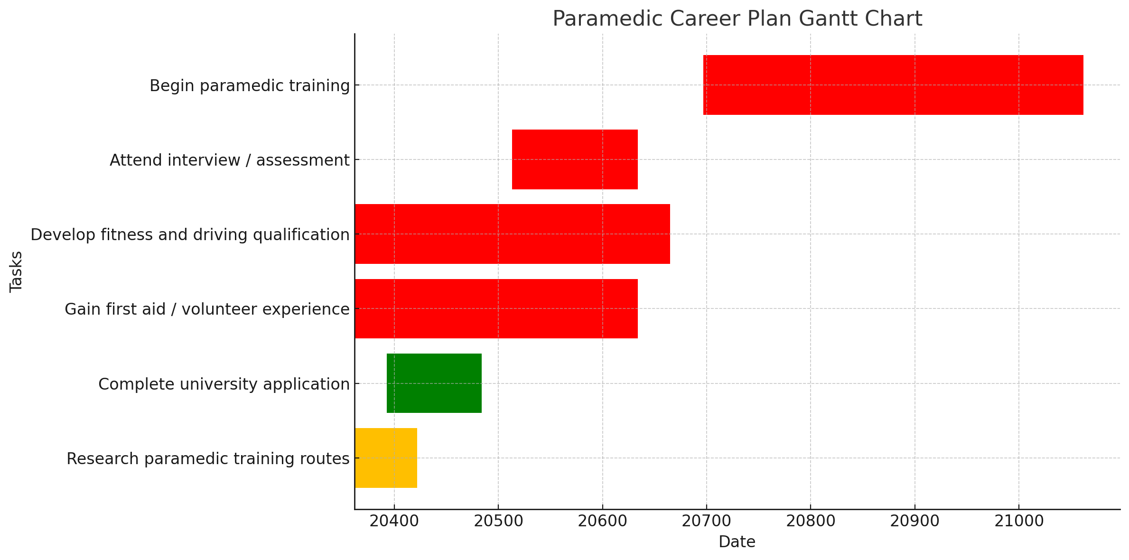
Orange is nearly done.
Green is done on time.
This Gantt chart can help in goal organisation, attention maintenance, and progress tracking. Key employability skills include self-control and time management, and reflection at every stage promotes continuous improvement (Lock, 2020). This kind of graphic planning tool promotes responsibility and guarantees that tasks are reasonable and doable.

Task 7-Making Changes-Report
Title- Improving Relationships Among Care Home Staff As a manager of a care facility, I've seen that better staff communication is necessary to boost collaboration and the standard of resident care. Implementing a digital communication platform (such as a secure messaging app) is the specific modification that is suggested in order to facilitate information exchange between nurses, management, and care personnel. To do this, a trial program will be implemented prior to the full implementation, and employees will receive training on how to use the system. Success will depend heavily on effective leadership and engaged employees. The approach will proceed in three steps, as per Lewin's (1951) Change Management Model: unfreeze (explaining the need for improved communication), change (introducing the new system with support), and refreeze (making it standard practice). Staff reluctance to use technology, insecurity, or a lack of training time are examples of potential obstacles. Offering practical workshops, obvious advantages, and continual feedback opportunities can help overcome these. For leaders to handle problems sympathetically and uphold trust throughout the process, emotional intelligence will be essential. The change's overall goals are to increase productivity, decrease misunderstandings, and enhance staff satisfaction and care quality results.

Task 8-Self reflection
I can use Gibbs' (1988) Reflective Cycle to consider what I've discovered about myself during this module. Initially, I was uncertain about my professional identity and lacked confidence in my ability to network and express myself. Emotions- I felt overburdened by future career planning and nervous about building my personal brand. Evaluation- As the module went on, I gained confidence by learning about communication, emotional intelligence, and resilience. Peer feedback also assisted me in identifying my areas of strength. Analysis- I've been able to successfully balance priorities since learning about time management and employability skills. My awareness of networking and personal branding has increased my initiative in establishing business connections. In conclusion, I now understand that the secret to both professional and personal success is self-awareness and flexibility. I can continuously evaluate my development and pinpoint areas for growth thanks to reflective learning. Action Plan- Going forward, I'll use reflection frequently, ask for feedback, and keep developing my leadership and resiliency abilities. In my prospective paramedic profession, where emotional regulation and collaboration are critical, these will be vital.

References
Gibbs, G. (1988) Learning by doing: A guide to teaching and learning methods. Oxford: Oxford Polytechnic.
Goleman, D. (1998) Working with emotional intelligence. New York: Bantam Books.
Granovetter, M. (1973) ‘The strength of weak ties’, American Journal of Sociology, 78(6), pp. 1360–1380.
Lewin, K. (1951) Field theory in social science. New York: Harper & Row.
Lock, D. (2020) Project management. 11th edn. London: Routledge.

Masten, A. S. (2001) ‘Ordinary magic: Resilience processes in development’, American Psychologist, 56(3), pp. 227–238.

NHS Confederation (2023) Urgent and emergency care: workforce pressures and solutions. Available at: https://www.nhsconfed.org (Accessed: 23 October 2025).

NHS Employers (2023) Equality, diversity and inclusion (EDI) improvement plan. Available at: https://www.nhsemployers.org (Accessed: 23 October 2025).

NHS England (2023) NHS Equality, Diversity and Inclusion Improvement Plan. Available at: https://www.england.nhs.uk (Accessed: 23 October 2025).

NHS England (2024) Ambulance quality indicators: response times. Available at: https://www.england.nhs.uk(Accessed: 23 October 2025).

NHS Health Careers (2023) How to become a paramedic. Available at: https://www.healthcareers.nhs.uk (Accessed: 23 October 2025).

NHS Health Careers (2023) NHS Careers and networking guidance. Available at: https://www.healthcareers.nhs.uk(Accessed: 23 October 2025).
The Open University (2023) Building your personal brand. Available at: https://www.open.edu/openlearn (Accessed: 23 October 2025).
Granovetter, M. (1973) ‘The strength of weak ties’, American Journal of Sociology, 78(6), pp. 1360–1380.
NHS Health Careers (2023) NHS Careers and networking guidance. Available at: https://www.healthcareers.nhs.uk
Lynch, M. (n.d.) Ambulance response time cartoon. CartoonStock. Available at: https://www.cartoonstock.com(Accessed: 17 November 2025).
CartoonStock (n.d.) “Last question, and how would you rate the ambulance response time …” by Mark Lynch. Available at: CartoonStock.com (Accessed: 17 November 2025).

