Max Beasley
2304218@student.uwtsd.ac.uk
Research and case scenario in Data Security and Compliance
Data Security and Compliance

Contents
Task 1 2
Task 2 9
Acronyms used 9
Table of figures 9
Introduction 9
Approach 9
Organizational structure 9
Policies, procedures and compliance 10
Planning and governance 11
Risk management 12
Contingency planning 13
Discussion of approach Conclusion 13
References 14

Task 1

research into various network / data security solutions
Max Beasley
Student University of Wales Trinity St David, Swansea, Wales
2304218@student.uwtsd.ac.uk

Abstract
In the modern world the amount of devices connected to the internet has exploded, this has created many opportunities for organizations but has also lead to the rapid growth of people who would aim to do harm using this medium. Therefore it is essential that organizations implement a robust set of measures that can secure their data from unwanted theft and damage as this may cause irreparable harm to an organizations business as in the modern world trust is the backbone of data privacy, if someone cannot trust in their data's integrity they are unlikely to stay with a service.
Therefore In this paper I will conduct research on various methods that can be implemented to help secure data form being compromised. During this research I will endeavor to use a variety of academic and peer reviewed sources to reinforce my claims and provide integrity to my research.

Research into various cybersecurity methods

- Firewalls
In this section I will investigate the use and implementation of firewalls, one of the most common security technologies. But what is a firewall? Habtamu Abie in his paper 'An Overview of Firewall Technologies' describes a firewall as 'A computer, router or other communication device that filters access to the protected network' [1].
however it is important to note that in this description he is clearly describing a hardware firewall as can be seen with his use of 'router' and 'device' both of which are used to describe physical equipment. When talking about firewalls it valuable to know the difference between hardware and software firewalls to avoid confusion. A hardware firewall is a piece of physical equipment that sits between a wider network and the portion that is to be protected, they also use differing methods compared to software firewalls, the main technique being packet filtering which is best employed in a dedicated unit. Hardware firewalls also help reduce resource bottlenecks as they the nature of them being dedicated mean they have access to their own computing resource, however this comes with the trade-off of increased cost of purchase, maintenance and complexity. As you can see in figure 1 the fire wall sits at the entry point between the internet and private network.
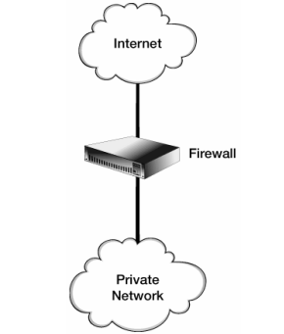

Fig1 Hardware firewall (from Diff)

Whereas software firewalls are 'program based applications' [2] that run on an already existing device such as a PC or server, the scope of software based firewalls is focused on protecting the specific device therefore scans incoming packets that are destined for one of the ports that it is protecting and checks it against a pre-determined block list. Software firewalls come with the advantages' of being ways to install and relatively low cost as no dedicated hardware is needed, however this means that they are less scalable and rely on valuable system resources that might be needed elsewhere.
Although these two methods often accomplish the same task it is common to employ both for added redundancy and security. Figure 2 below shows the difference between software and hardware firewalls.

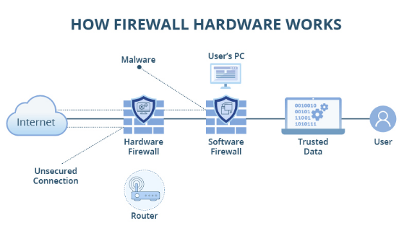
Fig 2 (software vs hardware)[3]

Firewalls protect networks by isolating them from wider networks that cannot be secured by a user, it does by acting as guard at the entrance to the network and creating a DMZ (demilitarized zone) around the desired network so that no unauthorised traffic can enter or leave the secured network .Most firewalls rely on the concept of packet filtering to accomplish this and defend against potentially harmful data packets but what is packet filtering? Put simply packet filtering is the process by which the firewall identifies problematic packets and then proceeds to block them. This is achieved using a set of rules defined by the network administrator, who can block destinations our sources of network traffic. [4]

In the modern world of computing where almost every device is connected to some form of network there is an essential requirement to secure said networks form any potential threats as ant device connected to a network is venerable to network threats. This Is why firewalls in some form is essential for any device connected to a network especially the internet, as without one any potential attacker could interact with your device. This is why when working with any data that needs to be protected measures should be implemented to reduce the risk to that data and its users. The implementation of a firewall is one of the first steps that should be taken so that the data can be isolated form the wider internet and prevent threats form interacting and gaining access to a network. An example of this would be preventing any users outside the network DMZ from accessing internal connection such as SSH or TELNET. [5]

Throughout this analysis and research I have aimed to use a strong set of academic journals and papers to support my conclusions. The first two sources that I have used are overviews of the topics discussed, both of these materials are peer reviewed and from recognised institutions. However these sources are from the year 2000 and 2005 respectively, but it can be argued that because the topics covered are fundamental to the field they are still useful and accurate as the foundation of the knowledge on firewalls has not changed. The remainder of the sources are of a more recent nature so the information is accurate to a greater extent. Because of the abovementioned factors I believe that the accuracy of my research is good and transferable.
- Access controls
When securing data it is important to consider that the threat that may arise from inside the organization or form those who may already have access to a system, therefore it is vital to introduce limitations on what users can do, this is why for the end user the most commonly encountered data security measure is access control. Access control is the process used of restricting how a user can interact with a computer system, this is done in an effort to increase security and prevent unauthorized access to the system and data. An example of access control would be the username and password someone would use to log into an account for a piece of software, this is the most noticed form of access control to the user as they are required to make inputs to gain access. However the backbone of access controls are the permissions, these are a set of rules that govern what the user has access to once they have used their credentials to gain access into a system. [6] The figure shown below gives an example of how authentication and access control are used to protect the data (represented as objects)

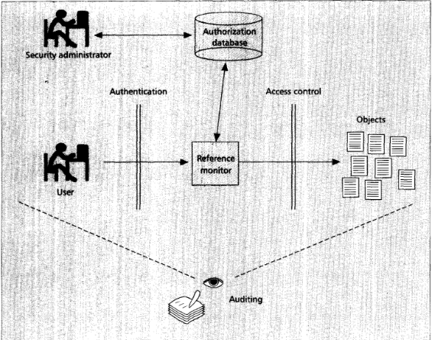
Figure 2 [6]

Implementation
When implementing access controls there are three main objectives that an access control system should complete, these are as given by Volume 22 of the 'Sensors' journal, identify authenticate and authorization [7]. First the system must identify who is attempting to gain access then validate if that users is indeed who they claim to be and finally if the previous step is fulfilled the system must then check if the user has the authorization to access the material or system that they are attempting to access.
The first stage is usually carried out using usernames and password unique to each user, this is how we identify who is trying to gain access. Authentication is often times provided by the users password, however this is becoming less common as a password can be compromised if the user has not set a strong password or has insecurely stored the password, this can be mitigated by enforcing password policies that require passwords to be of given standard e.g length and complexity, but this does not remove the problem of someone else knowing the password and claiming to be the user. This problem has increasingly been addressed using the process of two factor authentication (commonly known as 2FA), this is used in conjunction with the users password and is the process of proving the users identity by challenging them to enter a prompt like a code from an authenticator app installed on a user's personal device or a location only the real user would have access to [8]. There are many ways that 2FA is used an can be implemented and as it increases in popularity more advanced methods have developed such as the use of biometrics to prove identity, such as the use of fingerprints. Look to Figure 3 to see an example of how two factor authentication may be implemented and used. Finally when it comes to authorization this is achieved by checking the users permissions against the restrictions placed on the item they are trying to access to see if their access level is sufficient. In a secure environment all data should have an access category placed upon it to ensure it is only access by those who need to.
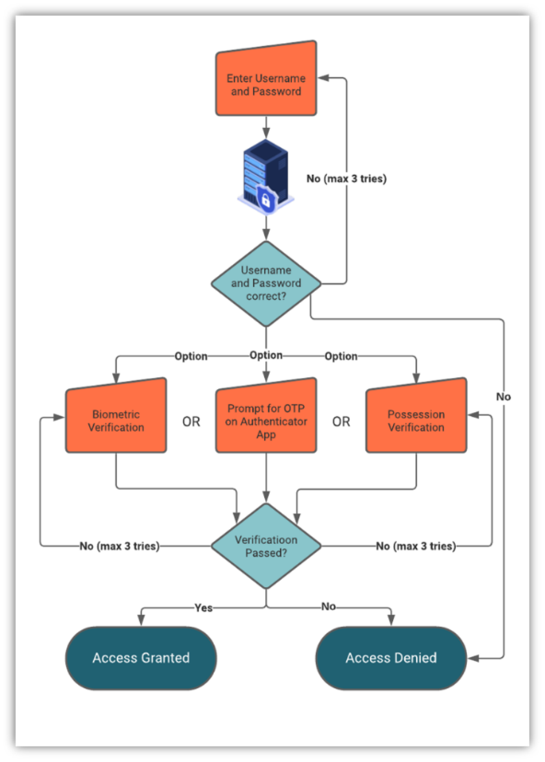
Figure 3 [9]

Limitations
However it should be noted that access controls should not be used in a vacuum but in conjunction with other security measures such as firewalls and VPNs. This fact is highlighted in the Asian Journal of Research in Computer Science as it gives examples of how ransomware attacks can be mitigated using access controls but many malicious actors will attempt to go around access controls by using methods such as phishing (a form of social engineering) to bypass the access controls [10]
It is also important to take into account the user experience of a system when designing access control policies. The aim should be to secure data and infrastructure but not limit the users ability to complete a task. The importance of this is highlighted in the CIA triad model (Figure 4) for data security, this says that data should be confidential, trusted and available. If access controls are implemented correctly they should play their part in balancing the three aspects of the CIA triad. this is of further importance as availability has been found to be the most overlooked aspect of the triad principles as 35.7% of papers focused on information security cover availability as a main topic (figure 6), and as access controls are the main tool used is to limit availability to protected material it is vital that they are implanted in a way that strikes an appropriate balance.[11].

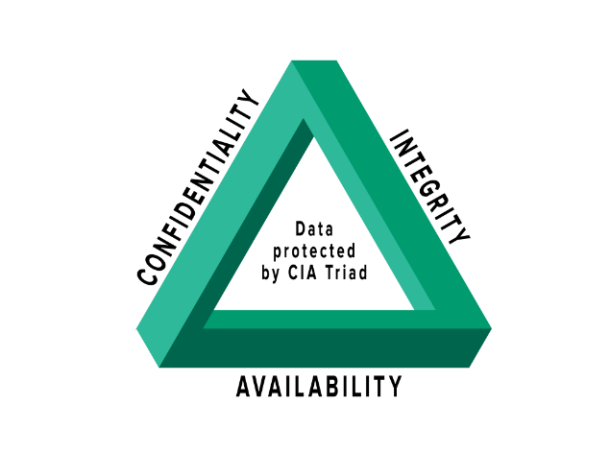
Figure 4 [16]

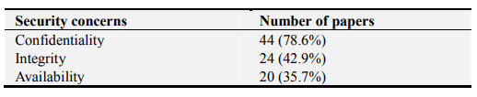
Figure 5 [11]

- VPNs
VPNs have emerged especially in recent years as an invaluable tool for securing data from unwanted monitoring or interception and creating s secure working environment. VPNs or virtual private networks are pieces of software that can be used to create a secure network on top of an unsecure network such as the public internet [13]. VPNs have been increasingly used in recent times to facilitate remote working for company employees, a VPN allows them to securely access a corporate network from any location, an example being their home network. VPNs are essential when transmitting data over the public internet if sensitive corporate data is involved.

Tunneling
VPNs are able to create this secure connection by using a method called tunneling, this is the process of creating an end to end encrypted data path that can be used to safely communicate across a potentially insecure line where data may be prone to interception by a third party, a VPN allows all traffic to be encrypted so that if the data is intercepted it cannot be deciphered. Tunnelling is achieved by the use of a variety of different protocols that can provide different functionality based on the goal, this could be a focus on speed and access or a focus on security. If the focus is speed a protocol that splits the data up and sends some packets encrypted and some not, this helps increase speed at the tradeoff of security as some data may be able to be decoded. Whereas if security is of vital importance a Protocol that focuses on encryption and obfuscation would be used [14]. See figure 6 for an example of tunneling.

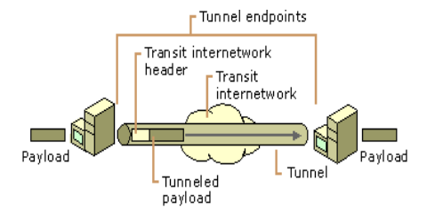
Figure 6 [15]

Remote access
In the corporate world VPNs are increasingly being used to aid flexible working, this is achieved by using VPNs to establish secure remote connections to company networks and devices, this allows an employee to access a device that may be physically locate many miles away as if they were present in the location with the device. This also reduces the risk that would come with allowing a non-company device to access a network as a VPN allows any PC style device to access the network securely without the needs to enforce the same levels of security policy on the home device as the user is interacting with a remote environment on an encrypted tunnel. However there is an increased risk from DDOS (Denial Of Service) style attacks as the connection is still dependent on the reliability of an external network which the organization has no control over. Figure 7 shown below is an example of a VPN used for remote working.

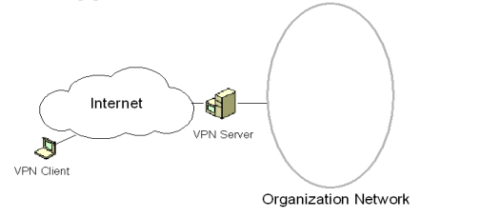
Figure 7 [15]

- Conclusion
All of the three topics that I have covered in this papers are prime examples of technologies that are readily available in the modern IT landscape. They provide protections against many types of threats that may be encountered by an organizations networks from common viruses and worms to more complex items such as malware, and importantly protection against human error.

- References
[1] H. Abie, "An overview of firewall technologies," Telektronikk, vol. 96, no. 3, pp.47–52, 2000.
[2] R. Panchal, "Firewalls: Hardware vs. software," Dosegljivo, 2005.
[3] "Introducing the Difference: Hardware Firewalls vs Software Firewalls | FS Community." FS.com. https://community.fs.com/blog/hardware-vs-software-firewalls-whats-the-difference.html (accessed Dec 11).
[4] D. B. Chapman, "Network (In) Security Through IP Packet Filtering." USENIX Summer, 1992.
[5] M. Alicea and I. Alsmadi, "Misconfiguration in Firewalls and Network Access Controls: Literature Review," Future Internet, vol. 13, no. 11, 2021. doi: 10.3390/fi13110283. Available: https://www.proquest.com/scholarly-journals/misconfiguration-firewalls-network-access/docview/2602055396/se-2?accountid=130472 https://libkey.io/libraries/1422/openurl?ctx_ver=Z39.88-2004&ctx_enc=info:ofi/enc:UTF-8&rfr_id=info:sid/ProQuest&rft_val_fmt=journal&rft.genre=article&rft.jtitle=Future+Internet&rft.atitle=Misconfiguration+in+Firewalls+and+Network+Access+Controls%253A+Literature+Review&rft.au=Alicea%252C+Michael%253BAlsmadi%252C+Izzat.&rft.aulast=Alicea&rft.aufirst=Michael&rft.date=2021-01-01&rft.volume=13&rft.issue=11&rft.spage=283&rft.isbn=&rft.btitle=&rft.title=Future+Internet&rft.issn=&rft_id=info:doi/10.3390%252Ffi13110283 https://doi.org/10.3390/fi13110283
[6] R. S. Sandhu and P. Samarati, "Access control: principle and practice," IEEE Communications Magazine, vol. 32, no. 9, pp.40–48, 1994. doi: 10.1109/35.312842.
[7] A. Mishra, et al., "Cybersecurity Enterprises Policies: A Comparative Study," Sensors, vol. 22, no. 2, pp.538, 2022. doi: 10.3390/s22020538. Available: https://www.proquest.com/scholarly-journals/cybersecurity-enterprises-policies-comparative/docview/2621378419/se-2?accountid=130472 https://libkey.io/libraries/1422/openurl?ctx_ver=Z39.88-2004&ctx_enc=info:ofi/enc:UTF-8&rfr_id=info:sid/ProQuest&rft_val_fmt=journal&rft.genre=article&rft.jtitle=Sensors&rft.atitle=Cybersecurity+Enterprises+Policies%253A+A+Comparative+Study&rft.au=Mishra%252C+Alok%253BYehia+Ibrahim+Alzoubi%253BGill%252C+Asif+Qumer%253BMemoona+Javeria+Anwar.&rft.aulast=Mishra&rft.aufirst=Alok&rft.date=2022-01-01&rft.volume=22&rft.issue=2&rft.spage=538&rft.isbn=&rft.btitle=&rft.title=Sensors&rft.issn=&rft_id=info:doi/10.3390%252Fs22020538 https://doi.org/10.3390/s22020538
[8] A. F. Pomputius, "A Review of Two-Factor Authentication: Suggested Security Effort Moves to Mandatory," Med.Ref.Serv.Q., vol. 37, no. 4, pp.397–402, 2018. doi: 10.1080/02763869.2018.1514912. Available: https://doi.org/10.1080/02763869.2018.1514912
[9] S. Security, "How Does Two Factor Authentication Work?", Savvy Security, https://cheapsslsecurity.com/blog/how-does-two-factor-authentication-work/ (accessed Dec 11, 2024).
[10] N. R. Mayeke, et al., "Evolving Access Control Paradigms: A Comprehensive Multi-Dimensional Analysis of Security Risks and System Assurance in Cyber Engineering," Asian Journal of Research in Computer Science, vol. 17, no. 5, pp.108–124, March 8 2024. doi: 10.9734/ajrcos/2024/v17i5442. Accessed: Dec 11, 2024, [Online]. Available: https://journalajrcos.com/index.php/AJRCOS/article/view/442
[11] O. Masmali and O. Badreddin, "Model Driven Security: A Systematic Mapping Study," August 5 2019. doi: 10.11648/j.se.20190702.12. Accessed: Dec 11, 2024, [Online]. Available: https://www.researchgate.net/publication/335822278_Model_Driven_Security_A_Systematic_Mapping_Study
[12] M. S. Rao, et al., "The Use of Virtual Private Networks to Facilitate Remote Working: A Critical Review of Cyber Security Implications to Develop Successful VPN Systems," 2023 3rd International Conference on Advance Computing and Innovative Technologies in Engineering (ICACITE), 2023. doi: 10.1109/ICACITE57410.2023.10182752.
[13] M. O. Akinsanya, C. C. Ekechi and C. D. Okeke, "VIRTUAL PRIVATE NETWORKS (VPN): A CONCEPTUAL REVIEW OF SECURITY PROTOCOLS AND THEIR APPLICATION IN MODERN NETWORKS," Engineering Science & Technology Journal, vol. 5, no. 4, pp.1452–1472, April 26 2024. doi: 10.51594/estj.v5i4.1076. Accessed: Dec 11, 2024, [Online]. Available: https://www.fepbl.com/index.php/estj/article/view/1076
[14] Trends in Data Protection and Encryption Technologies, Springer Nature, 2023. doi: 10.1007/978-3-031-33386-6[Online]. Available: https://library.oapen.org/handle/20.500.12657/75398
[15] R. E. Sheriff, "The 2010 Electronics and Telecommunications Research Seminar Series: 9th Workshop Proceedings," pp.233, April 14 2010. Accessed: Dec 11, 2024, [Online]. Available: https://bradscholars.brad.ac.uk/handle/10454/4355
[16] D. Walkowski. "What Is the CIA Triad?" https://www.f5.com/labs/learning-center/what-is-the-cia-triad (accessed Dec 11).

Task 2
A review of methods for the implementation of a robust data security policy and system

Acronyms used
Acronym | Meaning
T.D | Top-down
B.U | Bottom-up
UK | United kingdom
ACM | Associations for Computing Machinery
VPN | Virtual private network
DMZ | Demilitarized zone
2FA | Two factor authentication

Table of figures
Name | Page
Figure 1 – Top down overview | 10
Figure 2 -Risk assessment example | 12

Introduction
In this report I will produce an outline of possible steps that could be implemented in order to produce a robust cybersecurity and data security framework and solution for the CyStresSolution business. I will provide a variety of example of how policies could be implemented and will back this up with carefully conducted research to emphasize my points.

Approach

Organizational structure
The first decision that must always be made is that of the overall leadership and organizational structure. In this area there are two widely common structures, the top-down and bottom-up approaches (T.D and B.U). The T.D approach (an example of which can be seen in Figure 1) is the most common type of organizational approach, this relies on task and ideas being filtered down through the organization, however this Is reliant on all members of the chain possessing sufficient knowledge to allow them to make sufficiently informed desiccations. Alternatively there is the B.U approach this approach leverages the experience of team members within the organization to produce a plan and then send it up the chain for approval and review. This comes with distinct advantage of allowing for a wider range of ideas to circulate [1].

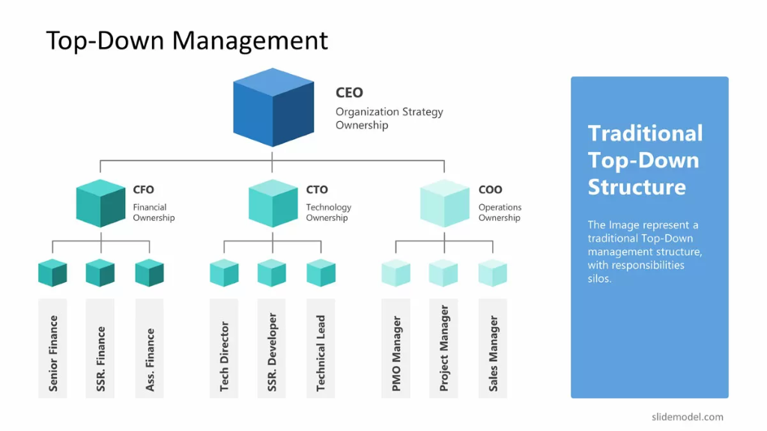
Figure 1 [2]

Taking the abovementioned information into account I would recommend that CyStresSolution implement a modified version of the T.D approach. This approach will take all the characteristics of the T.D approach but implement policy to ensure that plans are created by those with knowledge of information and data security practice and convention, where those without experience should be limited to an advisory and oversight role.

Policies, procedures and compliance
When designing a new data and information security policy it is important to comply and adhere to pre-established conventions in order to ensure the policy is on par with other organization's policy. This is especially true if sensitive data is shared with external organizations [3]. As a minimum the policies and procedures should be based on meeting the minimum protections that are set out in the law for the country where the data is being handled, in the case of the UK this would be the 'data protection act 2018' more commonly known as GDPR [4,5]. GDPR sets out how organizations can collect, use and store peoples personal data. Therefore all policies should be in line with GDPR. It is also worth noting that there are many standards and templates for security policies, an example is the ACM code of ethics which are a good starting point for policies.

For CyStresSolution this means that the management should collaborate to create a unified data security policy that fulfills the requirements of local legislation and best practices. Below is a short list of some items that may will be covered by a policy.
- Length of time data is stored for
- Is the data necessary
- How should the data be stored

Once a security policy has been established the organization should then go onto create procedures that are aimed at fulfilling the ethos of the security policy. It is important to note the difference between policy and procedure, policy is the overall goal that should be targeted whereas the procedures are the physical steps taken but users or employees to fulfill the policy. An example of a procedure may be, of the policy states that data should only be stored for a maximum of six months the procedure would be to ensure that all data stored for more than six months is either deleted or reviewed. However policy and procedure do not only apply to the data but also the employees. As part of the security policy provisions should be made to ensure that employees are doing their parts to ensure the safety and integrity of the data that they work on. This will come in the forms of setting policy for how users can access the system that stores the data. This is the type of policy that must be closely monitored as any break in the policy by an employee may lead to data being compromised [5].

Once the organization holds the data it is their responsibility to protect that data at all times, this is why protections should be put in place at every point at which the data will pass. This means securing the data as it moves and as its stored, this is where a security policy will define the measures that need to be implemented to ensure this is the case. This may take the form of implementing VPN technologies if the data needs to be transferred offsite [7], or implementing network firewalls to ensure no-one outside the organization can access the network, therefore maintaining the DMZ. Policy does not only cover the digital space however, in order for a secure network to remain so the physical technologies that defend it must be protected, this means ensuring the physical equipment is secure with physical access control.

Planning and governance
Once a policy is in place and implemented it is important that the work of ensuring data security does not cease. Planning should always be underway for future network or procedure updates as the world of cyber security is always developing with new threats arise and old ones subsiding, this is why an organization should ensure that there is a team in place that can constantly and consistently review new threats, like new software vulnerabilities and plan changes accordingly [8]. This is also where the idea of governance comes in, this is the principle that someone should maintain overall responsibility for the data and its protection, in an ideal scenario this would be a dedicated lead at the head of a team but in smaller organizations this responsibility may fall on someone inexperienced and or overworked, this is why it is important to plan for this in the policy stage and have long term goals in mins. Furthermore when maintaining a secure system it is important to foster a culture of communication with employees as identifying issues and vulnerabilities as soon as possible can allow them to addressed and the risk minimized in the shortest possible time period [9].

Risk management
Managing risk is a key part of maintain data integrity as the if all risks are managed to the best of the organizations ability the probability of a breach or attack taking place and causing harm to data or its integrity is low. As previously mentioned one of the most effective ways of mitigating risk is ensuring that there is constant monitoring of any new potential threats and staying on top of any emerging trends in the cybersecurity space. It is important to note that there are some risks that cannot be completely eliminated, such as the risk of a user's login credentials being compromised, this can be mitigated by implementing technologies such as 2FA to help mitigate the risks but it is impossible to remove the risk [10]. This is why it is important to plan for events that any events that may transpire from the risks so that If the risks become active appropriate measures can be taken to reduce the fallout and damage to the organization. There are many frameworks that can be developed or implemented to help in the process of risk management, the most common of these is a risk assessment framework that can allow for periodical risk assessment to be performed in order to identify and categorize possible new risks and help develop solutions to eliminate or mitigate said risks figure 2 shows an example of a risk assessment.

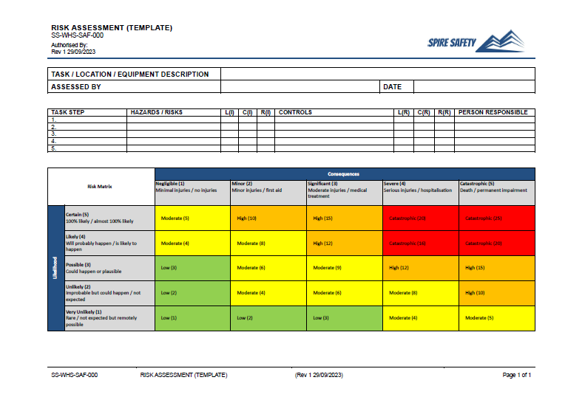
Figure 2 [11]

Contingency planning
Being able to respond to an emergency in a quick and meaningful way is the backbone of having a robust security and business policy. The ability to return to business as usual is both important for the organization and its customers, for the customers a quick return to service reduces trust in the organization which then benefits from decreased reputation loss. The risk management process acts as the starting point when developing a contingency plan, a risk assessment can be used to identify areas of risk that need to be considered. If the discovered risks are of a nature that cannot be overcome it is then necessary to put plans into place for if that risk becomes active. An example of a contingency plan would be if a security vulnerability is discovered in software that may take time to patch, a contingency plan will be put into place that will instruct employees how to respond to protect data and preserve service functionality. However it is important to note that no all threats are known so it is vital to have generalized plans to combat less specific threats like a general data breach or hardware failure. To manage recovery priorities an assessment of services should be conducted to create a list of priorities so that the most critical infrastructure can be restored first to restore service and safeguard against further risk [11].

The other side of risk management and disaster recovery is protecting against physical threats and risks that are not caused maliciously. These risks can range from flooding due to natural disaster or fire. In these cases it is important to produce a disaster recovery plan that can prepare the organization for these types of risk. This should also be implemented at the planning stage so that redundancy can be built into the system, this could take the form of off-site backups for critical data [12].

Discussion of approach Conclusion
In this review I have outlined a variety of procedures and methods that could be employed in order to produce a robust data security platform that is both redundant and compliant with various standards and legislations. I believe that the processes that I have outlined are suitable for this organization as they are based on standards outlined by well-respected agencies in the cybersecurity landscape, and furthermore the review is though in its approach to various challenges that may be encountered when operating a cybersecurity business.
However if given more time to develop this proposal I would spend more time exploring types of specific hardware and software that could be implanted and the benefits and shortcomings that this would provide

References

[1] M. Brady and A. Walsh, "Setting strategic direction: a top down or bottom up process?" Business Strategy Series, vol. 9, no. 1, pp.5–11, 2007.
[2] S. Model and G. Viera, "How to Decide Between Top Down & Bottom Up Management Styles." SlideModel. https://slidemodel.com/how-to-decide-between-top-down-bottom-up-management-styles/ (accessed Dec 12).
[3] J. O. Oyelami and A. M. Kassim, "Cyber security defence policies: A proposed guidelines for organisations cyber security practices," International Journal of Advanced Computer Science and Applications, vol. 11, no. 8, 2020.
[4] UK government. "The Data Protection Act." Gov.uk. https://www.gov.uk/data-protection#:~:text=The%20Data%20Protection%20Act%202018%20is%20the%20UK's%20implementation%20of,called%20'data%20protection%20principles (accessed dec 12).
[5] UK government. "Data Protection Act 2018." Legislation.gov.uk. https://www.legislation.gov.uk/ukpga/2018/12/introduction (accessed Dec 12).
[7] V. Bandari, "Enterprise Data Security Measures: A Comparative Review of Effectiveness and Risks Across Different Industries and Organization Types," International Journal of Business Intelligence and Big Data Analytics, vol. 6, no. 1, pp.1–11, January 20 2023. Accessed: Dec 12, 2024, [Online]. Available: https://research.tensorgate.org/index.php/IJBIBDA/article/view/3
[8] Y. Li and Q. Liu, "A comprehensive review study of cyber-attacks and cyber security; Emerging trends and recent developments," Energy Reports, vol. 7, pp.8176–8186, -11-01 2021. doi: 10.1016/j.egyr.2021.08.126. Accessed: Dec 12, 2024, [Online]. Available: https://www.sciencedirect.com/science/article/pii/S2352484721007289
[9] J. R. Nurse, "Effective communication of cyber security risks," 7th International Scientific Conference on Security and Protection of Information (SPI 2013), 2013.
[10] I. Lee, "Cybersecurity: Risk management framework and investment cost analysis," Business Horizons, vol. 64, no. 5, pp.659–671, -09-01 2021. doi: 10.1016/j.bushor.2021.02.022. Accessed: Dec 12, 2024, [Online]. Available: https://www.sciencedirect.com/science/article/pii/S0007681321000240
[11] Spire Safety, "Free Risk Assessment Template - Spire Safety Consultants", Spire Safety, https://spiresafety.com.au/resources/free-risk-assessment-template/ (accessed Dec 12, 2024).
[12] P. Fallara, "Disaster recovery planning," IEEE Potentials, vol. 23, no. 5, pp.42–44, 2004. doi: 10.1109/MP.2004.1301248.

