Georgia Whitehorn
1800474
ECAD7004 Researching the Learning.
“What are teacher perceptions and understanding towards trauma informed approaches in drama lessons?”
APPENDIX

Appendix 1: Ethical Approval Form.

Appendix 2a: Blank consent form.
Appendix 2b: Participant information letter.
Appendix 3a, b, c, d & e: Completed participant consent forms.

Appendix 4: Participant questionnaire.

Appendix 5a, b, c & d: Completed participant questionnaires.

Appendix 6: Observation Schedule.

Appendix 7: Observation Notes Template.

Appendix 8a, b, c & d: Completed observation notes.

Appendix 9: Questionnaire responses presented as pie charts.

Appendix 1: Ethical Approval Form
APPLICATION FOR ETHICAL APPROVAL

RESEARCH STUDENTS
This form is to be completed by the student within SIX months for full-time students and TWELVE months for part time students, after the commencement of the research degree or following progression to Part Two of your course.

Once complete, submit this form via the MyTSD Doctoral College Portal at (https://mytsd.uwtsd.ac.uk).

This document is also available in Welsh.

RESEARCH STAFF ONLY
All communications relating to this application during its processing must be in writing and emailed to pgresearch@uwtsd.ac.uk , with the title ‘Ethical Approval’ followed by your name.

STUDENTS ON UNDERGRADUATE OR TAUGHT MASTERS PROGRAMMES should submit this form (and receive the outcome) via systems explained to you by the supervisor/module leader.

In order for research to result in benefit and minimise risk of harm, it must be conducted ethically. A researcher may not be covered by the University’s insurance if ethical approval has not been obtained prior to commencement.

The University follows the OECD Frascati manual definition of research activity: “creative work undertaken on a systematic basis in order to increase the stock of knowledge, including knowledge of man, culture and society, and the use of this stock of knowledge to devise new applications”. As such this covers activities undertaken by members of staff, postgraduate research students, and both taught postgraduate and undergraduate students working on dissertations/projects.

The individual undertaking the research activity is known as the “principal researcher”.

Ethical approval is not required for routine audits, performance reviews, quality assurance studies, testing within normal educational requirements, and literary or artistic criticism.

Please read the notes for guidance before completing ALL sections of the form.

This form must be completed and approved prior to undertaking any research activity. Please see Checklist for details of process for different categories of application.

SECTION A: About You (Principal Researcher)
1 | Full Name: |  | Georgia Lowri Whitehorn
2 | Tick all boxes that apply: |  | Member of staff: | ☐ | Honorary research fellow: | ☐
 | Undergraduate Student | ☐ | Taught Postgraduate Student | ☒ | Postgraduate Research Student | ☐

3 | Institute/Academic Discipline/Centre: | University of Wales Trinity Saint David
4 | Campus: | Swansea
5 | E-mail address: | 1800474@student.uwtsd.ac.uk
6 | Contact Telephone Number: | 07446127370
 | For students:
7 | Student Number: | 1800474
8 | Programme of Study: | PGCE Secondary Drama with QTS
9 | Director of Studies/Supervisor: | Catherine Morgan

SECTION B: Approval for Research Activity
1 | Has the research activity received approval in principle?  (please check the Guidance Notes as to the appropriate approval process for different levels of research by different categories of individual) |  | YES | ☒ | NO | ☐
 |  |  |  |  | Date
2 | If Yes, please indicate source of approval (and date where known): Approval in principle must be obtained from the relevant source prior to seeking ethical approval | Research Degrees Committee |  | ☐
2 |  | Institute Research Committee |  | ☐
2 |  | Other (write in)  Catherine Morgan |  | ☒ | 15/3/2024

SECTION C: Internal and External Ethical Guidance Materials
 | Please list the core ethical guidance documents that have been referred to during the completion of this form (including any discipline-specific codes of research ethics, location-specific codes of research ethics, and also any specific ethical guidance relating to the proposed methodology). Please tick to confirm that your research proposal adheres to these codes and guidelines. You may add rows to this table if needed.
1 | UWTSD Research Ethics & Integrity Code of Practice | ☒
2 | UWTSD Research Data Management Policy | ☒
3 | British Educational Research Association (BERA) Ethical Guidelines for Educational Research, fourth edition (2018) | ☒

SECTION D: External Collaborative Research Activity
If there are external collaborators then you should gain consent from the contact persons to share their personal data with the university. If there are no external collaborators then leave this section blank and continue to section E.
1 | Institution
2 | Contact person name
3 | Contact person e-mail address
4 | Is your research externally funded? |  | YES | ☐ | NO |  | ☐
5 | Are you in receipt of a KESS scholarship? |  | YES | ☐ | NO |  | ☐
6 | Are you specifically employed to undertake this research in either a paid or voluntary capacity? | Voluntary | YES | ☐ | NO | ☐
7 |  | Employed | YES | ☐ | NO | ☐
8 | Is the research being undertaken within an existing UWTSD Athrofa Professional Learning Partnership (APLP)? | If YES then the permission question below does not need to be answered. | YES | ☐ | NO |  | ☐
9 | Has permission to undertake the research has been provided by the partner organisation? | (If YES attach copy)  If NO the application cannot continue | YES | ☐ | NO |  | ☐

Where research activity is carried out in collaboration with an external organisation
10 | Does this organisation have its own ethics approval system? | YES | ☐ | NO | ☐
 | If Yes, please attach a copy of any final approval (or interim approval) from the organisation (this may be a copy of an email if appropriate).

SECTION E: Details of Research Activity
1 | Indicative title: | What are teacher perceptions and understanding towards trauma informed approaches in drama lessons?
2 | Proposed start date: | 8/4/2024 | Proposed end date: | 31/7/2024
Introduction to the Research (maximum 300 words per section)
Ensure that you write for a Non-Specialist Audience when outlining your response to the points below:
- Purpose of Research Activity
- Proposed Research Question
- Aims of Research Activity
- Objectives of Research Activity
Demonstrate, briefly, how Existing Research has informed the proposed activity and explain
- What the research activity will add to the body of knowledge
- How it addresses an area of importance.
3 | Purpose of Research Activity  The purpose of this research activity is to support me in becoming an evidence based practitioner, to improve my research skills and draw on wider reading to inform my teaching practice.  (this box should expand as you type)
4 | Research Question  What are teacher perceptions and understanding towards trauma informed approaches in drama lessons?  (this box should expand as you type)
5 | Aims of Research Activity  As a researcher, I would like to develop my knowledge around trauma informed approaches in a drama classroom.  My aims as a researcher are to explore the teacher’s opinions, considerations and implementation of trauma informed approaches and practice in a drama classroom.  (this box should expand as you type)
6 | Objectives of Research Activity  To meet the aims, I will gather information from teachers by creating a questionnaire and completing observations that focus on staff practice and not learner participation.  (this box should expand as you type)
Proposed methods (maximum 600 words)
Provide a brief summary of all the methods that may be used in the research activity, making it clear what specific techniques may be used. If methods other than those listed in this section are deemed appropriate later, additional ethical approval for those methods will be needed. You do not need to justify the methods here, but should instead describe how you intend to collect the data necessary for you to complete your project.
7 | Questionnaire- qualitative and quantitive data.  The questions asked will be a combination of open, closed and scale. I will use the Likert Scale in regards to the scale questions.  I hope to gain unbiased and truthful responses from this research method by keeping the responses anonymous.  Observations- qualitative data.  The observations will be classed as a combination of structured. The predetermined category will be the knowledge and implementation of a trauma informed approach by the teachers, and how these features present themselves during drama lessons.  The observations will be documented in note form and will not reveal the identity of the participant.  (this box should expand as you type)
Location of research activity
Identify all locations where research activity will take place.
8 | The research will be undertaken in a Swansea based comprehensive school.  (this box should expand as you type)
Research activity outside of the UK
If research activity will take place overseas, you are responsible for ensuring that local ethical considerations are complied with and that the relevant permissions are sought. Specify any local guidelines (e.g. from local professional associations/learned societies/universities) that exist and whether these involve any ethical stipulations beyond those usual in the UK (provide details of any licenses or permissions required). Also specify whether there are any specific ethical issues raised by the local context in which the research activity is taking place, for example, particular cultural and/or legal sensitivities or vulnerabilities of participants. If you live in the country where you will do the research then please state this.
9 | (this box should expand as you type)

10 | Use of documentation not in the public domain: Are any documents NOT publicly available? | NO | ☒
10 |  | YES | ☐
11 | If Yes, please provide details here of how you will gain access to specific documentation that is not in the public domain and that this is in accordance with the current data protection law of the country in question and that of England and Wales.  (this box should expand as you type)

 | Does your research relate to one or more of the seven aims of the Well-being of Future Generations (Wales) Act 2015? | YES | NO
12 | A prosperous Wales | ☐ | ☒
13 | A resilient Wales | ☒ | ☐
14 | A healthier Wales | ☐ | ☒
15 | A more equal Wales | ☐ | ☒
16 | A Wales of cohesive communities | ☐ | ☒
17 | A Wales of vibrant culture and thriving Welsh language | ☐ | ☒
18 | A globally responsible Wales | ☐ | ☒
19 | If YES to any of the above, please give details:
Encourages teachers to be non-judgemental and responsive, not reactive to learner behaviours in the classroom. Encourages teachers to recognise the signs, symptoms and impact of trauma in young people and adapt their practice to be more inclusive.

(this box should expand as you type)

SECTION F: Scope of Research Activity
 | Will the research activity include: | YES | NO
1 | Use of a questionnaire or similar research instrument? | ☒ | ☐
2 | Use of interviews? | ☐ | ☒
3 | Use of focus groups? | ☐ | ☒
4 | Use of participant diaries? | ☐ | ☒
5 | Use of video or audio recording? | ☐ | ☒
6 | Use of computer-generated log files? | ☐ | ☒
7 | Participant observation with their knowledge? | ☒ | ☐
8 | Participant observation without their knowledge? | ☐ | ☒
9 | Access to personal or confidential information without the participants’ specific consent? | ☐ | ☒
10 | Administration of any questions, test stimuli, presentation that may be experienced as physically, mentally or emotionally harmful / offensive? | ☐ | ☒
11 | Performance of any acts which may cause embarrassment or affect self-esteem? | ☐ | ☒
12 | Investigation of participants involved in illegal activities? | ☐ | ☒
13 | Use of procedures that involve deception? | ☐ | ☒
14 | Administration of any substance, agent or placebo? | ☐ | ☒
15 | Working with live vertebrate animals? | ☐ | ☒
16 | Procedures that may have a negative impact on the environment? | ☐ | ☒
17 | Other primary data collection methods. Please indicate the type of data collection method(s) below. | ☐ | ☒
 | Details of any other primary data collection method:  (this box should expand as you type) | ☐ | ☒
If NO to every question, then the research activity is (ethically) low risk and may be exempt from some of the following sections (please refer to Guidance Notes).

If YES to any question, then no research activity should be undertaken until full ethical approval has been obtained.

SECTION G: Intended Participants
If there are no participants then do not complete this section, but go directly to section H.

 | Who are the intended participants: | YES | NO
1 | Students or staff at the University? | ☐ | ☒
2 | Adults (over the age of 18 and competent to give consent)? | ☒ | ☐
3 | Vulnerable adults? | ☐ | ☒
4 | Children and Young People under the age of 18? (Consent from Parent, Carer or Guardian will be required) | ☐ | ☒
5 | Prisoners? | ☐ | ☒
6 | Young offenders? | ☐ | ☒
7 | Those who could be considered to have a particularly dependent relationship with the investigator or a gatekeeper? | ☐ | ☒
8 | People engaged in illegal activities? | ☐ | ☒
9 | Others. Please indicate the participants below, and specifically any group who may be unable to give consent. | ☐ | ☒
 | Details of any other participant groups:  (this box should expand as you type) | ☐ | ☒

Participant numbers and source
Provide an estimate of the expected number of participants. How will you identify participants and how will they be recruited?
10 | How many participants are expected? | There will be a maximum of 5 participants.  (this box should expand as you type)
11 | Who will the participants be? | The participants will be one specialist drama teacher and 4 non-specialist drama teachers.  (this box should expand as you type)
12 | How will you identify the participants? | The participants identified will be teachers who teach drama in school.  (this box should expand as you type)

 | Information for participants: | YES | NO | N/A
13 | Will you describe the main research procedures to participants in advance, so that they are informed about what to expect? | ☒ | ☐ | ☐
14 | Will you tell participants that their participation is voluntary? | ☒ | ☐ | ☐
15 | Will you obtain written consent for participation? | ☒ | ☐ | ☐
16 | Will you explain to participants that refusal to participate in the research will not affect their treatment or education (if relevant)? | ☒ | ☐ | ☐
17 | If the research is observational, will you ask participants for their consent to being observed? | ☒ | ☐ | ☐
18 | Will you tell participants that they may withdraw from the research at any time and for any reason? | ☒ | ☐ | ☐
19 | With questionnaires, will you give participants the option of omitting questions they do not want to answer? | ☒ | ☐ | ☐
20 | Will you tell participants that their data will be treated with full confidentiality and that, if published, it will not be identifiable as theirs? | ☒ | ☐ | ☐
21 | Will you debrief participants at the end of their participation, in a way appropriate to the type of research undertaken? | ☒ | ☐ | ☐
22 | If NO to any of above questions, please give an explanation
 | (this box should expand as you type)

 | Information for participants: | YES | NO | N/A
24 | Will participants be paid? | ☐ | ☐ | ☒
25 | Is specialist electrical or other equipment to be used with participants? | ☐ | ☐ | ☒
26 | Are there any financial or other interests to the investigator or University arising from this study? | ☐ | ☐ | ☒
27 | Will the research activity involve deliberately misleading participants in any way, or the partial or full concealment of the specific study aims? | ☐ | ☐ | ☒
28 | If YES to any question, please provide full details
 | (this box should expand as you type)

SECTION H: Anticipated Risks

Outline any anticipated risks that may adversely affect any of the participants, the researchers and/or the University, and the steps that will be taken to address them.

If you have completed a full risk assessment (for example as required by a laboratory, or external research collaborator) you may append that to this form.
1 | Full risk assessment completed and appended? |  | Yes | ☐
1 |  |  | No | ☒
2 | Risks to participants  For example: sector-specific health & safety, emotional distress, financial disclosure, physical harm, transfer of personal data, sensitive organisational information
 | Risk to participants:  - Physical or psychological harm  - Emotional distress  - Disturbance to relationships  - Risk that participants may feel coerced into giving positive or biased responses to questions due to relationships and position in the organisation as an employee  (this box should expand as you type) | How you will mitigate the risk to participants:  ate the risk to participants:  - Ensure informed consent and assent process are robust and thorough e.g. clarity regarding the purposes, benefits and risks of taking part in the research, ensuring that young people fully understand their own position as a teacher and participant in relation to the research, and their right to withdraw from it at any time. Work collaboratively with the participants in promoting an understanding of the research purposes, and the rights of participating in it. I will ensure robust procedures for maintaining the confidentiality and anonymity of all participants to the research. Avoid revealing any stigmatising information regarding any of the participants, ensuring that their participation remains confidential. I will ensure procedures for data storage are in accordance with university procedures and ethical guidelines.  - I will ensure access to appropriate support should this become evident and reconsider/revise the approach being taken. I will work with gatekeepers in clarifying the availability of support services for those participating in the research. I will work collaboratively with gatekeepers in exploring any issues that may arise in the interviews which may be a cause of distress to each of the young people taking part in the research. I will ensure, as fully as possible, that participants understand the nature of the research, its purposes, and possible implications in order to avoid misunderstandings and manage expectations. Ensure regular followup communication with participants in order to re-affirm consent and to update them on the progress of the research.  - I will ensure to avoid discomfort and disagreement during the focus group discussion, I will develop a discussion guide which will define the parameters and scope of the questions being discussed. Participants will be given a participant information sheet intended to remind them of the following: Context and background to the research; Purpose of the discussion; Research questions; Informed Consent; Specific questions/statements to be addressed; Use of the data gathered in the discussion; Closure and briefing on the use of the information and data gathered in the discussion. I will moderate the discussion, providing reminders throughout as to the purpose of the discussion so as to ensure professional decorum is maintained in line with UWTSD codes of conduct. During the discussion if group members begin to be critical in a way that exposes participants to any degree of risk to the reputation of individuals or UWTSD, I will remind group members of their obligations with regard to professional conduct.  - I will ensure clarity with staff regarding the aims and focus of the research. Minimise disturbance of day-to-day activities within the provision due to the research project. I will ensure the confidentiality and anonymity of those participating in the research at all times. I will ensure appropriate and secure storage of data. Reassure participants that the information that they provide will not be disclosed without their consent. I will ensure interviews are conducted in a suitably confidential environment. Work with gatekeepers to promote an understanding of the nature of the research, and to gain assurances that the young people’s participation in it is fully supported and will not result in recrimination by staff or peers.  - I will ensure prior to the questionnaire and observations that participants will be provided with a participant information sheet with which informed consent will be sought. To avoid the risk of participants feeling coerced, a debrief and synopsised transcript of the discussion will be available to participants following the discussion.  (this box should expand as you type)
3 | If research activity may include sensitive, embarrassing or upsetting topics (e.g. sexual activity, drug use) or issues likely to disclose information requiring further action (e.g. criminal activity), give details of the procedures to deal with these issues, including any support/advice (e.g. helpline numbers) to be offered to participants. Note that where applicable, consent procedures should make it clear that if something potentially or actually illegal is discovered in the course of a project, it may need to be disclosed to the proper authorities
 | (this box should expand as you type)
4 | Risks to the investigator  For example: personal health & safety, physical harm, emotional distress, risk of accusation of harm/impropriety, conflict of interest
 | Risk to the investigator:  1) Allegations while conducting interviews.  2) Accusations of fabrication or falsification of data.  3) Concerns of coercion.  4) Participants may wish to withdraw.  5)A confidentiality breach due to data being released accidentally.  6) Risks relating to the possibility of unexpected negative emotions of the interviewees owing to, for example, an uncomfortable interview place, the anxiety for unintentional disclosure in reference to the participants or for any unintentional inappropriateness of conduct violating any possible document.  (this box should expand as you type) | How you will mitigate the risk to the investigator:  - I will ensure access to a suitable space that secures the confidentiality of the of the participant contributions, whilst also being visible to other colleagues.  - I will clarify with participants regarding access to transcripts of interviews or field notes. I will ensure debriefing with participants to include recapping on and clarifying where necessary the contributions that they have made. I will work with gatekeepers to promote a comprehensive understanding of the nature of the research project.  - It will be made explicit that participants are free to disengage and that in that event, this will not impact on assessment or outcomes of their programme of study.  - In the case of withdrawal from the participant selection, discussions would be conducted with the remaining participants and new participants will be recruited, if necessary, who will be fully briefed, and whose informed consent will be sought. For the case of a withdrawal from the staff group, a nominee will be sought in the relevant department/specialism.  - The research will be stored on the UWTSD cloud and any recordings, data or transcript will be password protected in electronic folders on UWTSD systems and subject to university protocols. However, GDPR statements will be included in any participant information and consent and that the researcher has completed training on GDPR and will ensure that all records are kept in secure cloud locations as a precaution and not on any hard drive.  - I will be cautious about the places to have interviews and choose quiet and public places. The participants are assured that all the personal data of the participants are securely stored in a safe place such as my password-protected laptop that is moved onto the shared drive. All the related laws and regulations should be carefully studied before the research activities to avoid unintentional misconduct that arouses suspicion and antagonism from authorities  (this box should expand as you type)
5 | University/institutional risks  For example: adverse publicity, financial loss, data protection
 | Risk to the University:  Reputational damage (Potential complaint against the researcher for causing emotional distress or embarrassment that could cause reputational damage)  (this box should expand as you type) | How you will mitigate the risk to the University:  I will ensure adherence to the UWTSD code of ethics and research standards and commonly agreed standards of good practice. Ensure compliance with data storage regulations and university guidelines, and security procedures. Ensure that research methodology is robust and that methods are appropriate. Adhere to the UWTSD code of conduct (and also the EWC code of conduct if you are a teacher). Establish clarity regarding procedures on reporting of disclosures in fieldwork settings. Work with partners to promote a comprehensive understanding regard the nature of the research in order to avoid misunderstandings and manage expectations  (this box should expand as you type)
6 | Environmental risks  For example: accidental spillage of pollutants, damage to local ecosystems
 | Risk to the environment:  Carbon footprint  Use of paper  (this box should expand as you type) | How you will mitigate the risk to environment:  I will ensure this research activity will mostly use electronic systems, reducing the need for bleached paper and the need for travel.  (this box should expand as you type)

 | Disclosure and Barring Service
 | If the research activity involves children or vulnerable adults, a Disclosure and Barring Service (DBS) certificate must be obtained before any contact with such participants. | YES | NO | N/A
7 | Does your research require you to hold a current DBS Certificate? | ☒ | ☐ | ☐
8 | If YES, please give the certificate number. If the certificate number is not available please write “Pending”; in this case any ethical approval will be subject to providing the appropriate certificate number. | 001837118594

SECTION I: Feedback, Consent and Confidentiality

1 | Feedback  What de-briefing and feedback will be provided to participants, how will this be done and when?
I will thank the participants for their involvement in my research.
I will confirm with them that the research is complete at the appropriate time.
I will provide my university email if the teachers wish to know the results of my research.

(this box should expand as you type)
2 | Informed consent  Describe the arrangements to inform potential participants, before providing consent, of what is involved in participating. Describe the arrangements for participants to provide full consent before data collection begins. If gaining consent in this way is inappropriate, explain how consent will be obtained and recorded in accordance with prevailing data protection legislation.
I will contact the participants via email, as they are teachers, giving them the opportunity to take part in the research project, discussing that any information that is gathered will be used only for the ECAD7004 modules and will not be shared otherwise.
Upon responding to my email that the selected participants are willing to take part, I will require them to sign a paper consent form to ensure they fully understand their rights when taking part in this research project.
Participants will be made aware that all information gathered will be kept anonymous and confidential. Participants will have the opportunity to withdraw from the research at any time.
(this box should expand as you type)
3 | Confidentiality / Anonymity  Set out how anonymity of participants and confidentiality will be ensured in any outputs. If anonymity is not being offered, explain why this is the case.
All responses from questionnaires will be kept anonymous to ensure the teachers are able to tell the truth in their answers.
As well as this, all responses will be gathered digitally to remove the risk of identification through handwriting.
The observation aspect of gathering information will be documented in the form of detailed notes to ensure that the information is accurate. The details regarding the participant will be kept anonymous when discussing the notes in the research project.

(this box should expand as you type)

SECTION J: Data Protection and Storage

 | Does the research activity involve personal data (as defined by the General Data Protection Regulation 2016 “GDPR” and the Data Protection Act 2018 “DPA”)? | YES | NO
1 | “Personal data” means any information relating to an identified or identifiable natural person (‘data subject’). An identifiable natural person is one who can be identified, directly or indirectly, in particular by reference to an identifier such as a name, an identification number, location data, an online identifier or to one or more factors specific to the physical, physiological, genetic, mental, economic, cultural or social identity of that natural person. Any video or audio recordings of participants is considered to be personal data. | ☐ | X
 | If YES, provide a description of the data and explain why this data needs to be collected:
2 | (this box should expand as you type)
 | Does it involve special category data (as defined by the GDPR)? | YES | NO
3 | “Special category data” means sensitive personal data consisting of information as to the data subjects’ –  (a) racial or ethnic origin,  (b) political opinions,  (c ) religious beliefs or other beliefs of a similar nature,  (d) membership of a trade union (within the meaning of the Trade Union and Labour Relations (Consolidation) Act 1992),  (e) physical or mental health or condition,  (f) sexual life,  (g) genetics,  (h) biometric data (as used for ID purposes), | ☐ | X
 | If YES, provide a description of the special category data and explain why this data needs to be collected:
4 | (this box should expand as you type)

 | Will data from the research activity (collected data, drafts of the thesis, or materials for publication) be stored in any of the following ways? | YES | NO
5 | Manual files (i.e. in paper form)? | ☐ | ☒
6 | University computers? | ☐ | ☒
7 | Private company computers? | ☐ | ☒
8 | Home or other personal computers? | ☒ | ☐
9 | Laptop computers/ CDs/ Portable disk-drives/ memory sticks? | ☐ | ☒
10 | “Cloud” storage or websites? | ☒ | ☐
11 | Other – specify: | ☐ | ☒
12 | For all stored data, explain the measures in place to ensure the security of the data collected, data confidentiality, including details of backup procedures, password protection, encryption, anonymisation and pseudonymisation:
All information will be stored on the Microsoft 365 One Drive that I will only have access to. The security measures to access the information are two factor authentication from myself.
When the research project is completed, all data collected will be removed.
Participants will be notified of this information.

(this box should expand as you type)

 | Data Protection
 | Will the research activity involve any of the following activities: | YES | NO
13 | Electronic transfer of data in any form? | ☒ | ☐
14 | Sharing of data with others at the University outside of the immediate research team? | ☐ | ☒
15 | Sharing of data with other organisations? | ☐ | ☒
16 | Export of data outside the UK or importing of data from outside the UK? | ☐ | ☒
17 | Use of personal addresses, postcodes, faxes, emails or telephone numbers? | ☐ | ☒
18 | Publication of data that might allow identification of individuals? | ☐ | ☒
19 | Use of data management system? | ☐ | ☒
20 | Data archiving? | ☐ | ☒
21 | If YES to any question, please provide full details, explaining how this will be conducted in accordance with the GDPR and Data Protection Act (2018) (and any international equivalents, where appropriate):
As the researcher, I will contact each teacher explaining the purpose of my research project and reiterate the research methods I have chosen.
I will ask the teachers if they are willing to participate in an anonymous questionnaire, of which the results will be kept confidential.
I will conduct the research by sending each teacher a Microsoft Word document that they will complete. I will ensure that any names are removed to ensure confidentiality is maintained. All completed questionnaires will be labelled as ‘Response A, Response B…’.

(this box should expand as you type)
22 | List all who will have access to the data generated by the research activity:
As the researcher, I will have access to the generated data.

(this box should expand as you type)
23 | List who will have control of, and act as custodian(s) for, data generated by the research activity:
As the researcher, I will have control of the data generated for the research activity.

(this box should expand as you type)
24 | Give details of data storage arrangements, including security measures in place to protect the data, where data will be stored, how long for, and in what form. Will data be archived – if so how and if not why not.
The data collecting will be stored on my Microsoft 365 One Drive which only I have access to with the use of two factor authentication as a security measure.

(this box should expand as you type)
25 | Please indicate if your data will be stored in the UWTSD Research Data Repository (see https://researchdata.uwtsd.ac.uk/ ). If so please explain. (Most relevant to academic staff)
 | (this box should expand as you type)
26 | Confirm that you have read the UWTSD guidance on data management (see https://www.uwtsd.ac.uk/library/research-data-management/) | YES | ☒
27 | Confirm that you are aware that you need to keep all data until after your research has completed or the end of your funding | YES | ☒

SECTION K: Declaration
The information which I have provided is correct and complete to the best of my knowledge. I have attempted to identify any risks and issues related to the research activity and acknowledge my obligations and the rights of the participants.

In submitting this application I hereby confirm that I undertake to ensure that the above named research activity will meet the University’s Research Ethics and Integrity Code of Practice which is published on the website: https://www.uwtsd.ac.uk/research/research-ethics/
1 | Signature of applicant: | G. Whitehorn | Date:  15/3/2024

For STUDENT Submissions:
2 | Director of Studies/Supervisor: | Catherine Morgan | Date: 15/3/2024
3 | Signature: | C. Morgan | Date: 15/3/2024

For STAFF Submissions:
4 | Academic Director/ Assistant Dean: |  | Date:
5 | Signature: |  | Date:

Checklist: Please complete the checklist below to ensure that you have completed the form according to the guidelines and attached any required documentation:
☒ | I have read the guidance notes supplied before completing the form.
☒ | I have completed ALL RELEVANT sections of the form in full.
☒ | I confirm that the research activity has received approval in principle
☐ | I have attached a copy of final/interim approval from external organisation (where appropriate)
☐ | I have attached a full risk assessment (where appropriate) ONLY TICK IF YOU HAVE ATTACHED A FULL RISK ASSESSMENT
☒ | I understand that it is my responsibility to ensure that the above named research activity will meet the University’s Research Ethics and Integrity Code of Practice.
☒ | I understand that before commencing data collection all documents aimed at respondents (including information sheets, consent forms, questionnaires, interview schedules etc.) must be confirmed by the DoS/Supervisor, module tutor or Academic Director.

RESEARCH STUDENTS ONLY
Once complete, submit this form via the MyTSD Doctoral College Portal at (https://mytsd.uwtsd.ac.uk).

RESEARCH STAFF ONLY
All communications relating to this application during its processing must be in writing and emailed to pgresearch@uwtsd.ac.uk , with the title ‘Ethical Approval’ followed by your name.

STUDENTS ON UNDERGRADUATE OR TAUGHT MASTERS PROGRAMMES should submit this form (and receive the outcome) via systems explained to you by the supervisor/module leader.

Appendix 2a: blank consent form

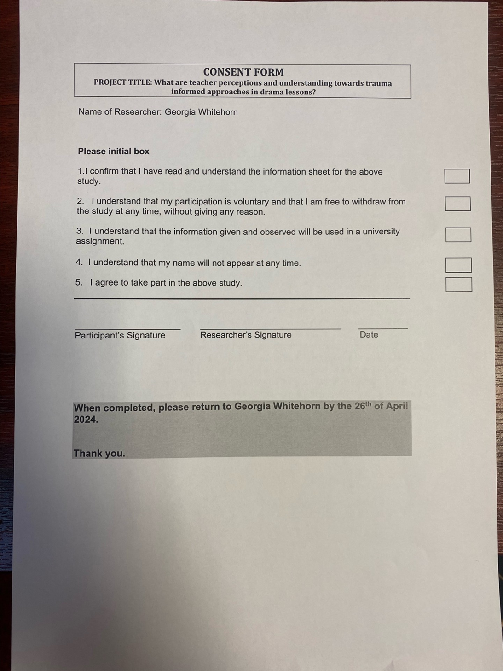
Appendix 2b: Participant information letter

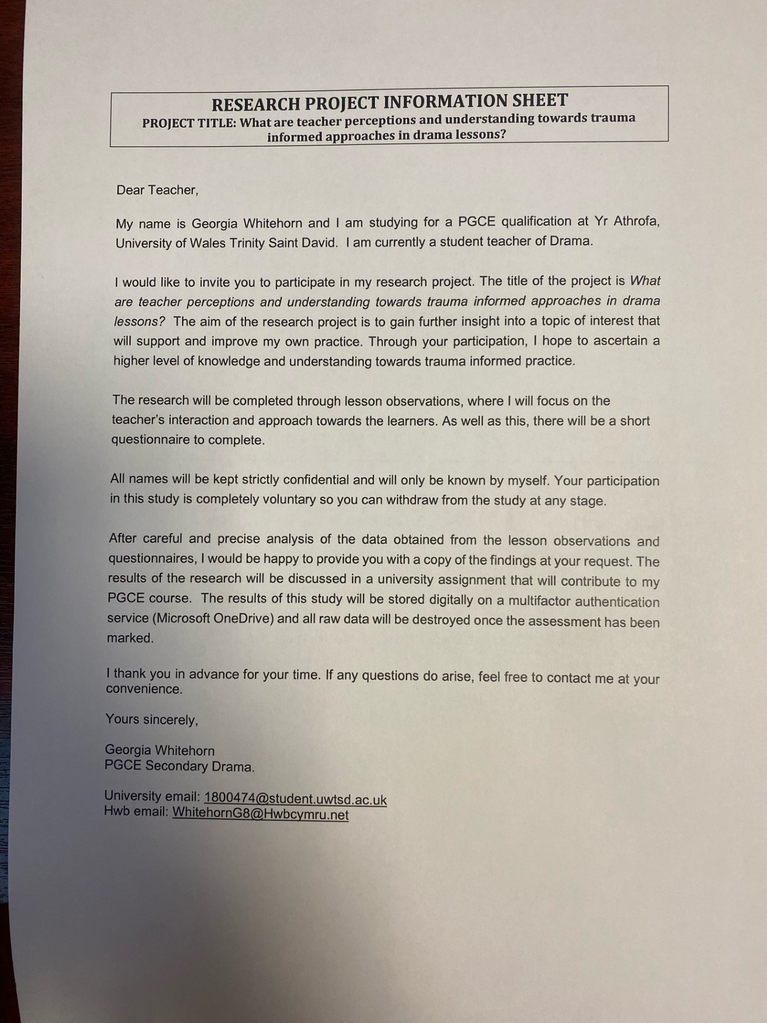

Appendix 3a: Completed participant consent form
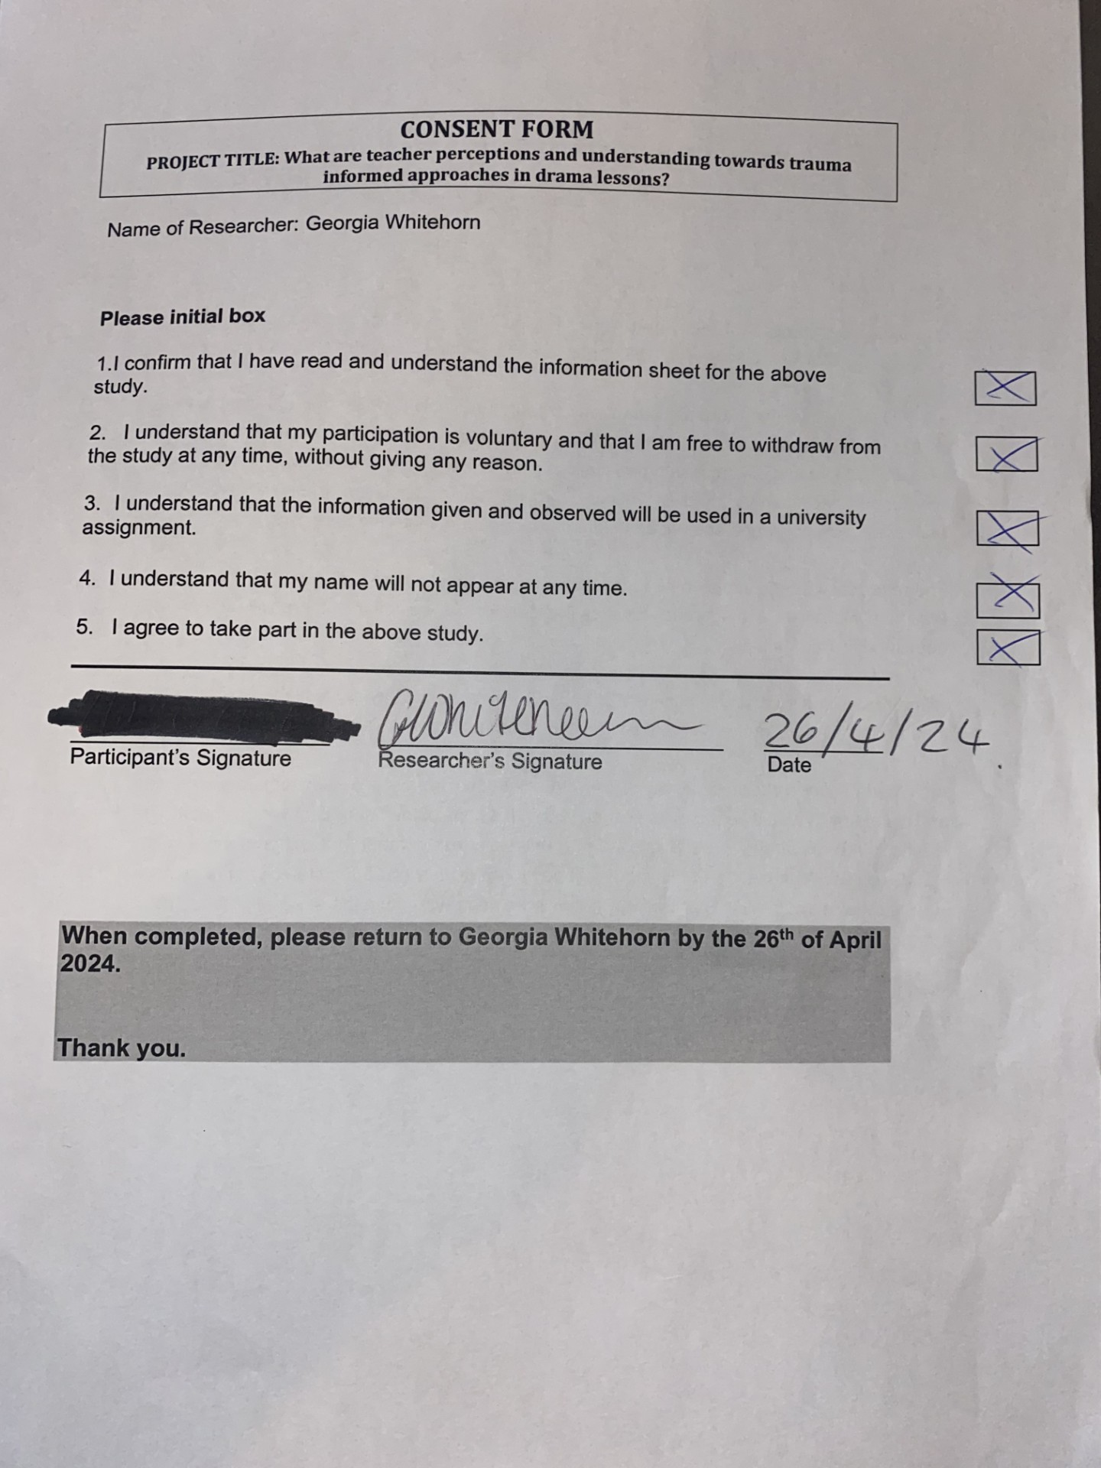
Appendix 3b: Completed participant consent form

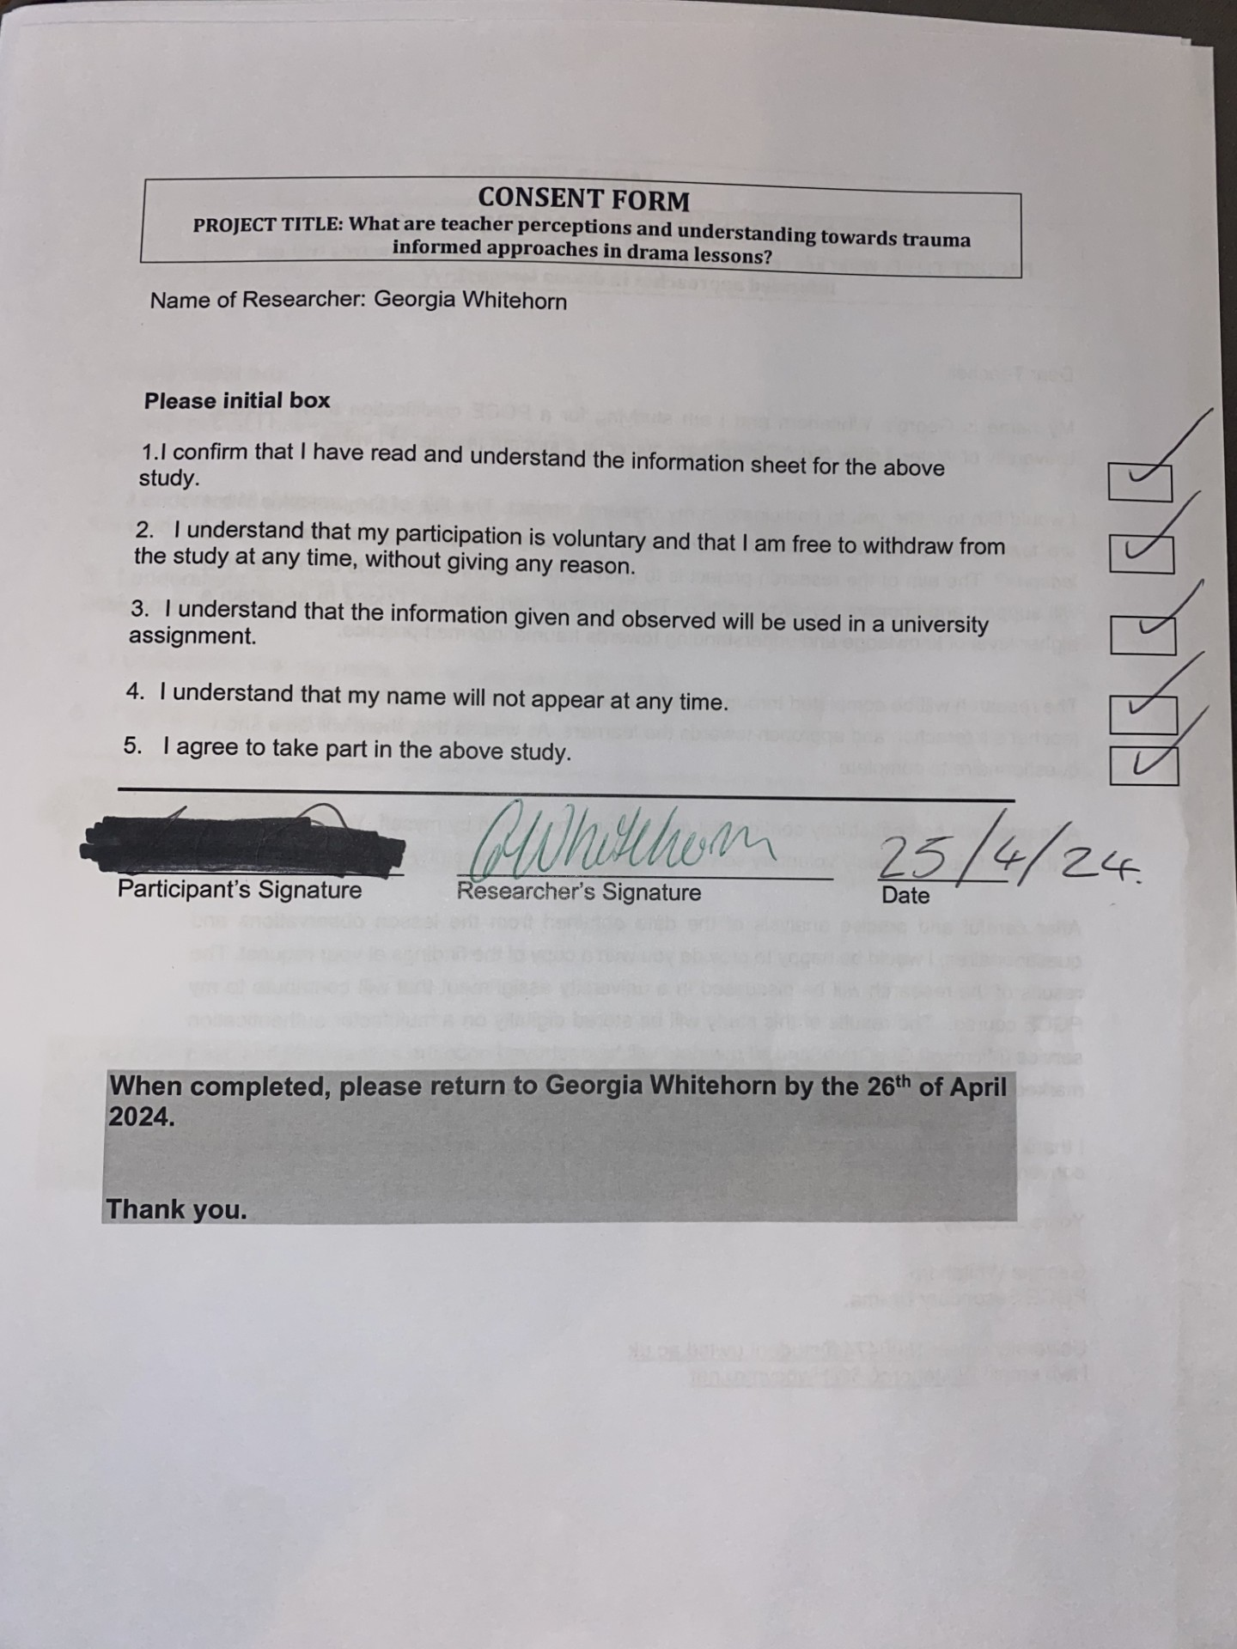
Appendix 3c: Completed participant consent form

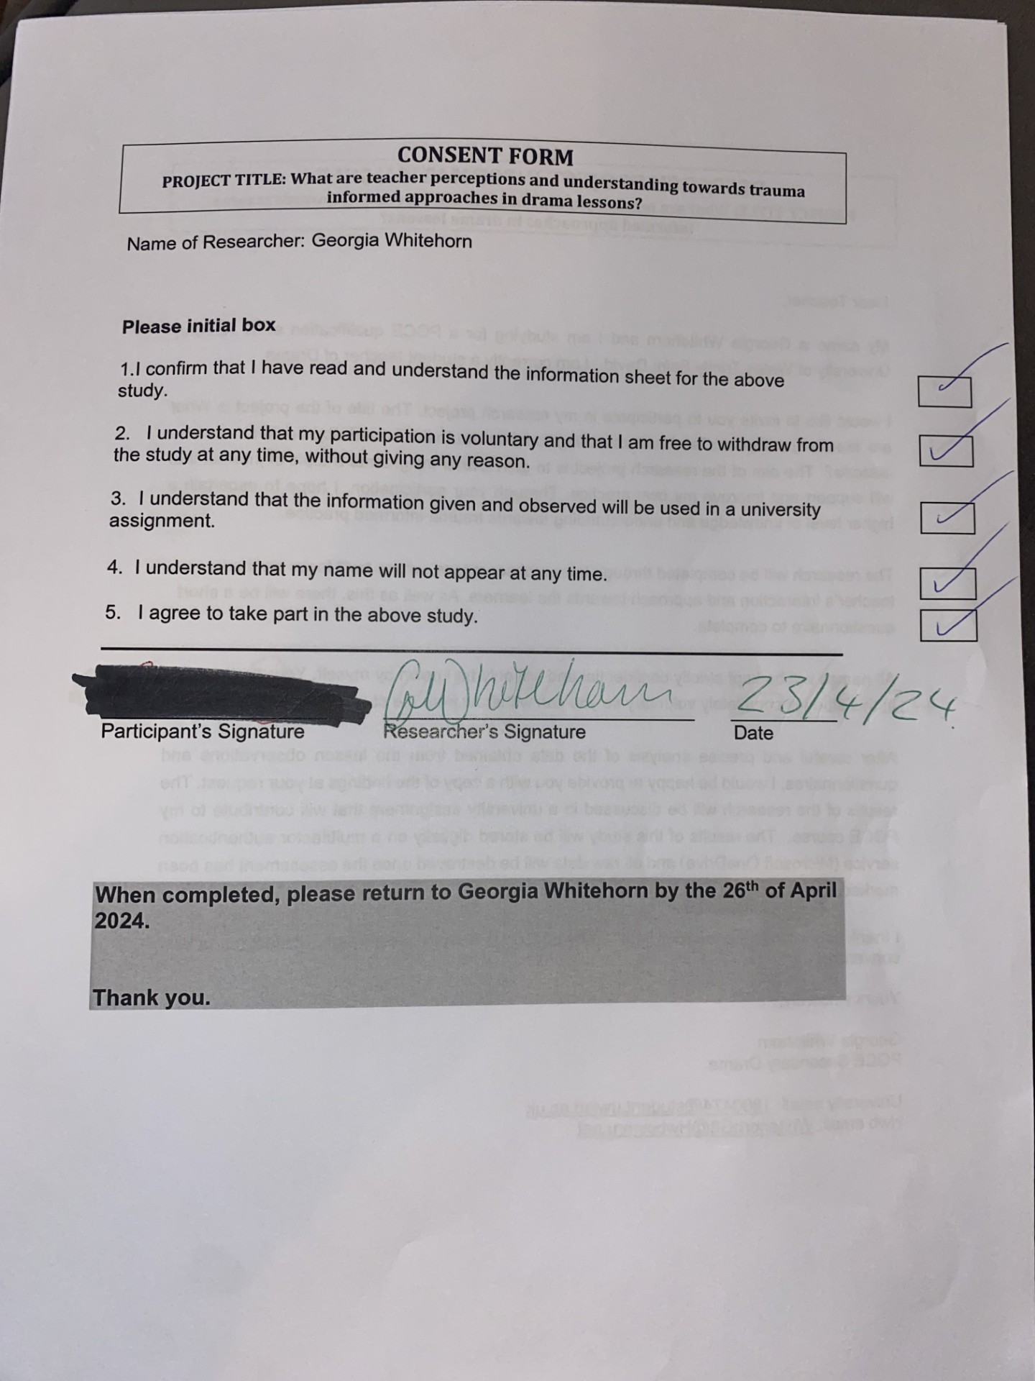
Appendix 3d: Completed participant consent form

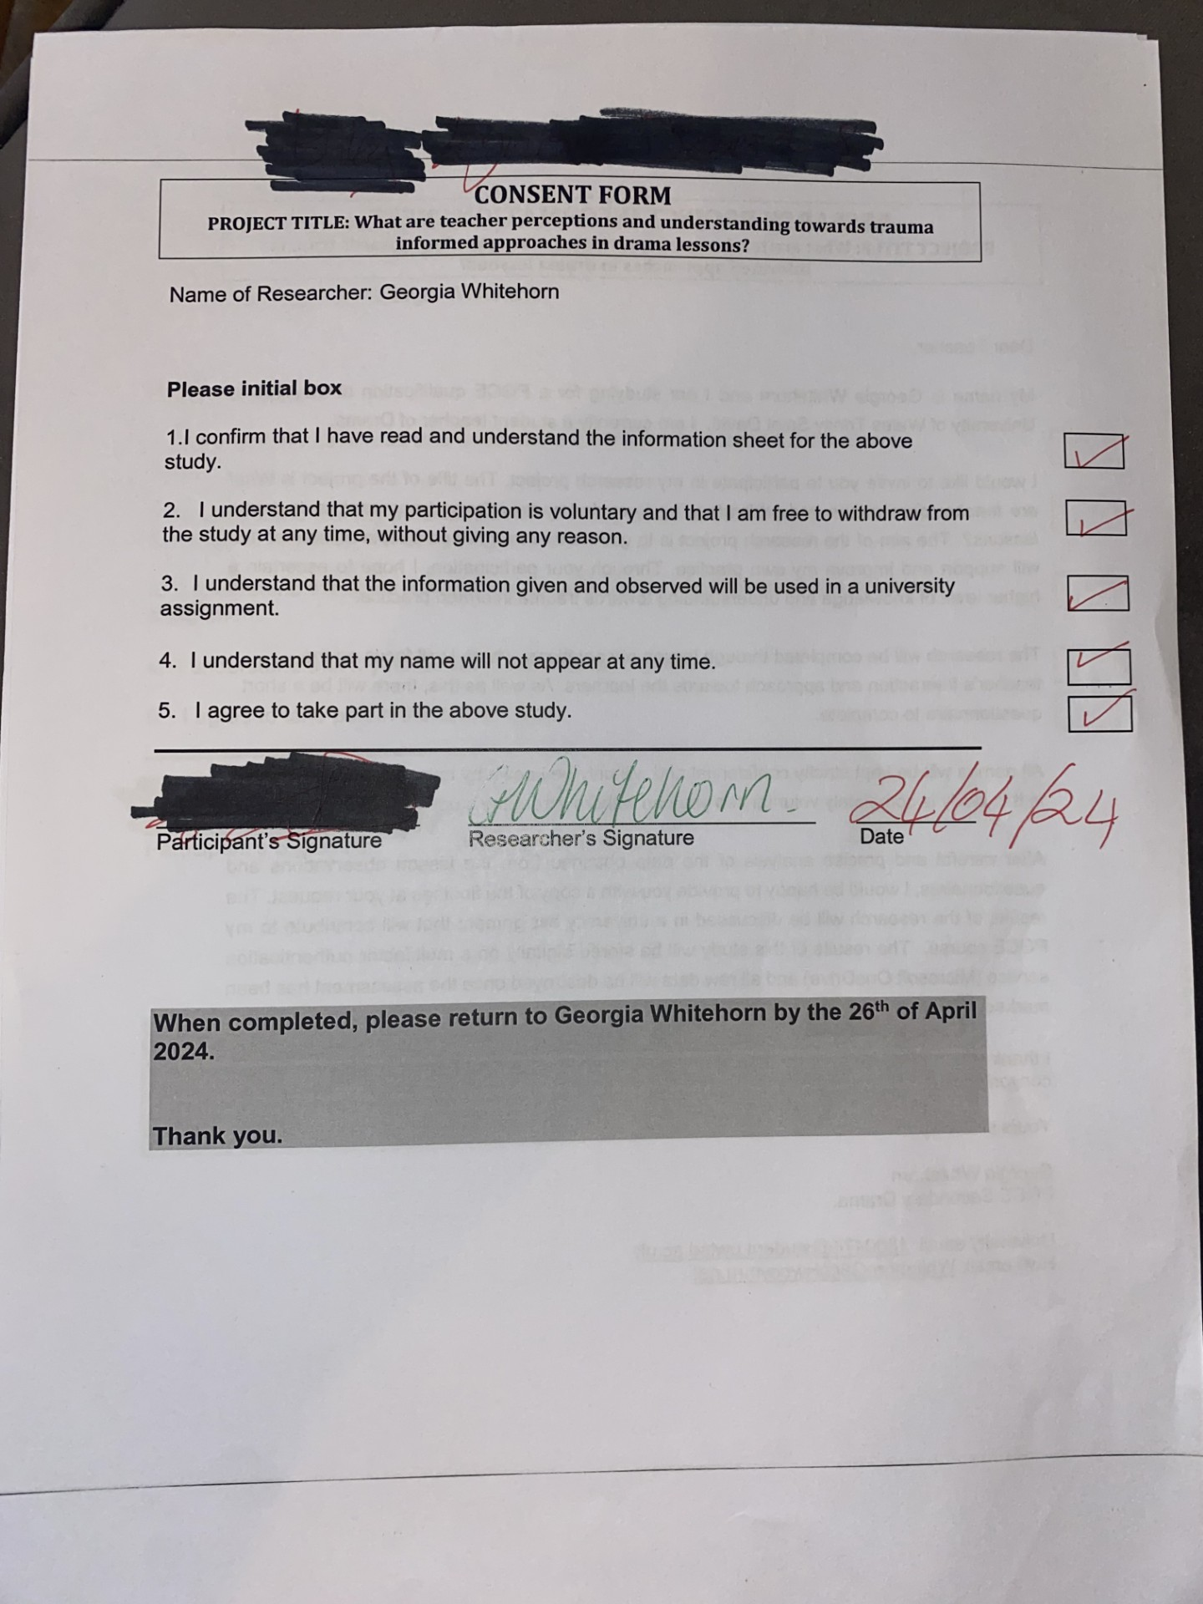

Appendix 3e: Completed participant consent form

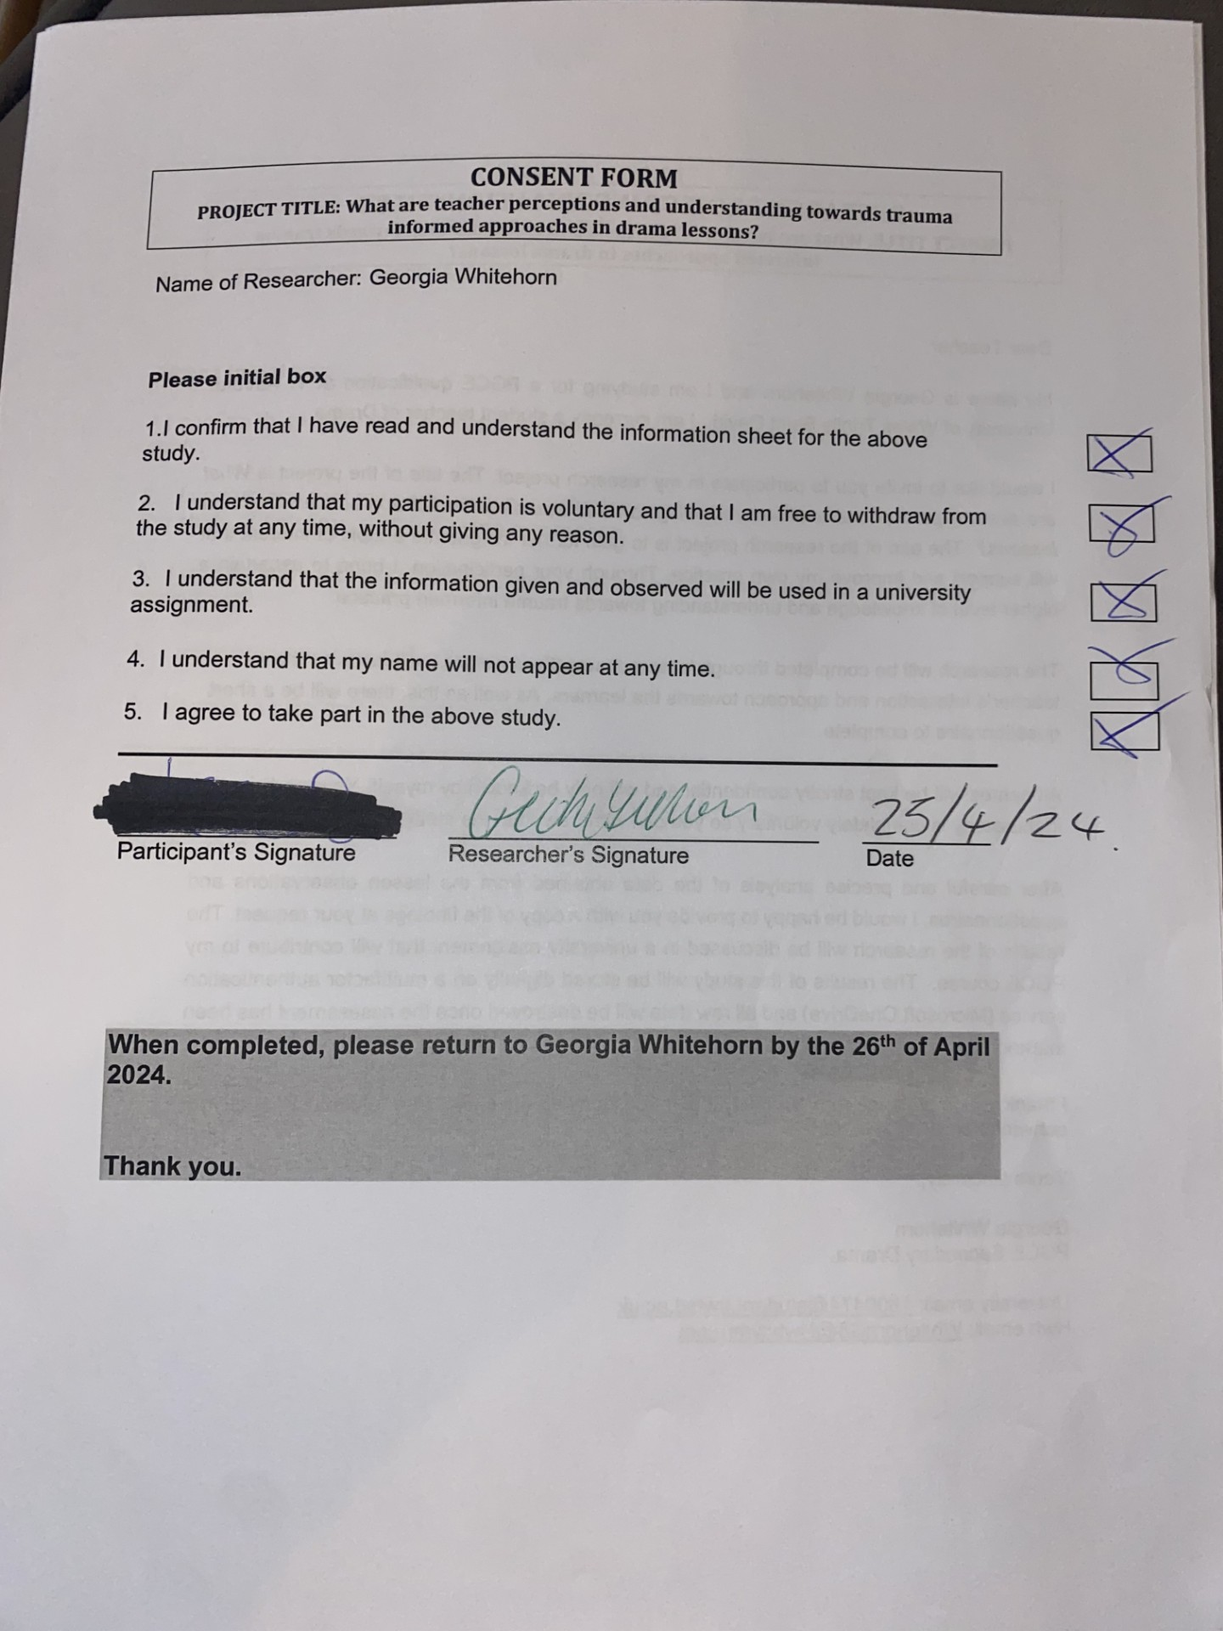
Appendix 4: Participant questionnaire

1.How many years of teaching experience do you have?
0-5 years
6-10 years
11-15 years
16-20 years
21+ years

2.How would you rate your understanding of trauma-informed approaches in general?
Excellent
Good
Fair
Poor
Very Poor

3.How would you describe a trauma informed approach in the context of a drama lesson?
4.Have you received any formal training around trauma informed approaches?
Yes
No
Unsure

5.If you answered yes to Question 4, what type of training did you receive?

6.To what extent do you implement a trauma informed approach in your drama lessons?
Always
Sometimes
Rarely
Never
7.To what extent do you agree that it is important to implement a trauma informed approach in drama lessons?
Strongly agree
Agree
Neutral
Disagree
Strongly disagree

8.Please share your experience of an occasion where you believe you have implemented a trauma informed approach in a drama lesson.

9.Where you have implemented a trauma informed approach, can you share the impact you thought it had on the learner/learners.
10.Is there anything you think you would do to improve your knowledge of a trauma informed teaching approaches?
Appendix 5a: Completed participant questionnaire

1.How many years of teaching experience do you have?
0-5 years
2.How would you rate your understanding of trauma-informed approaches in general?
Poor
3.How would you describe a
I would altar the theme or story of the script if I knew there were any pupils who might be triggered by the content because of their experiences.

4.Have you received any formal training around trauma informed approaches?
No

5.If you answered yes to Question 4, what type of training did you receive?
N/A

6.To what extent do you implement a trauma informed approach in your drama lessons?
Rarely
7.To what extent do you agree that it is important to implement a trauma informed approach in drama lessons?
Agree
8.Please share your experience of an occasion where you believe you have implemented a trauma informed approach in a drama lesson.
One choice of freeze frame was a robbery. I knew a pupil in my class had recently witnessed a robbery themselves so I took this option out and swapped it in for something else to avoid any triggers.
9.Where you have implemented a trauma informed approach, can you share the impact you thought it had on the learner/learners.
I believed that this was a sensitive initiative that hopefully meant that pupil avoided having to relive their traumatic experience.
10.Is there anything you think you would do to improve your knowledge of a trauma informed teaching approaches?
I should attend more training.

Appendix 5b: Completed participant questionnaire
1.How many years of teaching experience do you have?
6-10 years
2.How would you rate your understanding of trauma-informed approaches in general?
Fair

3.How would you describe a trauma informed approach in the context of a drama lesson?
Choosing material and stimuli which is not going to trigger students. It is difficult to think about every possible scenario that could be triggering, otherwise there would be nothing left but when planning the curriculum design I do subconsciously think about appropriateness of the tasks. Example when doing tableaus and stimuli we often use family scenarios, but keep these generic and open to interpretation as not all families are the same. I tend not to do anything that has drug, violence or sex in KS3, I know some schools study plays in year 9 with such topics but I tend to keep scripts and stimuli light hearted and child friendly as there is less chance of trauma from them.

4.Have you received any formal training around trauma informed approaches?
Unsure

5.If you answered yes to Question 4, what type of training did you receive?
n/a

6.To what extent do you implement a trauma informed approach in your drama lessons?
Sometimes

7.To what extent do you agree that it is important to implement a trauma informed approach in drama lessons?
Agree

8.Please share your experience of an occasion where you believe you have implemented a trauma informed approach in a drama lesson.
Year 11 were doing a piece called 'Walking with Shadows', it contained themes of depression, self-harm, potential suicide (barring in mind this play has been on GCSE spec to study previously), so I didn't think of potential trauma it could cause. On initial read through we discussed the themes and if anyone was uneasy with the themes they could express and we could adapt or change etc. The students were happy, but then as we were getting to finishing blocking some of the cast were struggling as they found it quite harrowing, but again we had conversations and were too far in to change the script. However, we were due to perform to year 10s and year 9, but we had just had an incident of knife crime and a death within year 9, so we had to not perform to the year 9's last minute. This was so it would not be triggering and we had to find an older/mature audience to perform to.

9.Where you have implemented a trauma informed approach, can you share the impact you thought it had on the learner/learners.
Pupils often in improvisation pupils (particularly boys) like to include violence etc, but we often have the conversation that it could be upsetting etc, and therefore conversation and discussion about such things is very important. With regards to the themes in the year 11 performance, after discussion saying things like 'having more gritty themes can have a more heightened and impactful performance resulting in higher grades' and 'remember you are acting, and can either draw from experience or we can block out and just act'. I know that sounds quite direct, but the pupils can then dethatch themselves from their situations and focus on the character they are acting. I am also aware the majority if students probably see more violence and trauma triggering situations on tv, films and games they play, so it is a fine balance at times.

10.Is there anything you think you would do to improve your knowledge of a trauma informed teaching approaches?
I would love to have further training and guidance as I feel this there is not enough freely given. Unless trauma informed approaches are delivered as a while school inset, there is no finance available for additional training on a departmental level.
I do now choose scripts and stimuli that are more suitable as a result of my previous experience so hopefully a lot less likely to trigger trauma, but this can be difficult if pupils get to chose their own stimuli etc, but I do give guidelines as to what they can and can't do.

Appendix 5c: Completed participant questionnaire

1.How many years of teaching experience do you have?
11-15 years

2.How would you rate your understanding of trauma-informed approaches in general?
Fair

3.How would you describe a trauma informed approach in the context of a drama lesson?
A sensitivity to learners' past experiences may affect planning in terms of topics covered or the content of lessons. Trigger warnings could be used where appropriate if material covers more mature themes. In a drama lesson a teacher may also be more 'tuned in' to the fact that a pupil may use something like a devised piece to reflect their past traumatic experiences.

4.Have you received any formal training around trauma informed approaches?
Yes

5.If you answered yes to Question 4, what type of training did you receive?
Inset, external speaker.

6.To what extent do you implement a trauma informed approach in your drama lessons?
Sometimes

7.To what extent do you agree that it is important to implement a trauma informed approach in drama lessons?
Agree

8.Please share your experience of an occasion where you believe you have implemented a trauma informed approach in a drama lesson.
Limited experience as a non-specialist, but I have used trigger warnings when using more sensitive materials.

9.Where you have implemented a trauma informed approach, can you share the impact you thought it had on the learner/learners.
I think more than anything, it creates a level of respect and maturity in the classroom, as pupils themselves may not be aware of the impact of trauma on their peers.

10.Is there anything you think you would do to improve your knowledge of a trauma informed teaching approaches?
As a non-specialist I would like to observe lessons where these approaches are consciously considered, as well as reading more professional literature on the topic.

Appendix 5d: Completed participant questionnaire

1.How many years of teaching experience do you have?
6-10 years

2.How would you rate your understanding of trauma-informed approaches in general?
Good

3.How would you describe a trauma informed approach in the context of a drama lesson?
Making sure learners are aware they can withdraw from practical lessons if there's any sensitive topics e.g. improvisation of a family unit that they find difficult to act out. Observe pupils engagement with the lesson and observe any signs of isolation/withdrawal. Creating a safe learning environment where pupils are empowered to take part and giving them a choice over their learning. E.g. if a pupil is too anxious to perform in front of the class they can be a director of a group or provide feedback on groups.

4.Have you received any formal training around trauma informed approaches?
No

5.If you answered yes to Question 4, what type of training did you receive?
6.To what extent do you implement a trauma informed approach in your drama lessons?
Sometimes

7.To what extent do you agree that it is important to implement a trauma informed approach in drama lessons?
Agree

8.Please share your experience of an occasion where you believe you have implemented a trauma informed approach in a drama lesson.
When pupils don't want to perform in front of the class and it causes them anxiety I have allowed them to come back on a break time to perform to just me. Building up trust between learners and empowering them to feel confident within lessons.

9.Where you have implemented a trauma informed approach, can you share the impact you thought it had on the learner/learners.
Yes

10.Is there anything you think you would do to improve your knowledge of a trauma informed teaching approaches?
Attend a course that was offered.

Appendix 6: Observation Schedule
Participant number | Year group | Observation date | Lesson number
Participant 2 | year 8 class | 03/05/2024 | 3rd lesson
Participant 3 | year 7 class | 06/05/2024 | 2nd lesson
Participant 4 | year 8 class | 07/05/2024 | 5th lesson
Participant 1 | year 9 class | 09/05/2024 | 5th lesson

Appendix 7: Observation notes template

ECAD7004
Researching the Learning
Observer name:
Event occurred | What happened? | What did the teacher do?
Summary of observation notes:

Appendix 8a: Observation notes

ECAD7004
Researching the Learning
Observer name: Georgia Whitehorn
Event occurred | What happened? | What did the teacher do?
N/A | N/A | N/A
Summary of observation notes:
No events of significance occurred during this observation.

Appendix 8b: Observation notes

ECAD7004
Researching the Learning
Observer name: Georgia Whitehorn
Event occurred | What happened? | What did the teacher do?
Yes | A learner was reluctant to perform due to anxiety. | The teacher had a conversation with the learner and their group.  Two learners approached the teacher and expressed that one group member was extremely anxious and reluctant to perform in any capacity.  The teacher hesitated and said;  “what? Not at all?” to which the learners responded by shaking their heads.  The teacher paused and replied by saying “I’ll tell you what, if you carry on rehearsing for the rest of this lesson, and when we come to perform, your group can stay in the audience. And you can perform it just to me at lunchtime instead so there is no pressure. How do you feel about that?”
Summary of observation notes: Only one significant interaction was noticed during this lesson. The teacher responded to the situation by providing an alternative option.
ECAD7004
Researching the Learning
Appendix 8c: Observation notes
Observer name: Georgia Whitehorn
Event occurred | What happened? | What did the teacher do?
N/A | N/A | N/A
Summary of observation notes:
No events of significance occurred during this observation.
ECAD7004
Researching the Learning
Appendix 8d: Observation notes
Observer name: Georgia Whitehorn
Event occurred | What happened? | What did the teacher do?
N/A | N/A | N/A
Summary of observation notes:
No events of significance occurred during this observation.

Appendix 9: Questionnaire results presented as pie charts



