BSc Applied Computing,
Data Warehousing & Data Mining
ACCA6026
Data Mining – Component 2
Rajeev Nath



14th August 2026
Word count -2500
Ima David - 2321435

Table of Contents

Introduction 3
Task 1 3
Title: Data Mining Analysis for Online Retail Customer Churn Prediction 3
1.2 Dataset Description and Exploration 4
1.3: Data Pre-processing and Post-processing 6
1.4: Sample Runs and Analysis Methods 11
1.5: Business Recommendations 16
1.6: Reflective Commentary 16
References 18
Appendix 20

Introduction
This report analyses the Online Retail Customer Churn Dataset to explore customer behaviour, identify customer segments and assess whether churn can be predicted. Tableau was used to examine the dataset and present key distributions, while the data was prepared and transformed for analysis in Weka. K-means clustering was applied to identify customer groups, and ZeroR, J48, Logistic Regression and Random Forest were evaluated using ten-fold cross-validation. Their results were compared using accuracy, precision, recall, F1-score, AUC and confusion matrices. The findings were then used to develop practical business recommendations and reflect on the strengths, limitations and possible improvements of the analysis.

Task 1
Data Mining Analysis for Online Retail Customer Churn Prediction
1.1 Purpose and Practice of Data Mining
Data mining is the practical process of finding useful, previously hidden patterns in prepared data and turning them into knowledge that supports action. For this online retailer, the work should follow CRISP-DM: understand the business problem, understand and prepare the data, build models, evaluate the results and deploy useful findings. The process is iterative, so an unexpected result may require an earlier stage to be repeated [1].
Churn prediction is a supervised classification task because Target_Churn already shows whether each customer left. A model can learn links between churn and factors such as total spend, purchase frequency, returns, support contacts, satisfaction and time since the last purchase. It can then estimate the risk for active customers, allowing the retailer to contact high-risk customers early. Performance must be judged with a confusion matrix, precision, recall, F1-score and ROC area, not accuracy alone, because missing a likely churner has a business cost [2].
Customer segmentation is an unsupervised task because the groups are not known beforehand. Clustering customers by income, spending, purchases, transaction value, returns, satisfaction and engagement can reveal groups such as loyal high-value customers, promotion-responsive shoppers or inactive low-spend customers. Weka will perform most of the classification and clustering, while charts can explain the patterns to managers. The results support targeted offers, service improvements, retention budgets and campaign planning [3]. However, a model should support rather than replace judgement: managers must check whether patterns are useful, stable and fair, protect personal data, monitor outcomes after deployment and retrain models regularly.

1.2 Dataset Description and Exploration
Tableau was used to explore the Online Retail Customer Churn dataset because it recognises numeric, text and Boolean data types and supports clear visual comparison [4]. The file contains 1,000 customer records and 15 attributes. Customer ID is stored as a number but was treated as an identifier, not a measure. The ten numeric analysis fields are Age, Annual Income, Total Spend, Years as Customer, Number of Purchases, Average Transaction Amount, Number of Returns, Number of Support Contacts, Satisfaction Score and Last Purchase Days Ago. Gender, Email Opt In, Promotion Response and Target Churn are categorical or Boolean fields.
A data-quality check found no missing values in any attribute, so all 1,000 records were retained. This matters because missing data can weaken comparisons or introduce bias if handled without checking the cause and pattern. Current quality guidance recommends examining input data and documenting these checks before analysis [5].
Figure 5 brings the main descriptive results together. The churn chart shows 526 customers marked True and 474 marked False, equal to 52.6% and 47.4%. The target is therefore close to balanced, although churners form a small majority. Total Spend ranges from 109 to 10,000. Its histogram uses 500-unit groups, with approximately 38–61 customers in each group. The bars are fairly even across the range, so there is no single dominant spending band.
The mean Total Spend is 5,158.6 for churned customers and 4,994.4 for non-churned customers, a difference of 164.2, or about 3.3%. Average Satisfaction Score is also very similar: 3.0038 for churners compared with 2.9409 for non-churners. Tableau’s summary tools support measures such as count, mean, minimum and maximum when checking these patterns [6]. Overall, the visuals suggest that spending and satisfaction alone do not clearly separate the two churn groups. These are descriptive findings rather than proof that either variable causes churn; later modelling is needed to test their predictive value.
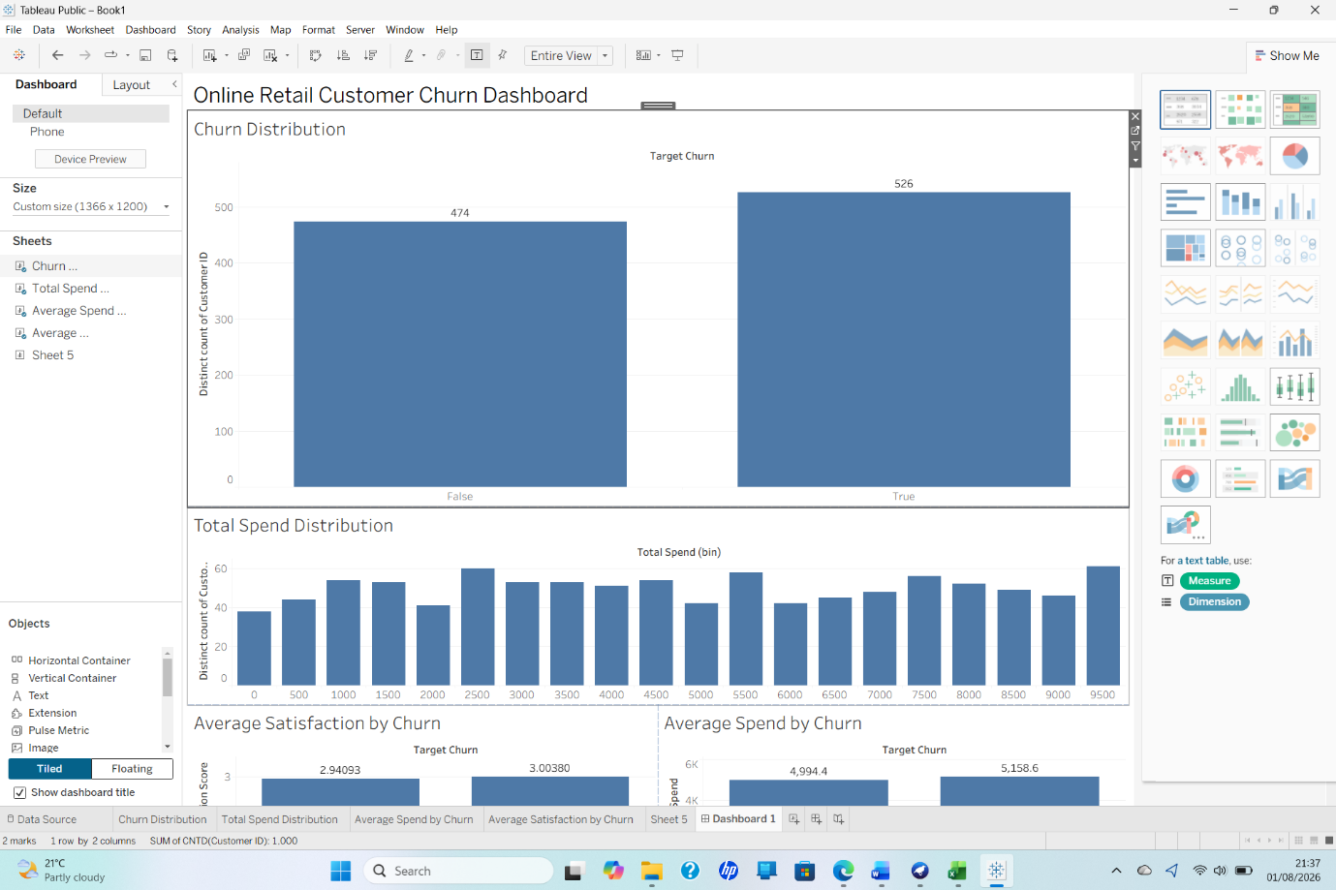
Figure 1. Online Retail Customer Churn Exploration Dashboard.
Source: Author’s analysis using Tableau.

1.3: Data Pre-processing and Post-processing
Data preprocessing was completed in Weka before classification or clustering. This matters because dependable models require relevant, consistent data [7]. The original CSV contained 1,000 customer records and 15 attributes. A working copy was saved so the original remained available for checking.
Data quality and missing values
Weka’s Preprocess panel was used to inspect each attribute, data type, value range, distribution and missing-value count. The inspection found zero missing values across all 15 attributes. Therefore, no rows were deleted and no mean, median or mode replacement was applied. This avoided changing complete observations unnecessarily. Customer_ID also contained 1,000 distinct values across 1,000 records, indicating no repeated identifiers. Figure 5 records the working dataset after the identifier was removed.
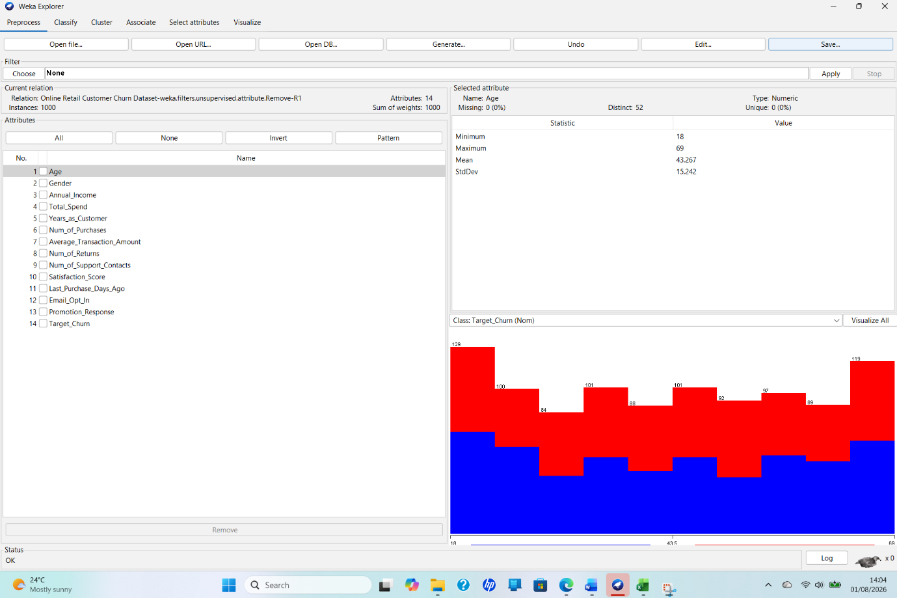
Figure 2: Removal of the Customer Identifier During Pre-processing in Weka (Author’s Analysis).
Categorical variables
Gender, Email_Opt_In, Promotion_Response and Target_Churn were correctly recognised as nominal attributes. Gender contained Female, Male and Other, with no missing entries, as shown in Figure 6. Manual one-hot encoding was unnecessary because Weka classifiers can process nominal attributes, and some algorithms perform the required transformation internally [8]. Target_Churn was set as the class attribute, with TRUE representing churn and FALSE representing retention.
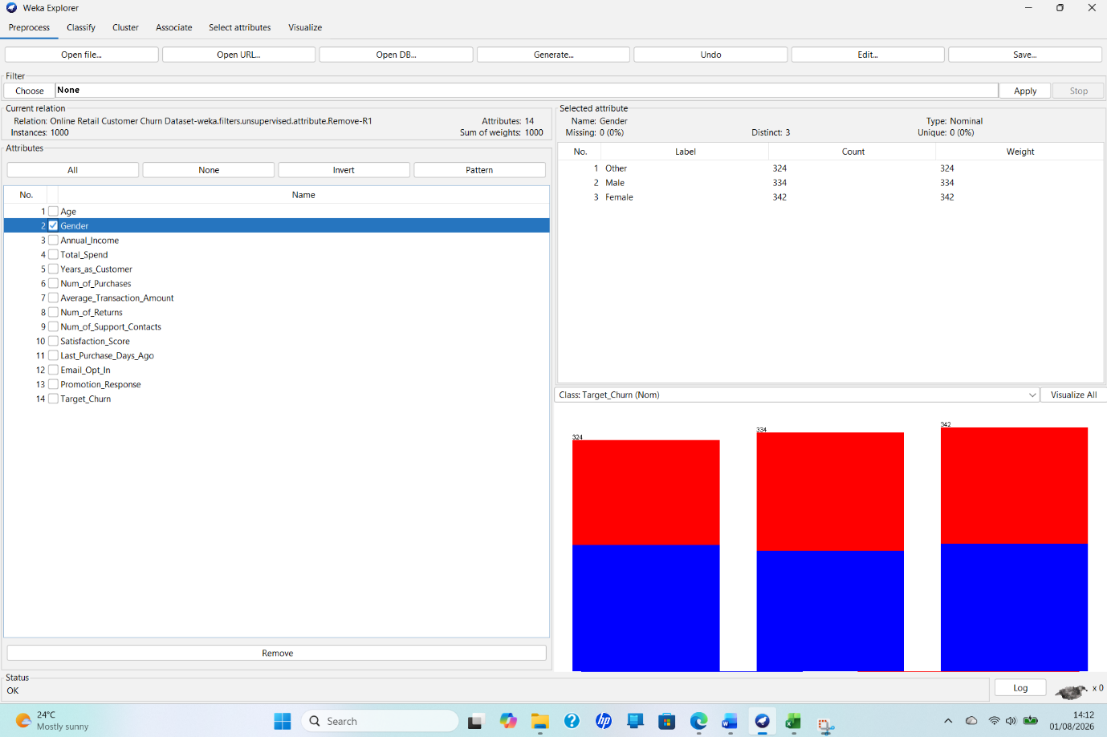
Figure 3: Verification of a Categorical Attribute in Weka (Author’s Analysis).
Class balance
The class distribution was checked before modelling. There were 526 churned customers (52.6%) and 474 retained customers (47.4%), giving an imbalance ratio of only 1.11:1. No oversampling, undersampling or Synthetic Minority Oversampling Technique (SMOTE) was applied because both outcomes were already well represented. Using synthetic observations here could change the natural distribution without addressing a genuine imbalance. Resampling is more relevant when one class is seriously under-represented and a model may favour the majority class [9].
Feature selection and engineering
Customer_ID was removed because it is an administrative identifier, not a meaningful measure of customer behaviour. Retaining it could encourage a model to learn record-specific noise rather than patterns that apply to new customers. Following its removal, three useful variables were engineered. Return_Rate was calculated as Num_of_Returns divided by Num_of_Purchases, allowing return behaviour to be compared fairly between frequent and occasional buyers.
Customer_Value_Segment grouped customers by Total_Spend into three nearly equal groups: Low Value (333), Medium Value (333) and High Value (334), as shown in Figure 8. Engagement_Segment used Last_Purchase_Days_Ago to create Recent (1–90 days; 241 customers), Moderate (91–180 days; 259 customers) and Dormant (181–364 days; 500 customers). Figure 9 confirms these counts. Feature engineering can make raw fields easier to interpret and reveal useful business patterns [7].
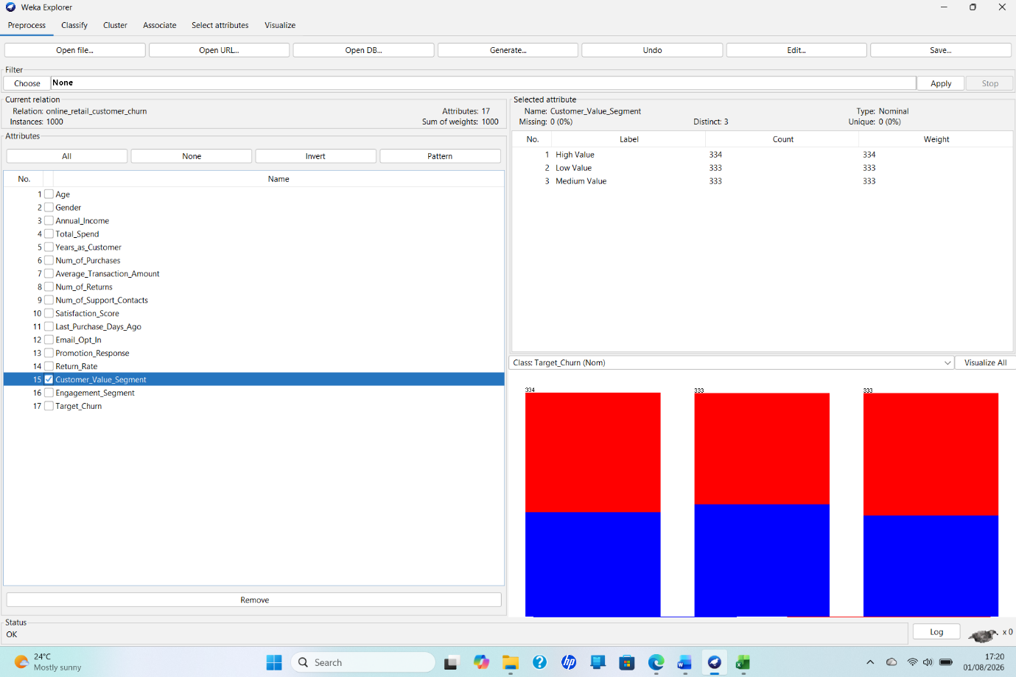
Figure 4: Distribution of the Engineered Customer Value Segments in Weka (Author’s Analysis).

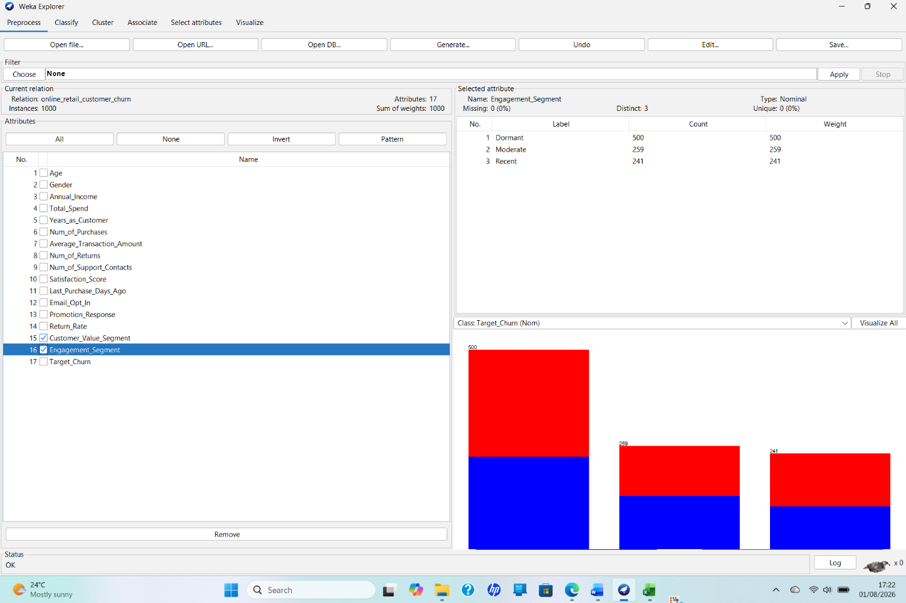
Figure 5: Distribution of the Engineered Customer Engagement Segments in Weka (Author’s Analysis).
Final preparation and post-processing
The final ARFF file contained 1,000 instances and 17 attributes: 13 original predictors, three engineered variables and Target_Churn. Figure 7 verifies this structure. Numeric fields were left in their original units because tree-based models do not require scaling; any algorithm-specific transformation will be stated during model testing. Saving the dataset in ARFF format preserved its declared numeric and nominal data types, engineered fields and class definition for later Weka experiments. The prepared file was saved separately to support repeatable analysis.

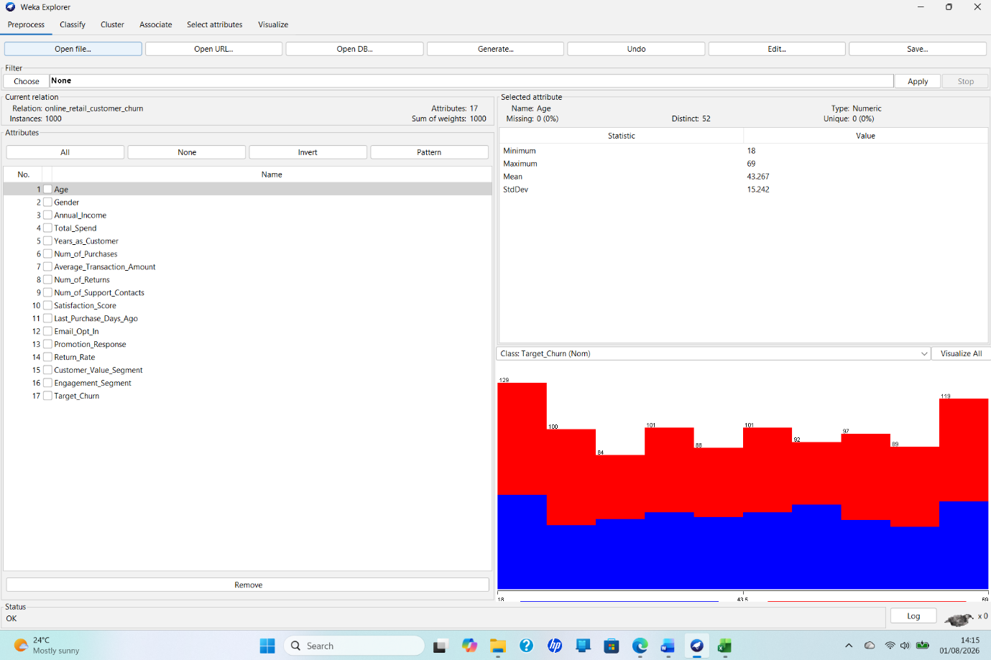
Figure 6: Final Pre-processed Dataset with Engineered Customer Features in Weka (Author’s Analysis).
After modelling, the Weka outputs were converted into clear comparison tables and charts. Accuracy, precision, recall, F-measure, ROC area and confusion matrices will be reported, with particular attention to correctly identifying churners rather than relying on accuracy alone. Cluster sizes and customer profiles will also be translated into clear business labels. This post-processing will connect technical results to retention decisions while maintaining an auditable link to the Weka evidence [10].

1.4: Sample Runs and Analysis Methods
The analysis combined unsupervised customer segmentation with supervised churn prediction. Weka was used because it provides preprocessing, modelling and evaluation within one consistent environment [8]. The Tableau exploration in Section 1.2 provided supporting evidence: 526 customers churned and 474 did not, while the average spending and satisfaction values of the two groups were only slightly different. These small descriptive differences suggested that churn could be difficult to predict using the available attributes.
Customer Segmentation
For clustering, the target variable and the two existing segment labels were excluded so that they could not determine the clusters in advance. Age, gender and annual income were also removed, leaving 11 behavioural attributes. SimpleKMeans was run using Euclidean distance, three clusters, seed 10 and a maximum of 500 iterations. Three clusters were selected to produce a manageable set of customer profiles for marketing decisions. However, this was a practical business choice rather than proof that three was the mathematically optimal number. K-means is appropriate for grouping unlabelled customer records around cluster centroids, although its results can be affected by variable scale and initial starting points [3].
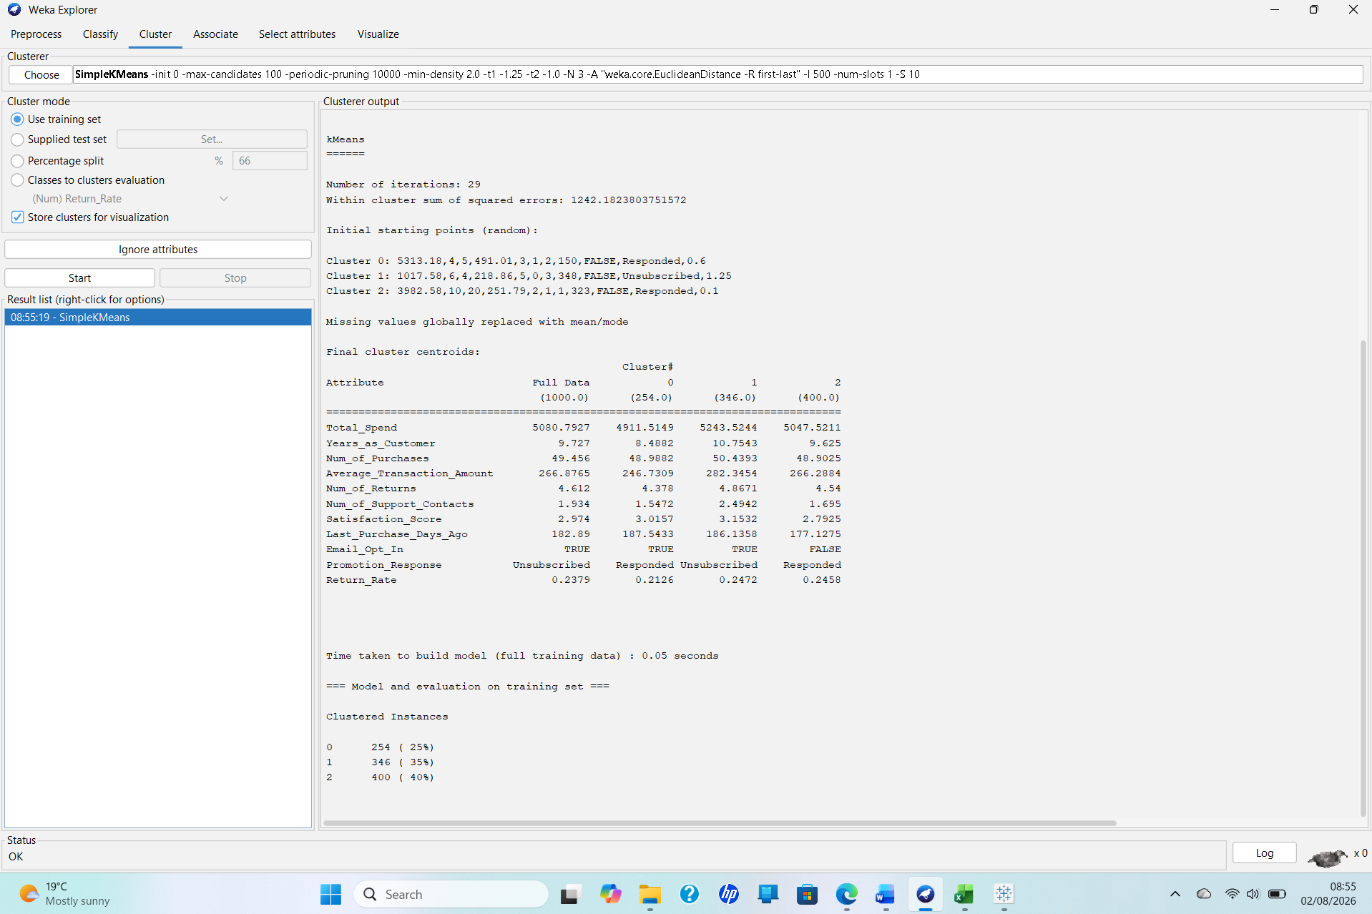
Figure 7. SimpleKMeans (k = 3) cluster centroids and cluster sizes. Source: Author’s Weka output.
The model converged after 29 iterations and produced a within-cluster sum of squared errors of 1242.18. As Figure 1 shows, Cluster 0 contained 254 customers (25%), Cluster 1 contained 346 (35%) and Cluster 2 contained 400 (40%). Cluster 1 had the highest mean total spend (£5,243.52), customer tenure (10.75 years), average transaction amount (£282.35), satisfaction score (3.15) and number of support contacts (2.49). Cluster 2 had lower satisfaction (2.79), no email opt-in as its modal value and the most recent purchase activity, averaging 177.13 days. Cluster 0 had the lowest return rate (0.213) and fewest support contacts (1.55).
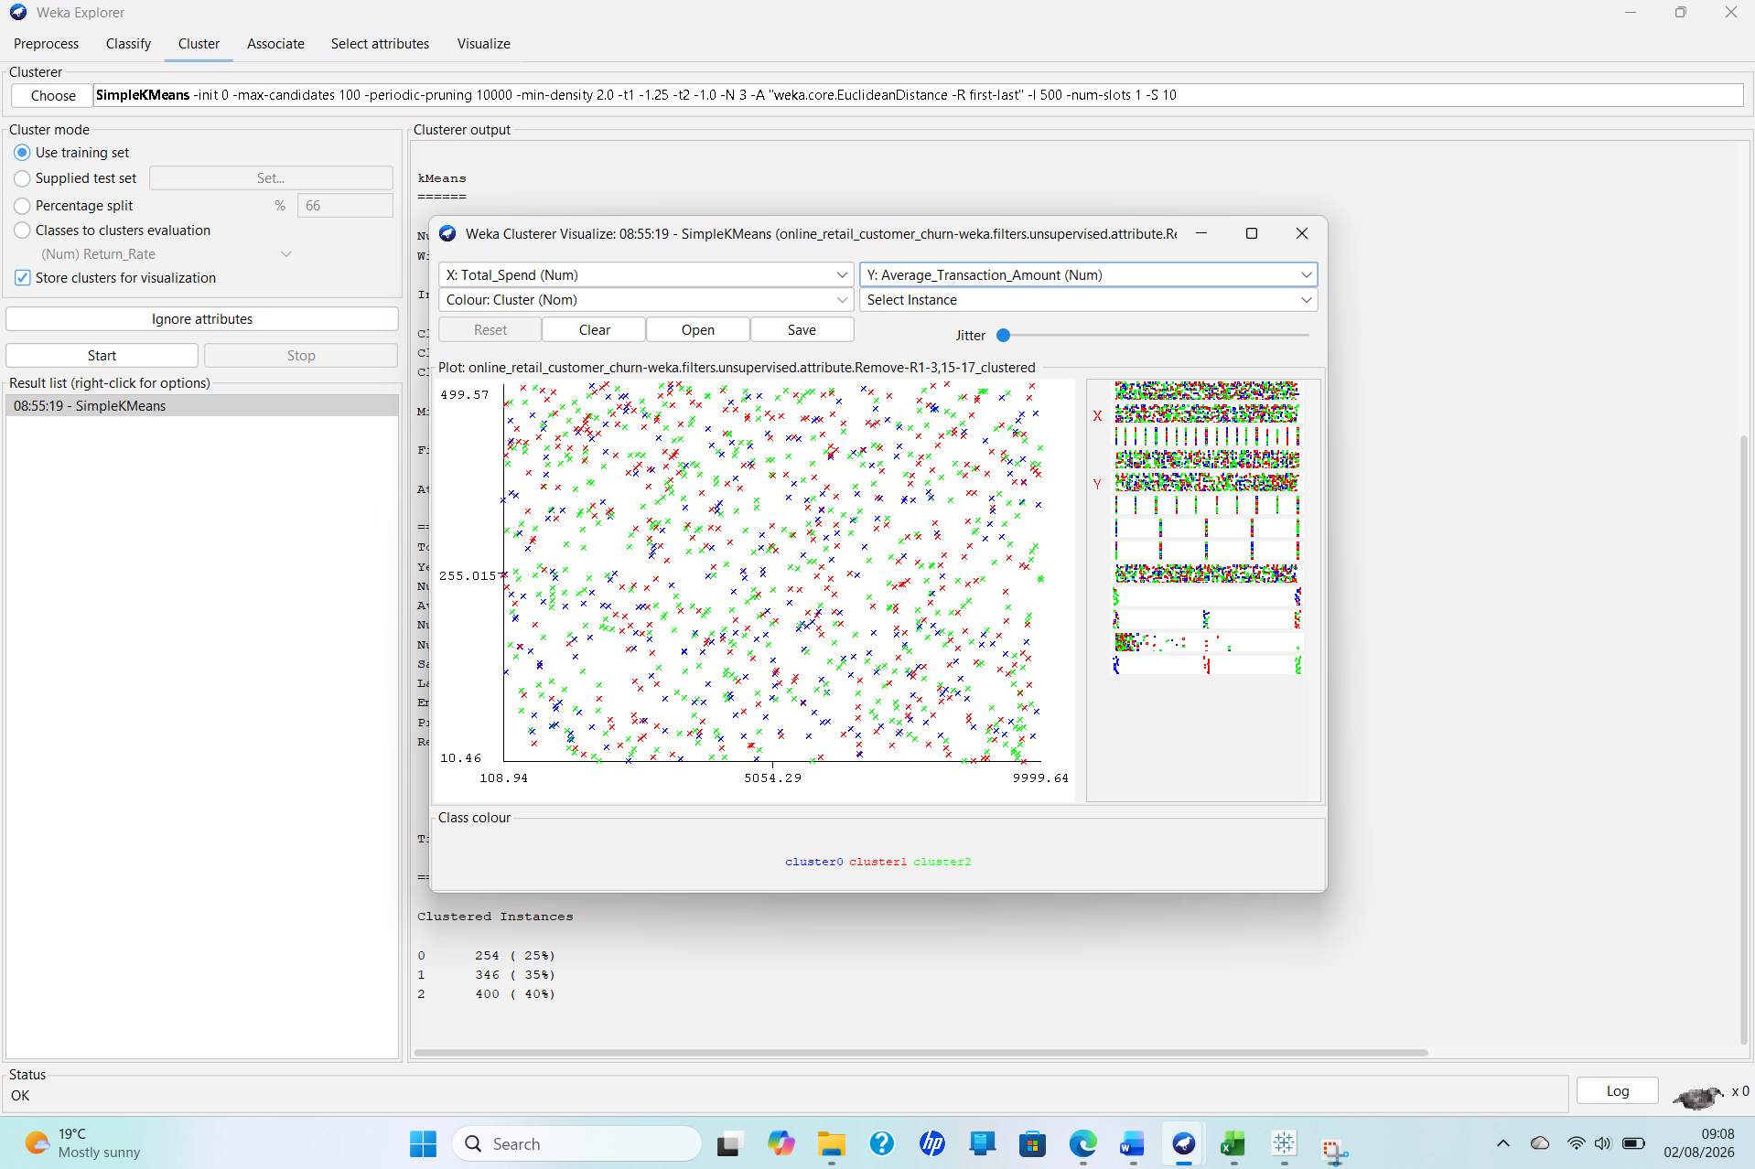
Figure 8. SimpleKMeans cluster visualisation of Total Spend against Average Transaction Amount. Source: Author’s Weka output.
Figure 8 shows considerable overlap among the three clusters. They should therefore be treated as exploratory customer profiles rather than clearly separated market segments. A stronger future analysis would standardise the numeric variables and compare several values of k using measures such as silhouette score.
Churn Classification
Churn prediction was tested using J48, logistic regression and Random Forest. J48 was chosen because its decision rules are relatively interpretable. Logistic Regression provides a probability-based model, while Random Forest combines multiple decision trees and can capture nonlinear relationships and interactions [10]. ZeroR was also included as a minimum baseline because it predicts only the majority class.
All four models used stratified ten-fold cross-validation. This maintains approximately the same class proportions in every fold and allows every observation to be used for training and evaluation [12]. It is more dependable than evaluating a model on the same observations used to build it.
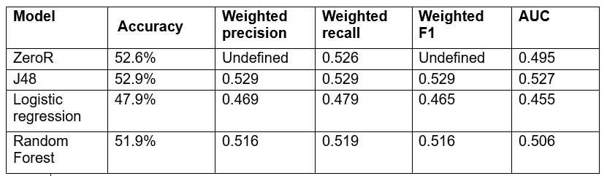
Table 1.4.1: Comparison of churn-classification model performance using stratified ten-fold cross-validation in Weka (author’s analysis).

Full ten-fold cross-validation outputs for J48, Logistic Regression, Random Forest and the ZeroR baseline are presented in Figures A1–A4 in the Appendix.
J48 recorded the highest accuracy at 52.9%. Its confusion matrix contained 240 correctly predicted non-churners, 234 false churn alarms, 237 missed churners and 289 correctly identified churners. Logistic regression achieved 47.9% accuracy, while the 100-tree Random Forest achieved 51.9%. ZeroR obtained 52.6% simply by predicting every customer as a churner. Consequently, J48 exceeded the baseline by only 0.3 percentage points, and its kappa value of 0.056 was close to chance agreement.
Accuracy alone is insufficient because it does not distinguish between different errors. Churn recall measures the proportion of actual churners detected, whereas precision measures how many customers predicted to churn actually did so. F1 provides a balance between precision and recall. AUC evaluates ranking performance across classification thresholds, with a value near 0.5 indicating approximately chance-level discrimination [13].

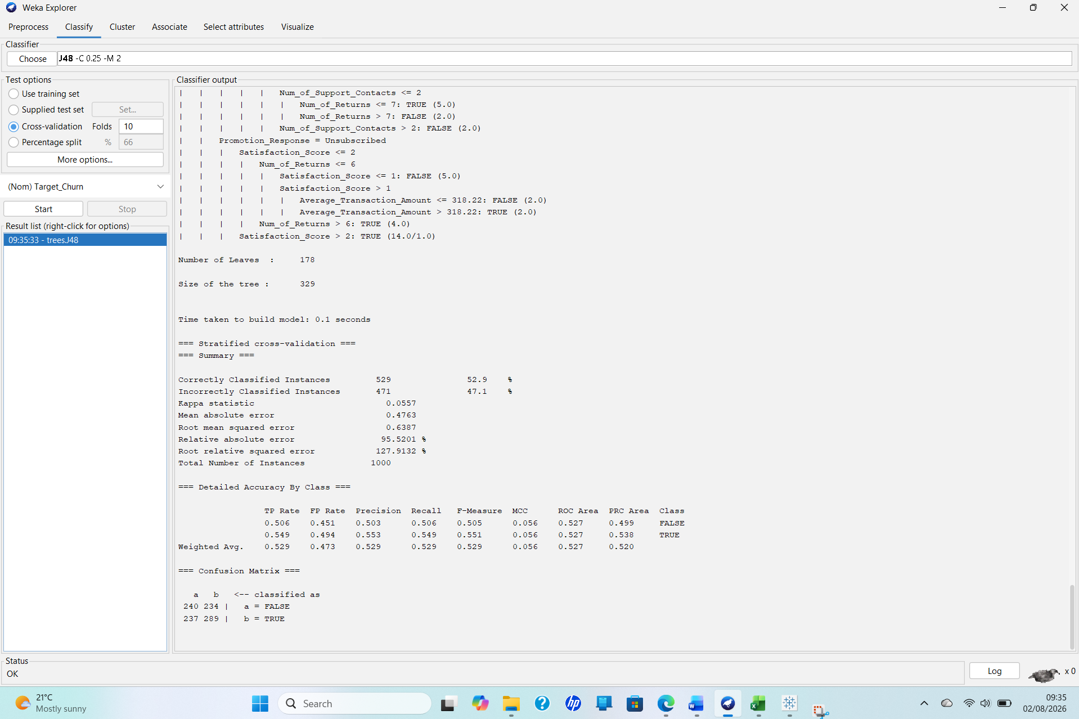
Figure 9. J48 ROC curve for the TRUE churn class (AUC = 0.5274). Source: Author’s Weka output.
Figure 9 confirms that the J48 ROC curve is close to the diagonal. Although logistic regression produced the highest churn recall of 0.633, its churn precision was only 0.504, meaning that many customers would receive unnecessary retention interventions.
Overall, none of the classifiers is ready for operational use. J48 is the least weak model and the easiest to explain, but it offers almost no improvement over ZeroR. The appropriate business conclusion is that the current attributes contain limited churn signal. Future work should verify the target labels, remove derived variables that could cause leakage, engineer changes in customer behaviour over time and validate any improved model using a separate untouched test set.

1.5: Business Recommendations
The findings do not support deploying any classifier as an automated churn system. J48 was strongest, but its 52.9% accuracy was only 0.3 percentage points above ZeroR, while its AUC of 0.527 indicates weak separation between churners and non-churners. Managers should treat the analysis as a starting point for controlled retention experiments, rather than use individual predictions.
The three clusters offer practical campaign groups. Cluster 1 had the highest average spend (£5,243.52), longest tenure (10.75 years) and most support contacts (2.49). These valuable but service-intensive customers should receive faster complaint resolution, service-recovery offers and loyalty recognition. Cluster 2 combined the lowest satisfaction (2.79), email opt-out as its modal value and the most recent purchasing activity. Managers should improve delivery, checkout and support experiences, and use account messages or permitted channels instead of unsolicited email. The Information Commissioner’s Office states that electronic marketing generally requires consent or a valid soft opt-in [14]. Cluster 0 had fewer support contacts and the lowest return rate, so low-cost loyalty messages and routine monitoring are suitable.
Each action should be tested against a control group. Management should track incremental retention, margin, repeat purchases, offer cost, complaints and opt-outs—not response rate alone. Future data collection should add monthly behavioural snapshots, order frequency and recency trends, delivery delays, complaint resolution, browsing, basket abandonment and campaign history. A precise churn window and auditable consent fields are required. Models should be retrained only after external validation, with access controls, drift monitoring and documented human oversight following NIST’s risk-management principles [15].

1.6: Reflective Commentary
Overall, the models did not perform well enough for real-world churn decisions. J48 gave the best Weka result, with 52.9% accuracy and an AUC of 0.527. However, this was only 0.3 percentage points above the 52.6% ZeroR baseline, so the practical improvement was very small. Random Forest achieved 51.9% accuracy, while Logistic Regression achieved 47.9%. Precision, recall, F1, AUC and the confusion matrices gave a more honest picture than accuracy alone.
The analysis had strengths. The classes were balanced, there were no missing values, and every classifier used the same stratified ten-fold cross-validation. ZeroR provided a benchmark, Tableau clarified the distributions, and k-means provided an exploratory view of customer groups. Limitations included only 1,000 records, no independent time-based test set, an unclear churn observation period and overlap between the three clusters.
Next time, I would compare J48 with more existing models. A Kaggle analysis using a related version of the dataset reported 57.0% accuracy for Random Forest, 56.5% for XGBoost, 52.0% for AdaBoost and 49.5% for Support Vector Machines [16]. My J48 result was therefore higher than AdaBoost and SVM, but lower than Random Forest and XGBoost. This is not a direct ranking because the Kaggle notebook used a 200-record test split, whereas I used ten-fold cross-validation. I would rerun every model on the same cleaned data and evaluation design, tune the settings, standardise clustering variables, test several values of k, reserve the newest customer period for final testing, and measure whether targeted retention offers create real business value.

References
[1] F. Martínez-Plumed, L. C. Contreras-Ochando, C. Ferri, J. Hernández-Orallo, M. Kull, N. Lachiche, M. J. Ramírez-Quintana, and P. A. Flach, “CRISP-DM twenty years later: From data mining processes to data science trajectories,” IEEE Transactions on Knowledge and Data Engineering, vol. 33, no. 8, pp. 3048–3061, Aug. 2021, doi: 10.1109/TKDE.2019.2962680.
[2] M. Imani, M. Joudaki, A. Beikmohammadi, and H. R. Arabnia, “Customer churn prediction: A systematic review of recent advances, trends, and challenges in machine learning and deep learning,” Machine Learning and Knowledge Extraction, vol. 7, no. 3, Art. no. 105, 2025, doi: 10.3390/make7030105.
[3] O. N. Akande, H. B. Akande, E. O. Asani, and B. T. Dautare, “Customer segmentation through RFM analysis and K-means clustering: Leveraging data-driven insights for effective marketing strategy,” in Proc. 2024 International Conference on Science, Engineering and Business for Driving Sustainable Development Goals (SEB4SDG), 2024, pp. 1–8, doi: 10.1109/SEB4SDG60871.2024.10630052.
[4] Tableau, “Data types,” Tableau Desktop and Web Authoring Help. [Online]. Available: https://help.tableau.com/current/pro/desktop/en-us/datafields_typesandroles_datatypes.htm. [Accessed: Jul. 25, 2026].
[5] United Nations Statistics Division, “Module for quality assurance when using administrative and other data sources to produce official statistics,” 2025. [Online]. Available: https://unstats.un.org/unsd/methodology/dataquality/aos/. [Accessed: Jul. 26, 2026].
[6] Tableau, “Summary card,” Tableau Desktop Help. [Online]. Available: https://help.tableau.com/current/pro/desktop/en-us/inspectdata_summary.htm. [Accessed: Jul. 27, 2026].
[7] A. Géron, Hands-On Machine Learning with Scikit-Learn, Keras, and TensorFlow, 3rd ed. Sebastopol, CA, USA: O’Reilly Media, 2022. [Online]. Available: https://www.oreilly.com/library/view/hands-on-machine-learning/9781098125967/. [Accessed: Aug. 1, 2026].
[8] E. Frank, M. A. Hall, and I. H. Witten, The WEKA Workbench: Online Appendix for Data Mining: Practical Machine Learning Tools and Techniques, 4th ed. Hamilton, New Zealand: University of Waikato, 2016. [Online]. Available: https://ml.cms.waikato.ac.nz/weka/Witten_et_al_2016_appendix.pdf. [Accessed: Aug. 1, 2026].
[9] R. Suguna, J. Suriya Prakash, H. Aditya Pai, T. R. Mahesh, V. Vinoth Kumar, and T. E. Yimer, “Mitigating class imbalance in churn prediction with ensemble methods and SMOTE,” Scientific Reports, vol. 15, Art. no. 16256, May 2025, doi: 10.1038/s41598-025-01031-0.
[10] I. H. Witten, E. Frank, M. A. Hall, and C. J. Pal, Data Mining: Practical Machine Learning Tools and Techniques, 4th ed. Cambridge, MA, USA: Morgan Kaufmann, 2016. [Online]. Available: https://shop.elsevier.com/books/data-mining/witten/978-0-12-804291-5. [Accessed: Jul. 30, 2026].
[11] L. Breiman, “Random forests,” Machine Learning, vol. 45, no. 1, pp. 5–32, Oct. 2001, doi: 10.1023/A:1010933404324.
[12] Scikit-learn Developers, “StratifiedKFold,” Scikit-learn Documentation. [Online]. Available: https://scikit-learn.org/stable/modules/generated/sklearn.model_selection.StratifiedKFold.html. [Accessed: Jul. 30, 2026].
[13] T. Fawcett, “An introduction to ROC analysis,” Pattern Recognition Letters, vol. 27, no. 8, pp. 861–874, Jun. 2006, doi: 10.1016/j.patrec.2005.10.010.
[14] Information Commissioner’s Office, “Guidance on direct marketing using electronic mail,” Apr. 28, 2026. [Online]. Available: https://ico.org.uk/for-organisations/direct-marketing-and-privacy-and-electronic-communications/guidance-on-direct-marketing-using-electronic-mail/. [Accessed: Aug. 2, 2026].
[15] E. Tabassi, Artificial Intelligence Risk Management Framework (AI RMF 1.0), NIST AI 100-1. Gaithersburg, MD, USA: National Institute of Standards and Technology, Jan. 2023, doi: 10.6028/NIST.AI.100-1.
[16] A3AMAT02, “Churn prediction,” Kaggle, 2024. [Online]. Available: https://www.kaggle.com/code/a3amat02/churn-prediction. [Accessed: Aug. 4, 2026].

Appendix
This appendix presents the supporting Weka outputs for the classification models discussed in Section 1.4, including J48, Logistic Regression, Random Forest and the ZeroR baseline.

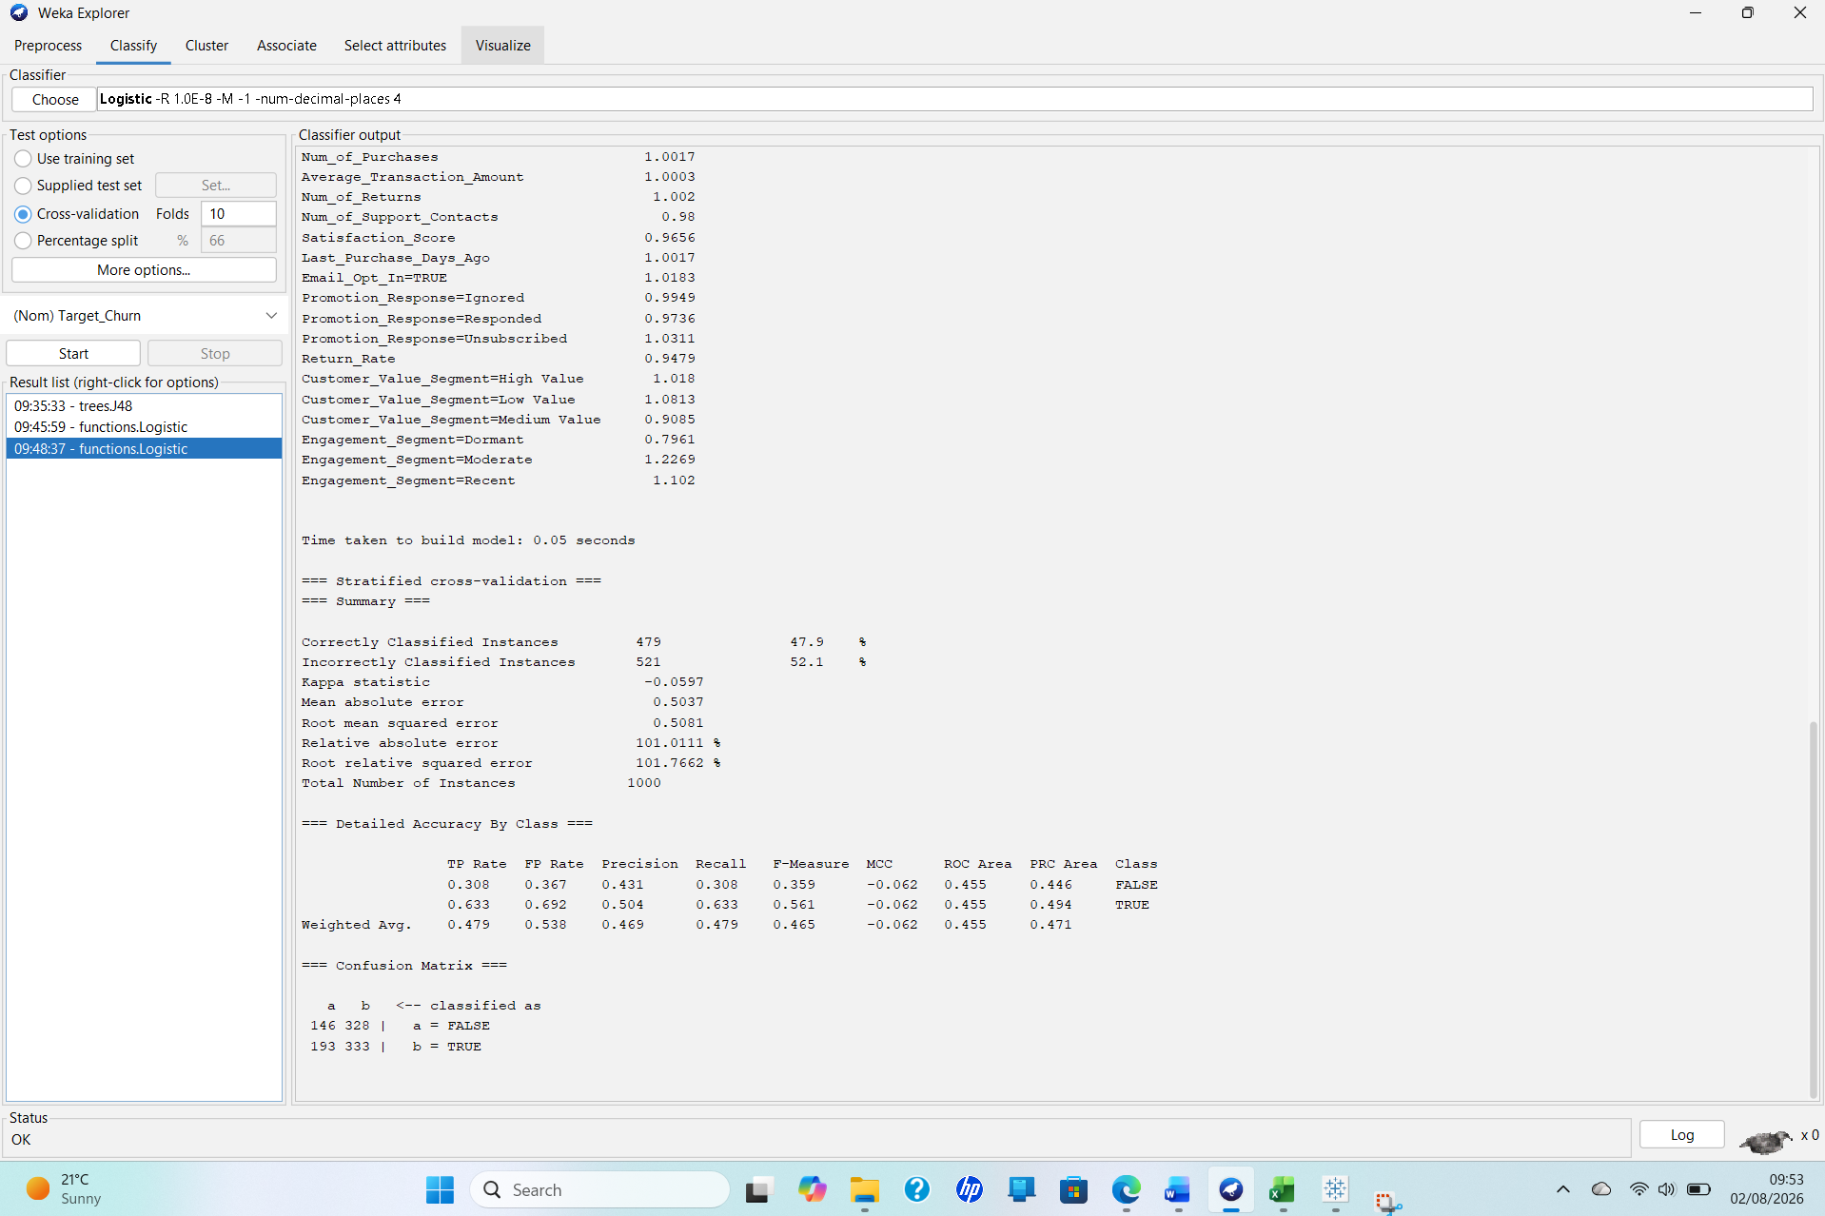
Title: Figure A1: J48 decision-tree results using ten-fold cross-validation in Weka (author’s analysis).
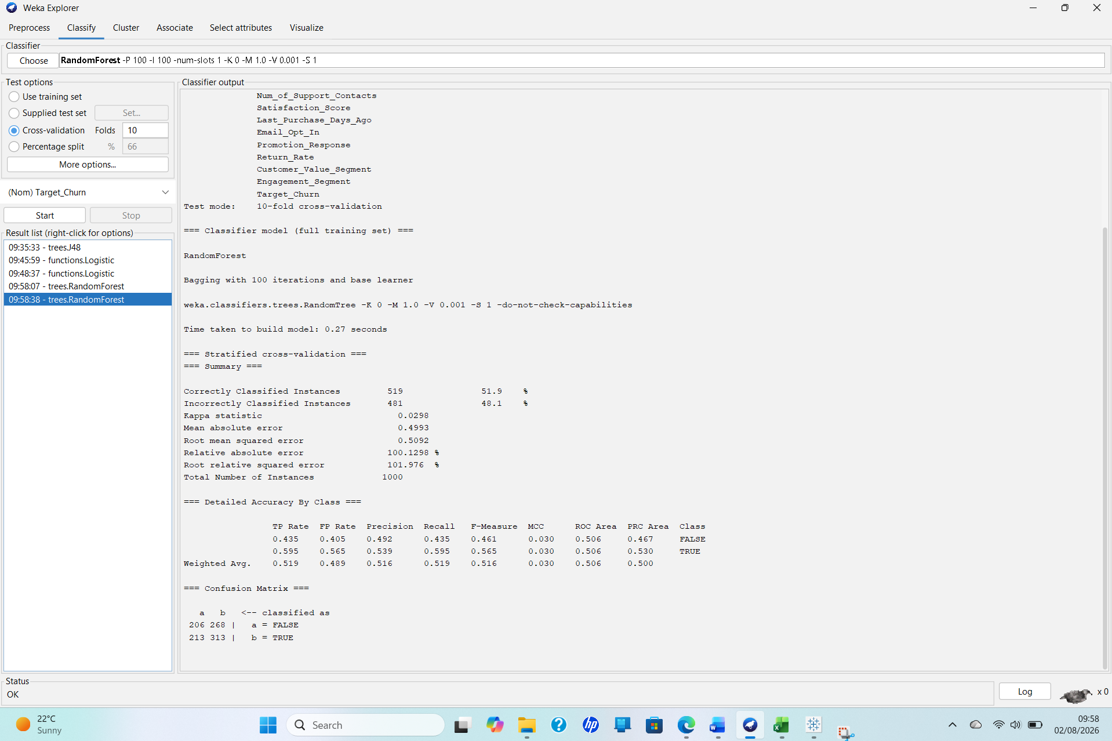
Title: Figure A2: Logistic Regression results using ten-fold cross-validation in Weka (author’s analysis).
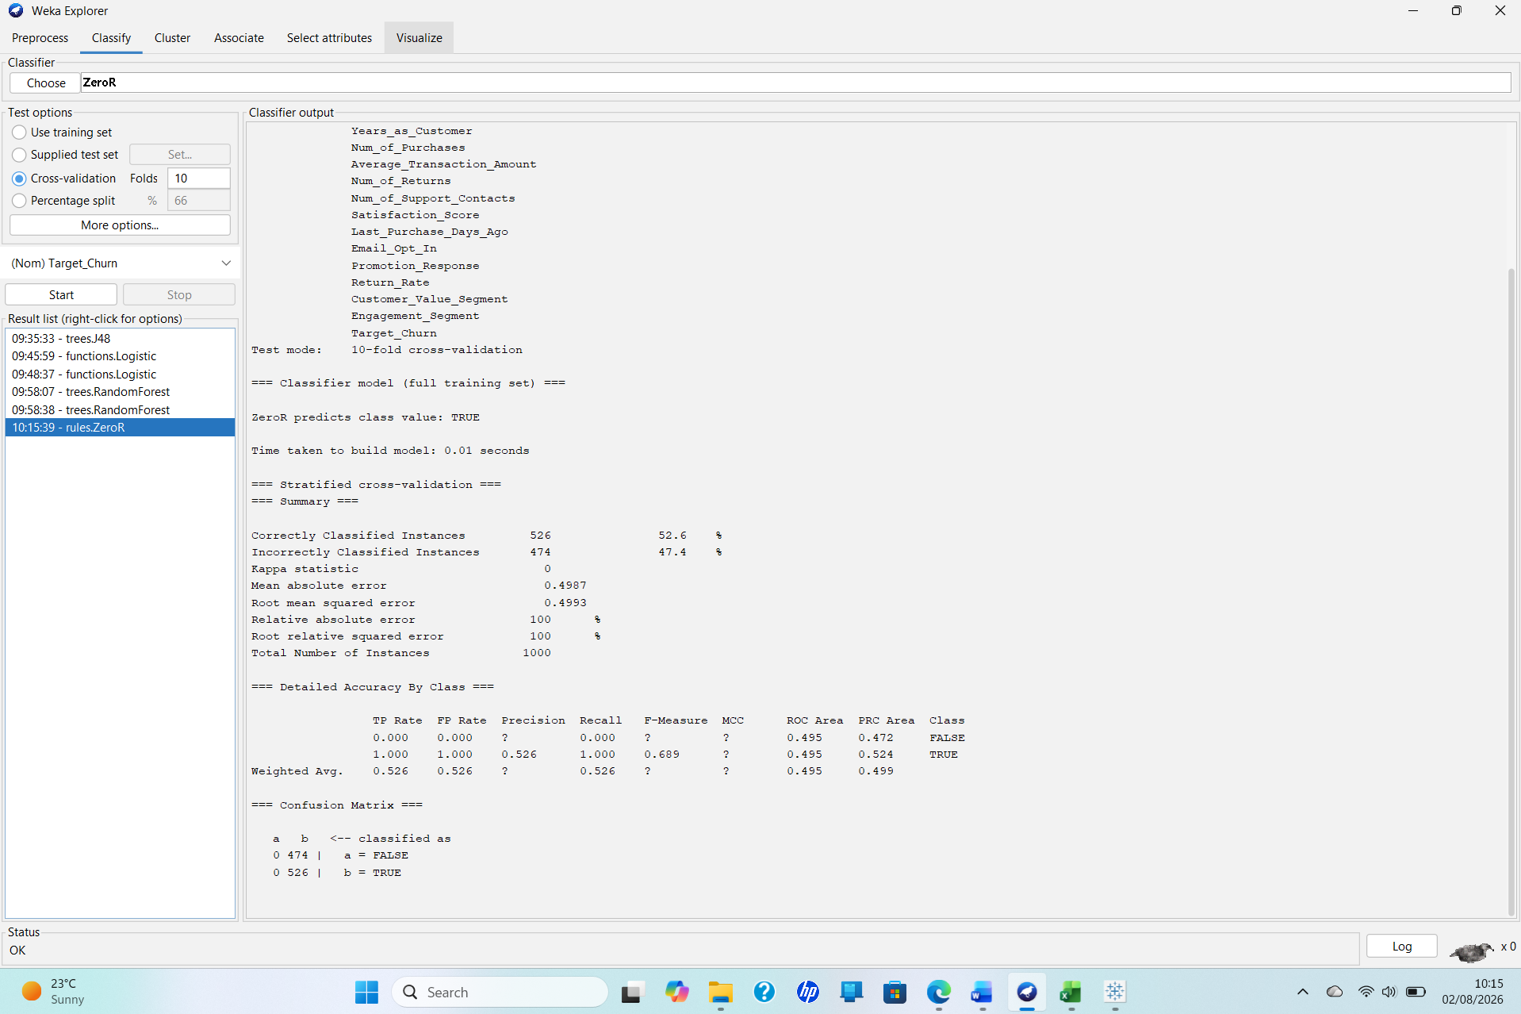
Title: Figure A3: Random Forest results using ten-fold cross-validation in Weka (author’s analysis).

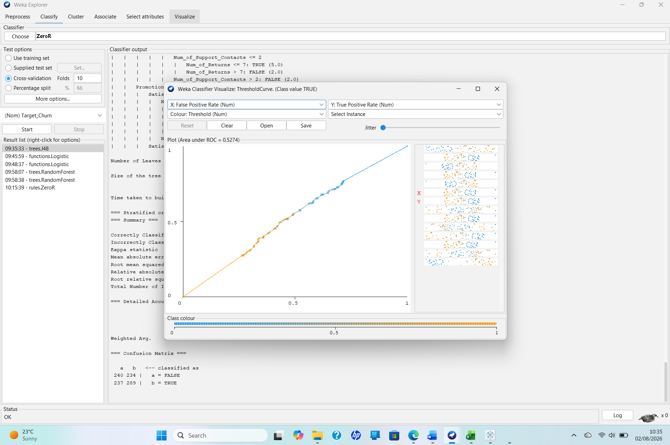

Title: Figure A4: ZeroR baseline results using ten-fold cross-validation in Weka (author’s analysis).

