University of wales trinity saint David

communication within the workplace
Jerssica Roberta da Silva (1809931) (BMSK4002_LON)

module lecturer: anupam mazumdar

Table of contents

Introduction…………………………………………………………..…2
Communication…………………………………………………….…..3
-Intrapersonal communication……………………………………...3
-Interpersonal communication……………………………………...3
Shannon-Weaver Communication Model………………………..…3
Berlo’s Model…………………………………………………………….4
Verbal communication…………………………………………………5
Written communication………………………………………………..5
Nonverbal communication…………………………………………….6
Body language…………………………………………………………..8
Active listening………………………………………………………….8
Assertiveness …………………………………………………………..8
Nonverbal communication cues……………………………………..8
The communication at my workplace……………………………….9
How the communication can be improved in my workplace……9-10
How these improvements would impact on our performance…….10
Conclusion………………………………………………………………….11
References………………………………………………………………….12

Introduction

Communication is part of the human beings needs, all the time, somehow people are communicating in the most variables channels. Nowadays, have a developed communication skill is mandatory for your professional career success and even for your personal life. More then high qualified professionals, recruiters are also seeking for professional who can speak with effectiveness and assertiveness. Also, be a good listener is very important to assure the quality and effectiveness of the communication process. This report contains the definition of communication, examples of both verbal and nonverbal communication in their importance. Also, contains the Shannon-Weaver Communication Model and how the lack of communication in the workplace can compromise the success of the operations.

Communication

Communication is the definition of the act of sharing and disclose thoughts, convictions, ideas and information. Communication is present in every human being’s everyday lives. The only way to learn, teach or just share some thoughts or ideas is by communicating. The communication can be verbal or nonverbal and both is very important to a successful communication process. The intrapersonal e interpersonal communication is linked in the communication cycle (Maund, et al., 2017).
Intrapersonal communication is the process of ‘talk to yourself’, in other words it is when you have a reflexion or intern debate about something that you have heard or seen or about your feelings or experiences. Basically, is the way to discover yourself absorb information and make decisions (Almeida, 2018).
Interpersonal communication is the process of sharing information. For that process occur is needed at least two people, one sender to deliver the message and one receptor to receive the message.
In late 1940’s Weaver and Shannon wrote a model of communication where they explained how the process should work to reach success. According to them, the sender needs to encode its thoughts converting its understandings into a message. when the sender encodes the message, he must to choose the channel of communication in which he will transmit the message to the receptor. On the other hand, after receiving the message the receptor will decode it, what, means repeats the intrapersonal communication process of understanding and then give a feedback or response (Hendricks, 2003-2019)
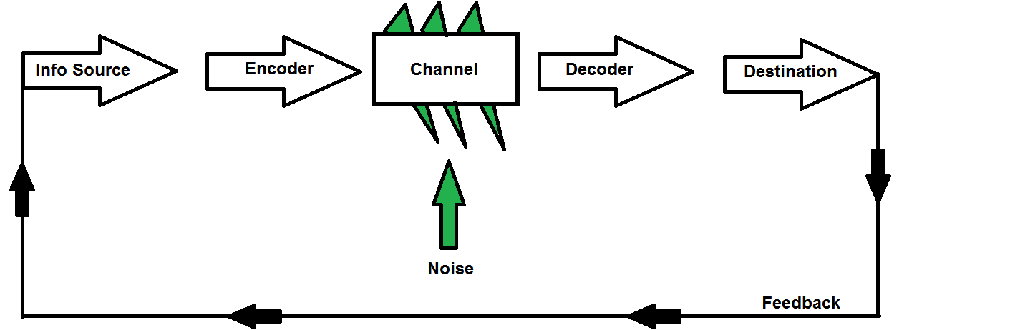
Find bellow Shannon-Weaver Communication Model:

(Beyer, 2012)
Berlo’s Model (SMCR Model)


(Businesstopia, 2018)

S- stands for Sender: who transmits the message
M- stands for Message: the contents transmitted
C- stands for channel: the via where the sender will transmit the message
R- stands for receiver: who will receive the message
In this model is not shown either the noise or the feedback, thus in this model there is no two-way communication.
Verbal communication

Verbal communication is the sharing of ideas, thoughts or information by using speech. To ensure the effectiveness of this process is imperative to be clear and direct when you speak to the audience. By clarity the speaker can understand that is necessary to adjust his vocabulary according to the public or person with whom he is speaking, for that happens aspects such as academic knowledge (for technical terms, specially), cultural and linguistics should be taken in consideration in order to obtain a complete and successful communication process.
As said by Willian B. Yeats (2018), “think like a wise man but communicate in the language of the people”, some professionals have specifics technical terms, for example lawyers and doctors among others, to avoid misunderstandings they need to find simpler terms to explain themselves, otherwise some of their clients might not understand what they want to say (Yeats, 2018).
External aspects can interfere this process as well, for example in a call when the signal is poor it will compromise the quality of the call and might not allow that the message is transmitted, this interference is called the noise in the communication process.

Written Communication

Written communication is very important and works as a complement or alternative for the verbal communication. As the name says, it occurs when people communicate by using written channel, such as emails, text message, letters among others. As occurred in the verbal communication, it needs to be clear in order to be understood, the difference is that the feedback or response is not immediate as in the verbal communication.
The development of the written communication brought a huge benefit to the human civilization. In the societies before written communication the knowledge was shared via oral communication only, it was an obstacle for the human’s evolution as they need to storage all the information acquired in their memories. After the written development they could be written down the information they had, therefore giving more space for their memory search for more knowledge and information and at the same time that information will always be alive for the future generations. Therefore, is conclude that written communication was remarkable for the human knowledge and development (Porto, 2006-2019).

Nonverbal communication

As its name says, nonverbal communication is all kind of communication where the verbal resources are not used. Signals, symbols, gestures, facial expressions and body language are examples of nonverbal communication. Nonverbal communication works a support or complement of the verbal communication or in certain cases when people are unable to speak it can work as substitute of it.
Find bellow examples of the communication via gestures when people are unable to communicate using other resources. In this case it is the communication using the respective signals for the scuba divers.
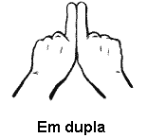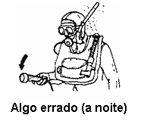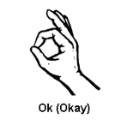
(In pairs) (Something Wrong (at night)) (OK)
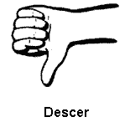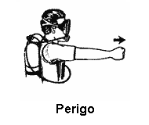 (Mayrink, 2005)

(Go down) (Danger)

As you can conclude, for the divers learn these gestures are so important as learn to read and speak. They are the only way to communicate under water. Also, symbols are everywhere in the road, buses, train stations and is impossible imagine how it would be if they do not had existed. A good example of symbols is the traffic lights which regulates the traffic avoiding accidents. The symbols are extremely important for people who is permanently unable to talk or to listen as speechless and deaf people. Also, the symbols enable that everyone can ‘read’ what is in it, for example the tourist when visit another country are able to understand some rules, directions or touristic points thru the symbols. Below is an example of a symbols where contains verbal and nonverbal messages.
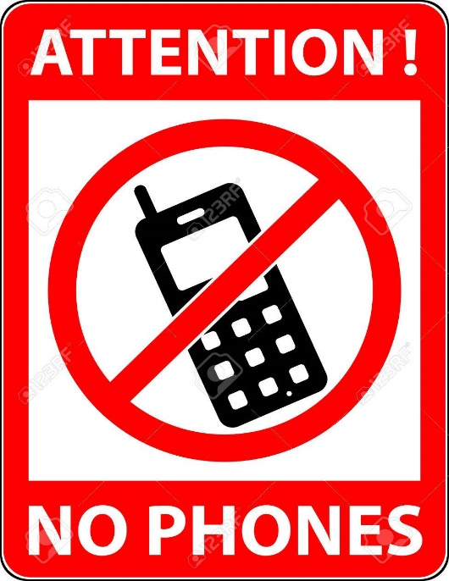 (Dryashkin, 2019)

Body language

Body language is the language spoken by your body. According to John R Stoker (2019), “93/7 Rule: 93% of communications take place through nonverbal behaviour and tone, only 7% of the communication occurs through the use of words” (Stroker, 2019). Therefore, people can ‘listen’ much more than the words that are coming out of your mouth.
All the gestures that you make with your fingers, hands, wrists, arms and shoulders, they way you move your head, you posture to sit or stand up, all the facial expressions and eye contact are called body language and when they match with the words that you are saying then they are a support for them. For example, if in a job interview the recruiter ask you if you are clear about a question and you say yes but your facial expression gives signals of doubts, he probably will not believe that you understood that question. In this case, the body language is not a support for what you are saying but a contradiction.
In a job interview the candidates are evaluated in every aspect, besides their competences they also evaluate the candidate’s posture and even if the candidate dress according. The eye contact transmits confidence, attention and interested to the listener. And should last time enough to show it. However, keep the eye contact for too long can be uncomfortable and seems intimidating or threatening.
Active listening

Active listening is a very important skill in the communication process, listening carefully to another person is a crucial factor for the effectiveness of the communication. Active listening suggests listening without interruptions and trying to understand the meaning of the message transmitted. Then when you respond you should start by repeating part of what was said, therefore the person will know that you have listened with attention. This process helps the speaker to acknowledge if the message whether been clear by having the receptor restarted by saying what they heard.

Assertiveness

Assertiveness is the ability of make sure that you are clear enough to be completely understood by your audience. Adjust your vocabulary when/if necessary and do not if the audience should know about a certain subject just because you know is an attribute of an assertive speaker. Being assertive bring many of benefits for everybody, thus the speaker will assure the success of the communication by not giving room for misunderstandings.

Cues for a successful nonverbal communication in a job interview

- Posture: the head must be straight and up enough to show confidence but not too high to seem arrogant;

- Eye contact: try to find the balance between look into the recruiter eyes and divert the eye contact, if you keep this contact for too long it can be interpreted as intimidating o, however if it is too short could seem that you are not interested or listening;

- Gestures: avoid gestures that can lead the recruiter think that you are anxious or nervous or not receptive such as cross your arms on your chest;

- Facial expression: keep a slight smile on your face shows confidence and positiveness.

The communication at my workplace

After all the research that I have done to accomplish this assignment, I can evaluate the communication at my workplace as good. Most of the times all the information that is given is received correctly. However, few episodes happened where clearly show a lack of communication. Once I have required one day holiday to my assistant manager, but I told him that I need to know whether he approved or not immediately as I would need to book a flight, otherwise I would not need that day off. I had confirmed with him if he would tell me later, on the same day and he said yes. He was busy in that time and was not listening to me with attention and have not wrote it down, a week later he texted me on WhatsApp saying that my holiday has been approved and I replied saying thanks, but I will no longer need that day.
He was promoted, and a new assistant manager took his position, then one day when I went to work this new assistant manager asked me why I went to work on that day as for him I should be on holiday. I showed him the message on WhatsApp and he allowed me to work normally. However, for this mistake of the previous manager, the new manager lost a lot of time scheduling the day and finding someone else to cover me and then he found out that it was not needed, it was a waste of time.
Another mistake that happened for lack of communication in my workplace was one day in the fireworks. Once a year they have fireworks in the business park where I work, many of the employees are foreign and some do not speak English fluently. Is true that if someone lives in a country, they should try to speaker the official language of that country but if the company hire people who do not speak that language then they should ensure that somehow at least the most important such as safety will be understood by them. Also, they always use very formal terms in the meetings, even being known that people might not understand.
One of my colleagues did not understand the safety instructions about the fireworks where was prohibited to walk around certain buildings in certain hours as the fireworks would come from the top of that buildings. They just passed that information in a meeting verbally and of course in English. Thus, just after the fireworks had finished, he walked around those buildings. a security lady saw him there and asked him to head back into the safety area. Thank God nothing happened to him, but it could had ended up in a tragedy.

How the communication can be improved in my workplace

My suggestion for the first case is that the managers should improve their active listening to the employees. In the other hand I could have texted or called him or even talked to him when he was less busy, maybe he probably would have given more attention and this mistake would not happen.
In the second case, if they hire people who does not speak English, they need to adjust their language, being more assertive making sure that everybody will understand them. the way they can do it is by speak slower and adjust the vocabulary according with the people who has less English vocabulary. Or even asking to the colleagues who has a better knowledge of the language and understood the message to help each other.

How these improvements would impact on our performance

The productivity will increase as the managers would not waste time by scheduling something unnecessarily, therefore he will be able to spend his time in something else that needs to be done.
Also, if we are all clear about what they are saying and requiring from us, I am sure that the results of our job would be more satisfactory

Conclusion

In conclusion, a good communication is extremely important for the interpersonal relationships. Be good at communicate means be clear, objective and direct, use the most adequate channels and always ensure that your audience understood your message. The verbal and nonverbal languages must to match and works as a support for ach other to have an effective communication process and mistakes that can put our lives in danger would not happen.

References

Almeida, N., 2018. Keep Blog. [Online]
Available at: https://blog.keeplearning.school/conteudos/como-anda-sua-comunicacao-intrapessoal
[Accessed 05 01 2019].
Beyer, G., 2012. Garth Box. [Online]
Available at: http://garthbox.com/the-shannon-weaver-model/
[Accessed 05 01 2019].
Dryashkin, D., 2019. 123RF. [Online]
Available at: https://www.123rf.com/photo_58503231_stock-vector-no-phone-telephone-cellphone-and-smartphone-prohibited-symbol-sign-indicating-the-prohibition-or-rul.html?fromid=dHJQM3p5TFZqZUhIbUZsamVxK092dz09
[Accessed 05 01 2019].
Hendricks, B., 2003-2019. Study.com. [Online]
Available at: https://study.com/academy/lesson/shannon-weaver-model-of-communication-history-features-application.html
[Accessed 01 01 2019].
Maund, A., Schriek, M. & Tinkler, P. K., 2017. Certificate in Higher Education: Skills for the Workplace Student Yearbook. 1st ed. London: SAGE Publications Ltd.
Mayrink, C., 2005. Brasil Mergulho. [Online]
Available at: http://www.brasilmergulho.com/sinais-de-mergulho/
[Accessed 20 12 2018].
Porto, G., 2006-2019. InfoEscola Navegando e Aprendendo. [Online]
Available at: https://www.infoescola.com/comunicacao/comunicacao-verbal/
[Accessed 24 12 2018].
Stroker, J., 2019. Good Reads. [Online]
Available at: https://www.goodreads.com/quotes/1280294-93-7-rule-93-of-communication-occurs-through-nonverbal-behavior
[Accessed 02 01 2019].
Yeats, W., 2018. Be Bold and Speak. [Online]
Available at: https://www.beboldandspeak.com/
[Accessed 04 01 2019].

