Loredana Maria Roman(1919227)
Digital Skills and Research Methods (BMSW4003)
Rula Alousi
digital skills and research methods

Contents
1. INTRODUCTION 2
2. BACKGROUND 2
3. Aim and Objectives 5
4. METHOD 5
5. RESULTS 6
6. DISCUSSION 8
7. DATA ANALYSIS 8
8. CONCLUSION 9
APPENDIX 10
Appendix 1 10
Appendix 2 11
Appendix 3 11
Appendix 4 12
Appendix 5 12
Appendix 6 13
Appendix 7 13
REFERENCES 15
References 15

INTRODUCTION

VLE (Virtual Learning Environment), is a platform made for learning and teaching. This platform was made to complete and expand the physical learning environment. VLE allows teachers and students to save space by storing lessons, assessments, plans, and libraries in a virtual space (Firefly, n.d.). The main online platforms currently in use are Moodle and Zoom.
Moodle or Modular Object-Oriented Dynamic Learning Environment was founded and launched by Martin Dougiamas in two-thousand-two. The purpose of Moodle was to give a boost to the institutions and organizations from around the world, by giving them the chance to offer education and training to students on a free and safe online platform. Nowadays, Moodle has become the most used Learning Management System (LMS) across the globe. (eThink, 2020).
Conferring to (Tillman, 2020), Zoom is an online platform where people can have a virtual meeting by using video or audio-only or both. In two-thousand-nineteen and two-thousand-twenty, have been registered over three-hundred million meeting users every day.
According to the researches completed so far, in the following report, I would like to highlight the benefits, advantages, disadvantages, and impact of VLE on students.

BACKGROUND

This literature review summarises the background, impact of VLE, and benefits on students.
As reported by “The Open University” in the 2000s most of the universities have acquired all the tools they needed to promote the VLE. After all, VLE has been a critical change in open education for two reasons:
First of all, VLE supplied educators and learners with vital knowledge about virtual learning, providing all the users with a minimum of information on how the virtual learning environment operates.
The second reason has been to provide for educational institutes an online platform (Moodle) where the teachers and students can easily implement their pieces of knowledge accumulated. Also, on this platform, they can meet up and establish projects (The Open University, n.d.).
The current debate about the impact of VLE on students is outlined by demonstrating that students have been changed from passive learners to active learners, by using VLE, students also increase their engagement in lectures (Eimear Ryan, 2019).
The benefits of VLE in particular for Moodle and Zoom platforms are:
Moodle is a free online learning platform produced to keep a safe and integrated system for teachers, administrators, and students. The local and global organizations and institutes together with Shell, London School of Economics, State University of New York, Microsoft, and the Open University, rely on Moodle. This online platform is the most frequently utilized around the world, with more than 213 million users daily (Moodle, 2020).
Moodle provides the possibility to access their educational materials at any time by using “Moodle Mobile App”, but this app gives students and their teachers the instance to save time and space.
At the same time, Moodle allows the teachers, to assure the students' have all the necessary material they need to study (eThink, 2019).

Another important platform is Zoom. This online platform is been inaugurate in January 2013 by Eric Yuan (Oca, 2020). This platform is coming out with lots of benefits for instructors and students such as meetings by using video, audio, chat. Allows working in groups, if they are not in the classroom, the capacity to build a basic “screencast” and share it among their learners, and allow the convenience to learners to take notes directly on the documents shared (ELISE MUELLER, 2020).
One and the other platforms can have a positive or negative impact on students. The positives views are they can study at their own home without traveling, but at the same time, the teachers do not have complete control over students and the learning environment.
According to Matthew Walker, online learning affects not only the teachers but also the student’s health, in particular sleep habits. In addition to Jennifer Katzenstein, which explain she observed that online learning can affect children of all ages (Balram, 2020).
This software allows accessing lectures and the required material necessary for study anywhere, at any time, and also boost the teachers and learners to use virtual lectures. Consequently, some of the students can be easily distracted and have a lack of attention.

Conforming to (EduSys, 2020) explain, virtual learning is not the best for everyone. The virtual learning environment requires computers and the internet which is not accessible for everyone, the internet might not be available in the area they leave on, and the computer is not cheap equipment that everyone can afford it. At the same time, face-to-face communication is not encouraged, emotions and feelings developed when students and teachers are right next to each other are not present in VLE.
As reported by (EduSys, 2020), real-time teaching experience and traditional student-teacher collaboration are at risk.
In our days, due to the current pandemic, the virtual learning environment plays an important role,
learning from a distance is a good way to stop the spread of the virus, so, is important that
students and teachers are introduced to education technology and they can continue them
mission (EduSys, 2020).
The (EduSys, 2020) research, elaborates on the impacts of VLE on the students; how the VLE improves the traditional learning environment and the benefits brought with it, but also its negative impacts on the students and how their daily routine is affected.

Aim and Objectives

The main aim of this research is to outline how VLE helps the students to continue their studies and develop their skills from distance.
The second aim of this research is to show how VLE helps students and teachers to save time and space.
The third aim of this research is to describe the advantages and disadvantages of VLE on students of UWTSD.

METHOD

The data collected for this report is divided into primary and secondary data. The secondary data was carried out from different websites, and the primary data was collected in the form of a questionnaire (Survey Monkey). The main purpose of the questions was to find out from the students if VLE has a positive impact, and how this platform helps them. The Survey was sanded to my class colleges which are part of the UWTSD (20 participants). The questionnaire is divided into two parts, from 1 to 6, multiple-choice questions, and the second part the question with the number 7 is an open question. All responses to the questionnaire are anonymous.

RESULTS
 | Question | Choices | Responses | Answered | Skipped
Q1 | Are you a student at UWTSD? | Yes | 100.00% | 7 | 0
 |  | No | 0.00% | 0 | 0
 | Total |  |  | 7 | 0
Q2 | How often do you use MOODLE? | Usually | 42.86% | 3 | 0
 |  | Sometimes | 42.86% | 3 | 0
 |  | Always | 14.29% | 1 | 0
 |  | Rarely | 0.00% | 0 | 0
 |  | Never | 0.00% | 0 | 0
 | Total |  |  | 7
Q3 | How efficient do you think is MOODLE? | Very efficient | 57.14% | 4 | 0
 |  | Efficient | 42.86% | 3 | 0
 |  | Low efficient | 0.00% | 0 | 0
 | Total |  |  | 7
Q4 | How easy is it for you to access the information from MOODLE? | Verry difficult | 0.00% | 0 | 0
 |  | Difficult | 0.00% | 0 | 0
 |  | Neither easy nor difficult | 0.00% | 0 | 0
 |  | Easy | 85.71% | 6 | 0
 |  | Very Easy | 14.29% | 1 | 0
 | Total |  |  | 7
Q5 | How helpful do you find MOODLE? | Extremely helpful | 85.71% | 6 | 0
 |  | Somewhat helpful | 14.29% | 1 | 0
 |  | Not at all helpful | 0.00% | 0 | 0
 | Total |  |  | 7
Q6 | How familiar was MOODLE for you when you start the course? | Extremely familiar | 0.00% | 0 | 0
 |  | Very familiar | 14.29% | 1 | 0
 |  | Somewhat familiar | 0.00% | 0 | 0
 |  | Not so familiar | 57.14% | 4 | 0
 |  | Not at all familiar | 28.57% | 2 | 0
 | Total |  |  | 7
Q7 | How do you think MOODLE can be improved? | In my opinion doesn’t need improvements |  | 1
 |  | Through feedback from students and tutors |  | 1
 |  | It looks ok like that |  | 1
 |  | I don’t know |  | 1
 |  | By introducing a search engine accessing all materials |  | 1
 | Total |  |  | 5 | 2

DISCUSSION

Looking at appendix one we can see that all the participants have confirmed that they are students at UWTSD.
The data collected from question number two (appendix two) reflect that three students out of seven usually use Moodle, three students are using it sometimes, one student uses it always and none of the students have answered with rarely or never. As we can see all the answers have been positive which means that students are making the most of this platform, Moodle.
In appendix three shown, we can see that four students have confirmed that Moodle is very efficient and three just efficient. Having no negative answer, we can say that this platform has good efficiency.
Looking at appendix four we can see that one student from seven has no difficulties in accessing the info from Moodle and six of the students are finding it just easy to access. However, none of the students have found this platform difficult to use, Moodle helps the students to access the information easily.
According to the data collected in appendix five, where six students out of seven are finding this platform extremely helpful in their studies, and one student somewhat helpful, we can say that Moodle has a positive impact on the students.
Observing appendix six, four of the students were not so familiar with this platform, two students not at all familiar, and just one student was very familiar with Moodle. Most of the students did not have experience in this learning environment, however, from the answers provided from the questions we can say that most of them have learned how to use and access the information from the platform.
Finally, in appendix seven we have an open question where the students recommended how to improve the use of Moodle. At this question, we have five answers and two skipped. Looking at the Results section we can see the integral answers of the students, for example, two students have recommended improving the platform by analysing the feedback from students and tutors, introducing a search engine accessing all materials.

DATA ANALYSIS

The data was collected in addition to the analysis system available on Survey Monkey. For this research MS. Excel was also used to display the data in a pie chart and analyse it as shown in the Appendix section. As a limitation founded in this research was that 20 questioners were distributed to students of the UWSTD however only 7 participants have responded.

CONCLUSION

Nowadays, Virtual Learning Environment (VLE) is a key point for learners and teachers, the online platform allowed students to continue their studies from a distance, and teachers can perform their jobs. At the same time, by using VLE the students and teachers are developing new skills, save time by reducing the travel, and space by using an online platform to store the learning materials.
According to the survey completed by the students of UWTSD, online learning had a positive impact on them.

APPENDIX

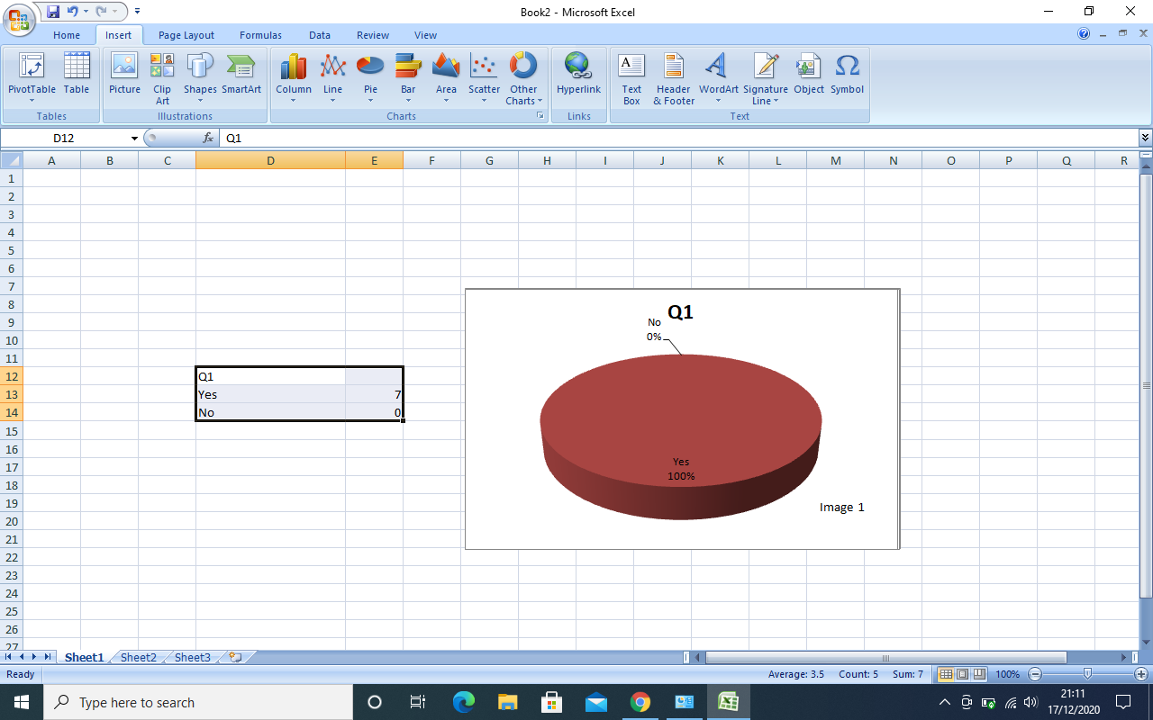
Appendix 1

Appendix 2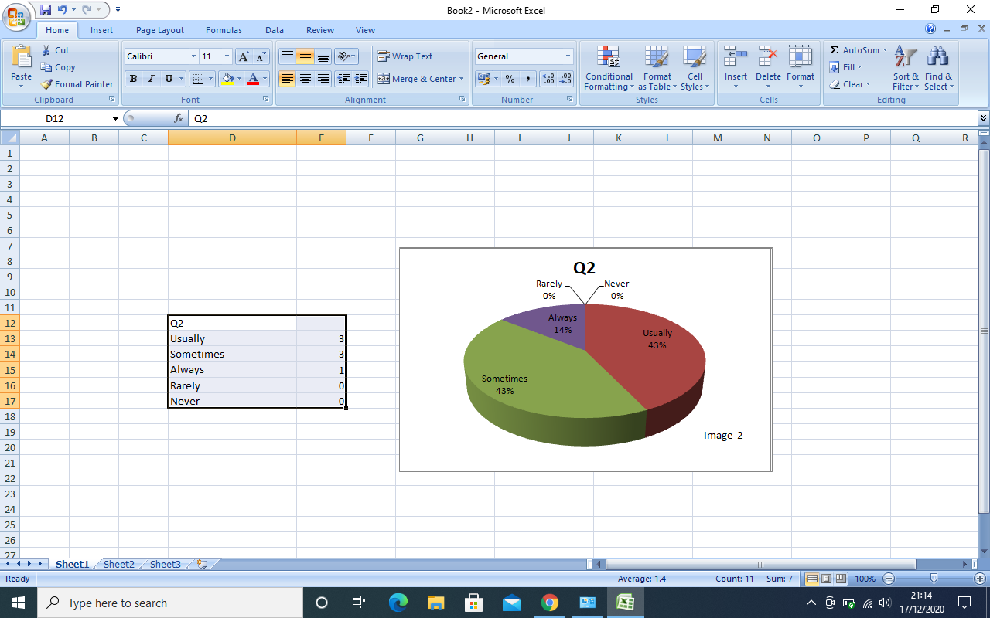

Appendix 3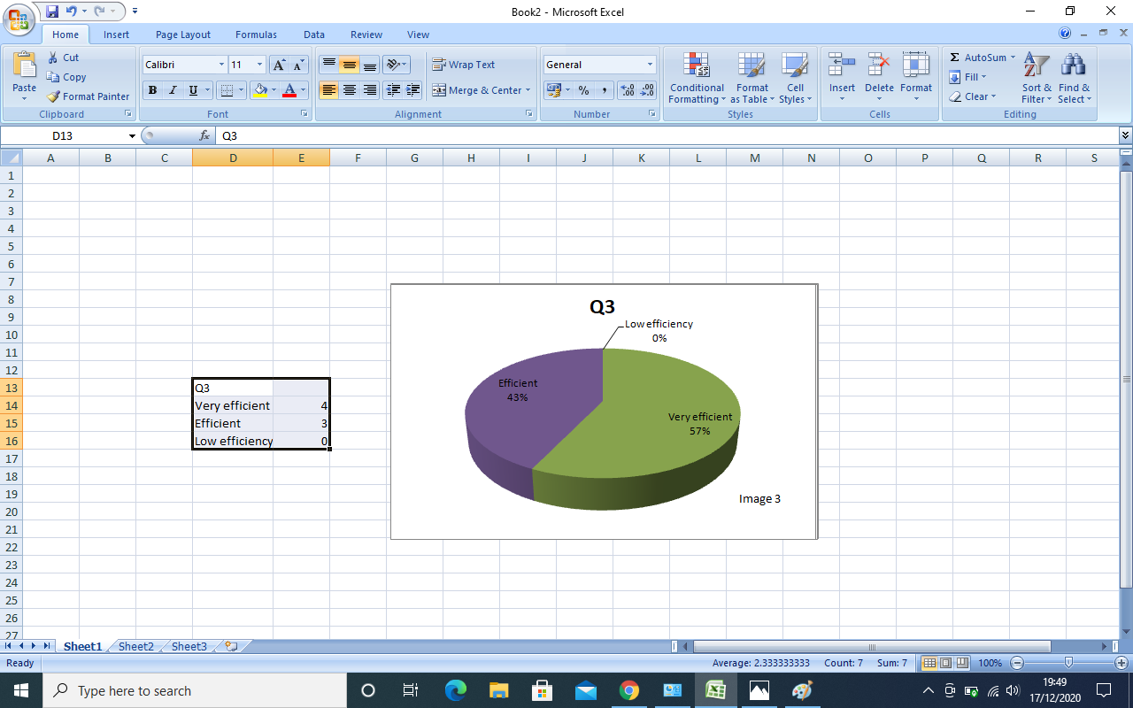

Appendix 4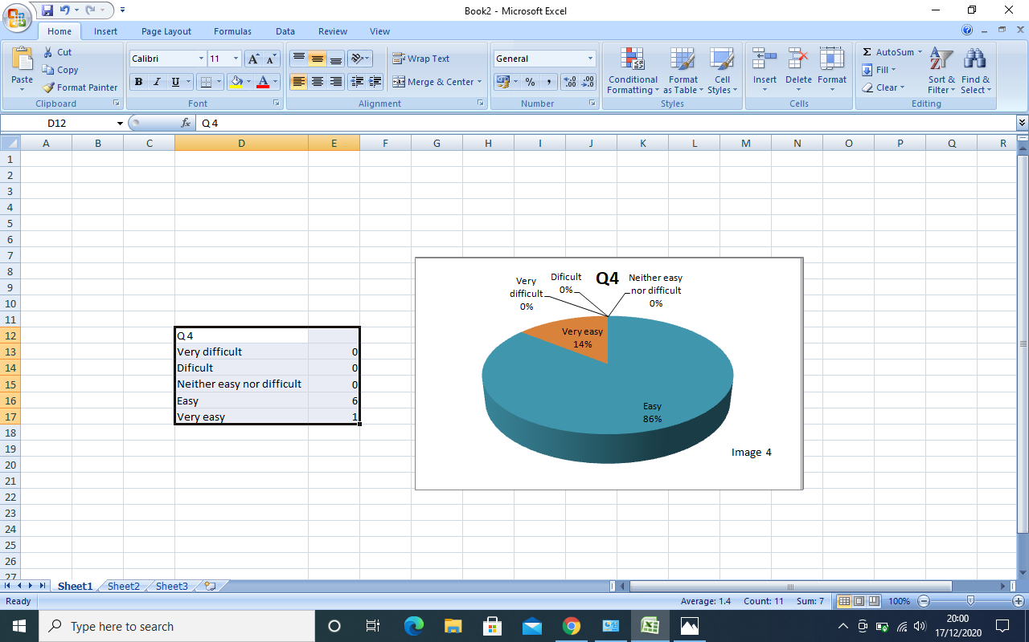

​

Appendix 5
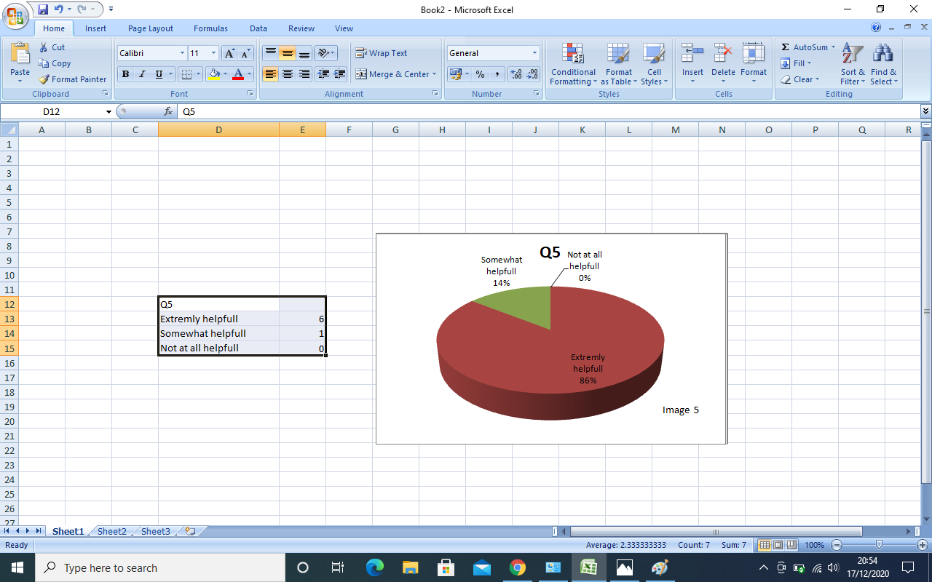

Appendix 6
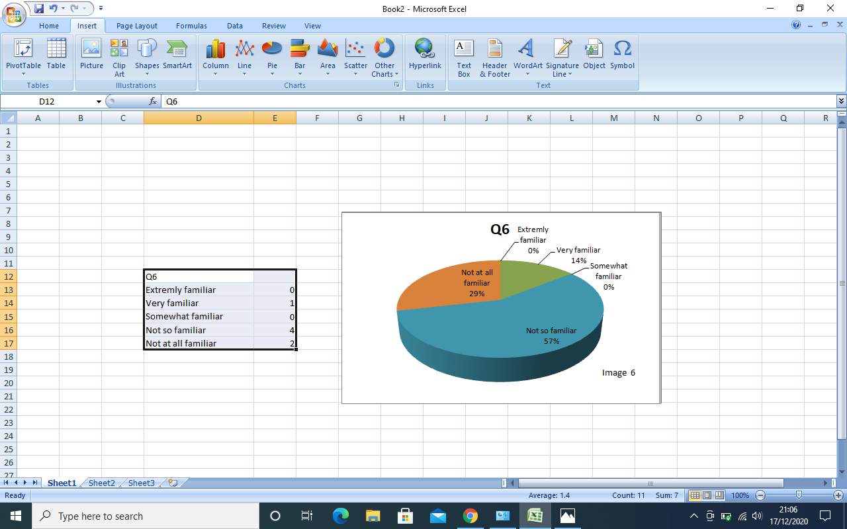

Appendix 7
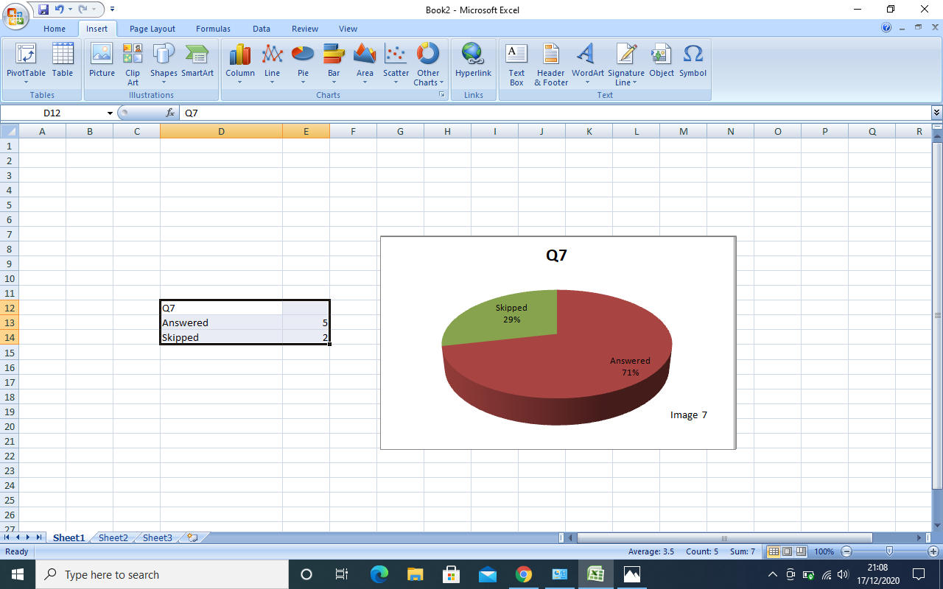

REFERENCES

References
Balram, A., 2020. the johns hopkins New-Letter. [Online]
Available at: https://www.jhunewsletter.com/article/2020/04/how-online-learning-can-affect-student-health
[Accessed 08 11 2020].
EduSys, 2020. EduSys. [Online]
Available at: https://www.edusys.co/blog/what-is-virtual-classroom
[Accessed 19 11 2020].
Eimear Ryan, C. P., 2019. PubMed.gov. [Online]
Available at: https://pubmed.ncbi.nlm.nih.gov/31229502/
[Accessed 11 11 2020].
ELISE MUELLER, P., 2020. Duke. [Online]
Available at: https://learninginnovation.duke.edu/blog/2020/02/zoom/#:~:text=Benefits%20of%20Zoom&text=The%20ability%20to%20connect%20synchronously,rooms%20to%20meet%20with%20peers
[Accessed 11 11 2020].
eThink, 2019. eThink. [Online]
Available at: https://ethinkeducation.com/blog/moodle-in-higher-education-improved-learning-outcomes/#:~:text=Learning%20Benefits%20of%20Moodle%20LMS&text=Access%20to%20learning%20materials%20anytime,have%20physical%20materials%20on%20hand.
[Accessed 11 11 2020].
eThink, 2020. eThink. [Online]
Available at: https://ethinkeducation.com/uk/what-is-moodle-guide/
[Accessed 17 10 2020].
Firefly, n.d. Firefly. [Online]
Available at: https://fireflylearning.com/what-is-a-virtual-learning-environment-vle
[Accessed 17 10 2020].
Moodle, 2020. Moodle. [Online]
Available at: https://docs.moodle.org/310/en/About_Moodle
[Accessed 12 11 2020].
Oca, B. M. d., 2020. Slidebean. [Online]
Available at: https://slidebean.com/blog/startups-zoom-company-story-eric-yuan-skype
[Accessed 12 11 2020].
The Open University, n.d. OpenLearn. [Online]
Available at: https://www.open.edu/openlearn/education-development/open-education/content-section-4.1
[Accessed 11 11 2020].
Tillman, M., 2020. Pocket-lint. [Online]
Available at: https://www.pocket-lint.com/apps/news/151426-what-is-zoom-and-how-does-it-work-plus-tips-and-tricks
[Accessed 03 11 2020].

