KAMILAH MAYNARD
2014670
Changemakers: Building your Personal Brand for Sustainable Employment
Assignment 1: E-Portfolio Evidence of Learning
- Curriculum Vitae (CV)
- Cover Letter
- TV Pitch
Dr Tayo Korede
BMHP5015_BIRM
(Source: Virtutes for Life, 2022).

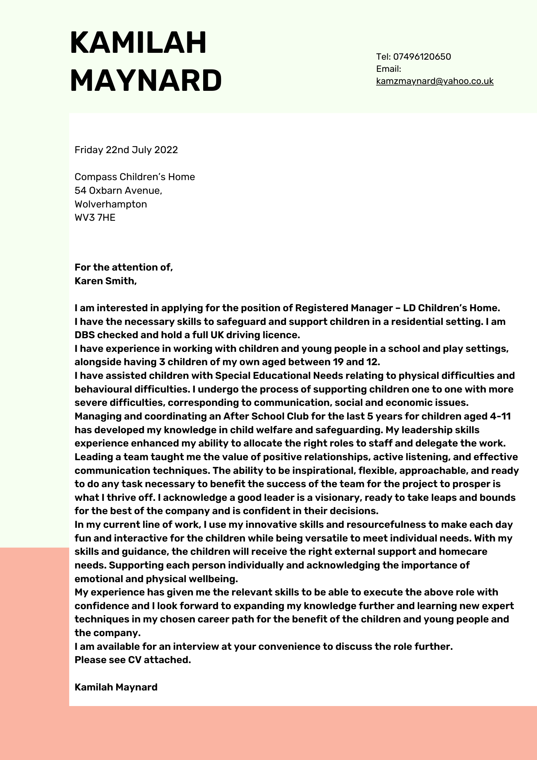
TV PITCH
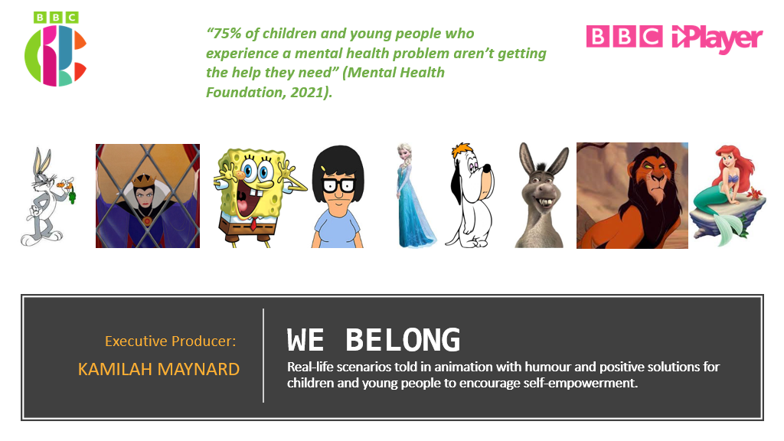
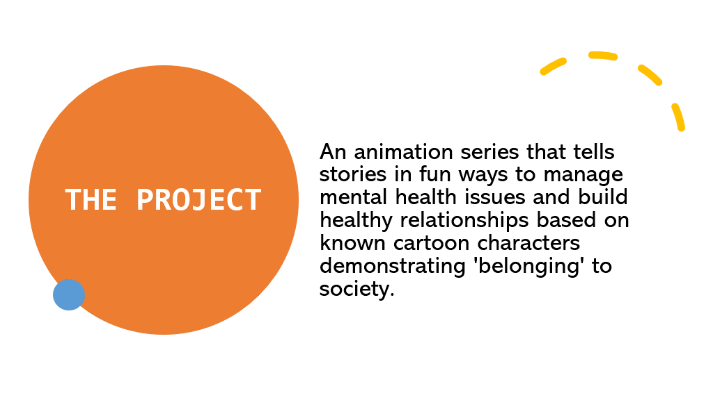
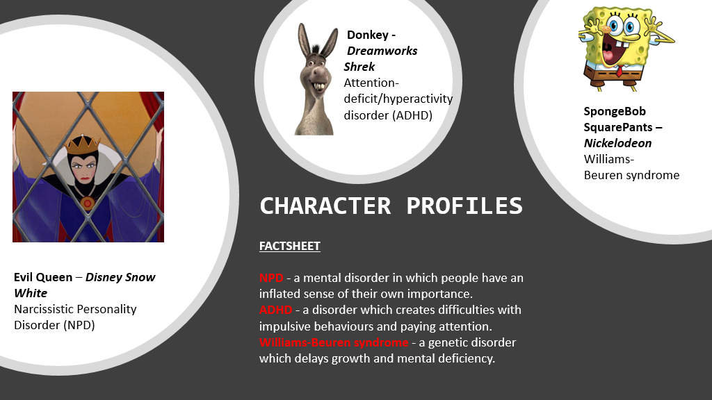
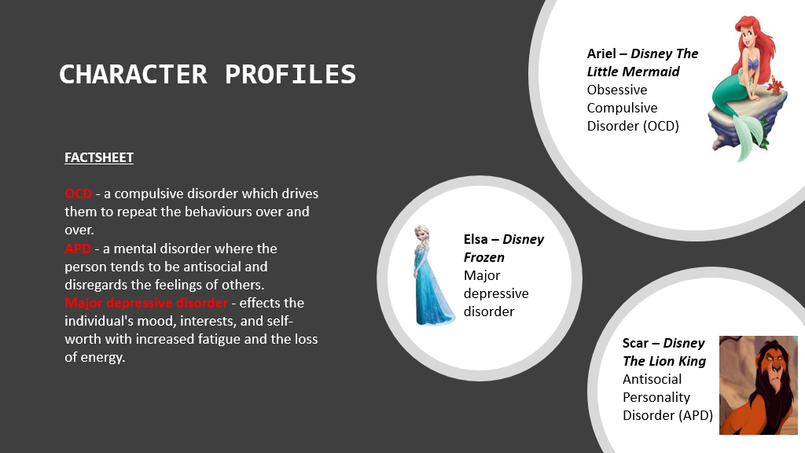
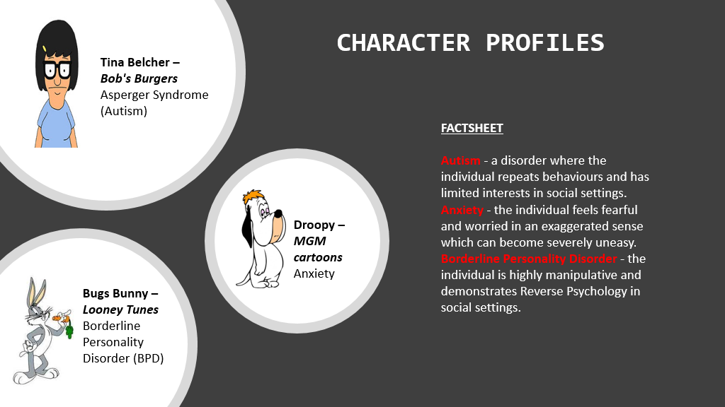
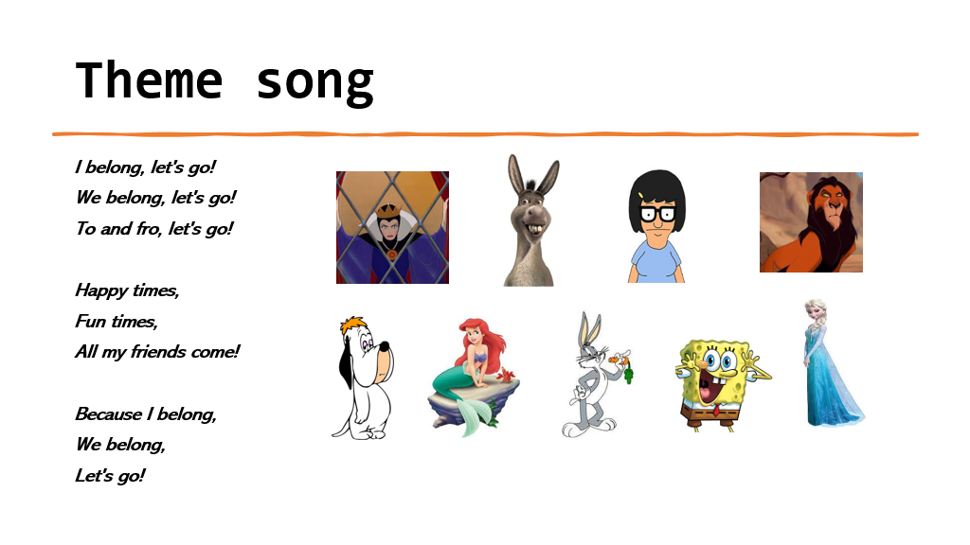
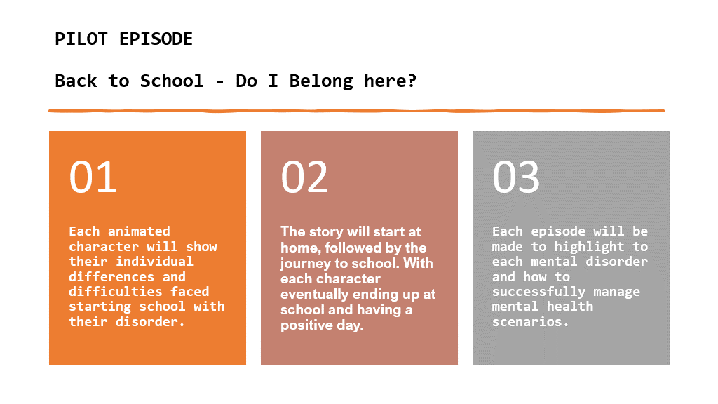
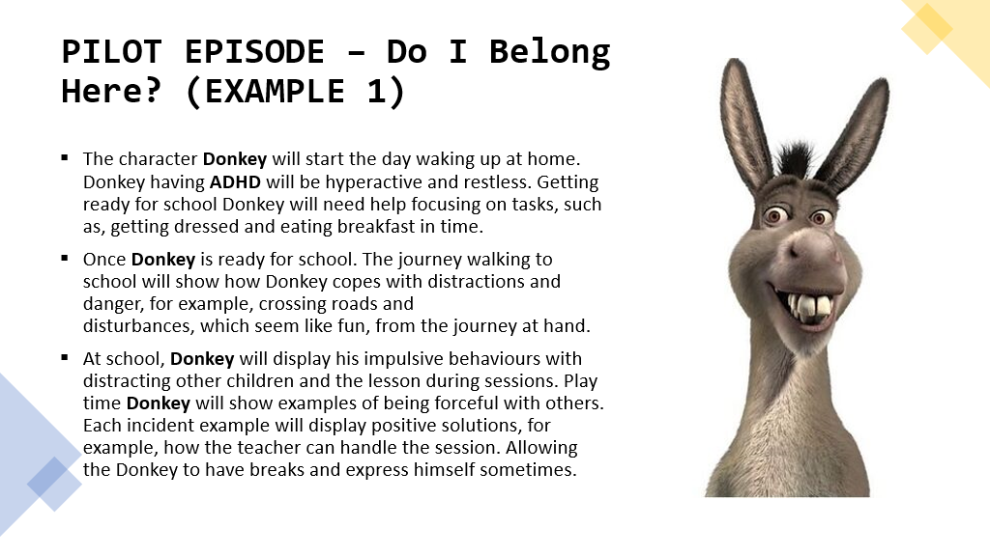
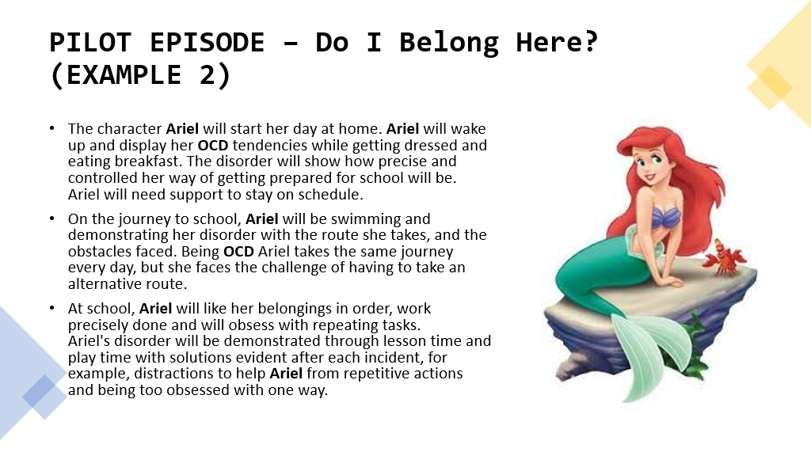
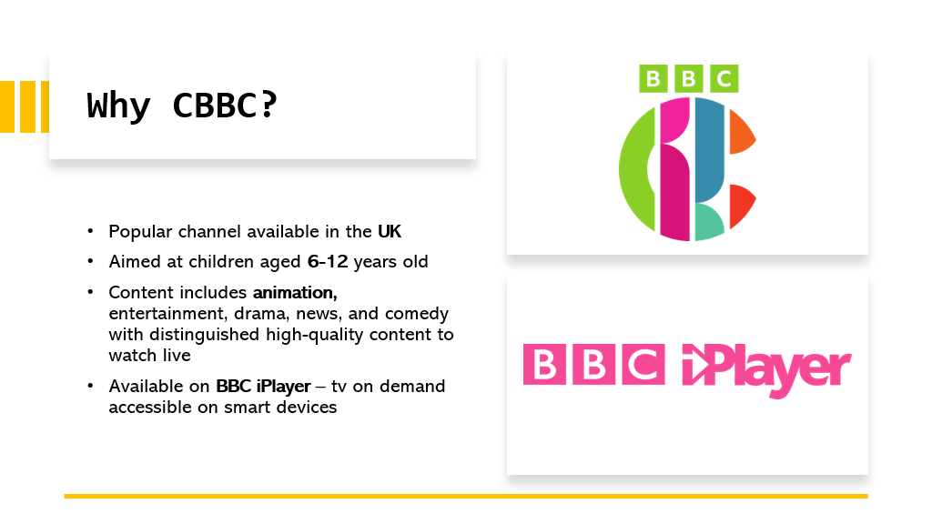
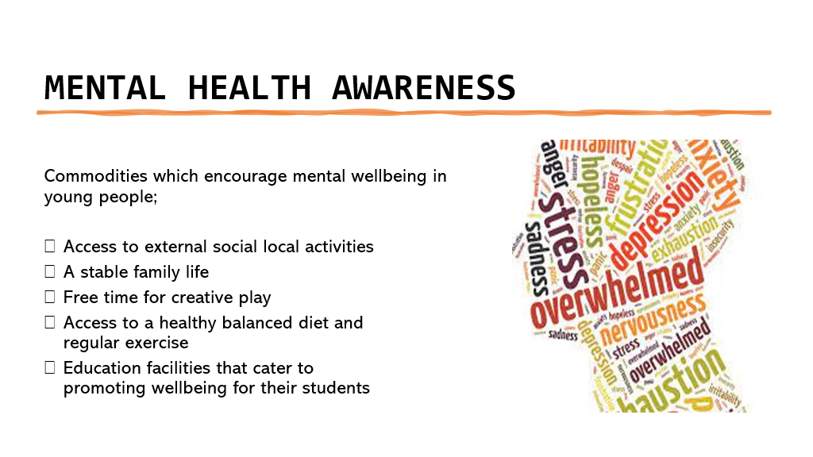
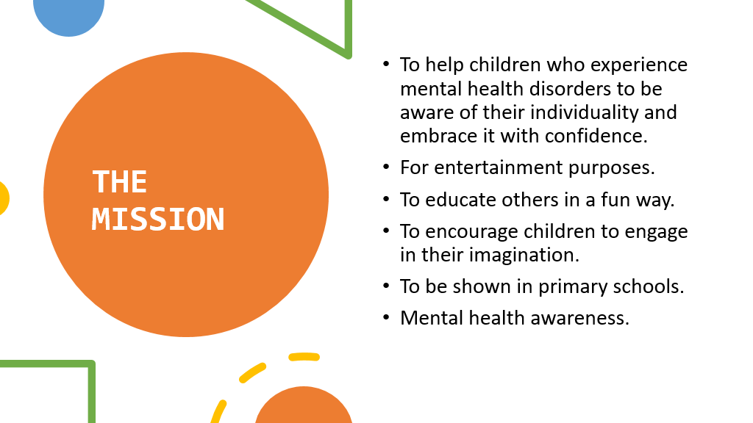
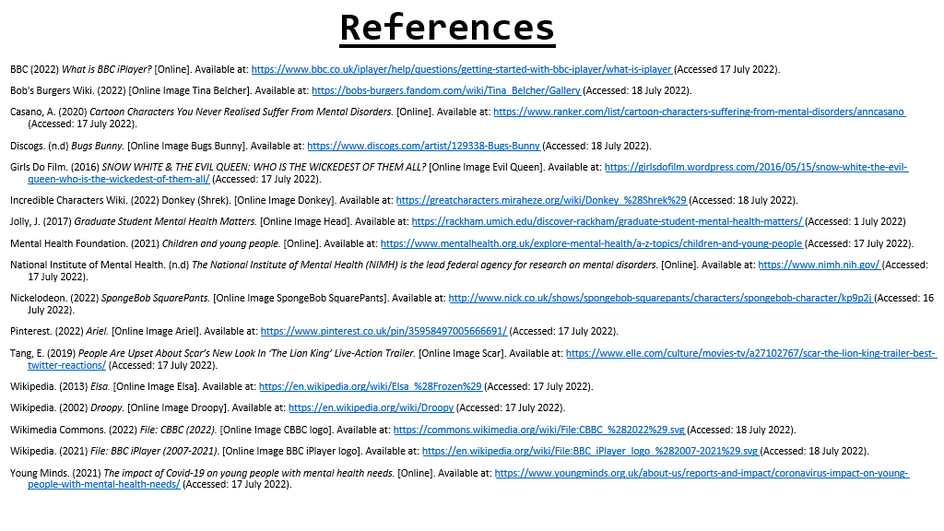

Virtues for Life. (2022) 23 Creativity Quotes to Ignite Your Self Expression. [Online Image Creativity]. Available at: https://www.virtuesforlife.com/23-creativity-quotes-to-ignite-your-self-expression/ (Accessed: 18 July 2022).
Canva.com (2022) available at: https://www.canva.com/ (Accessed 16 July 2022).

