
Kinetic Energy Recovery
Alternative Propulsion Systems
BEng Automotive, Motorsport and Motorcycle Engineering
ACHA5010
Will Davies
2400569
Mark Sandford
Word Count: 2481
Handed In: 30/11/2025

Contents
Kinetic Energy Recovery 1
1.0 Introduction 3
2.0 Vehicle Selection and Research 4
2.1 Test Mass 4
2.2 Frontal Area 4
2.3 Rolling Resistance Coefficient 4
2.4 Coefficient of Drag 4
3.0 Worldwide harmonised Light vehicle Test Procedure (WLTP) 5
5.0 KERS Power Input 11
6.1 KER Systems 11
Flywheel 11
Super Capacitor 11
Battery 11
6.2 KERS Selection 11
6.3 Size of Components 12
6.4 Efficiency Values 12
8.0 System Operation 14
8.1 System Operation 14
8.2 Assumptions 14
8.3 Driver Feel 15
Bibliography 16

Introduction
This assignment has been colluded to show research and the use of evaluation when investigating alternative powertrain designs and their energy recovery systems. the purpose of this assignment is to analyse a KERS System of my choice and for it to be applied to my specific vehicle. Within this assignment there is evaluation on a specific KERS design and information reported on other KER Systems to give an all-round view on how these designs work and what will be the best one for my specific vehicle and its use. In the tasks, the use and research of the WLTP cycle is used to show how the tractive forces of my chosen vehicle and how using calculations for creating a regenerative energy system would change the way the car behaves under braking and acceleration. The vehicle chosen is a mk6 Fiesta. This vehicle started production in 2008. The vehicle has 80bhp from the factory and has 140N.m of torque. This report will deliver graphs, sizing of components and a comparison of the different KERS systems, how they work and why I chose a specific system which fits my vehicle well.

2.0 Vehicle Selection and Research
Vehicle Selected – Mk6 Ford Fiesta 2007. The reason why I chose this vehicle is that I currently own this car and thought it would be interesting to use and see how my vehicle would change its performance when adding a KERS system to it.

2.1 Test Mass
Curb Weight = 1026kg (Without driver) (Automobile Catalogue) (2010)
1 driver = 100kg
1 passenger= 68kg
Luggage = 25kg
Total Test Mass = Curb Weight + 1 Driver + 1 passenger + Luggage = 1,219kg
(Automobile Catalogue) (2010)

2.2 Frontal Area
Height = 1429mm = 1.429m
Width = 1683mm = 1.683m
Frontal Area = Height x Width
= 1.429 x 1.683 = 2.405m²
(Automobile Catalogue) (2010)

2.3 Rolling Resistance Coefficient
Crr for Admiral tyres is 0.0091
Therefore Frr = Crr*mg
Frr = 0.0091*1,219*9.81 = 108.82

2.4 Coefficient of Drag
Drag coefficient = 0.34

3.0 Worldwide harmonised Light vehicle Test Procedure (WLTP)
The suitable test for a Mk6 fiesta would be a class 3 test as it produces more than 34W/kg
Ford Fiesta mk6 = 80hp = 59.66kW
kW = hp x 0.7457
Test Mass = 1219kg
Power-to-weight ratio Calculation
Power-to-weight ratio = kW/mass(kg) x 1000
59.66/1219 x 1000 = 48.96W/kg
The WLTP cycle categorises vehicles into three different classes which are depending on their power-to-weight ratio. As the ford fiesta produces 59.66kW and has a test mass of 1219kg, the power-to-weight ratio would be 48.96W/kg. This results in a greater vale than 34W/kg, meaning that the ford fiesta fits into the WLTP class 3 which is intended for the more powerful vehicles with a higher acceleration capability.
4.0 Plotted Spreadsheet

Figure 1: Aerodynamic Resistance V Time

Figure 2: Rolling Resistance V Time

Figure 3: Acceleration Resistance V Time
Figure 4:Tractive Forces V Time
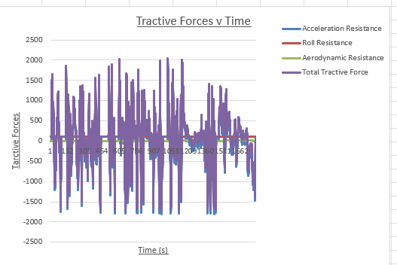

Figure 5: Power V Time

Figure 6: Braking Energy

Figure 7: Cumulative Forces

Figure 8: Tractive Power V Time

Figure 9: Cumulative Tractive Energy V Time

5.0 KERS Power Input
As stated in the brief, presume all the recovery is used in a single period. Therefore, looking at “figure 3: braking energy”, you can see that the largest amount of braking force is 5.95kJ. This means that this is the maximum or 100% of what the KERS system needs to hold for full capacity. The maximum braking power is -5945.6W or 5.95Kw. this is the peak power that the KERS system needs to be able to absorb. The event of this braking event has a duration of 1 second where energy is calculated by
E=P x t
E = 5945.57 x 1 = 5.95kJ
Therefore, the maximum about of braking power to be absorbed will be approximately 6kW with the KERS system being able to accept this charging power without any saturation.
6.0 KERS System

6.1 KER Systems
There are multiple KER Systems to chose from. From the use of a flywheel regenerative system, super capacitor and even a standard battery regenerative system.

Flywheel
The flywheel system works with mechanical energy being stored by a spinning high-speed flywheel when under braking. A clutch engages and engages a continuously variable transmission. This type of system is good for high-speed racing.

Super Capacitor
A super capacitor system uses the mechanical energy and converts the energy into electrical energy and is stored into a super capacitor instead of the energy being store chemically. This system has a charging phase when the car endures braking and has a boost phase when the car accelerates.

Battery
The battery KERS system works on using chemical energy storage via a lithium-ion battery. An electric motor becomes a generator and converts the kinetic energy into electrical energy. The electrical energy is directed into the battery by an AC/DC inverter. It’s like how hybrids work in today’s vehicles.

6.2 KERS Selection
The KERS system of choice is a Super Capacitor. This KERS system is good for stop and go traffic with frequent braking, resulting in a frequent recharge of the battery. The charge and discharge time would be seconds and is designed for rapid and repeated energy cycling. With the peak braking power being 5.95kW and the energy per braking event is 5.95kJ, the KERS system must accept at least 6kW of instantaneous power with it being able to store at least 6kJ in one single braking event. With the use of acceleration, it should be able to deliver short bursts of power.
Peak Braking Power | 5.95kW
Energy per Braking Event | 5.95kJ
Voltage system | 48V
Vehicle Type | Small ICE Hatchback
Drive Cycle | WLTP Class 3

6.3 Size of Components
With the energy storage needing a requirement of E=5.95kJ. the window of voltage would be 48V – 32V.
Supercapacitor Equation = 0.5 x C x (V^2max – V^2min)
Window term = 48^2 – 32^2 = 1280
Therefore = C = 2 x 5950/1280 = 9.3 F
This result also means that a super capacitor module will be >50F. this is due to there being a safety margin and having the super capacitor cels come in fixed sizes.

6.4 Efficiency Values
The MGU will need to be able to handle more than 6kW of regenerative energy, therefore the MGU inside this super capacitor has a unit of 10kW of power meaning that it is more than capable of handling the minimum amount of regenerative energy.
The use of an MGU is the conversion mechanical energy into electrical energy and vice versa in the purpose of charging and discharging. Having the use of an MGU is critical as the MGU has a high capacitance but also has a high amount of efficiency when converting the energy.
The rating of the DC-DC converter has a converter rating of 12kW as it will be handling a power flow between 48Volts and a super capacitor bank. The DC-DC voltage rating being 12kW shows that it can handle this amount of flow. Using a DC-DC converter is ideal as this is dealing with high amount of voltage, and being able to have a high handling power flow makes the job so much quicker and more efficient.
The super capacitor module has a voltage rating of 48V system and a capacity rating of 100F as it is typical to have this type of rating for an automotive mobile. The minimum amount of energy is 6kJ, therefore a margin of 18kJ will be suitable. The super capacitor having a high voltage rating allows the capacitor to hold more voltag . this is ideal when the driver puts their foot down for an extended period, giving the car that extra bit of power.
To conclude the super capacitor as my chosen KERS system, the super capacitor is the better KERS system to use as it meets the power requirement of 6kW and can easily store the event energy of 6kJ in a lightweight, small hatchback. It is perfect for the minimal amount of degradation against battery. Also, the use of a super capacitor is much simpler than the use of a flywheel KERS system .
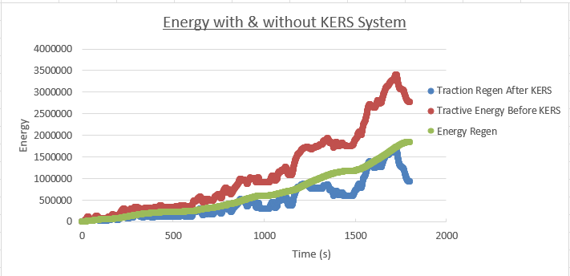
7.0 Kinetic Energy Recovery Graph

Figure 10: KERS Graph
Evaluating the graph above “Figure 10”. It is visible that the energy regen is relatively constantly above the line of Traction Regen Before KERS and then reaching its peak at the end when the graph shows when the car is braking the most. There is a compatible difference between when using KERS and when not as can see in Figure 5. To recap the performance of regen, you can clearly see a constant increase in the regen proving that the ford fiesta will be improved in performance when using the KERS system. By looking at the graph, it is clear to see that the super capacitor can hold a minimum of 6kJ even when the WLTP braking event are short, the battery is being charged and discharged when under the next acceleration.
Before the introduction of KERS you can see that the energy is high and increases and then has a sudden drop of energy. Whereas with the use of KERS in the cumulative regen, the energy increases, as drop in the same place but not has dramatic as without KERS. This would be affected with the influence of the 6kJ storage capacity. The capacity may have been full and then gets depleted under acceleration.

8.0 System Operation

8.1 System Operation
The Super Capacitor. As the vehicle is a city vehicle, it makes sense for the super capacitor to be the system of choice as the battery will be recharging in stop and go traffic. When the car decelerates, the energy motion is converted into electrical energy without the risk of losing a mass amount of energy via heat loss. Energy will get lost via wires and the components but not enough to compromise the performance of the Super Capacitor. The electrical energy gets stored into a super capacitor and when the car accelerates again, that electrical energy is depleted and gets sent straight to the wheels. The MGU is the component that converts the mechanical energy into electrical on deceleration, and when accelerating converts it back into mechanical energy. The PCU or the Power Control Unit as known, controls the moment of switching of the electric current between the MGU and the battery.
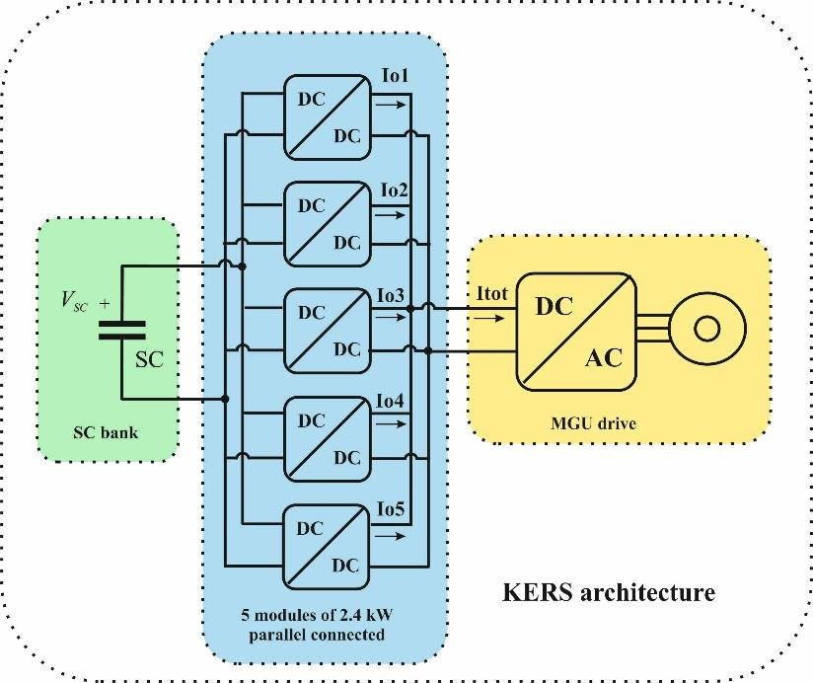
This KERS system has a charge and boost cycle. This occurs from the first instant deceleration to be able to store the kinetic energy. With the boost cycle being applied when the car is accelerating once more. The peak charge power is 5.95kW and the braking event energy of 5.95kJ, and the super capacitor is more than capable of delivering good performing results when the minimum is approximately 6kJ and 6kW. This is down to the super capacitor being able to easily absorb the pulses of energy.
Figure 11: KERS Flow Diagram
As looking at “Figure 11”, you can see the flow state of how the energy is created, converted and released/stored. As the wheels are moving the kinetic energy gets transferred from the wheels to the driveshaft which would be kinetic and mechanical energy and then into the MGU. The kinetic energy is then converted using DC voltage turning the kinetic energy into electrical energy which is then transmitted into the super capacitor bank. This is the system of flow for charging, and when the accelerator is applied the reverse of this flow happens.

8.2 Assumptions
The assumptions that I concluded to was that the super capacitor would have a voltage fixed window. This would allow me to have a constant in seeing and calculating the results. Another assumption is that the ford fiesta mk6 would follow the WLTP speed trace the entire time during the test. Regarding the tractive forces, given the calculations, I had to assume that the rolling resistance coefficient and that the aerodynamic drag was the same for the entire test. As in real life these are variables that will change. Regarding the system, an assumption was made based on that the system would also have a temperature that remained in its limits and didn’t overheat. As time goes one, the efficiency of the system and its internals would decrease however this was an assumption that had to stay the same.

8.3 Driver Feel
The driver feel would be generally obvious as the brakes would feel different when applying the pedal. This is down to the fact of the friction brakes and how they could feel draggy when the pedal is applied and contact is made in the braking system.
The acceleration would also feel different as the acceleration would cause a faster throttle response with the assistance of the electric motor. Under acceleration there would be a smoother take-off at low speeds and a reduced gear frequency when accelerating. The driver will also feel a different behaviour in coasting due to drag torque and the responsiveness of the vehicle when urban driving.

Bibliography
Page 3 – Test Mass & Cd - https://www.automobile-catalog.com/car/2007/961595/ford_fiesta_1_4_16v_style.html. Accessed on 21/10/2025. Published by ISBN 978-83-931772-0-2 automobile-catalog.com
Page 4 – WLTP Procedure - https://www.automoli.com/gb/vehicles/ford/fiesta/fiesta-vi-mk6-3-door-7544/. Accessed on 21/10/25. Published by AutoISO Sp. z o.o.
Page 4 – BHP to kW - https://www.blackcircles.com/helpcentre/tyres/bhp-to-kw. Accessed on 24/11/2025. Published by Blackcircles.com
Page 14 – KERS System - Kinetic energy recovery system - Energy Education. Accessed on 30/11/2025.
Page 14 – MGU size - Supercapacitor-Technical-Guide.pdf. Accessed on 30/11/2025. Published by Cornell Dubilier
Page 10 – Super Capacitor Bank - Super Capacitor bank Design for Battery Swap - Electrical Engineering Stack Exchange. Accessed on 30/11/2025. Published by Stack Exchange INC
Page 11 – KERS Systems - https://www.mdpi.com/2411-5134/4/4/62?utm_source. Accessed on 30/11/2025. Published by MDPI AG
Page 14 – Super Capacitor Information - Regenerative braking - Energy Education. Accessed on 30/11/2025.
Page 14 – System Operation - (PDF) Design of Regenerative Braking System and Energy Storage with Supercapacitors as Energy Buffers. Accessed on 30/11/2025. Published by ResearchGate GmbH
Page 15 – KERS Flow diagram - Schematics of the KERS architecture | Download Scientific Diagram. Accessed on 30/11/2025. Published by ResearchGate
Page 15 – driver feel - [1910.02440] Efficacy of Haptic Pedal Feel Compensation on Driving with Regenerative Braking. Accessed on 30/11/2025. Published by Cornell University
Page 15 – Driver feel - https://www.sciencedirect.com/science/article/abs/pii/S2214785322001973?utm_source. Accessed on 30/11/2025/ Published by Elsevier B.V.

