Belinda C Golding (1706757)
BA (Hons) Fine Art (Studio, Site and Context)
Module M5X01599
13th December 2018
Tutor Sarah Toombes
Word Count 1919

Within a given time period, select examples of what could be considered high and low cultural artefacts. Discuss these, taking into consideration the surrounding social, political and historical context.

In order to begin discussion of this question I want to briefly outline what culture is and in reference to this discussion what is deemed to be high culture and what is seen as low culture. ‘(Define culture!)’ David Hickey profoundly states in his book (Air Guitar, 1997, page 21) where indeed the description of culture in the 20th and 21st century is so broad and expansive that it is inclusive of spirituality, music, literature, film, philosophy. Culture is also the aesthetic languages of painting and sculpture and intangibles such as spoken languages and customs. ‘Culture is the general sphere of knowledge and of representation of lived experiences within historical societies divided into classes’ Guy Debourd states in (Society of the Spectacle 1967) It is within these classes that we find ‘high’ and ‘low’ culture, and therefore ‘high’ and ‘low’ art/artefacts. The French sociologist, philosopher and anthropologist Pierre Bourdieu defined ‘high’ art as highly conceptualized, intellectualized, privy only to the highly educated minority. Where as ‘low’ art is for the less well educated hoi polloi comprising of popular music, television, Hollywood movies, celebrity magazines, escapist fiction and camp (boundless)
The time period that I will discussing for the purposes of this essay is the 1960’s with the first three artefacts taken form 1060’s America and the final one from Great Britain. During the 1960’s America historically was in throes of living the ‘American Dream’ where all American citizens should prosper through the increase of industry, infrastructure and mass production. Society was booming and in relation to art this time period saw the biggest art movement in American history with the free, expressive, gestural art that emerged through Abstract Expressionism. Whilst Great Britain had the Kitchen Sink Art Movement, where angry young artists depicted drab, unglamorous scenes of industry the Americans had Jackson Pollock and Lee Krasner dripping and splashing paint around. Their art was deeply philosophical and profoundly intellectual with it’s dealings of witchcraft and spirituality (Landau 1989). Then along came Pop Art with Andy Warhol leading the pack and producing paintings and silk screens of soup cans, brillo pad boxes and Mariyn Monroe. All the things that as I briefly outlined previously are deemed to be part low culture. Which leads me on to the first artifact that I will be discussing.

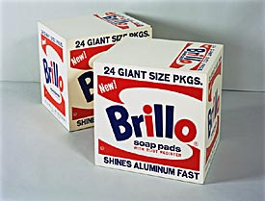
‘Brillo Boxes’ 1964 (silk screen on hardboard) Andy Warhol

The Pop Art Movement saw the appearance of art depicting objects of everyday, common life and making their way into art galleries In America. The Biannchini Gallery in New York in 1964 disguised itself as a small scale supermarket . Large signs hanging in the aisles indicated the locations of various comestibles ‘eggs’ ‘canned soup’ ‘bread’ ‘fresh vegetables’ as well wax replicas of various cheeses and meats. (Whiting, 1997, page 30) When the Brillo Boxes went on display in Manhattan’s Stable Gallery in 1964 Arthur Danto (one of world’s foremost Warhol experts and a professor of philosophy at New York’s Columbia University recalled walking out of the exhibition in awe believing he had just witnessed the ‘end of western art’ (The Guardian, 21st August 2000) Had the lines at that conjecture been blurred between ‘high’ and ‘low’ art? Art galleries normally frequented by the highly educated elite, exhibiting art works depicting common household commodities would possibly answer that question with a plausible, yes. Warhol et al were responding and mimicking the mass production lines of the increasing capitalist society. Where ‘commodity fetishism ‘ as theorized by Karl Marx in Das Kapita (Capital, Critique of the Political Economy, 1867) was beginning to emerge after the dark and hard times of post war austerity, Andy Warhol was taking advantage, and when he famously said ‘business is the best art’ he was merging the low and the high culture. They may appear to exist , develop, and function independently , but in fact they are perennial egos which at times interact directly. High and Low art , like Beauty and the Beast, go hand in hand .(Varnedoe and Gopnik, 1990, page 19). This leads me on to the next artifact that I will be deconstructing.

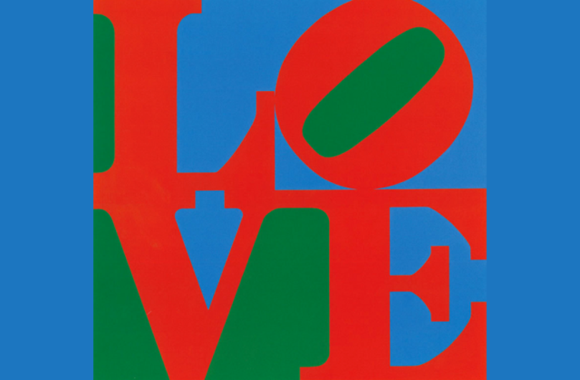
‘Love’ 1966, Robert Indiana. Paint on canvas and large scale sculpture.

Robert Indiana like Andy Warhol was a member of the Pop Artist and also lived and worked in the Manhattan area of New York. However, whilst Andy Warhol was proliferating his art business. Robert Indianna was responding and reacting along side millions of other Americans to the bloody and insidious Vietnam War that took place between 1955-1975. During that period the American people were governed by five different presidents. There became mass unrest as millions of people revolted at the unnecessary death toll of millions of innocent civilians. Americans wanted peace.
Robert Indianna’s ‘Love’ paintings were originally designed as Christmas cards and commissioned by the Museum of Modern Art and has appeared on tapestries, stamps, banners, artefacts which if we refer back to the previous depiction to low and high art, these would be deemed to be low art as they have been massed produced, heavily replicated and infiltrated into the public domain where as high art is seen as elitist, privy to art galleries and the select few.

During the period of 1965 – 1970 there was an increase in peace protests lead by artists, such as Carol Summers whose art piece ‘Kill For Peace 1967, which was organized by artist Jack Sonenberg. This portfolio comprised of ‘artists and writers in protest against the war in Vietnam. Robert Indianna with his ‘Love’ piece was also doing just that. He was using his skill as an artist to bring art to the masses and speaking for the masses, allowing them to use their voice against the abhorrent war in Vietnam that America was part of. As discussed in the previous paragraph the ‘Love’ piece could be seen as ‘low’ art due to the nature of it’s replication and mass production but the narrative and context which fuelled the piece was highly politicized, with strong social issues and values, so in that context the ‘love’ piece would be seen as ‘high’ art. Again we see the low the high culture depend upon each other and they have to exist simultaneously. This leads me on now to the third artifact that I will discussing.

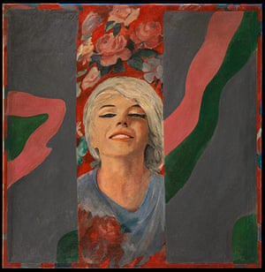
‘Colour Her Gone’ 1962 oil paint on hard board

Pauline Boty was the only female member of the Pop Artists. I have chosen this artefact to discuss as it is painting of the Hollywood icon, sex symbol, fashion icon and actress Marilyn Monroe who represented everything that was popular culture. However as previously discussed just as Andy Warhol was responding to society at the time so also was Pauline Boty. “It’s almost painting mythology, present day mythology, film stars etc, 20th century gods and goddesses . People need them and the myths that surround them, because their lives are enriched by them. Pop Art colours those myths’’ (The Guardian October 2017). Pauline Boty was depicting in her paintings what was deemed to be ‘low’ art but her art was also political. The 1960’s in America was the beginnings of the Feminist Art Movement which took full throttle in the 1970’s. The Feminist Art Movement was born out of the inherent sexism in the art world but also in the world in general. Female artists were not represented in art galleries, few females went into art schools. The art world was male dominated, this is apparent in Pop Art as Pauline Boty was the only female in the movement. Sexism in the art world then was rife which sparked he Feminist Art Movement. However, in 1993 Waldemar Januszczak, the then art critic for The Guardian declared on the BBC’s The Late Show ‘Since she was such a bad and derivative painter, Boty’s dolly bird status was the only thing that anyone would find interesting about her’ This statement can only mean that Boty’s work had no place in the ‘high art canon, due to the seemingly shallow subject matter that would be found in low culture. There was no other artist though that was tackling and critiquing gender and mass culture’s use of gender. Again like Warhol and Indianna Boty was responding to the socio politics of mass culture at that time. Therefore in terms of politics and progression Boty was leading the way so it would be futile to see her art as low culture.

The final artifact that I will be discussing is by British artist Bridget Riley.

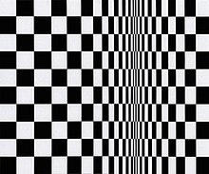
Movements in Squares, 1961, acrylic paint on canvas

Whilst America had the Pop Art Movement in the 1960’s Britain was seeing artists such as Bridget Riley who was a member of the Op Art Movement, that used geometric shapes, (usually squares and triangles) using monochrome (and colour) paintings to create optical illusions to make the two dimensional surface pattern appear to move and vibrate. In their simplicity Bridget Riley’s paintings are simple patterns and compositions of colour but they are highly conceptualized in that they are there to create uncertainty and provoke thought. These paintings inspired textile patterns and psychedelic posters which as previously discussed are commodities of low culture. However Riley’s art practice is grounded in a utopian, social vision. She views her art as an inherently social act, as the viewer completes the experience of painting. This belief in an interactive art led her to resist commercialization, and in her mind, the vulgarization of Op Art by the fashion world. (The Art Story, Modern Art Insight) The 1960’s saw geometric patterned clothing designed by fashion designers such as Mary Quant and checked, polka dot clothing designed by Valentino. In terms of the highly conceptualized thought process behind the narrative of ‘Movements in Squares’ it would indeed be seen as high art. However on the other side of the coin because of their influence to mainstream fashion and mass culture they could be seen as ,low art. The answer to the initial question would be that this artifact is indeed both low and high art.

In terms of any conclusion with this discussion as to whether the artefacts I have deconstructed are either categorized into ‘low’ or ‘high’ art it can be said that each of the art pieces I have discussed would fall under both categories. Previous reference has been drawn to the fact that high and low culture exist together, taking from each other and co-existing simultaneously. From this brief discussion it is apparent that ‘low’ and ‘high’ culture, hence ‘low’ and ‘high’ art are mutually exclusive. I will end this essay with a quote from David Hickey, taken from his book, (Air Guitar’ 1997, page 100). ‘Is a painting by Jackson Pollock or a film by Stan Brakhage high art? Yes? Well, if so could the art of Jackson Pollock or Brakhage exist without the imprimatur of Dizzy Gillespie and Charlie Parker. I have understood it without its being informed by the cultural context of American jazz? Without the free-form exuberance of bebop? My answer no way, Jose. And conversely could bebop exist without Jackson Pollock? You betcha. And could rock and roll exist without Warhol? Yep. And could Andy Warhol exist without rock and roll, I don’t think so’

BIBLIOGRAPHY

Baudrillard J 1994 (Simulacra and Simulation) United States, The University of Michigan Press.
Biggs, M and Karlsson, H 2001 (The Routledge Companion to Research in the Arts) Abingdon, Oxon, Routledge.

Debord, G (no date listed) (Society of the Spectacle) London, Rebel Press.

Hickey, D 1997 (Air Guitar, Essays on art and Democracy) Los Angeles, Art issues. Press.

Landau, E 1989 (Jackson Pollock) London, Thames and Hudson.

Lippard, L 1991 (fourth edition) (Pop Art) London, Thames and Hudson.

Varnedoe, K and Gopnik, A 1990 ( Modern Art and Popular Culture) New York, Harry N Abrams ltd.

Whiting, C 1997 (A Taste for Pop, Pop Art, Gender, and Consumer Culture) United Kingdom, Cambridge University Press.

ARTICLES

The Guardian, (Warhols box of tricks) August 21st 2010

The Guardian, (If only we took selfies like Andy Warhol) November 16th 2018

The Guardian (Ali Smith on the prime of pop artist Pauline Boty) 22nd October 2016.

VIDEOS
https://www.youtube.com/watch?v=ulZ64VDhwXM..Andy Warhol

https://www.khanacademy.org/humanities/us-history/postwarera/1960s-america/a/the-vietnam-war

https://youtu.be/F43Gy0xpy6w

