A Critical Evaluation and the Identification of Next Teaching and Learning Steps Focussing on a Case Study of an Individual Learner or a Group of Learners, based on an Observed Critical Incident.
Introduction
Within the field of Education, a Critical Incident (CI) is commonly known as an unintentional or unexpected event that takes place and seeks to activate more in-depth awareness about the learning or teaching in the classroom environment (Richards and Farrell, 2010, p. 13). Furthermore, Joshi (2010) expresses that Critical Incident Analysis is extremely effective within the teaching profession and it’s development, as this allows teachers’ to question their own practice and broaden their knowledge around good practices within the classroom in order to improve. In addition to the above, Tripp (1993) also believed that the analysis of Critical Incidents in the classroom was an advantageous approach within the field of teaching, as this allowed teachers to self-reflect on their own practices in the classroom and pose critical questions about all aspects of teaching that takes place. An increased awareness to thinking critically has been identified to be a very ‘useful’ and ‘valuable’ skill to have, in everyday life (Waller, 2021, p. 8).
Therefore, throughout the course of this written assignment, consideration will be given as to why self-reflection is an important factor within the teaching profession, and also critical discussion around how praise in the classroom can have a positive or negative impact on leaners. In addition, how this critical incident has impacted on my own thoughts on how to improve my on professional practice in teaching will be summarised.
Key words: Critical Incident (CI), Critical Incident Analysis (CIA), Reflective Practice (RP), Praise, Encouragement.
The Role of Critical Reflection
Following the research of many models of reflective practice (Dewey, 1933; Schon, 1983; Kolb, 1984; Gibbs, 1988; Brookfield, 1998, 2005) it was evident that the role of critical reflection within the teaching profession had had a substantial impact on teachers’ abilities, understandings, and tendencies in their own practice, which later resulted in increased success and growth in their professional development.
Critical Reflection within education, is commonly viewed as a process of teachers looking back on (i) what they have achieved in that experience, (ii) contemplate about what they achieved during that experience and (iii) learning from that experience (Conway, 1994) in order for them to move forward and develop alternative teaching methods or ways of acting to improve their practice in the future.
Dewey (1933) believed that to become a successful reflective individual, this required the teacher concerned to possess characteristics of open-mindedness, taking responsibility for their own actions and a wholeheartedness approach to the process.
As a PGCE student, possessing these qualities is something I would like to develop into my own teaching practice as I believe that developing these characteristics is of great importance to me in both discovering and developing new teaching methods in order to improve my own practice. With regards to teaching standards in Wales, adopting such an approach allows further development in the teaching profession, by the seeking out of other colleagues’ opinions and advice to not only develop innovation in themselves but also to demonstrate how this advice might impact on their own practices in order to improve (Welsh Government, 2011). In this connection, I am strongly of the view that taking responsibility of one’s own actions in the classroom is crucial within the teaching profession e.g., identifying one’s own mistakes made during the teaching lesson, in order to make changes to teaching strategies to become more successful in future practice.
Although there are several models that connect to reflective practice, all these models involve similar core elements which assist and enable teachers in becoming a critical reflective individual. Such elements involve the analysis of individual’s own assumptions, doubting their knowledge, having awareness of the environment around them and envisioning alternative methods to improve (Brookfield, 1998).
Critical reflection came into existence by way of Schon’s (1983) model of reflection. This model demonstrated the differentiation between ‘reflection in action’ and ‘reflection on action’.
Reflection in action alludes to the process of pondering during the event happening and changing what has happened in the moment as appose to ‘reflection on action’, which alludes to the process of pondering after the event has taken place - to encourage ideas for the future. The adoption of this approach is believed to support trainee teachers in the classroom environment to think like a more experienced teacher with a view to the individual becoming more understanding of how to establish better teaching practices. However, Brookfield (1995) discovered in his reflection model that there were some limitations in connection with the use of critical reflection where he refers to the individual’s negative expectations. This can relate to the individual’s personal experiences and cultural backgrounds, as not all individuals will feel motivated by critically reflecting upon their own practice, good or bad, in the classroom.
Another familiar reflective model which is commonly used within the teaching profession is that of Kolb’s (1984) ‘Learning Cycle’. Kolb stressed that by analysing and drawing a conclusion from a particular experience in the classroom was a beneficial technique which enables the individual to reflect on his/her own practice in order to improve teaching methods, with new experiences. The benefit of using this model within the teaching profession is to allow teachers to become more reflective in their practice and develop essential skills throughout their career to enhance the learning within the classroom (Sharlanova, 2004).
However, Miettinen (2000) is strongly of the opinion that Kolb’s ‘Learning Cycle’ is a very secluded process and believes there should be some interaction with others in the profession and environment to reach the full potential of the outcome.
Therefore, by teachers finding the right model of reflection to develop and improve their teaching practice, this will allow them to follow a more structured approach to thinking critically, which will assist them in achieving greater success in the future.
School and Class Context
Throughout the process of the observation, reference was made to the findings of British Educational Research Association (BERA) (2018) whereby it was observed that such dedication to the ethical considerations were adhered to throughout the whole process. “The confidential and anonymous treatment of participants’ data is considered the norm for the conduct of research” (BERA, 2018, p. 21). For this reason, the name of the school, the staff, and the pupils observed during the process will be kept anonymous for the purpose of the individual’s privacy.
For the purpose of the assignment, the observation took place in a diverse English medium comprehensive school in South Wales, with the ages of the pupils ranging from 11 to 18 years. The school had around 1,263 pupils of mainly minority ethnic backgrounds, welcomed those from religious and non-religious family backgrounds who came to the school from various locations over a wide contrasting geographical area.
It has been ascertained that within the school just under 16% of the pupils had Additional Learning Needs (ALN) and 5% had a diagnosis of an Additional Learning Need, which are figures above the average percentage for ALN schools (Estyn, 2018). In relation to school meals just under 9% of the school were eligible for Free School Meals (FSM) with this being significantly below the average percentage of children who receive FSM nationally (Estyn, 2018). From my time observing in the school environment, it was evident to me that there was a robust faith ethos amongst all staff whereby they encouraged ‘love, acceptance, responsibility and forgiveness’ throughout the whole environment (Estyn, 2018).
Critical Incident
The Critical Incident (CI) which was observed (See Appendix 1) took place in a KS3 humanities lesson, where the topic of learning for new pupils of the school was ‘an introduction to Geography’, the aim of which was to give them a basic insight into the subject to prepare them for future, more detailed lessons. The lesson took place just before dinner break, and the learners came into the classroom in, what could only be described as a ‘rowdy’ fashion.
Throughout the entire lesson, it was observed that most of the learners were restless and were being distracted by certain little things in the classroom e.g., pens, glue and books that were visible on the desk in front of them.
Towards the end of the geography lesson, the classroom teacher showed the class a picture differentiating between poorer and more affluent areas generally and once they had studied it asked them what they thought about such a situation. This led to a group of learners putting their hands up to answer the question. The teacher further proceeded to ask the class about a matrix question whereby she asked the learners “Does anyone know what a matrix question is?”. In response to this question, only one learner put their hand up to answer the question and before the learner answered the question the teacher stated “It looks like you’re the only one with your hand up. What do you think it is?”. The learner then replied with the correct answer to which the teacher further responded “Well done. It looks like you’re the only professional in the room”.
This comment that was observed was believed to be the CI that was identified throughout the observation that took place. The teacher then carried on with the lesson asking the learners to work in groups, and using the matrix tabulation, think of questions which relate to the picture they had been shown, to further discuss as a class.
When considering the New Curriculum for Wales it was proposed in Donaldson’s Report in 2015 that schools should deliver a curriculum that concentrates on meeting the four purposes of education (Donaldson, 2015) (See appendix 4). From the observation, it was clear that this geography lesson allowed the learners to become ambitious, capable learners by allowing them to build upon a body of knowledge to develop the skills to be able to connect and apply that knowledge in different contexts (p. 29).
This was identified when the pupils learnt a new questioning strategy (matrix questions) which could be used in different situations such as other lessons i.e., to think of questions in an ‘outside of the box’ manor in order to deal with questions of which they are not quite sure of the answer.
This CI was also linked to the ambitious, capable learners’ purpose by explaining the ideas and concepts about which they were learning about at the end of the geography lesson (p. 29). The classroom teacher engaged the whole class in discussing what questions the learners had come up with as a group, in order to ensure that everyone had a greater understanding of a matrix type question. Such approach highlighted ambitious and capable learners.
Another purpose that was linked to the geography lesson was that of the learners becoming more ethical and informed citizens by giving them the knowledge in the lesson about their culture, community, society and the world as present and also of the past (p. 30). This lesson clearly gave the learners an increased understanding of the differences between poorer and more affluent societies. This allowed the learners to understand that not every culture, community and society are the same, and that some families are less fortunate than others. Therefore, this, hopefully, prepared the learners to become better citizens of Wales and the world at large.
Literature Review
Praise is an expression that is commonly used to compliment learners when being successful in the classroom environment and to encourage them in their education. In addition, when learners receive praise in the classroom this allows them to consider themselves as smart and more able to further focus more on their learning to become motivated and successful (Hufton, Elliott, and Illushin, 2003). This was noticed when observing the chosen critical incident, whereby, after the learner who was praised for answering the given question correctly, continued to answer more questions throughout the lesson. This may have been due to the fact that the learner was more confident and felt more intelligent and motivated by the teacher for answering the original question correctly. Without learners being positively motivated this could lead to challenges within their future educational development such as leaving them with a lack of curiosity within their learning which might lead them to despair (Hamjah, Ismail, Rasit, and Rozali, 2011).
Praise is more often used in the classroom when a teacher gives feedback to a learner or a group of learners for performing well in a specific activity, and this gives those concerned enjoyment and fulfilment in their learning. Therefore, giving praise to individuals is an essential strategy which enable the classroom teacher to regulate and monitor the running of the classroom and suitably manage any substandard behaviour which might occur (Conroy, Sutherland, Snyder and Marsh, 2008).
In this connection, Skinner’s (1938) behaviourist theory and standards of operant conditioning proposed that the impact that is related to a behaviour, will determine whether or not that behaviour will appear again in the future. When considering the classroom environment, when learners receive a positive response from an adult e.g., the class teacher giving praise to an individual for a certain activity, this could help in ascertaining the learner’s level of development, motivation, and behaviour. Skinner associates this response of praise from a teacher to a pupil as ‘positive reinforcement’, and by the learner receiving such praise, this reduces adverse behaviours and fosters ‘on task engagement’ and helps to develop positive attitudes in the classroom environment (Stormont, Smith, and Lewis, 2007).
This was evident from the observed critical incident, as after the teacher praised the learner this kept the learner and his peers on task for the rest of the activity e.g., coming up with other questions to ask in relation to the matrix question table. This was identified by Barry and Wentzel (2006) who suggested that those pupils who interact with more engaged learners with prosocial behaviours in the classroom, are more likely to exhibit such behaviours themselves assisting them to set their own positive goals.
In a more recent exercise Burnett and Mandel (2010) conducted a study with 56 primary school children and 5 teachers to investigate perceptions of positive feedback and praise, and also observed these strategies in the classroom environment. From this study, Burnett and Mandel identified that whenever learners received positive reinforcement from the class teacher, this gave them greater motivation to make their best efforts to receive praise more often throughout the school day and, as such, this made them feel better within themselves and built on their self-esteem (Simonsen et al, 2008).
Therefore, there was no doubt as to why the learner from the observed critical incident carried on putting all his effort into the learning, as this had a greater impact on his confidence, wellbeing and self-esteem throughout the school day which gave him a ‘feel good’ factor as argued by Burnett and Mandell (2010).
Additionally, by teachers providing positive attitudes within the classroom environment, this has also shown to have encouraged positive engagement from learners, especially those with Emotional and Behavioural Disorders (EBD).
This was identified by Sutherland, Alder, and Gunter in 2003 whereby their conducted study discovered that learners with EBD engaged more with tasks in the classroom and more positive behaviours were expressed when frequent praise was directed towards them by the class teacher throughout the lesson. This was due to the fact that the learner was involved within a positive environment which motivated them to return that positive behaviour to the teacher in the classroom.
Although the learner who was observed within the critical incident did not suffer with EBD, this studies outcome can be related to the learner in question as he seemed to be more interested in the topic as the praised continued. Therefore, due to the frequency of praise throughout the lesson, this created a positive learning environment for the learner which, in turn, led to increased motivation in his learning desire which further contributed to the creation of a positive behavioural pattern in the lesson.
However, despite the beneficial effects of positive reinforcement in the classroom, there are also researchers who argue that praise can also have adverse consequences on learners. This was argued by Mueller and Dweck (1998) who believed that the amount of motivation a learner possesses depends on the type of praise any leaner receives e.g., being praised constantly on achievement in one particular subject will only manifest success in that subject and the learner won’t further challenge themselves to learn something more complex.
Dweck (2008) in a more recent study identified that praise gives learners a ‘short burst of pride, followed by a long string of negative consequences” (p. 36). However, Mueller and Dweck did notice that if a learner is praised for the effort, they have put into their work in the classroom, this stimulates a passion in their learning rather than the end goal constantly being a successful outcome. Therefore, if learners aren’t praised for their efforts in the classroom despite the outcome and only praised for their successful achievements then the latter will renounce and become complacent than those who are given praise for their efforts.
In contrary to Sutherland, Alder, and Gunter’s (2003) research the outcome of which concludes that the giving of praise in the classroom was an effective strategy, Kohn (1993) identified that any reward which is given to a learner, including praise will, in the long run have the opposite effect on an individual, resulting in the end goal being compromised. This opposite effect may lead to the individual becoming less successful in their education and further lead to developmental delays in their learning or their behaviour. Kohn (1993) also agreed with Dweck (2008) whereby he stated that although short term rewards are effective in the moment of the situation, in the long term they become less prominent. This is due to the individual becoming reliant on praise when doing something positive and thereafter, when the praise is removed from the situation, the learner becomes less motivated, or the negative behaviour emerges again.
In relation to this Kohn (1993) believed that such a situation occurring is due to the negative behaviour not being explained to the learner by the teacher as to why such negative behaviour is being displayed and why the situation must be managed. Kohn (2001) further concluded in a later study that praise in the classroom is, in fact, an ineffective strategy to use with the learners. He identified in his study, that praise neither conditions learners to attain good achievement levels in the classroom nor remain intrigued in other given tasks.
In connection with this, Black (1992) believes that giving of praise had a negative impact on learners because there was a lack of training within schools to use this strategy effectively in the classroom. He further discussed that the use of ineffective praise in the classroom with learners can actually “hurt students more than it helps them” (p. 2). This opinion was further researched in a more recent report ‘Training our Future Teachers Classroom Management’ by Greenberg, Putman, and Walsh (2014) and interestingly concluded that newly qualified teachers today are trained more in the area of setting new rules and routines instead of the giving of encouragement, as they firmly believed that the giving of praise was a more suitable and natural strategy for teachers to adopt. If this is to be the case for teachers in schools today, then not being able to reinforce the learner effectively by the giving of praise may have a negative impact on the individuals learning ability as well as the learning ability of the remaining members of the classroom e.g., insecurity or poor self-esteem.
Many studies have identified over the years that if children have a sense of insecurity or low self-esteem in the classroom environment, then this could restrict their behaviours and engagement in their learning ability and they could become reserved and uncommunicative which will have a negative effect on the running of the classroom (Raver et al, 2009; Reyes et al, 2012).
Siegel’s (2010) model relating to well-being concluded that individuals’ thoughts and experiences shape our physical connections in the brain. Therefore, by experiencing ineffective praise in the classroom this may take a toll on the learners’ wellbeing which might subsequently have a negative impact on their learning abilities in the classroom.
In conclusion, by exploring numerous studies around how praise has an influence on learners in the classroom environment, it was recognised that much of the research was inconsistent when considering the outcomes. Overall, the research demonstrated that praise in the classroom environment was generally seen to have a positive effect on learners (Hufton, Elliott, and Illushin, 2003; Stormont, Smith, and Lewis, 2007; Burnett and Mandel, 2010) however, at the same time, in some circles praise was seen to have a negative effect (Mueller and Dweck, 1998; Kohn, 1993; Raver et al, 2009; Reyes et al, 2012).
Therefore, in future research, consideration should be such that if praise has such a positive impact on leaners in the classroom, on their motivation towards their schoolwork and their general attitude to learning then the question might be asked ‘’what might happen if the school put emphasis on training their staff to give praise in the right circumstances for praise to become effective as a whole school approach?”.
Reflection
By exploring the literature regarding praise towards learners, I believed to think about what I could do in my own practice to utilize and make the best of appropriate strategies of praise in the classroom environment which would allow learners to become more engaged in their own individual learning experience. As I have identified from the literature review above that praise given towards learners in the classroom can have both a positive and negative effect, I have considered that by using the strategy of ‘encouragement for effort’ instead of ‘prise for actual achievement’ in my own teaching practices would be the most beneficial way forward.
By adopting a positive approach in the classroom towards the learners by the use of either verbal or non-verbal encouragement practices, this, I believe would allow the learners to achieve higher standards and be more successful in their schoolwork which was also identified by Barlett, and Anderson (2012). Such an approach could include something as simple as ‘a smile in the morning’ or a verbal ‘Bore da Dafydd!’ as the learners entre the school as such actions will give learners a positive start to the day and hopefully encourage and enable them to respond in a positive manor with their schoolwork.
By having positive energy as a schoolteacher, this would go a long way to having a positive outcome with the learners in the classroom by assisting them to develop strengths in particular areas, build upon their resiliency to press on whilst want to give up and further encouraging their efforts in their work. As such, in my own teaching skill set the use of specific encouragement in the classroom will be a useful tool e.g., if a learner has completed a picture, then I as a teacher could reply “Look at that drawing. I can tell you’ve worked really hard to complete it and you have put a lot of effort into the colouring.” By being more specific towards that individual this allows them to build up confidence so that in the future, if they find any other activity difficult then they can persevere and continue to make their way through the activity concerned, to reach a successful outcome, instead of giving up (Hitz and Driscoll, 1989).
In addition to this, by using encouragement in the classroom this might significantly improve rates of self-motivation in individuals. I would consider using this strategy in my own teaching methods by the use of making short positive remarks towards the learners, throughout the lesson, as applicable to encourage them to concentrate on their performance and quality of their work. Such positive remarks would hopefully encourage and develop the learner in their own ability to think about what they have done to deserve this encouragement from the class teacher and encourage and motivate them to accept more challenges throughout their school experience.
It has been established in research studies that pupils who are encouraged by their teachers throughout their learning experience will more often or not decide to accept more challenging activities in the classroom, compared to those who are praised. The reason for this being that they are afraid of being a failure in the learning process by often choosing the easier option (Mueller and Dweck, 1998). Because of this I believe that this way forward will be a useful strategy to adopt as I would like my pupils to regularly challenge themselves in their own learning techniques in order for them to open windows of opportunities thus helping them to overcome failure, take reasonable risks and adapt their ways of learning to achieve successful outcomes. Dweck (2017) believed that this strategy in the classroom will allow learners to develop a ‘growing mindset’.
In consideration of the above encouragement strategies, it is my belief that by adopting the right ones, at the right time in the classroom this approach will assist all learners in improving their ability however long or difficult it might be or how long it might take to achieve. Additionally, if those learners do not eventually achieve a successful outcome, it is my considered opinion that they would be in a far better position educationally than when they started.
Conclusion
As stated, this assignment was intended to evaluate a critical incident observed within a school setting and to identify strategies which would be beneficial in my own teaching practice in the future.
Arising out of the completion of this assignment, it was identified that in many cases the use of praise in the classroom environment by the teacher to individual learners went a long way to both motivating and encouraging them in the development of their classroom skills with a view to eventually reaching their full potential. Contrary to this theory, some researchers have concluded that if there was a poor approach in implementing such a ‘praise based’ strategy then this might lead to learners being negatively impacted.
Considering these two opposite conclusions relative to my reflection on the observed critical incident this assignment has allowed me to establish my own thoughts in relation to the most effective approaches that are used by professional teachers in today’s society. This will enable myself to develop confidence as a trainee teacher and enable myself as I progress through my teacher career to both continue my development and improve my teaching and learning competencies.
Though, at present being a reflective practitioner this will allow myself to follow the QTS standards to the best of my ability and develop further teaching and learning strategies and apply them into teaching practices with a view to providing a better outcome for the learners.
As concluded above, in developing future skills moving forward the preferred option when it comes to praise in the classroom would be to adopt the practice of placing more emphasis on ‘prise for the effort’ as opposed to ‘praise for the achievement’.

References
Barlett, C.P. and Anderson, C.A. (2012) Direct and indirect relations between the Big 5 personality traits and aggressive and violent behavior. Personality and individual differences, 52(8), p. 870-875.
Barry, C. M., & Wentzel, K. R. (2006). Friend influence on prosocial behavior: The role of motivational factors and friendship characteristics. Developmental psychology, 42(1), p. 153.

Black, S. (1992) In judicious use of praise. The Executive Educator, 14(10), p. 24-27.

British Educational Research Association (BERA) (2018) Ethical guidelines for educational research. 4th edn. Available at: https://www.bera.ac.uk/researchers-resources/publications/ethical-guidelines-for-educational-research-2018 (Accessed: 4th October 2021)

Brookfield, S. (1995) Becoming a Critically Reflective Teacher. San-Francisco: Jossey Bass.

Brookfield, S. (1998) Critically reflective practice. Journal of Continuing Education in the Health Professions, 18(4), pp.197-205.

Brookfield, S. (2005) Becoming a Critically Reflective Teacher. San Francisco: Jossey Bass.

Burnett, P. C., & Mandel, V. (2010) Praise and Feedback in the Primary Classroom: Teachers' and Students' Perspectives. Australian Journal of Educational & Developmental Psychology, 10, 145-154.

Conroy, M.A., Sutherland, K.S., Snyder, A.L. and Marsh, S. (2008) Classwide interventions: Effective instruction makes a difference. Teaching Exceptional Children, 40(6), pp.24-30.

Conway, J. (1994) Reflection, the art and science of nursing and the theory-practice gap. British Journal of Nursing, 3(3), pp. 114-118.

Dewey, J. (1933) How we think: A restatement of the relation of reflective thinking to the educative process. Boston: Heath.

Donaldson, G. (2015) Successful Futures; Independent Review of Curriculum and Assessment Arrangements in Wales. OGL: Crown Copyright 2015

Dweck, C. (2017) Mindset-updated edition: Changing the way you think to fulfil your potential. Hachette UK.
Dweck, C. S. (2008). The perils and promises of praise. Educational Leadership, 65, 34–39.
Estyn (2018) A report on The Bishop Of Llandaff C.I.W. High School. Available at: https://www.estyn.gov.wales/system/files/2020-08/The%2520Bishop%2520of%2520Llandaff%2520C.I.W.%2520High%2520School_1.pdf (Accessed: 4th October 2021)
Gibbs, G. (1988) Learning by doing: A guide to teaching and learning methods. Oxford: Oxford Further Education Unit.
Greenberg, J., Putman, H. and Walsh, K. (2014) Training Our Future Teachers: Classroom Management. Revised. National Council on Teacher Quality.

Hamjah, S.H., Ismail, Z., Rasit, R.M. and Rozali, E.A. (2011) Methods of increasing learning motivation among students. Procedia-Social and Behavioral Sciences, 18, pp. 138-147.
Hitz, R. and Driscoll, A. (1989) Praise in the Classroom. ERIC Learing house on Elementary and Early Childhod Education Urbana IL. p. 3.
Hufton, N.R., Elliott, J.G. and Illushin, L. (2003) Teachers' beliefs about student motivation: Similarities and differences across cultures. Comparative Education, 39(3), pp.367-389.

Joshi, K.R. (2018) ‘Critical incidents for teachers’ professional development’ Journal of NELTA Surkhet, 5, pp.82-88.

Kohn, A. (1993) Punished by Rewards: the trouble with gold stars, incentive plans, A’s, praise, and other bribes. Boston: Houghton Mifflin Co.

Kohn, A. (2001) Five Reasons to Stop Saying" Good Job". Young Children, 56(5), pp. 24-30.

Kolb, D. A. (1984) Experiential learning: Experience as the source of learning and development (Vol. 1). Englewood Cliffs, NJ: Prentice-Hall.
Miettinen, R. (2000) The concept of experiential learning and John Dewey's theory of reflective thought and action. International journal of lifelong education, 19(1), 54-72.

Mueller, C.M. and Dweck, C.S. (1998) Praise for intelligence can undermine children's motivation and performance. Journal of personality and social psychology, 75(1), p. 33.

Raver, C.C., Jones, S.M., Li-Grining, C., Zhai, F., Metzger, M.W. and Solomon, B. (2009) Targeting children's behavior problems in preschool classrooms: a cluster-randomized controlled trial. Journal of consulting and clinical psychology, 77(2), p. 302.

Reyes, M.R., Brackett, M.A., Rivers, S.E., White, M. and Salovey, P. (2012) Classroom emotional climate, student engagement, and academic achievement. Journal of educational psychology, 104(3), p. 700.
Richards, J.C. and Farrell, T.S.C. (2010) Professional development for language teachers. Cambridge: CUP.
Schon, D.A. (1983) The reflective practitioner. New York: Basic Books.

Sharlanova, V., (2004) Experiential learning. Trakia Journal of Sciences, 2(4), pp.36-39.

Siegel, D. (2010) Mindsight: Transform your brain with the new science of kindness. Simon and Schuster.

Simonsen, B., Fairbanks, S., Briesch, A., Myers, D. and Sugai, G. (2008) Evidence-based practices in classroom management: Considerations for research to practice. Education and treatment of children, pp. 351-380.

Skinner, B. F. (1938) The behavior of organisms: An experimental analysis. New York: Appleton-Century.

Stormont, M.A., Smith, S.C. and Lewis, T.J. (2007) Teacher implementation of precorrection and praise statements in Head Start classrooms as a component of a program-wide system of positive behavior support. Journal of Behavioral Education, 16(3), pp.280-290.

Sutherland, K.S., Alder, N. and Gunter, P.L. (2003) The effect of increased rates of opportunities to respond on the classroom behavior of students with emotional/behavioral disorders. Journal of Emotional and Behavioral Disorders, 11(4), pp.239-248.
Tripp, D. (1993) Critical incidents in teaching: developing professional judgement. London: Routledge.
Waller, B.N. (2021) Critical thinking: Consider the verdict. 6th edn. Youngstown State: Pearson Education Inc.

Welsh Government (2011) Revised professional standards for education practitioners in Wales. Available at: https://hwb.gov.wales/professional-development/professional-standards (Accessed: 4th October 2021).

Appendices
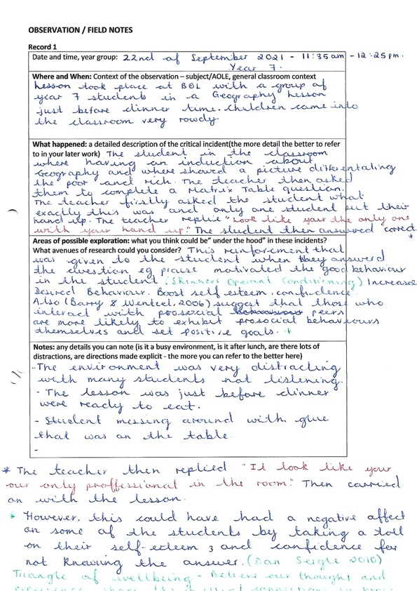
Appendix 1

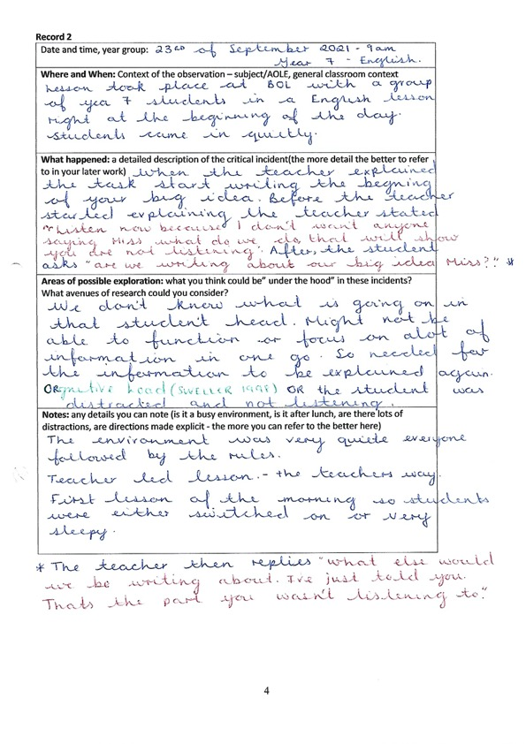
Appendix 2

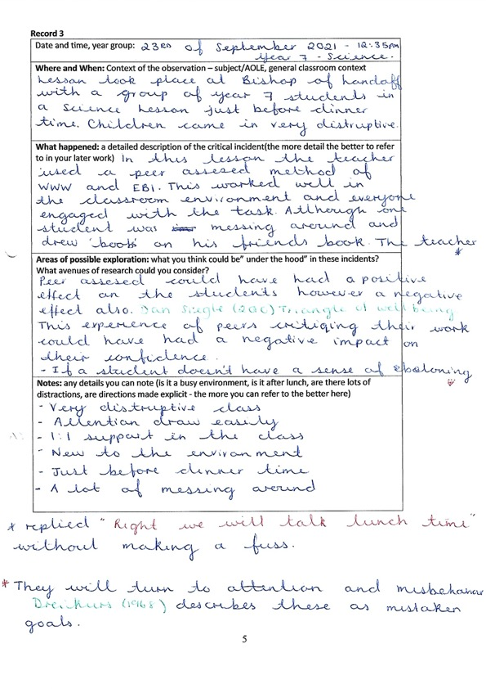
Appendix 3

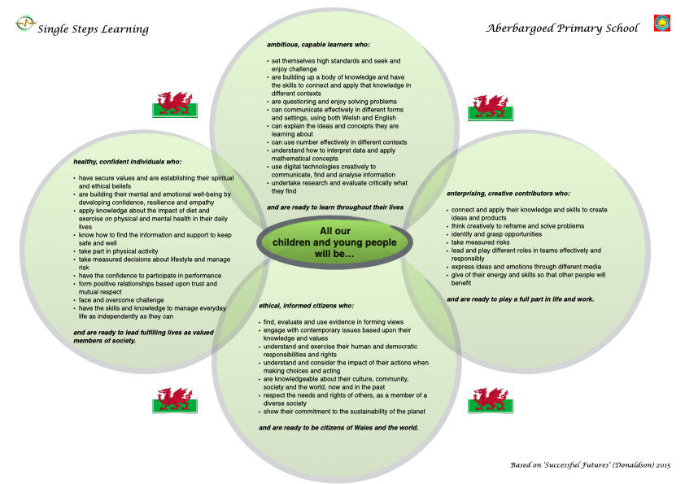
Appendix 4

