

Name – Joseph Humphreys

Student Number – 2504075

Course – HNC Quantity Surveying

Module – Construction Materials

1. Introduction – Barbican Estate, London .........................

2. The Framing Material’s Strength, Durability
and Climatic Resistance .........................................

3. Time, Labour, Programme and Cost Compared
to Steel Framing ...............................................

4. Ease of Assembly and Adaptability ..............................

5. Problems in the Integration of Services
Provision and Solutions ........................................

6. Challenges at the Point of Demolition
and End of Life ...............................................

7. Environmental and Community Impacts
of Concrete Production ........................................

8. Conclusion ....................................................

9. Sieve Analysis Results ........................................
9.1 Completed Table (% Passing) ...............................
9.2 Fine and Coarse Aggregate Calculation .....................
9.3 Particle Size Distribution Commentary .....................

10. References ...................................................

Introduction- Barbican Estate, London
The Barbican Estate is a well-known example of a large-scale reinforced concrete development in the (Historic England, 2020). Designed by Chamberlin, Powell and Bon and constructed between the 1960s and 1970s, it was built to address post-war housing shortages while also delivering a modern, mixed-use urban environment (Glancey, 2018). The estate includes residential towers, podium level walkways, and cultural facilities, all primarily constructed using reinforced concrete framing.
The Barbican provides a valuable case study for analysing how framing materials influence cost, construction methods, lifecycle performance, and environmental impact. This assignment evaluates reinforced concrete framing across key areas including structural performance, cost comparison with steel, adaptability, services integration, end of life demolition challenges, and the environmental implications of concrete production. (Royal Institution of Chartered Surveyors, 2021).
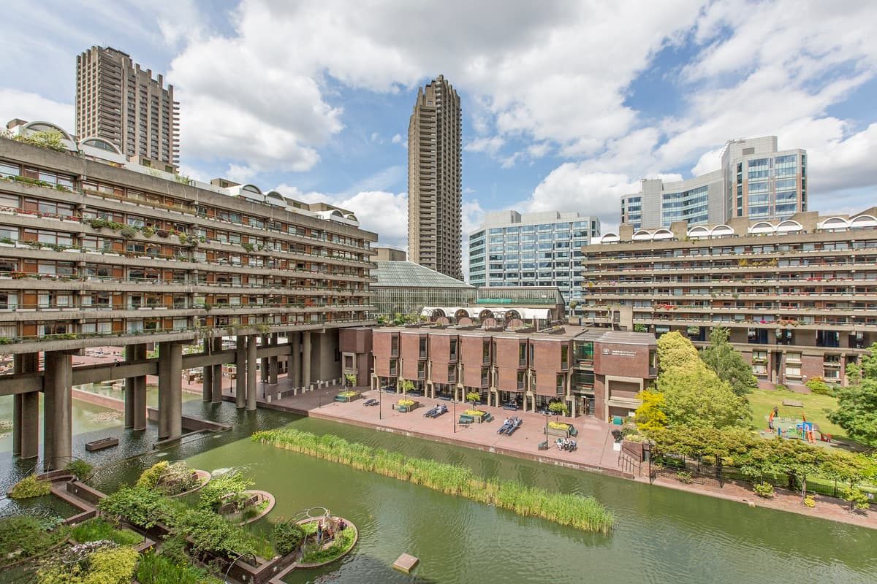
(Bloomfield, 2019)
The Framing Material’s Strength, Durability and Climatic Resistance
Reinforced concrete is widely used in construction due to its ability to combine the compressive strength of concrete with the tensile strength of steel reinforcement (Neville, 2011). In the Barbican Estate, this combination allows the structural frame comprising columns, beams, slabs, and cores to support significant vertical and horizontal loads.
The strength of reinforced concrete makes it particularly suitable for high-rise residential buildings. The towers at the Barbican rely on concrete cores and columns to transfer loads safely to the foundations. The monolithic nature of in-situ concrete construction also enhances structural stability, as elements are cast together to form a continuous frame. This reduces the number of joints and potential weak points compared to other materials.
Durability is another key advantage. When properly designed and constructed, reinforced concrete can last for many decades with relatively low maintenance (ICE, 2019). The Barbican Estate, now over 50 years old, demonstrates this durability, although some deterioration has occurred due to environmental exposure. Factors such as carbonation and reinforcement corrosion have required ongoing maintenance. 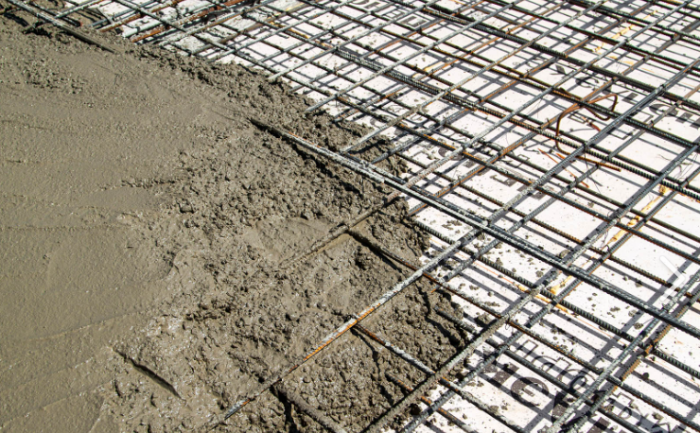
(Howard, 2024)
In terms of climatic resistance, London’s environment presents moderate challenges. The city experiences rainfall, humidity, and occasional freeze-thaw cycles. Reinforced concrete performs well in such conditions due to its density and resistance to weathering. However, moisture ingress can lead to long term issues if not properly managed. Adequate concrete cover to reinforcement and good quality control during construction are essential to prevent premature deterioration. (BRE GROUP, 2016)
Fire resistance is a major benefit of reinforced concrete. Unlike steel, which can lose strength rapidly at high temperatures, concrete provides natural fire protection to the embedded reinforcement. This makes it particularly suitable for residential developments where fire safety is critical. (Drysdale, 2011)
Overall, reinforced concrete offers high strength, good durability, and strong resistance to the climatic conditions found at the Barbican site, although it requires maintenance to address long term degradation mechanisms.

Time, Labour, Programme and Cost Compared to Steel Framing
From a quantity surveying perspective, comparing reinforced concrete with steel framing involves analysing programme duration, labour requirements, and cost efficiency.
Reinforced concrete construction, particularly in-situ construction as used at the Barbican, is labour intensive. It involves several activities, including erecting formwork, fixing reinforcement, pouring concrete, and allowing time for curing. Each stage must be completed before the next can begin, which can slow down the overall programme. (Brook, 2016)
In contrast, steel framing is typically faster to construct. Steel components are prefabricated off-site and delivered ready for assembly. This allows for rapid erection on site, reducing construction time and potentially lowering labour costs. For modern projects, this speed can result in significant savings, especially where programme duration is critical. (Lawson, 2008) ( Steel Construction Institute, 2020).
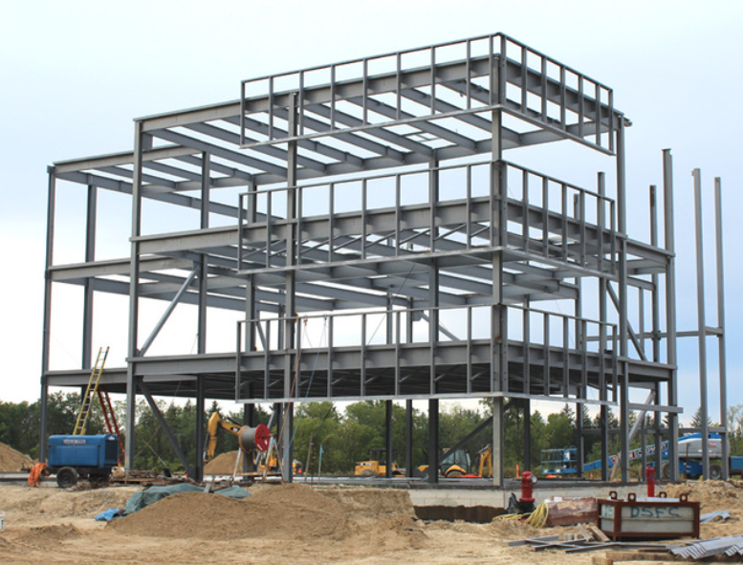
(Understand Building Construction, n.d.)
However, during the period when the Barbican was built, reinforced concrete was often more cost-effective in the UK. Materials such as cement and aggregates were readily available, and the construction industry had a workforce skilled in traditional concrete methods. Steel, on the other hand, required more advanced fabrication and was often more expensive. (Ashworth, Hogg and Higgs, 2013).
Labour costs also differ between the two systems. Reinforced concrete requires a larger workforce for tasks such as formwork construction and reinforcement fixing. Steel construction requires fewer workers but relies on skilled operatives and lifting equipment such as cranes.
Lifecycle costs are another important consideration. Reinforced concrete structures generally have lower maintenance requirements than steel, particularly in terms of corrosion protection and fireproofing. This can make concrete more economical over the building’s lifespan, even if initial construction is slower. (ICE,2019)
In summary, while steel framing offers advantages in speed and reduced on site labour, reinforced concrete can be more cost effective in certain contexts, particularly when considering long-term performance and maintenance.

Ease of Assembly and Adaptability
The ease of assembly of reinforced concrete depends on the construction method used. In the case of the Barbican, in-situ concrete construction required significant time and labour due to the need for formwork and curing. This makes it less efficient in terms of speed compared to prefabricated systems such as steel.
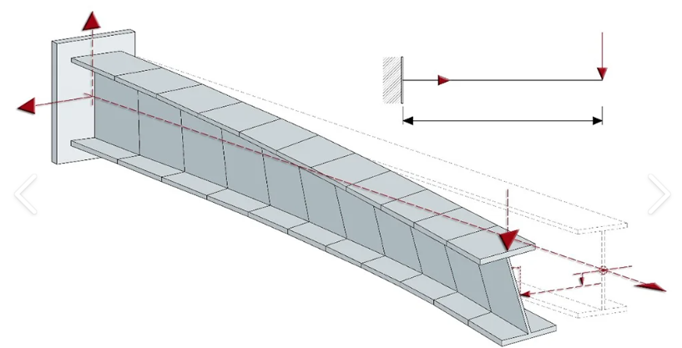
(Graitec, 2022)
However, reinforced concrete offers excellent flexibility in terms of building shape. Concrete can be cast into almost any form, allowing architects to create complex geometries. The Barbican Estate features a variety of forms, including towers, terraces, and curved elements, all of which were made possible by the versatility of concrete.
In terms of adaptability during the building’s lifecycle, reinforced concrete presents both advantages and limitations. The structural frame is strong and durable, allowing for internal reconfiguration such as changes to partitions and layouts. This is beneficial for adapting the building to different uses over time.
However, making significant structural changes can be difficult. Cutting through reinforced concrete elements or altering load-bearing components requires specialised equipment and careful structural assessment. This can be costly and time-consuming compared to steel structures, which are generally easier to modify.
Despite these challenges, the Barbican has undergone various refurbishments over the years, demonstrating that reinforced concrete buildings can be adapted, although not always easily. For quantity surveyors, this highlights the importance of considering future adaptability during the design stage, as it can have significant cost implications later in the building’s life.
(Chudley and Greeno, 2016). (Brook, 2016).
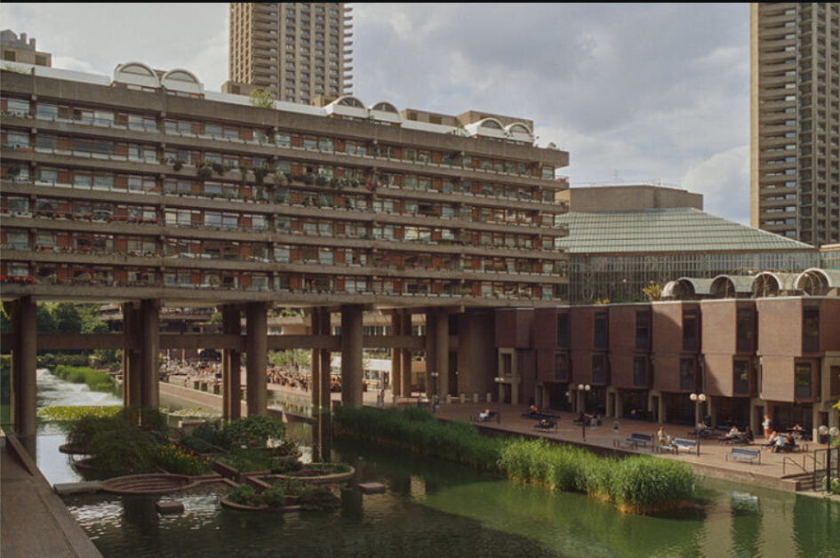
(Designboom.com, 2026)

Problems in the Integration of Services Provision and Solutions
Integrating building services within reinforced concrete structures can be challenging due to the material’s rigidity and lack of flexibility after construction. At the Barbican, services such as electrical wiring, plumbing, and ventilation systems had to be carefully planned and coordinated during the design stage.
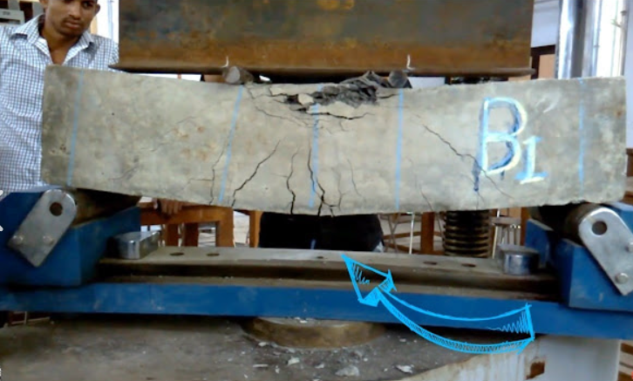
(Admin, 2018)
One of the main problems is that once concrete is cast, it is difficult to make changes. This means that any errors in service planning can be costly to correct. Embedding services within concrete elements can also make maintenance and future upgrades more difficult.
Another issue is space constraints. Reinforced concrete structures often have limited voids for services, which can lead to congestion and conflicts between different systems. This requires careful coordination between structural and services engineers to ensure that all requirements are met.
To address these challenges, several solutions were used. Service risers were introduced to provide vertical distribution of services, while horizontal distribution was achieved through designated service zones. In some areas, suspended ceilings and raised floors were used to create accessible spaces for services.
Modern refurbishment works have introduced more flexible solutions, such as surface-mounted services and modular systems, which allow for easier maintenance and upgrades. These approaches demonstrate how design strategies can evolve to address the limitations of reinforced concrete structures.
(Chartered Institution of Building Services Engineers, 2015).
(CIBSE, 2015).
Challenges at the Point of Demolition and End of Life
At the end of a building’s lifecycle, reinforced concrete structures present specific challenges in terms of demolition and disposal. The Barbican Estate itself is unlikely to be demolished due to its heritage status, but it still provides a useful example for analysis.
One of the main challenges is the strength and mass of reinforced concrete. Demolishing such structures requires heavy machinery and can be time-consuming and expensive. The presence of embedded steel reinforcement adds complexity, as it must be separated from the concrete for recycling.
Another issue is waste management. Concrete demolition generates large volumes of waste, which must be processed and disposed of responsibly. While crushed concrete can be reused as aggregate, this process requires additional energy and resources.
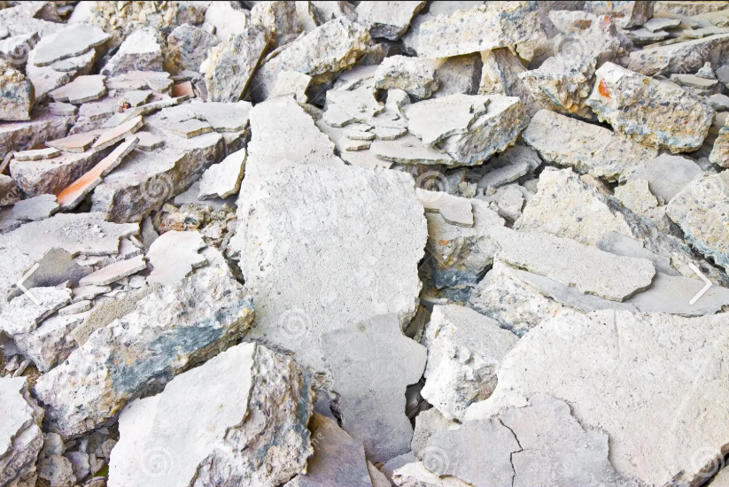
(Scatena, 2016)
There are also environmental concerns associated with demolition, including dust, noise, and disruption to the surrounding community. In densely populated areas such as London, these impacts must be carefully managed through planning and mitigation measures.
From a quantity surveying perspective, demolition costs can be significant and should be considered as part of whole life costing. Designing buildings for deconstruction, rather than demolition, is an emerging approach that aims to reduce these impacts, although it is more difficult to achieve with larger reinforced concrete structures.
(Pacheco-Torgal et al., 2013).
(BRE, 2016)
(WRAP UK, 2020).
Environmental and Community Impacts of Concrete Production
The production of concrete has significant environmental and social impacts, which are increasingly important considerations in modern construction.
One of the main environmental issues is the production of cement, a key component of concrete. Cement manufacturing is energy intensive and produces large amounts of carbon dioxide, contributing to climate change. It is estimated that the cement industry accounts for a significant proportion of global carbon dioxide emissions.

(Greenspec, 2021)
In addition to carbon emissions, concrete production requires the extraction of raw materials such as limestone, sand, and aggregates. This can lead to environmental degradation, including habitat destruction, landscape changes, and loss of biodiversity. Quarrying activities can also have negative impacts on local communities, including noise, dust, and increased traffic.
The transportation of materials further adds to the environmental impact, particularly for large projects like the Barbican, which require substantial quantities of concrete.
There are also social impacts to consider. Communities located near cement plants or quarries may experience reduced air quality and associated health issues. Construction activities can also cause disruption through noise, dust, and road congestion.
However, the construction industry is increasingly adopting more sustainable practices. These include using alternative materials such as recycled aggregates, reducing cement content through supplementary cementitious materials, and improving energy efficiency in production processes.

(International Energy Agency, 2022)
(Pacheco-Torgal et al., 2013)
(World Green Building Council, 2021)

Conclusion
The Barbican Estate provides a valuable case study for analysing reinforced concrete framing in a real-world context. The material offers significant advantages in terms of strength, durability, and fire resistance, making it well-suited to the environmental conditions of London. However, it also presents challenges in terms of construction time, labour intensity, and adaptability.
Compared to steel framing, reinforced concrete is generally slower to construct but can offer cost advantages and lower maintenance over the building’s lifecycle. The integration of services requires careful planning, and end-of-life demolition poses environmental and practical challenges.
Finally, the environmental impact of concrete production is a major concern, highlighting the need for more sustainable approaches in the construction industry. For quantity surveying professionals, balancing cost, performance, and environmental considerations is essential in delivering successful projects.

A) complete the table to obtain % passing each sieve

Sieve size (mm) | Mass (g) | % on sieve | % passing
125 | 0 | 0 | 100
75 | 0 | 0 | 100
63 | 0 | 0 | 100
37.5 | 120 | 9.6 | 90.4
20 | 137 | 10.96 | 79.44
10 | 143 | 11.44 | 68
6.3 | 105 | 8.4 | 59.60
3.35 | 45 | 3.6 | 56
2 | 130 | 10.4 | 45.6
1.18 | 63 | 5.04 | 40.56
0.6 | 105 | 8.4 | 32.16
0.3 | 102 | 8.16 | 24
0.212 | 109 | 8.72 | 15.28
0.15 | 98 | 7.84 | 7.44
0.063 | 55 | 4.4 | 3.04

B) calculate the percentage of fine and coarse aggregate in the mix-using 4.75mm boundary (between 6.3mm and 3.35mm)
Fine aggregate -56.6%
Coarse aggregate- 40.4%
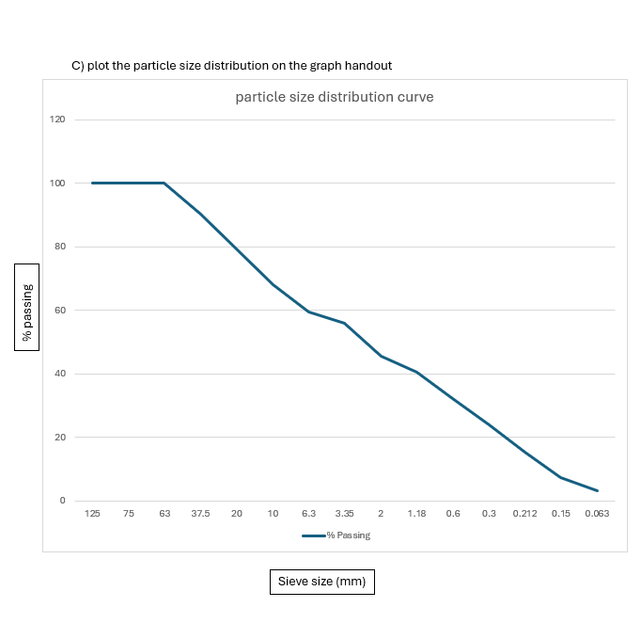

D) comment on this sample aggregates particle size distribution and suitability for direct use as an aggregate
The aggregate is poorly graded with an uneven particle size distribution. It is not suitable for direct use due to high voids and poor packing characteristics. However, it may be used after blending with other aggregates to achieve a well-graded mix.

Referencing-
Admin (2018). Flexural Failure of Reinforced Concrete Beam I Flexure Strength I Concrete Laboratory Testing. [online] Engineering Society. Available at: https://www.engineering-society.com/2018/02/flexural-failure-of-reinforced-concrete.html [Accessed 26 Mar. 2026].

Bloomfield, R. (2019). What it’s like to live at the brutalist Barbican Estate 50 years on. [online] Evening Standard. Available at: https://www.standard.co.uk/homesandproperty/property-news/the-barbican-estate-at-50-why-londons-brutalist-concrete-housing-estate-and-grade-iilisted-landmark-remains-highly-prized-a131876.html. [Accessed 26 Mar. 2026].

BRE (2016) Building materials and performance. Available at: https://www.bregroup.com [Accessed 26 Mar. 2026].

CIBSE (2015) Guide M: Maintenance engineering and management. Available at: https://www.cibse.org [Accessed 26 Mar. 2026].
Designboom.com. (2026). Available at: https://static.designboom.com/wp-content/uploads/2025/11/concrete-towers-water-gardens-elevated-paths-barbican-david-altrath-lens-designboom-05-768x512.jpg [Accessed 26 Mar. 2026].

Glancey, J. (2018) The Barbican Estate at 50. Available at: https://www.theguardian.com [Accessed 26 Mar. 2026].
Greenspec (2021). The Environmental Impacts of Concrete. [online] www.greenspec.co.uk. Available at: https://www.greenspec.co.uk/building-design/environmental-impacts-of-concrete/. [Accessed 26 Mar. 2026].

Graitec. (2022). Advanced Stability - Advance Design | GRAITEC. [online] Available at: https://graitec.com/uk/resources/technical-support/documentation/advance-design-technical-articles/advanced-stability-advance-design/ [Accessed 26 Mar. 2026].

Historic England (2020) Barbican Estate listing. Available at: https://historicengland.org.uk [Accessed 26 Mar. 2026].

Howard, W. (2024). Reinforced Concrete: Understanding its Strength and Versatility. [online] 614 Concrete. Available at: https://614concrete.com/reinforced-concrete-understanding-its-strength-and-versatility/. [Accessed 26 Mar. 2026].

ICE (2019) Concrete durability guidance. Available at: https://www.ice.org.uk [Accessed 26 Mar. 2026].

IEA (2022) Cement and CO2 emissions. Available at: https://www.iea.org [Accessed 26 Mar. 2026].

RICS (2021) Construction cost and lifecycle guidance. Available at: https://www.rics.org [Accessed 26 Mar. 2026].

SCI (2020) Steel construction advantages. Available at: https://www.steelconstruction.info [Accessed 26 Mar. 2026].
Scatena, F. (2016). Demolished concrete structure in a construction site - background image. [online] Dreamstime. Available at: https://www.dreamstime.com/demolished-concrete-structure-construction-site-background-image-image143926679 [Accessed 26 Mar. 2026].
Understand Building Construction. (n.d.). Steel Frame Structures | Steel Framing | Steel Structures. [online] Available at: https://www.understandconstruction.com/steel-frame-structures.html#google_vignette. [Accessed 26 Mar. 2026].

WGBC (2021) Sustainable construction materials. Available at: https://www.worldgbc.org [Accessed 26 Mar. 2026].

WRAP (2020) Recycling construction materials. Available at: https://www.wrap.org.uk [Accessed 26 Mar. 2026].

