Student Name: Lavinia Curtean  Student ID: 2232073  Module Title: Foreign Languages & Cultural Awareness  Module Code: BMIH5003  Lecturer: Heidi Prosser  Date: 07/02/2024 | 
ASSIGNMENT 1: PORTFOLIO
(4 Components)

Component 1: Professional Reflection (500 words +/- 10%)

Weighting: 25%
During my hospitality job at the bar and restaurant on the ground floor of the Premier Inn Wembley, I saw cross-cultural guests engage in ways that were both helpful and difficult. One interesting case involved a Spanish friend who was trying to order “tostadas” for breakfast but kept getting buttered toast instead. It looked like a simple request got lost in translation, but it was caused by deeper cultural assumptions. This made me realise how I struggle to navigate ethnic situations that happen a lot in hospitality.
Because London is so diverse, many foreign tourists stay at the Premier Inn Wembley because it is close to famous sports grounds and music halls. According to Marneros, Papageorgiou and Efstathiades (2020), the relaxed eating spot serves breakfast especially for travellers who are jet-lagged or getting used to the new time zone. But even simple requests can get confusing when people do not speak or understand the same language or culture well. Even though both the Spanish guest and the English host spoke English, it was hard to figure out what they were trying to say. The Spanish guest talked about ‘tostadas’ in the way that people in his country do, which are crispy, fried tacos that are popular for breakfast in Spain and Latin America. Yet, the English server had no idea what ‘toast’ meant, so he or she thought of the buttered bread slices that are a common part of both British and American breakfasts.
This difference in how different cultures understand words that are otherwise known shows how complicated cross-cultural service situations can be (Waqanimaravu and Arasanmi, 2020). Dean and Popp say that underlying sociolinguistic rules control not only language but also larger patterns of behaviour that can ‘break down communication’ without meaning to. To meet his needs, the server's British spelling of ‘toast’ made things worse by making him angrier. To get past deeply held beliefs, it seems important to be able to adapt to different cultural behaviours and communication styles.
Seeing this for myself made it clear to me that I need to improve my cross-cultural service skills, even when I am just talking to someone in English. By being more sensitive to different cultures from the start, like by explaining words that people do not understand, I can help avoid and ease tensions, making sure that requests meet the real needs of guests.
As I move forward in Premier Inn Wembley's globalised hospitality world, I want to get better at adapting by making better use of staff knowledge, guest understanding, and culture tools. I have learned that misalignments can happen without warning, whether they are caused by direct language hurdles or more minor sociolinguistic differences among English users. But working on myself to learn more about other cultures can help me handle variety well. I hope to provide service that is both sensitive to and appropriate for international guests by combining the knowledge of my global team with more in-depth self-education on cultural settings. Improving human connections and making sure everyone has the best experiences is a constant goal that is well worth it (Heimerl et al. 2020).
References:
Marneros, S., Papageorgiou, G. and Efstathiades, A., 2020. Identifying key success competencies for the hospitality industry: the perspectives of professionals. Journal of Teaching in Travel & Tourism, 20(4), pp.237-261.
Waqanimaravu, M. and Arasanmi, C.N., 2020. Employee training and service quality in the hospitality industry. Journal of Foodservice Business Research, 23(3), pp.216-227.
Heimerl, P., Haid, M., Benedikt, L. and Scholl-Grissemann, U., 2020. Factors influencing job satisfaction in hospitality industry. SAGE open, 10(4), p.2158244020982998.
Component 2: Training Plan (500 words +/- 10%)

Weighting: 25%

Identified cultural misunderstanding
The observed culture mistake is based on tightly defined ideas about food terms and situations involving guest service (Liu, Liu and King, 2022). For example, the English server's idea of ‘toast’ as split bread is different from the Spanish guest's idea of ‘tostadas’ as crispy fried tacos. This difference in sociolinguistics comes from having different frames of reference that are shaped by different community rules and behaviours around breakfast. Even though English was a shared language, people still interpreted it in different ways based on their culture. Instead of grammar or language, the breakdown was caused by the different meanings given to common words. So, cultural knowledge must be built into training plans to avoid service confusion like this.
Training plan
Why?
When guests make requests, cultural differences could hurt the level of service and make them less satisfied. As global travel grows, so does the variety of people who work in hospitality. Understanding service to guests from all over the world, staff must be able to deal with language and social differences (Choi et al. 2020). This cultural knowledge is built up through training.
What?
The training will cover cultural awareness, sociolinguistic and nonverbal communication styles by guest region, cross-cultural service etiquette, and how to handle mistakes through role-playing. To spark interest, the materials will show staff culture ideas that they might wrongly think are true for everyone.
Who?
Required for all hotel staff who deal with guests, such as front desk, cleaning, food and beverage workers, cooking staff, and events and party teams. Getting new employees up to speed. From the top down, management must show how to accept and respond to different cultures and must do this daily.
Where?
Short, involved online lessons that let you learn at a personal pace. After that, classes were held on-site during staff shifts. These included peer discussions, manager-led role plays, and arguments where ideas were applied to real service cases from the hotel. Refresher classes that are part of meetings for the whole staff.
When?
Staff must go through training every year as part of their career growth and skill improvement. mini modules before big foreign events or festivals that are expected to have a lot of different kinds of people. Before the service, talks that go over important cultural norms for booked groups, weddings, or conferences. Key messages are reinforced every day through statements from leaders and community engagement.
References:
Choi, Y., Choi, M., Oh, M. and Kim, S., 2020. Service robots in hotels: understanding the service quality perceptions of human-robot interaction. Journal of Hospitality Marketing & Management, 29(6), pp.613-635.
Liu, Y., Liu, J. and King, B., 2022. Intercultural communicative competence: Hospitality industry and education perspectives. Journal of Hospitality, Leisure, Sport & Tourism Education, 30, p.100371.
Component 3: Student Self-Reflection (500 words +/- 10%)

Weighting: 25%
Introduction
As both hotel staff and customers come from more different cultures, developing my own cultural knowledge has become more important to me as a leader. By using Gibbs' reflective cycle to look at a major cross-cultural service mistake at my Premier Inn Wembley job, I realised I needed to question my deeply held beliefs and improve my empathy, adaptability, and communication skills to work well in multicultural settings. Through my thinking, I am gaining a better understanding of how complicated the situation is and how I can improve as a leader by making an action plan that puts culture education first.
Description
In the story I tell, an English waiter kept bringing toast to a Spanish friend who was having a hard time ordering ‘tostadas.’ Even though people were using common English words, different culture ideas about the breakfast dish made it harder for everyone to understand each other. The guest said they wanted crisp, fried tacos instead of buttered bread, which the service thought they were. Even though they were trying to be flexible, the mismatch made things more difficult, showing how difficult it is to serve people from different cultures. According to Ghani et al. (2022), flexible communication is important for trade.
Evaluation
When I looked back at my answer, I realised I did not have enough cultural knowledge or language skills to explain words clearly; I just assumed they had worldwide meanings. I thought we had a lot in common, but I did not understand how the Spanish guest's culture shaped his frame of reference. My narrow beliefs could lead to problems with service and send a message of disrespect for foreign customers that goes against the idea of kindness. I need to improve my cross-cultural skills a lot. These include understanding sociolinguistics and nonverbal communication, getting team members to help me learn about different countries, and looking for outside cultural tools. According to Hai (2021), constant ethnocentrism makes moral leadership less effective. To help my staff live up to our standards, I need to encourage culture openness based on principles through experience, education, and foreign exchange.
Analysis
While people were looking at the factors that make Premier Inn a great place for people from all over the world to stay, people forgot to include cultural differences in things like customs, communication styles, and needs. My own childhood and social groups also taught me to make assumptions that were never really tested. As a sector becomes more linked, it is important to focus on knowledge gaps so that mistakes do not hurt an organization's image. Also, continuous ethnocentrism goes against our company values and service purpose. To improve intercultural skills, leaders must first stop seeing staff variety and foreign guests as problems and start seeing them as natural advantages.
Conclusion
This experience shows how important it is for both individuals and organisations to keep improving their cultural intelligence, especially among management. Even if someone speaks English fluently, there are still cultural differences in how people behave, what they expect from service, and other things that need to be fixed for international exchange to continue to be good. As both a moral obligation and a way to stay ahead in a competitive industry, I need to promote success not despite diversity, but because of it. I can do this by growing personally and by making sure that cultural awareness is built into the whole company.
Action plan
My first step in my action plan is to improve my culture knowledge through language learning, foreign exchange, community discussion between diasporic communities, and study on regional hospitality. I will oversee reviews that put cultural inclusion back at the centre of training materials, classes that include staff opinions on guest cultures, and localization policies that strike a balance between brand cohesion and freedom to meet the needs of a wide range of visitors. It is possible to think more broadly when you look at both non-Western and mixed culture models. Continuous feedback systems to find service gaps at cultural turning points and involvement programmes that celebrate our global community both inside and outside of work will help viability (Kloutsiniotis and Mihail, 2020). Most importantly, our messages and ways of thinking need to change so that variety is seen as our main strength instead of a side issue. We should also be open to the positive effects that foreign exchange can have on our lives.
References:
Ghani, B., Zada, M., Memon, K.R., Ullah, R., Khattak, A., Han, H., Ariza-Montes, A. and Araya-Castillo, L., 2022. Challenges and strategies for employee retention in the hospitality industry: A review. Sustainability, 14(5), p.2885.
Kloutsiniotis, P.V. and Mihail, D.M., 2020. High performance work systems in the tourism and hospitality industry: a critical review. International Journal of Contemporary Hospitality Management, 32(7), pp.2365-2395.
Hai, T., 2021, August. Blended Learning in Hospitality Education and Training: Review and Discussion. In 2021 International Conference on Modern Educational Technology and Social Sciences (ICMETSS 2021) (pp. 227-231). Atlantis Press.
Component 4: Training Presentation (6 Slides)

Weighting: 25%
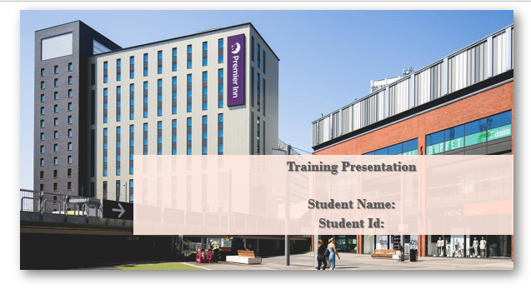
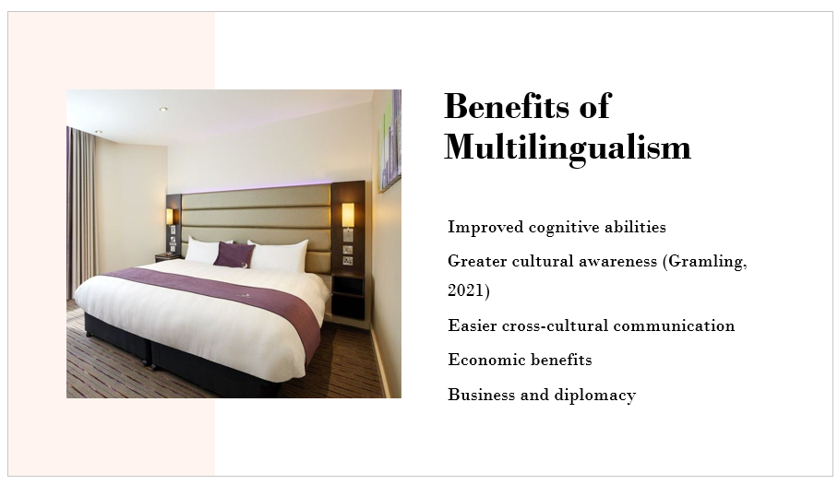
Being bilingual is good for both people and groups in many ways. Speaking more than one language makes one smarter in many ways, like being able to focus, solve problems, and think critically. People who speak more than one language are also more culturally aware and sensitive because learning a language opens their minds to new ideas and points of view. On a larger scale, countries with multiple languages have easier contact across cultures, which helps with business, diplomacy, and unity. The cognitive, societal, and economic benefits of being able to speak more than one language make it clear that it should be respected and promoted.
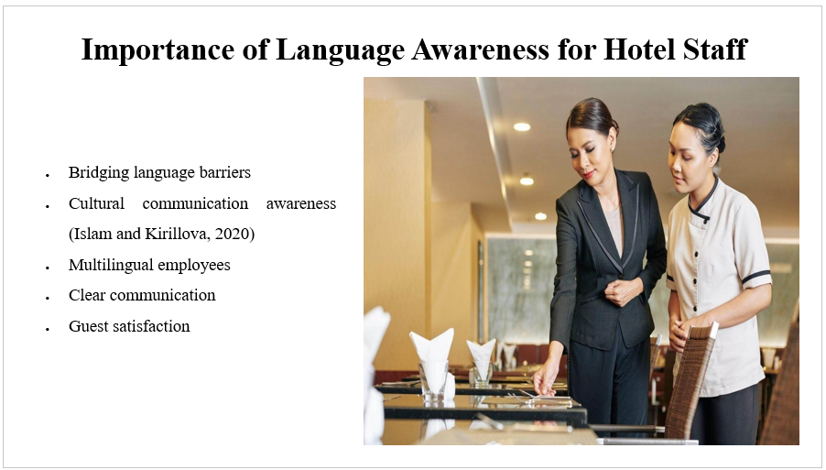
Being able to communicate and understand other languages well is an important part of giving great service in the hotel business. A hotel that has staff members who speak more than one language and can talk to people from different backgrounds in a nice and clear way makes the place feel friendly and open to everyone. Employees who speak more than one language also make deals and conversations go more smoothly by getting past language obstacles. Also, knowing how people from different cultures talk to each other cuts down on mistakes and makes guests happier. So, hotel managers should hire people who speak a variety of languages, understand different cultures, and are sensitive to the subtleties of language.
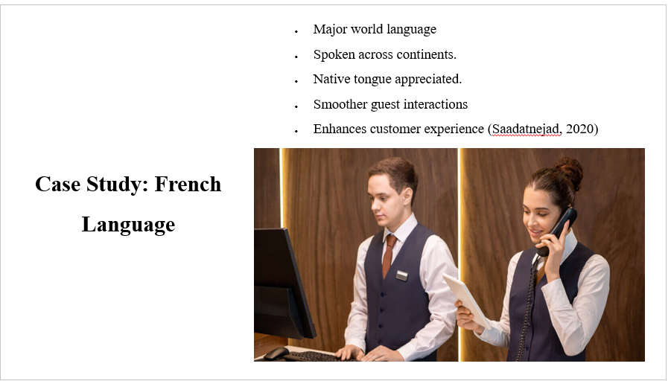
French is a big world language that is spoken on many countries. It is important for hotel staff to be able to speak French. Guests who know French would rather be spoken to in their own language than English. French-speaking guests can have easier check-ins, purchases, and talks when one hire staff who can speak more than one language, including French. French is very useful at Premier Inn Wembley in the UK during big sports events that have a lot of French fans. People who speak French help these guests feel at home and welcome. Customers have a better experience when it can help them in their own language.
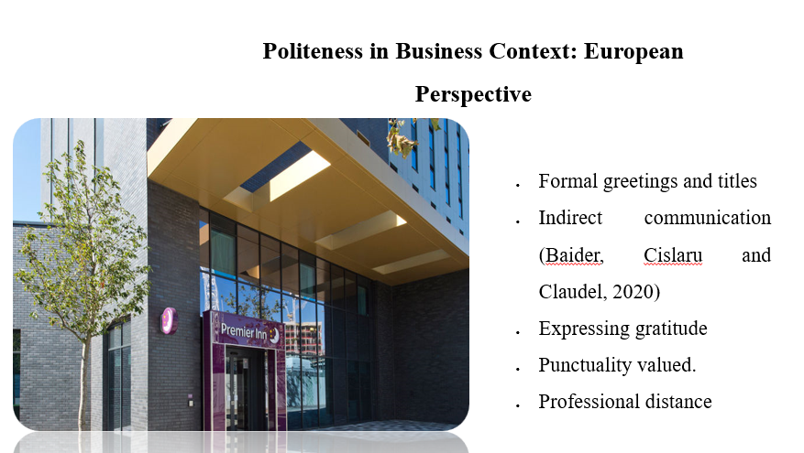
When doing business in Europe, being polite and following the rules is very important. In contrast to societies that value speed, Europeans value polite language, titles, and a more informal way of communicating. It is expected to meet someone formally and use conditional language. In Europe, business manners also include being on time, shaking hands firmly, swapping business cards, and keeping a professional space. It is important for people who work in hospitality and serve European guests and business travellers to understand these cultural standards and communicate properly.
References (no screenshots):
Baider, F.H., Cislaru, G. and Claudel, C., 2020. Researching politeness: from the ‘classical’approach to Discourse Analysis… and back. Corpus Pragmatics, 4, pp.259-272.
Gramling, D., 2021. The invention of multilingualism. Cambridge University Press.
Islam, M.S. and Kirillova, K., 2020. Non-verbal communication in hospitality: At the intersection of religion and gender. International Journal of Hospitality Management, 84, p.102326.
Saadatnejad, Z., 2020. Improving Intercultural Competence through Literary Texts and the Strategies of Teaching it in French Language. Language Related Research, 10(6), pp.345-372.

