NAME: MABEL TWUMASI
STUDENT NUMBER: 1919483
MODULE TITLE: EFFECTIVE TEAM WORKING AND COMMUNICATION (BMSW4002_LON)
LECTURER: MISS GULNAR ALI

MODELS OF COMMUNICATIONS
Communication is having the ability to be able to interact with a person, group of people or to any targeted audience through vocals or speech, photos, signs or symbols, body expressions and writings. This can be carried through various forms.
Thoughts, ideas and information are initially developed in an individual’s mind which is then conveyed to a targeted audience. These thoughts or ideas are then organized and the method of combining these ideas and information into words are named as encoding (Juneja, 2001).
Non vocal communication
With nonverbal communication, we mostly use our body language, signal and signs. The nature in which a person smile, move and responds will inform a participant about their feelings, mood and will know if the individual is being honest and also paying attention to what is being said. When all the nonverbal cue suits the words you are speaking, they improve fidelity, understanding and relationships. Anxiety, distrust and uncertainty can be created if they do not match (Segal, Smith, Robinson and Boose, 2019).

Vocal communication
Major differences between vocal and non-vocal contact are questions of degree rather than a form. In verbal communication, the ideas and thoughts passes through oral media such as scripts or remarks, slideshows, and many others. Ideas are disseminated in the verbal communication by the sender in the form of remarks or words. Unprocessed ideas and thoughts- may perplexed its audience so it is vital for the sender to know how essential the processed thoughts and ideas are and how to conveyed them over (Juneja, 2001).

Models of communication
Models really ensures that thoughts and ideas are easy to comprehend. Every individual can simply comprehend the mechanics through a model and make an overview from it. A model makes learning easy and easy to be absorbed, in simpler terms (Juneja, 2001).

Shannon-Weaver model (Shannon and Weaver Model of communication)
Shannon Weaver's communication model was developed in 1948, after Claude Elwood Shannon published an article in Bell System Technical Journal with Warren Weaver and named it "A Mathematical Theory of Communication.” Shannon, an American physicist, and Weaver was a scholar. The mathematical theory was later called the communication model of Shannon Weaver, the "mother of all models," and is more technical than other linear models (Businesstopia in communication, 2018).

In Shannon Weaver model of communication, messages come from an individual who gets the thoughts or ideas before it is transferred to the sender. Where the message or thoughts is derived from is the source. Those thoughts, ideas or information are then carried from the brain then to the mouth which appears as signal which then enters the receiver but with many disruptions. The recipient instead transfers the message on to his final destination or other thoughts of other men.
Data Origin (Message / Thought)
Transmitter (brain-to-mouth) [Along with perceived barriers to noise and distractions
↓
Signpost
↓
Receiver (signal receiving)
↓
Full Destination (The message eventually gets)

Some forms that involve sounds, signals and disorders as it is communicated from the sender and eventually get to the receiver and disrupt discussion. Sounds from street sources, market places, shouting from children and all forms of noises that are connected to the signals or in other words the details (Businesstopia in communication, 2018).

The original model of Shannon and Weaver is made up of five elements: the source of information, the transmitter, the channel, the receiver, and the destination. The source of the information is where the information is stored. The message is encoded into signals to send the information, so that it can travel to its destination. Upon decoding the message, it moves through the channel adapting the signals for transmission. However, the channel carries some noise or disturbance that may change the detail from the source being transmitted from the signal. The message then gets to the receiver after the wave, which is retrieved (decoded) from the signal until it eventually reaches its destination.Communications is regarded as a way of transmitting and receiving information according to this growing understanding of communication. This model's attributes are its usability, its generality and its quantifiability. This model was developed by mathematicians Claude Shannon and Warren Weaver were based on the following elements:
• A source of content, which creates a response.
• A transmitter translating the message into a signal.
• A channel for which the transmitting signals are adapted.

• A receiver that recreates and decodes the encoded message from a series of transmitted signals.

• A destination for information which processes the message.
Shannon and Weaver concluded this principle entails three types of communication problems:
1. The technological problem: How can the message be conveyed accurately?
2. Semantic issue: how exactly is the word 'conveyed'?

3. The effectiveness problem: How efficiently does the context obtained influence behaviour? (Businesstopia in communication, 2018).
Daniel Chandler criticizes the transmission model in the following terms:
- It assumes that communicators are isolated individuals.
- It makes no allowance for differing purposes.
- It makes no allowance for differing interpretations.
- It makes no allowance for unequal power relationships (Chandler, 1994).
Berlo
In 1960, David Berlo expanded Shannon and Weaver's 1949 linear model of communication and created the sender-message-channel-receiver (SMCR) model of communication. The SMCR model of communication separated the model into clear parts and has been expanded upon by other scholars. Berlo's communication process is a simple application for person-to-person communication, which includes communication source, encoder, message, channel, decoder, and communication receiver. In addition, David Berlo presented some factors that influence the communication process between two people. The factors include communication skills, consciousness level, social system, cultural system, and attitude. The encoding process is where the motor skills exist through voice, writing, handling, etc. The message goes into the medium that holds the letter. Then they move on the receiver continues. The cycle of encoding is where the sensory competencies emerge by listening, seeing, sensing contact, etc. Eventually, the communicating cycle stops at the target, which is the portion that uses the cognitive skills, personality, awareness, social structure and community to translate the message (Berlo's SMCR Model of Communication - Businesstopia, 2018).
The Berlo's Communication Model evolved from the mathematical model of Claude Shannon and Warren Weaver, first published in 1948 in the "Bell System Technical Journal." The paradigm was developed initially to enhance the technological communication, but was later broadly applied in various communication fields. Berlo's SMCR communication model defines the various components which make up the basic communication cycle. Because this collaboration method often stresses message encryption and encoding, it can be used to communicate more efficiently. Criticisms of Berlo's SMCR model, there is no idea of feedback and there is no understanding of the outcome. There is no noise concept in the communication process, or any kind of barriers. This is a linear communication construct, there is no two-way communication. Due to any of the above listed reasons, both parties have to be close message (Berlo's SMCR Model of Communication - Businesstopia, 2018).

Components of Berlo’s SMCR Model of Communication
Berlo's SMCR Communication Model comprises four components to define the communication process. Various variables affect various elements in the model.
Berlo’s Model of Communication(S-M-C-R Model)
Encoding Decoding
Receiver
Channel
Message
Source of information

Sender
The sender of the message is the source who creates and sends the message to the receiver. The source is the origin of the communication process, which is the encoder of the letter. Often important to the recipient are variables which may affect the sender. Consider how to view the letter, such as: Berlo’s SMCR Model of Communication identifies the following factors that affect the source:

Communication skills
Reading, speaking and listening are some form of communication skills.

Attitude
A message will have a different understanding to listeners or audience if the view point from the messenger has changed.

Knowledge
Understanding the message being delivered has more effectiveness when communicating the message.

Social systems
As people have different beliefs, religion, values and rules, this shape their way of thinking hence different people responds different to messages. Their origin and circumstances will also have impact on how they absorbs messages.

Culture
Cultural differences may result in the message being translated differently.
Message
The message is the information or meaning package that is forwarded from sender to receiver. You can send the message in different forms, such as audio, speech, text, video, or other media. The message transmitter always wants the receiver to interpret the message in some way. Then the meaning of the source is converted into a coded message. With fair certainty the recipient should understand the message (Berlo's SMCR Model of Communication - Businesstopia, 2018).
Schramm model of communication
Schramm’s model of communication gained its sources from the Shannon weaver’s model of communication. In 1954, Wilbur Schramm developed the Schramm model of communication Wilbur Schramm (1954).
Unprocessed thoughts or ideas have no vital significance if not looked at cautiously and put into words before it is carried onto other people. As these thoughts or ideas are being carried, it encoded and transformed into substance. After the message have been received by the receiver, it then relies on the individual to be able to comprehend the thoughts from the sender or the purpose of the message. Unless the receiver is able to comprehend the information, the message will have no meaning to him or her. For a functional communication to be established, there must be an encoding and decoding of the message and without that, information will not flow between two people. In this model of communication, Wilbur Schramm concluded that without a receiver giving a feedback to a sender, communication is not complete (Juneja, 2001).
He also indicated that we should also examine the impact that a message has (both desired and undesired) on the target of the message. Between parties, communication includes acts that confer knowledge and experiences, give advice and commands, and ask questions. These acts may take many forms, in one of the various manners of communication. The form depends on the abilities of the group communicating. Together, communication content and form make messages that are sent towards a destination. The target can be oneself, another person or being, another entity (such as a corporation or group of beings).
Communication can be seen as processes of information transmission governed by three levels of semiotic rules:
- Syntactic (formal properties of signs and symbols).
- Pragmatic (concerned with the relations between signs/expressions and their users).
- Semantic (study of relationships between signs and symbols and what they represent).
- Therefore, communication is social interaction where at least two interacting agents share a common set of signs and a common set of semiotic rules. This commonly held rule in some sense ignores autocommunication, including intrapersonal communication via diaries or self-talk, both secondary phenomena that followed the primary acquisition of communicative competences within social interactions.

Analysis
Communication does not only occur through verbal but nonverbal, nevertheless, different models have placed some significant features on the various which have been elaborated.
Shannon-Weaver communication model is widely used from the different types of communication models that have been developed, and this explains that as information comes from a source (a person's mind's thoughts), it is then transferred to the mouth as a signal that is disrupted by noise before it reaches the final destination. This model ensures effective communication between two people but with many noises that affects their communication.
David Berlo in 1960, extended the Shannon-Weaver concept and developed the 1949 linear communication model of Shannon and Weaver, which created the communication model of the sender-message-channel-receiver (SMCR) (Berlo, 1960). Berlos model explains that: communication skills, awareness level, social system, cultural system, and attitude are all factors which help translate the message. In this model, the message is the vital unit of communication and without this, communication will not occur. In the Schramm’s model of communication, feedback from the receiver of the message is required by the sender and without the feedback communication is not complete.
As demonstrated in Schramm communication model, this talks about how the type of recipient of a message will decipher the message based on their communication capacities and the message to the recipient being desired or undesired, etc.

Appendix

Below are some screenshots of in class activities;
Appendix A

A formal letter to my work manager.

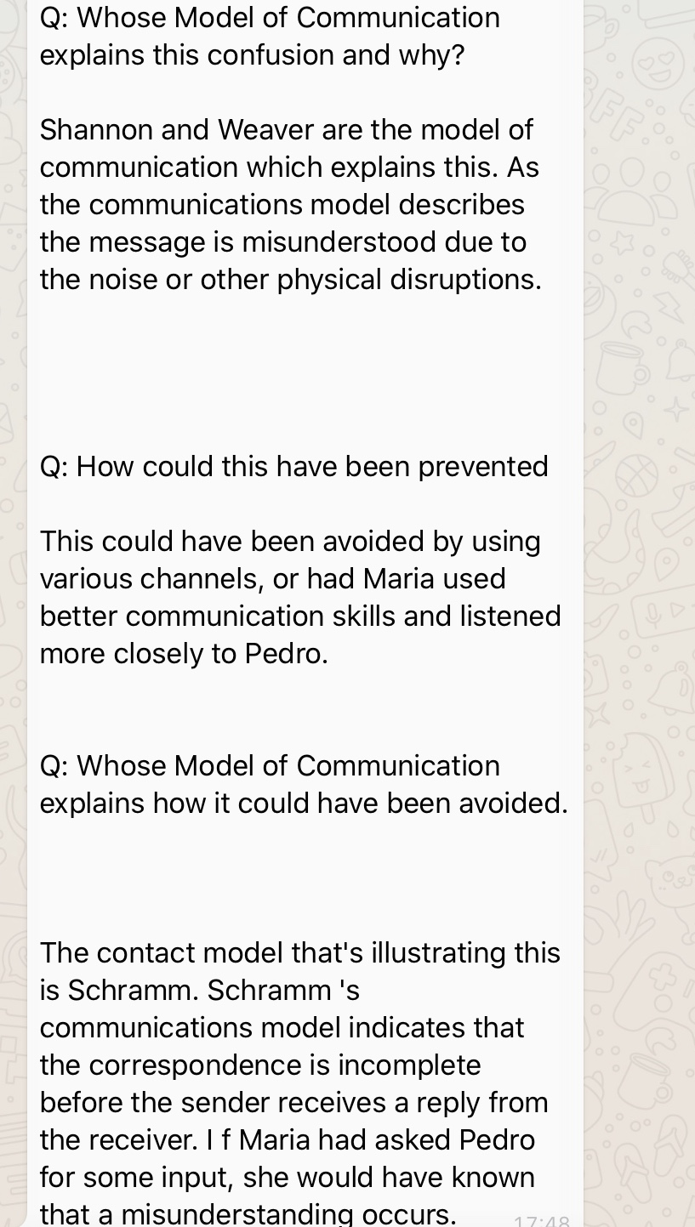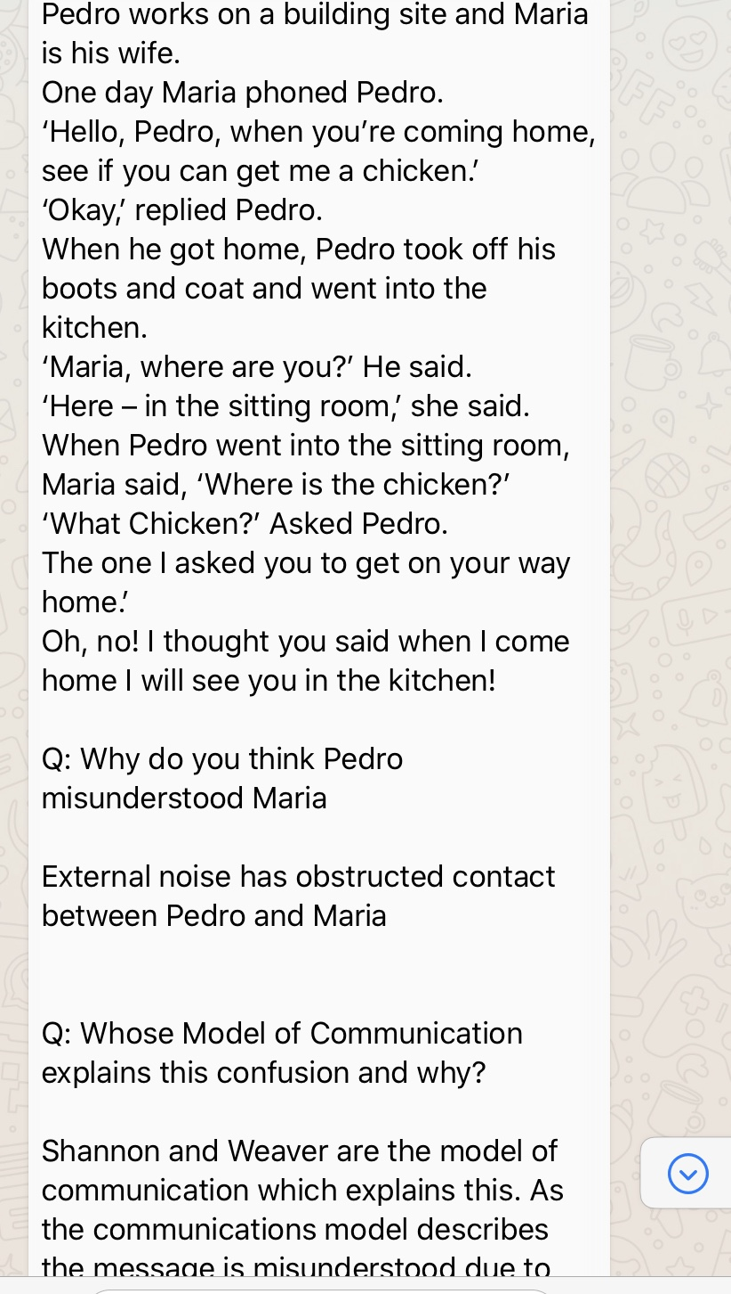

References
- Businesstopia. 2018. Shannon And Weaver Model Of Communication - Businesstopia. [online] Available at: <https://www.businesstopia.net/communication/shannon-and-weaver-model-communication#.> [Accessed 25 August 2020].
- Businesstopia. 2018. Berlo's SMCR Model Of Communication - Businesstopia. [online] Available at: <https://www.businesstopia.net/communication/berlo-model-communication> [Accessed 25 August 2020].
- Juneja, P., 2001. Schramm's Model Of Communication. [online] Managementstudyguide.com. Available at: <https://www.managementstudyguide.com/schramm-model-of-communication.htm> [Accessed 26 August 2020].
- Juneja, P., 2001. Understanding Communication And The Communication Process. [online] Managementstudyguide.com. Available at: <https://www.managementstudyguide.com/understanding-communication.htm> [Accessed 25 August 2020].
- Miller, K., 2005. Communication Theories. 2nd ed. Boston, Mass.: McGraw-Hill.
- Segal, J., Smith, M., Robinson, L. and Boose, G., 2019. Nonverbal Communication - Helpguide.Org. [online] Helpguide.org. Available at: <https://www.helpguide.org/articles/relationships-communication/nonverbal-communication.htm> [Accessed 25 August 2020].
- Jakovela, 2007. The Transmission Model Of Communication (By Daniel Chandler). [online] Jakovela's Weblog. Available at: <https://jakovela.wordpress.com/2007/11/06/the-transmission-model-of-communication-by-daniel-chandler/> [Accessed 25 August 2020].

