SCHOOL OF TOURISM & HOSPITALITY
Student name: |  | Student number:
Programmes: | BA (Hons) International Hotel Management
Module: | Personnel Resourcing and Development | Module Level (4, 5, 6): | 5
Module code: | BMIHS00S | Contribution to Overall  Module Assessment (%): | 50%
Lecturer: | Kathryn Roberts  Emma Roberts | Internal Verifier: | Dale Clarke
Assignment Title: | Research Project Proposal | Assignment No: | 2 of 2
Submission deadlines: | 8th July 2022 by 23.55 | Return date of provisional marks & written feedback: | 5th August 2022

Measuring Employee Engagement and Talented Employee Retention within the Accor Hotel
Contents
Introduction & Background of Accor Hotel 3
Literature Review 5
Purpose of Employee Engagement 5
Significance of Employee Engagement 6
Accor A Great Place for Measuring Employee Engagement 8
Method of Measuring Employee Engagement 9
Benefits of Measuring Employee Engagement 10
Evaluation & Conclusion 11
Reference 13

Introduction & Background of Accor Hotel
In 1967, when Paul Dubrule and Gérard Pélisson established the first Novotel in France, no one expected their innovative hotel business model to succeed. As the narrative of these two close friends unfolds, Accor tells it to the audience via his narration. Those with their innovative thinking and lack of inhibitions pushed the envelope of what was previously deemed possible to new heights. It all started with their desire to build a hotel chain, which led to the creation of Accor Hotels. Over 5,300 of the company's outlets in 110 countries are located outside of the United States, including one in the UK (Accor, 2022). Today, company's co-founders' legacy of hospitality innovation is carried on by more than 230,000 amazing employees who bring their passion for guests to life every day. Those who follow in our footsteps are continuing the legacy that we established all those years ago. A total of £65.01 million was earned by Accor UK last year as a consequence of the company's almost 1,487 hardworking employees.
Accor is also well known for its employee engagement program. As part of Accor's continuous attempts to develop new methods to improve business operations, one of the many possible routes for raising overall performance that is now being studied is the company's approach to increasing employee engagement. As a direct consequence of this development, the organization came to the conclusion that it was necessary to modify and extend the scope of the employee engagement survey it had been conducting.
In order to satisfy clients, hotel staff must emphasize customer satisfaction and deliver service that is both customized and adaptive. A hotel can accommodate a wide variety of guests, each with their own distinct set of wants and aspirations. Employees who have a strong sense of personal responsibility are more likely to be productive and willing to go the additional mile for their employers. Customers and clients alike are delighted when employees go above and beyond what is expected. The hotel sector is looking for someone with a mix of these skills. Productivity is 21% higher in firms where employees are more excited about their job than it is in those where they are less enthusiastic (Albrecht, 2020). There are a lot of factors that contribute to a hotel's high rate of employee turnover in the UK, and lack of employee engagement is one of them. Therefore, this is a research proposal for measuring employee engagement and talented employee retention within the Accor Hotel.
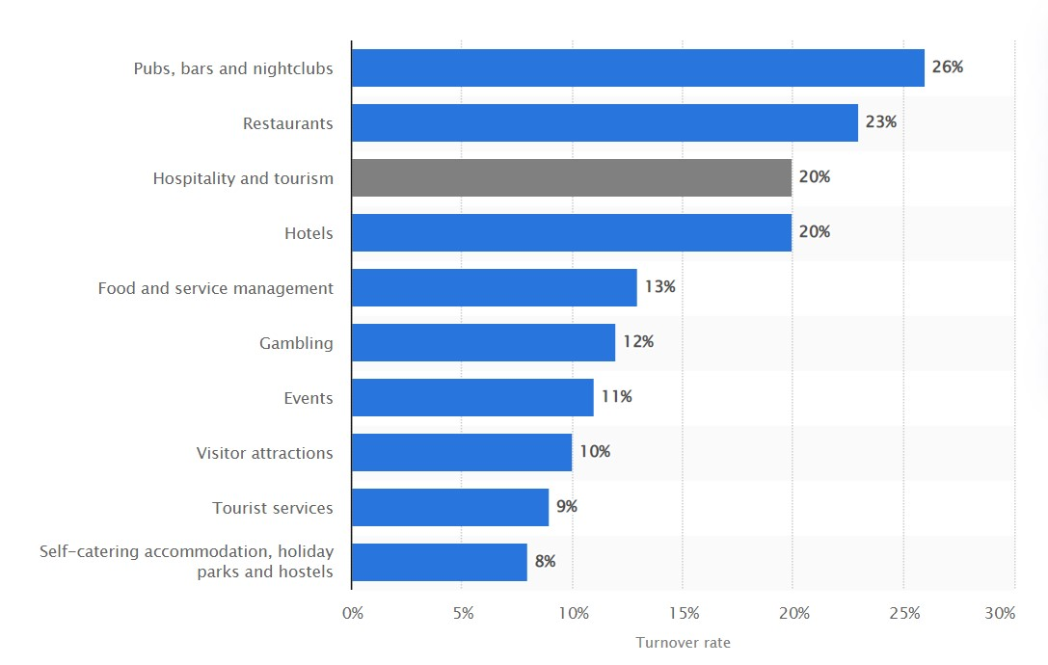
Figure 1: Employee Turnover in different industries in UK. Source: (Statista, 2022)

Literature Review

Purpose of Employee Engagement
Employee engagement in the workplace is creating an atmosphere where everyone in an organisation feels empowered to perform their best work every day, motivated by a shared sense of purpose and a strong feeling that their efforts are contributing to the firm's success (Byrne, 2021). In order to keep workers engaged, a business must have mutual trust, honesty, and open communication with them. To achieve business success, it is an approach that boosts both collective as well as individual performance and output and It can be measured. It's a good to amazing experience. Because of this, it may be fostered and significantly expanded, or it might be lost and forgotten altogether.
Engaged employees are seen as full members of the team, given clear goals to work toward, and given the freedom to make their own decisions. They are also given regular and relevant feedback. In addition, employees have the opportunity to learn and develop, and their achievements are recognised. To cut down on absences, sickness, accidents, misunderstandings, and grievances, it's critical to increase employee engagement and motivation in the workplace (Connell and Teo, 2020). Management can't encourage people to work harder by manipulating their commitment and emotions to urge them to work harder. Employees may become sceptical and disillusioned if they are able to see through these approaches fast.

Significance of Employee Engagement
There is a genuine feeling of passion and excitement that transcends beyond sports, activities, and events to employee engagement. Engagement by workers has a direct bearing on output. It is impossible to overstate the benefits. Engaged employees perceive how they fit into the larger context of the company (Mone, 2020). Because of this, employees will make better judgments. Motivated companies surpass their competition. In times of economic depression, their EPS is higher and they recover quicker. It's crucial for a company's growth and innovation to have a strong workforce that is engaged. Conducting a poll of employee engagement is critical to better understanding your company's needs.
Following are the major benefits of employee engagement
- Increase Productivity: Engaged workers demonstrate pro-corporate behaviour because they have a strong feeling of commitment to the company's aims and ambitions. It is because of this attitude that productivity rises by 21% (Gallup, 2022).
- Higher Growth: Engaged employees make the organisation more responsive to consumers. Selling more doesn't guarantee profit. Engaged employees contribute to organic growth by boosting customer evaluations by 10%. This strategy may improve sales 20% and profitability 22% (Garber, 2020).
- Reduced Absenteeism: Satisfaction, involvement, and motivation may minimise absenteeism. Increasing employee involvement may reduce absenteeism by 41%; picture the effect of improving the whole employee experience.
- Increased Employee Safety: Satisfied and secure workers have a 70% reduced risk of job accident, according to survey of Gallup (Narayanan, 2021). As a result, businesses must implement and maintain health and safety requirements. In the workplace, as in manufacturing, this is vital.

Figure 2: Effects of Employee Engagement. Source: Self-created.

Accor A Great Place for Measuring Employee Engagement
In the words of Accor's management, a motivated employee is more likely to be successful. All of these factors are affected by a high level of motivation and engagement in a company's consumers, employees, and customers. Accor intends to expand its present business over the long run. By being recognised for Accor’s efforts in training and developing its employees and managers, the company could assure that it had a steady supply of people to support its future development (Segalla, 2022). It is vital that Accor offer employees with the required training so that they can open other hotels in the near future. Workers at hotels may be asked to work a broad variety of shifts, some of which may include weekends, holidays, and other times that are not typical for their trade. Putting too much emphasis on a company's dedication to the well-being and pleasure of its customers is impossible without employees’ well-being (Townsend and Wilkinson, 2020). As part of its commitment to the well-being of its employees, Accor encourages its employees to participate in an interactive, multidisciplinary programme, as well as providing a venue for the exchange of ideas and a resource for employee well-being concerns. As a further commitment to its employees' well-being, Accor has established a centre for employee concerns about health and happiness. A whopping 87% of Accor's workforce says the company has a fantastic working environment as a result of the company's comprehensive commitment to employee engagement.
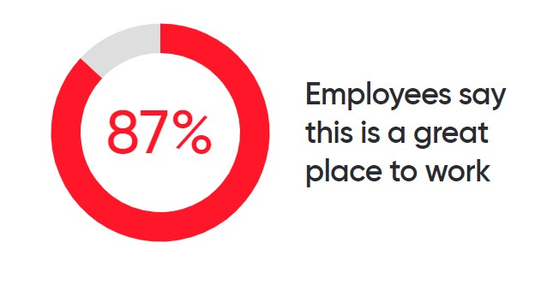
Figure 3: Employee satisfaction level at Accor. Source: (Demirçiftçi and Kızılırmak, 2020)

Method of Measuring Employee Engagement
As a result of the lack of agreement on what it implies, determining levels of employee involvement may be tricky. The word "happy" is sometimes used interchangeably with "contentment," while "dedication to the company's goals" is another. One-on-one meetings with employees are a great way to assess employee satisfaction and productivity (Turner, 2020). It's a great idea to arrange hour-long casual meetings with each member of the team to get a sense of how they're doing.
Face-to-face feedback collecting allows managers to learn more about each issue presented since manager can receive more specific information (Garber, 2020). As a manager, it is his or her responsibility to assist the employees overcome their apprehension so that they may be more open with one another.
Three core factors for One-on-One conversation are,
- Keeping Right Mindset: Keep in mind that the meeting is supposed to be a discussion, not a lecture. Employees are expected to remain at the centre of the dialogue while the surveyor offers guidance and support (Chanda, 2019). To have a successful discussion, you must be able to converse about things that are of mutual interest.
- Having Regular Schedule: Regular one-on-one conversations are crucial. Schedule recurrent appointments to prevent employee misses. A surveyor may do this to demonstrate commitment. Frequently cancelling meetings with a direct report may convey the wrong impression.
- Having Flexile Agenda: Meeting agendas should be planned by employee-surveyor jointly. As part of the survey, ask employees to share any problems or concerns. Goals, feedback, acknowledgement, and professional ambitions are conversation topics (Kumar and Pansari, 2020). Enabling more frequent and successful meetings.

Benefits of Measuring Employee Engagement
If an individual has an emotional and mental connection to their work, they are more likely to be engaged in the activities associated with their employment. Studies have shown that a motivated workforce results in a rise of 21 percentage points in productivity and 22 percentage points in profitability (Gallup, 2022). To summarise, motivated professionals do higher-quality work and are more likely to stay in their employment for longer periods of time. If managers don't grasp what motivates their staff, they can't hope to excite those employees (Albrecht, 2020). The level of employee engagement may be measured, which can give managers with a better insight of how their workers evaluate the performance of the firm and where they can make changes.
Core benefits of measuring employee engagement,
- Identify strengths and areas of improvement: To prevent issues, it is essential to assess engagement on a regular basis. Employee engagement data may also be used to highlight successes and connect weaker teams or departments to their more successful peers (Byrne, 2021).
- Building trust: When management allows workers to voice their thoughts and feelings, it indicates that they care about their well-being (Connell and Teo, 2020). Using this method, management demonstrates that they are concerned about providing their employees with the finest possible experience.
- Building Stronger Culture: Everything from managers to front-line employees should be made aware of new information as it's available to the management. In order to make a better workplace, each and every one of the organisations must play a part.
- Understanding trends: Know what's happening in the company and how it compares to others on a local, team, or industry level. Follow the company's success and future (or not).

Evaluation & Conclusion
Accor is a large hotel brand which has massive operation worldwide. In UK alone the brand has 230 hotels and 1,487 employees (Accor, 2022). It will be difficult to survey all employees at once. Therefore, the surveys should be conducted by the managers of different departments of each hotels and One-on-One meetings are meant to be done by direct superiors with the employees. Despite the possibility that it may take a lot of time, it is unquestionably worthwhile to make the effort. One-on-one interaction between employees and their managers is beneficial for everyone involved.
Here are the benefits of One-on-One interaction in Accor,
- Managers will grow leadership skills: An additional benefit of one-on-one meetings for managers is that they may practise coaching skills in a more intimate setting. In today's corporate environment, coaching and development skills are in great demand (Onoufriou, 2020). Managers need to learn how to listen to their staff in order to provide them with positive feedback and help. The effect of this is that they're putting what they've learned about coaching into practise. If managers become better coaches, they may assist their people perform better.
- Helps in Building Trust: Direct communication between managers and their employees may go a long way toward fostering a climate of trust. People feel more secure and protected when they are part of a team that trusts and respects each other (Yadav, 2020). It is possible for workers and supervisors to create a more trusting and open connection over time.
- Helps to improve employee performance: Research that was carried out by Gallup found that having frequent one-on-one talks with workers was associated with higher levels of employee engagement (Yaneva, 2021). There is a threefold rise in the number of workers who are engaged in their job when there is regular communication between workers and their bosses. When workers are interested in what they do, it has a good effect not just on their productivity but also on their performance.
- Connects the employees with organisations goal: On a day-to-day basis, company goals are often forgotten about. Direct communication with workers enables them to have a deeper comprehension of the relevance of the job that they do (Aung, 2019). It is the responsibility of managers to investigate the relevance of their workers' work to the overall objectives of the organisation. It is important for workers to understand how the job they do contributes to the overall purpose of the firm while they are there. When people get together to work toward a similar purpose, there is the potential for genuine relationships to be created.

Reference
Albrecht, S., 2020. Handbook of employee engagement. Cheltenham: Edward Elgar.
Aung, M., 2019. The Accor Multinational Hotel Chain in an Emerging Market: Through the Lens of the Core Competency Concept’. The Service Industries Journal, 20(3), pp.43-60.
Byrne, Z., 2021. Understanding employee engagement. Milton Park, UK: Routledge.
Chanda, A., Sivarama Krishna, B. and Shen, J., 2019. Strategic human resource technologies. Los Angeles: Response.
Connell, J. and Teo, S., 2020. Strategic HRM. Prahran, Vic: Tilde University Press.
Demirçiftçi, T. and Kızılırmak, İ., 2020. Strategic Branding in Hospitality: Case of Accor Hotels. Journal of Tourismology, 2(1).
Gallup, I., 2022. Gallup. [online] Gallup.com. Available at: <https://my.gallup.com/> [Accessed 20 June 2022].
Garber, P., 2020. 50 activities for employee engagement. Amerherst: HRD Press.
Group.accor.com. 2022. Accor. [online] Available at: <https://group.accor.com/en> [Accessed 20 June 2022].
Kumar, V. and Pansari, A., 2020. Measuring the benefits of employee engagement. London, UK: Penguin Books.
Mone, E., 2020. Employee Engagement Through Effective Performance Management. Milton Park, UK: Routledge.
Narayanan, A., 2021. Gamification for Employee Engagement. Birmingham, UK.: Packt Publishing.
Onoufriou, N., 2020. Learning from sustainability practice: case examples from Accor, Scandic and Atlantica. Worldwide Hospitality and Tourism Themes, 12(5), pp.587-596.
Segalla, M., 2022. International perspectives on employee engagement. Milton Park, UK.: Routledge.
Statista. 2022. Statista. [online] Available at: <https://www.statista.com/> [Accessed 20 June 2022].
Townsend, K. and Wilkinson, A., 2020. The future of employment relations. Houndmills, Basingstoke, Hampshire: Palgrave Macmillan.
Truss, C., 2020. Employee engagement in theory and practice. London: Routledge, Taylor & Francis Group.
Turner, P., 2020. Employee Engagement in Contemporary Organizations. Cham: Springer International Publishing: Imprint: Palgrave Macmillan.
Yadav, S., 2020. Determining the Relationship between Employee Engagement and Employee Satisfaction: A Review of Literature. International Journal of Psychosocial Rehabilitation, 24(5), pp.5038-5048.
Yaneva, M., 2021. Employee Satisfaction vs. Employee Engagement vs. Employee NPS. European Journal of Economics and Business Studies, 4(1), pp.221-227.

