BSc Civil Engineering & Environmental Management
Construction Project Management
Civil Engineering Project Management and EIA Assignment

Lecturer: Juan A Ferriz-Papi
Report By: Lewis Evans
Student I.D: 1811314

Contents
Introduction: 3
Avoiding disappointment with your sub-contractor! 4
Tender Processes 5
How to avoid issues 7
Case Study 9

Introduction:
Purpose of this report is to show the importance of having and maintain the right subcontractor. Quality in construction projects is very important, and throughout the report you will see some of the best routes to build a relationship between main contractor and subcontractor and keep trust. Having trust can lead to big success and projects meeting the criteria on time. Throughout this report we should see the best ways to get great things from your subcontractor.

Avoiding disappointment with your sub-contractor!
As a main contractor, the most important aspect in construction procurement is sub-contractor selection. When hiring a sub-contractor, the objective should be to reduce project risk, increase the overall value to the client and attempt to develop long lasting relationships between the members of the project. Occasionally, contractors in the public sector, put construction projects out to tender when specialised works are required, which is why sub-contractor selection constitutes a critical decision for clients/contractors. The selection process should embrace investigation of sub-contractor’s potential to deliver a service of acceptable standard, on time, and within budget. This Process can take some time as once the subcontractor is selected the main contractor has full responsibility of their performance. So picking the right subcontractor to work alongside you is vitality important. Hiring a subcontractor can be long drawn out process as you want to make sure to get the right company working for you, that will hit targets that you have and provide the quality of work your client expects. In some circumstances specialised work needs to be done so it is critical that the right selection has be done. Subcontractors are viewed by the client as an extension of the main contractor (general contractor) and a failure by the subcontractor can adversely affect your company’s reputation. Unfortunately, some contractors don’t manage their subcontractors. They appoint them and then leave them to get on with the job. Often project staff aren’t briefed about what the subcontractor’s scope of work is. Time and again there is a lack of communication. When there are problems the subcontractor is blamed. So Building relationships with your subcontractor can have huge effect on the project and future projects.
Using the iron triangle can help with selection of the right subcontractor.
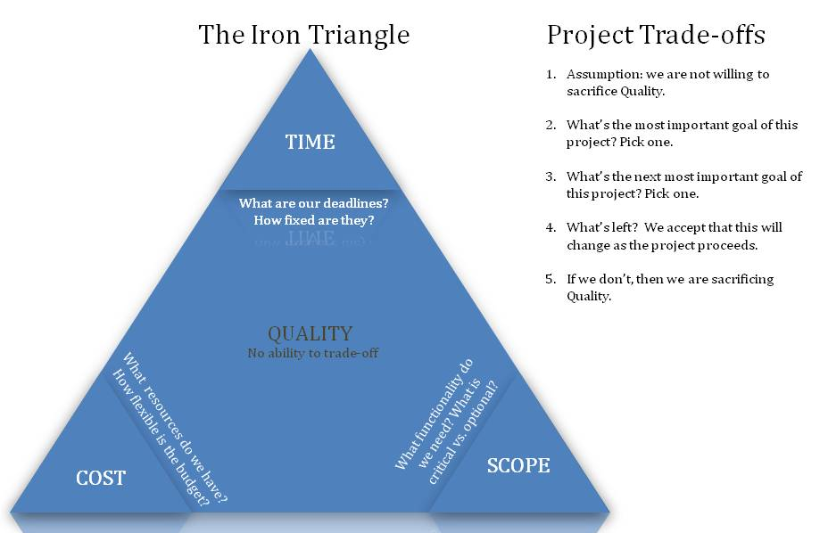

Tender Processes
Below are the ways in which contractor/suppliers will tender for new projects
Open Tendering
This allows anyone to submit a tender, supply services that are required. An advert will normally go out giving the contractor notice to put forward a tender. Doing it this way offers an equal opportunity to all contractors. Open tendering has been criticised for attracting tenders / expressions of interest from large numbers of suppliers, some of whom may be entirely unsuitable for the contract and as a result it can waste a great deal of time, effort and money. However, open tendering offers the greatest competition and has the advantage of allowing new or emerging suppliers to try to secure work. Designingbuildings.co.uk. (2019).

Selective tendering
Selective tendering means that a contractor has got to have an invitation to put in a tender. Suppliers will be known via their track record from previous jobs, and suitable for size and complexity of different contractors. Clients will have an approved of suppliers/contractors and will be regularly reviewed to keep track on performance. Selective tendering can give clients greater confidence that their requirements will be satisfied and should reduce the wasted effort that can be involved in open tendering. It may be particularly appropriate for specialist or complex contracts, or contracts where there are only a few suitable firms. Designingbuildings.co.uk. (2019).

Negotiated Tendering
This is where a client will pre-select a contractor on previous work or of nature of the project. A contractor may already be onsite and new work may become available, so again as they are set up this may mean they get pre-selected to carry out the new work. This can reduce the cost of tendering and allow early involvement on the scheme. One disadvantage with this tender process is it can cause atmosphere being contractors as everyone would like a shot at the tender. Designingbuildings.co.uk. (2019).

Knowledge of the company could influence the final choice Categories considered:
- Subcontractor known. Worked before with him and satisfied with financial stability and work
- Well known reputation. Need to confirm financial standing
- Completely unknown. Need of full investigation about performance record and financial stability

Selection
There are many things to look for when selecting a contractor/supplier for the project. Companies house can be useful to find out about them, assessments of their past track records. It’s really important to understand where they could have exposed risk through commitments. Below are just some of the things that can be evaluated,

History

Current position the contractor/supplier is in

Future position it will be in once project as started

Legal position

Technical capability

Other indicators (Rep in the insurance market)

Time taken to pay suppliers

Table can also be used to help with selection.
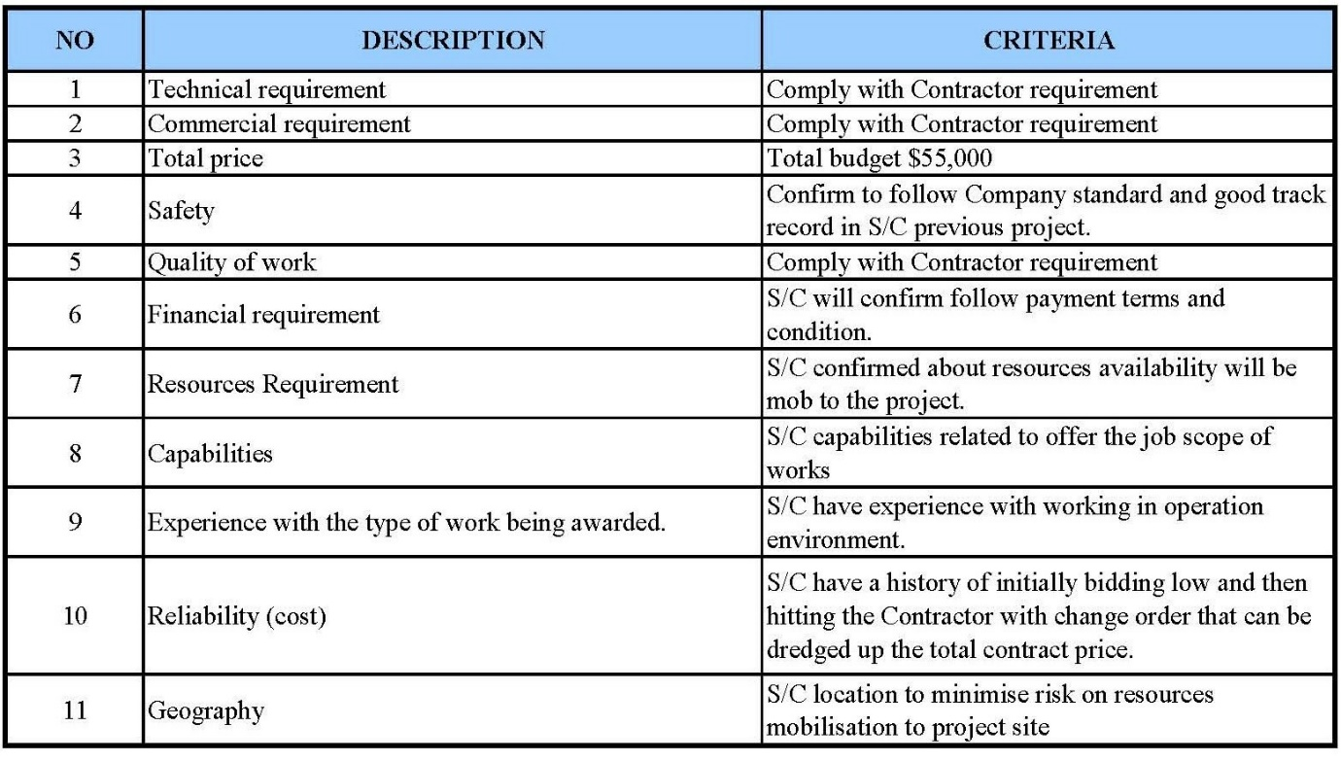W#05_Ros_Subcontractor Selection.

How to avoid issues
Sometimes subcontractors do get into problems. It’s important to understand the reason for these problems which may be due to the main contractor’s poor management, delays, lack of communication or change of scope. However, it is also often due to the subcontractor’s poor management, lack of cash flow or incompetence. By understanding the problem, you may be able to take action to rectify the problem or at least prevent it from getting worse.
- Hold regular meetings to discuss any issues
- Promote rewards, this will increase work and keep motivation high, keeping work to a high standard
- Training, if subcontracts are trained to main contractor standards, they will provide a better quality of work. Skill is achieved by training and education and provides employees with pride of performance and the confidence to make decisions about their tasks.
- Introduce a bond, this will help make sure that continued work is finished to client standard, if not subcontractor will be liable to complete work
- Payment to be on time. You can build a good relationship with payments of completed work on time, they will gain your trust and always try to complete work to your standard.
Managing your subcontractors
Health and safety
‘The subcontractor should be aware of: - Hazards on site - Site rules and safety procedures - What to wear - Special equipment needed - What to do in an emergency
Subcontractors must comply with HSWA and other H & S legislation
Cooperation and communication are needed to make sure all parties can meet their obligations’ (Juan Antonio Férriz Papí)
Some important points to note when managing subcontractors are to ensure:
the contractor’s person managing the subcontractor understands:
- the subcontractor’s scope of work
- who is responsible for supplying materials
- how the subcontractor will be reimbursed

the subcontractor:
- complies with the project’s safety requirements
- produces work of acceptable quality
- works according to the project schedule
Other Major Factors
- the subcontractor receives access and information on or ahead of schedule and isn’t delayed by the contractor or other subcontractors
- regular meetings are held with the subcontractor to discuss safety, quality and environmental matters, as well as progress on the project and any delays and claims, and that minutes of these meetings are distributed to the relevant parties
- subcontractors acknowledge the receipt of drawings and information issued to them.
- where relevant, the subcontractor supplies shop drawings in accordance with the project schedule, including allowing for obtaining the required approvals from the contractor or the client
- communication with the subcontractor of a contractual nature is in writing, any verbal instructions should be followed up in writing
- only the contractor’s delegated responsible staff communicate with the subcontractor (I have had subcontractors receive conflicting instructions from our staff resulting in confusion and errors)
- action is taken as soon as it appears that the subcontractor could be in trouble.
- is forewarned of the contractor’s intention to back-charge them for work or services supplied by the contractor and that these charges are invoiced regularly
- the subcontractor is paid in accordance with the contract
- the subcontractor has suitable quality, safety, environmental and industrial relations procedures in place that comply with the project requirements
- subcontractors don’t begin work until there’s a signed contract in place and they’ve supplied the required sureties and insurances
- the subcontractor’s staff, equipment and their own subcontractors are approved by the contractor
- the subcontractor’s personnel attend the contractor’s project induction
- correspondence from the subcontractor is promptly dealt with

Case Study
(on how a company can grow trust with its client)

Kenham Building Limited is a London-based firm providing building and renovation services for residential and commercial projects since 1998.

CHALLENGE With a large project on the horizon, Kenham wanted to find a project management solution that would standardize processes and streamline information across all projects.

SOLUTION Procore offered a comprehensive platform that was both intuitive and user-friendly. With automated workflows, Kenham eliminated manual processes, saving its team hours and helping the company grow.

The catalyst came in the form of a house. Or rather, 13 of them. As the General Manager at Kenham Building Limited, a London-based firm providing building and renovation services for residential and commercial projects, Joshua Schumann is responsible for making the company run as efficiently as possible. In 2017, when a developer approached Kenham about a large 13-house project, Schumann recalls that it was the nudge he and his team needed. They began searching for leading project management software in the hopes of standardising processes as projects (and the company) grew.

Partnering with Procore

Prior to using Procore, important project information at Kenham lived in multiple systems. However, this created siloed data which hindered both collaboration and the ability to locate the most up-to-date version of documents.

“One person often wanted to upload their drawings to Dropbox, another wanted Google Drive, and someone else wanted to email drawings. When you’ve got an architect, an engineer, and probably an M&E consultant all sending drawings in different capacities, it becomes a bit chaotic,” Schumann explains.

Kenham wanted to find a way to consolidate all data into a single, centralised location. At the time, the team also relied on manual paper processes and printed drawings that made it difficult to standardise processes. They wanted to find a solution that was automated to help them be more proactive.

“We wanted to make sure that boxes were ticked and things weren’t getting missed or overlooked. For example, when we purchased materials, we were ordering two days beforehand rather than two months before,” recalls Schumann.
With the 13-house project on the horizon, Schumann and his team decided to act. “It would have been hard for the senior management to keep track of everything with that kind of expansion. While everyone may be able to keep track of their own projects or their upcoming projects, it can be difficult if everyone’s keeping track in slightly different capacities. That’s where we found that Procore shines. People can have a quick overview of all the project data, and then that’s it. It’s so easy.” Procore.com. (2019). [online] Available at: https://www.procore.com/downloads/casestudies/CaseStudy_Kenham.pdf [Accessed 7 Jun. 2019].

Conclusion

From this research I have found, it has shown me that main contractors and subcontractor can do very specialised projects together, but also things can go wrong. The balance between main contractor (PC) and subcontractor needs to be right for quality, cost and time of the project to be right for client. If This all works it will also allow them to have a long-lasting relationship with the PC with many more opportunities to work together. Trust is major factor when it comes to the selection process of a sub-contractor. As a main contractor, it should be, at the very least, expected that known or unknown sub-contractors should offer competitive bids in an attempt to build up main contractors’ trust in their integrity and their determination to provide the performance required for the current project. As a new sub-contractor, it is in their best interest to offer favourable bids. They will be more likely to be selected via the tender process if the main contractor is selecting based on cost. The experience they will gain by winning these contracts, will give them the potential to or open up the possibility to transform their reputation-based performance into an experience-based performance. This will increase their chance of being considered when a main contractor wants to select a sub-contractor based on familiarity/preference in future projects.

“Subcontractors need to be managed by the main contractor (general contractor) to ensure that their performance meets the project’s safety and quality requirements, and that work is in accordance with the project’s schedule and specifications. Failure to manage subcontractors properly often leads to disputes, claims, project delays, substandard work and even accidents. This leads to project failure, often resulting in all parties losing money and the client getting their project late which negatively impacts the contractor’s reputation.”

References
Designingbuildings.co.uk. (2019). Tender processes for construction contracts - Designing Buildings Wiki. [online] Available at: https://www.designingbuildings.co.uk/wiki/Tender_processes_for_construction_contracts [Accessed 1 Jun. 2019].
&rarr;, V. (2019). W#05_Ros_Subcontractor Selection. [online] mahakam2012. Available at: https://mahakam2012.wordpress.com/2012/06/18/w05_ros_subcontractor-selection/ [Accessed Jun. 2019].
Paul Netscher, July 2015. Managing your Subcontractors – Linked In
Stakeholdermap.com. (2019). Project Management Triangle - Time, Cost and Quality - Iron Triangle. [online] Available at: https://www.stakeholdermap.com/project-management/project-triangle.html [Accessed Jun. 2019].
Juan Antonio Férriz Papí Moodle.uwtsd.ac.uk. (2019). UWTSD Moodle 2018/19: Log in to the site. [online] Available at: https://moodle.uwtsd.ac.uk/pluginfile.php/207854/mod_resource/content/1/Subcontractors.%20Slides.pdf [Accessed Jun. 2019].
Procore.com. (2019). [online] Available at: https://www.procore.com/downloads/casestudies/CaseStudy_Kenham.pdf [Accessed Jun. 2019].

