Task 1: Locating Sources
Identify and locate three different sources (a report, a journal article, and a website) related to the question
“What employability skills do business graduates need to succeed in the modern workplace?”
Show how you used keywords, search terms, and Boolean operators to find them, and explain how you know which type of source each one is and why it is appropriate for the research question.

Source Type & Why It Is Appropriate | URL/DOI | What search engine did you use? Google/Online Library/Library AI Assistant | Keywords/Boolean Operators Used
Article because it is the most accurate source type between the options | https://librarysearch.uwtsd.ac.uk/permalink/44WHELF_UWTSD/lrq2gq/cdi_informaworld_taylorfrancis_310_1080_14703297_2022_2049851 | Library AI Assistant | Employabilit Skills and Business Graduates and Succeed in Modern Workplace
https://librarysearch.uwtsd.ac.uk/permalink/44WHELF_UWTSD/lrq2gq/cdi_unpaywall_primary_10_17687_jeb_v7i2_463
COPY THE PERMALINK TO CLIPBOARD
CLOSE

Task 2: Evaluating Information (CRAAP Test)
Your colleague has forwarded you a source from a peer reviewed journal, and they are not sure whether it is appropriate to use and has asked for your help. Your task is to evaluate the source by using the CRAAP Test to assess its appropriateness.
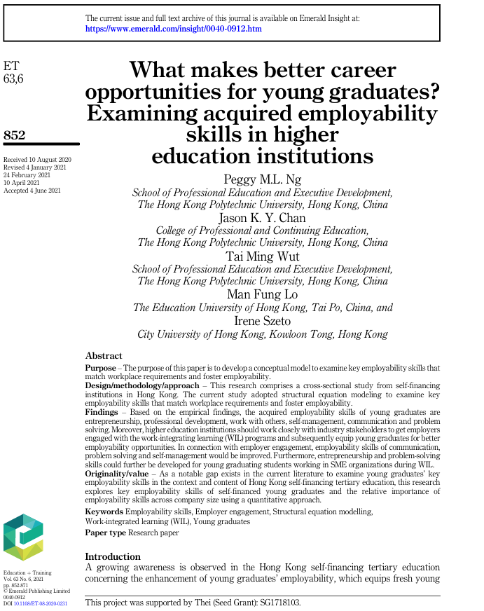

CRAAP Test
Currency | Received 10 August 2020  Revised 4 January 2021  24 February 2021  10 April 2021  Accepted 4 June 2021
Relevance | As we can see in abstract this research explores key employability skills of self-financed young graduates and the relative importance of employability skills across company size using a quantitative approach.
Authority | School of professional Education and executive development, The Hong Kong Polytechnic University, Hong Kong, China  College of professional and Continuing Education, The Hong Kong Polytechnic University, Hong Kong, China  School of professional Education and Executive Development, The Hong Kong Polytechnic University, Hong Kong, China  The Education University of Hong Kong, Tai Po, China, and Irene Szeto, City University of Hong Kong, Kowloon Tang, Hong Kong.
Accuracy | Is a revised source made in trusted places.
Purpose | The purpose is to develop a conceptual model to examine key employability skills that match workplace requirements and foster employability.

Task 3: Source Analysis
Your manager has provided you with a short extract from a source and has asked you to analyse the source by Identifying one strength, one weakness, and providing a brief explanation of the strength and weakness identified.
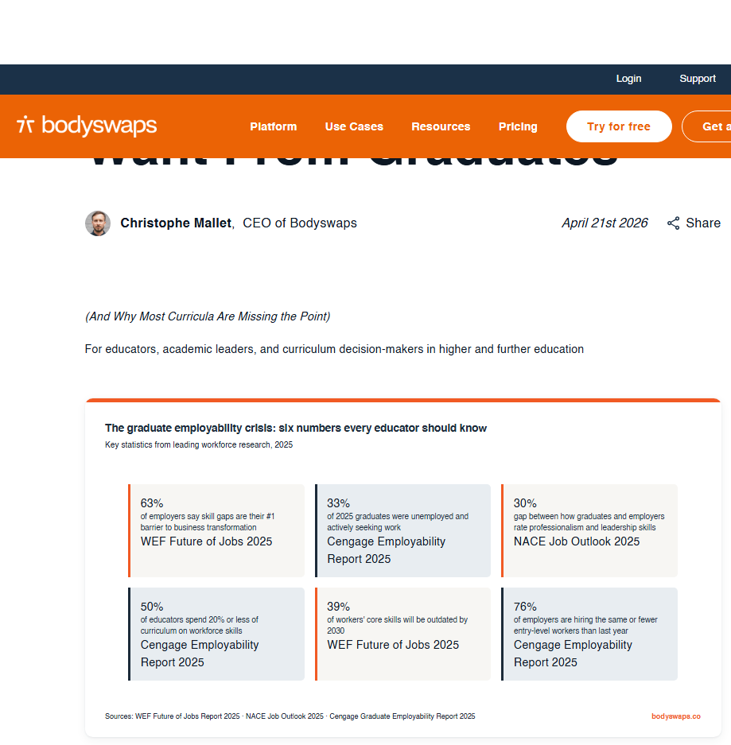
.

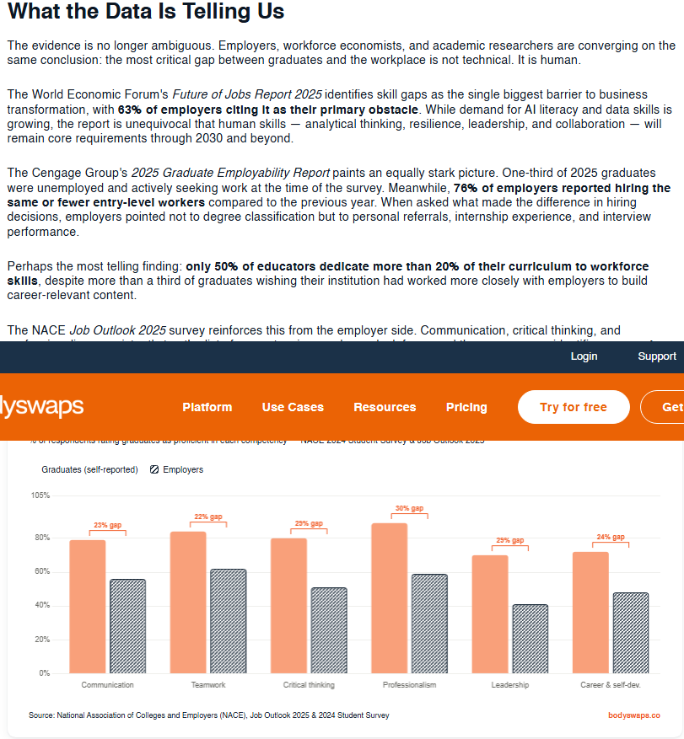

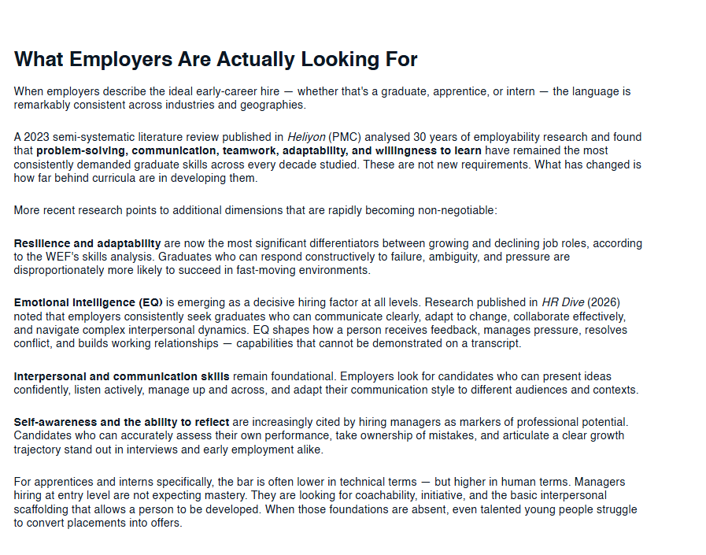

Please click the link, if you wish to read the article online.
What Employers Actually Want From Graduates

Strength of the Source:

The Strength is that is a very good way to look for the information we are looking for, as we talking with students that are totally enrolled with the context.

Weakness of the Source:

Two weakness is that this source is a little bit old and it was made only on China, so we have kind of a limited perspective about the theme.

