Digital Skills Date 23/10/2026
By Maninder Pal Singh
Digital Tools used in daily life
These are digital tools different ones I use in daily life

My Screenshots/Photos
- Please add 4–6 screenshots or photos of your digital life.
- You can use your phone or laptop.
- For each screenshot, write one or two sentences explaining what it shows.

Screenshot/Photo 1
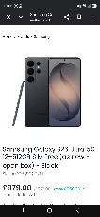
I use my Samsung phone in my daily life to make calls send texts make contactless payments. I use different apps on phone like my work app to where is my work rota is scheduled.

Photo 2 tik tok
[
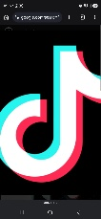
I use tik tok in my daily life to check latest fashion, watch current affairs like news check for new music watch documentary. I also check what latest music is trending.

Photo 3 Bank Card
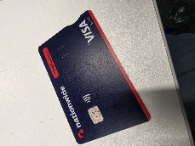 I Use my bank card to make payments when I am shopping pay bills I will need my sort code and account number if I want to send money into another account

Photo 4 Laptop
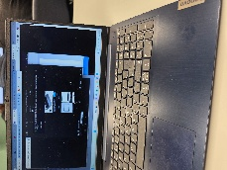
I use my laptop in my daily life to make word documentation, excel and spreadsheets and use the internet for general research I watch youtube on laptop

Photo 5 printer
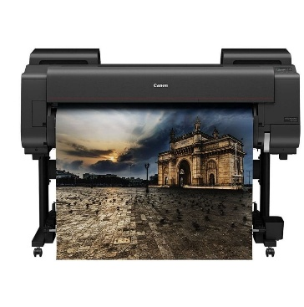
I use a printer in my daily to printout emails word documents like assignment print pictures from phone.

Photo 6 USB STICK
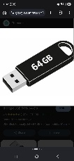
I use this USB stick in my daily life for saving document such as Pictures, Word. I can open the USB when I insert it in MY Laptop port then click it on my computer then click USB then it will open one by one

My Short Reflection
- Write 5–8 simple sentences about your digital life.
- You can use the sentence starters below if helpful.
About my digital life I different digital tools for many things like using phone for making calls printer to printout documents laptop for using word.
It gives me more knowledge on things I do not know about. You can use different tool to give you a better idea that what new technology is upgrading and you know new gadgets coming out.

Sentence starters
- I use digital tools to …
- I feel confident when I …
- I want to improve …
- I often use these tools: …
- I sometimes feel nervous about …
- I hope this module will help me …
- Digital skills are important for me because …
You can write more if you want.

Submission Checklist
Before you submit, please check:
​​​ ☐ I added 4–6 screenshots
☐ I wrote short sentences for each screenshot
☐ I wrote my short reflection
☐ My work is my own
☐ My file opens correctly
​​☐ My file opens correctly

