Feasibility Report – Employee Engagement through Continuous Improvement
Contents Page

- Executive summary Page 2
- Introduction Page 2,3
- Aim and objectives of report Page 3,4,5
- Case for change Page 5,6,7,8,9
- Research design Page 9,10
- Results of primary quantitative data Page 11 - 23
- Results of primary qualitative data Page 24,25,26
- Conclusions Page 26,27
- Recommendations Page 28,29
- References Page 29 - 33
- Appendix 1 Page 34
- Appendix 2 Page 35
- Appendix 3 Page 36,37
- Appendix 4 Page 38
- Appendix 5 Page 39
- Appendix 6 Page 40,41,42
- Appendix 7 Page 43

- Executive Summary
The aim of this report is to assess the feasibility of implementing a 12 month trial of the continuous improvement model outlined in appendix 1 and 2 with a view to initiating a culture change programme to embed continuous improvement and achieve service excellence through employee ownership of ideas enhancing employee engagement and retention at the Bidfood Chepstow depot.

- Introduction
“Employee engagement is the emotional commitment the employee has to its organisation or its goals” (Kruse, 2012). Organisations that manage to increase their employees’ engagement level, are far more likely to experience higher retention rates, increased profit, and improve customer satisfaction (Xu and Thomas, 2011).
When organisations are faced with daily challenges and problems reach the surface, organisations rely on workforce knowledge to solve a variety of problems (MacDuffie, 1995). Therefore, the importance of teamwork, sharing knowledge, and listening to people’s ideas and suggestions is a key within the lean culture.
According to Liker (2004) the heart of the Lean theory is a relentless elimination of waste, arguing that it encourages employees to continually improve the processes they are involved with.
Motivation plays a key role in engaging employees, and in lean theory, Liker (2004) highlights the importance of motivation in order to develop exceptional people and teams that follow a company’s strategy.
The lean culture also intends to challenge employees and involve them in decision making and problem solving to increase their self-confidence and move them in a direction towards self-actualisation (Liker, 2004).
This report will look at the feasibility to trial the model outlined in appendix 1 and 2 that can be adopted for any idea at any depot/business area to generate ideas through employee communication, participation and ownership.

In order to assess the feasibility of implementing the model, this report will analyse operational employee’ views around acceptance to change, continuous improvement and engagement through participation to assess the potential success or failure of implementation. Primary research will be used to assess the models capability in achieving the desired aims and objectives. (See project initiation document for the model potential based on an example idea).

The outcome of this feasibility report will discuss the potential successes and risks of a 12 month pilot with proposed recommendations for ongoing implementation of the model.

- Aim and Objectives of Report
Report Aim
To assess the feasibility of running a 12 month trial of the model. The key objective of the model is to provide a process that will enable the innovation of continuous improvement ideas through employee participation to take service excellence to the next level using manufacturing concepts to continuously improve and build engagement, creating a culture of service excellence at operational level.
Report Objectives:

- To assess Chepstow’s operational employees acceptance to change, current views on communication and their opinions on whether their views are valued by line managers
  - Measured through primary quantitative research in the form of questionnaires.

- To assess Chepstow’s operational employees desire for involvement in continuous improvement projects and whether employees feel that participation would increase engagement levels.
  - Measured through primary quantitative research in the form of questionnaires.

- To combine quantitative and qualitative research to assess the potential success or failure of a 12 month pilot.
  - Measured through primary quantitative research in the form of questionnaires and primary qualitative research in the form of line manager interviews.

- To create recommendations including communications, project structure, opportunities and risks to be considered in the potential roll out of a 12 month trial period for managers to ensure a successful pilot launch.
  - Measured through manager actions and implementation of the project plan over a 12 month trial period.

- Case for change

This literature review presents the business case for the project by discussing relevant theory in the context of Bidfood. The review focuses on continuous improvement, employee participation, employee engagement and retention.

Bidfood is a wholesale foodservice distributor in the UK. Providing an extensive range of catering solutions to institutional, hospitality and catering. Bidfood distributes branded food products, groceries, non-food items, wines and catering equipment.

The main strengths of Bidfood are, wide business operations, strong revenue
growth along with strong product and brand portfolio. Geographic concentration residues to be a concern area. Future risks include rising UK wages, rigid regulations and changing consumer preferences, which could have an impact on the company growth strategy. Acquisition along with expansion and the increase in UK population all give advantage to growth opportunities (Carpenter, 2018).

Bidfood SWOT analysis
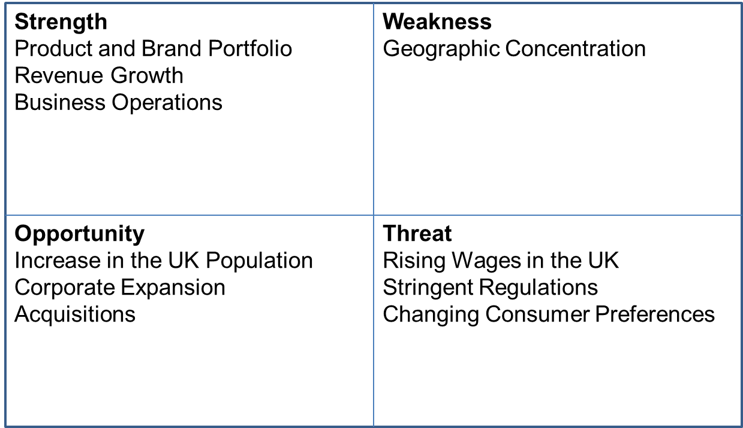

A key threat to the food wholesale industry is the changing customer preference. Constant evolving trends lead to customer preferences changing. Failure to respond to customer demand for products may affect its operations.

At depot level, the challenge of a constantly changing environment, influxes in demand, seasonal increases, daily operational challenges, quality control, handling understaffing problems, customer complaints and employee conflict create a fast paced changing environment for managers to operate within (Work.chron.com, 2018).

The fast paced environment that presents itself with managers, if not planned, can result in problems being viewed as negative rather than opportunities. Ohno (1988) views problems as kaizen opportunities in disguise. His view is to encourage employees to relentlessly investigate problems encountered, using a hands-on approach to arrive at root causes creating ownership. This results in a decrease of challenges concerned with ‘quick fix’ solutions implemented by managers in an environment where time is everything. The kaizen process requires engaging employees daily in making small improvements, ultimately resulting in larger organisational improvements (Miller, 2014).

Arnheiter and Greenland, (2008) state that there can be an absence of awareness with managers. When faced with role challenges a tendency to “not look deep enough to find the leverage points and connections that ultimately change everything” and instead, get trapped on the surface, solving one problem while creating several more” (Murphy, 2018). A shift change from reaction to prevention is required however, Wheatley (2006) states that establishing an improvement culture isn't a quick process, it progresses slowly, from shared experiences and lessons over time.

To evolve while dealing with the pressures of management in a fast paced environment Pulakos, Arad, Donovan, & Plamondon, (2000) state that employees need to creatively solve problems; learn new tasks and demonstrate adaptability. This is supported by Molloy and Noe (2010) who believe employees must “learn for a living.” In particular, an individual's perceptions of their ability to solve problems could motivate them to engage in problem-solving efforts, having a positive impact on performance.

Evans and Lindsay (2016) state that the key factor that impacts employee engagement is involvement. They define involvement as "any activity by which employees participate in work-related decisions and improvement activities, with the objectives of tapping the creative energies of all employees and improving their motivation."

Smith et al.,(1969) states that employee engagement is a major part of retention. Meyer and Allen, (1991) support this and add engagement constitutes organisational commitment. According to Farace et al. (1977) an individual is more likely to become disengaged with low job satisfaction if they receive minimum opportunity for input or processing.

In line with Maslow’s hierarchy of needs, workers need to feel a sense of belonging to an organisation (Simply Psychology, 2018). Wagner (1994) highlights the basic concept is power sharing arrangements among employees who would be deemed as hierarchical unequal’s. This strongly suggests the need to implement a model that increases participation in decision-making to increase job satisfaction. This is supported by Latham et al. (2004) who states that "perceived motivational effects of increased employee involvement" is key to retention.

This literature review, indicates that the implementation of a model to create an environment of employee participation in problem solving and continuous improvement will help to focus managers on prevention rather than reaction, increase the interaction of employees in decision making, improve processes and service standards allowing the business to adapt to changes in customer preference with ease. The review also highlights that the implementation of the model will increase employee retention and engagement through participation and ownership.

- Research Design
The research for this feasibility study will be based on primary data in the form of questionnaires and interviews; a further opportunity for secondary research to clarify and compare results can be taken from the Bidfood annual employee engagement survey, however, due to timing of this report and the publishing of the annual employee engagement survey this will not be covered in this report but will form part of the recommendations for success/failure measurements in the future. The primary data will be analysed to form the basis of the recommendations for potential project implementation.
A mixed methods research technique which combines the use of quantitative and qualitative methods will be used. Creswell and Plano Clark (2007) state that the combined approach can offer an enhanced understanding of research problems. Niglas (2004) states that the use of a range or qualitative and quantitative method results, provide mutual confirmation that a higher confidence will be seen in the results being valid.
Quantitative research, descriptive in form and produced as questionnaires has been used to understand the employees current approach to change, employees views of the current communication level, the extent that employees look for improvements within their role, an understanding of employee satisfaction through participation in change and an investigation into the desire to become involved in improvement projects. The questionnaires will be aimed at all employees at the Chepstow depot excluding any managerial roles.
Questionnaires will be anonymous to ensure a true reflection is captured, if the respondents know that their answers will be kept confidential they are more likely to respond (Lavrakas, 2008).
Qualitative casual research through first line manager one to one interviews at Chepstow will be used to understand views on employee participation in improvements projects. Views on the relationship between participation and engagement and any correlation between existing management styles and the release of power to allow for ownership and learning. The purpose of using casual research will attempt to explain the cause and effect relationship between variables through prior first line management experience as an experimentation (Mooi and Sarstedt, 2011). In essence to see if the second event; absence of employee participation in improvements (the effect) is a consequence of the first; first line management traits (the cause).
126 employees completed the questionnaire out of a total of 172 totalling a 73% completion rate. This included employees from, Transport, Warehouse Nights, Warehouse Days, Customer Service, Stock & PI, Telesales and Field sales. The questionnaire can be found in appendix 3.
7 line managers, directly responsible the employees within each department were interviewed.
- Results of primary quantitative data
This section shows the results from the questionnaire issued to 172 employees with a 73% completion rate. The first set of questions were taken from De Bonvoisin (2015) readiness to change quiz, her theory is based around approaching change with a positive mind-set and surrounding oneself with strong, inspiring people to help create an environment where change is accepted. The questions were adopted to understand the change quotient at Chepstow. The question results were as follows:
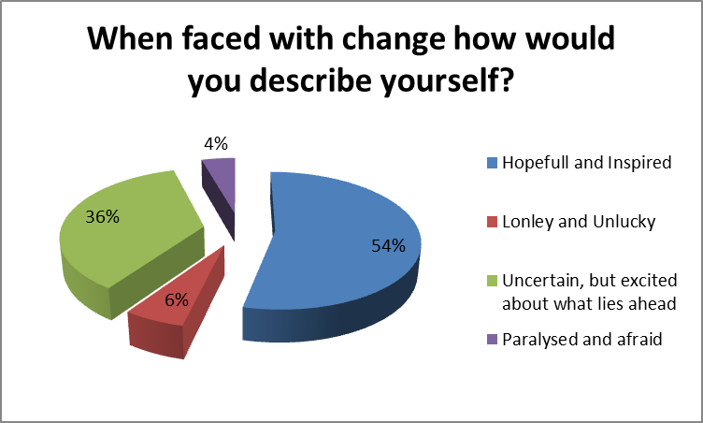
10% of employees felt opposed to change whereas only 4% of the 10% felt that they would become isolated as a result. 90% of employees were positive towards change.
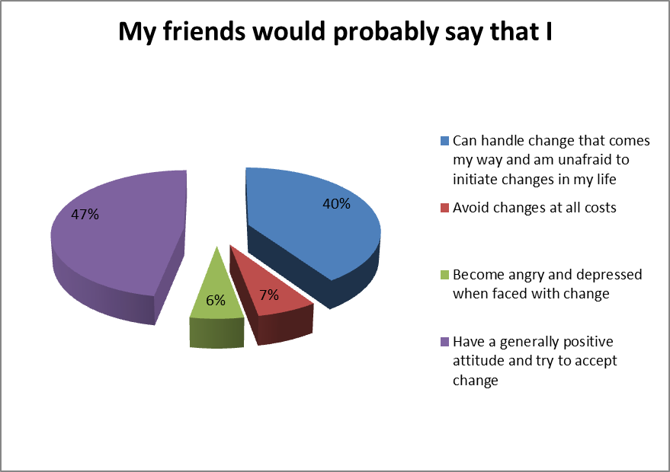
87% of employees have an acceptance to change whereas only 13% avoid change.
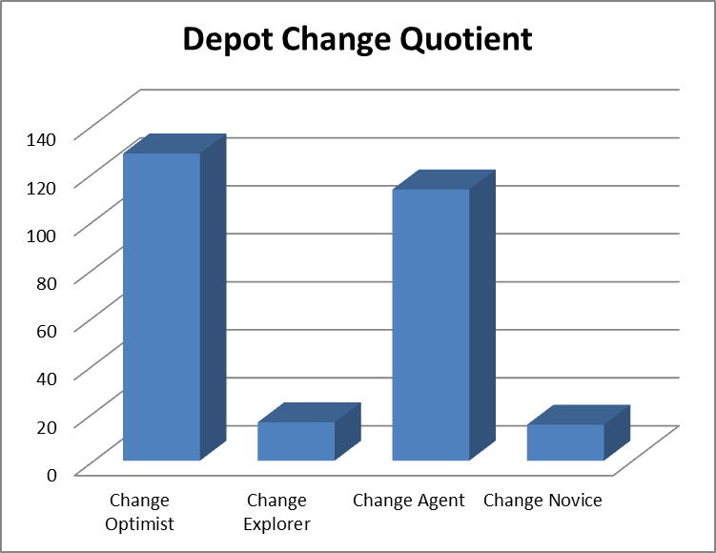
Using the basis of De Bonvoisin (2015) work, the combined scoring of the first two questions gave the above results. 47% of employees actively seek out changes to their given situation. 42% of employees act as a change agent, they help to implement change if given sufficient time to do so. 6% of employees are not opposed to change but would not particularly welcome it either. These people would need support and communication to become actively involved in change potentially from change optimists and change agents. Only 5% of employees do not like change and would try to avoid it at all costs.
Correlation between the employees that fell within the change novice category and qualitative research is evident. Change novices fall within Warehouse Days, Telesales and Customer Service with the majority sitting within Warehouse Days as outlined below. Qualitative research suggests that there are areas of disengagement within the Warehouse Days team that may suggest that the change novice quotient is not a true refection but rather an element of interference. This is discussed in section 7.

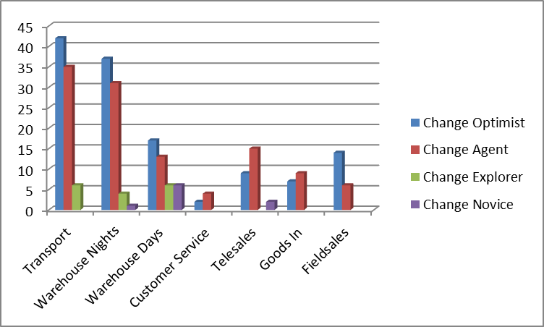

Question 4 suggests that as an overall depot, the majority of employees currently look for improvements in their work with only 9% of employees falling into the never or rarely category.

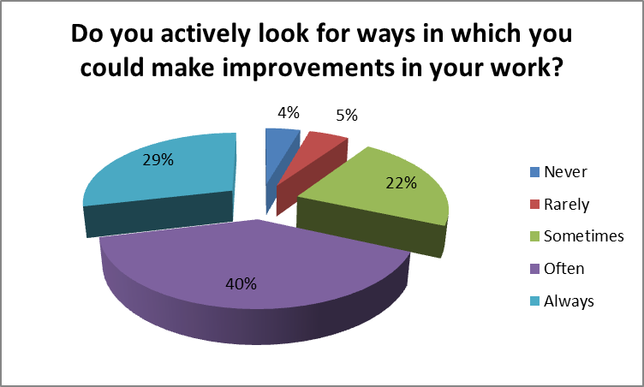

The results of question 4 highlight that Chepstow has the current employee support that would need to be in place to implement the model as outlined in the project initiation document to increase employees participation in improvement projects.

Question 5 shows current communication of improvement ideas which is discussed in more detail during the qualitative research analysis in section 7.

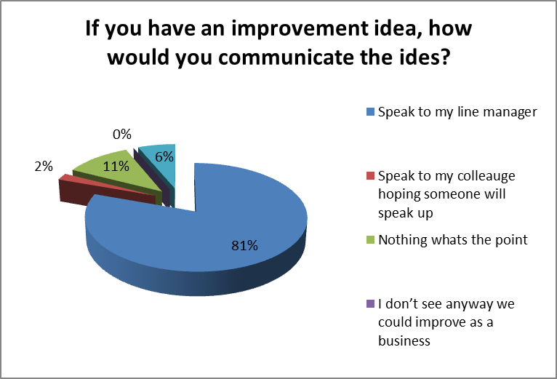

Question 5 results also suggest that some ideas, if highlighted are not acted on or feedback is not given. This is discussed more in qualitative research section 7.

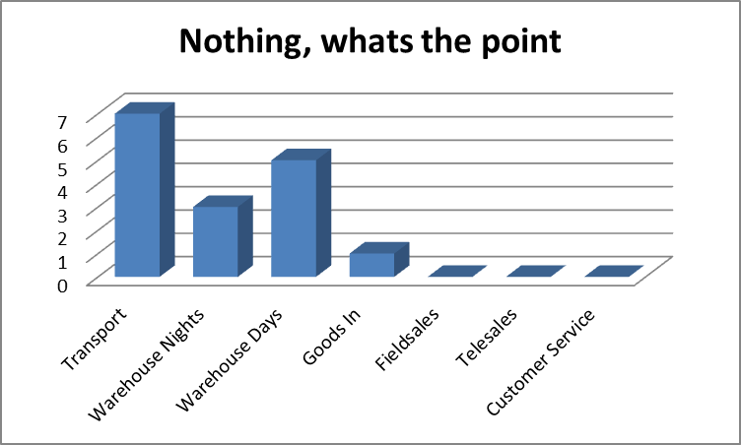

Question 6 shows that over half of the workforce 57% would like the opportunity to become directly involved in improvement projects.
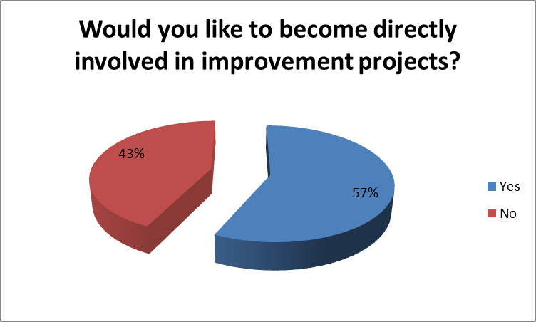

From the 57%, there were employees from each department across the business that would become involved. This fits within the proposed model allowing direct feedback from employees to Service Excellence Ambassadors, generating views, feedback and input from colleagues.

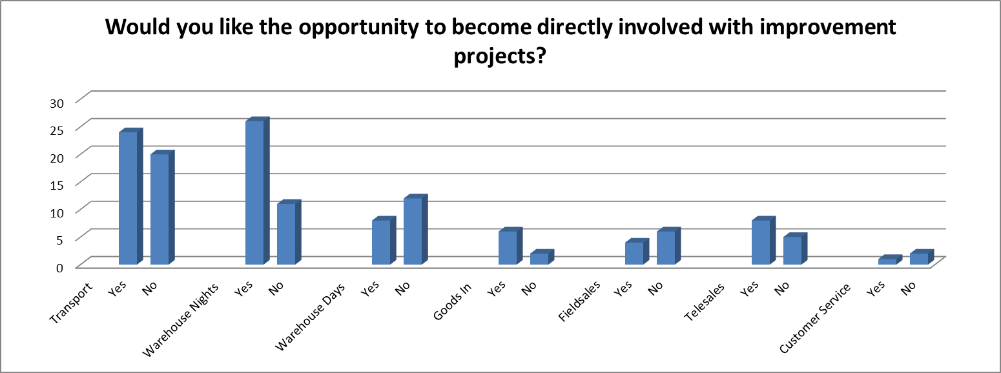

Question 7 assesses engagement levels through participation. The outcome of this question supports the findings of Wagner (1994) and Latham et al. (2004) and the need to implement a model that increases participation in decision-making to increase job satisfaction. 68% of employees highlight the increase in awareness of a belonging feeling and positivity that participation has been acted upon as Latham et al. (2004) states "perceived motivational effects of increased employee involvement" is key to retention. 12% made the direct correlation between participation and engagement. 16% felt that it is part of their job to act on improvements whereas only 4% stated that they would not like to be involved in improvement projects.

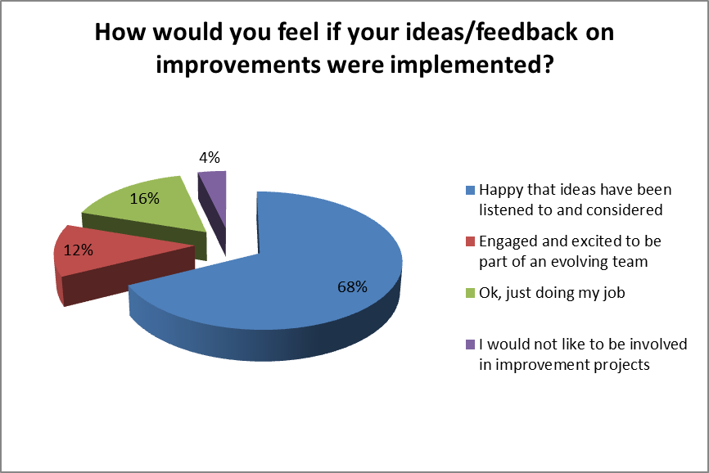

Further analysis of the above results for question 7 shows that the majority of those who would not apply their preference to an engagement or sense of belonging answer were predominantly from Warehouse Days. This relates back to the combined findings of questions 2 and 3 and is discussed in section 7.

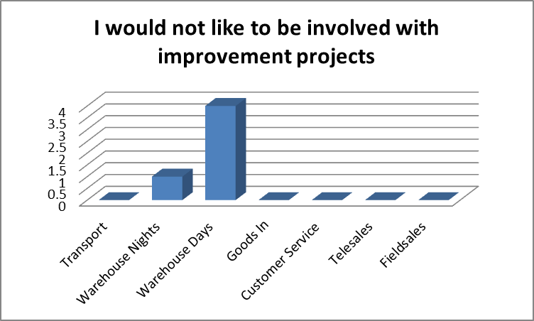

Question 8 shows that 67% of employees feel that they are encouraged to communicate ideas, this will be discussed further in section 7.

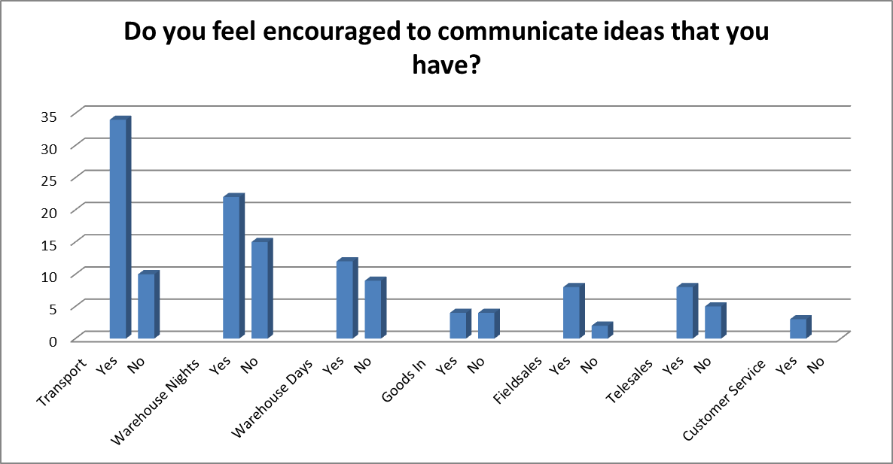

The results of question 8 can be analysed in conjunction with question 13 shown below. Whereas 67% of employees feel they are encouraged to communicate their ideas, only 32% of them feel they are listened too. This suggests a lack of feedback or continuation of any improvement ideas. The reasons are investigated as part of the qualitative research interviews in section 7.

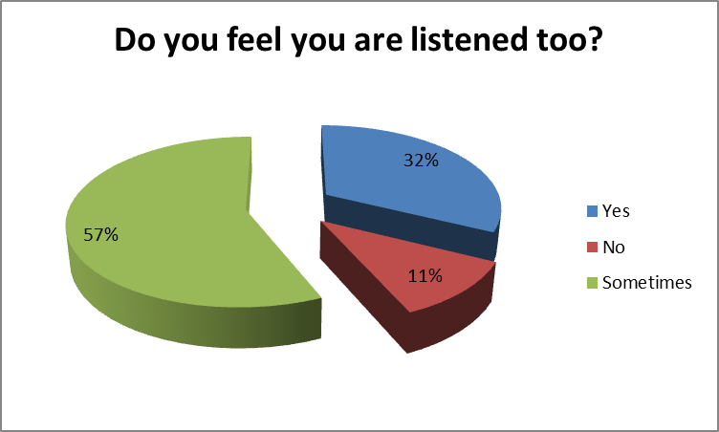
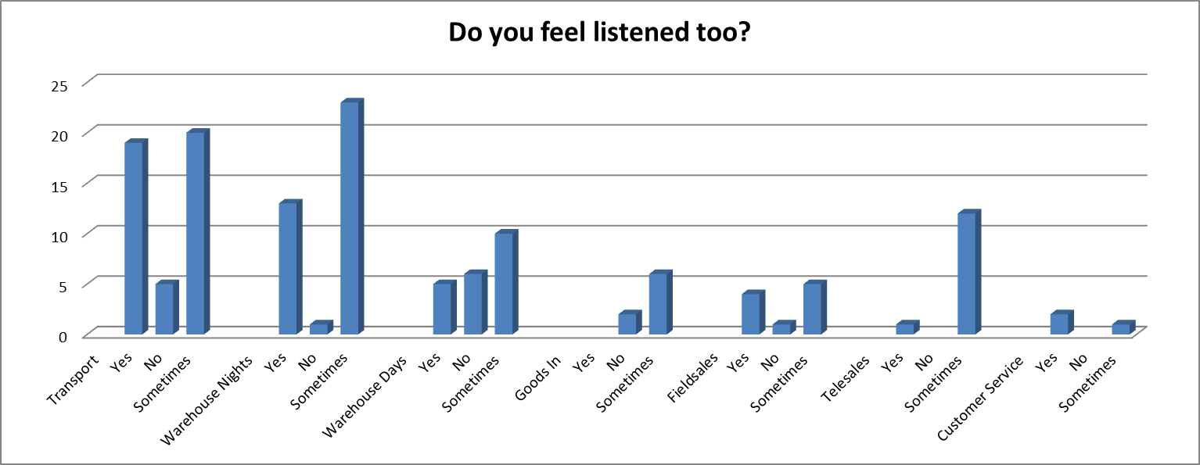

Question 9 shows that 75% of employees would actively review notice boards of improvement projects.

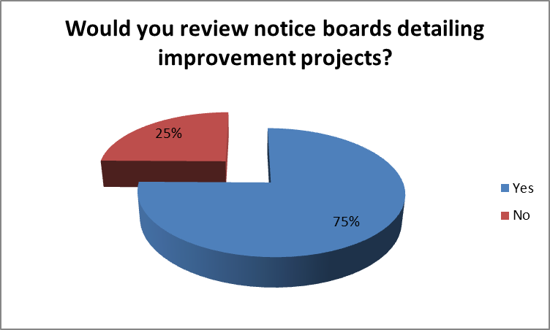

Question 10 shows that out of the 75% of employees reviewing noticeboards, 69% would actively add their feedback and ideas to any current updates of improvement projects. This showing opportunities to break any barriers of communication and keep employees up to date with improvements and changes that would impact their work. In addition this would allow focus to be aligned to those that came out as a change explorer and change novice giving them advance notice and opportunity to understand improvements and work alongside those directly involved in the improvements creating a positive engaging environment. In this case, barriers to change according to Molloy and Noe (2010) would be significantly reduced.

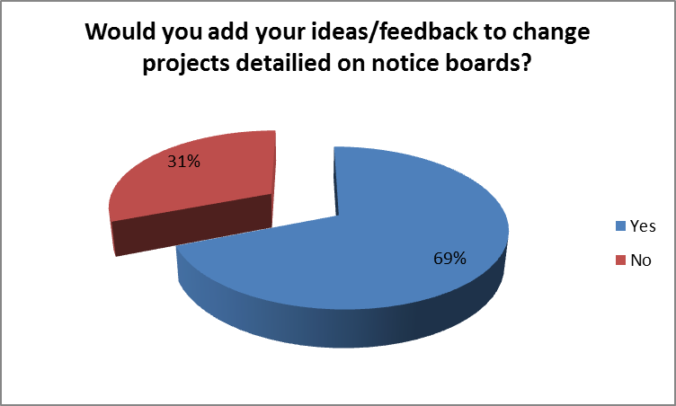

Question 9 links to question 12 which shows how well employees feel they are communicated too. Currently less than half of the employees feel that they are communicated too well. In comparison with question 9 the 75% of employees that would actively review noticeboards suggests that the satisfactory, bare minimum and not at all would increase to well or very well by implementing the model as described on the project initiation document.

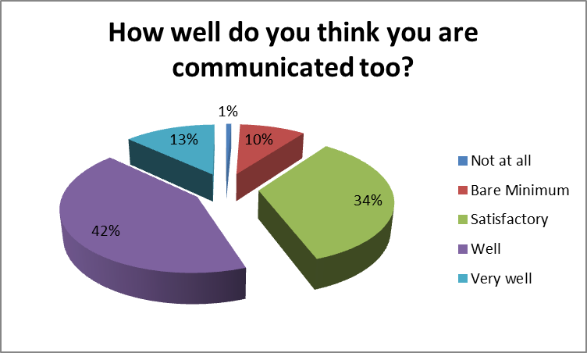

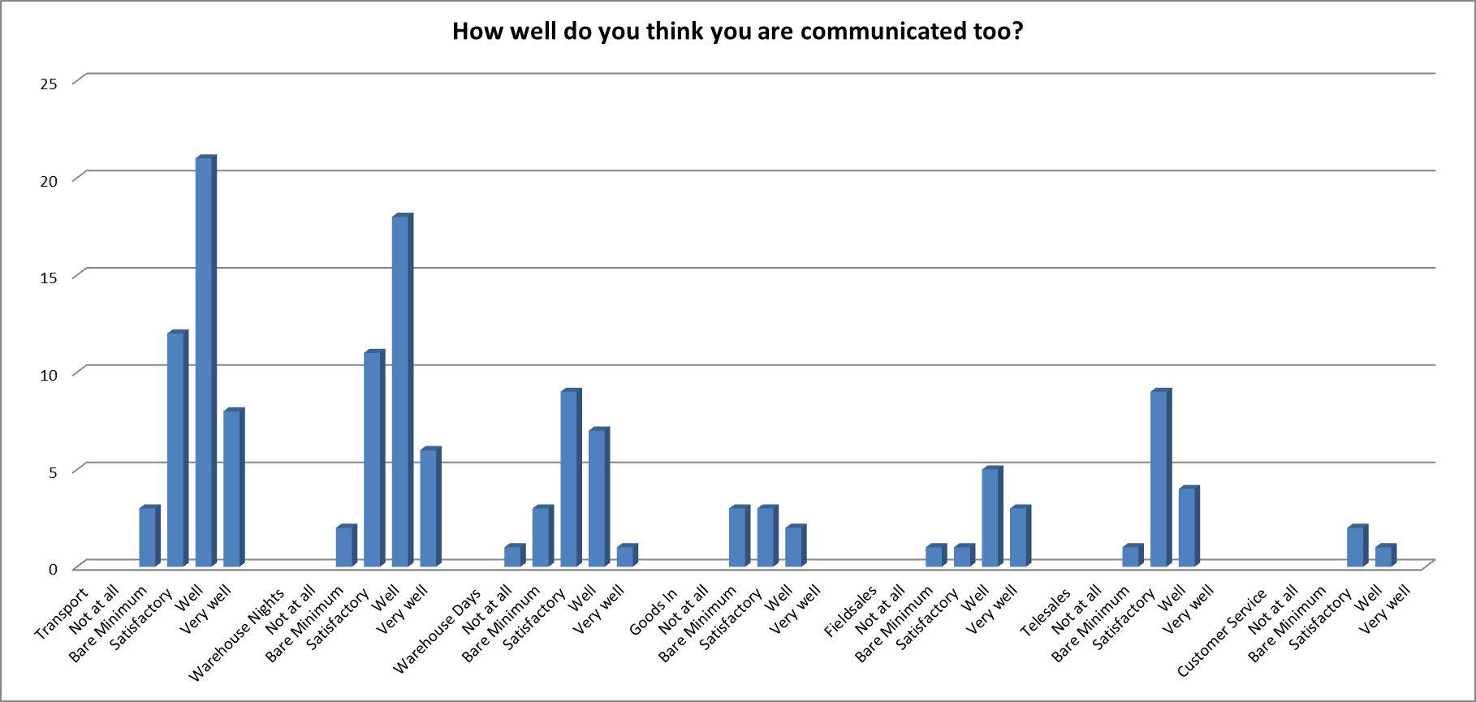

Question 11 asked directly if employees would like to have an opportunity to train in problem solving. 62% of employees stated that they would.

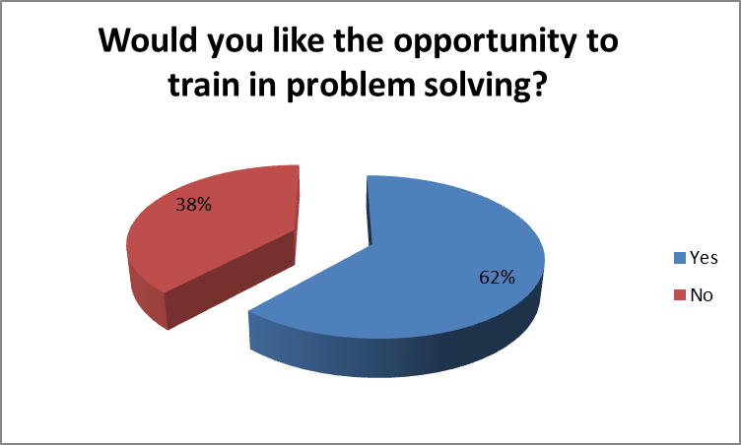

The department split for those wanting the opportunity to train in problem solving is as follows:

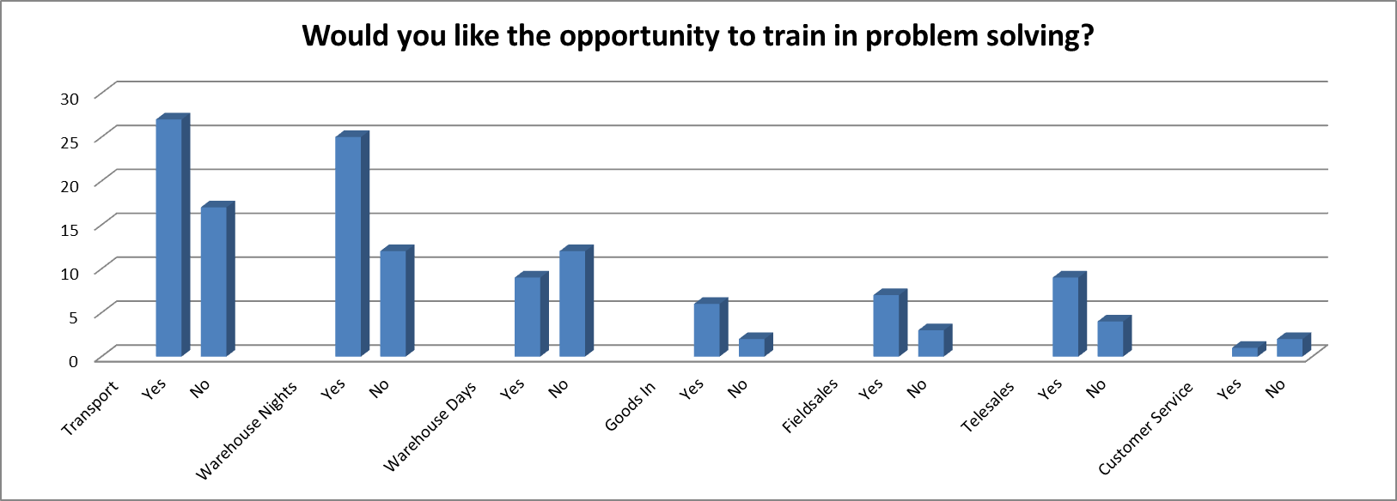

The only departments that were not within the majority favor were Warehouse Days and Customer Service however, there were employees from both departments that would like the opportunity to train.

Question 14 was designed to get employees thinking about improvements in communication, 29 responses were received. Key themes included noticeboards and meetings with employees from other departments, busting silos and allowing communication to flow through the business, moving away from information being contained within one department. The proposed model acts on impact of other departments through working groups to discuss and resolve problems collectively, each understanding and being able to articulate the impact a decision would have on their retrospective teams.

Finally the questionnaire asked if employees would like to form part of a depot improvement focus group and if so to state their name. 22 employees put their names forward, each department other than field sales and customer service showed direct interest in becoming involved.

- Conclusion of primary quantitative data

7 line managers including Warehouse Days, Warehouse Nights, Customer Service, Stock and PI, Transport, Telesales and Fieldsales were interviewed. The questions that were asked can be found in appendix 4.

Discussions regarding managers perceptions of their teams attitudes to change highlighted that if the reasons for change are communicated and understood by employees then the consensus seemed to be that their teams acceptance towards change was positive which coincides with the questionnaire results.

The Warehouse Days Manager stated “a number of my shift (old contract) do not/will not like any form of change and will push back negatively”. This is confirmed in the findings of the questionnaire results where the highest % of change novices were present.

All managers were questioned around their experience of acting upon improvement ideas generated from their teams. The objective of this was to ascertain whether or not the 11% of employees stating “what’s the point” when responding to question 5 was down to prior improvement ideas not being responded to by line managers.

The general response which was tested through the questioning of past examples showed that mostly any ideas produced were given feedback however, one response stated “I try my best but depends what’s going on as my day tends to be full of resolving issues”. This suggests a relation to the point made by Murphy (2018) where managers essentially get trapped on the surface, solving one problem while creating several more. This response could be an occasional occurrence of all managers at Chepstow as Jussim, (2012) states that in an interview situation the human desire to try and answer questions positively can sometimes point away from actual reality.

Managers generally felt that they actively listened to their employees however, when questioned on barriers to communication the following responses were received; time constraints, customer issues, levels of understanding within the team and negative team members this highlighting some of the reasons why 67% of employees feel they are encouraged to communicate their ideas, but only 32% of them feel they are listened too.

When questioned around links between participation and engagement all managers had experienced positive behaviours from employees as a result of implementing one of their ideas. Manager comments when directly asked if there was a link were as follows; “definitely if you believe in an idea and totally engage, participation is easy because you believe in what is trying to be achieved”, “absolutely 100% there is a link. How would you expect people to be engaged without the participation of all stakeholders”.

Finally managers were questioned on their ability to remove credit from themselves and allow employees to receive credit should an idea be implemented. The results showed that there would be no barriers to this with all managers reacting positively to the question. All managers expressed positivity towards their employees becoming directly involved in improvement projects with the following responses; “I think that it’s a brilliant idea and when people own ideas they behave differently in a more positive way towards them”, “No problem at all, it could only be a good thing to increase productivity and sales”, “would welcome, can only benefit the department and the wider business”, “very positive, staff involvement is key”.

- Conclusions

Based on the outcomes of both quantitative and qualitative research, evidence suggests that Chepstow’s operational employees’ current acceptance levels to change would act in favor to implement the model to create a culture of continuous improvement, increased employee engagement and increased employee retention.

The model will allow for improvements in communication through the Service Excellence Ambassador role as outlined in the project initiation document acting as a correspondent to their retrospective teams and enabling discussions on improvements to take place within their day jobs in a position of trust and equality with colleagues.

Through clear process the model will generate a regulated avenue for feedback to be issued in a structured way to all employee generated ideas. Each idea to be reviewed against set criteria in line with operational requirement and wider business initiatives such as the operational efficiency programme. This process will ensure employees are responded to regardless of time constraints and managers firefighting everyday tasks.

The results show that employee desire to become actively involved in continuous improvement projects is set at 69%, with an interest in the increased awareness of such projects set at 75%. Management experience in employee behaviours following implementation of ideas along with the questionnaire results of employees feeling increased engagement set at 80% demonstrates Evans and Lindsay (2016) view that the key factor that impacts employee engagement is involvement.

In essence the evidence suggests that a 12 month trial of the model will increase process and service improvement, employee engagement, retention and in turn potentially customer satisfaction as a result of service improvements while creating a communication channel for interdepartmental discussion and development of ideas to find the best solution to any given problem or idea.

- Recommendations for Model Implementation

  - Develop a communication plan to include briefings and handouts for project launch
  - Develop a project time line (initial Gantt chart appendix 5)
  - To secure on site NVQ Level 2 training in Business Improvement techniques for 7 Service Excellence Ambassadors, 1 from each department.
  - To secure on site NVQ Level 5 training in Service Improvement for 4 key Line Managers.
  - Develop the Service Excellence Ambassador Job Description (appendix 6)
  - Develop the Service Excellence Ambassador Advert (appendix 7)
  - Purchase 3 panel 6 foot project boards for each department
  - Section 1 panel of the project boards for new employee ideas
  - Create idea/feedback cards to be added to the project boards for all employees to use
  - Plan for monthly project development meetings in advance, planning cover for Ambassadors to attend.
  - Plan for monthly senior team update meetings on improvement projects.
  - Allow access to computers for the development of individual idea progress charts, process flows and improvement tracking
  - Plan in quarterly reviews of the model and its progress
  - Review engagement levels in a comparison of 2018 and 2019 annual employee survey results

Risks
- Managers and employees must communicate expectations on a regular basis. Failure to keep communication lines open may result in decisions being made without full understanding of impact.
- Employees must work together to monitor, initiate and promote small improvements on processes and service standards. Changing everything at once can cause misunderstanding and frustration. Managers authorising improvement projects must make one change at a time making sure it sticks before making another.
- Managers need to empower employees and allow them to explore. Employees must be able to experiment with ideas, trial runs, to try and test ideas within agreed parameters. The process of innovation is flawed and has moments of imperfection.

References

- Arnheiter, E.D. and greenland, J.E., 2008. Looking for root cause: a comparative analysis. TQM Journal, 20(1), pp. 18-30.

- Carpenter, J (2018) ‘company profile BFS Group Limited’ Marketline. Available at http://advantage.marketline.com.ezproxy.uwtsd.ac.uk/Product?ptype=Companies&pid=AE35C0B0-3B5B-44D7-8BB2-C5DD6A456F12 accessed 05/05/2018

- Creswell, J. and Plano Clark, V. (2007) Designing and Conducting Mixed Methods Research, Sage, Thousand Oaks.

- Evans, J. and Lindsay, W. (2016). Managing for quality and performance excellence. Managing tor Quality and Performance Excellence, eighth edition, South-western Cengage Learning

- Farace, R.V., Monge, P.R. and Russell, H.M. (1977), Communicating and Organizing, Addison-Wesley, Reading, MA, p. 281.

- Jussim, L. (2012). Social perception and social reality. New York: Oxford University Press.

- Kruse, K. (2012, 6 22). What Is Employee Engagement. Retrieved from Forbes: http://www.forbes.com/sites/kevinkruse/2012/06/22/employee-engagement-what-andwhy/

- Latham, B.W., Seijts, G.H. and Tasa, K. (2004), "Goal setting and goal orientation: an integration of two different yet related literatures", Academy of Management Journal, Vol. 47 No. 2, pp. 227-239.

- Lavrakas, P. (2008). Encyclopedia of Survey Research Methods - Volume 1. London [etc.]: Sage Publications.

- Liker, J. K. (2004). The Toyota Way. New York: the McGraw-Hill companies.

- MacDuffie, J. P. (1995). Worker's Roles in Lean Production. In S. Babson, Lean Work (pp. 54-69). Detroit: Wayne State Univesity Press.

- Meyer, J.P. and Allen, N.J. (1991), "A three-component conceptualization of organizational commitment", Human Resource Management Review, Vol. 1 No. 1, pp. 61-89.

- Miller, J., 2014. What's So Hard About Engaging People in Improving Their Workplace? The Journal for Quality and Participation, 37(2), pp. 10-14.

- Molloy and Noe, 2010. J.C. Molloy, R.A. Noe “Learning” a living: Continuous learning for survival in today's talent market S.W.J. Kozlowski, E. Salas (Eds.), Learning, Training, and Development in Organizations, Routledge, New York, NY (2010), pp. 333-361

- Mooi, E. and Sarstedt, M. (2011). A Concise Guide to Market Research. Berlin, Heidelberg: Springer-Verlag Berlin Heidelberg.

- Murphy, J. (2018). The Root Cause of All Problems: Identify your Continuous Improvement 5 'Whys'. [online] Insights.btoes.com. Available at: http://insights.btoes.com/article/the-five-whys-root-cause-of-continuous-improvement-problems [Accessed 5 May 2018].

- Niglas, K. (2004) The Combined Use of Qualitative and Quantitative Methods in Educational Research, Tallinn Pedagogical University Press, Tallinn.

- Ohno, T. (1988), Toyota Production System; Beyond Large-scale Production, Productivity Press, Cambridge, MA, p. 3

- Plano Clark, V.L. (2005) Cross-disciplinary Analysis of the Use of Mixed Methods in Physics Education Research, Counseling Psychology, and Primary Care. Doctoral dissertation, University of Nebraska-Lincoln.

- Pulakos et al., 2000. E.D. Pulakos, S. Arad, M.A. Donovan, K.E. Plamondon, Adaptability in the workplace: Development of a taxonomy of adaptive performance, Journal of Applied Psychology, 85 (2000), pp. 612-624

- Simply Psychology. (2018). Maslow's Hierarchy of Needs. [online] Available at: https://www.simplypsychology.org/maslow.html [Accessed 5 May 2018].

- Smith, P.C., Kendall, L.M. and Hulin, C.L. (1969), The Measurement of Satisfaction in Work and Retirement, Rand McNally, Chicago, IL.

- Wagner, J.A. (1994), "Participation's effects on performance and staisfaction: a reconsideration of research evidence", The Academy of Management Review, Vol. 19 No. 2, pp. 312-330

- Wheatley, M., 2006. it never ends. PM Network, 20(12), pp. 34-41.

- Work.chron.com. (2018). How to Work in a Fast-Paced Environment as a Manager. [online] Available at: http://work.chron.com/work-fastpaced-environment-manager-6023.html [Accessed 5 May 2018].

- Xu, J., & Thomas, H. C. (2011). How can leaders achieve high employee engagement? Leadership & Organisational Development Journal , 32(4), 399-416.

Appendix 1
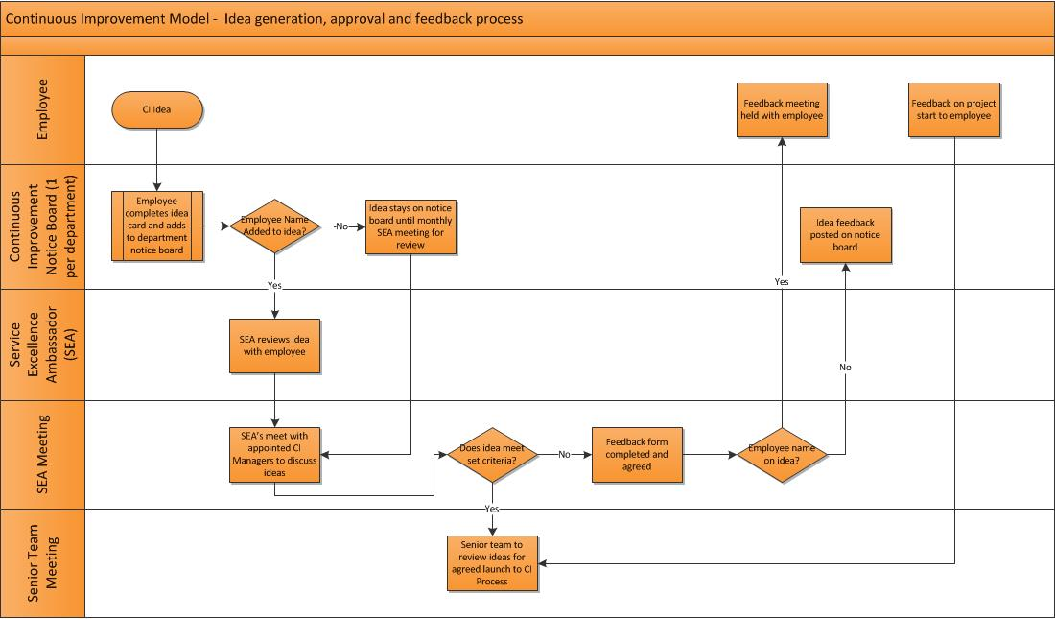
Appendix 2

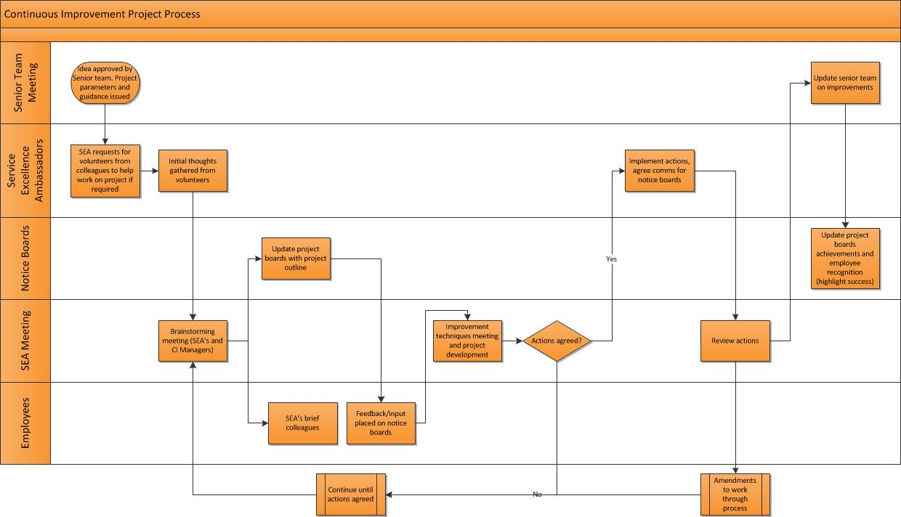

Appendix 3

Appendix 4

Interview Questions for first line managers – clarity of quantitative research
Department -
- Tell me about your teams perception and actions towards change.
- Give me an example of when one of your team has approached you with an improvement idea?
- How did you act on that idea?
- Have there ever been times when you have not issued feedback on an improvement idea?
- What were the reasons?
- Talk to me about giving credit for ideas to employees, how do you feel about removing the credit from yourself as the department manager?
- Give me an example of when you have implemented an employee’s improvement idea.
- How did they feel when it was implemented?
- What behaviours did you witness?
- Talk to me about the relationship between participation and engagement, do you think there is a link?
- How do you actively encourage employees to come forward with improvement ideas?
- How do you communicate to employees?
- What barriers are in the way?
- How well would you say you listen to employees feedback?
- Give me an example of a time where you have actively listened and taken action
- How would you feel about your employees working directly on improvement projects?

Appendix 5

Appendix 6



Job description
Job title: Service Excellence Ambassador
Division/depot: Chepstow
Reports to (job title): Line manager (In depot)
Number of subordinates: 0 |  | Job titles: n/a
Peer group: |  | Job titles:
Job purpose/business benefit of role
The Service Excellence Ambassador role is to provide expertise in the continuous improvement projects working with all departments to find the root cause and develop action plans to address and implement.

This role will have a significant impact on the success of the project but is not limited to the project timeline. This will be an ongoing role that will shape the future of continuous improvement and Service Excellence within Bidfood.

There will be one role per department to manage communication to their teams and meet with other department Service Excellence Ambassadors to build a culture of continuous improvement. Service Excellence Ambassadors will be given on-site training, to equip them for this key role.

This responsibilities of the Service Excellence Ambassador are carried out in addition to their current role.
Accountabilities – may include, but not limited to:
1 | Communication  - Updating project boards  - Communicating project updates with team members  - Collating feedback from colleagues  - Collating Ideas for improvements and giving feedback  - Update Project Manager on progress of project work
2 | Receive training  - Participate in NVQ Level 2 in Business Improvement Techniques
3 | Project work  - Complete project work where required, seeking advice from project Manager  - Attend project meetings monthly
4 | Health and safety accountabilities:  - Comply with the Company Health & Safety Policy.  - Support the BS OHSAS 18001:2007 accreditation process.  - Comply with all verbal and written instructions in matters pertaining to Health & Safety.  - Attend Health & Safety training courses as per instructions from line managers.

Measures & Key Performance Indicators

During Project
- Successful completion of project work
- Quality of feedback to project team on progression
- Ability to recognise and escalate problems in a timely way
- Feedback from colleagues on project progress
- Results of efficiencies

Budgets/people (Summarise any responsibilities in terms of figures)
1. Financial (e.g. costs/orders/sales/revenue budgets):
Capital: Revenue:
2. People (e.g. staff managed – direct and indirect
Employees (total): split into Direct: / Indirect:
3. Other relevant statistics/details (e.g. projects managed/payroll costs):
4. Internal Contacts: Bidvest Direct Project Team (duration of project); E-Commerce Team (post project)
5. External Contacts: All customers that trade with the Depot
Jobholder requirements (Knowledge, skills and key behaviours)
Requirements for qualifications, specialist knowledge, skills or key behaviours the jobholder will need to demonstrate to do the job effectively.
- Good IT skills
- Understanding of continuous improvement
- An ability to share knowledge, listen, and show patience
- Understands that people react differently to change; one size doesn’t fit all.
- Enthusiastic and positive attitude, approachable
- Attention to detail - someone who will take care in looking/checking and recording results
- Works effectively with others and encourages involvement
- Has good business knowledge
- Confident with managers and in front of colleagues
- Someone who has knowledge of the way things work now but is prepared to accept change
- Someone not afraid to escalate problems

Behaviour requirements
Care  Take pride in what you do, no matter what you do
  - Caring about our customers and colleagues
  - Being accountable and taking ownership to find great solutions
  - Having passion for what you do and who you do it for
  - Caring about the details
Share  Work together to make great things happen
  - Keeping customers and colleagues informed and connected
  - Involving the right people at the right time
  - Collaborating across teams to achieve the same goals
  - Being ‘joined up’ in your approach
Dare  Take brave steps to achieve extraordinary results
  - Making bold decisions
  - Challenging the status quo and having conviction in what you know is right for the business
  - Being innovative and proactive in how you approach things
  - Not being afraid to invest time in things that add value

Appendix 7
Service Excellence Ambassador

Job Title: Service Excellence Ambassador | Ref:
Department: Current | Hours: As required
Division/Location: Chepstow Depot
Reporting to: Line Manager
Benefits: As per current position
We are looking for Service Excellence Ambassadors to train in continuous improvement techniques. Your new skills will provide expertise in continuous improvement projects working with all departments to improve processes, service and standards.

Service Excellence Ambassadors will have a significant impact on the success of improvement projects, focusing on finding the root cause of problems and developing action plans to address and implement. This will be an ongoing role that will shape the future of continuous improvement and Service Excellence within Chepstow.

We are looking for 1 Service Excellence Ambassador per department to manage the end to end communication process of improvement projects to their teams along with taking ownership of ideas and implementation.

Key responsibilities will include:

- Participation in NVQ Level 2 in Business Improvement Techniques
- Updating project boards
- Communicating project updates with team members
- Collating feedback from colleagues
- Collating ideas for improvements and giving feedback
- Update Project Manager on progress of project work
- Complete project work where required, seeking advice from project Manager
- Attend project meetings monthly

The responsibilities of the Service Excellence Ambassador are carried out in addition to your current role. You will be granted time away from your role on a monthly basis to work on improvement projects, attend meetings and communicate with your teams. Time given off the job will be dependent on project type and demand.

If you looking to expand your knowledge base, become involved in wider business initiatives, work alongside the management team actively inputting your ideas and ideas on behalf of your team then we would like to hear from you.

The additional responsibility will be a development opportunity, there will be no financial incentive attached.

To apply, please complete a letter outlining your reasons for applying and send to James Brunnock, Warehouse Manager
Email: jamesbrunnock@bidfood.co.uk
Closing Date: | 11/05/2018

