Name: Paul Richards

Student No: 0251968

Course: Applied Computer Networks and Cybersecurity

Module: Information Engineering
(ACCB4013)

Date:17/07/2020

Contents

Entity Relationship Diagram 3
Relationships: 4
Tables, primary and foreign keys 4
Customer Details Table 4
Customer Orders Table 5
Receipt Table 5
Book Details Table 6
Publisher Table 7
Book Dealer Table 7
Stock Table 8
Order Table 8
SQL INSERT STATEMENTS 8

Database Design 9
Forms 9
Main Form 9
Table Forms 10
Book Details Form 10
Book Dealer Form 11
Customer Details Form 11
Customer Order Form 12
Order Form 12
Publisher Form 13
Receipt Form 13
Stock Form 14
Query Forms 14
Customer Orders Query Form 14
Stock Query Form 16
Quick Book lookup 17

User Guide 18
Searching for records in a table 19
Navigating through a table 20
Adding a record in a table 21
Deleting a record in a table 22
Searching for records using a query 23

Entity Relationship Diagram

The entity relationship diagram provides an overview of the database design for the city book store. The entity relationship diagram contains the following:

- The relationships between the tables.

- The tables.

- The primary and foreign keys of the tables.

Relationships:

- A customer makes an order.

- Order depends on payment.

- Depending on stock. If the book is in stock, the store sells it immediately. If the book is not in stock, the store orders the book from the publisher or book dealer.

- If the book is a best seller, they contact the publisher to order the book.

- If the book is a collectable, they contact the book dealer to order the book.

Tables, primary and foreign keys

I have created the following eight tables for the City Book Store.

Customer Details Table

The customer details table will hold the customer’s name and contact details. The information in the table will be used to deliver books to customers who use the mail order service. The information will also be used, to post newsletters about what books are for sale. The table will contain a newsletter field to inform the user which customers have requested a newsletter.

Each customer will have a unique Customer ID. The primary key will be the Customer ID field.

The sql for the customer details table is below:
Create table CustomerDetails
(Customer_ID varchar(15) constraint Customer_ID_pk Primary Key,
Customer_name Text(50),
Address varchar(50),
Town Text(50),
City Text(50),
County Text(50),
Postcode varchar(50),
Country Text(50),
Telephone varchar(50),
Email Address varchar(50),
Newsletter Text(50));

Customer Orders Table

The Customer Orders table will contain the orders for a customer. Each order will have a unique order number. The primary key will be the customer order ID field. The customer orders table will have the following links or foreign keys to other tables:

Customer Details – a foreign key has been set up on the customer ID field to link the customer to the order.

Orders – a foreign key has been setup on the order ID field to link the order to the store orders.

Book details table – a foreign key has been set up on the title field to link the book to the order.

Receipt table – a foreign key has been set up on the payment code field, to link the order to the customer’s payment and receipt.

The sql for the customer orders table is below:
CREATE TABLE CustomerOrders
(
Order_ID Text(15) constraint publisher_ID_pk Primary Key,
Customer_ID Text(50),
Title Text(50),
Quantity_Ordered Text (50),
Payment_Code Text(15),
Delivery_Status Text(15),
Delivery_Date Date,
CONSTRAINT customerbkt_fk FOREIGN KEY (Title) REFERENCES Book_Details (Title),
CONSTRAINT customerpay_fk FOREIGN KEY (Payment_Code) REFERENCES Receipt (Payment_Code),
CONSTRAINT customerid_fk FOREIGN KEY (Customer_ID) REFERENCES CustomerDetails (Customer_ID),
CONSTRAINT customerord_fk FOREIGN KEY (Order_ID) References Order (Order_ID));

Receipt Table

The Receipt table will record all card purchases made by the customer and provide proof of purchase. Each card purchase will have a unique payment code. The primary key will be the payment code field.

The sql for the receipt table is below:
Create Table Receipt
(Payment_Code varchar(15) constraint payment_code_pk Primary Key,
Card_Type Text(10),
Card_Number varchar(50),
Security_Code varchar(50),
Expiry_Date Date);

Book Details Table

The book details table contains what books are for sale. Each book has a unique title and the title of the book will be used to identify each book. The primary key will be the title field. The book details table will have the following links or foreign keys to other tables:

Stock Table – a foreign key has been setup on stock ID field, to link the stock levels to the book.

Publisher Table – a foreign key has setup to the publisher ID field, to link the publisher to the book.

Book Dealer Table – a foreign key has been setup on book dealer ID field, to link the book dealer to the book.

The sql for the book details table is below:
CREATE TABLE Book_Details(
Title TEXT(50) CONSTRAINT title_pk PRIMARY KEY,
ISBN TEXT(50),
Author Text(50),
Edition Text(50),
Year Text(50),
Condition Text (50),
Price Text(50),
Stock_ID Text (50),
Publisher_ID TEXT(50),
Book_Dealer_ID TEXT(50),
CONSTRAINT stock_fk FOREIGN KEY (Stock_ID) REFERENCES Stock (Stock_ID),
CONSTRAINT pub_fk FOREIGN KEY (Publisher_ID) REFERENCES Publisher (Publisher_ID),
CONSTRAINT bd_fk FOREIGN KEY (Book_Dealer_ID) REFERENCES Book_Dealer (Book_Dealer_ID));

Publisher Table

The Publisher table will contain the contact details of a publisher. If they run out of copies of a best seller, they can look up the publisher who produces the book. Each Publisher will have a unique ID. The primary key will be the publisher ID field.

The sql for the publisher table is below:
Create Table Publisher
(Publisher_ID Text(15) constraint publisher_ID_pk Primary Key,
Publisher Text(50),
Address Text(50),
EmailAddress Text(50),
Telephone Text(50));

Book Dealer Table

The Book Dealer table contains the details of the book dealers. If they run out of copies of a collectable book, they can look up the book dealers details to order more books. Each Book Dealer will have a unique ID. The primary key will be the book dealer ID field.

The sql for the book dealer table is below:
Create Table Book_Dealer
(Book_Dealer_ID Text(15) constraint Book_Dealer_ID_pk Primary Key,
Book_Dealer Text(50),
Address Text(50),
EmailAddress Varchar(50),
Telephone Varchar(50));

Stock Table

The Stock Table, will be used to monitor stock levels. Each book will have a unique stock ID to monitor stock levels of a book. The primary key will be the stock ID field. A foreign key has been set on the book title field, to link the stock levels with the book.

The sql for the stock table is below:

Create Table Stock
(Stock_ID Text(15) constraint publisher_ID_pk Primary Key,
Title varchar(50),
Quantity varchar(50),
CONSTRAINT stbooktitle_fk FOREIGN KEY (Title) REFERENCES Book_Details (Title));

Order Table

The Order table contains all orders from both staff and customers. The primary key will be the order ID field. A foreign key has been set on the title field, to link the order to the book.

The sql for the order table is below
Create Table Order
(Order_ID Text(15) constraint Order_ID_pk Primary Key,
Title Text(50),
Purchase_Order_No varchar(50),
Delievery_Status TEXT(50),
Delivery_Date Date,
CONSTRAINT booktitle_fk FOREIGN KEY (Title) REFERENCES Book_Details (Title));

SQL INSERT STATEMENTS

I have created 3 insert statements for inserting records via sql in a table.

Below is the sql for the 3 tables:

Insert statement for CustomerDetails Table
INSERT INTO CustomerDetails ( Customer_ID, Customer_name, Address, Town, County, Postcode, Country, EmailAddress, Telephone, Newsletter )
VALUES ('CUST001', 'Bob', '12 Old Road', 'Port Talbot', 'Neath Port Talbot', 'SA122SN', 'United Kingdom', 'bob@gmail.co.uk', 01792772244, 'Yes');

Insert statement for Receipt table
INSERT INTO Receipt ( Payment_Code, Card_Type, Card_Number, Security_Code, Expiry_Date )
VALUES ('PAY001', 'VISA', '4539824178862954', 311, '22/2022');

Insert statement for Publisher table
INSERT INTO Publisher ( Publisher_ID, Publisher, Address, EmailAddress, Telephone )
VALUES ('PUB001', 'Penguin Books', '12 New Road', 'contactus@penguin.co.uk', 01792772244);

Database Design

Forms

There is one main form called Book System. On the main form there are eleven buttons. Eight out of eleven buttons open forms linked to tables. Three of the buttons open forms linked to queries.

Main Form

Screenshot of the main form is below:

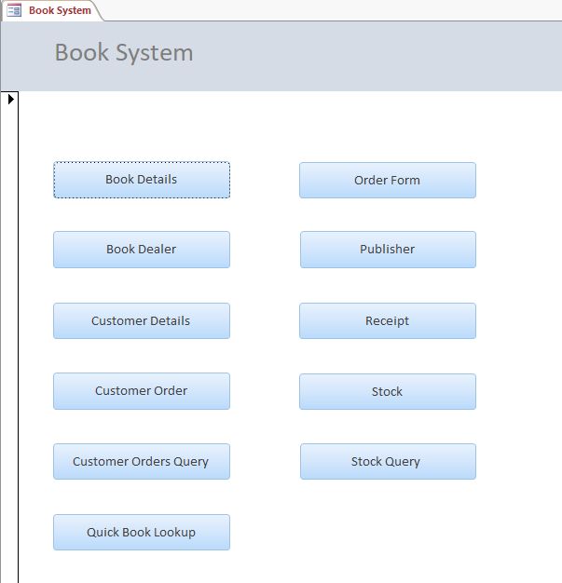

Table Forms

Screenshots of the table forms are shown below.

Book Details Form

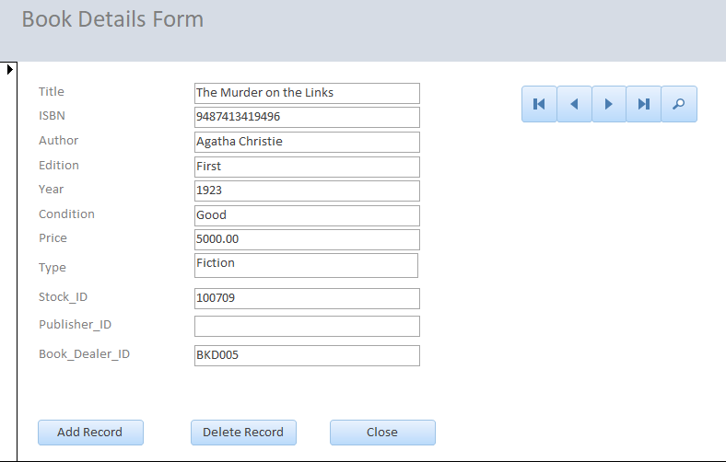

Book Dealer Form

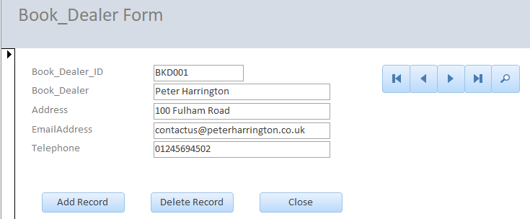

Customer Details Form

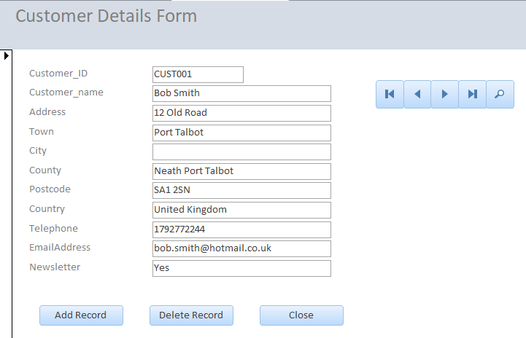

Customer Order Form

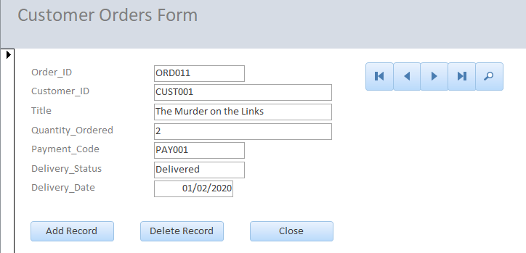

Order Form

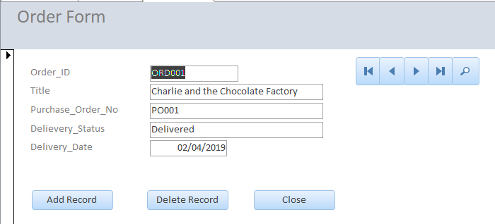

Publisher Form

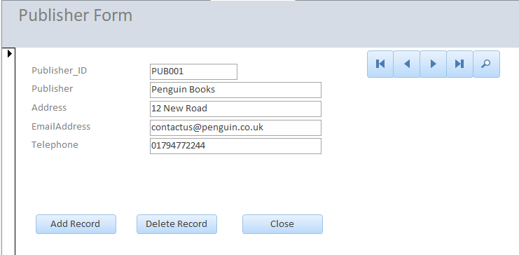

Receipt Form

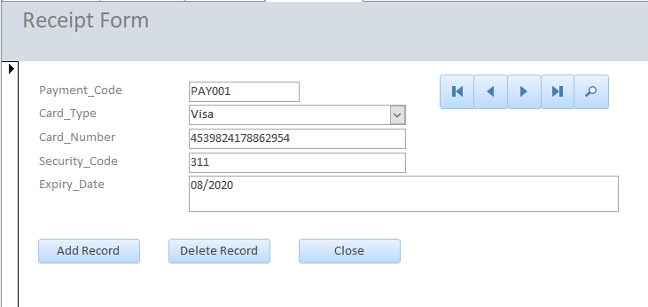

Stock Form

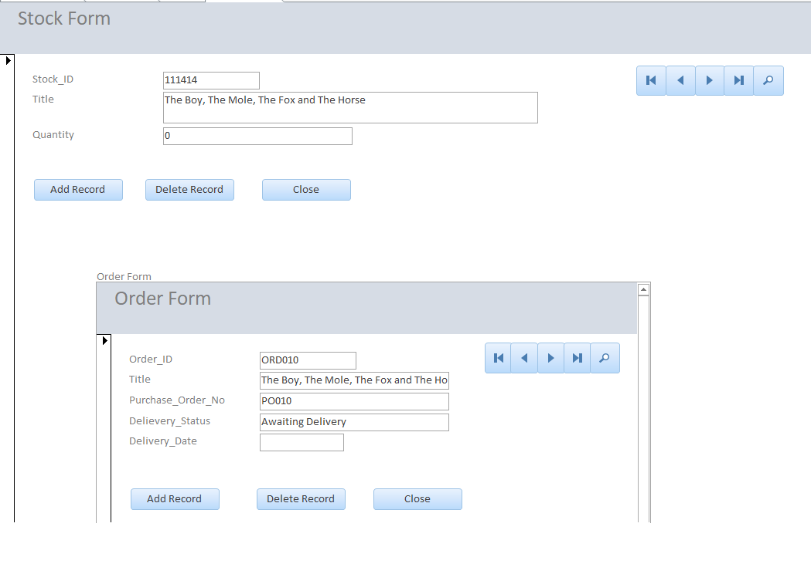
The stock order form also contains the orders form which matches each stock item to an order.

Query Forms

Below are screenshots of the query forms and the output of their queries

Customer Orders Query Form

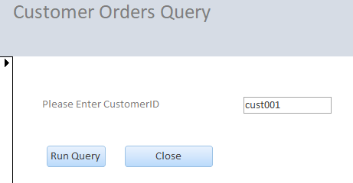

The customer orders query is linked to the customer details table, the orders table and the book details table.

The run query button runs the customer orders macro that produces the output of the query in a form of a report and table. Below are screenshots of the output of the report and table.

Report
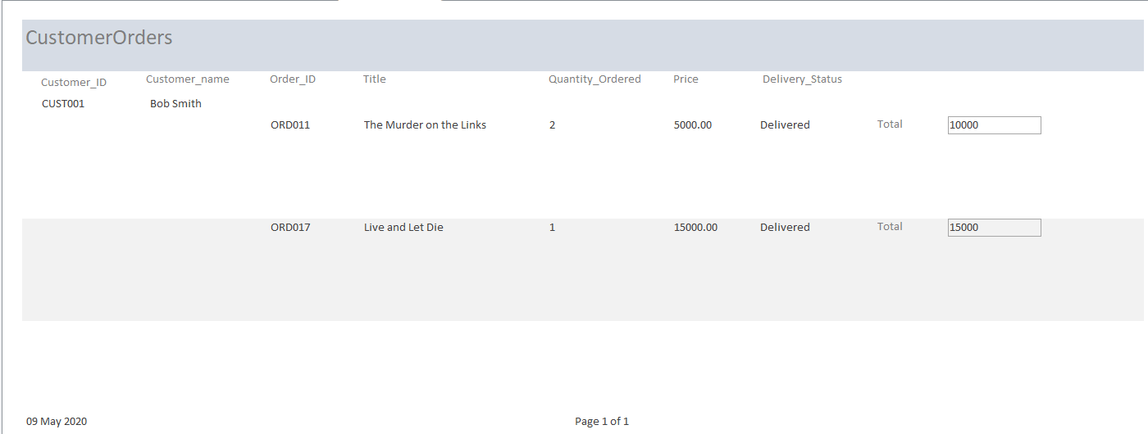

Table

Stock Query Form

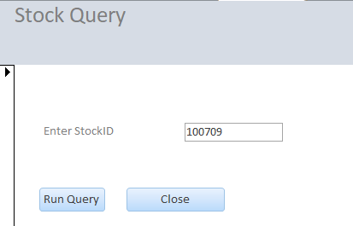

The stock query is linked to the stock table and to the book details table.

The run query button runs the stock order macro that produces the output of the query in a form of a report and table. Below are screenshots of the output of the report and table.

Report
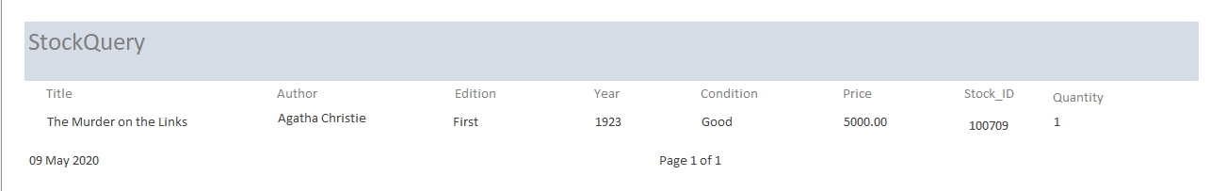

Table

Quick Book lookup

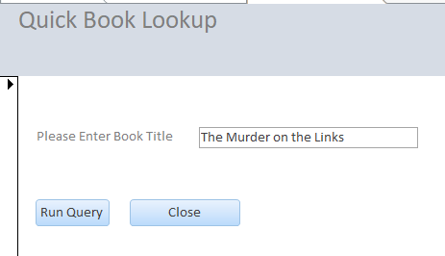

The Quick book lookup is linked to the book details table.

The run query button runs the booklookupmacro which produces the output of the query in a form of a report and table. Below are screenshots of the output of the report and table.

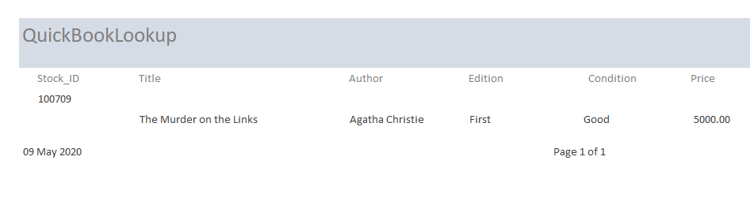

User Guide

When the user launches the system, they will be presented with a main form called book system. From the main form they can access tables and queries by clicking on a button, see screenshot below. Each button leads to another form which is linked to a table or query.

Screen clipping taken: 07/05/2020 17:07

Searching for records in a table

If a user wants to search for a record in a table, they click on the relevant button for the table and perform the search in the form. E.g. If a customer contacts the user asking if their address can be updated. The user enters the customer details form by clicking on the customer details button. The form will show the first record in the table, as shown in the screenshot below.

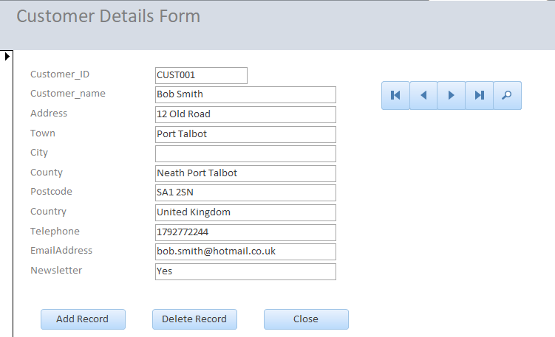

In order to search for a record, the user needs to click on the magnifying class icon on the left, as shown in the screenshot below.



Then in the ‘find what’ drop down box, the user enters the customer ID e.g. CUST004, and clicks on the find next button, as shown in the screenshot below.

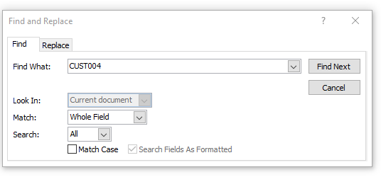
The user will be presented with the customer’s record, as shown in the screenshot below.

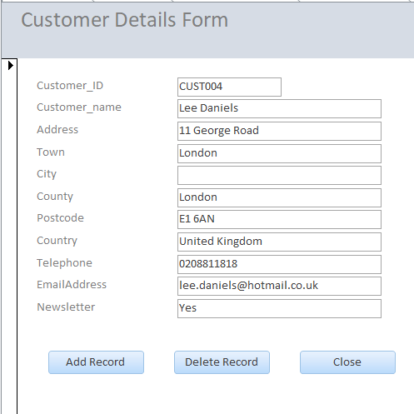

Navigating through a table

If the user wishes to navigate through the records, they have four buttons to choose from which are positioned on the left hand side of the form.

The arrow button pointing right, as shown below, allows you to move forward one record.



The arrow button pointing left, as shown below, allows you to move back one record.



If the user wants to go to the last record, they click on the button pointing right with a vertical line, as shown in the screenshot below.



If the user wants to go to the first record, they click on the on the button pointing left with a vertical line as shown in the screenshot below.



If the user wishes to return to the main menu or form, they click on the close button.



Adding a record in a table

If the user wants to add a record, they click on the add record, as shown below.



The button, will take them to a blank form screen where the user can add the details of customer.

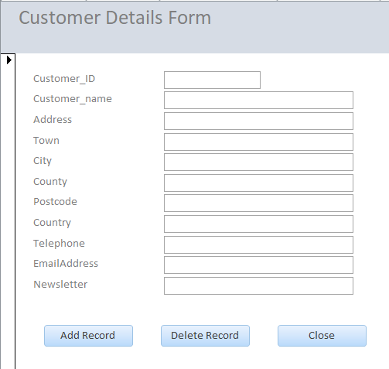

Once you fill in the details of the form, click add record button. The record will be added to the table and a blank form screen will appear again to add another record.

Deleting a record in a table

If you wish to remove the record, go to the record you wish to remove, click on the delete button as shown in the screenshot below.



It will ask you if you are sure about deleting the record, click on yes to delete the record, as shown in the screenshot below.

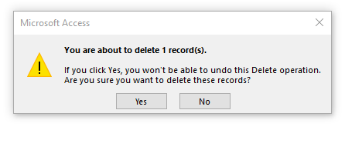

Searching for records using a query

If a user wants to carry out a search using a query, they click on the relevant query and perform a search. For example, if a user needs to perform a customer order search, they click on the customer orders query, they will be presented with the following screen.

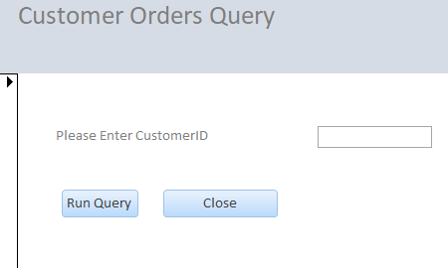

They enter the customer ID and click on the run query button below, as shown in the screenshot below.

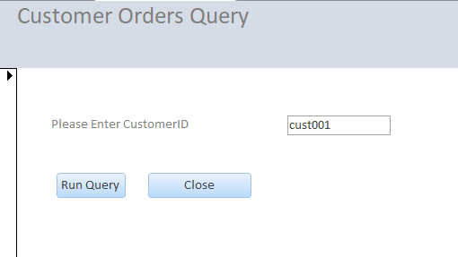

The query will produce the output of the query in the form of a report and table, as shown below.

In the customer order report it will perform a calculation and provide a total for each item, based on quantity ordered and price, as shown in the report above.

