-Management Economics-
Assessment Component 1
Student: Alexandru Csaba Eros

Table of Contents

Introduction ………………………………………3

Discussion………………………………………….3

Conclusion…………………………………………8

References……………………………………9-10

Introduction
Organisations need to adopt using an efficient marketing structure for being able to run the business properly and address the requirements for the benefit of the bdusiness. Furthermore, an effective structure of the market can help the organisations to effectively decide the outcome of the business while ensuring effective decisions are taken for being able to handle the economic factors. In the opinion of Lábaj et al. (2018), the structure of the market effectively influences the needs of the business while making the organisation attain benefits like enhanced rate of efficiency, creativity and productivity in the long run. Therefore, this study intends to present the evaluation and discussion of the possible market structure that is being adopted by the businesses, alongside the impact that is laid of these structures on the decision of the managers of the business.
Discussion
Evaluation and discussion of the possible market structure
Various structures of the market are effectively causing the business to run effectively or to follow a guided approach of running the business. These approaches effectively assist in deciding the results of the business operation and the effective ways, the perks of the business can be enhanced. In the words of Arnett et al. (2021), the structure of the market can effectively assist in shaping the decision of the business leaders while running the business and effectively result in attaining the result as per the business operational activities. On the other hand, the structure of the market further helps in attaining an understanding of the allowances that are availed and distributed by the business professionals for the benefit of the organisation, alongside the relationships of the stakeholders of the business. It is also said that the market structure effectively assists in identifying the relationships of the business personnel and the associated workforce that manages the chain of supply, distribution of products and the reach of the consumers for being able to determine the success of the organisation (Sun et al., 2017).
Furthermore, the determination of the structure of the market is based and dependent upon the size of the market, the number of companies offering the same services and products, alongside the demand of the customers for availing the goods and services. It is furthermore being stated that the structure of the market effectively assists in determining and establishing the relationship between the business and customers. This is being done by evaluating the quality of the product and effectively assessing the owners of the organisations that run the business in the market in terms of making a purchase and selling the products (Fu et al., 2021). Therefore, the structure of the market is categorised as perfect competition, duopoly monopoly and oligopoly. The discussion of specified structures of the market are presented here as:

Pure Competition market structure

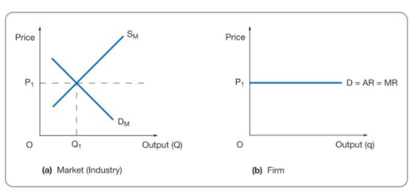(
Griffiths, & Wall, S. (2011). Economics for business and management (Third edition.). Pearson Education Limited.)
The determination of the pure competition structure of the market is being done by assessing the competition of various small and same organisations in the market segment. On the other hand, a major organisation would lack the ability to have an effective marketing power, when the industry produces a standard level of production, as organisations might lack the interest and capability to influence market prices. The demand and supply of the materials and services determine the number of goods and services that are needed to be produced, as well as the market prices set by the organisations in the market segment. It can also be stated that the products that are being produced are equal to that of the size of the market for being able to meet the customer needs (Nendissa et al., 2018). Therefore, there are various challenges to the process of entry and exit of products in the market. It is required for the various organisations to follow different market structures and strategies as per the need in pursuit of running the business efficiently. It can be furthermore that the structure and the completion in the market are almost negligible compared to the other structures and therefore, removes the pressure of maintaining the market competition (oecd, 2018).
It can be furthermore stated that the marketing structure of pure competition is a concept that follows the theories and effectively relates with similar characteristics while making sure an effective guide is provided for being able to take care of the market competition for other marketing sectors. In a competitive marketing structure, the same types of products are sold, which is not the case in terms of a retailer offering a different or better product than another retailer. It is required for the pure competition structure of marketing to follow the strategy of incorporating one pricing and therefore it is very usual for retailers to have been using the same structure of pricing (LAI and REQUATE, 2020). This approach of marketing structure effectively allows the entry of the new organisations in the market while allowing them with an opportunity to run the business efficiently. The cost of the products is determined following the availability of materials and on customer payments. Competitive market structure is easily influenced by the forces of the market and only following the approach of budding competition cannot provide a proper ruining market structure. ‘Foreign Exchange Markets’ are the major examples that can describe the structure of pure competition, where traders exchange money.

Duopoly
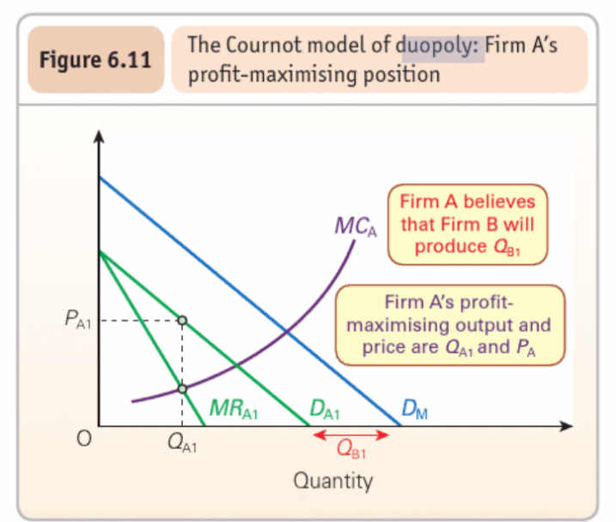
( Sloman, & Garratt, D. (2019). Essentials of economics (8th ed.). Pearson.)
This is the structure of the market that is being run by the major organisations of the market and is effectively responsible for being able to hold the major dynamics of the segmented market. In the opinion of Nioche et al. (2019), most organisations have the urge for being able to compete with the duopoly market structure and the major organisations associated with the process. In the duopoly market system, two competing manufacturers supply a large number of products, which leads to occupying the larger shares of the market and the sole provider of the customer needs. Organisations rely on actions and decisions that are being made strategically, and therefore, the businesses can have an impact while competing with large organisations. There are high levels of collaboration that support the reliance of the organisations on the factors like high profitability of the market. Furthermore, organisations are more likely to be highly competitive if parallel and assistive working is avoided for the sake of being the major consumer of profits (Aliaga, et al., 2020).
On the other hand, it can also be stated that the market leaders are always vigilant in the market to avoid the practices of anti-competition and therefore strict monitoring of the market leaders may conclude that there will be no cooperation while running the business in the segmented market. An effective strategy of segregation can ensure that the particular products can assist in serving and meeting the needs of the customers while making sure the necessary power to govern alone is also attained in the long run (Askar, 2020). For being able to describe the duopoly market structure, it can be stated that there are high barriers while entering the market that can arise due to the principles of the market segment (Zhou et al., 2020). This process further provides the major companies of the market to attain a larger share of profit as the market has been equally divided for being run by these two organisations. Therefore, the duopoly b strategy of the marketing structure is being effectively followed by the organisation for being able to attain benefits continuously. MasterCard and Visa are the major organisations of duopoly market structure, that is being followed in the financial market of credit and debit.

Monopoly
(Sloman, & Garratt, D. (2019). Essentials of economics (8th ed.). Pearson.)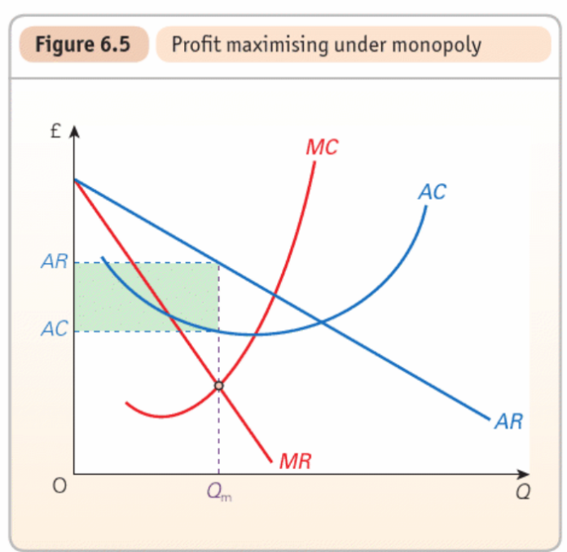
The monopoly structure of the market refers to the process that allows a business to sell products and deliver services with the uniqueness that results in reducing the competition while providing the company to attain benefits. As opined by Bhattacharya et al. (2020), providing different features of a product and services can allow the business to sustain itself in a competitive market and allows one to charge higher for being able to earn profits in the long run. Modification of the products and services for being able to add uniqueness includes items like style, name of the brand, location, promotional activities, packaging and various range of pricing strategies. Organisations provide efficient competition for the monopoly structure of the business and follow this different strategy of single marketing because consumers do not have a complete opinion of the products as there always remains the possibility of attaining an alternative approach (Sanchez-Cartas, 2020). It is further required for the business in a monopoly structure of work to promote the business activities continuously and use the creativity for being able to attract a larger base of customers. It is also important to effectively follow a proper strategy of pricing while ensuring an effective marketing platform usage that works efficiently as variation in the production of products can be seen. Some of the major examples that follow this process and the similar marketing structure are Google and Microsoft which competes with each other in the market of product and service-based IT (BBC, 2020).

Oligopoly
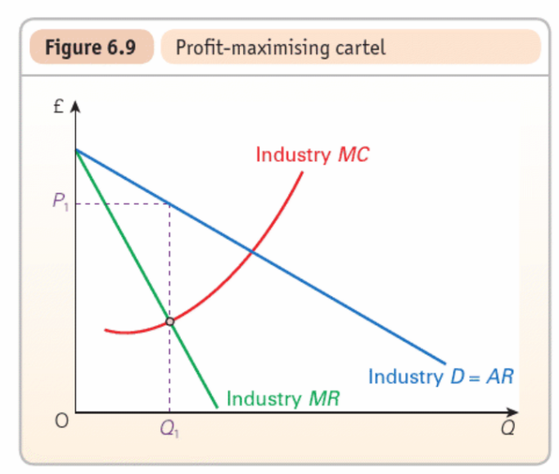(
( Sloman, & Garratt, D. (2019). Essentials of economics (8th ed.). Pearson).
In this structure of the market, the small business comprises the entire market and is effectively responsible for being able to determine the policies of pricing independently. Furthermore, in the oligopoly structure of the market, the number of business are limited, faces challenges while making an entry in the market as a fresh organisation and is mostly dependent on each other for running the business (Dhalla and Oliver, 2016). This structure of the market is effectively profitable for the existing organisations as challenges are created for the new entrants of the market in terms of availing licence and building the image of the brand for being able to run the business with efficiency. The information technology industry is one of the most suitable examples of the oligopoly market structure, where the organisations would for being able to attain customers for being able to sell their products and services. To be precise, Bitcoin can be termed as one of the core examples that naturally falls in the structure of oligopoly.
The effect of the market structure and the decision of the managers
It can be effectively stated that the selection of the market structure for being able to run the business lays a significant impact on the managers of the business in terms of making a decision. This is because each of the structures of the market is different and therefore, the organisations have to follow all the principles and possess the required qualities for being able to run the business (Yang et al., 2021). Therefore, the impact laid by the market structure on the decision of the managers is presented here as:
A monopoly market is a potential market that effectively provides the ruling opportunity of one organisation and therefore, the margins of profit are controlled in the market. The efficiency of the distribution of price is rooted in the structure of a monopoly market. Product manufacturers can reap the benefits of successful product distribution and marketing as they are the sole completion of the market. Organisations running the business in the monopoly structure of market structure can control the prices of the products that are to be manufactured alongside the delivery of services. Therefore, the managers in this structure would be able to decide on the quality and pricing of the product as per the information of the goods produced as per the demand (Bhaskar and Roketskiy, 2021). Therefore, this structure can effectively affect the decision of the managers of the business in terms of assuring the quality of the product and deciding the pricing range for the benefit of the company.
On the other hand, the Duopoly market structure means that two major organisations are operating the business in the entire share of the market. Therefore, it can be stated that the usage of the same production and pricing strategy is to be sued by the organisation, while the sale would be determined based on the preference of the customers and the image of the brand (Askar, Ibrahim and Elsadany, 2021). Therefore the manufacturers need to ensure the production of enough products for being able to deliver variety and options for the customers. Therefore it can be stated that the managers are needed to effectively make the right decisions in terms of price, quantity and quality of products while running the business efficiently.
In the case of the market structure of Oligopoly, a market structure is effectively characterized and comprised by the presence of various small scale organisations. Small organisations in this segmented market structure are responsible for producing the goods and selling them for being able to meet the customer needs. Therefore, an advantage is attained in the business that creates challenges for the businesses that are trying to make an entry in the market in terms of attaining proper permission, licence and adequate image of the brand that can help in sustaining the business (Arnosti and Weinberg, 2022). Therefore, the managers of the business in this particular structure may face challenges in terms of making decisions for the enhancement of the business activities and excelling further.
On the other hand, the pure competition market structure provides an opportunity to create an environment in the market without the domination of particular segments or organisations while allowing traders to trade equally. In the view of Dickson and Tonin (2021), the structure of pure competition in the market structure effectively helps to create a better environment for the business to run the operational activities efficiently and operate more to gain a larger profit base. Therefore, it can be effectively said that this market structure puts a positive impact on management and the decision-making process while running the business. This is said as this particular market structure forces the production process to be based upon the demands of the customers while undermining the ability of consumers and retailers (Zhang, 2021). Therefore, the managers of the business are laid an impact upon the decision-making ability and ensuring higher quality of products in the most economical pricing is needed to be considered for being able to run the business and sustain the organisation.

Conclusion
This study has aimed at presenting the evaluation and discussion of the possible market structure that is being adopted by the businesses. It has been found out that various structures of the market have various features and characteristics. The duopoly market structure effective states that two major organisations are responsible for effectively holding the major share of the market and running the business. On the other hand, the oligopoly structure of business rates that small scale businesses work and comprise the entire market while making the chances low for the new entrants to run the business. Furthermore, the impact that is laid of these structures on the decision of the managers of the business has also been discussed in the task that states that different structures create an opportunity for the managers to focus on the product, price and quality for being able to make the right decision and attract customers for being sustainable.

References
Griffiths, A. and Wall, S. (2011) Economics for business and management. Third edition. Harlow, England: Pearson Education Limited.
Sloman, J. and Garratt, D. (2019) Essentials of economics. 8th ed. Harlow: Pearson.
Marks, SG 2014, Managerial Economics, Wiley Textbooks, New York.
Keat, P.G., Young, P.K.Y. and Erfle, S.E. (2014) Managerial economics : economic tools for today’s decision makers. Seventh edition. Harlow, England: Pearson Education Limited.
Aliaga, W., Bhaya, A. and Kaszkurewicz, E. 2020. Dynamics of Duopoly Models with Undecided Clients under Decentralized Affine Feedback Advertising Policies. Complexity, 2020, pp.1–11.
Arnett, D.B., Dass, M. and Bhoumik, K. 2021. Re-examining market structures: Resource-Advantage theory and the market offering ecosystem perspective. Journal of Global Scholars of Marketing Science, 31(2), pp.189–199.
Arnosti, N. and Weinberg, S.M. 2022. Bitcoin: A Natural Oligopoly. Management Science.
Askar, S.S. 2020. A Dynamic Duopoly Model: When a Firm Shares the Market with Certain Profit. Mathematics, [online] 8(10), p.1826. Available at: https://www.mdpi.com/2227-7390/8/10/1826/htm [Accessed 25 Feb. 2022].
Askar, S.S., Ibrahim, A. and Elsadany, A.A. 2021. Dynamics of a Heterogeneous Constraint Profit Maximization Duopoly Model Based on an Isoelastic Demand. Complexity, 2021, pp.1–14.
BBC 2020. Google sued again over anti-competitive search practices. BBC News. [online] 18 Dec. Available at: https://www.bbc.com/news/business-55357340 [Accessed 25 Feb. 2022].
Bhaskar, V. and Roketskiy, N. 2021. Consumer privacy and serial monopoly. The RAND Journal of Economics.
Bhattacharya, A., Morgan, N.A. and Rego, L.L. 2020. Customer Satisfaction and Firm Profits in Monopolies: A Study of Utilities. Journal of Marketing Research, 58(1), pp.202–222.
Dhalla, R. and Oliver, C. 2016. Industry Identity in an Oligopolistic Market and Firms’ Responses to Institutional Pressures. Organization Studies, 34(12), pp.1803–1834.
Dickson, A. and Tonin, S. 2021. An introduction to perfect and imperfect competition via bilateral oligopoly. Journal of Economics.
Fu, H., Huang, C., Teng, Z. and Fang, Y. 2021. Market Structure, International Competitiveness, and Price Formation of Hainan’s Fruit Exports. Discrete Dynamics in Nature and Society, 2021, pp.1–13.
Lábaj, M., Morvay, K., Silanič, P., Weiss, C. and Yontcheva, B. 2018. Market structure and competition in transition: results from a spatial analysis. Applied Economics, 50(15), pp.1694–1715.
LAI, P. and REQUATE, T. 2020. DIVISION OF LABOR UNDER PERFECT COMPETITION. The Singapore Economic Review, pp.1–9.
Nendissa, D.R., Anindita, R., Hanani, N. and Muhaimin, A.W. 2018. DYNAMICS OF DEGREE OF BEEF CATTLE MARKET CONCENTRATION IN KUPANG OF EAST NUSA TENGGARA, INDONESIA. Russian Journal of Agricultural and Socio-Economic Sciences, 78(6), pp.379–384.
Nioche, A., Garcia, B., Boraud, T., Rougier, N. and Bourgeois-Gironde, S. 2019. Interaction effects between consumer information and firms’ decision rules in a duopoly: how cognitive features can impact market dynamics. Palgrave Communications, 5(1).
oecd 2018. DIRECTORATE FOR FINANCIAL AND ENTERPRISE AFFAIRS COMPETITION COMMITTEE Market Concentration. [online] Available at: https://one.oecd.org/document/DAF/COMP/WD(2018)46/en/pdf [Accessed 25 Feb. 2022].
Sanchez-Cartas, J.M. 2020. The Panzar–Rosse H Statistic and Monopoly. Issues on its Use as a Market Power Measure. The B.E. Journal of Economic Analysis & Policy, 0(0).
Sun, B., Jing, W., Zhao, X. and He, Y. 2017. Research on market power and market structure. International Journal of Crowd Science, 1(3), pp.210–222.
Yang, Y., Zhang, K. and Kannan, P.K. 2021. EXPRESS: Identifying Market Structure: A Deep Network Representation Learning of Social Engagement. Journal of Marketing, p.002224292110335.
Zhang, W.-B. 2021. Cournot-Nash Equilibrium and Perfect Competition in the Solow-Uzawa Growth Model. Revista CEA, 7(15), p.e1801.
Zhou, W., Zhou, J., Chu, T. and Li, H. 2020. A Dynamic Duopoly Cournot Model with R&D Efforts and Its Dynamic Behavior Analysis. Complexity, 2020, pp.1–19.

