Electrical & Electronic Engineering

Workshop – Non-inverting Amplifier
Changemakers
Rebecca Coles
2218001
Table of Contents
Abstract 2
Proteus 2
Workshop - Breadboard 3
Workshop - PCB 4

Abstract
In this assignment we were required to understand how to build and simulate on Proteus a non-inverting amplifier. Additionally, we were required to build the same circuit on a breadboard and on a PCB.
Began first by simulating this on Proteus. See screengrab of non-inverting amplifier below.

Proteus
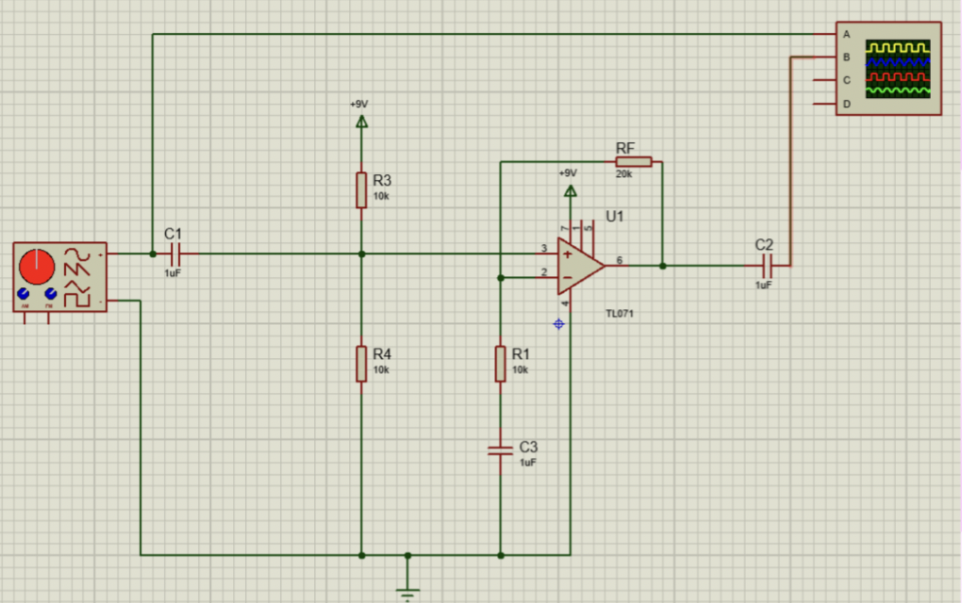

Fig.1 – Non-inverting amplifier built on Proteus.

Once amplifying, we recorded each value at different frequency levels. See table below.

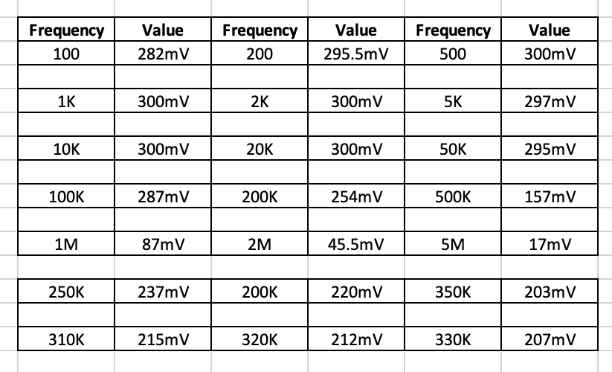

Table.1 – Change in frequency results on proteus.

From this we are able to work out -3db point, bandwidth, gain and GBP. See results below.

-3db = Max * 0.707 = 212
Bandwidth = 320Khz
Gain = 3
GBP = 320 * 3 = 960

Workshop - Breadboard

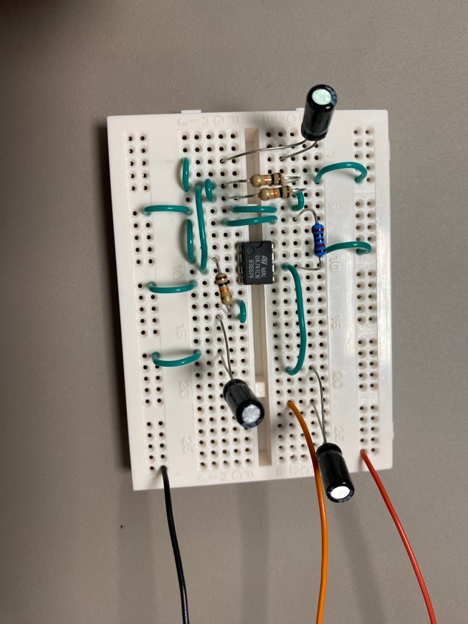
In the workshop we were required to build a breadboard. We built a non-inverting amplifier. Once complete we connected our breadboard to a power supply and oscilloscope. We used this to record our real life frequency changes. See table below from simulation on breadboard in the workshop.

Fig.2 – Non-inverting amplifier circuit built on breadboard.

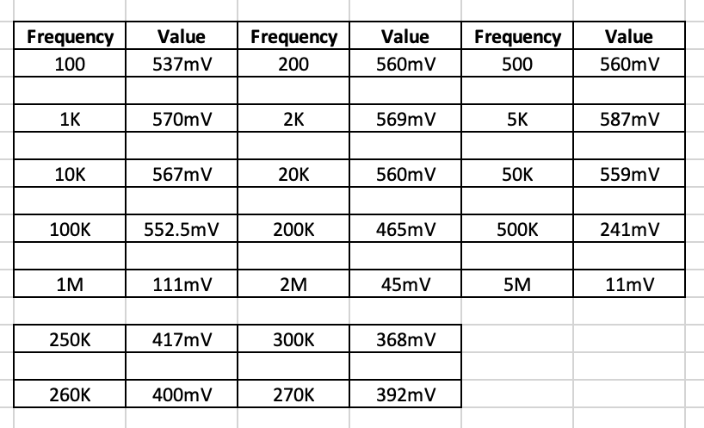

Table.2 – Change in frequency results on a breadboard.

-3db = Max * 0.707 = 401
Bandwidth = 260Khz
Gain = 3
GBP = 260 * 3 = 780

Workshop - PCB

After designing the non-inverting amplifier on proteus and then simulating it on a breadboard, we then designed the amplifier on a programme called Easy PC. After designing the PCB, it was then sent away to be designed.

Once soldering each component to the PCB, I then connected it to a power supply and oscilloscope and recorded the results again. See below.

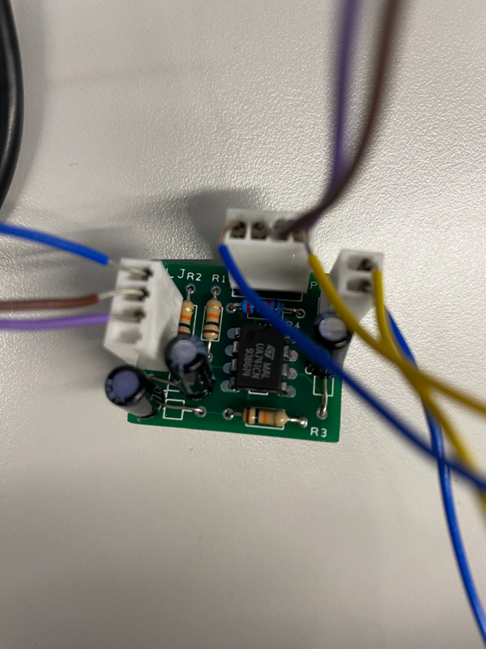

Fig.3 – Non-inverting amplifier built of a PCB, using Easy PC

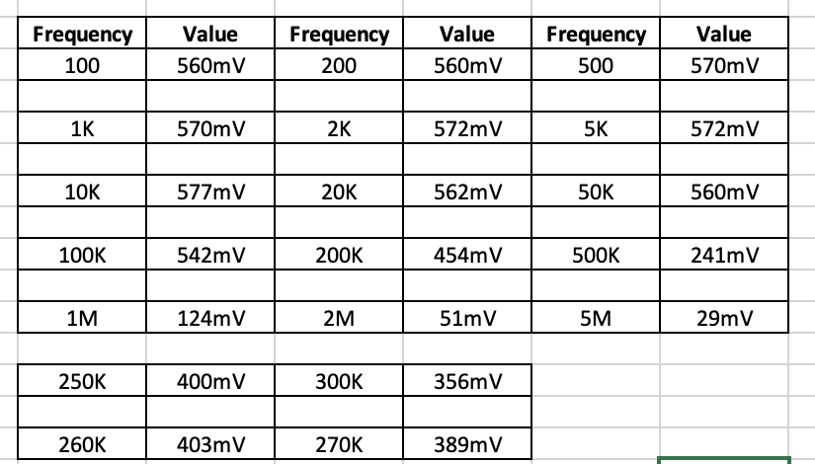

Table.3 – Change in frequency results of PCB, built on Easy PC

-3db = Max * 0.707 = 407
Bandwidth = 260Khz
Gain = 3
GBP = 260 * 3 = 780

