Nestle Milk Supply Project Consultation Plan

Course name: Organizational Consultancy
Course code: SBUS6122
Student number: 1704338
Student name: Siqi Li
Content
Executive summery……………………………………………………………………3
Introduction……………………………………………………………………………3
- Project justification……………………………………………………………….4
1.1 Programme objectives……………………………….……………………….4
1.2 Recommendation………………………………………………….………….4
2.0 Business case and approach……………………………………………………….5
2.1 Pricing strategy—low penetration strategy……………………………..……5
2.2 Market Segmentation and Product Diversification…………………….…….5
2.3 Advertising Strategy………………………………………………………….6
3.0 Consultancy Team……………………………………...………………………….6
4.0 Communication Strategy ………………………………………………………….7
5.0 Project Plan ……………………………………………………………………….8
6.0 Time plan……………………………………………………………...………….10
7.0 Research methodology……………………………..…………………………….10
7.1 Interview …………………………...……………………………………….11
7.2 Paper questionnaire ………………………………………………..……….12
8.0 Cost……………………………………………………………………...……….12
9.0 Quality assurance, risk management and ethics………………………………….13
10.0 Benefits ………………………………………………………...……………….13
11.0 Research results…………………………………………………………...…….14
Proposed strategy ……………………………...…………………………………….16
Conclusion …………………………………………………………………..……….16
References…………………………………………………………...……………….17

Executive summery
China has a large number of consumers. It is necessary for enterprises to seize the Chinese market and steadily expand the market. At the same time, China’s dairy industry is very competitive. It is very difficult for Nestle to occupy the market and expand in China. This project will analyze the current situation of China’s dairy market and provide you the most appropriate market expansion plan.

Introduction
Nestlé is a Swiss transnational food and drink company headquartered in Vevey, Vaud, Switzerland. It is the largest food company in the world, measured by revenues and other metrics, since 2014. (foodengineeringmag.com, 2018) As one of the largest consumer markets around the world, it is vital to consider how to develop and continuously expand the Chinese market which has attracted the attention from all over the world. Since 2016, Nestlé’s performance in China began to decline. According to statistics, sales in 2016 were down 7.4% from the previous year. In order to develop and expand in the Chinese market, this project will consider what approaches need to be undertaken in the form of a plan to achieve the goal.

- Project justification
- According to the Top 100 Food & Beverage Companies in 2017, Nestle ranked first in the world with total sales of $92.3 billion. (food engineering, 2018) Although Nestle is the world’s first food and beverage company, its share in China’s dairy market is very low. According to the 2017-2022 analysis of the operation status of Chinese market and the Research Report on the investment proposal, Nestlé’s share of dairy products market in China ranked seventh in 2015 and the total shares of sixth to tenth are less than any one of the Mengniu or Yili. It is easy to imagine the gap between Nestle and other companies. (2017-2022 analysis of the operation status of Chinese market and the Research Report on the investment proposal, 2017) Hence, it is very important for Nestle to make a project to expand the new market.
- The potential of young people is huge, their importance as future consumers can be achieved early through this route. It will improve Nestle great future developments as it advances to seize the potential additional consumer groups.
1.1 Programme objectives
The project aims to
- Assess the potential for nestle to be the primary and kindergarten milk provider to the children’s school.
- Understand the method and approach about how to expand into the new market and attract more consumers.
- Determine what other products would complement this as a part of future cross-selling.
- Determine what nestle need to know about the market especially understand the teens market, like what do they want, what is the most popular things.
1.2 Recommendation
In order to achieve these objectives, the consultancy team will recommend some suitable strategies according to the theory of how to expand new market. Expand into a new business base using new technology to meet the requirements of new sets of customers. Diversify into a new market base using existing technology. Expand into a new technology base to supply new products to existing customers. (Davies and Hobday, 2005). Based on these theories there are three feasible strategies to use.

2.0 Business case and approach
In this part, the consulting team will provide some suggestions for your company according to the company’s situation and market development. We will combine business cases for analysis. The first strategy is pricing strategy, and why I put pricing strategy as the first approach? pricing moves markets. Perhaps alternative view of Marshall McLuhan’s point is that, pricing is the message. In an age when "free" is a viable business strategy, more than ever pricing decisions communicate important things about your brand, your business model and your product. (Smith, 2012) Formulating a reasonable price strategy is the first step to expand the market.

2.1 Pricing strategy—low penetration strategy
A pricing strategy takes into account segments, ability to pay, market conditions, competitor actions, trade margins and input costs, amongst others. It is targeted at the defined customers and against competitors. (The Economic Times, 2018) There are several different pricing strategies, like penetration pricing, economy pricing and skimming strategy. For this project, the consultancy team will select low penetration pricing strategy. The low penetration price can enable the product to be the first sold in its category to a large number of customers. (Schindler, 2012)
Of course, low penetration pricing does not mean low quality. What we want to promote is to sell high quality products with a slightly lower price than the competitors, while guaranteeing profits.
There is a famous business case in China. MINISO is a Japanese fast fashion designer brand and its products are mainly about home furnishings, which is not different from other fast fashion brands. However, it has more than 2600 stores around the world. (Miniso.com, 2018) It also achieved great success in China and many young people like to buy the products in MINISO. One of the important factors for success is it low price and high quality.
2.2 Market Segmentation and Product Diversification
Market segmentation refers to the process of classifying customers into groups based on different needs, characteristics or behavior. (Lao, 1998) Market segmentation strategy helps company better understand the different needs of consumers at different levels, on this account to consolidate the company’s development and expand its market advantage. In terms of market segmentation, Mengniu who is the competitor of Nestle doing far better than Nestle.
Product diversification strategy refers to spreading of firm activities across a number of distinct product-markets that are more or less related on to be specified dimensions. (Pils, 2009) Mengniu as a dairy company has a wide variety of products. It subdivides the consumer market into several categories, including the Milk Deluxe, which meets the high-end consumer market, and the Future Star that caters to the needs of children. Moreover, there are many different brands of yogurt under its company. By contrast, Nestlé’s dairy products are much fewer than Mengniu. In addition to traditional Nestle pure milk, there are no other diversified products that can attract new consumers to buy.
Therefore, the consulting team recommends that the company segment the market according to different consumer groups and provide diversified products. For example, launching the new product which is a growth milk and more suitable for children and teenagers, in addition, making more changes in the taste.
2.3 Advertising Strategy
The benefits of advertising are multifaceted. For manufacturers, it will expand consumer groups and increase sales, if company use advertising by a rational way. (OUBAICHE, 2018)
There is an example to show why advertising is a good way to expand the new market. In order to further develop the market, Transformers has targeted the Chinese market which has 300 million children. Transformers cartoons are free to play in large and medium-size cities in China. This series of cartoons has played a very good sales effect and left a very deep impression on Chinese children. After that, a large number of Transformers toys came down from the screen and entered Chinese market.
Based on the advantages of advertising, the consulting team recommends that your company conduct appropriate advertising campaigns according to consumer preferences after full market research.
3.0 Consultancy Team
A good consultant can help company to view the problem more objectively and provide reasonable and feasible suggestions based on experience and knowledge. As Kubr (1996) defined, business consultants are resource roles and process roles. Our consulting team is engaged in both roles. The resource role means helping clients with their problems by using consultant’s experience and appropriated knowledge. The process role means helping the organization to solve its problems by marking it aware of organizational process. (Kubr, 1996) As a consultant, our team is not only having large professional business knowledge, but we could help your company to analyze the existing market situation by a better and suitable way. Though the integration and analysis of all kinds of resources, the consulting team will provide a reasonable long term development plan for your company. The most important point for the consulting team is broad knowledge and flexible work. On the other hand, the consulting team has more fresh eye and more rational ideas. We believe that consultants could help your company to find the problems by a rational and appropriate way.
By studying business and trade for three and a half years in China and British. In china, I studied in Shandong university of technology to learn international trade and how to communicate with clients. In addition, I got an excellent mark. Nowadays, I study in Carmarthen business school at UWTSD and I got more opportunities to combine practical and knowledge. I truly believe that I have ability to be a consultant to solve problem, make a reasonable plan for your company. At the same time, as a consumer, I buy nestle product form young age to now. I know what consumers want and I can help nestle to achieve goals. The result must be satisfying to both the enterprise and the consumers.
4.0 Communication Strategy
It is crucial to communicate effectively in negotiations to ensure you achieve your goals. (Business.qld.gov.au, 2018) Therefore, it is important to maintain good communication with the company. In order to achieve your goal, the consulting team will keep in touch with you in three ways, face-to-face, e-mail and skype, and communicate with you in time to understand the progress of the program.
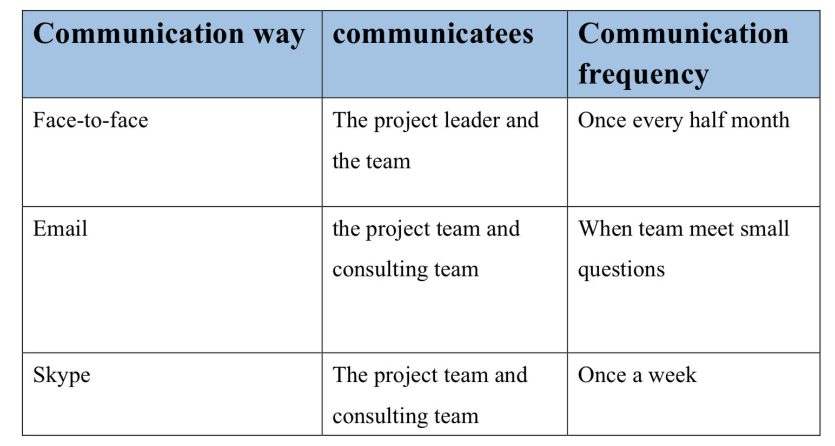
table 1: the communicate plan
- Face-to-face
Face to face communication is the most intuitive and effective way of communication. We hope to do it every hale month. Summarizing and discussing the project process and problems.
- Email
Email as the most convenient way of communication, it can be carried out at any time during work hours, especially when the project is experiencing minor problems.
- Skype
We hope to have a video call once a week to understand the progress of this week’s project and prepare for the next week’s work.
Of course, all of the communication strategies and plans are not changeless. Your company can adjust the plan according to the situation and progress of the project. We will try our best to cooperate with your company.
5.0 Project Plan
Combining the actual situation of the company with the development of the reality, this project is divided into four stages. They are communication phase, research phase, dissemination phase and implement phase.
- Communication phase: communication phase is the most important part of this project. In this period, there are three goals that our consulting team want to achieve. The first one is to identify the existing problems in your company and the main goal of this project. The second one is evaluating the current business situation of your company. Finally, discussing the solutions with your project team based on the results of the evaluation and communication. The communicating phase is run through this project from beginning to the end. Our consulting team hopes to keep good communication with your team before the end of the project.
- Research phase: the research phase will be a longer period in this project. The survey is mainly carried out in three aspects. The first aspect is to investigate the dairy market in Qingdao, mainly to understand the consumer’s requirements for dairy products including taste, price, packing and other aspects. The second aspect is to know the advertising mode of nowadays’ consumer market and clear the best way of advertising. Third one is to search the consumer groups, including children’s physical quality and eating habits, parents’ needs and so on. The last step is to collect the data and analyze it.
- Dissemination phase: the way of publicity can be varied. On the one hand, we should use the traditional way of television transmission, on the other hand, your company could spread it through new social media. The traditional way of publicity can be used by TV advertising. In this link, the new TV advertisements can be introduced to attract consumers according to the results of survey. The consulting team recommends that your company pay more attention on the new social media which is the most popular in nowadays. Advertising effects on new social media will get twice the result with half the effort.
- Implement phase: one month before the final determination of the plan, the consulting team will choose one or two primary schools or kindergartens for experiment. Through this month’s experiment, the deficiencies of the plan are clarified and adjusted in time. After the formal implementation of the project, your company needs to keep in touch with the cooperative schools and make sure that you can return the visit the school after the end of each quarter. In this way, your company could know whether schools and students have new requires or new suggestions.

6.0 Time plan

Figure 1: time plan
7.0 Research methodology
Research methodology is a way to systematically solve the research problems. It may be understood as a science of studying how research is done scientifically. (Kumar, 2008) Generally, the research process is divided into eight parts. There are define research problem, review of the literature, formulate hypotheses, research design, determining sample design, collecting sample design, analysis of data and interpret and report. In this project, the most important steps of this research process are determining sample design and collecting sample design. The data collection methods used in this survey are personal interviews and paper questionnaires.

7.1 Interview 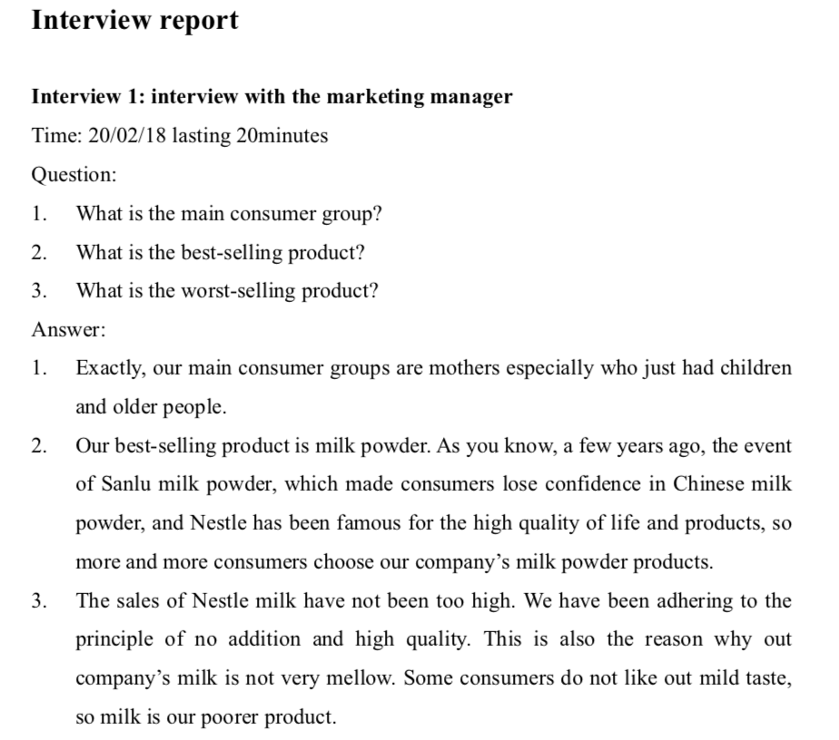
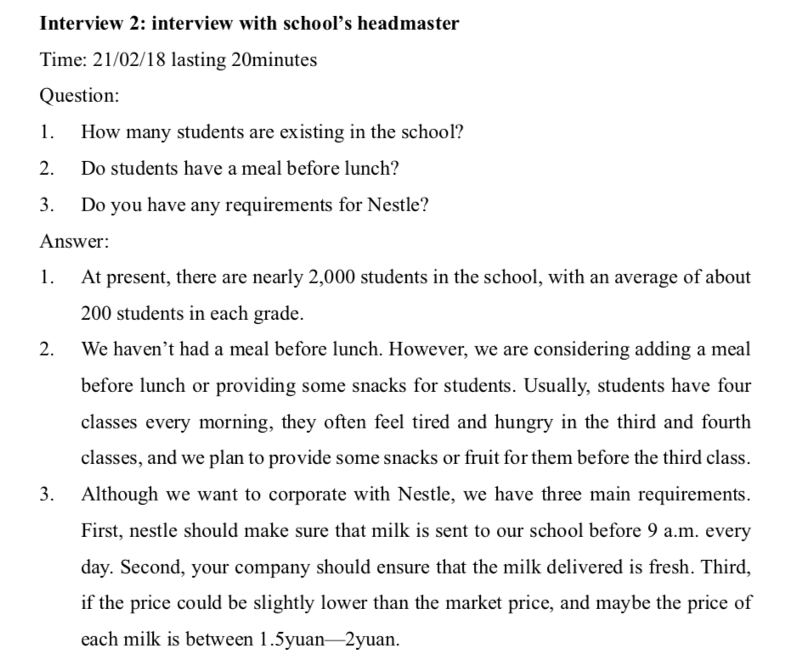
7.2 Paper questionnaire
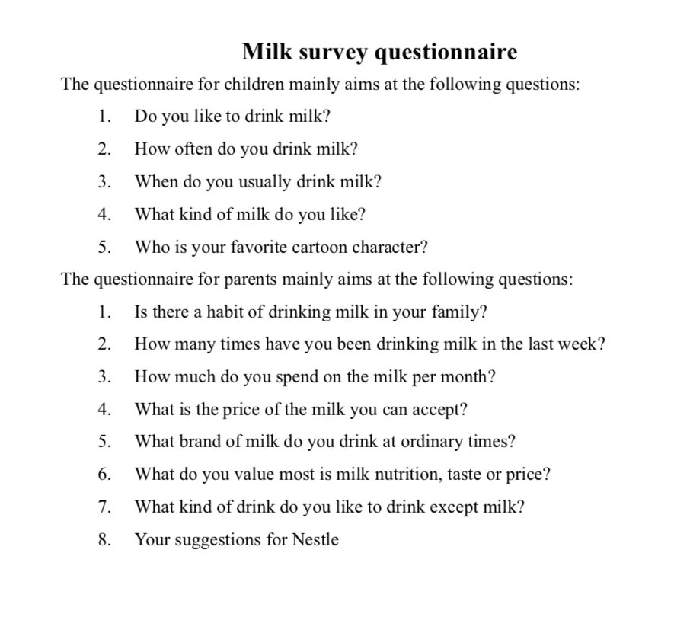
8.0 Cost
The cost of the project will be expressed in two aspects. On the one hand is the cost of money, on the other hand is the time spend. No matter it is time or money, it will spend the most in the research phase and dissemination phase.
- Research fee: initially, a total of 50,000 questionnaires were tentatively issued. According to the current market level, a copy of a sheet of paper would cost about 0.1RMB and 50,000 questionnaires totaling cost 5,000RMB, equal to $785.
- Disseminate fee: the dissemination phase will be divided into two parts; one is the traditional TV promotion. According to the different television channels and different time, the cost will be different. The consulting team recommend that advertisements be broadcast at golden time from 8 p.m. to 10 p.m. in CCTV and Qingdao TV which is often seen by local consumers. As for advertising content, we can make adjustments according to the survey results, and decide whether to use celebrity to disseminate or cartoon dissemination which is closer to teenager. Of course, cartoon image publicity will be more economical and practical. The TV publicity period may cost 500,000 RMB, equal to $79,000.
Another one is new social media publicity. Advertising on social platforms cost about 50,000RMB per week, equal to $7,900.
- Cost on consulting team: as a young consulting team, we hope to help you solve problems with affordable price and professional skills. In this project, we hope you will be able to pay $80,000, which includes all the data collection, data analysis, question finding and problem solving.
- The project is expected to take 6 months from the preparation stage to the final implementation. The detailed timetable can refer to the part 6, Time Plan.
9.1 Quality assurance
Customer satisfaction leads to repeat business, customer referrals, increased sales and profits. A quality assurance system eliminates defective products and continuously evaluates the process to improve products and services. Quality assurance can result in a consistently reliable product or service. Increased reliability in the end product results in customer satisfaction and brand loyalty. (Luanne Kelchner, 2017)
According to these benefits, nestle should make its product process clarity and do a promise about the product quality for consumers.
9.2 Risk management
Risk management is the identification, evaluation, and prioritization of risks (defined in ISO 31000 as the effect of uncertainty on objectives) followed by coordinated and economical application of resources to minimize, monitor, and control the probability or impact of unfortunate events or to maximize the realization of opportunities.(Hubbard , Douglas 2009)Nestle as food and drink company, how to ensure the safety of food is the most important thing the company needs to consider.
9.3 Ethics form
All the method has been mentioned in this PID are compliance with Law of the PRC on the Protection of the Rights and Interests of Consumers and Food Safety Law of the People’s Republic of China. The consulting team assures that the information and content contained in the report are derived from legal channels and will not infringe upon the legitimate rights and interests of anyone.
10.0 Benefits
This project aims to provide the nestle product to the local primary school in Qingdao. Therefore, there are many benefits for the nestle company if this project come true.
- The most intuitive benefit is it will increase the company's sales and help company to gain more interest.
- Expanding the consumer group and leading cross selling is another benefit. By providing company’s product to children will appeal more parents to buy company’s goods. In addition, it is not only focus on milk, also buy Nestle other products.
- The greatest benefit to the long-term development of the company is the expansion of brand influence. By this project, more and more consumers know Nestle culture, the quality of products. There is no doubt about that it is conducive for company’s long-time development.
11.0 Research Results
Based on the current dairy market environment and data collected, the consulting team use Porter’s Five Forces Analysis to analyze the current situation of Nestle. the five forces model is an essential tool for understanding the competitive structure of an industry (Michaux, Cadiat and Probert, 2015). The results are as below:
- Rivalry between competitors:
- The distribution of China’s dairy industry is decentralized and consumer brand loyalty is not high. The industry is a non-differentiation competitive market.
- Yili’s new products emerge in endlessly. Mengniu’s ecological ranch attracts many consumers’ attention.
- Mengniu, Yili and Guangming occupies a large share of China’s dairy market.
- Threat of new entrants:
- In fact, the competition in China’s dairy market is extremely fierce. Mengniu Yili and Guangming has occupied the market and new entrants are hard to enter the market. Therefore, there is no threat from new entrants for Nestle.
- Bargaining power of buyers:
- The consumers have many choices and the power of bargain is very high.
- With the emergence of food safety problems, our consumers are more concerned about safety of products. This makes consumer spending more rational and the bargaining power higher.
- The consumption ability of our residents is getting higher and higher.
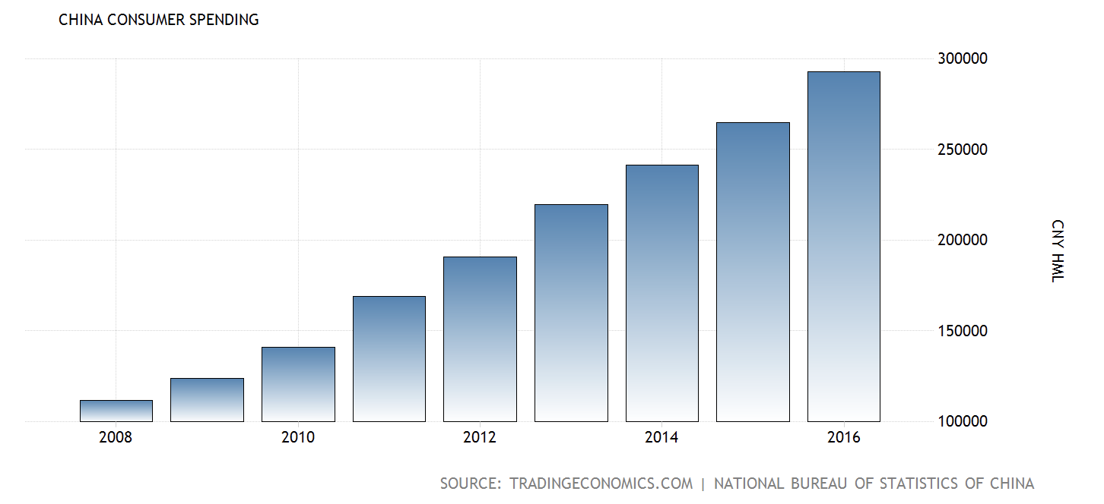
Figure 2: China Consumer Spending
- Bargaining power of suppliers
- There are a lot of defects in the connection mechanism between the farmers and the enterprises in China. At the same time, the quality of the product is faced with the more stringent testing standards of the dairy enterprises, and the suppliers are still in an inferior position in the bargaining.
- At the end of 2012, the volume of dairy cattle in China’s large-scale cattle farm was 274 thousand and 900, which increased by 8.14%, and the total fresh mile production reached 796 thousand and 500 tons in the year, up 12.68% from the last year. (Zheng, 2014) The milk yield of dairy cows is increasing, and the comprehensive level of dairy farming is improving
- Threat by substitute products
- Although milk has high nutritional value, most consumers in China are intolerant of lactose, so many consumers are willing to choose soya-bean milk, which has lower prices and more suitable for Chinese
Proposed strategy
Based on the objectives of the project, the consulting team will provide some constructive suggestions combine with analysis results.
For short term: low penetration strategy. For short term develop, we recommend Nestle use low price strategy and high quality products to ensure cooperation with schools and maintain good relationship with schools. At the same time enhance brand reputation.
For medium term: product diversification. With the deepening of cooperation with schools, nestle could launch more new products. Keeping good cooperative relationship with school, in addition, properly sponsor school’s activities. For example, sports meeting. Nestle can award prizes to the winners during the sports meeting to promote cross-selling.
For long term: market segmentation and advertising strategy. For future development, it is essential and important to segment the market. During the period of cooperation with schools, nestle should step up publicity efforts, expand popularity and create good reputation. Striving to become a milk supplier to all primary and secondary schools in Shandong province.

Conclusion
The report helps Nestle to analyze the current dairy industry situation in China by Porter’s Five Forces Analysis. In addition, to help the company collect data and analyze consumer needs through interviews and questionnaires. At the same time, put forward a constructive plan for Nestle to become a primary school milk supplier in Qingdao.

References
2017-2022 analysis of the operation status of Chinese market and the Research Report on the investment proposal. (2017). Beijing: Bosi Data Research Center.
Business.qld.gov.au. (2018). Communicating effectively for business | Business Queensland. [online] Available at: https://www.business.qld.gov.au/running-business/marketing-sales/managing-relationships/communicating-effectively [Accessed 12 Apr. 2018].
Davies, A. and Hobday, M. (2005). The business of projects. Cambridge: Cambridge University Press, p.56.
food engineering. (2018). 2017 Top 100: The World’s Top 100 Food & Beverage Companies. [online] Available at: https://www.foodengineeringmag.com/articles/96916-top-100-the-worlds-top-100-food-beverage-companies? [Accessed 10 Apr. 2018].
foodengineeringmag.com. (2018). [online] Available at: https://www.foodengineeringmag.com/articles/94498-the-worlds-top-100-food-beverage-companies---2015-change-is-the-new-normal [Accessed 20 Mar. 2018].
Hubbard, D. (2009). The failure of risk management. Hoboken, N.J.: Wiley & Sons.
Kelchner, L. (2018). The Importance of Quality Assurance. [online] Bizfluent. Available at: https://bizfluent.com/info-7765915-importance-quality-assurance.html [Accessed 10 May 2018].
Kubr, M. (1996). Management consulting. Geneva: International Labour Office.
Kumar, C. (2008). Research methodology. [S.l.]: Aph Publishing Corporatio.
Lao, F. (1998). Marketing management. Manila: Rex Book Store.
Michaux, S., Cadiat, A. and Probert, C. (2015). Porter's Five Forces: Understand competitive forces and stay ahead of the competition. 50Minutes.
Miniso.com. (2018). MINISO 名创优品 Japan Brand Profile. [online] Available at: http://www.miniso.com/getinfo.php?cid=186&top=1 [Accessed 22 Mar. 2018].
OUBAICHE, Z. (2018). Advantages of Advertising: 12 Major Advantages of Advertising– Explained!. [online] Linkedin.com. Available at: https://www.linkedin.com/pulse/advantages-advertising-12-major-explained-zahira-oubaiche [Accessed 12 Apr. 2018].
Pils, F. (2009). Diversification, Relatedness, and Performance. Wiesbaden: Springer Science & Business Media.
Schindler, R. (2012). Pricing strategies. Los Angeles: Sage.
Smith, T. (2012). Pricing strategy. Mason, Ohio: South-Western/Cengage Learning.
The Economic Times. (2018). Definition of Pricing Strategies | What is Pricing Strategies ? Pricing Strategies Meaning - The Economic Times. [online] Available at: https://economictimes.indiatimes.com/definition/pricing-strategies [Accessed 22 Mar. 2018].
Tradingeconomics.com. (2018). China Consumer Spending | 1952-2018 | Data | Chart | Calendar | Forecast. [online] Available at: https://tradingeconomics.com/china/consumer-spending [Accessed 10 May 2018].
Zheng, C. (2014). Analysis of the competition pattern of China's dairy industry -- Based on the five forces analysis model of Potter. Western China, pp.110-114.

