Declaration
I declare that this assignment is all my own work and that I have acknowledged all materials used from the published or unpublished works of other people. All references have been duly cited.
Html & CSS web development
By Dylan Evans (1701153) Software Engineering

Contents
1.1 Introduction 2
2.1 Requirements 2
2.1.1 Introduction to website 2
2.1.2 Site map 2
2.1.3 wireframe diagram of homepage 3
3.1 Implementation 4
3.1.1 Screen grabs of website 4
3.1.2 Validation 9
3.1.2.1 Validation of webpage (home) 9
3.1.2.2 Validation of CSS 9
4.1 Evaluation 10
4.1.1 Accessibility evaluation (WCAG 2.0) 10
4.1.2 Evaluation of completed website 11
4.1.3 Recommendations for future improvements 11
5.1 References 12
5.1.2 Citations 12

Introduction
This report will outline the requirements implementation and evaluation of a website for the business Shine Cymru. The report will show how the website was implemented from start to finish including the design stage and evaluation of the website.

2.1 Requirements

2.1.1 Introduction to website
The purpose of the Shine Cymru website is to promote the business. The business of Shine Cymru is a life skills centre for 16-25 year olds with learning difficulties/ and or disabilities. The target audience of the website would be the users of the centre people aged 16-25 with learning difficulties or disabilities the website would also be targeted at the parents/guardians of the users of the centre so that they could refer them to use the centre.

2.1.2 Site map

2.1.3 wireframe diagram of homepage
Copyright
ASDAN Logo
Paragraph 2 – what we do
Paragraph 1 – who we are
Motto
Logo
Banner
Navigational links
Logo

3.1 Implementation
3.1.1 Screen grabs of website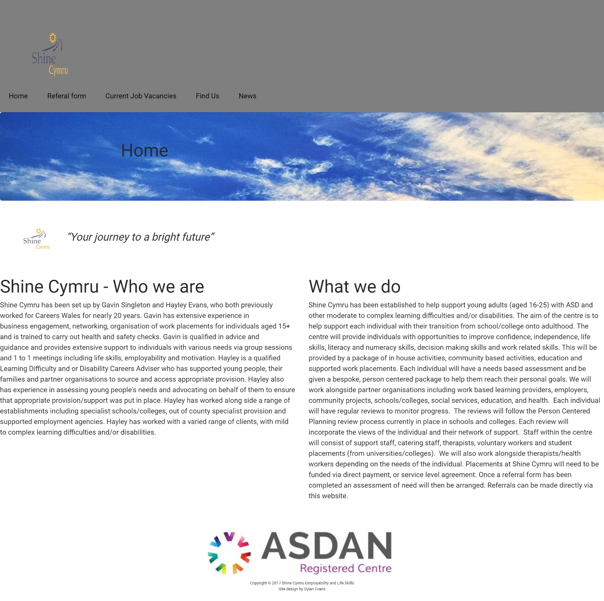

Above is a screengrab of the home page of the shine Cymru website
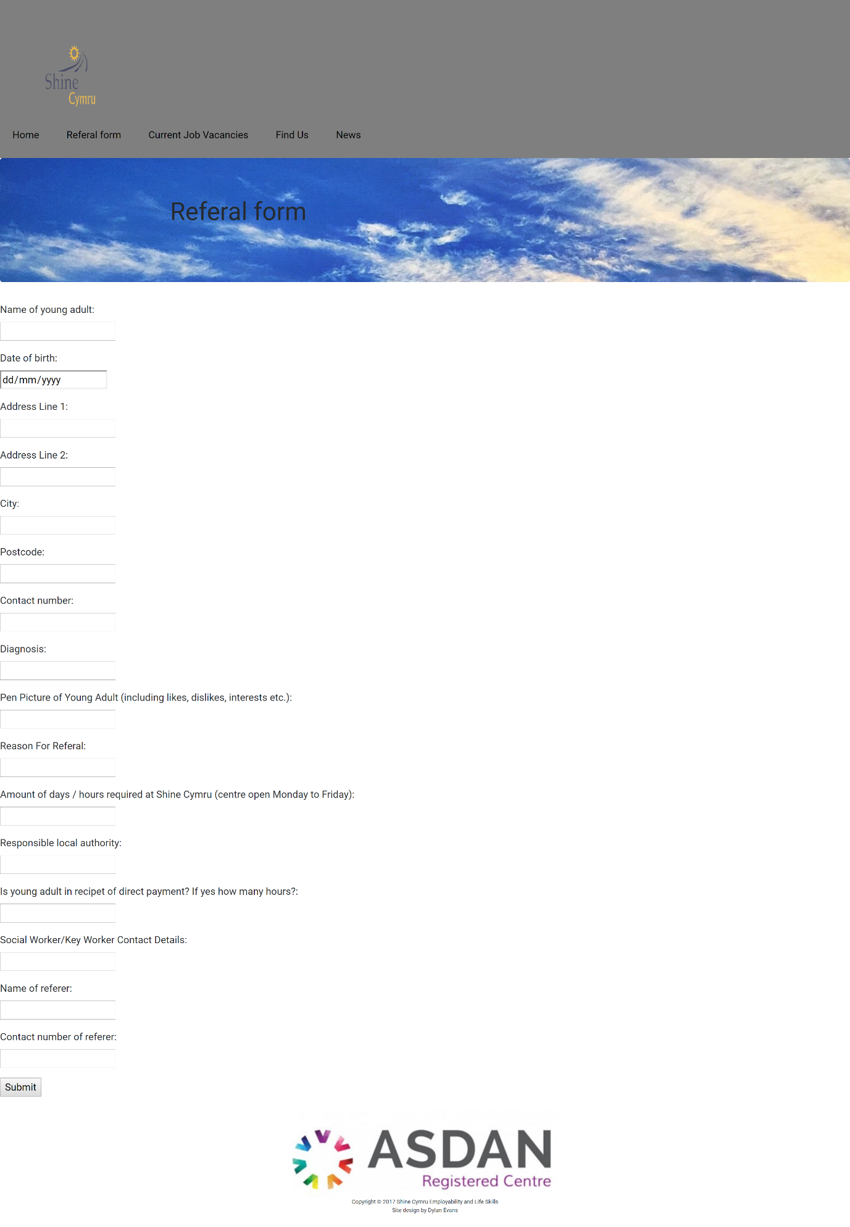

Above is a screengrab of the referral page of the shine Cymru website
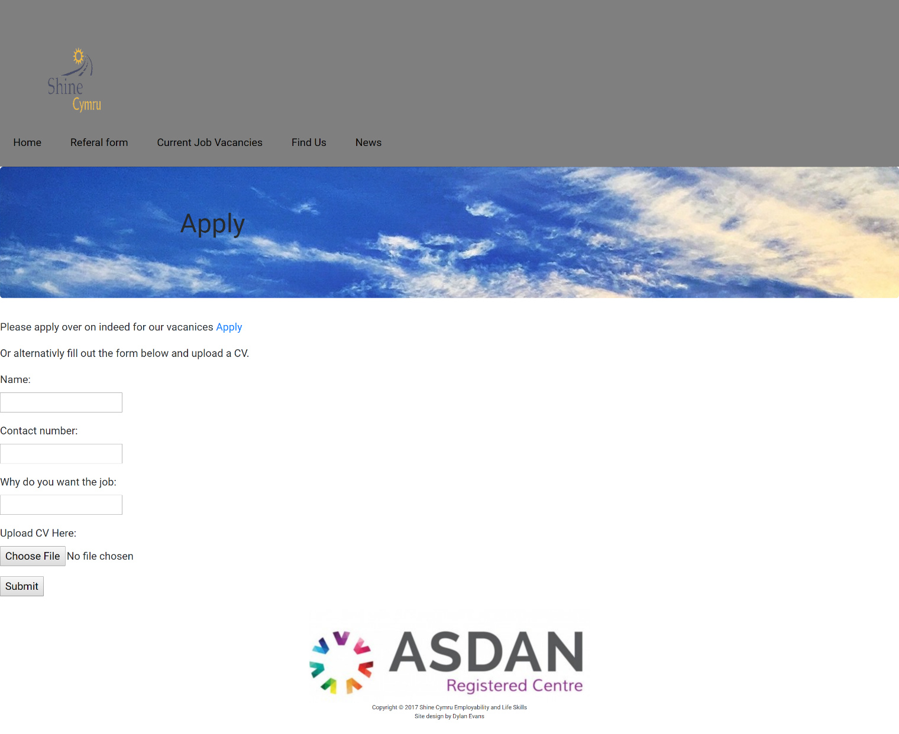

Above is a screen grab of the application page for the shine Cymru website

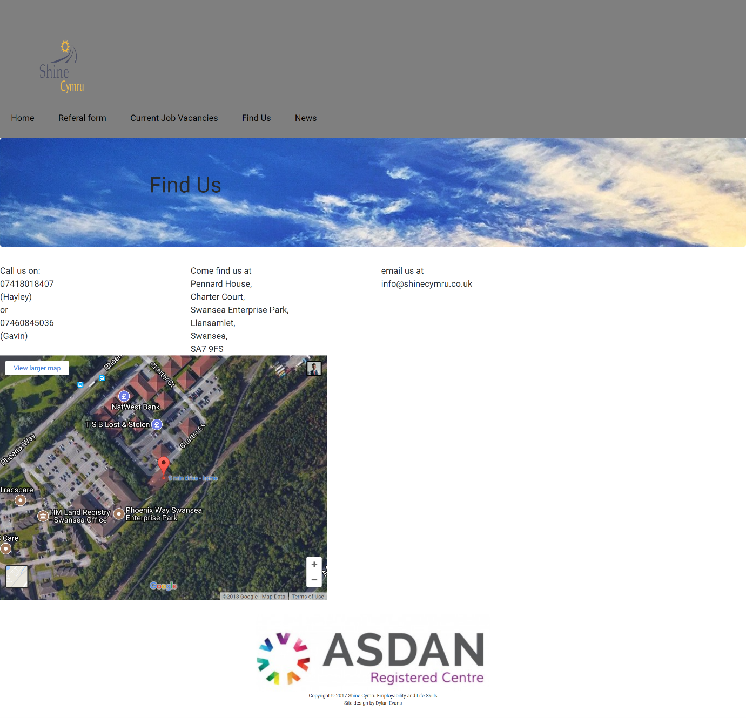

Above is a screengrab of the find us page of the shine Cymru website a google maps iframe has been used to show the location of the centre

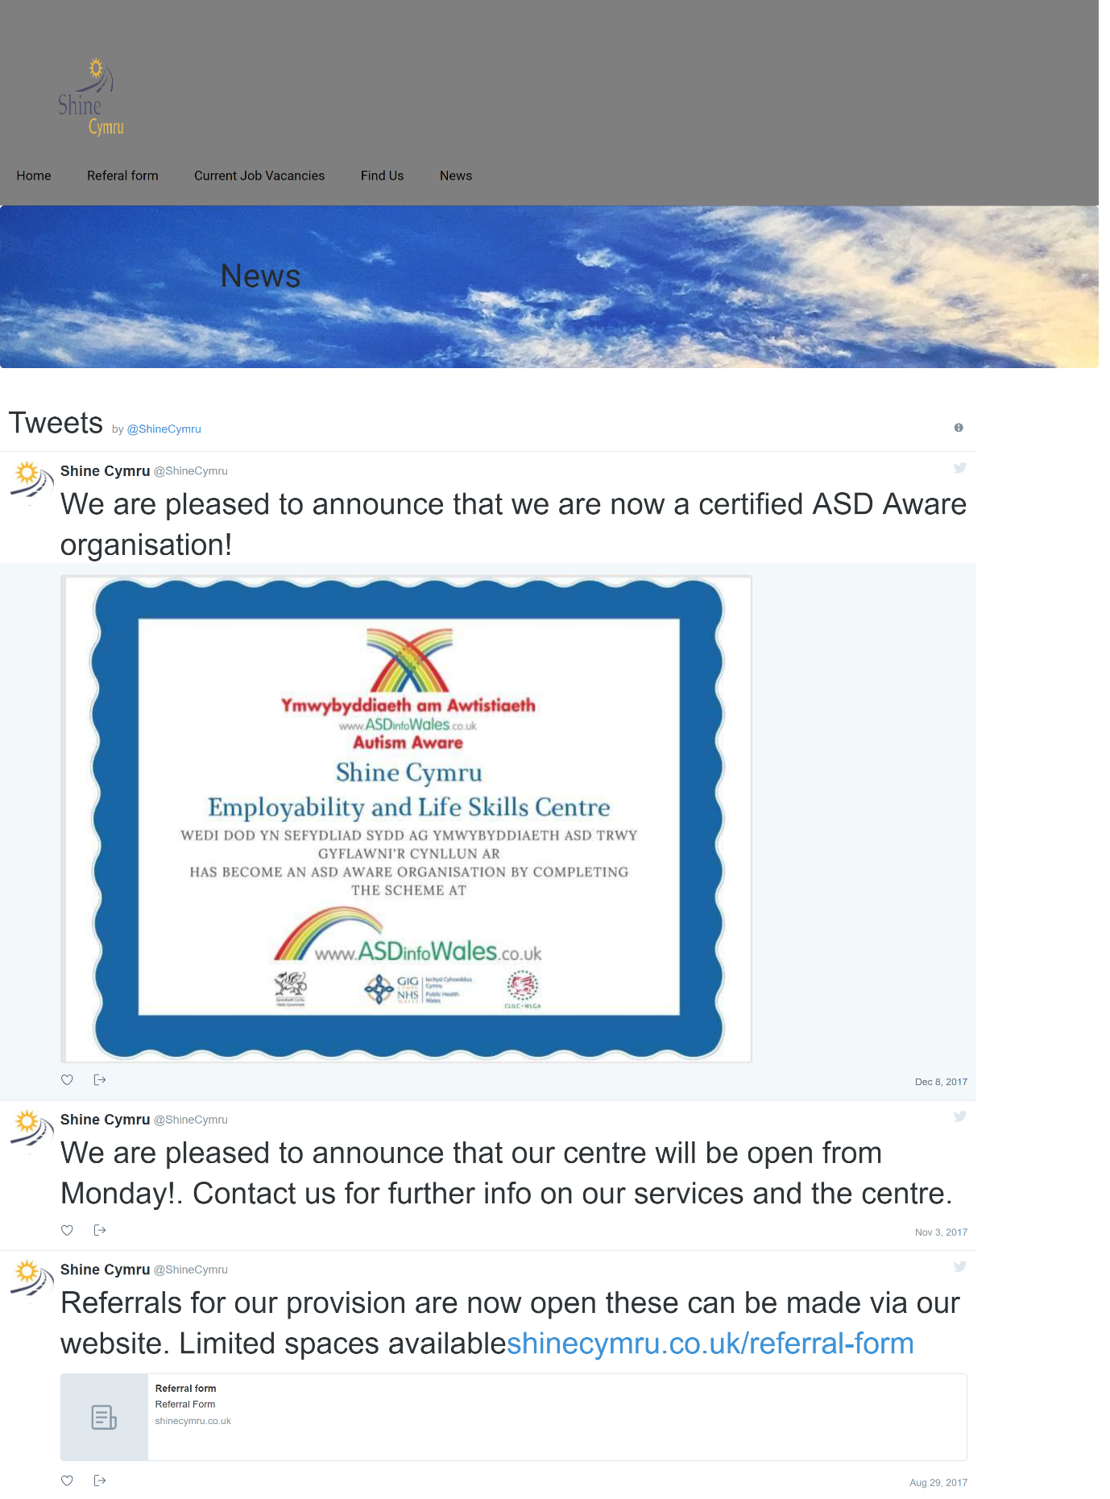
Above is a screen grab of the news page of the shine Cymru website. A third party plugin has been used to show the twitter feed of shine Cymru.

3.1.2 Validation

3.1.2.1 Validation of webpage (home)
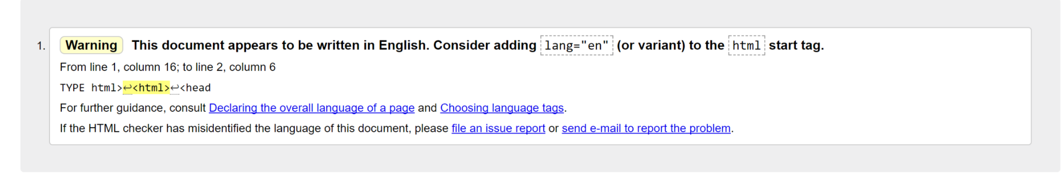 [1]
Above is a screenshot of all the errors in the homepage of the shine Cymru website. As shown there is only one error which is more than a warning than an actual error. The w3 validator [1] suggests to add “lang=”en” “ in the html start tag so that if the page was in multiple languages when someone who speaks a different language accesses the site it would display in their language.

3.1.2.2 Validation of CSS
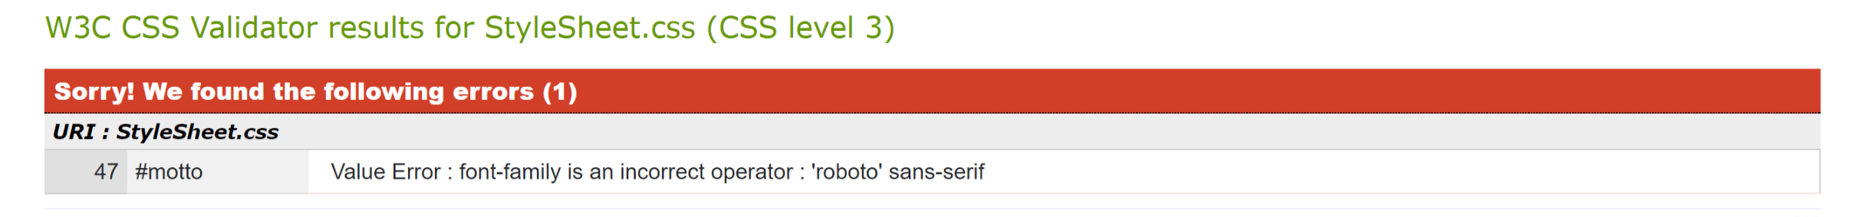
[2]
Above is a screenshot of the validation of the CSS document. This is a silly error there is a missing comma after ‘roboto’ this is easily corrected by changing ‘roboto’ sans-serif to ‘roboto’, sans-serif.

4.1 Evaluation

4.1.1 Accessibility evaluation (WCAG 2.0)
The wave accessibility tool [3]was run on the shine Cymru website to test for accessibility issues. This tool gave some errors which will be explained in this evaluation. The errors are shown in the screenshot below:
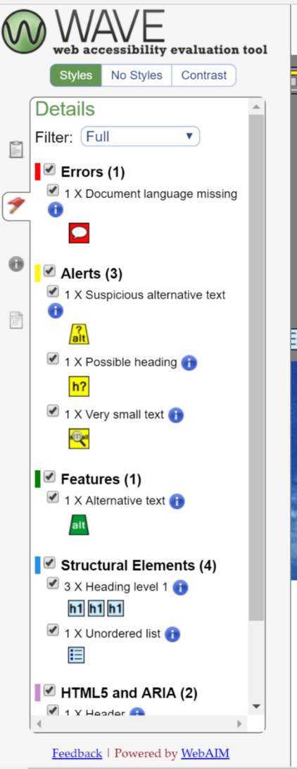
There is only one error which is that the document language is missing. This is easily corrected as all you have to do is add one line of code <html lang="en">. This matters because when the reader loads the website they want it to be in their language, this tag specifies the language so that if the website is written in multiple languages it will automatically load in the readers language.
The rest of the errors are just suggestions to things on the website which could be improved. For example “suspicious alternative text” [3]is just suggesting that the alternative text is not enough for readers who cant load images. This particular alert is relating to the alternative text of the logo this is just set to “logo” this should be enough to describe it but as it is only one word the tool shows this alert.
There is also an alert saying “very small text” [3] this suggests that the text on the shine Cymru website is too small this can be easily resolved by adjusting the font size on the website. This is important as for users which have eyesight impairment this could make it difficult for them to read the site.
Overall the wave accessibility tool has not shown many errors which suggests that the site is compliant with WCAG 2.0 standards. All of the headings forms, colours and navigation have reached the standards of WCAG 2.0 and don’t require improvement therefore the shine Cymru website is accessible in terms of WCAG 2.0.
[3]

4.1.2 Evaluation of completed website
The purpose of this evaluation is to show the design, usability and content of the Shine Cymru business it will evaluate whether the website has met the requirements and show whether the website as a whole shows the company in the correct way.
The Shine Cymru website is a useable site with a good overall look and feel. The website fulfils it intended purpose which is to promote the shine Cymru business to the users (16-25 year olds with learning difficulties and or disabilities) the websites design comes from the tagline “your journey to a bright future” this shows in the header image which is a picture of the bright sky. The website is easy to navigate and is basic this is to fulfil the intended use as some of the users with learning difficulties and or disabilities may have difficulties in using the computer this therefore will help them to navigate the website with ease.
The content of the website includes all information you need to know about shine Cymru as a business and has a find us page which shows where you can find the companies building located on the enterprise park in Swansea.
To test the content of the webpage the author asked his mum Hayley Evans (director of Shine Cymru) whether the website as a whole meets the requirements of the company and advertises them in the correct way and that the content is accurate and up-to-date in terms of the business. Hayley Evans reply was “Overall the website is excellent, it accurately describes the business as a whole and is up to date with the companies services. The websites overall look is basic which helps the users of the centre to be able to use the centre if they have difficulty in doing so. Overall the website is great and meets the requirements of the company.” [4]
To conclude the evaluation the author thinks that the Shine Cymru website meets the requirements as it accurately promotes the business and it allows the target audience (parents or guardians of 16-25 year olds with learning difficulties and or disabilities) to find the business easily and refer their young adults into the centre.

4.1.3 Recommendations for future improvements
If the website was to be relooked at in the future things which could be added are a login area for parents to see the progress of their son/daughter this area could include feedback from social workers in shine Cymru and also pictures of them using the centre. Another improvement could be a staff login area to modify the site or to check information like rotas.

5.1 References

[1] | “w3 Validator,” w3, [Online]. Available: https://validator.w3.org/. [Accessed 1 January 2018].
[2] | “jigsaw validator,” w3, [Online]. Available: http://jigsaw.w3.org/css-validator/validator. [Accessed 1 January 2018].
[3] | “Wave accessibility tool,” WebAIM, [Online]. Available: http://wave.webaim.org/. [Accessed 2 January 2018].
[4] | H. E. (. C. Director), Swansea, 2018.

5.1.2 Citations
https://www.pexels.com/photo/body-of-water-near-brown-soil-under-blue-sky-during-sunset-128458/ - image used for header
https://www.gateway-north-east.org.uk/wp-content/uploads/2016/10/ASDAN_RegisteredCentre_logo_colour_web.jpg - asdan registered centre logo in footer.
https://developers.google.com/maps/documentation/embed/ - api used to embed map into find us page.
https://dev.twitter.com/web/embedded-timelines - api used to embed the twitter timeline into the news page.

