Cloud-Based Web Services
ACCA6024 – MD

(REST API demonstration was produced with local host on Microsoft Edge)

Isobel Sutcliffe – 1808257
1808257@student.uwstd.ac.uk

Content
Section 1 – Introduction 1
Section 2 – Web Services 2
Section 2.1 – Representational State Transfer (REST) 2
Section 2.2 – Simple Object Access Protocol (SOAP) 5
Section 2.3 – Graph Query Language (GraphQL) 7
Section 3 – Compare and Contrast Web Services 9
Section 4 – Conclusion 10
References 11

Section 1 – Introduction
This report looks at 3 examples of different dynamic web services that are currently available and being used in the wider Internet of things. It also looks to compare them against one another and suggest appropriate scenarios for using the three web services.

What is a web service?
A Web service can be defined as a software system designed to support interoperable machine-to-machine interaction over a network. It has an interface described in a machine-processable format (specifically Web Service Description Language (WSDL)). Other systems interact with the Web service in a manner prescribed by its description using SOAP messages, typically conveyed using Hypertext Transfer Protocol (HTTP) with an Extensible Mark-up Language (XML) serialization in conjunction with other Web-related standards. [1]
Or a little more simply – a web service is a standardised medium to propagate communication between the client and server applications on the World Wide Web. A web service is a software module that is designed to perform a certain set of tasks. [2]

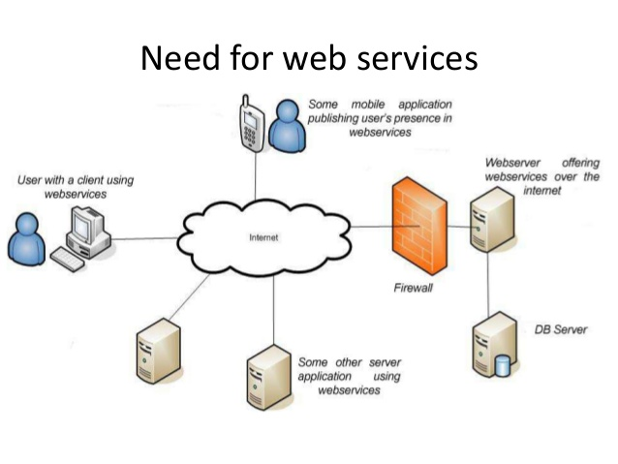
Figure 1 - Example of user interaction with Web-services [3]
Web services that are to be reviewed
- REST;
- SOAP;
- GraphQL.

Section 2 – Web Services

Section 2.1 – Representational State Transfer (REST)

What is REST?
REST is acronym for REpresentational State Transfer. REST is a style of architecture based on a set of principles that describe how networked resources are defined and addressed. These principles were first described in 2000 by Roy Fielding as part of his doctoral dissertation. REST is an alternative to SOAP and JavaScript Object Notation (JSON). [4]
Fielding’s dissertation [5] goes into detail with regards to how a set of interaction constraints can be applied to retain guiding principles. He goes on to state that REST is a hybrid style derived from several of the network-based architectural styles described earlier in his work.
An overview of the guiding principles/constraints are listed below in figure 2.
Architectural Constraint | Description
Client-Server | The Client-Server constraint models the interactions and separates the role of requesting and the role of providing service.
Stateless  (communication) | Stateless constraint refers to client-server communication and requires that every request from the client to the server is independent from previous ones. Consequently, there is no server-side session state kept during such interactions and each request should be descriptive enough to be fully understood on its own.
Cache | The Cache constraint mandates that responses by the server should indicate (probably implicitly) whether they can be cached or not.
Uniform Interface | The Uniform Interface constraint imposes the generality of components’ interfaces and requires that these interfaces have system-wide universal semantics. Also, this constraint introduces and describes the resource-orientated modelling of a system’s content, realized by its dependence to further architectural constraints, usually referred to as Uniform Interface’s sub constraints. Specifically, REST states that the uniformity of interfaces in a RESTful architecture is obtained by its conformance to the four following constraints: identification of resources, manipulation of resources through representations, self-descriptive messages, and hypermedia as the engine of application state (usually referred to as HATEOAS or the “hypermedia constraint”).
Layered System | The Layered System constraint mandates that the organization of the system follows a hierarchical, layered fashion, where each layer provides services to the layer above and consumes services from the layer below.
Code-On-Demand | Code-On-Demand allows for client agents’ logic to be extended by downloadable and executable code. This last constraint is an optional constraint and Fielding argues that it should be supported by an architecture conforming to REST in the general case. However, there may be contexts that this behaviour is disabled, and that possibility should be acceptable.

Figure 2 - Table of Architectural Constraints of REST [6]

RESTful web services make use of HTTP Protocol to communicate between the client and the server. [7]
HTTP Request
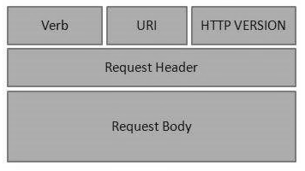
Figure 3 - HTTP Request [7]

- Verb – Informs of the request to get a required resource, commonly used methods include GET, POST, DELETE and PUT.
- URI − Uniform Resource Identifier (URI) to determine the server of the relevant resource.
- HTTP Version – Identifies the HTTP version in use, e.g. HTTP v1.1.
- Request Header – Contains the metadata for the HTTP Request message as key-value pairs, e.g. Accept-Language: EN
- Request Body – Request message body. Optional.

HTTP Response
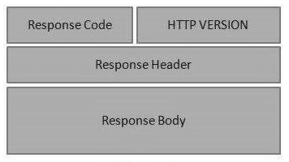
Figure 4 - HTTP Response [7]

- Status/Response Code – Identifies the Server status for the requested resource, e.g. 301 moved permanently, 200 request has succeeded.
- HTTP Version − Indicates the HTTP version, e.g. HTTP v1.1.
- Response Header − Contains the metadata for the HTTP Response message as key-value pairs, e.g. Content-Type: html.
- Response Body − Response message body. Optional

The four commonly used methods contained within Verb (HTTP Request) are [7]:
GET – provides a read only access to the targeted resource;
POST – allows a user to create a new resource;
DELETE – allows a user to remove a resource;
PUT – allows a user to update or create a new resource.

Principle Benefits [8] & [9]
The benefits from using RESTful include:
- Tend to be faster than web services, such as SOAP, as it does not have to adhere to strict specifications, therefore consuming less bandwidth and resource;
- RESTful applications offer flexibility as they can utilise different formats, such as HTML, XML, JSON and plain text;
- Independent of language and platform usage, allowing RESTful web services to be written in any programming language and executed on any platform;
- Due to the stateless nature of REST, each call to the web service will contain all the information it will need to process the request and does not need to rely on client-server storage of context;
- As REST is a cacheable it greatly improves performance of the web service as it eliminates unnecessary call to the backend.

Principle Drawbacks [9]
There are drawbacks to be considered with REST, they include:
- No set standards to follow when building REST based API’s leads to many permutations, which can be confusing to new or inexperienced users;
- RESTful applications are limited to HTTP protocol.

Section 2.2 – Simple Object Access Protocol (SOAP)

What is SOAP?
SOAP is the acronym for Simple Object Access Protocol it is a message protocol that allows distributed elements of an application to communicate. SOAP can be carried over a variety of lower-level protocols, including the web-related HTTP, it defines a header structure that identifies the actions that various SOAP nodes are expected to take on the message, in addition to a payload structure for carrying information. [10]
Or more simply SOAP is a method of transferring messages, or small amounts of information, over the internet. [11]
SOAP has a message structure that has the following elements to it:
Element | Mandatory/Optional | Description
Envelope | Mandatory | Used to define the start and the end of the message
Header | Optional | Contains optional attributes of the message that may be required to process the message.  This can be at an intermediary point or at the endpoint of the message.
Body | Mandatory | Contains the XML data comprising the message being sent.
Fault | Optional | Provides information about errors that occur while processing the data.

Figure 5 - Table Describing the Elements of SOAP [12]
Structure:
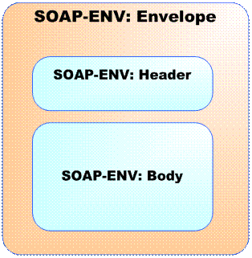
Figure 6 - Diagram Displaying the SOAP Structure [13]

Principle Benefits [9] & [14]
The benefits from using SOAP include:
- Potentially higher security as SOAP has its own security with WS Security;
- Independent of language and platform usage, allowing SOAP web services to be written in any programming language and executed on any platform;
- WSDL describes the web services methods, access and other parameters, allowing for a one place learning stop for users to learn the API;
- As SOAP is protocol neutral it allows access via HTTP, SMTP, TCP and other application level protocols.

Principle Drawbacks [9] & [14]
There are drawbacks to be considered with SOAP, they include:
- SOAP can be considered slow, due to the use of the XML format, which needs to be parsed to be read. It has many defined standards that must be followed. This causes a higher consumption in bandwidth and resources;
- Dependant on WSDL, does not have any other mechanism for discovering the service.

Section 2.3 – Graph Query Language (GraphQL)

What is GraphQL?
GraphQL is a relatively new open-source query language for APIs and a runtime for fulfilling those queries with existing data. GraphQL provides a complete and understandable description of the data in the API, giving clients the power to ask for exactly what they need and nothing more, it makes it easier to evolve APIs over time, and enables powerful developer tools. [15]
GraphQL has been developed in a way that allows it to “play” well with other background languages. Which ensures its flexibility to be added as a layer to any existing server logic. [16]
There seems to be several reasons quoted for the use of GraphQL, these include [16] & [17]:
- It provides easily readable queries for the human eye;
- The language easily deals with many databases, including existing ones;
- It is suited for both microservices and complex systems;
- It can help with query batching and caching;
- The user is not faced with over or under fetching problems;
- Requests can be tailored to the users specific needs;
- It can be used for rapid application prototyping.
Principle Benefits/Features [17] & [18]
- GraphQL provides declarative query language, which is not imperative;
- It is hierarchical and product centric, allowing for easy and rapid innovation and iteration;
- GraphQL is strongly typed meaning queries are executed within the context of a particular system;
- Queries in GraphQL are encoded in the client rather than in the server;
- It has all the features of the application layer of the Open Systems Interconnection (OSI) model;
- Helps provide a mobile first user experience – Since mobile apps have rich User interfaces (UI) and are used over slow networks, GraphQL helps to load only the relevant data without killing the Developer Experience;
- Handles complex schema – Modern UI applications are becoming more and more complex with user experience (UX), GraphQL allows the user to combine data from a variety of sources;
- Microservices orchestration solution – GraphQL, especially with Apollo Server, provides many features to hide backend complexity from clients;
Principle Drawbacks [17] & [18]
- Overkill for small applications;
- GraphQL does not depend on the HTTP caching methods that enable storing request content;
- GraphQL does not understand files. Hence, a file uploading feature is not included in it;
- With GraphQL, be prepared to have a lot of pre-development education like learning the Schema Definition Language;
- Using a technology based on its popularity is not enough – Since a technology solves one or many specific issues, popularity is never sufficient to validate a technology choice;
- GraphQL will not solve all performance issues out the box – GraphQL is not a performance optimiser tool, the user is still responsible for improving performance.

Section 3 – Compare and Contrast Web Services

Representation of the three web services - [17] & [8] & [19]
Difference | REST | SOAP | GraphQL
Year of Release | 2000 | 1998 | 2015
Type | Architectural | Protocol | Query Language
Function/Approach | Data driven – access a resource for data | Function driven – transfer structed information | Unable to substantiate
Data Definition | Server | Server | Client
Standards | No defined standards to follow | Defined standards requiring strict following. | Unable to substantiate
Data Format | Permits many data formats, including plain text, HTML, XML and JSON | Only uses XML | Permits more than one data format, JSON and XML
Statefulness | Stateless in nature – no server-side sessions | Stateless by default but a SOAP API can be made stateful | Unable to substantiate
Security | Supports SSL and HTTPS, inherits security measures from the underlying transport. | Supports WS-Security and SSL. | No obvious security, inherits security measures from the underlying transport.
Bandwidth/Performance | Requires fewer resources and is lightweight | Requires more resources and bandwidth | Requires client side resources.
Data Cache | Can be cached | Cannot be cached | Cannot be cached
Business Logic | Uses URI to expose the business logic. | Uses services interfaces to expose the business logic. | Unable to substantiate
Payload Handling | Needs no knowledge of the API | Has a strict communication contract and needs knowledge of everything before any interaction | Unable to substantiate
ACID Handling | Lacks ACID compliance | Has built-in ACID compliance to reduce anomalies | Unable to substantiate
Transfer Protocols | Tends to be used in line with HTTP | SMTP, HTTP, UDP and others | Uses HTTP
Popularity | Preferred over SOAP | Less Preferred | Growing Community

It would be very difficult to do a full comparison on the three web services as they are not considered to be the same type of webservice. One is a protocol, another an architectural concept, whilst the remaining one is a query language, all be it a powerful one.

Section 4 – Conclusion
All three webservices have a place in the Internet of Things due to their uniqueness and ability to deliver different services based on the needs of the projects that they are intended for.
REST is ideal if the project needs are java script driven and have an intensive load for processing or looking to scale up eventually, as REST can process them a lot quicker than SOAP and is easily scalable. It is worth noting, however, that security of the data being used would need to be considered when thinking of REST as the go to solution, as it relies on external security.
Building applications with SOAP would include a much higher level of security, but can be the poorer choice, as developers tend to prefer REST, unless there is a significant level of resources on both sides as well as the need for the tighter security it affords. Health Records applications could be considered an ideal application for using SOAP as they have inbuilt security.
GraphQL is ideal when the number of queries need to be reduced and as it is based on the client side it is ideal for independency and applications on the go are the ideal choice for GraphQL. Considering it was developed with Facebook and it is on the go data retrieval, this gives a good indication of the many uses that GraphQL can be introduced to. It is still a relatively new language and probably has not yet reached or fulfilled its full potential. As part of the research it was difficult to substantiate some of the details, with regards to GraphQL to allow a fuller comparison due to a level of contradiction in articles.
At the present time, all three still have their uses and there does not seem to be any need for either of the three webservices to be retired just yet.

References
[1] “Web Services Architecture.” [Online]. Available: https://www.w3.org/TR/ws-arch/. [Accessed: 02-Jan-2021].
[2] “What are Web Services? Architecture, Types, Example.” [Online]. Available: https://www.guru99.com/web-service-architecture.html. [Accessed: 02-Jan-2021].
[3] “Image Displaying Web Services.” [Online]. Available: https://image.slidesharecdn.com/techgigwebservices-140514010219-phpapp01/95/webservices-overview-xml-rpc-soap-and-rest-6-638.jpg?cb=1400030388. [Accessed: 02-Jan-2021].
[4] “Representational State Transfer (REST).” [Online]. Available: https://www.service-architecture.com/articles/web-services/representational_state_transfer_rest.html. [Accessed: 02-Jan-2021].
[5] Fielding, “Fielding Dissertation: CHAPTER 5: Representational State Transfer (REST),” 2000.
[6] M. Athanasopoulos, K. Kontogiannis, and C. Brealey, “Considerations of adapting service-offering components to RESTful architectures,” in Enterprise Resource Planning: Concepts, Methodologies, Tools, and Applications, vol. 3–3, IGI Global, 2013, pp. 1522–1549.
[7] “RESTful Web Services - Quick Guide - Tutorialspoint.” [Online]. Available: https://www.tutorialspoint.com/restful/restful_quick_guide.htm. [Accessed: 06-Jan-2021].
[8] “SOAP vs. REST: A Look at Two Different API Styles | Upwork.” [Online]. Available: https://www.upwork.com/resources/soap-vs-rest-a-look-at-two-different-api-styles. [Accessed: 03-Jan-2021].
[9] “REST vs SOAP - Building Modern Applications - Auth0.” [Online]. Available: https://auth0.com/learn/rest-vs-soap/#! [Accessed: 10-Dec-2020].
[10] “What is SOAP (Simple Object Access Protocol)? - Definition from WhatIs.com.” [Online]. Available: https://searchapparchitecture.techtarget.com/definition/SOAP-Simple-Object-Access-Protocol. [Accessed: 10-Dec-2020].
[11] “SOAP (Simple Object Access Protocol) Definition.” [Online]. Available: https://techterms.com/definition/soap. [Accessed: 17-Dec-2020].
[12] “SOAP - Quick Guide - Tutorialspoint.” [Online]. Available: https://www.tutorialspoint.com/soap/soap_quick_guide.htm. [Accessed: 17-Dec-2020].
[13] “SOAP Message Structure | Tech Blog.” [Online]. Available: https://mytechprep.wordpress.com/2012/10/12/soap-message-structure/. [Accessed: 03-Jan-2021].
[14] “SOAP Web Services - javatpoint.” [Online]. Available: https://www.javatpoint.com/soap-web-services. [Accessed: 10-Dec-2020].
[15] “GraphQL | A query language for your API.” [Online]. Available: https://graphql.org/. [Accessed: 17-Dec-2020].
[16] “Learning GraphQL and Relay | Packt.” [Online]. Available: https://www.packtpub.com/product/learning-graphql-and-relay/9781786465757. [Accessed: 06-Jan-2021].
[17] “What is GraphQL? Tutorial with Example.” [Online]. Available: https://www.guru99.com/graphql-tutorial.html. [Accessed: 17-Dec-2020].
[18] “Why use GraphQL, good and bad reasons · Honest Engineering.” [Online]. Available: https://honest.engineering/posts/why-use-graphql-good-and-bad-reasons. [Accessed: 06-Jan-2021].
[19] “SOAP vs REST | Top 13 Best Comparison You Must Learn.” [Online]. Available: https://www.educba.com/soap-vs-rest/. [Accessed: 03-Jan-2021].

