Ionut Cojan- 2109652
Module: Developing workplace critical thinking
Module code: BMSW5101
Lecturer name: Faizu Edu
Table of Contents
Introduction 3
Background of the company 3
Key management theories used in TESCO 4
Application of theory 4
Benefits of practicing Mayo theory to motivating Tesco staff 5
Mayo's Motivational theory for enhancing the value of employees 5
Critical evaluation of Tesco beliefs, attitude, and values with interpreting theory 6
Specific organizational changes in Tesco in terms of beliefs, attitudes, and value systems after Covid-19 6
Recommendation for tackling changes of Covid-19 7
Conclusion 8
References 10

Introduction
An organization is an association or a corporation where several people work together for establishing a business or something. An organization is like a union that helps to optimize the utilization of economical resources and also human resources. Organizational values and beliefs are the principles that provide a vision of cohesiveness and also can define the identity of the business. These values and beliefs also help to define the organization to their employee's customers and also to the stakeholders by a preferred way of determining achieving outcomes for the customers. In this research the chosen organization is Tesco. The assessment of the impact of different organizational beliefs values and attitudes is done in this research based on Tesco organization that is a UK-based multinational merchandise retailer of groceries. This organization offers different kinds of food and nonfood products like fresh food, bakery, drinks, and different kinds of products of health and beauty. Tesco uses the Mayo theory to enhance the organizational motivation in culture and develop the encouragement of employees. By using this theory Tesco can assure their employee's satisfaction with their workplace culture.

Background of the company
Tesco is a general merchandise and a multinational retailer that carries out different businesses through multi-format shops or stores and also online. This multinational retailer operator Stores in different formats that are differentiated by the range and size of the product, including small and large one-stop formats (Tesco PLC .2020).Organizations also offer a wide variety of food products and also non-food products that are including bakery, grocery, drink, fresh food, entertainment, and home products. It also provides consultancy on insurance and banking services through Tesco bank within the United Kingdom. The company also presents business across Europe as well as the United Kingdom and the headquarter within the Welwyn Garden City of Greater London. There is 23,1223 no of employees are working with Tesco. The revenue of Tesco increases year after year. In 2022 the annual revenue of Tesco was$84.149 which is 12.16% higher than the previous year 2021.
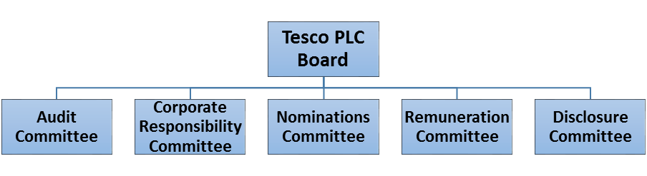
Figure 1: Background of Tesco
(Source: Tesco PLC .2020)

Key management theories used in TESCO
Management theory is a collection of different ideas that helps to recommend different rules that help to manage a business or an organization. By the management theory, an organization can implement different strategies for accomplishing different organizational goals and can find a way of motivating their employees for performing to their best ability. In Tesco, the Mayo theory of motivation is used for operating the organization management theories. This theory is operating throughout the whole company
. As per this theory, communication is a very important factor in the motivation of employees (Fadeyi, 2020). This communication can be occurred by 1 to 1 discussion with the higher authority or through different formal structures like news Shelters or appraisals. The theory of Elton Mayo suggested different factors that can motivate the employee at they are workplace. The different factors are greater communication and good teamwork. That theory also consists of different factors like assuring the well-being of the employee and ensuring work that is interesting and also nonrepetitive.
Showing interest in others and also involving others in deciding the main factors of motivation that Mayo suggested for the workplace. At Tesco, the theory of Mayo is seen as very important for progressively operating the company. In this theory, he explains that boredom at work and repetitiveness can lead to a reduction in motivation. Motivation can be improved by giving the employees a degree of freedom for making their choices and also by acknowledging employees' different social needs. Elton Mayo believed that employees' motivation can be improved by making them feel important. Internal and external factors can help to motivate a person for changing their actions. Internal factors help them to make desire for learning a new skill that can reward the employee. External factors like the target of sales or incentives can be a negative motivator if they are not possible to achieve (Alexander 2020).
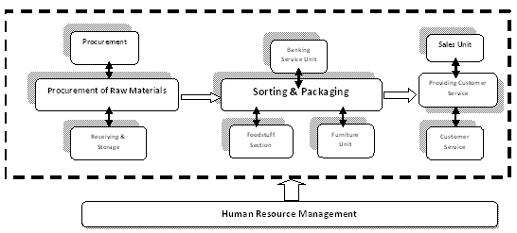
Figure 2: Key strategies in Tesco
(Source: Alexander 2020).

Application of the theory
The Mayo motivational theory is in practice at Tesco. For supporting the organization's growth motivated and well-trained fixable staff is very important for ensuring the recognition of customers' needs (Mayo et al. 2022). The theory of Mayo states that different employees can be motivated by different relational factors like attention and affection than any monetary rewards or different factors of environment like lighting, heat, or humidity. This theory helps managers to increase the productivity of their organization by treating their staff as unique individuals. In Tesco, employees are highly supported by the company at different levels from implies of the warehouse to the staff of the office or logistics. Tesco gives importance to the motivation of their employee for the growth of the company.

Benefits of practicing Mayo theory to motivating Tesco staff
Motivation in the workplace provides hard work for achieving greater output within less time and this also helps to reduce labor costs. These also require demonstrating pride and supervision in work that provides a greater impact on the customer. Motivated employees have a greater concentration that helps them to make fewer mistakes, lace cause of the accident, and not be involved in the conflict (Bowyer et al. 2022). It also shows greater loyalty to the customer and provides quality work.
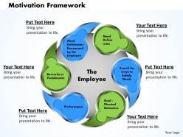
Figure 3: Motivational framework
(Source: Bowyer et al. 2022)

Mayo's Motivational theory for enhancing the value of employees
This theory discovered the importance to respect and trust for employees and it also follows realistic goals and an interesting environment within the workplace. At Tesco application of this theory achieve team and individual objective and focus on the customer by receiving feedback from others. This approach provides good results in business and provides a greater outcome in production providing encouragement, opportunity, and creative work.

Mayo theory measures staff satisfaction in Tesco
Tesco invites all staff every year and takes part in a survey by knowing the viewpoint of employees to express views and aspects of the job. These survey help to understand the available benefits of internal and external factors that also help to develop an action (Thompson and Ackroyd 2022). The employees are involved with internal and external factors; internal factors involve new skills that employees are learning from this theory. The external factor involves incentives as well as a sales target.
Mayo's theory enhance communication in Tesco
Communication is the most important factor for motivating employees that helps to interact employees to each other (Boddy 2019). On the other hand, this motivational theory also provides training and development by offering strategic planning for a career to achieve extraordinarily.

Critical evaluation of Tesco beliefs, attitudes, and values with interpreting theory
Every day, companies seek to further satisfy our clients, neighbourhoods, as well as the environment. Putting the consumer at the heart of all we do while also taking into consideration our responsibilities to the communities we represent as well as to society as a whole enables us to help our consumers, neighbourhoods, as well as the world a little bit better each day. Branding and reputation: Tesco's branding, which promotes the company's major expansion and success both in food and non-food products, has been its main competitive edge. By turning generic products become name brands, it was able to capture a large number of devoted consumers. Tesco is worried about the economy because it has the potential to affect consumption, expenditures, pricing, and profits. High levels of unemployment are among the issues that have the greatest effect on the economy (Xinyun 2018). Every organization's internal ecosystem must include aspects like company culture, corporate governance, and management. It is important to keep in mind that all these variables combine and can have different effects on how a business develops.
With this policy, Tesco promises to only purchase and sell ethically and has asked vendors to give ethics reviews the highest priority. Just on basis of its performance objectives, competency, and openness, all vendors are evaluated. Tesco does have a strong reputation, an effective marketing strategy, a sizable share of the market in the United Kingdom (UK), a large bank of money, and a superior technical presence inside its business operations. Moreover, it enjoys a competitive edge due to its dominance in the UK retail market (Barker et al. 2021).

Specific organizational changes in Tesco in terms of beliefs, attitudes, and value systems after Covid-19
Changes within the organization
Tesco is the 9th largest retailer in the world which is measured by their revenues but this organization also faces different issues during covid-19 that decrease their product and quality of their services. The failure of understanding the trend and differences between cultures of other countries are the most important issues that Tesco faces due to covid-19. As a result of covid-19 Tesco faces unprecedented changes in its organizational belief, attitude, and values. It becomes the time to understand different compliance and expectations, focusing on renewing and repositioning in wake of the further normal time (Metwally and Diab 2022). The significant impact of covid19 on Tesco introduces a strong and heavy-burning platform of changes in different areas that are impossible to adjust to the type of changes that Tesco encountered.
Changes in organization beliefs
Tesco has been forced for doing in a different way with much more stuff required for working from home. The working processes of this organization had to change in a frequent way for the survival of the organization. Delegates also saw that the impact of covid-19 makes different changes in the different organizations in a different way. Impacts depend on the size and the type of industries (Samdani 2020). Tesco has a belief in the wellness of the staff and also the well-being of the staff increases their organizational paramount to the forward. They assure that their staff required different new things for working remotely and also the time of collaboration becoming a part of a virtual team.
Changes in organization value
Tesco made some changes in its organizational belief and attitude. They realized that two critical changes are associated due to covid 19. The first one is working remotely -these changes can be associated with technical and also behavioural. The adaptability, belief, and attitude of Tesco is the key to success with this kind of change. Due to covid-19, there was important awareness that is needed for change and also they are some resistance the change in different cases. The next challenge that Tesco observed due to Covid was the ability of the staff who are able to work with technical equipment and system with different kinds of tools in a productive manner from home. For this work, they need the right infrastructure and the right system in their house along with proper training and support of different technical equipment (Harahap et al. 2022). Different digital platforms like zoom WebEx ensure the social interaction that helps to solve the challenges of Tesco.
Changes in Organization staff
Returning the staff to the office is a challenge for Tesco. With the reduction of lockdown limitations, Tesco opened up and give the opportunity to the staff for working physically under safety and precautions. Tesco has reported that fear of travelling, new convenience, and relative safety that comes from working at home has created resistance from the side of staff's returning to work.
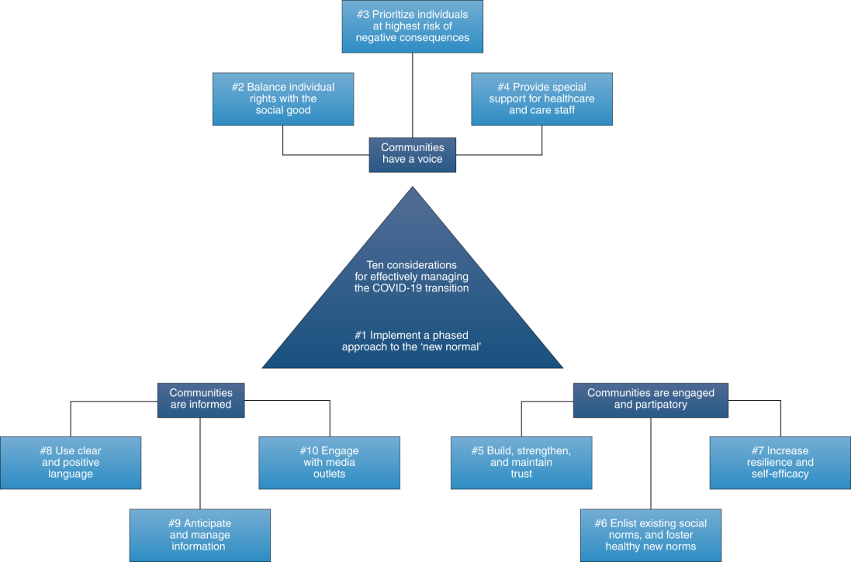
Figure 4: Effective management in Covid-19
(Source: Harahap et al. 2022)

Recommendation for tackling changes to Covid-19
For tackling the challenges that Tesco faces after Covid-19 this organization initiates a project of approaching their staff on the basis of their persona which is called return to the office. The most important technical site of this initiative is to assuring a safe environment for the staff of Tesco. The organization tries to ensure the people's trust and feelings of safety in the working environment.

Tesco can lead the ADKAR approach that helps Tesco to break the fear and anxiety of the staff by making a clear sense of awareness about the need for the changes. Mitigation of the pandemic requires mass and well-coordinated change of behaviour to succeed. Tesco can use the De- densification strategies that make the spacing between desks for considering the circulation of workable strategies (He et al. 2021). Protocol to improve cleaning within the area of offices is another way of removing the fear of infection. Strong communication between the higher authority of the organization and the employees can help to make a clear knowledge about the office policies that help to improve the workability of the employees.

Tesco can the design of the workplace help to provide different supportive features in reinforcing the sense of safety to employees that help them to make good decisions about their personal needs. Adaptation of exceedingly consistent and very clear communicational protocol can help Tesco to tackle changes that are the cause of Covid-19. The increased need for mental health and well-being of the staff can be the way of Tesco's method of tackling changes of Covid19.
Tesco can balance between communal space and private space is very important for the psychological wellness of the employee. Proper designing of private space is highly important for the employees because that helps them to recharge regularly and also helps to work in a stress-less way (Altena et al. 2020). Other different strategies also help Tesco to return their employees to the office after the lockdown period of covid19. Social distances due to covid 19 increase the desire for communication and connection.
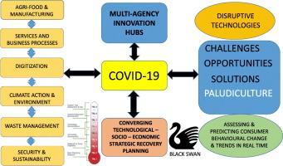
Figure 5: Tackling challenges of Covid 19
(Source: Simpson and Manber 2020).
Tesco can provide centralized space it can be possible to encourage employees for maintaining a sense of togetherness. Through this centralized space, employees can share their contributions, thoughts and personal stories that help them to make a sense of community. The different digital platforms can help to keep a connection with the employees of the remote working place. Hosting video calls and dedicating space to the employee will help to make a bridge between the office and the employee who is working from home (Simpson and Manber 2020). Virtually building a community can help people to keep in touch and also help them to encourage their work. The design of the workplace is able to provide different supportive features for reinforcing the sense of employees’ safety and empowerment in making good decisions as per their personal needs.
Tesco can provide clear and prominent communication protocols during the period of Covid19. The organization needs existing policies for the betterment of its business rules and the success of its organization. The crisis of covid-19 make opportunities for reshaping the workplace and creating spaces that are meaningful to the human experience. By tailoring these above-mentioned recommendations Tesco can tackle challenges that they face in the post covid environment and can create a more effective and profitable business in the future.

Conclusion
This study conclusively describes Tesco's organization which is a multinational retailer it aims to serve its customers healthy and fresh food at an affordable price. In this study management theory of Elton Mayo is discussed and the different application of this theory over Tesco is also elaborated for benefit of the Tesco organization. Critical evaluation of this Mayo theory on Tesco’s values, attitudes, and beliefs are also described in this study. Different changes that Tesco faced over their values and attitude after Covid-19 are also described in this research and also the recommendations are also mentioned here tackling the changes that face Tesco after Covid-19.

References
Alexander, I.N., 2020. The influence of technological innovations on organization's competitive advantage: Case study on Irish food retail company (Tesco) (Doctoral dissertation, Dublin, National College of Ireland).
Altena, E., Baglioni, C., Espie, C.A., Ellis, J., Gavriloff, D., Holzinger, B., Schlarb, A., Frase, L., Jernelöv, S. and Riemann, D., 2020. Dealing with sleep problems during home confinement due to the COVID‐19 outbreak: Practical recommendations from a task force of the European CBT‐I Academy. Journal of sleep research, 29(4), p.e13052.
Barker, H., Shaw, P.J., Richards, B., Clegg, Z. and Smith, D., 2021. What Nudge Techniques Work for Food Waste Behaviour Change at the Consumer Level? A Systematic Review. Sustainability, 13(19), p.11099.
Boddy, D., 2019. Management: Using Practice and Theory to Develop Skill. Pearson UK.
Bowyer, A., Holt, J., Go Jefferies, J., Wilson, R., Kirk, D. and David Smeddinck, J., 2022, April. Human-GDPR Interaction: Practical Experiences of Accessing Personal Data. In CHI Conference on Human Factors in Computing Systems (pp. 1-19).
Fadeyi, A.P., 2020. An Analysis on the Application of Motivational Theories at Workplace and the Impact on Employee Engagement: A Study of Tesco Ireland (Doctoral dissertation, Dublin, National College of Ireland).
Harahap, D.A., Ferine, K.F., Irawati, N., Nurlaila, N. and Amanah, D., 2021. Emerging advances in E-commerce: Panic and impulse buying during the COVID-19 pandemic.
He, W., Zhang, Z.J. and Li, W., 2021. Information technology solutions, challenges, and suggestions for tackling the COVID-19 pandemic. International journal of information management, 57, p.102287.
Mayo, N.L., Russell, H.A., Holt, K. and Williams, G.C., 2022. Implementation of a self-determination-based clinical program to reduce cardiovascular disease risk. Journal of Health Psychology, p.13591053211068124.
Metwally, A.B.M. and Diab, A., 2022. An institutional analysis of the risk management process during the COVID-19 pandemic: evidence from an emerging market. Journal of Accounting & Organizational Change.
Samdani, T., 2020. Impact of Tesco's Private Label brands on buying behaviour of Millennials in terms of brand preference in Irish market (Doctoral dissertation, Dublin, National College of Ireland).
Simpson, N. and Manber, R., 2020. Treating insomnia during the COVID-19 pandemic: observations and perspectives from a behavioral sleep medicine clinic. Behavioral Sleep Medicine, 18(4), pp.573-575.
Tesco PLC .2020. home. Available at: https://www.tescoplc.com/about (Accessed: November10, 2022)
Thompson, P. and Ackroyd, S., 2022. Organisational Misbehaviour. Organisational Misbehaviour, pp.1-100.
Xinyun, T., 2018, December. A Multimodal Critical Analysis in Business Discourse: the Case of the Corporate Annual Report of Tesco. In 5th International Conference on Education, Language, Art and Inter-cultural Communication (ICELAIC 2018) (pp. 433-440). Atlantis Press.

Part 2- Reflective Journal

Discriminates between - and analyses the difference between - beliefs, attitudes, and values within a workplace context.
This week one describes different important terms like critical thinking, belief, attitudes, and emotion. Is the process of discipline that skillfully and actively applies, conceptualizes, analyzes, and evolutions information by gathering observation, reflection, and guiding action and belief. According to Clay-Warner Robinson, (2008) Critical thinking also refers ability that helps to evaluate the information and be aware of the assumption. In addition, the value provides a measure within the important person who attached something to reflect on life.
According to Anderson De Silva, (2009) an attitude is a way that helps a person express and applies beliefs and values. Critical thinking is the process in which continuous questioning is a mission that is never finished. Critical thinking also regards negative and positive events. Trauma suggests people about the previous assumption that how triggering new thinking. Pleasing, joyful, and full-feeling events also trigger the reinterpreted action as well as ideas from a new point. Emotions are also the Central part of this process that previously accepted behavior, ideas, and values. Critical thinking could be replaced with rational skills. A tactic is to use critical skills to discover a solution to a problem. Among the most crucial aspects of rational reflection seems to be the ability to deal with opposing ideas. Critical thinking is the process of considering the evidence on both sides of a dispute and determining my position.
In week eight, according to www.ibm.com, (2021) it has been identified that; the development of workplace critical thinking is involved in managing the innovation and the creativity of changing work business and environment. Managing the innovation and creativity of the environment is more important to identify the product market and process development system. The characteristics of successful innovating companies also explain the systematic collection of all impulses that are implemented for the creativity of employees. It has the ability which also helps to identify the possibility of innovative ideas with producing good work for the team. This week also explains the project-based approach which also has the ability for managing the process. In order to develop the best characteristics of successful innovation for companies they are the cooperation of external experts is involved with universities and Research laboratories. It identifies employee motivation and also involves developing the product operation within a whole company. It continues with developing the education of employees with their ability in finance and innovation activities. The development of company innovation potentiality company also develops by high innovation of potential score that is high in the area of marketing, technological progress, quality management, strategy and planning, logistics, and human resource. The development of innovation on the potential assignment of the company also improves the work with the important concept of answering the question and reflecting on the existing situation for the company. The developing plan of strategy presents an idea about the company's future and it is mainly involved in the innovation program of the company by modifying the planning and vision of the organization. The financial indicators of this plan also explain the project management processes with developing their views on the goals of the business. The next part of marketing is involved in identifying the monitoring current market trends which evaluates all the market competition with the position of customer orientation. Monitoring the customer attitude toward the company product can develop information on the company's marketing and financial control system. The technical progress is discussed about the company's competitiveness in the future with progressing technology. According to getdivvy.com, (2022) the collection of different implementing technology also evaluates all the returns of the investment process with the calculation of a production cost and their monetary system. It is creating the development process of resources by identifying their quality and environment. In the quality and environment process, I also learn about the monitoring of changing conditions with quality management of the company. Employees' contribution to the system of quality also developed an environmental impact on the company process with proper regulation and legislation. The logistics are extremely focused on the flexibility and the optimization of company logistics. Organization and the human resource process also explain conflict resolution, management communication, and the company culture. The definition of innovation also defines as new products and processes that have major technique logical modification on the products development process. The innovation process develops by Research development, marketing, and production which have the opportunity to develop a change in the organization. The focus is to develop an effective manner of operation output perfect knowledge of customers and top quality of the product.
Critically assesses organisation’s own beliefs, attitudes and value systems and their impact on workplace behaviour.
Week six utilizing critical thinking goals and describes skills and critical thinking. This week also discusses contingency Management theory, this theory used by a leader who provides effectiveness on the contingent of how the leader matches the style with specific situations and settings.
According to Doyle (2018), this theory has decision-making that faced problems during different situations in the workplace. Organizational leadership and cultural style determine the process of decision-making for any company. Many organizations also use a mixture of consensus-based style and centralized. Show the distance-making process and the selection of logistical choices that provide available alternatives and options. When I try to make any good decision I must wait for negative and positive options that are considered alternatives. For effective decision making the person can able to forecast the outcome for each option and also based on determining items for a particular situation. The decent-making process also outlines different stages that are defining challenges, opportunities, and problems. Generating the possible solution by evaluating benefit and cost, advantage and disadvantage that is it with each option. Selection for a responsible solution also implements an option that accesses the impact of the decision and modifies the course of action that is needed. The decision criteria of critical thinking involve an important decision about an organization that evolutes suitability on each alternative. The key decision criteria improve profitability and enhance market share, sales and investment. In addition, this also enhances capabilities and resources by providing employee turnover, safety, and morale. Critical thinking skills involved different stages which are reasoning, analyzing, decision-making, problem-solving, and evolution.
According to McAdam, (2016), Contingency theory delivers an idea for a control system and organization structure that manages the characteristics of the external environment the organization operates to meet demands. There are involved different characteristics of contingency theory that affect an organization's ability and obtain success. To enhance the likelihood of gaining access that focuses on waste management approach in any situation. The mechanistic also works with the based innovative environment on organic work that organizes the best way for the organization. The conclusion provides the main focus of this research by helping the manager to improve the organization and resources and also compete with the global environment.
In week seven this aim session summarizes physical thinking, system theory, and exercise that are put into practice. The belief is providing an internal feeling that involved something truth that mainly involves irritation and is unproven. I also believe that walking under a ladder brings bad luck and I believe they have life after death. It also measures the earth of an important person who attached something and reflects life. The attitude of a person expresses or applies values, belief and it is also expressed throw behavior and works. Critical thinking skills involved an assumption of underline customs with a habitual way of acting and thinking. This critical thinking process evaluates Idea by generating creative thinking this process is known as an independent idea. Tolerate also collect information and also evaluate the solution. Critical thinking has creativity with openness, organization planning, strategic thinking, problem-solving, creativity, and making.
According to Soumya Choudhary (2014), the system approach has a set of objectives and elements that interact for achieving specific goals. The system also arranges hierarchically and this system has a superpower with a subsystem that is containing it. The social system that enhanced the study within Complex arrangements that includes individuals and beliefs that are related to whole Social Sciences. This system theory explains and also develops the hypothesis around different characters that are arising in the complex system and could not arise in a single system. This system theory has a goal that discovered the dynamic of explaining, condition, and constraint principles that can apply to every field and every level. This system provides an approach for analyzing, understanding, and thinking about the organization. Viewing an organization that made organisms on numerous parts that help to work took that in harmony and enhances the largest system effectively. The function of the system is to convert information, materials energy into a plan within the system. Involved different systems that are closed systems and open systems. The closed system has a fixed relationship with the system component that has no interaction with the environment. Environment and have the dynamic component that maintains safe regulation. The basic elements of the system are the goal, environment, control, input, process, output, and feedback. In the system theory, there are involve different characteristics like communication that provide a mechanism and place organization system to exchanging information in the environment. The system involved a set of related parts that turns output and input through the processing. Boundaries also have a separate system in the environment and the boundary system consist we different feature like physical boundary, linguistic boundary, systematic boundary, and psychological boundary. It is the principle that gets various growths and provides input and output by providing different processes. Balance also maintains regulation to encourage management and support systems.
Applies the critical assessment of an appropriate management theory
Management theory involved with human relation approach that is involved a set of intellectual skills as well as psychological habits that make it easier to solve problems discovered the truth, and communicate clearly. This week I also understand the importance of creating critical that prepare individuals for being better citizens, beta students, and better future employees. 93-person employee also agrees about the candidate's demonstration capacity that helps to think critically, solve problems and communicate clearly.
According to Emswiler, (2020) another importance of critical thinkers is that becoming a critical thinker provides valuable meaning for worldwide content. Good critical thinking seeks out different information that is including contrary evidence and also tastes their belief as well as reasoning. The goal also finds the truth by conforming to the new option. In my opinion, critical thinkers are fair, empathy, and open-minded. This practice recognizes intellectual humility which is also good for critical thinkers. Different standards of good reasoning involve important formulation to access and gather relevant information by gathering ideas. Communication also effectively figures solutions to complex problems that influence by thinking of others. This week also describes the human relation approaches that are involved in the need for attention, social interaction, and individual achievement. On the other hand, they also involve human resource principal that involves work factors, satisfaction for higher order, job satisfaction, and productivity. There also involve differing issues in the human relation approach that lack data and research to support relationships and full feelings of satisfaction and need. Managing and controlling manipulation and misuse.
In week four the aim session prepares for discussing skills for people who can be developing better preparation for the decision-making and problem-solving those are changing business environment. The aim also involves the thinking creativity of people and helps to provide critical and creative thinking for making better business decisions.
According to Scientific Management at Work (2018), scientific management theory is known as terrorism which is used in scientific methods to analyze efficient production processes and enhance productivity. This week also discusses logical stages that are involved in decision-making and problem-solving. Business environment information explosion, technology advances, evolving forms of business, complex business activities, increased regulation, globalization, and technology advances. The business has different characteristics innovation and change. Understanding and responding to customer demands help to develop the supply chain and mitigate risk. Believe in aging new technology that helps to launch new products and services. The successful business person sees the changing opportunity and then obstacles and prepares for the opportunity to change. The business also developed lifelong realizing, and continuous learning that keeps up preparation for change. Fast-century business involves communication skills, intellectual skills, and interpersonal skills. On the other hand, creative thinking is the process that actively generates ideas and discovered a solution for the problem. Please creative thinking involves an inquisitive mind and flexibility. This critical thinking skill helps me to utilize my thinking and ideas that provide better outcomes for the dilemma. Scientific management also impacts the organization and enhances the specific method of management that are constructed with effective work and training method.

References
Anderson, M., De Silva, S., (2009). Beliefs, Values, Attitudes; Me and us Ltd.
Clay-Warner, J., Robinson, T.W., (2008). Social Structure and Emotion; Elsevier.Df
Doyle, A., (2018). Decision making skills with examples, accessed on 25.03.2018at https://www.thebalance.com/decision-making-skills-with-examples-2063748
Emswiler, S., Creating Critical Thinkers, University of Miami accessed on 05.03.2018 at http://slideplayer.com/slide/3932171/
McAdam, R., et al., Towards a contingency theory perspective of quality management in enabling strategic alignment. International Journal of Production Economics (2016), https://pureadmin.qub.ac.uk/ws/portalfiles/portal/79084516/Kristel_Miller.p
On https://www.slideshare.net/SoumyaChoudhary/systems-approach-theory-with-case- study on 1 April 2018.
Soumya Choudhary (2014) Systems Approach Theory (With Case Study) accessed
www.ibm.com , (2022) Available at: https://www.ibm.com/search?lang=en&cc=uk&q=innovation%20case%20study [Accessed on 26.11.2022] getdivvy.com , (2022) Available at: https://getdivvy.com/blog/best-finance-podcasts/[Accessed on 26.11.2022]

