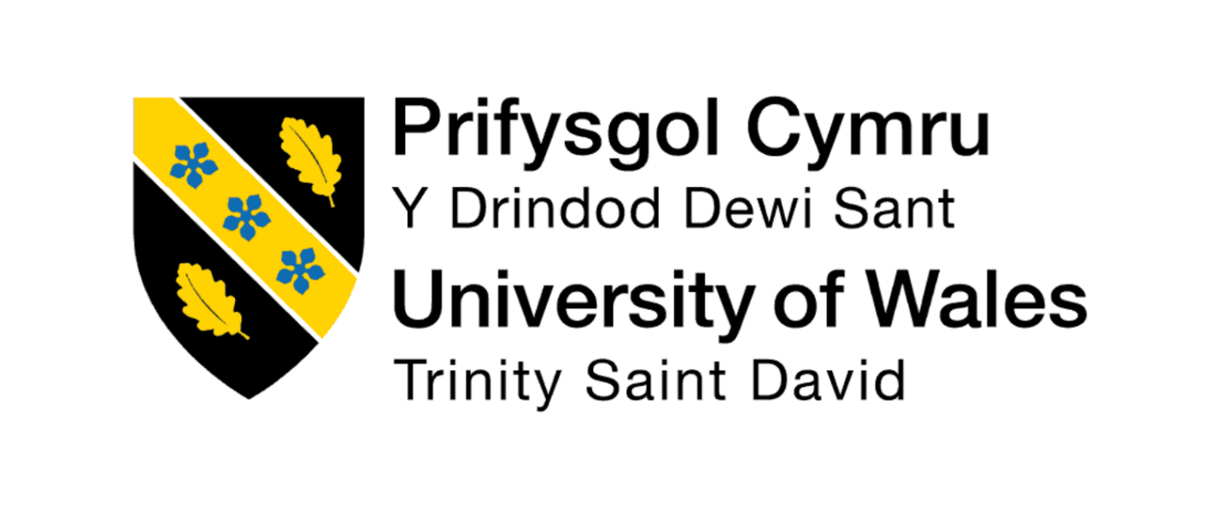
Student Name: Henri William

Student ID:2115861

Module Name: Marketing Management

Module Code: LCMB7024

Lecturer’s Name: Dr Laila Maazouz

Work Count:2500

Term 1

Table of Contents
Element 1: STP Analysis 3
Element 2: Marketing Mix 7P 5
Element 3: Marketing Strategy Pitch 8
Slide 1: Introduction – Meet Zara Blue Light 8
Element 4: Reflection 9
Reference List 12

Element 1: STP Analysis
Zara, the giant in the fast fashion industry, has been reputed to reproduce evolving fads on the runways, in order to make low-priced and wearable clothing quicker than ever. In line with the increasing need to be more sustainable, transparent and ethically-produced, Zara has developed a new brand called Zara Blue Light, which is concentrated on environmentally-friendly fashion. The origins of this project on strategic decisions follow Zara in its efforts to consonant with the trends of the market such as the environmental consciousness, the demand of sustainable products and the increasing tendency to become responsible consumers, as inherited by younger generations (Kumar, 2020). Zara Blue Light is the brand combination of high fashion and sustainability, with the items designed of organic fabrics, recycled polyester, and dyes with minimal impact, ensuring that it attracts the attention of consumers who would require the solution of exciting and eco-friendly options.
The tremendous diversification of consumer behaviour can explain the popularity of Zara Blue Light. They have emerged to be the most sustainability-conscious consumer groups, with the millennials and the Gen Z wanting more ethical brands with lesser carbon footprints and brands with greater transparency in the supply chain. Sustainable apparel is popular because there is a growing awareness of the impact of climate change among people around the world, the rise of conscious citizenship, and the acceptance of the concept of the circular economy (Balsara and Gómez-Zará, 2024). Digital savvy consumers are also very active in communication with their brands of telling true stories and providing information on product origin. As a means of dealing with them, Zara Blue Light will respond to these expectations by integrating the idea of sustainability into online marketing, collaborating with influential people, and the shopping process.
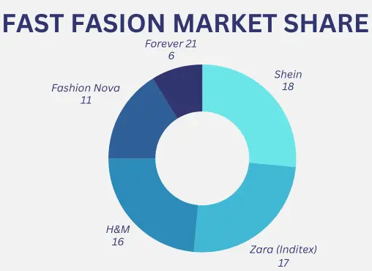
Figure 1: Fast Fashion Market Share
(Source: Ahmed, 2025)
Segmentation
The segmentation of the sustainable fashion market may be provided in terms of demographic, psychographic factors, behavioural and geographic factors.
- The segmentation will be determined by demographic (age, majority 18- 40 years), a higher educational level and the middle classes of income, which are able to pay a bit more to receive sustainable products.
- Psychographic classification is aimed at it being a green, value-conscious buyer and individuals who do not sacrifice style to purchase ethical brands exclusively.
- Behavioural segmentation is based on frequency of purchase, dedication to sustainability-based brand and sensitivity to transparency, along with environmental certification (Khatoon and Rehman, 2021).
- Geographic segmentation includes the urban communities in developed and emerging markets where there is high sustainability and Zara warehouses have high market penetrations.
Targeting
Zara Blue Light will focus primarily on the environmentally-conscious Millennials and Gen Z shoppers of age 18-35 years old who cannot be told apart in terms of their aesthetics and ethics when choosing the shopping option. This population is highly sensitive to online content, sustainability influencers, and transparency of the brand. They tend to go online to obtain the news of what the products are, they must be given the assurance by their submitting to awareness of the sustainability requirements, and they desire to be identified with the brands that uphold their personal values (Rahman et al., 2023). The target group is particularly attractive due to its high purchasing capacity, adoption patterns and a responsible outlook to the society (Ruiz-Navarro et al., 2024). The secondary consumers, including young professionals, also find Zara Blue Light appealing as they are concerned with sustainability in their work and sportswear and require wearing products released by the brand to support their active lives.
Differentiation and Positioning
Zara Blue Light is unique in its ability to blend the speed and lightness of its fashion factor with an effort at providing sustainability, an area its competitors are non-punishably unable to maintain the quality of their design. It is also not priced as highly as in the niche eco-brands that prioritise relations with the high market, Zara Blue Light does not sacrifice quality and even does not sacrifice ethical principles (Nayak et al., 2020). Its production processes put pressure on green resources, open supply chain, and reduced impact of the environment. Another digital addition to the brand is the digital storytelling, that shows what path each garment has been through in order to build trust and emotional connection to the consumer.

Zara Blue Light will be a developmental brand that aims at positioning itself as a low-cost, trendy, and responsible fashion brand that empowers the consumers to make sustainable choices without necessarily compromising on trendiness. The desired positioning can be summarised as: “Sustainable fashion made stylish, transparent, and affordable.”

Element 2: Marketing Mix 7P
Zara Blue Light brand model includes sustainable fashion, ethical production, and modern design. The 7Ps marketing mix as a support to this strategic direction would constitute a comprehensive guideline of realising and communicating the value statement of the brand. Every element of the marketing mix promotes the concept of the Zara Blue Light which is the provision of trendy, inexpensive, and eco-friendly fashions.
a. Product
The line of products offered by Zara Blue Light is also concerned with eco-consciousness, based on the clothes created with the help of environmentally-friendly materials such as organic cotton, Tencel, bamboo fiber, and recycled polyester (Niinimäki et al., 2020). The line stretches to casual and sportswear, business clothes and collections of seasonal purchases having few variations. Minimalist design and functionality, as well as longevity, imply that the products do not lose the reputable image of Zara as style-conscious and in line with consumer requirements of sustainability.
Every clothing is equipped with a digital product passport, which can be seen in the encode of a QR-code, a digital format containing the data regarding the sources of materials used in the garments, the chain of supply, the indicators of environmental impact (Stenton et al., 2021). Such transparency can be communized to reflect on the demands of the consumer who wants to receive authenticity and offers hope to consumers who are eco-friendly. Additionally, Zara Blue Light offers instructions on repair and care of garments advice to assist in enhancing the product life, which sells the concepts of the circular fashion.
b. Price
Zara Blue Light applies the value-based pricing strategy that makes it low but symbolises the experience of both expensive nature of eco-friendly materials and moral practices. The prices will be set at a small markup to the core collections of Zara, yet at a very competitive price to the high-end sustainable brands (Sagapova et al., 2022). The advantage of this pricing approach is that it allows to introduce eco-friendly fashion to the mainstream consumers who are, first of all, the Millennials and Gen Z willing to support sustainable brands but at the same time price-sensitive.
The Blue Light line presupposes also a tiered pricing at Zara, where basic essentials will be and a line with the prices ranging between competitive prices and few editions of sustainable products will be at mid-range price (Shimul, 2022). Periodical promotions, returns and package discounts stimulate trials and repeat purchases.
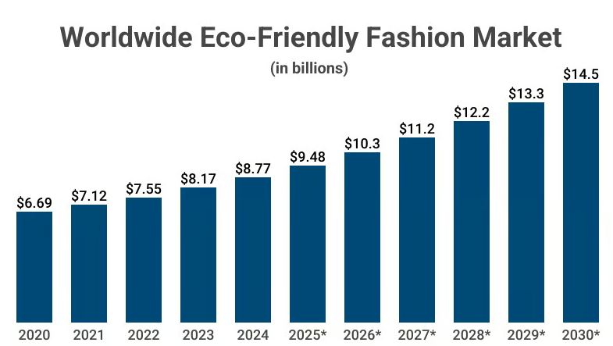
Figure 2: Worldwide Eco-Friendly Fashion Market
(Source: Capital One Shopping, 2025)
c. Place
The indisputable presence of Zara worldwide distribution network also means that Zara Blue Light is widely available to the population. The line will be sold in major flagship stores, chosen high-traffic stores and online platforms (Bailey et al., 2022). Physical, there exist special [(green zone] in-store displays of Blue Light products in an environment with a sustainability-focused theme, featuring environmentally friendly interior decor, screen displays, and informational materials related to sustainable fashion.
The digital presence will consist of a dedicated section on both the Zara site and the app whereby more storytelling on the products will be provided, interactive supply chain maps, and product impact calculators. Zara has an integrated supply chain that facilitates efficient distribution, as it makes it possible to control inventory in real time and minimise waste.
d. Promotion
The idea of Zara Blue Light promotion is based on authentic stories and open dialogue. The essence of the message is focused on sustainable materials, responsible sourcing and environmental responsibility without sacrificing on style. Tactics to be used in promotion are:
- The digital campaigns with the presentation of the production processes behind the scenes.
- Partnerships with sustainability and environmental activists, fashion bloggers, to gain the necessary credibility and address target audiences (Auerbach George et al., 2023).
- On websites like Instagram, TikTok, and YouTube, social media storytelling and the promotion of green awareness and information on the lifecycle of clothing.
- On store activities, such as sustainability workshops and meet the makers.
- Campaigns that adhere to the environment, e.g., recycling campaigns of clothes or planting trees.
Such promotional efforts put Zara Blue Light as a socially responsible and fashionable business whose consumers are environmentally conscious.
e. People
The value delivery of Zara Blue Light relies on people. The training of staff is based on sustainability, customer interaction, and product expertise. The sales associates are taught how to use sustainable materials, circular fashion, and how best to talk about environmental initiatives. This will guarantee stable and aware customer interactions. It is recommended that employees operating in the supply chain adhere to ethical labour practices endorsed by the fair working conditions and reporting (Owusu-Wiredu, 2024). Zara and sustainability auditors work together with certified suppliers to make sure that their standards and ethics are followed in the environment and social standards. The incentive of applying the involvement of the employees creates internal advocacy as well as strengthening external credibility in the brand.
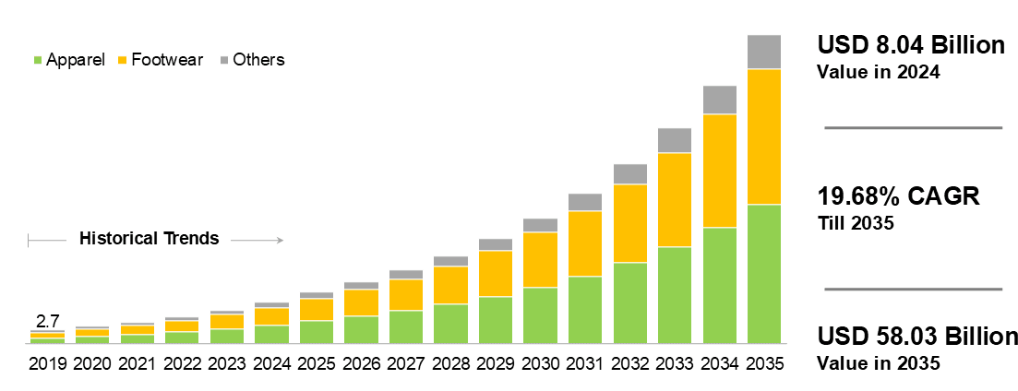
Figure 3: Sustainable Fashion Market
(Source: Roots Analysis, 2025)
f. Process
Zara Blue Light has sustainability in the product lifecycle. The supply chain concentrates in the ethical procurement, reduced water consumption and the utilisation of renewable energy, and the fragmentation of waste. The brand in processes where feasible, employs a circular model of production, which is recycling of textile waste and biodegradable packaging (Humayun and Bhavadharani, 2025). There is a streamline of the buying process of online fit advice, online try-ons, and traceability dashboards by using digital tools. The right logistics will ensure that the products will be ready in time and minimise carbon emissions. The in-store checkout and digital receipts and paperless indicate that the element of waste minimisation is taken into account as a brand feature.
g. Physical Evidence
The physical components of the evidence of Zara Blue Light include sustainability and modern design. There are Green Zones within the store that have recycled materials, greenery, natural lighting, and sustainable digital displays. The product tags and the packaging materials are produced using biodegradable products or recycled products, which reinforce the eco-friendly brand image.
There are digital interfaces of the brand on the internet which are clean-designed, soft in colour schemes and pictorial indicators of sustainability certifications (Bonelli et al., 2024). The transparency and trust are improved with the help of the QR codes on the garments, which could be used by the customers to receive the digital product passports.
Furthermore, the reusable bags in Blue Light brand and quite minimalistic packing create a comprehensive and recognisable brand image. All the physical and online touchpoints communicate the concept that sustainability and style can be combined.

Element 3: Marketing Strategy Pitch
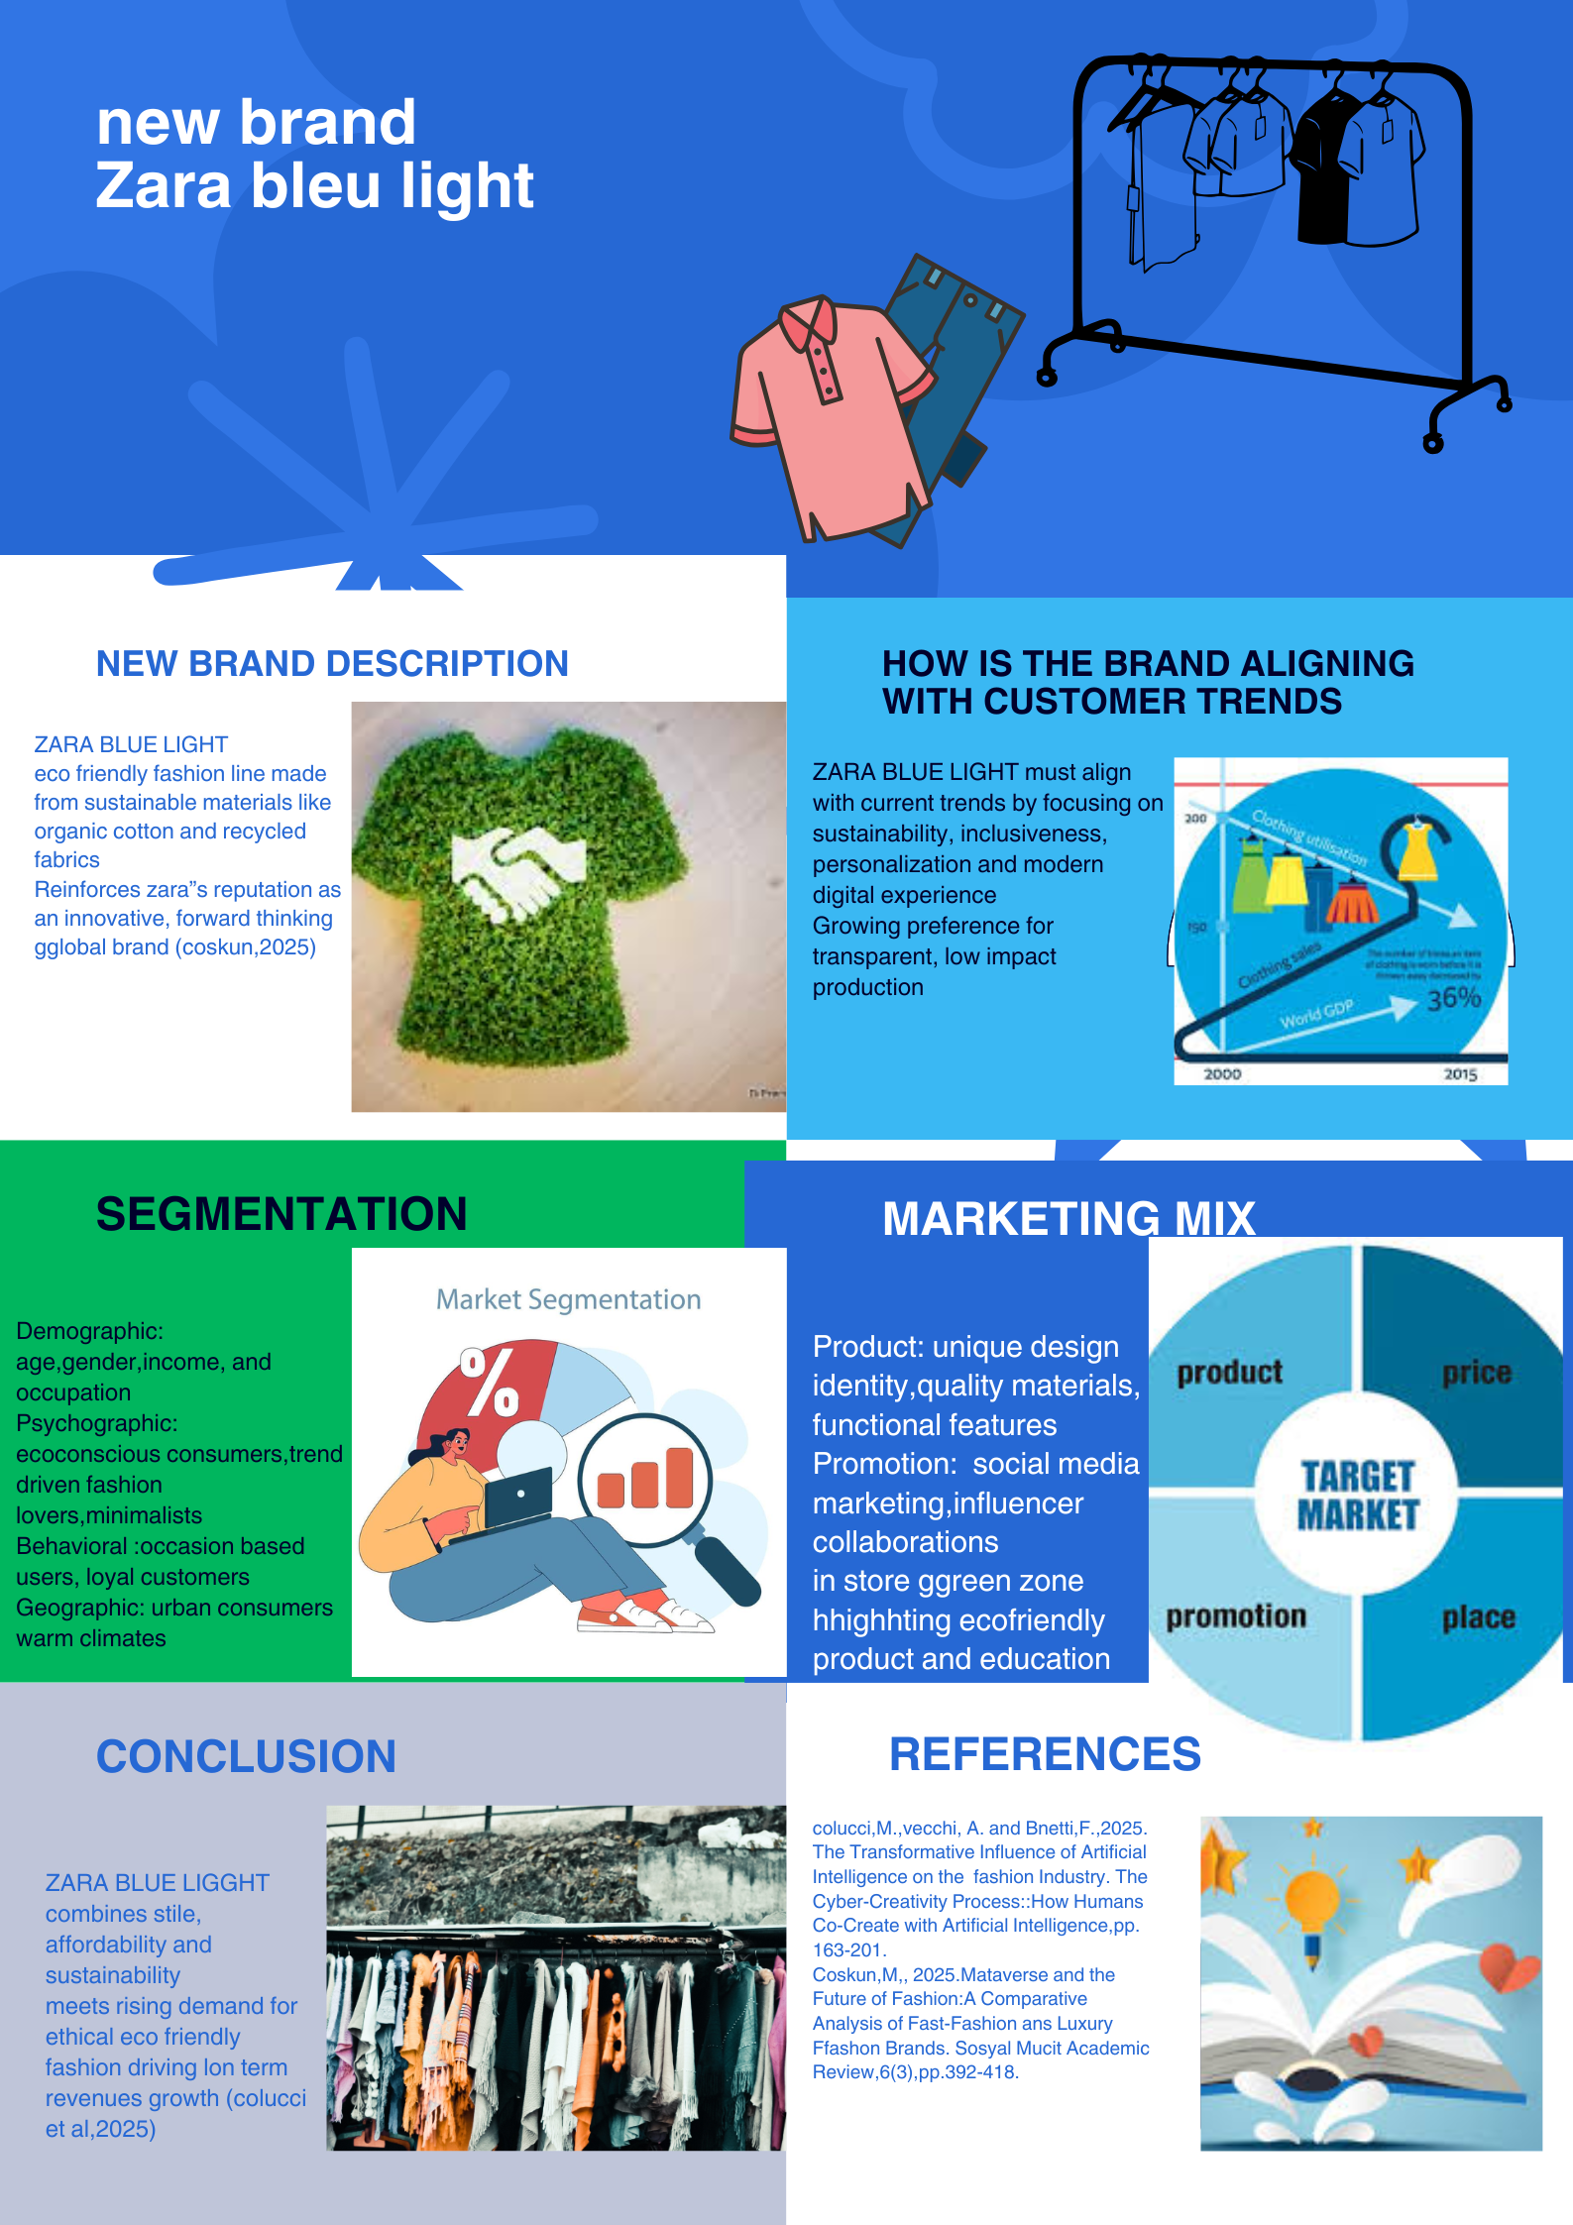
Element 4: reflection
The Zara Blue Light brand concept allowed me to further comprehend how it is possible to integrate the concept of sustainability with contemporary fashion, although keep the elements of style and affordability that the consumers consider when making the purchase. In the process of designing the strategy of branding and marketing, I realized that I should make all decisions based on core values of the brand. I also came to realise the need of modern brands to be authentic, especially when it comes to engaging in business with environmentally sensitive customers. This experience also enabled me to have an insight into the consideration between creativity and strategy when launching a new brand into a competitive market.
The work on the development of the marketing mix and the analysis of STP allowed me to improve my abilities in terms of studying consumer behaviour and drawing corresponding market segments, along with developing specific strategies. I came to know how crucial the data-driven insights were in the formulation of the price, promotion, and positioning decisions. It also included differentiation; I had to be capable of analysing how Zara Blue Light would be differentiated among the constantly growing brands of sustainable fashion. That has influenced me to research on the aspects of a product and consider the perceptions of a consumer and the trends emerging as a result.
Marketing strategy, pitching and presentation have enabled me to become more confident when it comes to making a presentation of visual and verbal communication. Reducing the information about complicated plans and organising it on short and strong slides also influenced me to select what was most important and present it in an engaging manner. In this, I was enabled to learn more on presentation and narration skills, particularly in the clear and persuasive presentation of the concepts on sustainability. The lesson helped me to see that good visuals, essential messages, and calculated circulation can make a significant contribution towards the engagement of people.
Analysing the overall performance, I can say that there are certain things that I can improve. In my future endeavours, I would conduct more intensive market research and involve a live information to demonstrate my arguments. The other aspect which I would eliminate whenever it comes to feedback is to ensure that the feedback is received earlier in the creativity so that I can perfect my ideas. Also, I feel that I ought to practice my presentation through digging more practice to make the presentation yield smoothly and without any doubt.
All in all, this project enabled me to acquire practical strategic, analytical, and communication skills. It improved my professionalism and creativity skills of critical thinking. These lessons will be very informative in my future branding and marketing project as it will make me undertake them in a deeper more assertive way.

Reference List
Kumar, P., 2020. A review of Relationship Marketing fundamentals. Journal of Talent Development and Excellence, 12(2s), pp.3915-3921.
Balsara, D. and Gómez-Zará, D., 2024, July. Virtual Threads: A Systematic Literature Review of 10 Years of VR/AR/MR Adoption in Fashion Design. In Proceedings of the 2024 ACM Designing Interactive Systems Conference (pp. 356-371).
Rahman, O., Hu, D. and Fung, B.C., 2023. A systematic literature review of fashion, sustainability, and consumption using a mixed methods approach. Sustainability, 15(16), p.12213.
Nayak, R., Nguyen, L.T., Panwar, T., Ulhaq, I. and George, M., 2020. Standards, organizations and lean concept in managing sustainable fashion supply chains. Supply chain management and logistics in the global fashion sector, pp.183-215.
Niinimäki, K., Peters, G., Dahlbo, H., Perry, P., Rissanen, T. and Gwilt, A., 2020. The environmental price of fast fashion. Nature reviews earth & environment, 1(4), pp.189-200.
Stenton, M., Kapsali, V., Blackburn, R.S. and Houghton, J.A., 2021. From clothing rations to fast fashion: Utilising regenerated protein fibres to alleviate pressures on mass production. Energies, 14(18), p.5654.
Sagapova, N., Buchtele, R. and Dušek, R., 2022. The Fashion industry and its problematic consequences in the green marketing era a review. In SHS Web of conferences (Vol. 135, p. 01011). EDP Sciences.
Bailey, K., Basu, A. and Sharma, S., 2022. The environmental impacts of fast fashion on water quality: a systematic review. Water, 14(7), p.1073.
Auerbach George, H., Tregenza, L., Stenton, M., Kapsali, V., Blackburn, R.S. and Houghton, J.A., 2023. Challenging perceptions of fast and slow in contemporary fashion: A review of the paper dresses trend in the United Kingdom and the United States during the 1960s. International Journal of Sustainable Fashion & Textiles, 2(1), pp.29-52.
Owusu-Wiredu, P., 2024. From a disposable to a sustainable fashion industry: A review of the shameful trade flows of used textiles and the need to address fast fashion. Corporate Governance and Sustainability Review, 8(1), pp.32-44.
Humayun, S. and Bhavadharani, M., 2025. Assessing the Impact of Cheap and Fast Fashion Industry on Society, Environment and Sustainability: What is the True Cost?. Habitus Toplumbilim Dergisi, (6), pp.211-222.
Bonelli, F., Caferra, R. and Morone, P., 2024. In need of a sustainable and just fashion industry: identifying challenges and opportunities through a systematic literature review in a Global North/Global South perspective. Discover Sustainability, 5(1), p.186.
Ruiz-Navarro, R., Hintzmann, C. and Corrons, A., 2024. Sharing Economy and Fast Fashion (Sustainability and virtual consumer behavior: A review and research agenda). Authorea Preprints.
Khatoon, S. and Rehman, V., 2021. Negative emotions in consumer brand relationship: A review and future research agenda. International Journal of Consumer Studies, 45(4), pp.719-749.
Shimul, A.S., 2022. Brand attachment: a review and future research. Shimul, AS Brand attachment: a review and future research. J Brand Manag (2022). https://doi. org/10.1057/s41262-022-00279-5.
Aguilera-Cora, E., Fernández-Cavia, J. and Codina, L., 2025. Place branding and sustainable development: A scoping review. Place Branding and Public Diplomacy, 21(1), pp.15-30.
Sharma, M. and Rahman, Z., 2022. Anthropomorphic brand management: An integrated review and research agenda. Journal of Business Research, 149, pp.463-475.
Madsen, D.Ø., Silva, E.S. and Hassani, H., 2020. The application of big data in fashion retailing: a narrative review. International Journal of Management Concepts and Philosophy, 13(4), pp.247-274.
Colucci, M., Vecchi, A. and Bonetti, F., 2025. The Transformative Influence of Artificial Intelligence on the Fashion Industry. The Cyber-Creativity Process: How Humans Co-Create with Artificial Intelligence, pp.163-201.
Coşkun, M., 2025. Metaverse and the Future of Fashion: A Comparative Analysis of Fast-Fashion and Luxury Fashion Brands. Sosyal Mucit Academic Review, 6(3), pp.392-418.
Ahmed, T. (2025, May 14) ‘Fast Fashion Market Share in 2025’. SylvanApparel.com. Available at: https://sylvanapparel.com/fast-fashion-market-share/ (Accessed: 15 November 2025).
Roots Analysis. (2025) Sustainable Fashion Market, Till 2035: Distribution by Type of Product … Industry Trends and Global Forecasts [online]. August. Available at: https://www.rootsanalysis.com/sustainable-fashion-market (Accessed: 15 November 2025).
Capital One Shopping. (2025) Eco-Conscious Consumer Statistics & Trends (2025 Report) [online]. Updated 1 March. Available at: https://capitaloneshopping.com/research/eco-conscious-consumer-statistics/ (Accessed: 15 November 2025).

