ALED WINTER

HNC/HND IN ELECTRICAL AND ELECTRONIC ENGINEERING
WIN21861113
TRANSISTOR AMPLIFIER

Table of Contents

Introduction 1
Objectives 1
Theory / Research 2
Equipment / Apparatus 7
Experimental Procedure / Mythology 9
Results 11
Evaluation 18
Conclusion 19
References 19

Introduction

Transistor amplifier circuits are used in every modern-day electronics with a wide range of applications ranging from audio amplification to signal processing. The aim of my report is to show my ability to demonstrate how to design and simulate transistor amplifier circuits, as well as to prove my designed circuits are operating and functioning correctly. Throughout the report I will be exploring the design and simulation of both single and two stage transistor amplifier circuits, explaining their efficiency and reliability for applications used every day.
Firstly, I will be conducting extensive research of three different types of transistor amplifier circuits configurations explaining their strengths and weaknesses, typically applications and their electrical characteristics.
Secondly, designing and simulating both circuits using Multisim, and showing my calculations to show that my resistor and capacitor values are correct and produce the given voltage gain given in the brief. I will also show my circuit diagram also created in Multisim which will show all the components and their values needed to create my circuit.
Finally, the report will conclude by reflecting on my work and outcomes of my design and simulation. Giving a detailed overview of how the design and practical creation of my amplifier circuit went compared to my simulation showing any differences and changes I needed to make in order for the circuit to work.

Objectives

- Investigating Transistor Amplifier Circuits: Conducting a detailed examination of three types of transistor amplifier configuration including common collector, common emitter and common base. Comparing their performances and key parameters such as voltage, current, power gain and impedance, also showing their strengths and weaknesses and typical applications.
- Designing and Simulating Amplifier Circuits: Here I will be using a program called Multisim to design and simulate my circuits, at the same time this will create both circuit diagrams for the single stage and two stage transistor amplifier circuit. To simulate the circuit, I will need my calculations which are created by the values given in the brief and used to create the simulation.
- Analyzing Supplementary Circuit Elements: Discussing the roles of supplementary elements, such as capacitors and resistors within the common emitter transistor circuits. Then show how they affect the overall performance and characteristics of the amplifier circuit.
- Improve Voltage Gain: Experimenting with ways to improve my voltage gain by introducing capacitors in the emitter circuit. This can be done in Multisim easily by adding and removing the capacitor on the emitter circuit and changing its value to suit the need of the gain.
- Desing and Simulate Two Stage Transistor Amplifier Circuit: To plan and design a two-stage amplifier circuit to achieve a goal of 10, using the values created by my calculations to create a circuit. Thus, comparing the simulation with theoretical expectations and showing my practical implications and limitations of the designed amplifier.
- Verifying The Circuit: To determine the frequency response and dynamic range of the amplified circuit to suit specific audio applications and verify impedance input and output of the designed amplifier.
- Creating The Circuit: Lastly creating the designed circuit in the laboratory using instruments to show that the circuit is inverting and giving the correct gain.

Theory / Research
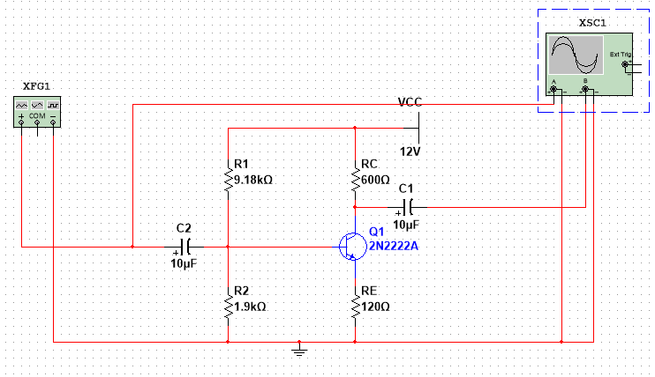
Transistor as an Amplifier: “A transistor is made up of layers of semiconductor materials which are the base, emitter and collector.” (Moraes, 2023) They are commonly used in amplifier circuits and can increase the amplitude of electronic signals. They are used in a wide range of applications, including audio systems, radio frequency communications, instrumentation and many other variants. Transistor amplifiers are categorized based on their configuration (common emitter, common base, common collector is most common) and consist of typically one or more transistors including capacitors and resistors to create a amplification. Their operation consists of a small voltage flowing between the base and emitter causing a much larger current to flow. This is called the gate a bit like a switch as shown in the image above of an NPN transistor as used in my circuit.
Common Emitter Configuration for a Transistor Amplifier Circuit

The image above shows the emitter configuration used widely in bipolar junction transistors (BJT) and is the common point between input and output circuits. Its characteristics are well suited and very popular for electronic circuits because of its high-power gain and medium voltage gain with a phase relationship of 180 degrees in input and output. Also including a high current gain. This is advantageous of applications like low noise amplification circuits, radio frequency transceiver circuits and RF circuits. (Elprocus, 2024) This configuration has a high voltage gain due to the ratio between output and input voltages and also provides a current gain due its unique configuration making it useful for application and various voltages. Also, the input and output impedances which is preferable in this configuration due to its low output as this is suitable for loads with varying impedance but has a moderate input impedance which is dependent on the resistors I choose in the design.

Common Base Configuration for a Transistor Amplifier Circuit
The common base configuration uses the base terminal as the common connection point between input and output circuits. In this configuration it will have a low input impedance and moderate output impedance, making it useful for radio frequency amplification and for application requiring current gain. It also has its advantages from being able to boost the voltage significantly which will create stronger signals with the need of much power and being able to handle a range of frequency making it versatile. But is limited by its power output and current gain having a value of 0. (AspiringYouths, 2024)

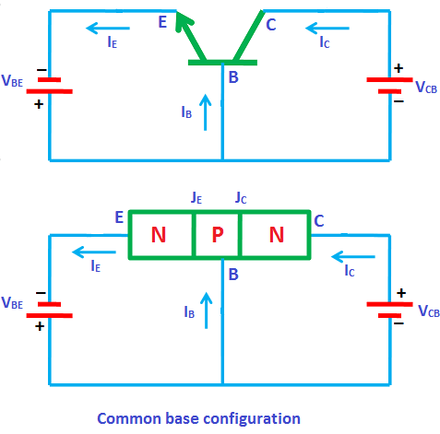 (physics-and-radio-electronics, n.d.)

Common Collector Configuration for a Transistor Amplifier Circuit

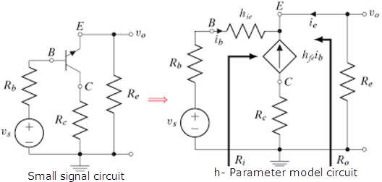
The Common Collector configuration is a widely employed arrangement in bipolar junction transistor (BJT) amplifiers, where the collector terminal is used as the common point between the input and output circuits. It’s called the common collector because the terminal is earthed through the power supply. (AspenCore, 2020) Its characteristics are having a high impedance input needing to be connected to a low impedance output load requiring a high current gain. “It is highly known for its feature of producing higher values of the gain in current” (Watelectronics, 2019) This configuration is used as a switching circuit and can be used in digital circuits with logic gates but is limited due its high output resistance and unstable voltage gain.
(Elprocus, 2013)

Equipment / Apparatus

Capacitors
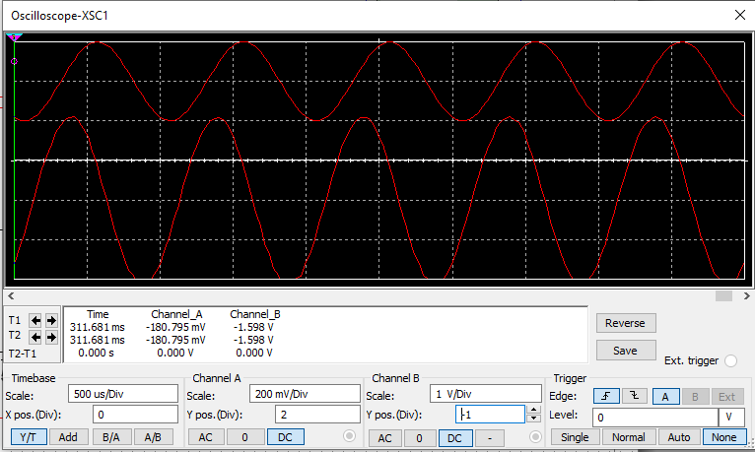
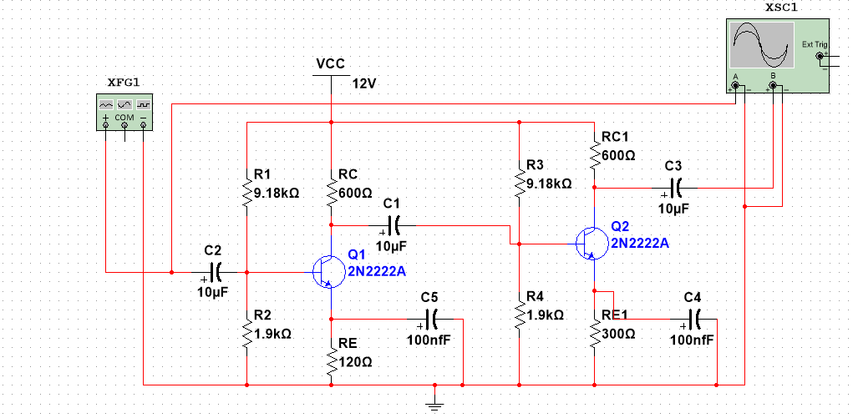
The capacitors used in amplifier circuits are used numerously in different ways. Firstly, in amplifier circuits capacitors are used by allowing AC of the input signal pass through while blocking the DC component, naming them coupling capacitors using C1 and C2. (AspenCore, 2020) The primary function for a capacitor is to filter out noise and stabilize voltage levels and protect components by saving them from fluctuation in the incoming power supply “Bypass capacitor is used to prevent noise from entering the system by bypassing it to the ground” (Components101, 2019) Bypass capacitors are extensively used in analog and digital circuits because they remove unwanted signals from supply voltage and are used in many applications such as, DC/DC converters, signal coupling/decoupling and between an amplifier and loudspeaker for clear audio.
The diagram above was designed on multisim by myself and shows the 2-stage amplifier circuit. To explain further the roles of the coupling capacitor I will be removing C4 from the circuit and then looking at the oscilloscope to see what has happened whilst it is being removed. Below is the oscilloscope of the missing capacitor showing its differences:
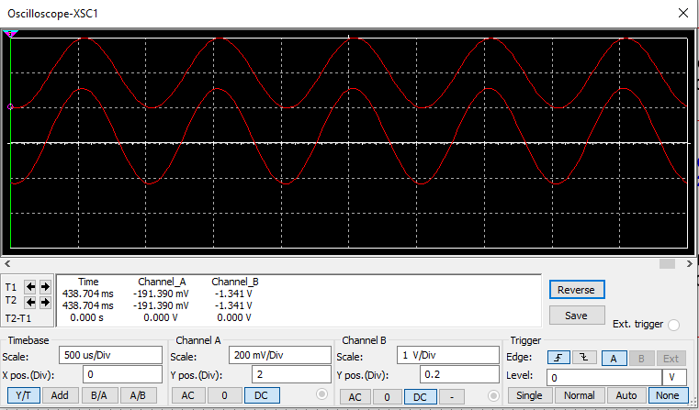
As you can see from the oscilloscope channel B has changed its properties from 4 boxes (as seen in the previous oscilloscope) to now 2.8 boxes. The capacitor C4 has a value of 100nf and has only changed the value in channel B and not affected Channel A.
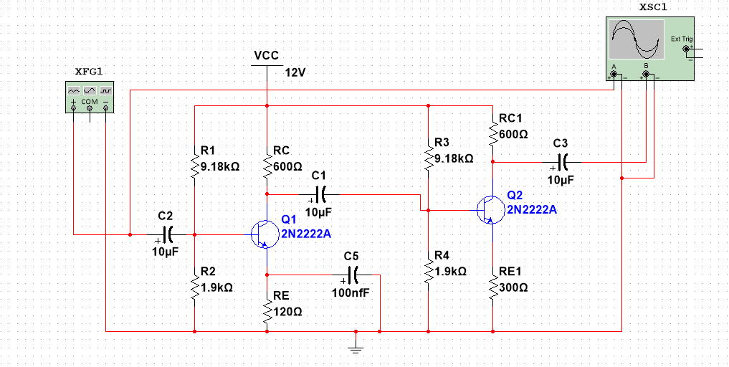
As you can see above the diagram is missing its coupling capacitor on the 2nd transistor (on the right) which is making the circuit reduce its gain therefore we can say that capacitor C4 us used to increase the gain if needed and in my case, I needed it.
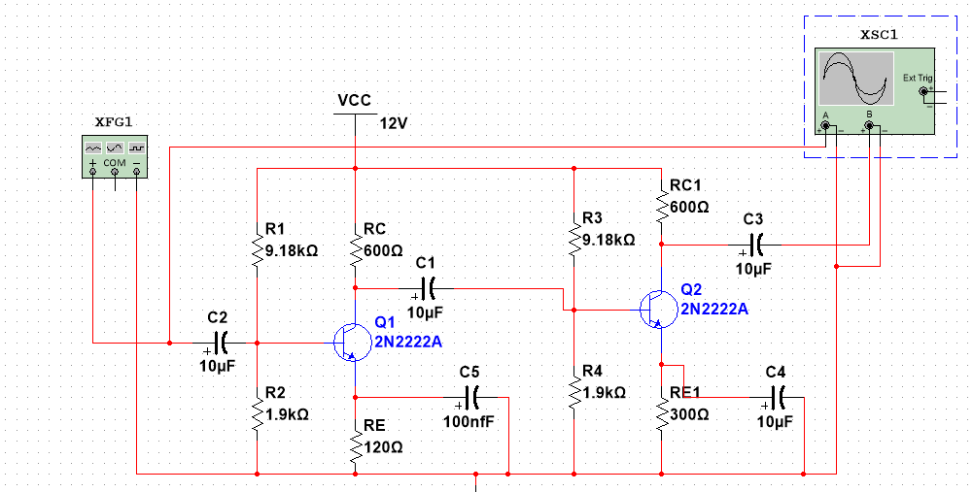
To experiment further I can also change the value of the capacitor C4 and again take a look at the oscilloscope so for this I changed the value from $100nF$ and $10μF$ and here is the result below. As you can see the Output (Channel B) is no longer inverting is showing a very high reading due to the increase in capacitance which is not suitable for my circuit.
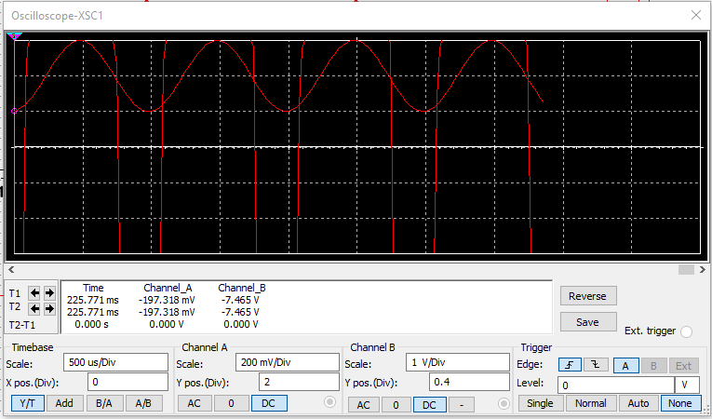

The transistor we have been tasked with is the 2N2222 NPN or BC109 NPN transistor, so I decided to choose the 2N2222 NPN as they are readily available for our practical exam later and are used all the time in electronic circuits due to their cost and availability. Unknown to knowledge this type of transistor was developed by an American company “Fairchild Semiconductor in the early 1960s.” (Evans, 2023) The 2N2222 NPN transistor is well known for its reliability and versatility and having a “high current capability and low saturation voltage make it ideal for amplification, switch and signal processing in a wide range of electronic applications” (Components101, 2017)
(Evans, 2023)

Resistors
Resistors used in a transistor amplifier circuit are critical, as they have an impact on contributing to stabilization, impedance and signal conditioning. “They play a crucial role in determining the overall performance of the amplifier” (Techschematic, n.d.) Resistors R₁ and R₂ supply voltage (DC) to the base of the transistor while resistors RC and RE control the collector and emitter currents. Changing these resistor values changed the amount of current flowing through the circuits thanks to ohms law $(R=V÷I)$ for our experiment we had to calculate and then choose resistors to use for our practical exam, as you know resistors do not come in every value so choosing one must be done carefully. Below is a table of colors corresponding to the value given on a resistor needed to identify their values.

Experimental Procedure / Mythology

Calculations

$$VC=\frac{VCC}{2}$$
$$VC=\frac{12 }{6}$$
$$RC = RL (For maximum power transfer)$$
$$IC= \frac{VC }{RC}$$
$$IC = 6 / 600 = 0.01A or 10mA$$
$$B = \frac{IC}{IB} so IB=\frac{IC}{β}$$
$$IB = \frac{10×{10}^{-3}}{100}=100μA$$
$$Gain Av=\frac{RC}{RE}$$

$$5=\frac{RC}{RE}$$
$$RE=\frac{RC}{5}$$

$$RE=\frac{600}{5}=120Ω$$
$$I1=11×100×{10}^{-6}=1.1A or 1100μA$$
$$I2=10×100×{10}^{-6}=1A or 1000μA$$
$$IC ≈IE=10mA$$
$$VE=IE×RE$$
$$VE=10×{10}^{-3}×120=1.2V$$
$$VR2 = VE+Base Emitter Junction \left(0.7V\right)$$
$$VR2 = 1.2+0.7$$
$$VR2=1.9V$$
$$VR1=VCC-VR2$$
$$VR1=12V-1.9V$$
$$VR1=10.1V$$
$$R1=\frac{VR1}{I1}$$
$$R1=\frac{10.1V}{1100μA}$$
$$R1=9181.81Ω or 9.18KΩ$$
$$R2=\frac{VR2}{I2}$$
$$R2=\frac{1.9V}{1000μA}$$
$$R2=1900Ω or 1.9KΩ$$
With the calculations complete and double checked I can now use Multisim to simulate the circuit and prove that my r1 + r2 values are correct and record my results.

Results

Below is my single stage amplifier circuit with the values used above in Multisim. Now I will simulate the circuit and calculate my gain to ensure I have achieved the correct value. As you can see the oscilloscope is on the right-hand side and the function generator is on the right-hand side and both can be seen below with their selected values.

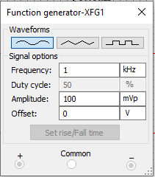
This is the function generator used in my circuit to give me my AC waveform seen later the oscilloscope. As you can see from the values below, I have decided to use a frequency of 1KHz. With the function generator set I can now run the program and look at my oscilloscope.

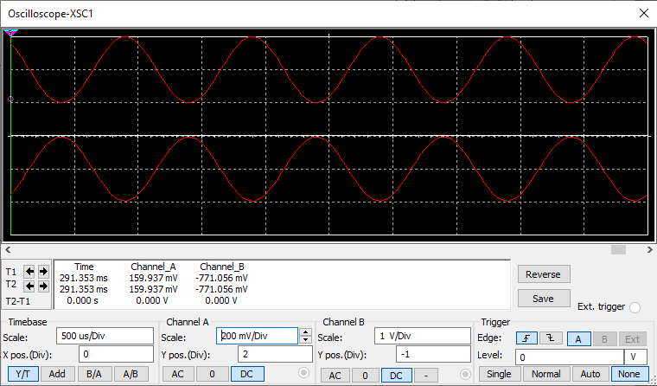
Below is the oscilloscope reading of an AC waveform using the program and as you can see the circuit is inverting correctly and is giving is a reading. The top AC waveform is our input labelled channel A and below it is our output labelled channel B. I decided to use a scale of 200mV per division on channel A and 1V per division on channel B to make it easier to visualize the waveforms to calculate voltage gain later.

With this information I can now calculate my voltage gain which given by task 2a a gain of 5 is needed. To calculate my voltage gain I need to look at my oscilloscope again between channels A &B to ensure that I have achieved a voltage gain of 5. This calculation is made by firstly multiplying both channels by their division so in this case it would be:
Channel A – Input = 2000mV x 2 = 4000mV
Channel B – Output = 1v x 2 = 2V or 2000mV
With this information I can now use the formula to calculate voltage gain which is:
$$Vout÷Vin$$
$$2000mV÷4000mV$$
$=5$ (Gain)

2 stage transistor amplifier circuit
This is the 2-stage transistor amplifier circuit created in Multisim to create a gain of 10. As you can see from the circuit, I have added coupling capacitors on the emitter leg of the transistor to earth to get me to the gain off an overall 10.
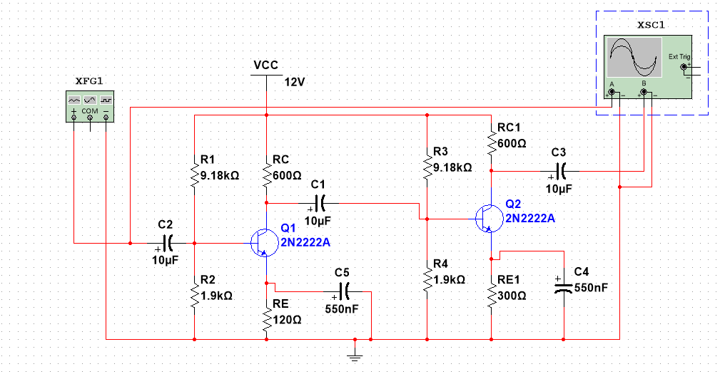

This is the circuit running of my 2-stage transistor amplifier circuit, as you can see the values used are as follows:
Channel A: Input = 200mV x 2 = 400mV
Channel B: Output = 1000mV x 4 = 4000mV

With this information I can now use the formula to calculate voltage gain which is:
$$Vout÷Vin$$
$$4000mV÷400mV$$
$$=10 (Gain)$$

Testing the circuit (practical)
This is my completed single stage amplifier circuit with values used in my calculations and is hooked up to 12v DC power supply and an oscilloscope. This circuit, like the first stage amplifier, is meant to give me a gain of 5 as calculated but we will see.

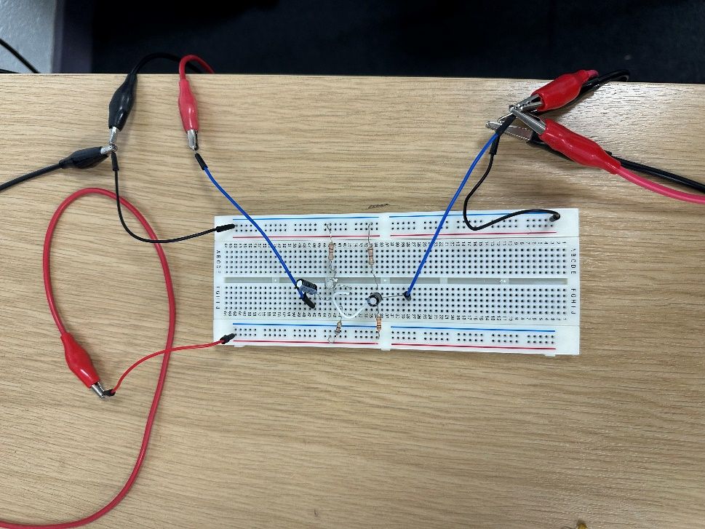
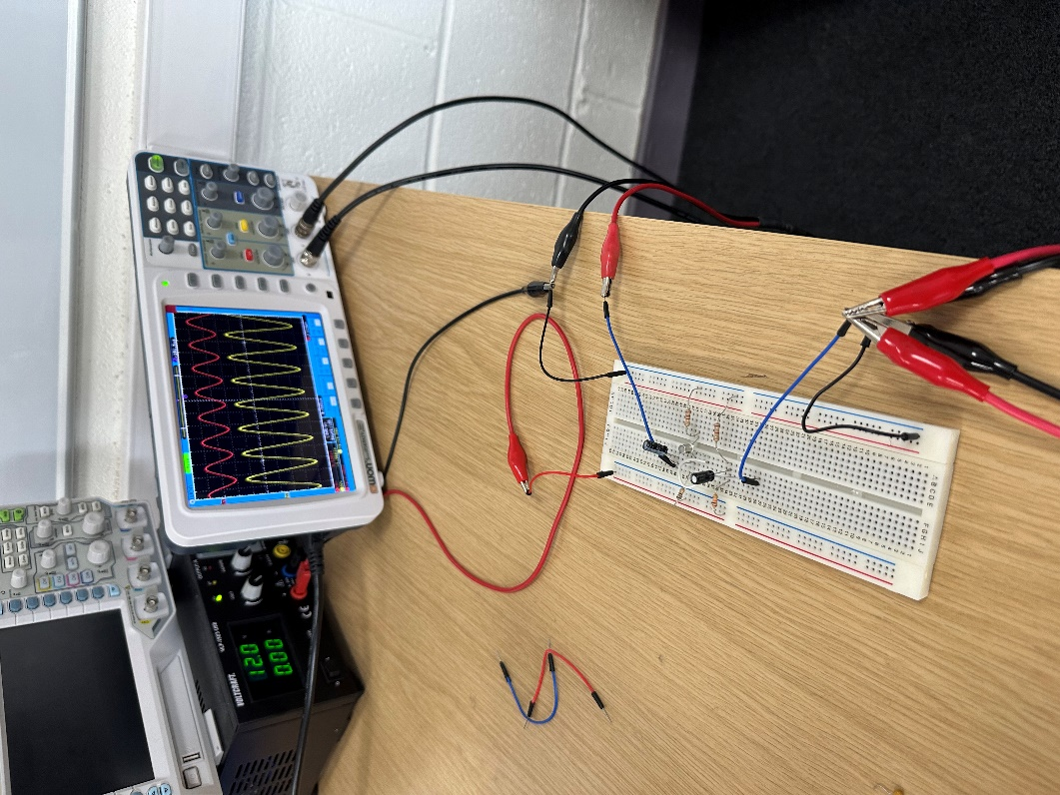

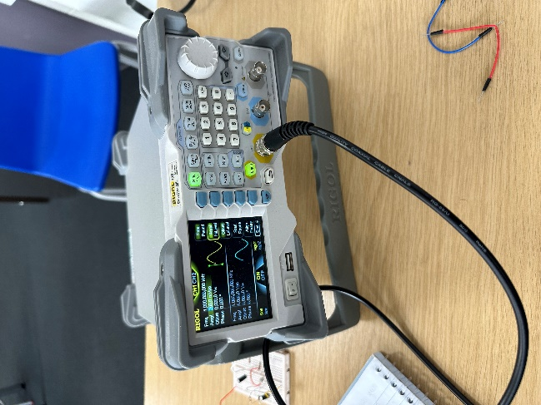

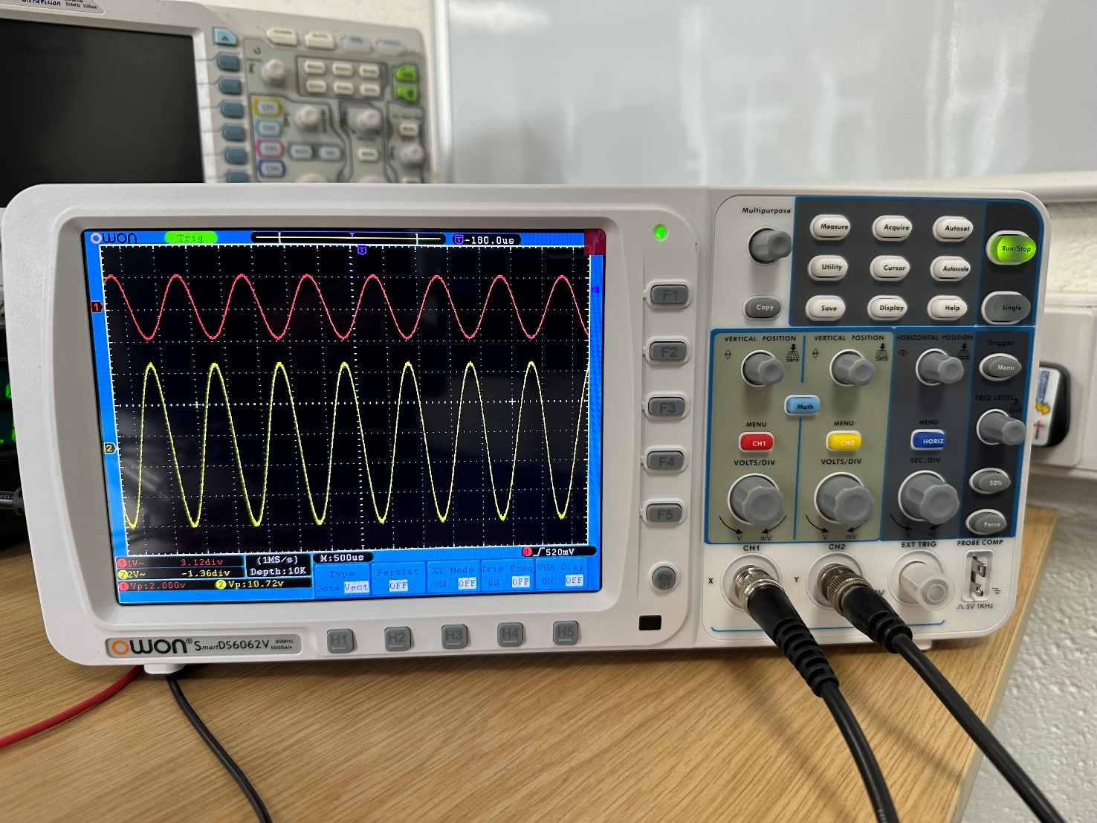

As calculated, I am getting a voltage gain of 5 on the oscilloscope shown here this is found by calculating the gain which is shown below:
Peak to peak from the oscilloscope Input = 2V (Red)
Peak to peak from the oscilloscope Output = 10V (Yellow)
With this information I can now use the formula to calculate voltage gain which is:
$$Vout÷Vin$$
$$10V÷2V$$
$$=5 (gain acquired)$$

After completion of the practical circuit building this is a picture of myself below with the circuit proving that I have built and tested the circuit myself.



Evaluation

Whilst creating the circuit in Multisim I did encounter some issues. Firstly, not getting the gain I wanted and getting a gain of 7 which took some troubleshooting by fault finding the circuit to check if it was at fault first. I did this by following all attached connections, making sure that they were all connected and not disconnected and ensuring I had the correct frequency and components in their correct places. Without any luck I dived back into my calculations in order to find the fault. After going through my current values, I noticed I had not used the correct values for micro amps which in turn changed the values of my r1 and r2. With this changed to the correct values I had the $9.81kΩ and 1.9kΩ$ which were used and gave me the gain of 5 I was looking for. I did not need the help of a coupling capacitor in my first stage amplifier since the gain was 5 and after running the program the extra voltage boost was not needed. But in my second stage it was necessary on both emitter legs to give the overall gain of 10 I needed, with this I was successful in completing the circuits and getting the correct gain. I used two 550nF capacitors on the emitter legs on both transistors as mentioned before but also used two $10μF$ capacitors for the two remaining in the circuit, one connected to my oscilloscope and the other to my function generator. Lastly whilst creating the circuit practically I had to choose resistors not of the same value as my calculation but going to the next highest resistor. This is due to resistors only being a set value and there would have to be endless resistors for all values to be available, therefore I used a 680$Ω$ resistor instead of a 600$Ω$ as per design. This didn’t change the gain very much as the change of resistance is so small. Overall, there were some discrepancies between the simulated and practical side of the experiments made, but simulated and practical experiments are both very different when doing them and I have learnt a lot from that.

Conclusion

To conclude, after completing the practical task I have a good understanding of transistor amplifier circuits, from experimental circuits using Multisim to designing and building a circuit. It did come with its challenges due to some problems along the way being encountered but it demonstrated the importance of checking over your work and not giving up on something new you’re not familiar with and how having the incorrect value can really affect your amplifier circuit. Looking ahead I can see myself exploring the use of amplifier circuits and possibly using them in my workplace more and seeing the potential that they can bring to ease complicated circuits.

References

References
Anusha V, R. T. R. N., 2019. ElectronicsHub. [Online]
Available at: https://www.electronicshub.org/bypass-capacitor-tutorial/
[Accessed 26 April 2019].
AspenCore, 2020. Electronics Tutorials. [Online]
Available at: https://www.electronics-tutorials.ws/amplifier/amp_2.html
[Accessed 9 January 2020].
AspiringYouths, 2024. Advantages and Disadvantages of Common Base Amplifier. [Online]
Available at: https://aspiringyouths.com/advantages-disadvantages/common-base-amplifier/?utm_content=cmp-true
[Accessed 18 June 2024].
Astels, D., 2018. AdaFruit. [Online]
Available at: https://learn.adafruit.com/transistors-101/basic-operation
[Accessed 08 March 2024].
calculator.net, n.d. Resistor Calculator. [Online]
Available at: https://www.calculator.net/resistor-calculator.html
Components101, 2017. 2N2222A NPN Transistor. [Online]
Available at: https://components101.com/transistors/2n2222a-pinout-equivalent-datasheet
[Accessed 11 December 2017].
Components101, 2019. Decoupling Capacitors and Bypass Capacitors – Working, Applications and Differences. [Online]
Available at: https://components101.com/articles/decoupling-capacitor-vs-bypass-capacitors-working-and-applications
[Accessed 23 October 2019].
Elprocus, 2013. Common Collector Amplifier Circuit and Its Applications. [Online]
Available at: https://www.elprocus.com/common-collector-amplifier-circuit-working/
[Accessed 2013].
Elprocus, 2024. Common Emitter Amplifier Circuit Working & Its Characteristics. [Online]
Available at: https://www.elprocus.com/common-emitter-amplifier-circuit-working/
[Accessed 7 May 2024].
Evans, 2023. 2N2222 Transistor, Specs, Datasheet, Equivalent and Features. [Online]
Available at: https://www.circuitdatasheet.com/2n2222-transistor-specs-datasheet-equivalent-and-features/
[Accessed 12 August 2023].
Moraes, C. F., 2023. Understanding Transistors: What They Are and How They Work. [Online]
Available at: https://www.wevolver.com/article/understanding-transistors-what-they-are-and-how-they-work
[Accessed 06 November 2023].
physics-and-radio-electronics, n.d. Bipolar Junction Transistor. [Online]
Available at: https://www.physics-and-radio-electronics.com/electronic-devices-and-circuits/transistors/bipolarjunctiontransistor/commonbaseconfiguration.html
[Accessed 2015].
Techschematic, n.d. UNDERSTANDING TRANSISTOR AMPLIFIERS: A COMPREHENSIVE GUIDE WITH CIRCUIT DIAGRAMS. [Online]
Available at: https://techschematic.com/transistor-amplifier-circuit-diagram
Watelectronics, 2019. Basics of Common Collector Amplifier, Characteristics and Applications. [Online]
Available at: https://www.watelectronics.com/basics-of-common-collector-amplifier/
[Accessed 5 October 2019].

