My

Professional Career Development

Essay

CLASS: BMSW4005

Sudent Name: Marinela Camelia Craciunel
Student ID:1818825
Lecturer: Charles Oham

Table of Contents

Introduction: 2
Personal Development Plan (PDP): 2
PDP: Junior HR Executive (Hospitality) 2
Employability skills: 3
Positive and Negative aspects: 4
Strategies for HR interview: 5
Using SMART goals at workplace: 6
Johari Window: 7
Employment law: 9
Gibbs Reflective: 10
Conclusion: 11
References: 12

Introduction:
In this essay I will be preparing a personal development plan comprising of the skills that I need to develop over a period of time which will assist me in playing my role properly within workplace. My personal development plan will be connected with my career development plan which would be made in a manner that would cover a period of 3 years. My objective is to be prepared fully for any kind of job situation that may arise within workplace. The strategies that I need to put in require being planned beforehand, much earlier than when I will be in that situation for real.
I would be taking in Gibbs Reflective Cycle, Johari Window and Smart Objectives to exhibit the manner in which I am going to prepare myself for the job profile and the learning I have obtained from the mistakes that I have committed during my university days or when I was working somewhere previously.

Personal Development Plan (PDP):

PDP: Junior HR Executive (Hospitality) (referred to Appendix)
Long-term goals
HR Executive’s role

Short term goals
Developing consumer service, mentoring and management related skills

Goals | Objective | Resources | Measurement | Target Date
Developing recruitment and selection skills and other organisational skills | Working towards developing the work force and who are diligent and professional all the time. The workforce should be able to meet the requirements of the company and enable it to service of superior sort. | Need to observe the senior managers and my supervisor. Meeting all task they are allocating to me. | Feedback coming in from my supervisor and team leader. | It is an ongoing process, will be measured in 2021 Q3.
Developing mentoring and skills of communication | Updating the materials regarding training for the new staffs for reflecting the changes which have been approved in current staff meetings | Needs 25 hours of office work out of my normal shift | Reviewing the updated materials of training by the HR and Business Development managers | End of June 2020
 | Completing the certification program for mentoring and gaining recognition as a mentor within my shifts | Training | Completing of the training process | End of October
Developing management skills | Taking on accountabilities within shifts for dealing with the relocation process, process of safe deposit box, key controlling process and billing related issues. | Having more accountability along with authority within the shifts | Feedback coming in from the shift manager and the Hr manager | End of June
Source: (Created by author)

Employability skills:
Understanding consumer needs:
Human Resource is usually the primary interaction that lot of people largely has with a particular company. From receptionist to the hiring or the recruitment manager, skills regarding consumer service needs to be at the front and in the centre of each interaction. In making sure higher levels of consumer satisfaction, it is significant for the HR in incessantly measuring and monitoring the requirements of its several consumers, determining the manner in which it is fulfilling those requirements alongside identifying any areas which represent the gaps. This need breakdown involves several perspectives alongside establishing that takes priority. For example, HR managers require valuing higher degrees of production along with long working hours while employees might be valuing more time off besides focusing on the needs of work/life balance (Grit 2019). Effectual HR consumer service will be working with both the groups in finding proper balance.
HRM and Mentoring:
Human Resource Management engages the procedure of recruitment along with selection of the employees, along with induction, development and training besides performance appraisal. Human Resource managers at certain point of time within their work schedule requires mentoring for bringing about a transformation within their firm along with their working style (Lejeune, Beausaert and Raemdonck 2018). Mentoring can assist an association in winning the present day’s escalating war on talent and skilful employees though will only be attaining this effectually if the program of mentoring is lined up with the long-term goals and strategic positioning of the firm. Through mentoring employees can support initiatives regarding career-development, helping firms in communicating its values and behaviours and offering employees with a sense of belonging, communicating and fostering an environment that is more inclusive.
Communication skills:
HR executives having good skills of communication tend to smoothen over the issues prior to them escalating and conveying the standards of the company in clear manner. Human Resource department tends to manage the most important resource that an organization has: human capital where interaction is necessary and no effective interaction is possible without communication- both verbal along with non-verbal. For instance, good skills of communication are important while hiring new employees. For gaining knowledge of the manner in which candidates are to be interviewed that best gauges their fit will make sure an HR professional asks them the right possible questions. Additionally, a job description of clear sort is deemed the best mean of attracting qualified applicants who posses’ full knowledge of what the work involves (Lejeune, Beausaert and Raemdonck 2018).
Management skills:
HR executives are stated being liaisons between the employees, departmental heads along with the company CEOs. They deal with tasks which need to be finished off by different individuals along with departments.
-Time Management
Drawing up contracts of employment along with dealing with plans of payroll and insurance are tasks that are time-sensitive. HR teams are accountable for meeting the deadlines besides fulfilling with applicable regulations (Grit 2019).

Positive and Negative aspects:
As my dream job I would be requiring the above mentioned skills so that I am able to manage any situation which might crop up at certain point of time. Having skills is necessary in present times as the competition is stated being tougher irrespective of the industry that I may end up in. Having such skills would not only have a positive impact on me on the personal front but also on the organization I will be working in. Man management, communication and understanding the needs of consumers have become essential especially as my choice of work field will be within the service sector. An employee or a manger’s calibre is best known when the organization is in crisis and that is when I want to prove my abilities and bail out the organization every time I am required in doing the same.

Strategies for HR interview:
As stated earlier during the mid-way of my University days I joined a UK based hotel and have been working there for the past 2 years within the job profile of junior HR executive. I gained knowledge on the fact that even the HR round within that hotel was an elimination round and so I had to prepare accordingly. I sought help from my lecturer on how to prepare for such an elimination round and he advised me that all I needed was a plan, a road map along with lot of courage in pressing on to my destination. He made me realize that an effectual plan largely emerges in being helpful for reaching a destination.
-Understanding the position of the job I applied for, which is Junior HR executive. I had to gather every potential detail about the job position such as the set of skills needed for the Junior HR job along with education qualifications (Lejeune, Beausaert and Raemdonck 2018).
-I made efforts in matching requirement of the hotel to my resume along with the profile. I tried matching the needs of job opening to my resume along with the profiles I shared with the recruiter. That certainly augmented my chances of getting recruited though that relied on my ability in justifying my understanding and knowledge of skills which matches with the needs of the company (Williams, Fulcher and Dinwiddie 2019).
-I had to go through my resume and ensure that I had listed all the significant details about myself and the details listed by me were true in accordance to my knowledge. I had to fully prepare myself in answering any potential question which can be asked based on my resume.
-Adding to that, I had to carry out extensive research about the hotel like the achievements they have made, new plans and policies they are working on along with work/life balance.
My professor also advised me in taking precautions which I needed to take on the interview day:
-Not to try to fake myself:
My lecturer pointed out that this is the foremost thing required in being taken care of. I was strictly advised not to pretend in front of the HR manager who would be conducting the interview. I was advised to be myself.
-Dress comfortably:
I was also advocated in wearing whatever I was comfortable with, however ensuring in keeping the dressing as simple as possible, eliminating any sort of accessories if I am used to wearing some, or keeping the number to minimum (Williams, Fulcher and Dinwiddie 2019).
As it was my first interview I was nervous and at one point of time I thought what if I falter while the interview process is on. I was told to be interactive with the HR manager to the extent possible and not to sound dull. No matter what happens I was told to wear a smile on my face, irrespective of the situation I am in within the interview process. I listed down certain questions that as per my professor were basic ones which can be expected within an HR interview:
Q1. Tell me about yourself or introduce yourself
Q2. What according to you are your weaknesses and strengths
Q3. Why should we hire you?
Q4. How are you going to deal with the work pressure we have?
Q5. How much comfortable are you with rotational shifts?

Using SMART goals at workplace:
The SMART method assists an individual or a business in pushing them further, giving them a sense of direction and assisting the individual or the business in organizing and reaching their goals (Moore 2017). During my initial days at the hotel I was put in the restaurant section’s food delivery counter to make sure delivery service goes in the smoothest of manner and the wait time of the consumers are kept at minimum. However, during rush hours it was often found that the certain deliveries were getting late and that consumers were getting irritated and showing discontent due to a higher waiting time.
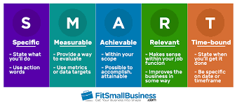
Source: (Moore 2017)
As a HR Executive I would need to manage my public speaking skills or in that manner my presentation skills via the SMART objectives.
Specific | Improving the service delivery and public speaking skills
Measure | The ability to make enough presentations and deliver them successfully
Achievable | Through effectual PowerPoint presentations and rehearsals great speeches can be delivered
Realistic | This concept is stated being realistic in the sense that if thorough research is being done on topics, and proper rehearsal prior to making each presentation, public speaking skills can be developed.
Timely | The process was to start instantaneously, will be taking about two weeks in training to learn everything about presentation.
Source: (Self-Created)

Johari Window:
The model of Johari Window is exercised in enhancing the perception of individual on others. This model is primarily being based on two perceptions- trust can be obtained by disclosing information about me to others and learning from the feedback provided by them. Each individual is being represented by the Johari window model via the four quadrants or the window pane. Each of the four quadrants signifies feelings, personal motivation, feelings and whether that piece of information is either known or unknown to oneself or others within the four viewpoints (Oliver and Duncan 2019).
When I got the job in the hotel, my co-workers knew very little about me and within that context the unknown areas along with the hidden areas were larger and the open area turned out to be smaller. As others had little information about me the blind spot was stated being smaller and the model turned out to be something as given below:
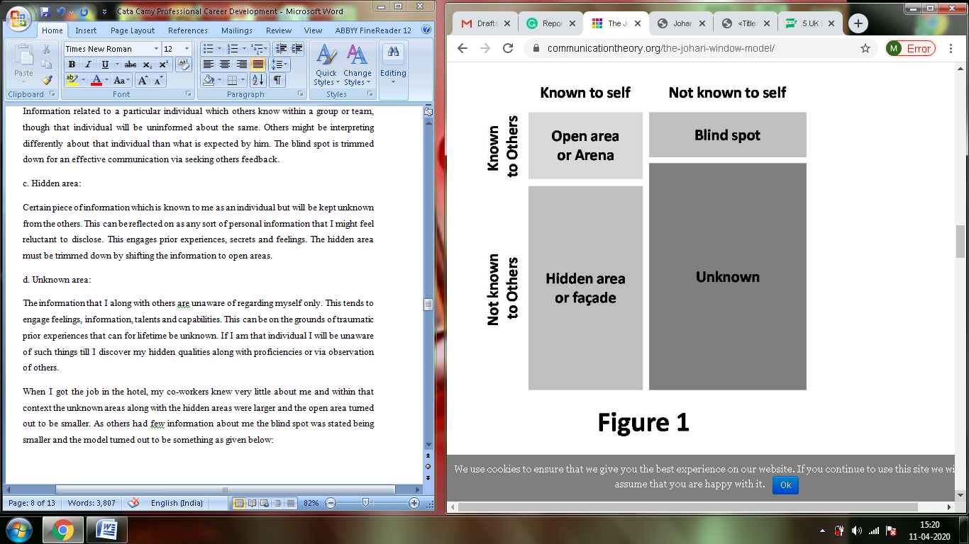
Source: (Oliver and Duncan 2019)
During my first few days at the hotel my preferred pastime was spend through a few sketches as I like pitting my imagination into paper that way. During free time I did not interact much with others and for the same my co-workers found me in being a bit shy and elusive. However, I was into that kind of job role where communication is important. The evaluation or feedback that I received from my co-workers made me realize how am I and I made efforts in being interactive and communicated more with my colleagues. This assisted me in increasing my open area and therefore making the areas of hidden and unknown smaller.
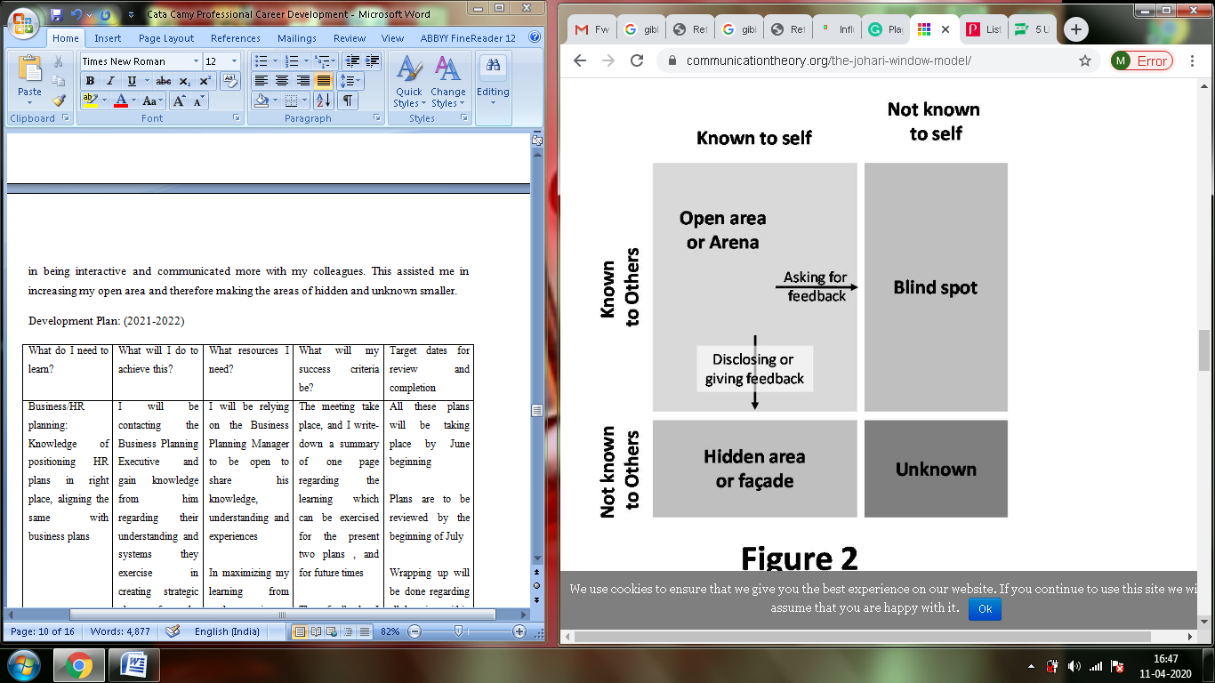
Source: (Shenton 2017)
Do I want to stay in the same hotel as HR?
The answer to the above question would probably be yes as in this hotel as Junior HR executive I have learnt a lot of things, I have gained confidence in presenting myself in better manner and have certainly developed my communication skills which I think is very important for a HR. I have developed patience and the hotel that I am working in has presented me with lot of opportunities to excel and build on my experience.
How I decided?
It is important to understand what I started with and where I am right now and where I want to be in future. It is important is joining the dots and make a clear objective so that my future gets brightened both personally and professionally. My seniors and colleagues have been very cooperative and they have always provided me with valuable feedbacks so that I can improve. This hotel gave me opportunity when I needed a job badly, now it is my turn to return them something back in constructive manner.
Recruitment in UK in post-Brexit era:
-Anonymous Resume Screening and Blind Interview
One of the initial trends UK recruiter’s needs being aware of is the augmented focus on anonymous resume screening alongside blind interviews. Certain form of biasness has been continuing to plague the firms during the process of recruitment, therefore to avert the same, more UK-based firms are instigating on employing this new approach deemed ‘scientific’ that can develop diversity hiring. More diversity leads to more diverse groups that leads to a workplace environment that is innovative, creative along with developed. The hospitality industry is one such sector though that tends to recruit a lot of multicultural people and might like to avoid the idea of blind recruiting so as to avoid visual biases. The hospitality sector has to look whether the candidate it is recruiting is presentable or not and for the same averting visual bias here is not that easy. However, the same can be applied at the initial stages of interviews prior to the final round (Wadsworth, Dhingra, Ottaviano and Van Reenen 2017).
-Quality Hire:
In accordance to LinkedIn, quality of hire continues in being the most important KPI for the recruiter, with many agreeing it to be the ‘magic metric’. That being mentioned, UK recruiters usually lack in confidence when it is about effectually measuring the metric. At the global scale, 33% feels they compute quality of hire effectually though U.K. sits at a lower point than the global average at 23%, signifying there is room for improvement.
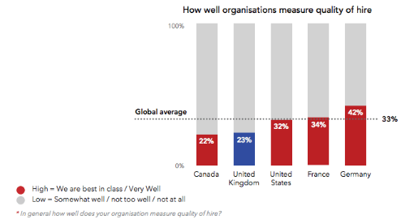
Source: (Campos, Coricelli and Moretti 2019)
One thing that UK recruiters can carry out is identifying the sources, selection criterion the hiring managers are best at in recognizing the new hires which performs to a high standard. Over a period of time, attributes associated with weaker and top performers can be categorized and understanding what attracted each of the groups can assist the HR in redefining their methods of recruitment (Campos, Coricelli and Moretti 2019).

Employment law:
Employment law regulates the relationship existing between the company and its employees, with the legislations positioned explaining the manner in which staffs along with the business under question needs to behave within a working environment (Taylor and Emir 2018). If I successfully become a HR executive, the understanding of employment law might be a complex affair for me in the initial stages and within the same timeframe I need to ask my seniors to provide me with a list of employment laws which I can refer back to while dealing with my regular operations. A few of the important among them which I think I need to remember are as follows:
-Employment Rights Act 1996:
One of the most comprehensive pieces of employment law legislation is the ‘Employment Rights Act 1996’, taking into account several topics like contracts of employment, dismissal in unfair manner along with redundancy (Deakin 2017).
-Employment Relations Act 1999:
This act establishes various workplace rights like recognition of the trade union, recognition besides industry related actions (Deakin 2017).
My aspiration to become a HR executive is not easy. I need to know and understand a lot of things that is happening across UK, especially the changes taking place within the labour market within the post-Brexit area. I need to have a clear knowledge of the trends that are happening across the UK sectors regarding recruitment of new talent. In the PDP plan I have mentioned about the manner in which I am going to prepare my CV and keep on updating the same as I go on adding new skills to my armoury with each passing year from 2020 to 2023. I want to sharpen my skills to that extent which can help me to achieve my dream job of being a senior HR manager either in this company or elsewhere. I have my target of becoming a HR executive and I am slowly moving towards the same with the above PDP plan that I have prepared along with the SMART objectives mentioned above. I will have these to look forward to and keep track of my progress.

Gibbs Reflective:
I have been in this UK hotel for 2 years now and I have learnt a lot of things as stated in the initial PDP plan like communication and man management skills and consumer service, which I find being important for the role of HR executive. Now I am able to better communicate with my seniors and my colleagues without any fear because I have that confidence that I am with such people who will help me, irrespective of the problem I am in. I have a gained a lot of confidence in face-to-face communication.
Being a HR executive is never easy as I have to deal with lot of people, both within and outside the organization. I realized that the journey to excel should start within me before I head to seek the help of my other seniors. I also felt that before I endeavour in my attempt to improve more personally I should atleast start with something that will give me confidence in attaining the next targets and I have found one in my communication.
The initial learning in the hotel was quite informative and at the same time enriching in the manner in which I have been trained initially. I realized that to achieve something the plans need to be positioned in the right place so that I have something to fall back on if things go wrong, a schedule or a chart that will help me in moving to the next step or an alternative plan. However, for being the future HR executive I need to gain knowledge on lot of things like identifying training needs, mentoring people and developing others. I have learnt that an executive’s success lies in his workers or juniors performing as per the desired expectations.
My sessions with the Business Manager has helped me a lot in understanding the needs of a HR executive, the role he needs to carry out and the obstacles that might play a part in the entire process. I now understand that keeping patience and an open mind helps in creating connections within workplace and motivate others who are emotionally down.
Overall I feel I will do a better job in times to come as the hotel’s HR executive and will be able to carry out the activities in best possible manner, something that will not only help me to improve but also others in the process.

Conclusion:
From the discussion carried out above it can be concluded that a PDP plan is important for every individual who is looking to have a successful career in their preferred job fields. The PDP plan was supported by a Gibbs Reflective Cycle along with SMART objectives that every individual needs to have in order to improve and succeed in long-term.

References:
Bjerke, M.B. and Renger, R. (2017) Being smart about writing SMART objectives. Evaluation and program planning, 61, pp.125-127.
Campos, N., Coricelli, F. and Moretti, L. (2019) Some unpleasant Brexit econometrics. VoxEU. org.
Deakin, S. (2017) Labour law and the developing employment relationship in the UK. Cambridge Journal of Economics, 10(3), pp.225-246.
Gibbs, G. (2018) The reflective cycle. Kitchen S (1999) An appraisal of methods of reflection and clinical supervision. Br J Theatre Nurs, 9(7), pp.313-7.
Grit, R. (2019) Managing your competencies: personal development plan. Routledge.
Lejeune, C., Beausaert, S. and Raemdonck, I. (2018) The impact on employees’ job performance of exercising self-directed learning within personal development plan practice. The International Journal of Human Resource Management, pp.1-27.
Luft, J. and Ingham, H. (2018) The Johari window. Human relations training news, 5(1), pp.6-7.
Mindtools.com. (2020) SMART Goals: – How To Make Your Goals Achievable. Available at: https://www.mindtools.com/pages/article/smart-goals.htm (Accessed on 10th of April 2020)
Moore, J., (2017) Setting SMART objectives. Headteacher Update, 2017(6), pp.14-14.
Morgan, P., (2017) Business Student's Guide to Study and Employability. 1st ed. London: Sage, pp.18-45.
Oliver, S. and Duncan, S. (2019) Looking through the Johari window. Research for All, 3(1), pp.1-6.
Scanlan, C.L. (2020) Preparing for the Unanticipated: Challenges in Conducting Semi-Structured, In-Depth Interviews.
Shenton, A.K. (2017) Viewing information needs through a Johari Window. Reference Services Review.
Smith, J. and Roberts, R. (2019) Reflective practice. Vital Signs for Nurses: An Introduction to Clinical Observations, pp.222-230.
Taylor, S. and Emir, A. (2018) Employment law: an introduction. Oxford University Press, USA.
Wadsworth, J., Dhingra, S., Ottaviano, G. and Van Reenen, J. (2017) Brexit and the Impact of Immigration on the UK. CEP Brexit Analysis, (5), pp.34-53.
Williams, B., Fulcher, L. and Dinwiddie, L. (2019) Why Would You Hire You? Preparing for a Successful Job Interview. American String Teacher, 69(1), pp.29-33.
Appendix


