I created Server_1 and configured it so it can be used as a Server. I installed Windows Server 2008 R2 as the Operating System. I set up two networks connection so it can be connected to Server 2 and Client 1.
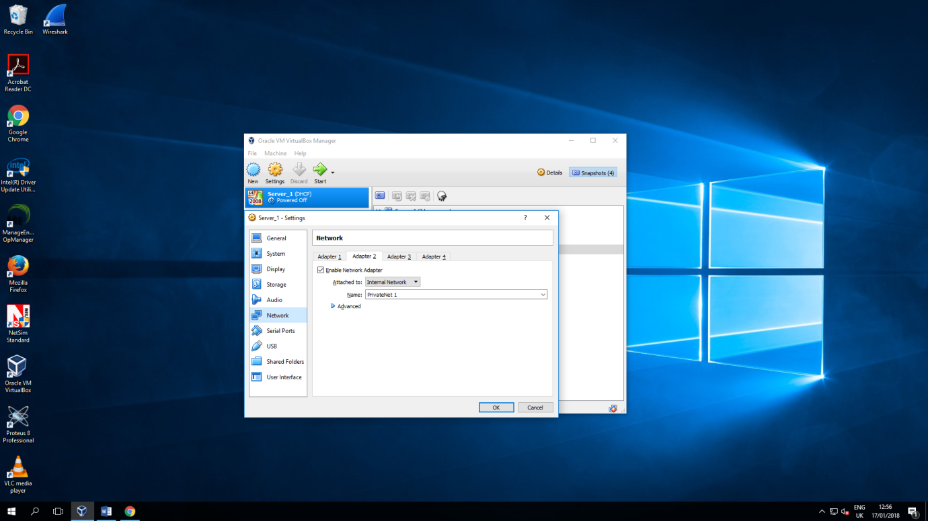

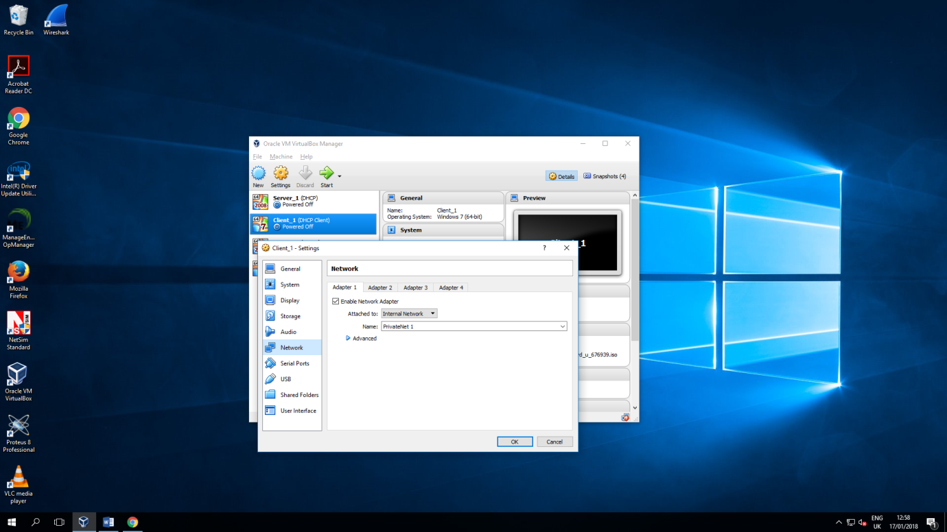
Next, I created Client 1 and set it up so it can establish connection to Server 1. I put Windows 7 as the operating system and created one network connection which is going to be connected directly to Server 1.
Then I created clones of Server 1 and Client 1 with exact same configuration.
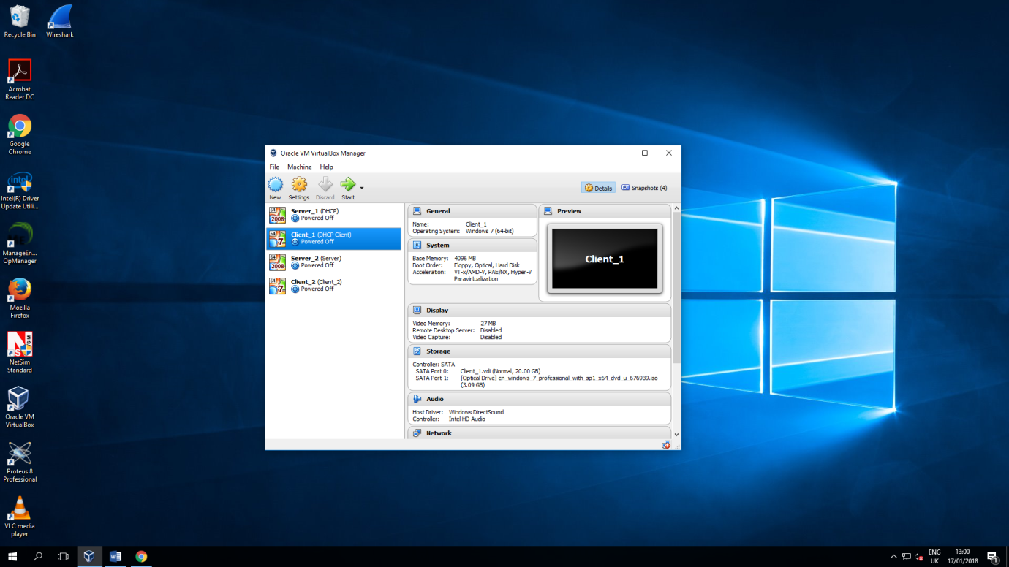

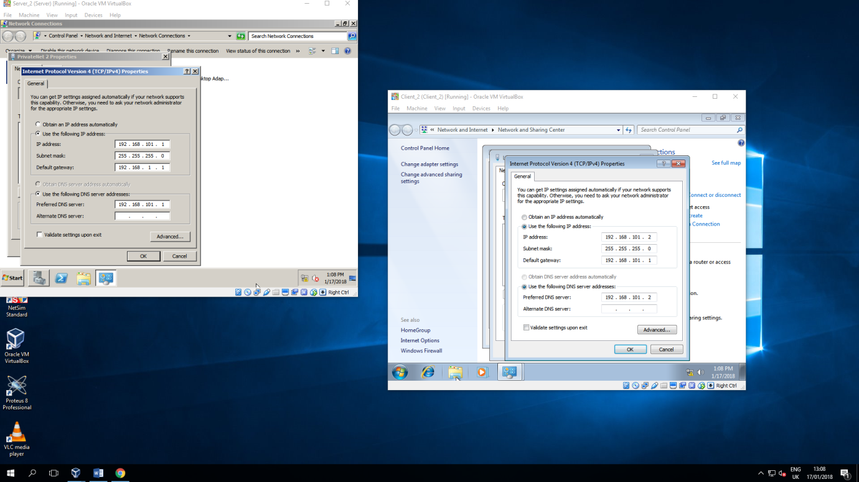
I configured the IP addresses of both server and client so they establish private network connection.
I did the same for the Public Network.

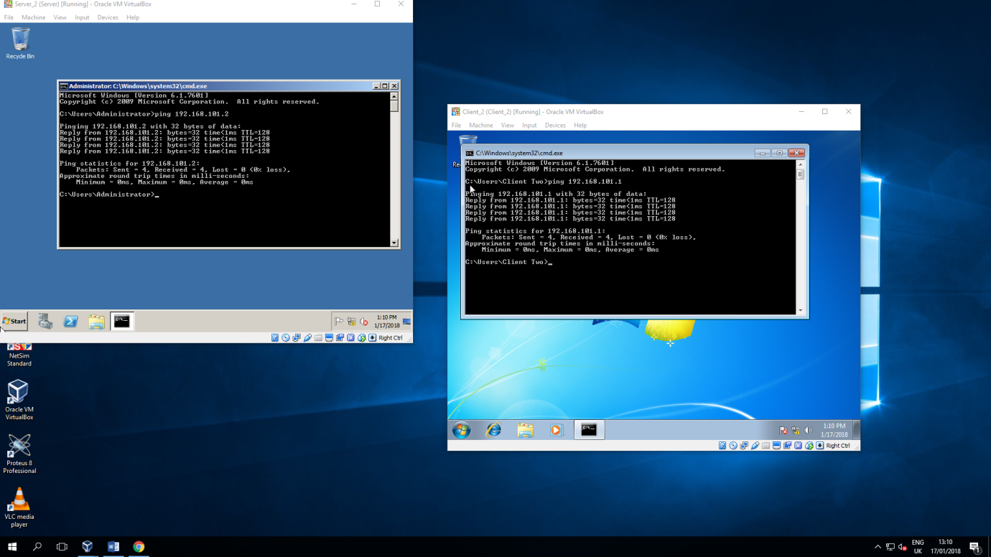
The screenshot shows the server and client communicating which means the network connection has been established and is working well.

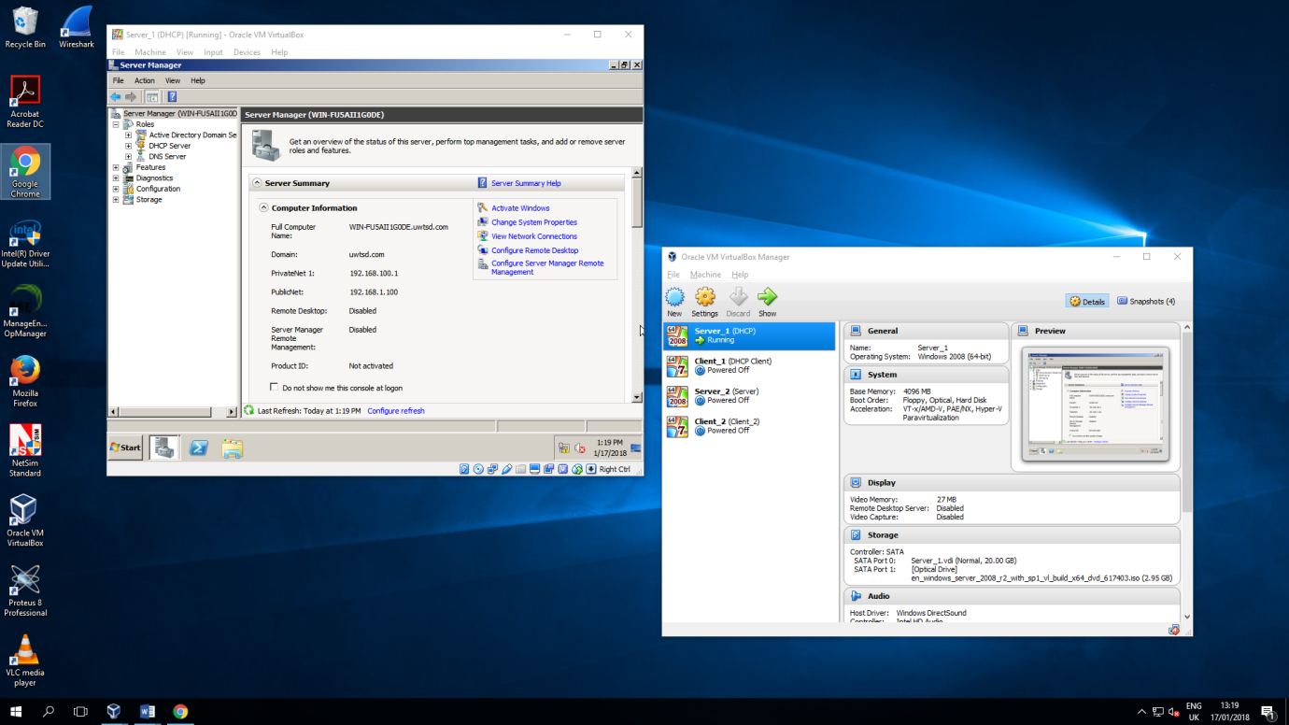
I created a Domain on Server one and connected Client one to this Domain.

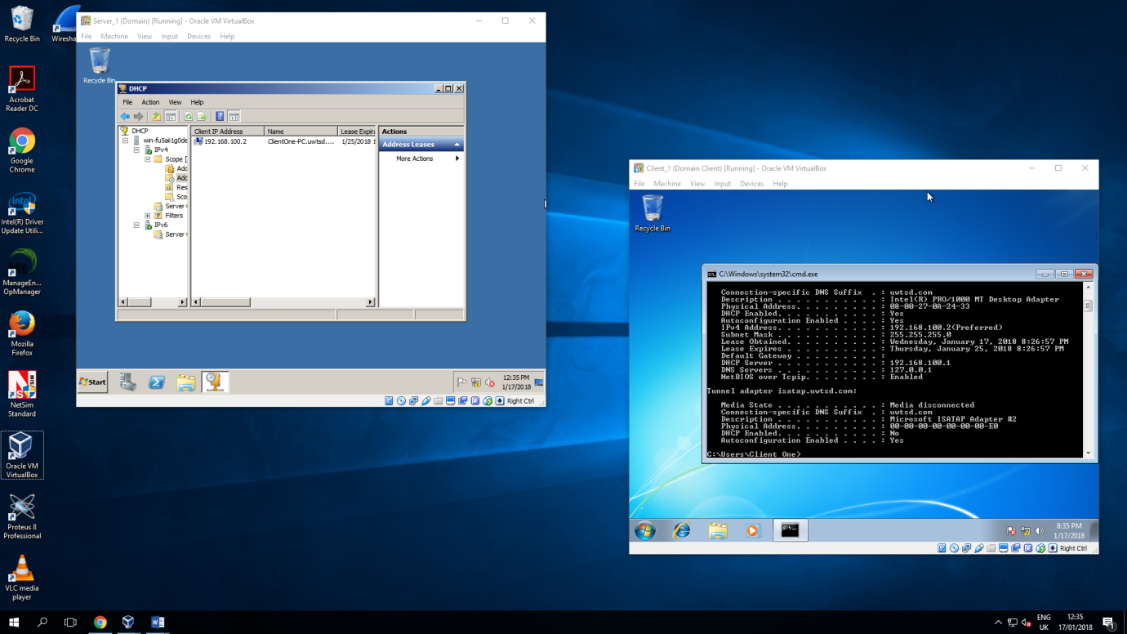
The last thing I did was creating DHCP. This screenshot presents the DHCP scope I created. I added the 192.168.100.2 IP address to the pool so my client will obtain it automatically.

The last screenshot presents the Default Gateway Configuration. It is set up as router and it has the Server’s IP.
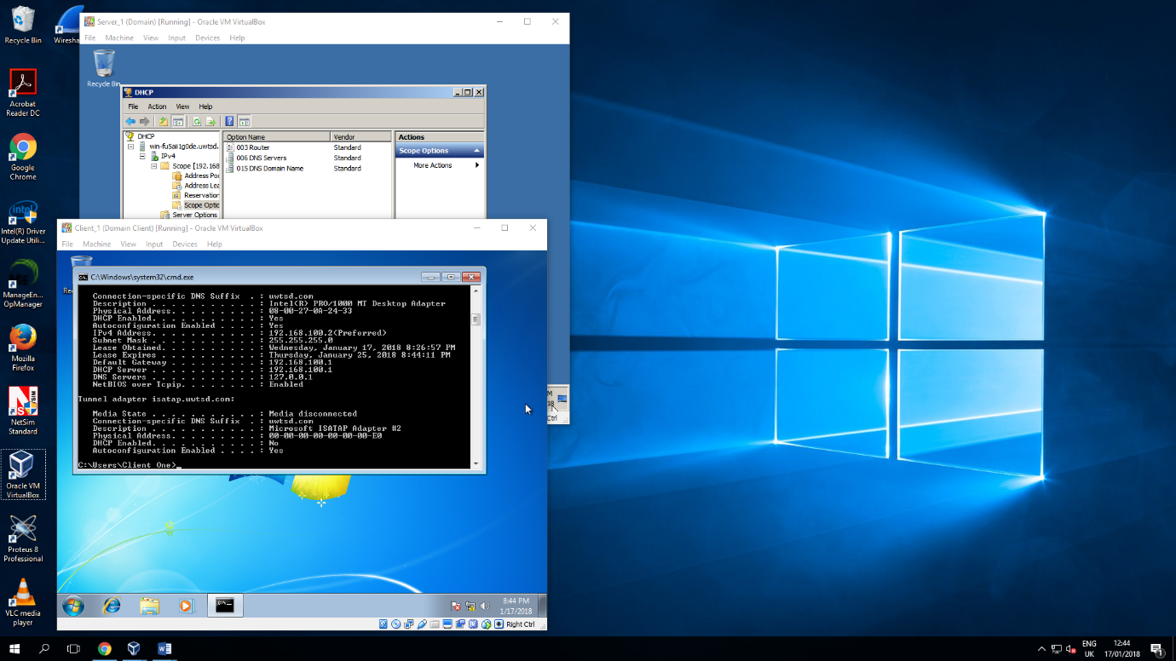

Observational Tasks 1
A). State the benefits of using Type 2 Hypervisor virtualisation software in your design. Comment on the strengths and weaknesses of the VirtualBox platform used in your network.
There are couple of benefits of using Type 2 hypervisor virtualisation software. This is excellent way to practise your practical skills without worrying you break something. Everything is done virtually and it is good exercise before working with the real servers. Another plus is that you can have multiple operating systems working at the same time which saves time and allows you to solve an error without having to switch between different machines all the time.
However, VirtualBox a fault. It consumes lots of CPU’s power and takes a lot of HD space. It really slows down a PC when you have multiple virtual machines fired up at once.

B). Explain, with use of diagrams, the significance of the following terms: Active Directory Forests, Trees, Parent and Child Domains.
Active Directory Forests allow administrator to manage the network to which other users, computers or devices are connected. Administrator can organize these objects to create different trees. Trees are networks within the network which are named the same as root domain and are always contiguous. Child domain shares the same domain naming master and schema master role and it inherits namespace of parent domain.

Child of A
Parent of B and C
A
Domain

Child of A
Parent of D
B
Forest
C
Domain
Child of C
Grandchild of A
D
Tree
Domain
Domain

C). Investigate and document the main roles and responsibilities of an Active Directory Domain Controller.
Active Directory Domain Controller manages the safety of relations between a user and a domain the user is connected to. It also manages and restricts the domain’s resources the users can use.
D). What actions could we take in the event of a Domain Controller becoming unavailable?
In the event of Domain Controller becoming unavailable we could try to create new domain and connect other machines to the new one. We also could try to reset the network to see if this is a network issue or other software problem.

