

Master of Business Administration
Human Capital Management (LCMB7023)

Assessment component 1: Individual report

Student Name:
Student ID:
Wordcount: 2697

Table of Contents
Introduction 1
How AI, Automation, and Digital Platforms Are Reshaping Labor Markets 2
How demographic and geopolitical problems influence employment markets and HR experts 5
Critical Industry and organisations' skills and talent shortage management 8
A reflection on personal preparedness 12
Conclusion 15
References 16

Introduction
Today's global employment environment requires more than technological abilities. Professionals need several abilities to handle complex, interconnected, and multicultural circumstances (Caligiuri et al., 2022). As globalisation changes the workforce, organisations want workers who can adapt to diverse cultures, communicate fluently, work with foreigners, lead with empathy, and take care of their own development and progress. Professionals who wish to succeed internationally must develop these soft skills as well as their technical talents. This reflection emphasises technology, communication, cooperation, leadership, and autonomous learning to assess an individual's global job preparation. Each of these talents is crucial in a global workforce with diverse teams and fast-changing technologies. This report assesses strengths and areas for growth to determine an individual's readiness for foreign work challenges and opportunities. It discusses how ready individuals are and how they must continuously learn to compete in a changing employment environment.
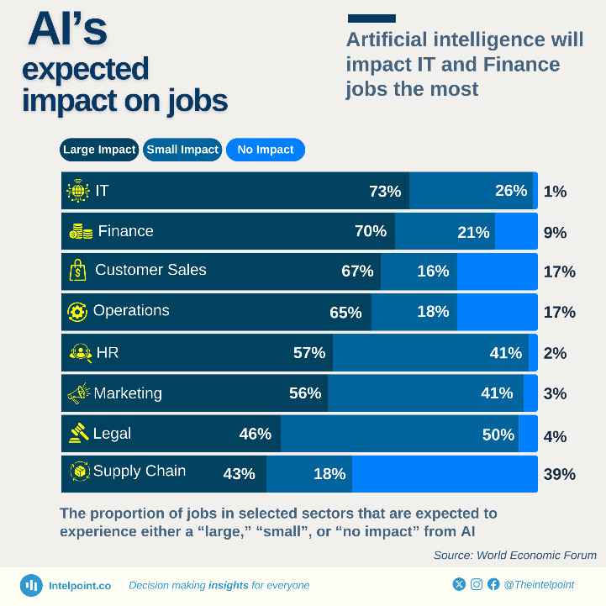
Figure 1 AI's expected impact on Jobs (Intelpoint, 2025).

How AI, Automation, and Digital Platforms Are Reshaping Labor Markets
AI, automation, and digital platforms are transforming global labour. These new technologies are eliminating certain jobs and establishing others that require different talents (Leopold, 2025).
Table 1 Job’s and AI.
Metric | Value
Jobs potentially displaced by automation by 2030 | 800 million
New jobs created by AI and automation by 2025 | 97 million
Global AI market size in 2025 | $244 billion
Annual growth of AI market | ~ $70 billion/year
Share of companies investing in AI | ~100%
Share of companies at AI maturity | 1%
Sources: (McKinsey, 2025; Statista, 2025)
Jobs Lost and Created
Automation and AI might eliminate 800 million jobs by 2030, according to McKinsey. But these technologies also expand opportunities (McKinsey, 2025). The World Economic Forum via Statista predicts 97 million new jobs from AI and robotics by 2025. Because of this dual effect, HR managers must focus on programs that help people develop new skills and enhance their present ones to transition into different positions. Statista (2025) predicts that 50% of workers will require new skills by 2025 to adapt to shifting job demands. HR departments must provide learning opportunities that help staff develop new skills and satisfy the need for a flexible workforce.
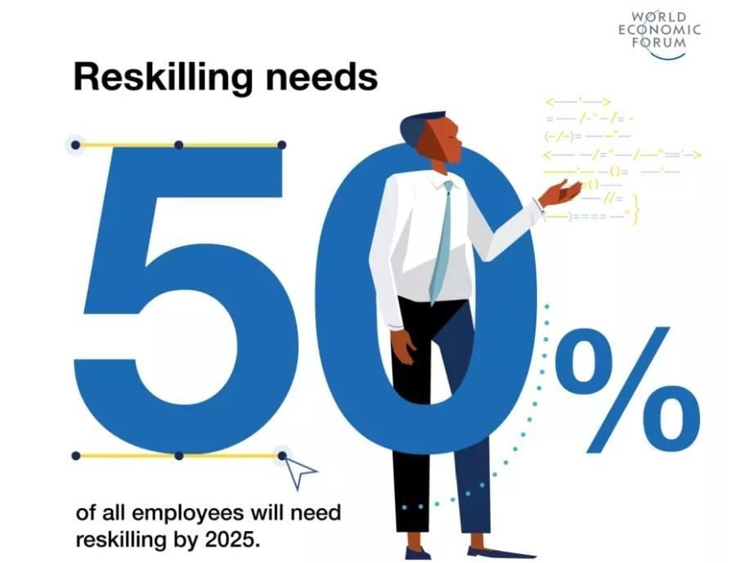
Figure 2 Reskilling for Jobs (World Economic Forum, 2025).
AI industry expansion and job market changes
According to Statista (2025), the global AI industry will be valued $244 billion by 2025, up $70 billion. McKinsey (2025) reports that most companies are investing in AI, but just 1% have completely developed it. This illustrates that AI is being embraced swiftly but unequally across fields. HR must manage job losses and demand for ICT jobs (Wong, 2024). HRM and IHRM will need more AI engineers and data scientists as AI improves. They must also learn how to improve business operations using AI. The gig economy and online platforms simplify job hunting. McKinsey (2025) reports that 15–30% of workers in numerous nations use freelancing and gig platforms. These platforms make hiring talent simpler but difficult to maintain. HRM and IHRM strategies must adapt to a more diverse workforce, including full-time and part-time workers (Sharma, 2025). This includes remote training, onboarding, performance tracking, and mending non-traditional employment contracts.

Post-Pandemic Remote Work Changes
Remote and hybrid work arrangements increased during the COVID-19 pandemic and have continued thereafter. McKinsey (2025) reports that 70% of companies employ remote and hybrid work models increasingly. Due to this transformation, HR professionals must find new methods to manage remote staff, ensure productivity, and maintain business culture on virtual platforms. Remote work also allows companies to hire workers from across the globe, which is important for filling hard-to-fill tech and other skilled roles (Wong, 2024). Keeping people motivated, offering everyone equal professional development opportunities, and balancing work and life are challenges of managing remote teams.
IHRM has a chance and a problem. When employing international workers, it must fulfil cultural standards and make HR procedures inclusive and culturally sensitive (Sharma, 2025). It also involves managing complex tax, benefit, and employment laws in many countries. These trends require HRM and IHRM to build proactive strategies to retrain people, adapt to digital platforms and remote work, and effectively manage global talent (Leopold, 2025). In a fast-changing employment market, HR departments must be open to new ideas and modify their processes to locate, train, and retain the finest individuals.

How demographic and geopolitical problems influence employment markets and HR experts
Geopolitical and demographic factors impact employment markets today (OECD, 2025). As labour markets integrate, these factors are altering workforce habits, making it tougher for HR professionals to identify competent individuals and accomplish their duties.
An elderly workforce
One in six people worldwide will be over 60 by 2030 (Datt, 2025). This workforce shift towards older workers affects HR greatly. Succession planning, ergonomic redesign, and phased retirement programs will increase as the population ages. HR departments must find strategies to retain older staff, provide flexible work hours, and effectively transfer knowledge from older to younger personnel (Dindarian, 2023). HR must also provide senior personnel with appropriate health and wellness programs so they may work without risking their health.
Youth Bulge in the Global South
There is 70% under-30 population in Sub-Saharan Africa. This will enable the HR professionals to hire young active staff (UNDP, 2023). But it is hard to align the capabilities of this younger group with the market demands. The HR should also establish youth employment and digital skills programs to prepare children to work in the present-day jobs such as technical and soft skills. Companies in the countries where the youth population is high need to find ways of including them in the economy (Farndale et al., 2019). The beginner's training programs and internship as well as employment are paramount. HR professionals also need to educate such workers on how to capitalize on automation.
Populations in the working age bracket are declining.
Low birth rates and high life expectancy are costing Japan, South Korea, and some parts of Europe working-age people. The World Economic Forum (2025) reported that its estimation might result in more than 15% of those working-age in some locations by the year 2050. Such a demographic change implies the lack of trained staff, and HR specialists must hasten the automation of their companies and revise immigration policies to cover labor deficits (Dindarian, 2023). Due to this very reason, the HR professionals have to target older agencies, women, as well as other underrepresented groups.
Cities and transformations in the work market.
The U.N. anticipates three-quarters of the global population to exist in urban areas by 2050 (United Nations, 2018). This trend of urbanisation is a big scale impact on HR. The level of skills can also vary in an urban area because of the higher employment levels. Housing, transport needs, and commute are issues in the urban areas that HR needs to take into consideration when developing recruitment solutions (Farndale et al., 2019). Firms may not be able to recruit in the overcrowded places as the cost of living and skill definition makes it difficult. HR has to pay urban workers relocation, telecommuting or flexibility in time (OECD, 2025).
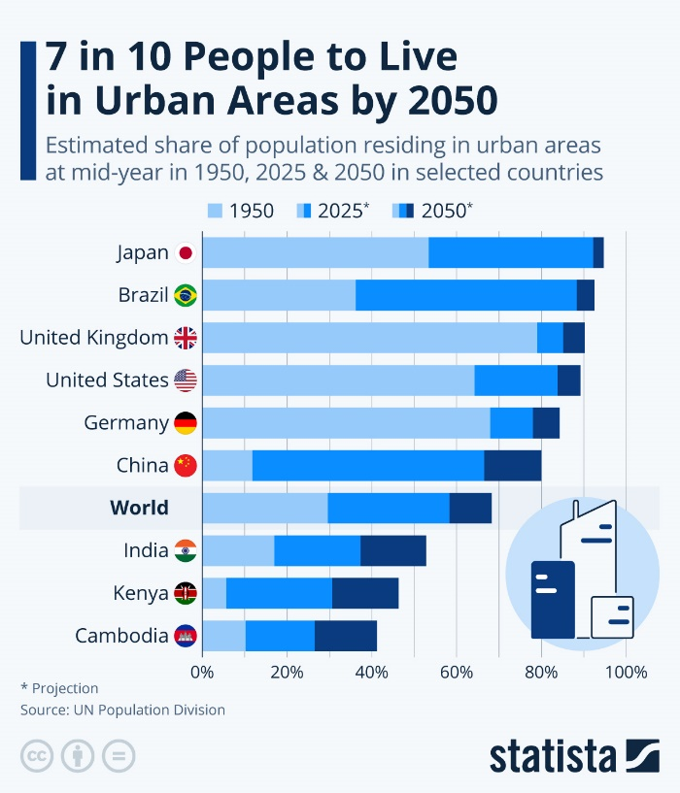
Figure 3 Urban Areas by 2050 (Statista, 2025).
Employment markets are being influenced by demographic and geopolitical changes. The HR professionals should be flexible to the workforce changes such as diversity, workforce skills shortage, migration and disruptions in the labour market. These geopolitical and demographic issues require HR planning in advance.

Critical Industry and organisations' skills and talent shortage management
Preparation Workforce gaps and lack of staff are haunting companies, especially in and around technology, health care and the green economy (Kabwe and Okorie, 2019). To be in the lead of the competition, companies need to establish effective devices to retrain, retain, and fill the skills why shortages.
Table 2 Skills Gap Statistics.
Sector | Skills Gap Statistics | Solution
Technology | 1.4 million unfilled tech jobs globally | Focus on attracting diverse talent, offering competitive salaries, and collaborating with educational institutions.
Healthcare | Aging populations and post-pandemic burnout | Develop retention strategies, such as flexible work hours, stress reduction programs.
Green Economy | Upto 32 million green jobs by 2030 | Invest in reskilling programs for existing employees, develop specialized training in sustainability.
General Skills Gap | 87% of organizations report skills gaps | Create reskilling programs, develop mentorship schemes, and offer cross-departmental training.
Source: (ILO, 2024; McKinsey, 2025; World Economic Forum, 2025)
Filling Skills Gaps
The lack of skills in the world is drastic. McKinsey (2020) also found that 87% of companies believe that their employees are not skilled. According to the report published by the World Economic Forum (2025), half of the workers will need new skills by 2025. The data indicate that companies should adopt viable reskilling programs to eliminate the skills gap. To address this obstacle, organizations can collaborate with academic institutions, educate their employees, or offer goal incentives to external qualifications (Whysall et al., 2019). Seminars, online courses, and on-the-job training could assist the employees to acquire new skills that can benefit the organisation.
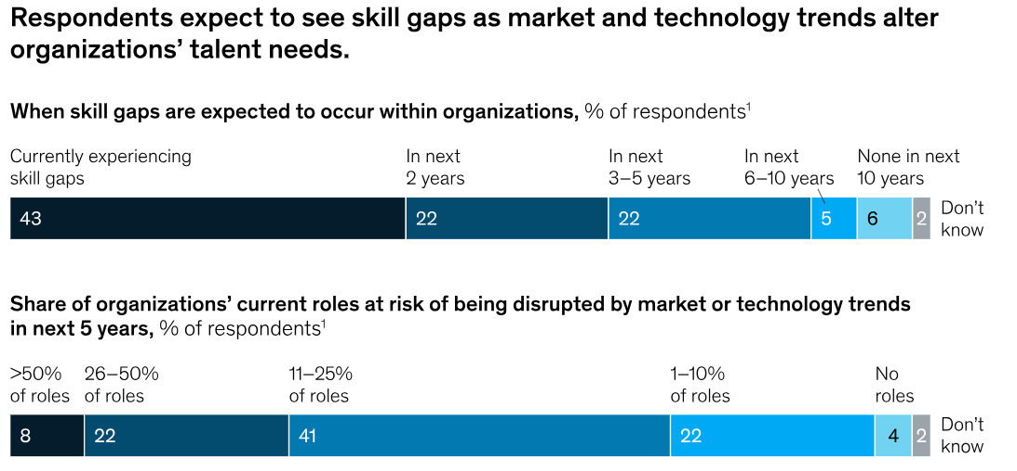
Figure 4 Filling Skill gaps (McKinsey, 2020).
Lack of talent in critical aspects.
The skills gap in major industries is deterred by changing industry requirements and new technology. The projections by Keevee (2025) are that by the year 2025, there will be 1.4 million IT employment opportunities worldwide. The root cause of such shortage is the shortage of skilled personnel to occupy the high-demand professions of artificial intelligence, cybersecurity, and data analytics. Firms should aim at hiring talented individuals of different backgrounds as a solution to this problem (Caligiuri et al., 2022). This involves providing computer employees with good wages, working hours and career development chances that address their changing needs (Kabwe and Okorie, 2019).
Problems in Healthcare
Nursing, mental health and elder care competencies are scarce due to the ageing population and pandemic fatigue. Keevee (2025) manages to come up with an estimate of 8.5 trillion as the cost of the skills gap per year. The epidemic exposed the issue of understaffing of healthcare facilities, and considering the ageing population and associated increased care needs, companies need to discover means of attracting and retaining the staff.
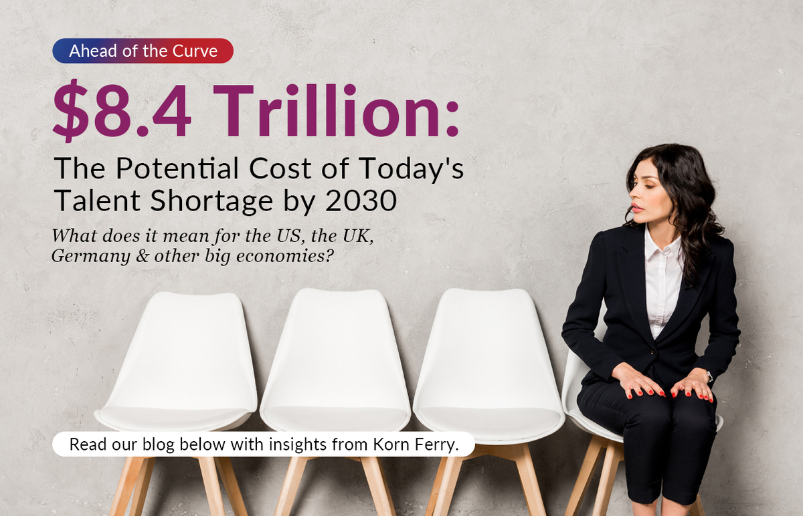
Figure 5 Skill gaps (SuperStaff, 2024).
One of the areas that healthcare businesses can concentrate on to retain employees is through the provision of mental health services, stress management schemes and flexibility in work. The use of automation and AI technology could help healthcare professionals to focus on the patient, as some administrative operations could be automated (Whysall et al., 2019). The long-term development of nursing and mental health support talent pool plan needs cooperation with schools to develop the plan.
Green Economy and Sustainability Jobs
Greening the economy has pros and cons. The ILO predicts upto 32 million green jobs by 2030 (ILO, 2024). Since the green economy requires environmental scientists, renewable energy, and sustainability experts, retraining people for these occupations is still difficult. Businesses must build green skills via specific training to remedy this. Working with schools to develop sustainable curricula may help narrow the skills gap (Caligiuri et al., 2022). Companies can also consider initiatives to help individuals switch from oil and gas to renewable energy and sustainability.

A reflection on personal preparedness
An international job requires more than technical skills. One also needs several interpersonal and self-management abilities. Employers want individuals who can work in all sorts of workplaces, communicate effectively, work well with people from diverse cultures, lead with empathy, and strive to improve as the world becomes more connected (Brumberger and Lauer, 2017). When I assess my readiness, I identify my strengths and shortcomings in technology, communication, cooperation, leadership, and self-learning.
Technology
This is because technology skills are essential to the modern economy of employment cases where globalisation occurs. The rapid development of technology is observed, especially in AI, robotics, and data analysis; thus, employees are expected to be flexible and educated (Xu et al., 2018). Various tools and platforms allow me to work effectively in the digital marketplace, machine learning, and data analysis, which I have studied and worked on in many ways. I have also been taught how to use Python, R, and other data visualisation technologies in real life, which are significant in the global job market. Technology is ever-changing, and thus my preparedness is pegged on my ability to learn and make use of emerging technology. This involves continuous learning which I do. I am prepared to deal with technological challenges as I am committed to the idea of keeping up with the times and mastering new programming languages and tools, as well as acquiring other certifications and courses as the technology evolves.
Table 3 Areas for development.
Skill | Strengths | Areas for Growth
Technology | Proficient in data analysis and programming | Continuously adapt to emerging technologies
Communication | Clear in written and verbal communication | Improve cross-cultural communication skills
Teamwork | Collaborative and empathetic in team settings | Enhance ability to lead and mediate diverse teams
Leadership | Inclusive and supportive leadership style | Develop cross-cultural leadership skills
Self-Directed Learning | Active in pursuing personal growth | Develop a more structured approach to learning

Communication
Good communication is important in a globalized employment environment where there are many cultures and languages. Both online and face-to-face communication tasks require the capability to present ideas, learn to listen to others, and adjust to a variety of audiences (Brumberger and Lauer, 2017). My strengths are in writing and talking, especially in school and employment. Conference presentation has increased my skills in organising, responding to questions, and communicating with different people. An international situation cannot be communicated with just linguistic skills. It also requires cross-cultural relations knowledge and control. I have engaged with multicultural teams, yet I need to acquire skills in communicating with them.
Teamwork
It is quite common with those who do not belong to the same country or time zone, and it is what matters in the global employment market. A number of school and non-school collaborations have enhanced my abilities in teamwork. The courses that I conducted with various organisations, including Dhaka urban health planning research studies, have taught me how to be flexible, understanding, and open-minded. Being a team member of a team that has members across several countries can prove hard because of different communication styles and time zones (Xu et al., 2018). I also resolved these problems as I focused more on communicating and used Slack, Trello, and Google Docs to streamline the work. I have a solid background, but I would like to develop my skills in controlling and mediating discussions within a variety of teams to make sure that the opinions of all members are represented and the cooperation is fruitful.
Leadership
My case is an international one where I must inspire and guide people of other cultures towards a shared objective. I have headed student and research projects. This has enhanced my decision-making process, problem-solving solving as well as conflict management. A good leader will have to address the health and well-being of members of the team and specifically handle a global workforce that has many expectations (Lyu and Liu, 2021). My leadership approach is participative and transparent, but I require the enhancement of cross-cultural skills. In leadership seminars, I desire to find out how to deal with multicultural teams in any part of the world. This will enhance my management of a team globally.
In my opinion, I can successfully work with the representatives of different countries and have a successful career on a global scale by learning more about the world, becoming a better leader, and understanding that I will never stop learning.

Conclusion
Strong technological, communication, and cooperation skills prepare the individual for global employment. Because they have empathetic leaders and work on themselves, they are more responsible with abroad clientele. These attributes provide them a fair chance of success, even if the global job market is challenging and they must work hard emotionally and professionally. Communicating, managing a team, and leading a global project are difficult. One must become a stronger cross-cultural leader who knows and manages cultural differences to achieve these things. Learning about employment, leadership, and new technologies is desired. To succeed long-term, they must shift their learning mindset and expand their global network. This dedication to improve will help them explore the new employment market and identify opportunities.

References
Brumberger, E. and Lauer, C. (2017). International Faces of Technical Communication: An Analysis of Job Postings in Three Markets. Technical Communication, [online] 64(4), pp.310–327. Available at: https://www.ingentaconnect.com/content/stc/tc/2017/00000064/00000004/art00005 [Accessed 15 Oct. 2025].
Caligiuri, P., Cieri, H.D., Minbaeva, D., Verbeke, A.L. and Zimmermann, A. (2022). International HRM Insights for Navigating the COVID-19 Pandemic: Implications for Future Research and Practice. JIBS special collections, pp.417–454. doi:https://doi.org/10.1007/978-3-030-80383-4_17.
Datt, K.B. (2025). One in six people will be aged 60 years or over by 2030 globally: WHO. [online] The New Indian Express. Available at: https://www.newindianexpress.com/lifestyle/health/2025/Oct/01/one-in-six-people-will-be-aged-60-years-or-over-by-2030-globally-who [Accessed 15 Oct. 2025].
Dindarian, K. (2023). Demographics, Education and Employment Dynamics. Future of Business and Finance, pp.161–191. doi:https://doi.org/10.1007/978-3-031-29344-3_13.
Farndale, E., Horak, S., Phillips, J. and Beamond, M. (2019). Facing complexity, crisis, and risk: Opportunities and Challenges in International Human Resource Management. Thunderbird International Business Review, [online] 61(3), pp.465–470. Available at: https://onlinelibrary.wiley.com/doi/abs/10.1002/tie.22037.
ILO (2024). Nature-based Solutions can generate up to 32 million new jobs by 2030, but investments in skills needed. [online] International Labour Organization. Available at: https://www.ilo.org/resource/news/nature-based-solutions-can-generate-32-million-new-jobs-2030-investments [Accessed 15 Oct. 2025].
Intelpoint (2025). Artificial intelligence will impact IT and Finance jobs the most - Intelpoint. [online] Intelpoint. Available at: https://intelpoint.co/insights/artificial-intelligence-will-impact-it-and-finance-jobs-the-most/ [Accessed 15 Oct. 2025].
Kabwe, C. and Okorie, C. (2019). The efficacy of talent management in international business: The case of European multinationals. Thunderbird International Business Review, 61(6), pp.857–872. doi:https://doi.org/10.1002/tie.22090.
Keevee (2025). 37 Skills Gap Statistics for 2025. [online] Keevee. Available at: https://www.keevee.com/skills-gap-statistics [Accessed 15 Oct. 2025].
Leopold, T. (2025). Is AI Closing the Door on entry-level Job opportunities? [online] World Economic Forum. Available at: https://www.weforum.org/stories/2025/04/ai-jobs-international-workers-day/ [Accessed 15 Oct. 2025].
Lyu, W. and Liu, J. (2021). Soft skills, Hard skills: What Matters most? Evidence from Job Postings. Applied Energy, [online] 300(12), p.117307. doi:https://doi.org/10.1016/j.apenergy.2021.117307.
McKinsey (2020). How companies are reskilling to address skill gaps | McKinsey. [online] www.mckinsey.com. Available at: https://www.mckinsey.com/capabilities/people-and-organizational-performance/our-insights/beyond-hiring-how-companies-are-reskilling-to-address-talent-gaps [Accessed 15 Oct. 2025].
McKinsey (2025). Superagency in the workplace: Empowering People to Unlock AI’s Full Potential. [online] McKinsey & Company. Available at: https://www.mckinsey.com/capabilities/mckinsey-digital/our-insights/superagency-in-the-workplace-empowering-people-to-unlock-ais-full-potential-at-work [Accessed 15 Oct. 2025].
OECD (2025). OECD Employment Outlook 2025 Can We Get Through the Demographic Crunch? [online] OECD. Available at: https://www.oecd.org/content/dam/oecd/en/publications/reports/2025/07/oecd-employment-outlook-2025_5345f034/194a947b-en.pdf [Accessed 15 Oct. 2025].
Sharma, N. (2025). To analyze how Automation and Artificial Intelligence are reshaping job markets and workforce dynamics. "Innovation and Excellence: Managing the Digital Revolution. doi:https://doi.org/10.9790/487X-conf6167.
Statista (2025). Topic: Artificial intelligence (AI) in labor and productivity. [online] Statista. Available at: https://www.statista.com/topics/11516/artificial-intelligence-ai-in-labor-and-productivity/ [Accessed 15 Oct. 2025].
SuperStaff (2024). Tackling the $8.452 Trillion Global Talent Shortage by 2030. [online] Philippine Outsourcing & BPO Call Center Services | SuperStaff. Available at: https://www.superstaff.com/blog/talent-shortage-by-2030/ [Accessed 15 Oct. 2025].
UNDP (2023). UNITED NATIONS DEVELOPMENT PROGRAMME REGIONAL SERVICE CENTER FOR AFRICA Youth in Africa: a demographic imperative for peace and security Horn of Africa, the Great Lakes and the Sahel. [online] UNDP. Available at: https://www.undp.org/sites/g/files/zskgke326/files/2023-05/undp-africa-youth-in-africa-2023-EN.pdf [Accessed 15 Oct. 2025].
United Nations (2018). 68% of the World Population Projected to Live in Urban Areas by 2050, Says UN. [online] United Nations Department of Economic and Social Affairs. Available at: https://www.un.org/development/desa/en/news/population/2018-revision-of-world-urbanization-prospects.html [Accessed 15 Oct. 2025].
Whysall, Z., Owtram, M. and Brittain, S. (2019). The New Talent Management Challenges of Industry 4.0. Journal of Management Development, [online] 38(2), pp.118–129. Available at: https://www.emerald.com/insight/content/doi/10.1108/jmd-06-2018-0181/full/html.
Wong, L.P.W. (2024). Artificial Intelligence and Job Automation: Challenges for Secondary Students’ Career Development and Life Planning. Merits, [online] 4(4), pp.370–399. doi:https://doi.org/10.3390/merits4040027.
World Economic Forum (2025). The Future of Jobs Report 2025. [online] World Economic Forum. Available at: https://www.weforum.org/publications/the-future-of-jobs-report-2025/digest/ [Accessed 15 Oct. 2025].
Xu, T., Zhu, H., Zhu, C., Li, P. and Xiong, H. (2018). Measuring the Popularity of Job Skills in Recruitment Market: A Multi-Criteria Approach. Proceedings of the AAAI Conference on Artificial Intelligence, 32(1). doi:https://doi.org/10.1609/aaai.v32i1.11847.

