University of Wales Trinity Saint David

Module Code: 5104
Module Name: Managing Projects in the Organisation
Programme: BA Leadership and Management Skills for the Workplace Level 5
Tutor Name: Dr Kenny Tang
Student Name: Manuela Mahwera
Student Number: 1713706

TABLE OF CONTENTS
Introduction 5
Project Scope, Stakeholders and Sponsors 6
Tools and Techniques of Project Management 7
Project Communication Methods 8
Benefits of Project Management 9
Characteristics of Project Managers 10
Organisational Structures 11
Programmatic Based Organisational Structure 11
Project-Based Organisational Structure 12
Project Types 13
Project Life Cycle 13
Project Initiation Stage 14
Project Planning Stage 14
Project Execution Stage 15
Project Termination Stage 15
PRINCE2 15
Initiation of Project 16
Planning of Project 16
Stage Control 17
Stage Management 17
Closing of Project 17
Risk Management Techniques 17
Risk Identification 18
Risk Analysis and Assessment 18
Risk Control 18
Appreciation of Soft Skills 19
Leadership 19
Communication 19
Time Management 20
Stakeholder Analysis 20
High Power and Interest 20
Low Power and Interested People 20
Low Power and Less Interested People 20
High Power and Less Interest 20
Reflection 21
SWOT Analysis 21
Strengths 21
Weaknesses 21
Opportunities 22
Threats 22
Personal Development Plan 23
Conclusion 25
References 26

Introduction
Proviz is a small company in the UK; it is a Sports Company that specialises in the design and the production of the reflective and high visibility sportswear for running and cycling (Proviz Sports, 2020). The premium British Company is although a small enterprise but it has been acknowledged globally as it sales online products to the 40 countries worldwide and has known as one of the most innovative sports brands with enhanced quality and style design specifically to empower customers and bring a positive change in the environment (Proviz Sports, 2020). Recently, Proviz UK has announced the New Sustainability Project, Proviz always focuses on making the light-emitting and reflective running gear and they announced the Sustainability Project intending to limit its impact of the production of the environment (Reade, 2019).
Therefore, to reduce the impact on environment Proviz UK has planned to make all the jackets from the recycled plastic bottles with a motivation for customers such that if they will recycle their old products they will also be rewarded Proviz (Proviz Sports, 2020). Proviz co-founder Anthony Langly-Smith has planned to manage the project and stated that the sea plays an important part in all of our lives and to save the sea and create a positive environment “The Proviz Sustainability Project” will set up to deliver and ensure all of their products, operations and services to align with ethical importance and integrity (Reade, 2019). The work on this project began from June 2019 when Proviz UK made all jackets inner lining manufactured from the Recycled Polyester of REPREVE. The project team involved all the workers in the firm from sales, marketing and production department and the customers wanted to participate in the recycling of their products (Berkun, 2008; Reade, 2019).
This report is analysing the project plan for “The Proviz Project” by identifying the scope, stakeholders and project management methods that can be used for successful implementation of the project

Project Scope, Stakeholders and Sponsors
Proviz UK was founded by Anthony and Rupert Langley-Smith and they presented “The Sustainability Project” in 2019 intending to grow in their reflective cycling clothing and other types of sportswear accessories. This project was originally aimed to achieve the continuous growth of the 93% revenue with the change in the production of jackets for environment safety (Proviz Sports, 2020). Moreover, as stated by (Reade, 2019) Proviz has evolved in an ever-changing retail environment as a business and a brand which constantly managed to stay ahead of their competitors and this continuous achievement was due to the effective production of innovation in their products with each passing year (Proviz Sports. 2020). Additionally, “The Sustainability Project” was aimed with a wide scope of providing benefit to the customers and participating in the safety of sea life by using plastic bottles. Proviz always aimed to embrace technology and work with the team that is dedicated towards their work and therefore they manage to maintain effective relationships with stakeholders, suppliers and sponsors (Proviz Sports, 2020).
The main stakeholders of the “The Sustainability Project” are its employees, customers and Newlife Charity for the disabled children. Proviz encouraged their customers for the recycling of their products and in the return of the products for recycling they will be getting a 20% discount code (Proviz Sports, 2020). Furthermore, when these products are returned by the customer Proviz recycle them as second-hand clothes with the use of plastic bottles and either donate to the Newlife charity or for the use of building or textile industry as secondary raw material (Newlife UK, 2020). Proviz collaborated with the Newlife commercial recycling division and donate their all samples and end of line stock products of “The Sustainability Project” which are de-labelled or de-branded (Reade, 2019). This also helped them in promoting their new project by campaigning at a national or local level. Moreover, other stakeholders of Proviz include Recycling Centres of the USA in which the REPREVE Recycled Polyester is developed from the Recycled plastic bottles, this is an amazing fibre used my many multinational famous brands such as North Face, Nike and Patagonia for fashion and athletic apparel (Unifi UK, 2020). Additionally, the brand also partnered with the World Bicycle Relief for this project as when the customer's checkout from the online page they are asked to support and donate for this campaign (Proviz Sports, 2020; World Bicycle Relief, 2020).

Tools and Techniques of Project Management
The appropriate technique selected for this project is the Classic or the Traditional approach. As stated by Handzic and Bassi (2017:4) the traditional project management is “A set of techniques and tools that can be applied to an activity that seeks an end product, outcomes or a service”. For the completion of “The Sustainability Project”, Proviz UK successfully implied this traditional approach in which they first came up with the innovative idea for the environment safety and the leaders of firm planned to deliver the jackets by the use of the plastic bottles to reduce their impact on the sea life (Reade, 2019). Later, the resources were collected and the Recycling Centres of the USA were approached for the production of plastic bottles in the REPREVE fabric which is used for the inner lining of the project. Consumers and the employees then reviewed the success of the project and it was observed that in since its idea was presented the customers were quite satisfied as they are also benefited from this (Spalek, 2016).
Another suggested tool for “The Proviz Project” is the Agile Project Management, using this method; the project can be successfully carried out using frequent iterations. The cycle involves four stages Plan, Do, Feedback and Improve (Haines, Idemudia and Raisinghani, 2017). The plan for the Proviz Project is to achieve continuous growth in the revenue with the change in the production of jackets for environment safety. For this, the requirement is to collect appropriate resources such as REPREVE material made from plastic bottles. Later, by overviewing the initial feedback from all the stakeholders improve the project through a contingency plan (Hebert and Deckro, 2011).

Project Communication Methods
Čulo and Skendrović (2010) highlighted in his research that one of the critical factors in the effective management of any project includes project management and often the failure of projects is due to communication gaps or miscommunication. Therefore, the project managers are responsible to fill in this gap in communication by getting involved with the project team as well as considering the demands of stakeholders, sponsors and other connected people with the project (Zulch, 2014).
The method of communication that is best selected for “The Sustainability Project” is the interactive communication methods as in this method all stakeholders are involved in communication and they all get an environment in which they can respond to each other in real-time (Cervone, 2014). So the methods effective for the interactive communication of the Proviz project include face-to-face meetings, phone calls, video conferencing, and messenger chats. However, to gather the relative information first there is a need to gather all the requirements for the projects and these can initially be discussed through emails with all the stakeholders (Čulo and Skendrović, 2010). Moreover, for formal communication and important messages are then communicated through corporate messengers such as Skype and Slack by integrating all stakeholders and eliminate certain difficulties (Cervone, 2014).

Benefits of Project Management
According to Berkun (2008), it is essential for any business that they reach its project goals within the allocated budget and defined time frame, also by the time of the release of the project it must add value to the business else all the team efforts in the delivery of the most valuable assets may get useless. The bureaucratic management theory by Max Weber, the ideal project management hierarchically revolves around structuring business. For “The Sustainability Project” successful implementation the manager should structure the project team through a clear division of labour and tasks by separating the assets and resources arranges for the project, Moreover, in this type of management hierarchical chain of command would be beneficial for the consistent regulations and meeting the project scope in time (Khorasani and Almasifard, 2017).
Moreover, it is argued by Roberts (2011) that achieving all the certain described characteristics are crucial especially for small businesses as compared to large enterprises. Therefore, the process of project management to identify and accomplish project goals and deliverables is beneficial, further, it also is essential in promoting the effective interaction and collaboration in between team members and stakeholders of the organisation. As mentioned in the research by Kerzner (2017), project management includes study and understanding of the work, task completion, identification of risks, limitations and challenges, alternate plan for the initiatives that can solve any complications within the fulfilment of project scope and the coordination and collaboration of the team.
Additionally, project management is well-known as an application of the appropriate tools and techniques and activities to meet the unique requirements of the new services or product (Kerzner, 2017). Project management tool applied for “The Sustainability Project” is the traditional approach which provides agility as well as flexibility and is open to changes required for the fixing of the plan and completion of a task through task-driven approach (Gomes, and Romão, 2016). Furthermore, this improves the quality of the product and ultimately enhances customer satisfaction. Besides, better resource management is also critical in any project for small business and project management provide a better estimation of the capability of resources. However, it is highlighted by Gomes, and Romão (2016) that project management is not only imperative for the success of any small business or project, but it also ensures the successful delivery of any project of any business dealing with the multiple aspects of crucial and relevant for the business regardless of the evolution stage of the businesses.

Characteristics of Project Managers
The journey of project management begins with initiation and ends with the successful closing of the project which requires skilled project managers (Berkun, 2008). However, as stated by Müller and Turner (2010), it can be argued that project managers have a specific ownership and leadership position because of the certain necessary characteristics. The foremost ability an effective project manager is to define and deliver the projects as planned according to the deliverables within the specified budget and deadline and meeting with the desired partners (Geoghegan and Dulewicz, 2008). This quality was observed in the project manager of “The Proviz Sustainability Project” by Anthony Langly-Smith. Moreover, other characteristics include a vision by the project manager for inspiring their team as he is the one who lifts the teammates and motivates them for the best use of their skills (Clarke, 2010). Furthermore, the building of a positive relationship between employees and project manager is essential which yields as a result of strong communication with clear goals, responsibilities, expectations, performance and feedback (Geoghegan and Dulewicz, 2008). Additionally, the project manager should have strong leadership qualities, he should have technical expertise, and an effective project manager is a good decision maker with negotiation and team-building skills (Clarke, 2010).

Organisational Structures
According to the study of Maduenyi et al. (2015), one of the most crucial factors in designing an organisational structure for projects is the factor of authority and responsibility delegated to the project manager. Furthermore, as per the study of Miśkiewicz (2017), top management in an organisation has an important function of designing and creating an organisational structure that is applicable to support the project management. Proviz can achieve this target by redesigning the organisation and emphasise on the nature of projects and assign roles and responsibilities to the project managers. Therefore, the study of Mansouri, Singh and Khan (2018) highlights that the organisation is responsible for defining the job of the project manager and creating organisational structures that are essential for the completion of the project. The project structure suitable for Proviz is project-based organisational structure. There are certain types of organisational structures discussed below which are created by the organisations to support the projects.

Programmatic Based Organisational Structure
The programmatic based organisational structure is based on the traditional structure in which authority is delegated to the program managers. However, the study of Van Der Vleuten et al. (2015) mentions that programmatic organisational structure is suitable for projects with one program sector and is not appropriate for projects that incorporate people with diverse backgrounds and different expertise (Islam, Jasimuddin and Hasan, 2015). Similarly, a programmatic based organisational structure hires people and staff from a similar area of expertise. The advantage of programmatic based organisational structure in Proviz is that the roles, responsibilities, and authorities regarding sustainability are established evidently.
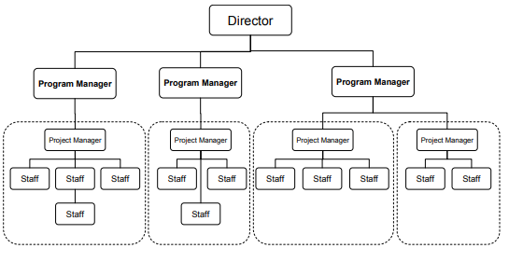
Figure 1. Programmatic Based organisational structure (Source: Van Der Vleuten et al., 2015)

Project-Based Organisational Structure
Project-based organisational structure provides a high level of authority and control to the project managers at Proviz. The study of Zheng, Wu and Xie (2017) mentions that project managers have complete authority and can attain resources for the project completion. However, in project-based organisational structure, the project manager is only limited to the objectives, scope, and budget identified for the project. The project-based structure also increases the project loyalty among personnel because of the responsibility which is held by the project manager regarding their career progression and growth (Islam et al., 2015). Project-based teams involved in the sustainability project of Proviz also consist of proper understanding regarding the nature, scope, activities, and goals of the project.
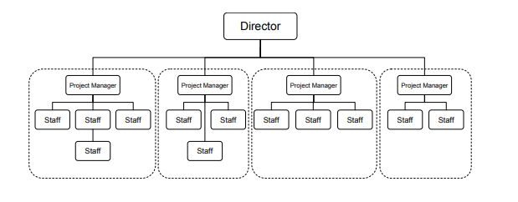
Figure 2. Project-Based organisational structure (Source: Zheng et al., 2017)

Project Types

Project Life Cycle
Project Life Cycle is known as the sequence of different phases that are involved in the project from its initiation phase to its closure phase. In the project life cycle stage, the sequence of the cycle is determined by the managers and different organisational factors. The study of Enshassi, Kochendoerfer and Al Ghoul (2016) suggests that the phases of projects have different control points that are controlled by time. Therefore, the project life cycle of Proviz also includes phases of initiation, planning, execution, and termination. By analysing the types of projects the suitable type of project for Proviz is PRINCE2 in which the managers can gain full control.
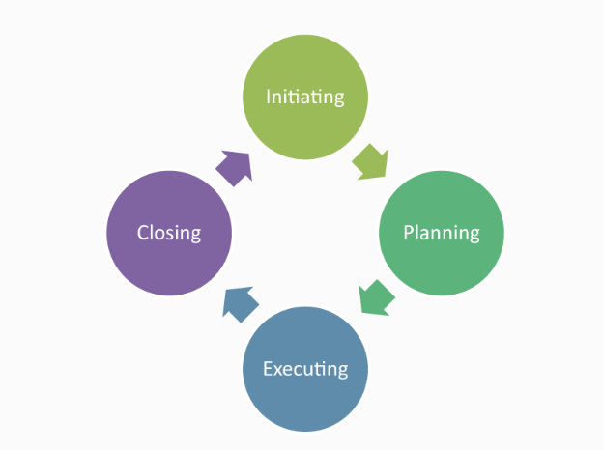
Figure 3. Project Life Cycle (Source: Enshassi et al., 2016)

Project Initiation Stage
The initiation stage of a project is aimed to create establish the scope of the project and determine the authority and aims required for the project (Enshassi et al., 2016). Therefore, in the initiation phase of the project of sustainability by Proviz will require the project manager to obtain information regarding the project and create a purpose and vision of the project.

Project Planning Stage
In a project planning stage, a detailed strategy regarding the project is performed which involves strategic planning and implementation planning (Enshassi et al., 2016). In the case of Proviz, strategic planning includes the overall approach required for the project development and in implementation planning, the central focus of the company is on applying the decisions for a successful project.

Project Execution Stage
The execution stage requires the implementation of the decisions and activities adopted in the planning phase (Enshassi et al., 2016). In the execution phase, Proviz will ensure to supervise and monitor the project effectively and prevent errors from occurring.

Project Termination Stage
The project termination stage is considered as the last stage of the project and after the completion, the project is finalised and moves towards its closure (Enshassi et al., 2016).

PRINCE2
PRINCE2 is known as the approach which is process-based and provides appropriate methods for execution of different types of projects (Tomanek and Juricek, 2015). PRINCE2 is also known as Projects In Controlled Environment in which each process is highlighted with important characteristics and objectives for the successful delivery of the project.
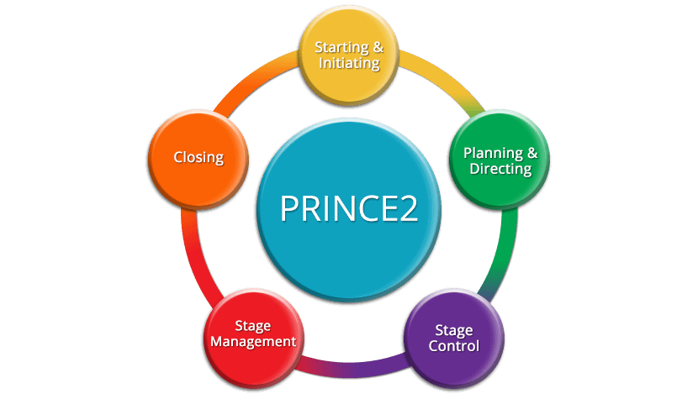
Figure 4. PRINCE2 (Source: Tomanek and Juricek, 2015)

Initiation of Project
In the initiation stage of PRINCE2, the project is initiated and the goals and objectives of the project are identified (Bentley, 2015). In the case of Proviz, the project initiation phase represents the agreement and commitment of the personnel and management on the objectives of the project.

Planning of Project
The planning stage of PRINCE2 represents the planning of a project which requires the formation of different strategies that are effective for the successful delivery of the project (Bentley, 2015).

Stage Control
In this process, the management team of Proviz can authorise the project manager to monitor and control the activities required in the project. The stage control process ensures that the project is running smoothly and the project situation is being constantly reviewed (Bentley, 2015).

Stage Management
The stage management process requires the project manager to ensure that the project is being managed appropriately and that the quality of the project is meeting the criteria set by the organisation (Bentley, 2015).

Closing of Project
This is the final stage of project delivery and requires the project manager to finalise the project and deliver it before the deadline of the project (Bentley, 2015).

Risk Management Techniques
According to the study of Cagliano, Grimaldi and Rafele (2015) risk management techniques are known as crucial and most important skills in many industries. Similarly, the study of Elzaml and Hussin (2015) states that management of risks is considered as a necessary part of any organisation or business. There are also certain risk management strategies required by organisations to mitigate and control the levels of risks present. Contingency management theory of Fiedler can be used to averse the dangers of risks involved in a project. According to the study of Alexander (2017), contingency management theory is directly linked to the quality of the leader and his capability to handle the situation of risk during a project.

Risk Identification
The study of Cagliano et al. (2015) suggests that risk management programs are initiated by identifying the risks that are considered as a threatening factor for an organisation. Therefore, the strategy of risk management allows the risk managers and the organisation to prevent the risks from happening by placing effective risk management techniques to minimise and reduce the potential threats caused by risks. Proviz can also identify their risks by practising brainstorming sessions, conducting staff interviews, facilitate workshops, and conduct a SWOT analysis.

Risk Analysis and Assessment
The risk analysis and assessment include the evaluation of different risks that are identified for the determination of severity and threat posed by such risks (Elzaml and Hussin, 2015). The study of Villa et al. (2016) highlights that the risk analysis and assessment also involves the quantification of risks for the planning of control and prevention techniques required to mitigate the risk. In the case of the Proviz sustainability project, it can be said that the company should conduct analysis which involves the identification of individuals who might get harmed or face consequences of the risk involved.

Risk Control
The process of risk controls includes creating processes and structures that are appropriate to control and avoid the risk. According to the study of Paltrinieri, Khan and Cozzani (2015), the structures and processes of risk control are developed by identifying the type of risk and nature of the analysis that is connected to the risk. Therefore, Proviz can control potential risks in their sustainability project by identifying the procedures and structures required for the avoidance of risk. The procedures include strategies for transferring risks, retention of potential risk, controlling losses, and avoiding risk.

Appreciation of Soft Skills
According to the study of Carvalho and Rabechini Junior (2015), soft skills are an important aspect of management and overall career growth because it is applied to various jobs present in different industries, especially in the position of leadership. There are various types of soft skills including communication, time management, leadership, building trust, etc. However, the study of Matteson, Anderson and Boyden (2016) identifies that soft skills are crucial in providing a competitive edge to the managers who have mastered such skills. Therefore, according to the study of Cimatti (2016), a combination of hard and soft skills is essential in project management.

Leadership
The study of Conger (2015) identifies that the factor of leadership is the most important soft skill present in project management. Therefore, as a leader proper understanding regarding teamwork and characteristics of a proper team is required. The study of Bolman and Deal (2017) mentions that the teams in a project change constantly which also results in changing and fluctuating objectives. The factor if leadership is essential in assessing the ideas and decisions that are made for the achievement of the organisational goals (Priest and Gass, 2017). The quality leadership in sustainability project of Proviz involves understanding of the goals and tasks of the project, including communicating the tasks and goals to the members of the team.

Communication
According to the study of Giles (2016) poor and ineffective communication causes damage to the quality of the project and hampers its success. The process of communicating clearly and openly is necessary for the management as well as the staff and personnel. The study of Leathers and Eaves (2015) states that the honesty and openness in communication from the top management and leaders of the organisation result in increased levels of trust, resulting in successful project management and delivery. Open communication among employees and managers in the project of Proviz results in the development of good listening skills and improves the levels of trust and commitment of parties involved in a project.

Time Management
The management of time is a crucial soft skill which is imperative for managers and personnel while working on a sustainability project at Proviz. According to the study of Grissom, Loeb and Mitani (2015) projects are assigned based on time allotted for each project which requires efficient time management and project control. However, the study of Oettingen et al. (2015) mentions that unproductive and futile time management often causes anxiety which affects team behaviour and productivity.

Stakeholder Analysis
Low
High Power and Interest  The stakeholders with high power and interest include the customers and management of Proviz.  Power  High | Low Power and Interested People  The stakeholders with low power and interest include employees of Proviz.
Low Power and Less Interested People  The stakeholders with low power and less interest include the suppliers known as the Recycling Centres of USA. | High Power and Less Interest  The stakeholders with high power and less interest include Newlife charity organisation.
Table 1. Stakeholder Analysis
The stakeholders of Proviz that are involved in the sustainability project are the customers, employees, suppliers, and Newlife charity. Furthermore, some of the stakeholders have the power to progress the project or block its initiation (Felipe-Lucia et al., 2015). Similarly, some of the stakeholders involved are interested and others might not concern themselves with the project (Ramus and Vaccaro, 2017). In the case of Proviz, the stakeholders are identified by the power and interest grid. Furthermore, Proviz also has a strong focus on the green agenda by recycling plastic bottles and limiting its impact on the environment. Fairtrade practices are also done by Proviz to satisfy their jacket manufacturers in the USA.

Reflection

SWOT Analysis
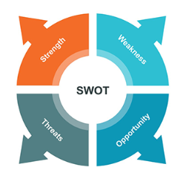
Figure 5. SWOT Analysis (Source: Gürel and Tat, 2017)
Strengths | Weaknesses
- Understanding of organisational structure.  - Understanding types of project.  - Understanding different risk management techniques.  - Assessing the importance of stakeholders. | - Slow learning curve.  - Limitations in research.
Opportunities | Threats
- Receiving on the job training  - Learning from colleagues.  - Receiving formal training.  - Receiving informal training. | - Limited support from the manager.  - Not being able to gain permission from the department to attend training classes.  - Limited funds for research.
Table 2. SWOT Analysis

Personal Development Plan
What are my development  objectives? | Priority | What activities do I need to undertake to achieve my objectives? | What support/resources do I need to achieve my objectives | The target date for achieving my objectives | The actual date of achieving my objectives
Understanding organisational structure | Critical | On the job training | Support from manager | 3/11/2020 | 4/5/2021
Understanding types of project | Beneficial | Learning from colleague | Support from colleagues | 6/07/2020 | 12/3/2021
Understanding different risk management techniques | Critical | Formal Training | Permission from the department to attend training classes | 8/08/2020 | 5/6/2021
Assessing the importance of stakeholders | Beneficial | Informal training | Providing sufficient funds to conduct research | 10/12/2020 | 25/10/2021
Review Date: 01/10/2020

Conclusion
The report has analysed project management methods and techniques for the project of the small business of the UK known as Proviz UK which is a Sportswear company and has recently announced “The Sustainability Project”. It has analysed in the report that the project was initially aimed to participate in reducing the impact on environment and sea life by introducing jackets made up of fibre that is made from plastic bottles. Thus, it reduces the plastic waste and reproduces it through REPREVE fabric which is effectively used in the recycling of customer’s old product which is either donated to the Newlife Charity or used a secondary product in the textile or manufacturing industry. The stakeholders of this project determined as the Newlife charity, employees, customers and the Recycling Centres of the USA in which the REPREVE Recycled Polyester is developed from the Recycled plastic bottles. Further, the techniques of project management used here are the Traditional Project Management approach whereas interactive communication was identified to be effective for the successful implementation of the project. Moreover, the process of project management to identify and accomplish project goals and deliverables is beneficial and effective project managers are involved in all the aspect of project management such as Risk management, communication with stakeholder, etc.

References
Alexander, E., 2017. After rationality: Towards a contingency theory for planning. In Explorations in planning theory (pp. 45-64). Routledge.
Bentley, C., 2015. The PRINCE2 practitioner: from practitioner to professional. Routledge.
Berkun, S., 2008. Making things happen: Mastering project management. Sebastopol, CA: O'Reilly.
Bolman, L.G. and Deal, T.E., 2017. Reframing organizations: Artistry, choice, and leadership. John Wiley & Sons.
Burke, R., 2013. Project management: planning and control techniques. New Jersey, USA, 26.
Cagliano, A.C., Grimaldi, S. and Rafele, C., 2015. Choosing project risk management techniques. A theoretical framework. Journal of risk research, 18(2), pp.232-248.
Carvalho, M.M.D. and Rabechini Junior, R., 2015. Impact of risk management on project performance: the importance of soft skills. International Journal of Production Research, 53(2), pp.321-340.
Cervone, H.F., 2014. Effective communication for project success. OCLC Systems and Services: International digital library perspectives.
Cimatti, B., 2016. Definition, development, assessment of soft skills and their role for the quality of organizations and enterprises. International Journal for quality research, 10(1).
Clarke, N., 2010. Emotional intelligence and its relationship to transformational leadership and key project manager competences. Project Management Journal, 41(2), pp.5-20.
Conger, J., 2015. Charismatic leadership. Wiley encyclopedia of management, pp.1-2.
Čulo, K. and Skendrović, V., 2010. COMMUNICATION MANAGEMENT IS CRITICAL FOR PROJECT SUCCESS. Informatologia, 43(3).
Elzamly, A. and Hussin, B., 2015. Classification and identification of risk management techniques for mitigating risks with factor analysis technique in software risk management. Review of Computer Engineering Research, 2(1), pp.22-38.
Enshassi, A., Kochendoerfer, B. and Al Ghoul, H., 2016. Factors affecting sustainable performance of construction projects during project life cycle phases. Factors Affecting Sustainable Performance of Construction Projects during Project Life Cycle Phases, 7(1).
Felipe-Lucia, M.R., Martín-López, B., Lavorel, S., Berraquero-Díaz, L., Escalera-Reyes, J. and Comín, F.A., 2015. Ecosystem services flows: why stakeholders’ power relationships matter. PloS one, 10(7).
Geoghegan, L. and Dulewicz, V., 2008. Do project managers’ leadership competencies contribute to project success?. Project Management Journal, 39(4), pp.58-67.
Giles, H., 2016. Communication accommodation theory. The international encyclopedia of communication theory and philosophy, pp.1-7.
Gomes, J. and Romão, M., 2016. Improving project success: A case study using benefits and project management. Procedia Computer Science, 100, pp.489-497.
Grissom, J.A., Loeb, S. and Mitani, H., 2015. Principal time management skills. Journal of Educational Administration.
Gürel, E. and Tat, M., 2017. SWOT analysis: a theoretical review. Journal of International Social Research, 10(51).
Haines, T., Idemudia, E.C. and Raisinghani, M.S., 2017. The conceptual model for agile tools and techniques. American Journal of Management, 17(3).
Handzic, M. and Bassi, A., 2017. Knowledge and Project Management. Springer.
Hebert, J.E. and Deckro, R.F., 2011. Combining contemporary and traditional project management tools to resolve a project scheduling problem. Computers & Operations Research, 38(1), pp.21-32.
Islam, M.Z., Jasimuddin, S.M. and Hasan, I., 2015. Organizational culture, structure, technology infrastructure and knowledge sharing. Vine.
Kerzner, H., 2017. Project management: a systems approach to planning, scheduling, and controlling. John Wiley & Sons.
Khorasani, S.T. and Almasifard, M., 2017. Evolution of management theory within 20 century: A systemic overview of paradigm shifts in management. International Review of Management and Marketing, 7(3), pp.134-137.
Leathers, D.G. and Eaves, M., 2015. Successful nonverbal communication: Principles and applications. Routledge.
LinkedIn. 2020. Proviz Sports. [Online] Available at: <https://www.linkedin.com/company/proviz-ltd/> [Accessed 30 March 2020].
Maduenyi, S., Oke, A.O., Fadeyi, O. and Ajagbe, A.M., 2015. Impact of organisational structure on organisational performance.
Mansouri, A.A.A., Singh, S.K. and Khan, M., 2018. Role of organisational culture, leadership and organisational citizenship behaviour on knowledge management. International Journal of Knowledge Management Studies, 9(2), pp.129-143.
Matteson, M.L., Anderson, L. and Boyden, C., 2016. " Soft Skills": A Phrase in Search of Meaning. portal: Libraries and the Academy, 16(1), pp.71-88.
Miśkiewicz, R., 2017. Organisational structure in the process of integration on the example of iron and steel industry enterprises in Poland. Difin.
Müller, R. and Turner, R., 2010. Leadership competency profiles of successful project managers. International Journal of project management, 28(5), pp.437-448.
Newlife UK. 2020. Newlife - The Charity For Disabled Children. [Online] Available at: <https://newlifecharity.co.uk/> [Accessed 30 March 2020].
Oettingen, G., Kappes, H.B., Guttenberg, K.B. and Gollwitzer, P.M., 2015. Self‐regulation of time management: Mental contrasting with implementation intentions. European Journal of Social Psychology, 45(2), pp.218-229.
Paltrinieri, N., Khan, F. and Cozzani, V., 2015. Coupling of advanced techniques for dynamic risk management. Journal of Risk Research, 18(7), pp.910-930.
Priest, S. and Gass, M., 2017. Effective leadership in adventure programming, 3E. Human Kinetics.
Proviz Sports. 2020. Sustainability | Proviz Purpose Project. [Online] Available at: <https://www.provizsports.com/en-gb/sustainability> [Accessed 30 March 2020].
Proviz Sports. 2020. The Proviz Story | Proviz Sports. [online] Available at: <https://www.provizsports.com/en-gb/proviz-story> [Accessed 30 March 2020].
Ramus, T. and Vaccaro, A., 2017. Stakeholders matter: How social enterprises address mission drift. Journal of Business Ethics, 143(2), pp.307-322.
Reade, K., 2019. Proviz Announce New Sustainability Project | Clothing | Run247. [Online] Run247. Available at: <https://run247.com/gear/clothing/proviz-announce-new-sustainability-project> [Accessed 30 March 2020].
Roberts, P., 2011. Effective project management: Identify and manage risks plan and budget keep projects under control. Kogan Page Publishers.
Spalek, S., 2016, May. Traditional vs. modern project management methods. Theory and Practice. In Smart and Efficient Economy: Preparation for the Future Innovative Economy, 21st International Scientific Conference.
Tomanek, M. and Juricek, J., 2015. Project risk management model based on PRINCE2 and SCRUM frameworks. arXiv preprint arXiv:1502.03595.
Unifi. 2020. REPREVE® - Made For The Good Of Tomorrow | Unifi. [Online] Available at: <https://unifi.com/repreve> [Accessed 30 March 2020].
Van Der Vleuten, C.P., Schuwirth, L.W.T., Driessen, E.W., Govaerts, M.J.B. and Heeneman, S., 2015. Twelve tips for programmatic assessment. Medical teacher, 37(7), pp.641-646.
Villa, V., Paltrinieri, N., Khan, F. and Cozzani, V., 2016. Towards dynamic risk analysis: A review of the risk assessment approach and its limitations in the chemical process industry. Safety science, 89, pp.77-93.
World Bicycle Relief. 2020. Proviz Has Partnered With The Charity World Bicycle Relief. [Online] Available at: <https://worldbicyclerelief.org/en/proviz-partnership/> [Accessed 30 March 2020].
Zheng, J., Wu, G. and Xie, H., 2017. Impacts of leadership on project-based organizational innovation performance: The mediator of knowledge sharing and moderator of social capital. Sustainability, 9(10), p.1893.
Zulch, B.G., 2014. Communication: The foundation of project management. Procedia Technology, 16, pp.1000-1009.

