University of Wales Trinity Saint David
Wales Institute of Science and Art


Electronic circuits testing and application

Vehicle electronics
ACHA 4031
Daniel Burden
2405219
04/2026
Contents
1 Task 3 1
1.1 Scope Time Division Calculations 1
1.2 Function Generator output square wave 1
1.3 Capacitor charge and discharge wave marked at correct points. (6) 2
1.3.1 Charging 2
1.3.2 Discharging 2
1.4 Basic Capacitor Calculations (6) 2
1.5 Capacitor discharge table (5) 3
1.6 Plot log(V) Gradient (5) 3
1.7 Gradient Calculations and Compare(8) 3
1.7.1 Gradient Calculations 3
1.7.2 Comparison table 3
1.8 Capacitor Uses (5) 4
1.9 Inaccuracies Question (4) 4
1.10 Risk Question (10) 4
2 References 4

Task 3

Scope Time Division Calculations
Period of a wave= $40$
Number of division = 10
Frequency($f)=\frac{1}{Period (τ)}$=$\frac{1}{40}=0.025$Hz
Time/division=$\frac{period of wave}{number of division}$=$\frac{40}{10}$=4

Function Generator output square wave
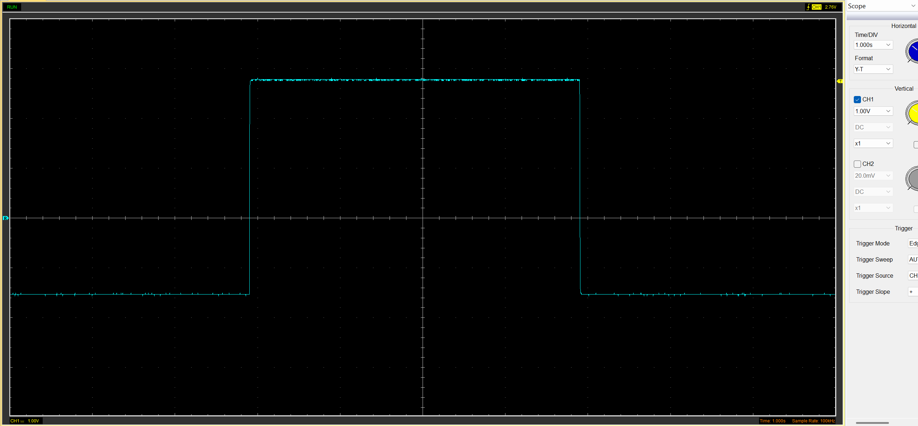
Figure 1 input got from a square wave

Figure 2 square wave with voltage time and sample rate
As can be seen in figure 1 the peak-to-peak value of 4.33 volts with its peak being 2.79 volts and its lowest point being -1.54 volts.

Figure 3peak to peak , peak and bottom point values

Capacitor charge and discharge wave marked at correct points.

Charging
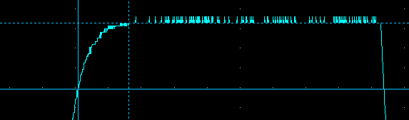
Figure 4 charging points from a sine wave
Figure 5 results got from that point

The charge starts at approximately 2v and ends up at a peak of 2.67v with capacitors charge

Discharging
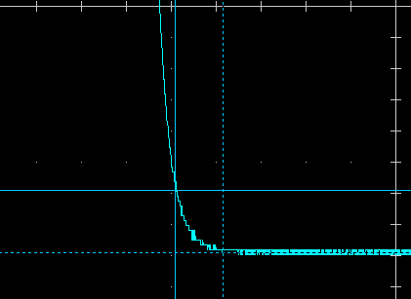
Figure 6 discharging point from the sine wave
Figure 7 results got from discharge point
The discharge starts at approximately -1.2v and after fully discharging ends at exactly -1.6v

Basic Capacitor Calculations
$$t=r×c$$
t | =Time constant(s)
R | =resistance(Ω)
C | =capacitance(F)
R=100 ohms
Time constant= 63.2%
Square wave
(Peak(v) - start(v)) x constant + start(v)

Peak=2.57v
Start=-1.79v
(2.57+1.79)x63.2%-1.79=0.97v
(50x10⁻⁶)x100=0.005 µF

Capacitor discharge table (5)
Table 1 table for capacitor discharge
Time (s) | Voltage (V) | ln (V) | dy = y2 – y1 | dx = x2- x1 | dy/dx
Time (s) | Voltage (V) | ln (V) | dy = ln(V)2-ln(V)1 | dx = Time2 – Time1 | dy/dx
0.001217 | 3.8588 | 0.957010321 | x | x | x
0.001237 | 3.1686 | 1.15328985 | 0.196279529 | 2E-05 | 9813.97644
0.001257 | 2.6039 | 0.957010321 | -0.19627953 | 2E-05 | -9813.97644
0.001277 | 2.0392 | 0.712557574 | -0.24445275 | 2E-05 | -12222.63735
0.001297 | 1.5059 | 0.409390726 | -0.30316685 | 2E-05 | -15158.3424
0.001317 | 1.0039 | 0.003892415 | -0.40549831 | 2E-05 | -20274.91557
0.001337 | 0.5961 | -0.517346841 | -0.52123926 | 2E-05 | -26061.96277
0.001357 | 0.3137 | -1.159318164 | -0.64197132 | 2E-05 | -32098.56615
0.001377 | 0.1255 | -2.07544952 | -0.91613136 | 2E-05 | -45806.56783
0.001397 | 0 | 0 | -2.07544952 | 2E-05 | -103772.476

Plot log(V) Gradient (5)
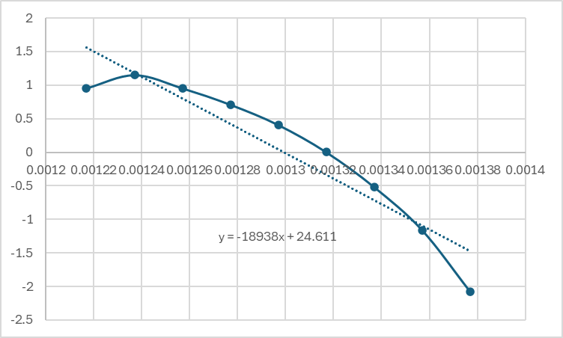
Figure 8 log(v) throughout time

Gradient Calculations and Compare(8)

Gradient Calculations
Gradient= $\frac{dx}{dy}=-28,377.27$
Gradient = −1/RC C = −1 / (R × Gradient) = −1 / (100 × −28,377) = 3.52 × 10⁻⁷ F ≈ 0.352 µF

Comparison table
Table 2 comparison table
 | Capacitance | Delta | Percentage difference
Actual | 1 µF | x | X
Marker Calculation | 50 µF | 49 µF | 490%
Gradient Calculation | 0.352 µF | −0.648 µF | 64%

Capacitor Uses (5)
KERS-in formula one capacitors were used in the Kinetic Energy Recovery System (kers) as to help the battery charge and discharge battery’s
Ignition- it is used in ignition systems to store energy to create a high voltage spark
Power supply-it is used in power supply to stop voltage surging the battery and doing damage to it
ABS-it is used in anti-lock braking system to keep motors stable during pulses in the motors
Data- used in data logging to keep voltages stable
Engine- they are used in engine sensors to get cleaner reading
Ev battery- used along a battery pack to help the stress on cells
Led lights- used to stop flickering in dashboard light as voltage may fluctuate
Stop/start-delivers burst of currents that may be rapidly needed
Turbo- used in wastegate actuators to control boost control

Inaccuracies Question
The main difference between the results are human error as one mistake if that’s from using the equipment or during the equations one fault can throw off all the results no matter how accurate the equipment may be. The fg-100 frequency generator being “£19.14” (amazon, n.d.) with something being so cheap mass used in university there is bound to be issue like whilst doing the test the first function generator did not work. The capacitors used in the test can potentially be difference thanks to human error even if the capacitor is the right type the capacitor can show different results as “the lifetime of the capacitor depends on technology use, operating condition and stress” (Frank Puhane, 2025) on the capacitor may effect the result. A mixture of any of these can cause issues as all it takes is one slip of a person or the function generator has being previously messed with or just a warn out capacitor can lead to the results being inaccurate and all this includes the tolerances that are made within each component what can throw everything off.

Risk Question
ISO is the international organization for standardising what is a big safety organization with the specific ISO number being “ISO/SAE 21434:2021 is a an international standard that requires engineers to have a set standard for cybersecurity in the reference of motor vehicles with ISO being the standard engineers have to hold themselves to with a standard of safety and precision ”(ISO/SAE 21434:2021 - Road vehicles — Cybersecurity engineering, 2021) and within car the most important component is the can bus system as the modern car so heavily relies on it but within the can bus “there is a lack of security measures within the can bus itself what can lead to security risks”(Avatefipour and Malik, 2018) .So with the rising risk of cyber attacks on cars there has being multiple methods including veCure what aimed at “solving the message authentication issues vehicles have by sending one message with the original data but a second message with a authentication”(Wang and Sawhney, 2014) this can help vehicle security as it add an extra authentication layer whilst not adding much extra time on whilst sorting out any legit can bus issues that may happen over the vehicles life span. Another way can bus can be protected “by having onboard systems authentication, integrity and confidentiality properties more specifically a message authentication code for a extra layer of security” (Dariz et al., 2017) this is similar to the veCure system as this is another way to get an extra authentication when trying to send a message to a can bus but with onboard security it could also identify any onboard issues on the car e.g. transmission issues. With both of these of these system “there main aims is to disguise and make unreadable as to make unreadable to the incorrect people as decrypting any messages”(Jukl and Čupera, 2015) as the two defence mechanisms fit along side the international standard as “ it is based on how to protect and what to protect”(Schmittner, Schrammel and König, 2021) and both of the systems aim to protect the same thing since both aim to make hacking into a car harder by using encrypted messages from ecus as the main use of ISO/SAE 21434:2021 “is based on the gateways and communications to and from ecus” (Schmittner, Schrammel and König, 2021) what both of the systems do in there own methods.

References
amazon, n.d. Function Generator -FG-100 DDS Function Generator Sine Frequency 1HZ-500KHz Counter Signal Source Generator Meter. [Online]
Available at: https://www.amazon.com/daytesy-function-generator-frequency-1hz%E2%80%91500khz/dp/b08z4bjjgq
Avatefipour, O. and Malik, H. (2018) ‘State-of-the-Art Survey on In-Vehicle Network Communication (CAN-Bus) Security and Vulnerabilities’. Available at: http://arxiv.org/abs/1802.01725 (Accessed: 12 March 2026).
Dariz, L. et al. (2017) ‘Trade-off analysis of safety and security in CAN bus communication’, 5th IEEE International Conference on Models and Technologies for Intelligent Transportation Systems, MT-ITS 2017 - Proceedings, pp. 226–231. Available at: https://doi.org/10.1109/MTITS.2017.8005670.
Frank Puhane, W. E., 2025. Capacitor Degradation and Failure Mechanisms: Exploring Different Causes Across Technologies, seville: TPC Technical Program.
ISO/SAE 21434:2021 - Road vehicles — Cybersecurity engineering (no date). Available at: https://www.iso.org/standard/70918.html (Accessed: 12 March 2026).
Jukl, M. and Čupera, J. (2015) ‘Using of tiny encryption algorithm in CAN-Bus communication’, pp. 50–55. Available at: https://doi.org/10.17221/12/2015-RAE.
Schmittner, C., Schrammel, B. and König, S. (2021) ‘Asset Driven ISO/SAE 21434 Compliant Automotive Cybersecurity Analysis with ThreatGet’, Communications in Computer and Information Science, 1442, pp. 548–563. Available at: https://doi.org/10.1007/978-3-030-85521-5_36.
Wang, Q. and Sawhney, S. (2014) ‘VeCure: A practical security framework to protect the CAN bus of vehicles’, 2014 International Conference on the Internet of Things, IOT 2014, pp. 13–18. Available at: https://doi.org/10.1109/IOT.2014.7030108.

Table of figures
Figure 1 input got from a square wave 2
Figure 2 square wave with voltage time and sample rate 2
Figure 3peak to peak , peak and bottom point values 2
Figure 4 charging points from a sine wave 3
Figure 5 results got from that point 3
Figure 6 discharging point from the sine wave 3
Figure 7 results got from discharge point 3
Figure 8 log(v) throughout time 5

Table of tables
Table 1 table for capacitor discharge 5
Table 2 comparison table 6

