
contemporary CHALLENGES: MAKING a difference
BMSW4007


Nela Frunza Haham 2210514
27 November 2023
UNIVERSITY OF WALES TRINITY SAINT DAVID

How Climate Change affects the weather
Ideas and Solutions

INTRODUCTION
Climate change is a critical issue of our modern day that calls for creative, comprehensive solutions that go across humankind. An important technique for tackling the multidimensional problems related to climate change is design thinking, a human-centric approach to problem-solving. Design thinking provides a novel viewpoint to investigate reliable, adaptive, and inclusive solutions as the globe struggles with the effects of rising temperatures, harsh weather, increased sea levels, intensified extreme weather events, and disturbances to ecosystems and biodiversity are some of these effects.
One of the biggest and most common problems affecting our planet right now is climate change how affects the weather. It speaks about long-term changes in regional and global climate patterns that are mostly caused by human activity, such as the release of gases, like carbon dioxide and methane into the atmosphere.
For the environment, economies, communities, and the welfare of future generations, these modifications to the Earth's climate system have far-reaching effects. With its emphasis on empathy, creativity, and teamwork, design thinking transcends conventional approaches to problem-solving. To provide solutions that speak to people personally, it promotes a thorough understanding of the needs, experiences, and worries of those impacted by climate change (IPCC,2021).

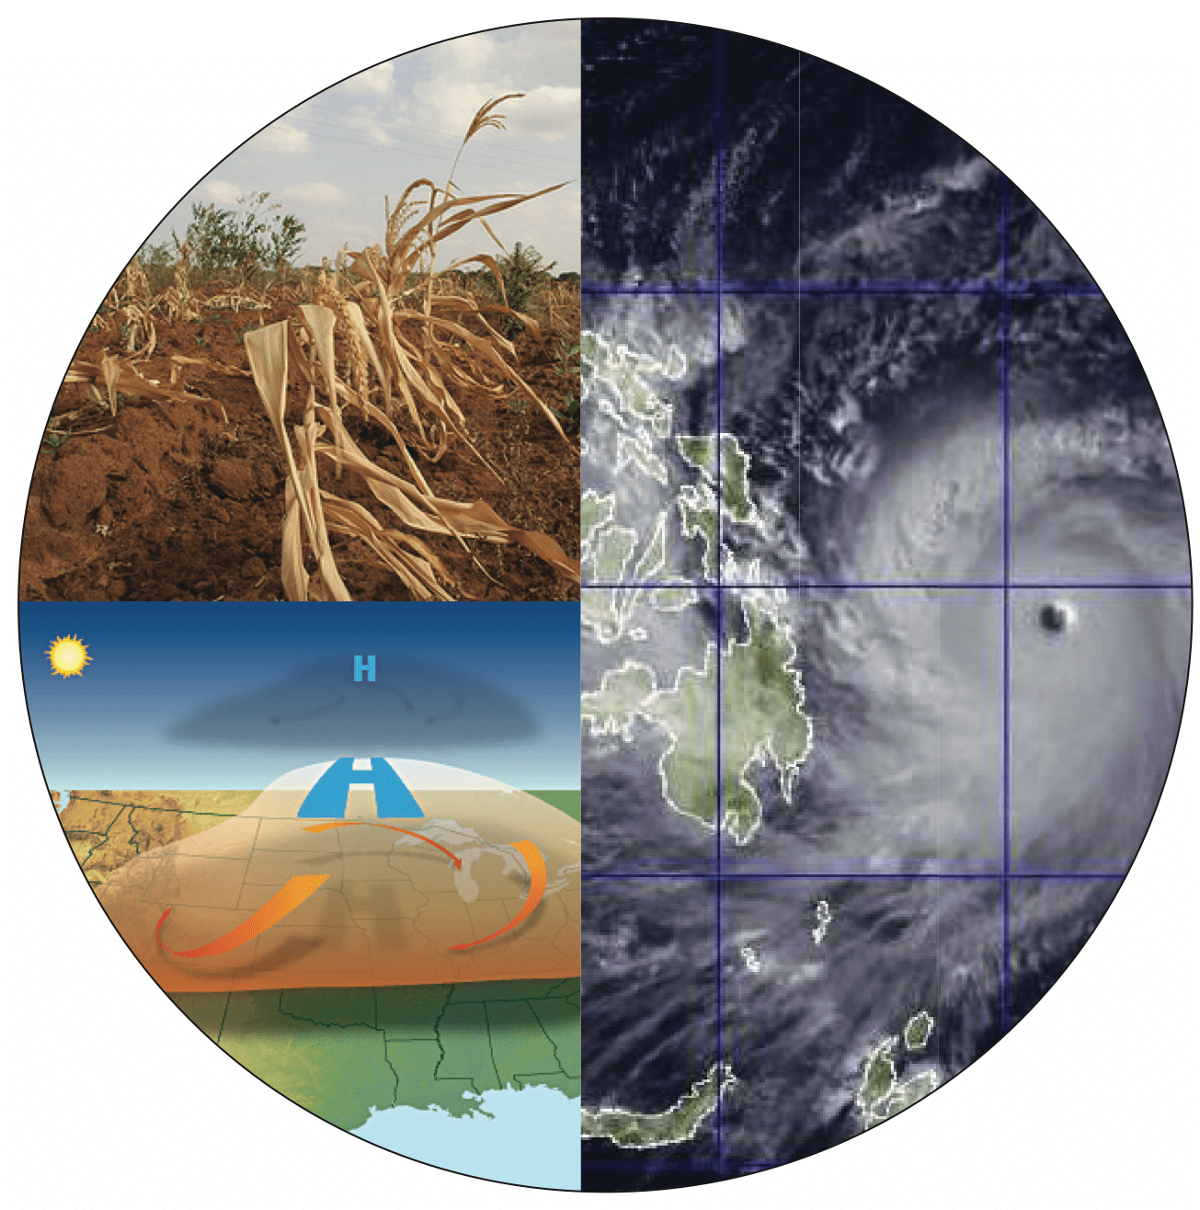

Findings

According to (Brown,2008) Ideate stage as it is known in the context of Design Thinking, is a crucial phase in which innovative solutions to difficulties are developed. Participants examine a variety of potential solutions during this phase by participating in brainstorming and idea production exercises. A process called ideation fosters original ideas, critical thinking, and the ability to suspend judgement. Design thinking promotes ideas and cross-disciplinary collaboration. Earth's average surface temperature has risen abnormally quickly during the past century, mostly because of gases created by human combustion of fossil fuels. This phenomenon is known as global warming. The gases that are classified as greenhouse gases include water vapour, carbon dioxide, nitrous oxide, ozone, and methane. Every year that goes by, it gets harder to anticipate the weather since there are fewer distinct seasons and higher average temperatures. Ever since the 21st century began, there has been a steady increase in the frequency of hurricanes, cyclones, droughts, floods, etc. The villainous force responsible for these alterations is global warming. The meaning of the word, which indicates the Earth's rising warmth, is rather obvious.
According to recent studies, many scientists believe the following are the primary four causes of global warming: deforestation, greenhouse emissions, pollution, and carbon emissions (Lineman,2015).
- Increased frequency and intensity:
Increased average temperatures brought on by global warming may cause heatwaves to occur more frequently and with greater intensity. These heatwaves may have detrimental effects on agriculture, the economy, and public health.
2.Changes in precipitation patterns:
Increased rainfall and a higher danger of floods in some areas can result from changing precipitation patterns brought on by warming temperatures. On the other hand, longer droughts and a shortage of water may affect other regions.
3.Rising sea levels and coastal flooding:
Sea level rise is one of the main effects of global warming. As a result of sea level rise, low-lying areas are flooding. Extreme weather has been experienced by many nations. We experience exceptionally high levels of rain, bitter cold, wildfires, and other natural calamities every year. Similarly, marine life is suffering greatly because of ongoing global warming. Along with other issues, this is contributing to the loss of marine species. Coral reefs, which are predicted to go extinct in the next several years, are also projected to undergo modifications. The future years will see an increase in these impacts, which will eventually stop the spread of the species. Furthermore, the adverse effects of global warming will eventually be felt by humans.
4.Changes in weather patterns:
Changes in atmospheric circulation patterns brought about by global warming may result in weather systems that are more persistent and produce lengthy heatwaves, intense rains, or protracted droughts.
6. Ecosystems Affected:
Severe weather effects like wildfires, powerful storms, and droughts can have a big effect on the environment. Ecosystem alterations, biodiversity loss, and habitat degradation are all possible outcomes of these occurrences.
7. Financial Implications:
Climate-related extreme weather events can lead to substantial losses in agriculture, considerable infrastructure damage, and higher insurance premiums, all of which have a substantial financial impact.
8. Dangers to Human Health:
Severe heat waves can be extremely dangerous to one's health, increasing the risk of heat-related illnesses and even death. The hazards are amplified due to global warming (Kim, Kabir, and Ara Jahan,2014).
9. Ideas and solutions:
Weather is a natural phenomenon, and we can’t control directly. Finding the appropriate solution is crucial, even though it is almost too late to decrease the rate of climate change of weather. To discover a solution to climate change everyone—individuals as well as governments—must cooperate. The management of pollution, population increase, and the utilisation of natural resources are a few things to think about. Cutting back on the amount of plastic we consume is a crucial contribution we can make. One of the contributors to global warming is plastic which takes years to recycle. Our generation will try to reduce carbon emissions by cutting down on burning fossil fuels. Deforestation is another element to consider, as it will help reduce global warming. To make the environment greener, more tree planting needs to be promoted and action to be taken towards it (Bastin,2019).

CONCLUSION
Weather patterns over the long term are changing due to climate change, which is caused by human activities like deforestation and the combustion of fossil fuels. Rising sea levels, altered rainfall patterns, altered temperature extremes, and an increase in the frequency and severity of extreme weather events are some of the effects. The effects of these modifications on agriculture, ecosystems, and human cultures are extensive.
Global warming will continue to pick up speed if humans continue to emit greenhouse gases. The effects are being felt on a much smaller scale, but they will soon intensify and become severe. Humans could save the day; all that is needed is to take it. Every person should cut back on their energy use. To cut down on energy waste, incentives should be provided for fuel-efficient vehicles and other electronics. In addition, this will lessen the amount of greenhouse gases in the environment and enhance air quality. Fighting together is the only way to overcome the evil of global warming.

.

REFERENCES

1. Brown, T. (2008). "Design thinking." Harvard Business Review, 86(6), 84-92.
2. Intergovernmental Panel on Climate Change (IPCC). (2021). "Climate Change 2021: The Physical Science Basis - Summary for Policymakers."
3. Bastin, J. F., et al. (2019). "The global tree restoration potential." Science, 365(6448), 76-79.
4.Lineman, M. (2015). Talking about climate change and global warming. PloS one, 10(9), p.e0138996.
5. Kim, K.H., Kabir, E. and Ara Jahan, S., 2014. A review of the consequences of global climate change on human health. Journal of Environmental Science and Health, Part C, 32(3), pp.299-318.

