

MODULE CODE: Digital Skills for Personal Development and Business Growth BMSW4008

ASSESSMENT COMPONENT: PORTFOLIO

STUDENT NAME: Elena Nicoleta Dinu

STUDENT NUMBER:2320466

LECTURER: Philippa Fitzgerald

DATE:12/12/2025
Contents
Task 1 3
Assessment of Digital Skills 3
References 3
Task 2 4
LinkedIn Learning Certificates for Office365 4
Task 3 5
Essay on Relevance of Excel in professional and personal life. 5
References 5
Task 4 6
7 Minute Reflective Presentation 6
References 6

AI Acknowledgement
I confirm that I have not presented any AI generated materials as my own work.
I confirm that I have copies of my drafts, notes, and other resources I used, which I may be asked to provide in evidence.

Task 1

Assessment of Digital Skills

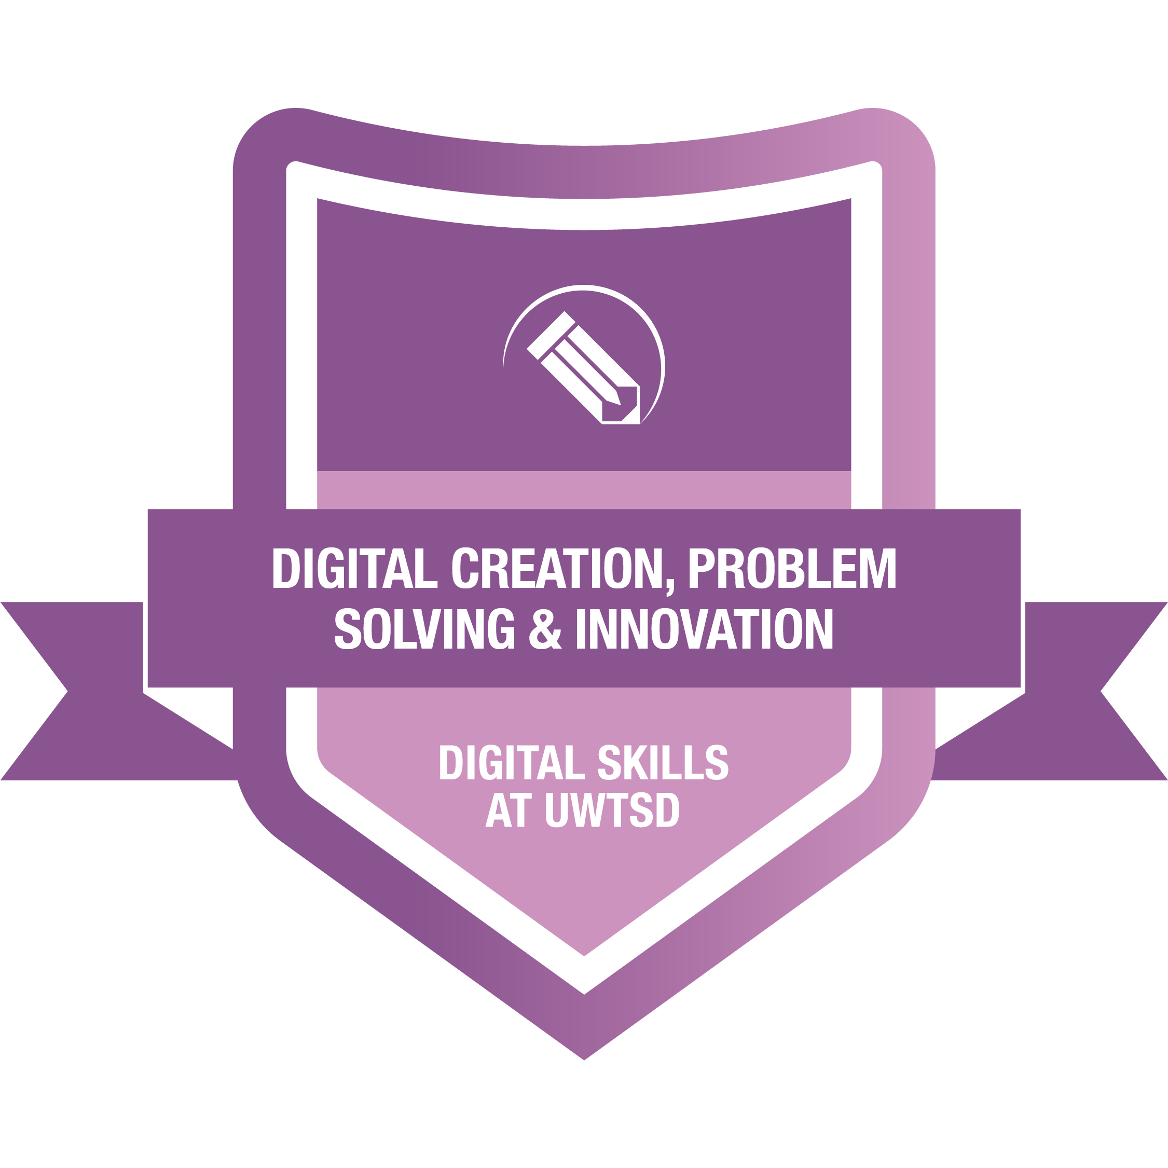
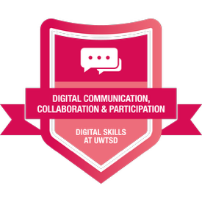
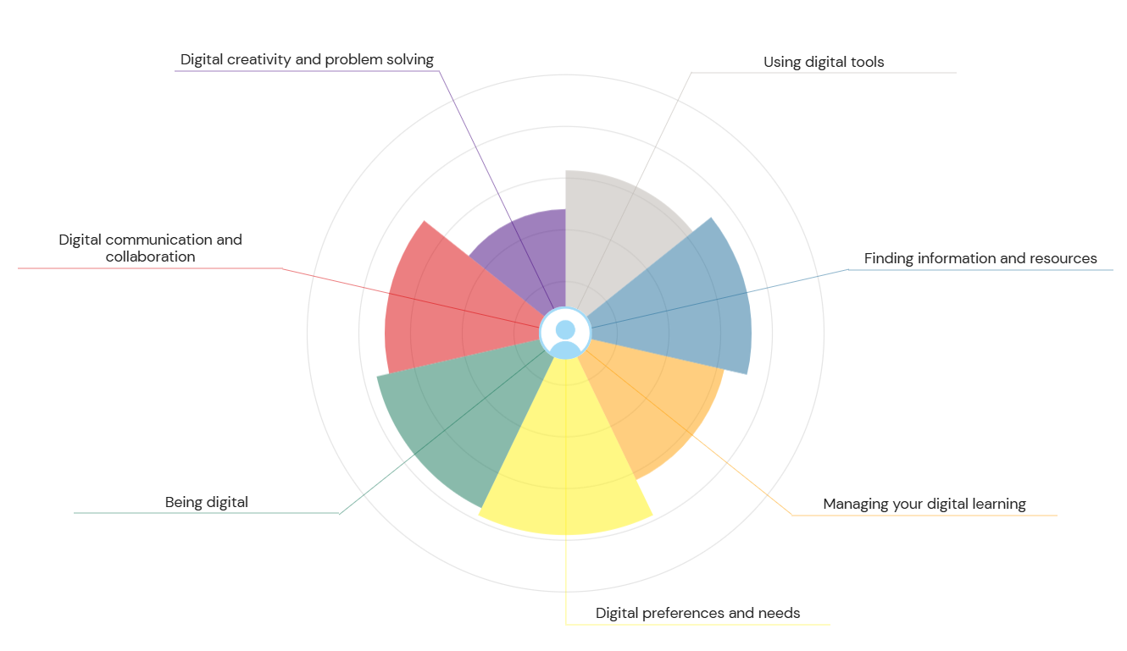
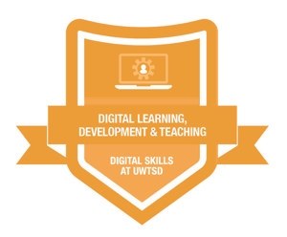
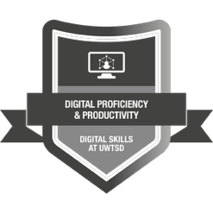
- importance of digital skills Plan for task 1
- Jisc badges summarised
- 2 strengths and weaknesses
- Conclusion
- Smart action plan

References

Task 2

LinkedIn Learning Certificates for Office365
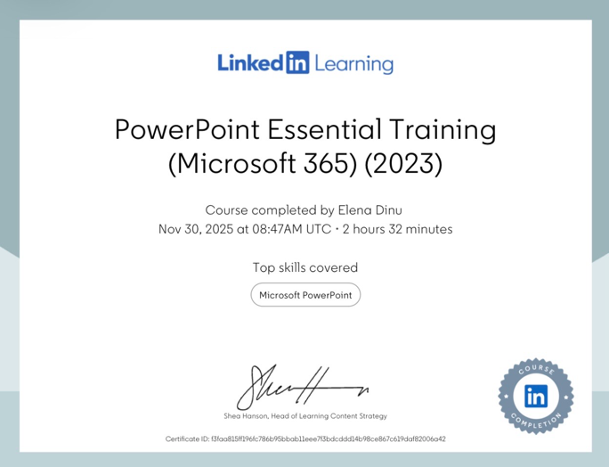
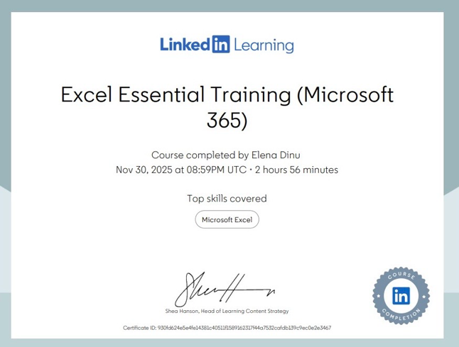
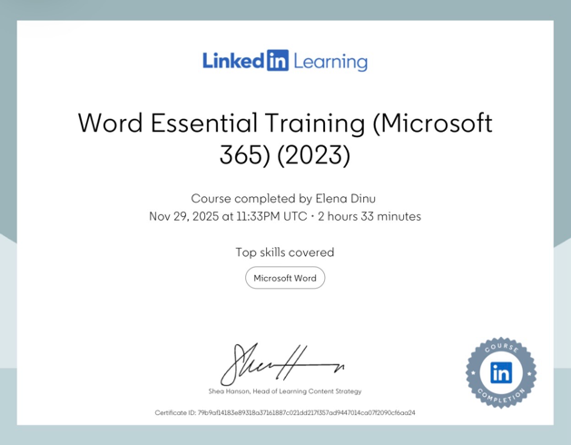

Task 3

Essay on Relevance of Excel in professional and personal life.

This essays is about Relevance of Excel in professional and personal life. Excel is spreadsheet program that is widely used, approximately 1 billion users from the whole word(Arnott,2025). There are several things that can be done while using Excel, such as creating table, using functions and charts are some of the few things that can be done in Excel(Arnott,2025). According to Ginsberg 2025, Microsoft Excel was introduced in 1985 and evolved significantly from a basic spreadsheet to data analysis tools for business and personal use. Excel in 2007 there was a huge increase in the number of rows and columns, users had access to 1 million rows and 16,000 columns according to the same source (Ginsberg, 2025). Microsoft Excel is used for so many reasons, however most of the people are using it for business purposes. Kaushik, 2025 mentioned that there are over 750 million people all around the world that uses Excel for business purposes, conducting tasks such as planning financial, data analysis which could include sales, stock count and so many others.
Plan for task 3
- History of Excel
- How is used in business
- In personal use
- How is taught in schools
- Used in educational settings
- Conclusion
family of 2.final.ods
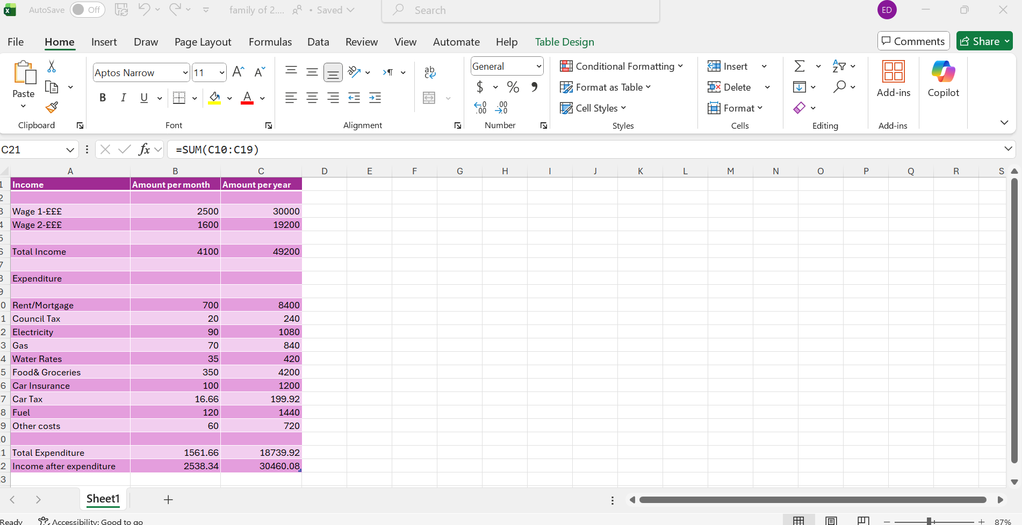

References
Arnott, S. 29th of May 2025, The History of Microsoft Excel. Available at: https://www.fullstackmodeller.com/blog/history-of-excel (Accessed date:27th of November 2025)
Ginsberg, C. 15th of July 2025, A Brief History of Microsoft Excel. Available at: https://www.nobledesktop.com/blog/history-of-microsoft-excel (Accessed date: 27th of November 2025)
Kaushik, A. 14th of April 2025, Importance and Uses of Excel in Business. Available at: https://www.wecreateproblems.com/blog/importance-and-uses-of-excel-in-business (Accessed date: 27th of November 2025)

Task 4

7 Minute Reflective Presentation

Embed PowerPoint here

References

Microsoft .no date, Outlook.com Introduced. Available at : https://news.microsoft.com/announcement/outlook-com-introduced/ (Accessed date: 30th of November 2025)

