11/18/2025
11/18/20



Module Name: Web and database
Module Code: ACCA 4023

Student Name: Catherine Gordon
Student ID: 2435425
Group: 1

Table of Contents
Introduction 3
Task 1: Implementation Guide: 3
Scenario Analysis 3
Entity-Relationship Diagram (ERD) 3
Data structure Development 3
Normalization Compliance 3
Sample Data Population 3
Query Development 4
Validation and Testing 4
Conclusion 4
References 5
Appendices 6
Appendix 1: Draft work 6

Introduction
This is where I'm going to be showing how I made my Access database. First, we’re going to make a new field. Field counts, going down the column, and rows go across, starting from left to right. Now I've explained that to create a new field, click on (click to add), you will see it under your tab bar, highlighted in yellow. Here you will be able to create a new field.

Task 1: Implementation Guide:

Scenario Analysis: The local authority has recently launched a green transport initiative called Eco Ride, an electric bike rental service available at several public locations, including parks, train stations, and university campuses. The aim is to make commuting greener and healthier. Riders can scan their ID at a rental point, take a bike, and return it to any nearby Eco Ride station. While the service is growing in popularity, the management team is facing challenges in handling operations due to its current reliance on paper forms and basic spreadsheets. Rider details and rental transactions are recorded manually, while bike maintenance needs are tracked informally. This results in limited visibility of which bikes are available, currently in use, or undergoing repairs. Consequently, the system experiences occasional double-bookings and unreturned bikes, making it difficult to produce accurate summaries or analyse overall service usage effectively.

The primary entities involved in the eco-rides' scenario include the riders, bikes, rental point, rental transaction, Maintenance, and team management, each of which is described in detail. The rider refers to the individual who utilizes the rented service. The bike represents the tangible item that can be rented at the rental point, where the bikes are physically stored, rented out, and returned. Rental transactions signify the process of renting a bike, while the management team consists of individuals responsible for overseeing Eco-Ride’s operations. The attributes associated with these entities include the riders' personal information, such as their ID number, name, and contact details; the bike's unique ID number, its availability, and any repairs needed; as well as the rental point’s locations for pick up and return. Additionally, transaction details encompass the transaction ID, start and end times, team members involved, and operational reports. Relationships are where the rider can have many rentals/ Eco-Ride can have many rentals

Entity-Relationship Diagram (ERD)
Create a well-labelled ERD showing entities, primary and foreign keys, and the relationships (with appropriate cardinality) between them.

Data structure Development
Using your ER model, construct the design by defining each entity and establishing relationships with appropriate constraints to ensure data integrity.
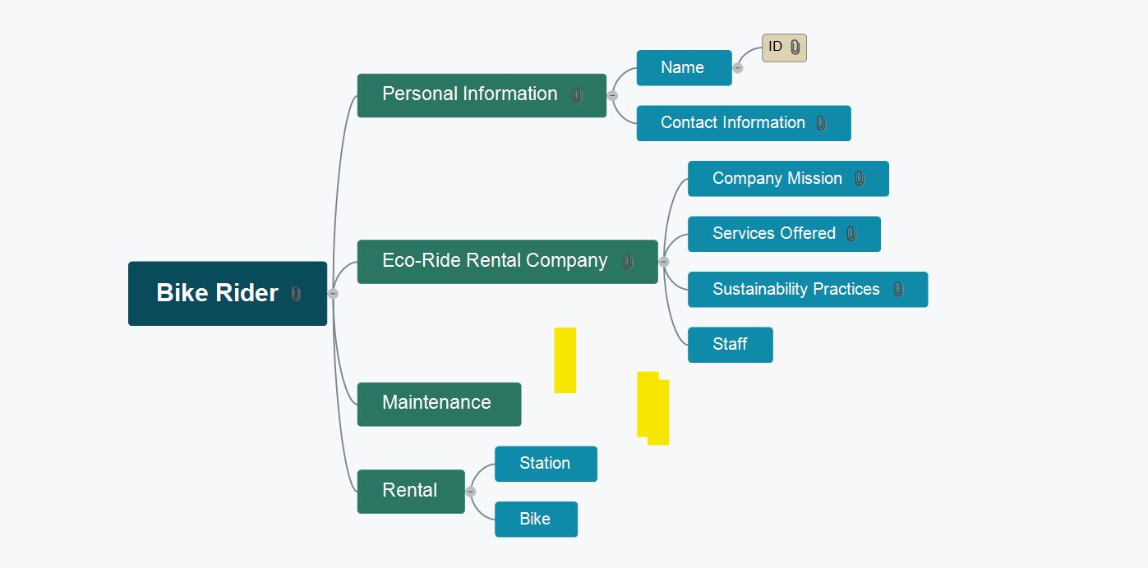

Part 1
When I create my field, I’ll have an option for the type of data needed.
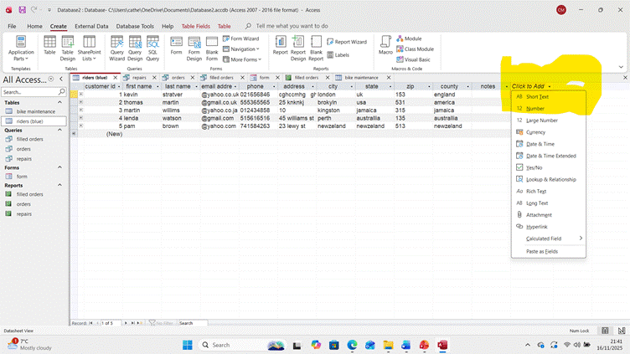
Part2
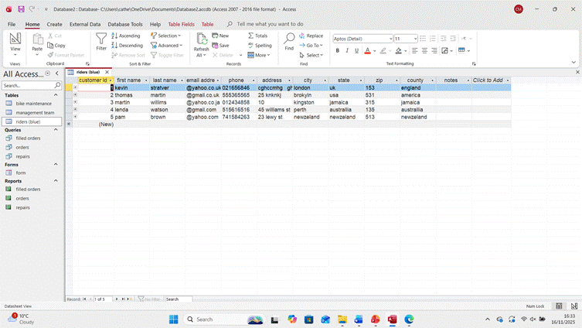
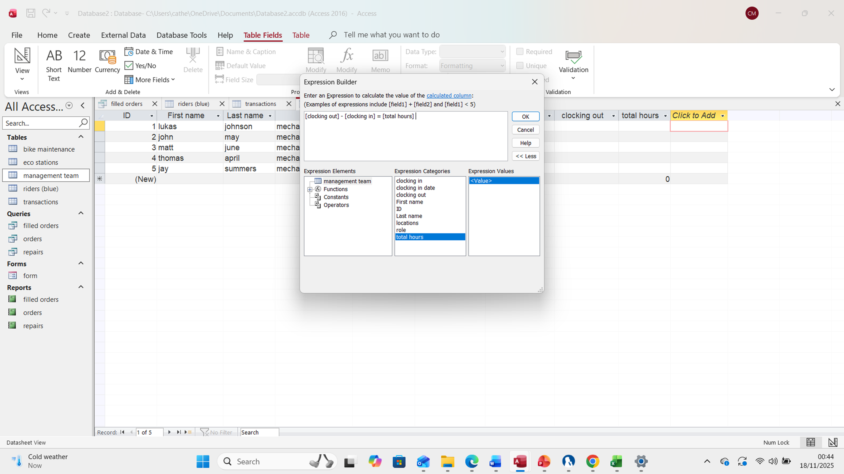
This is my table one completed, here I can see and track the customers' order and their information, such as name, address, ID number, etc. This will act as my Primary key information/ Records., which is now completed. Here, I can see and track the customers' orders

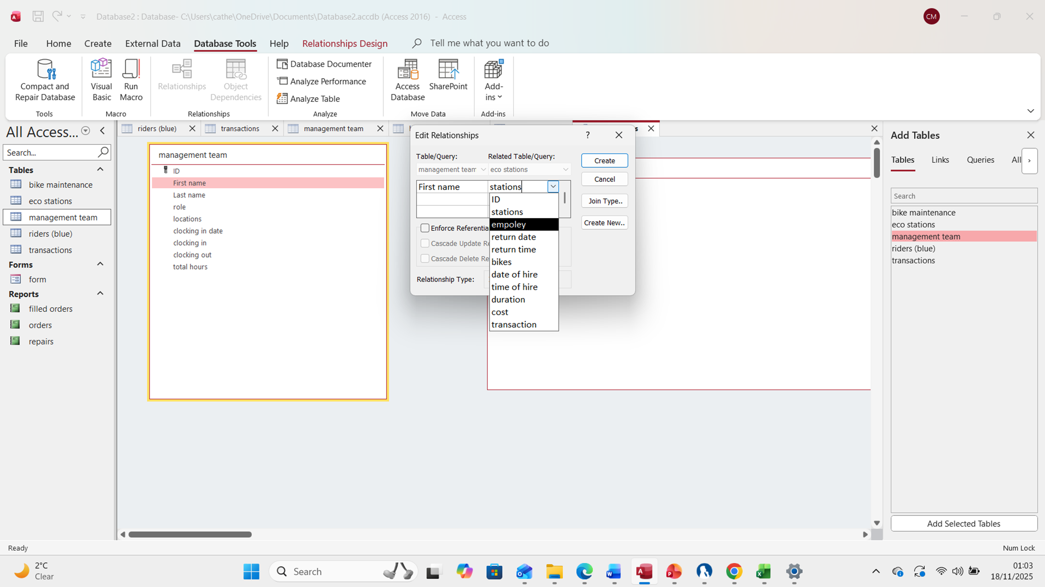
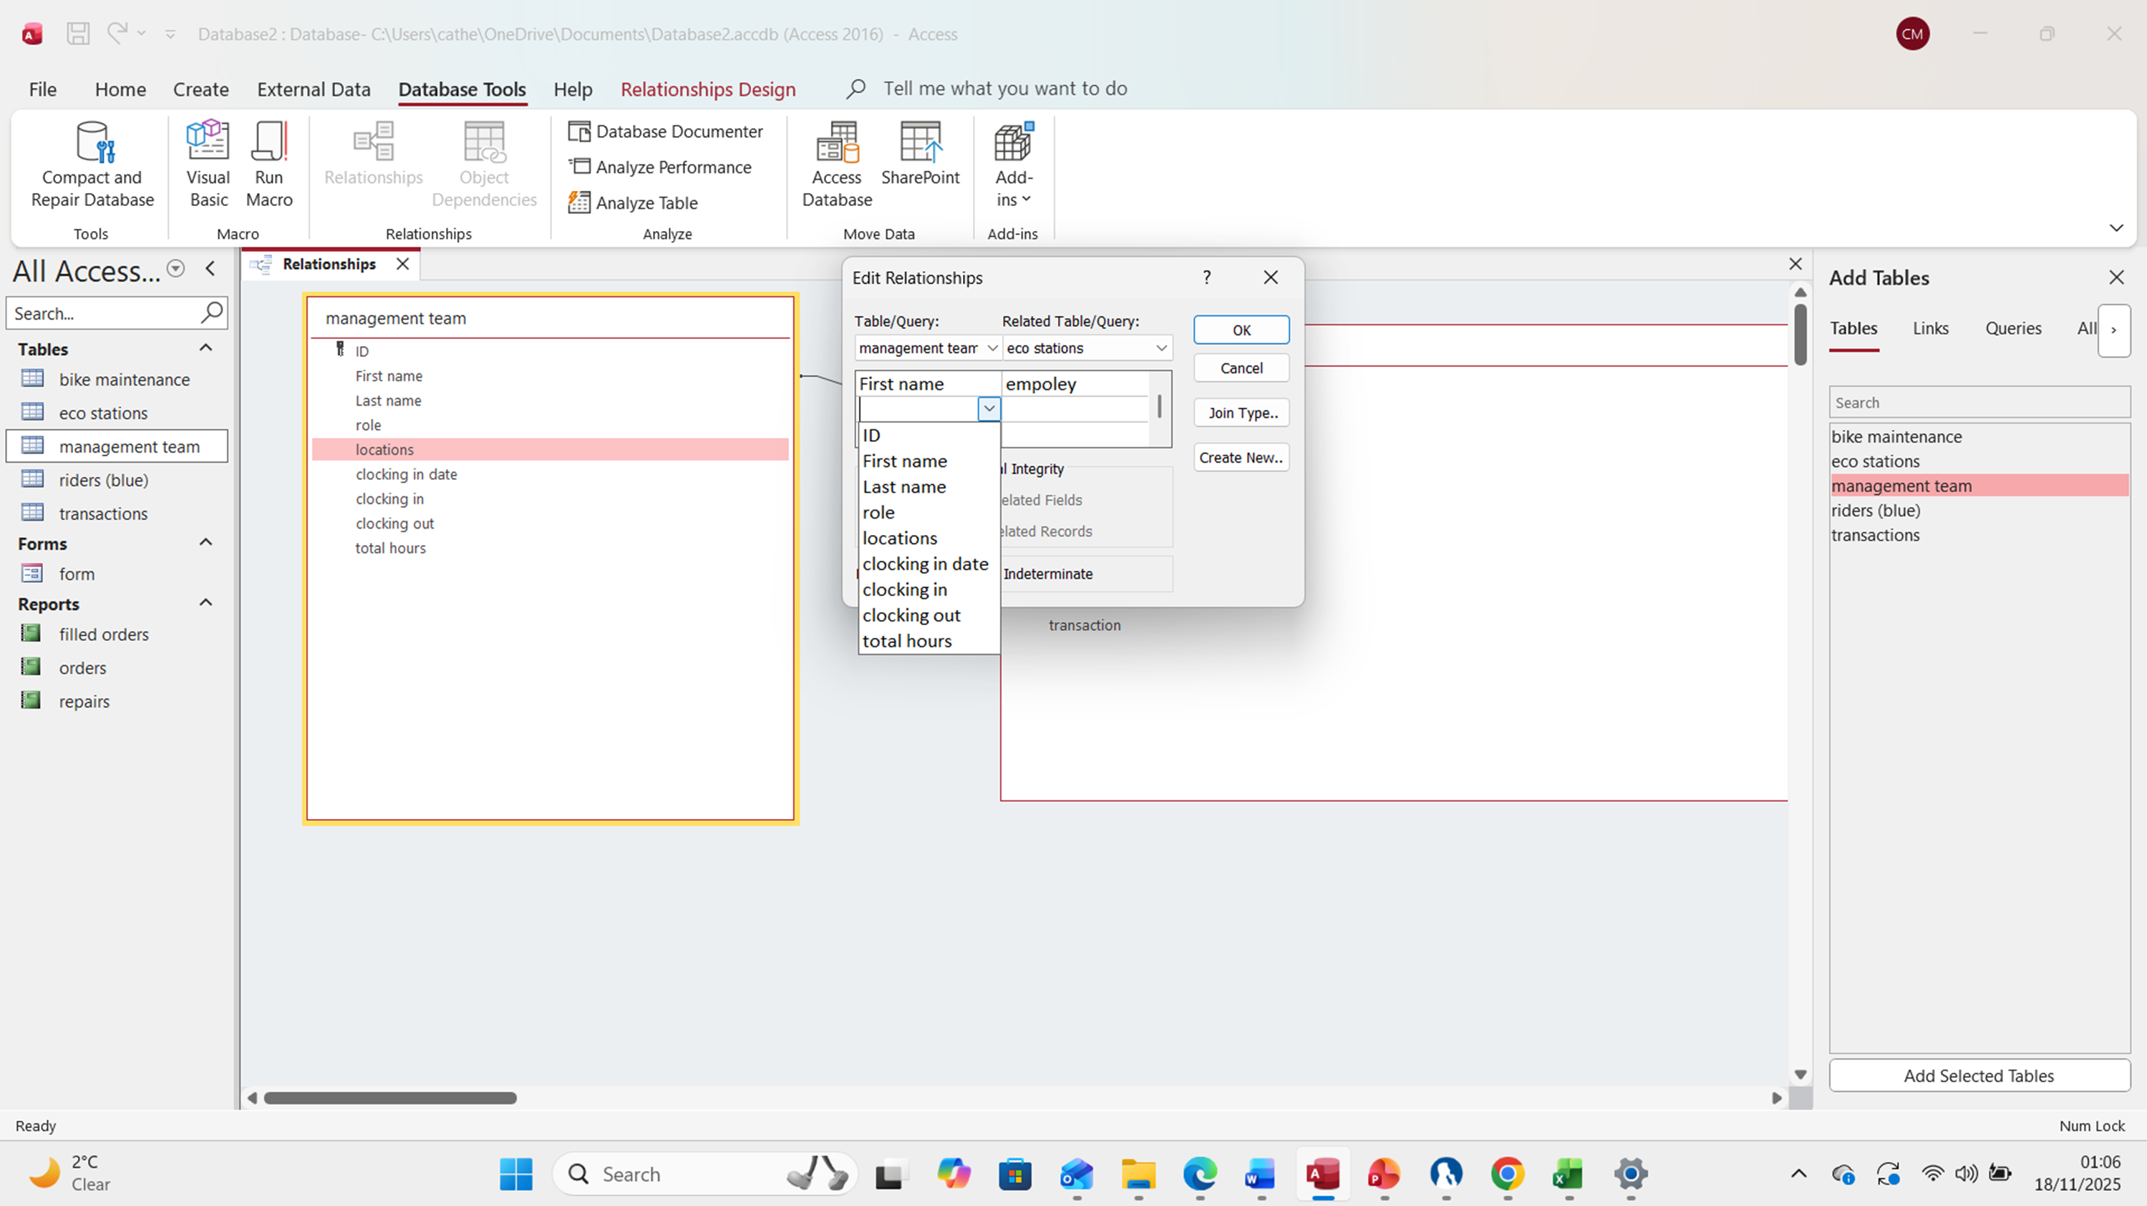
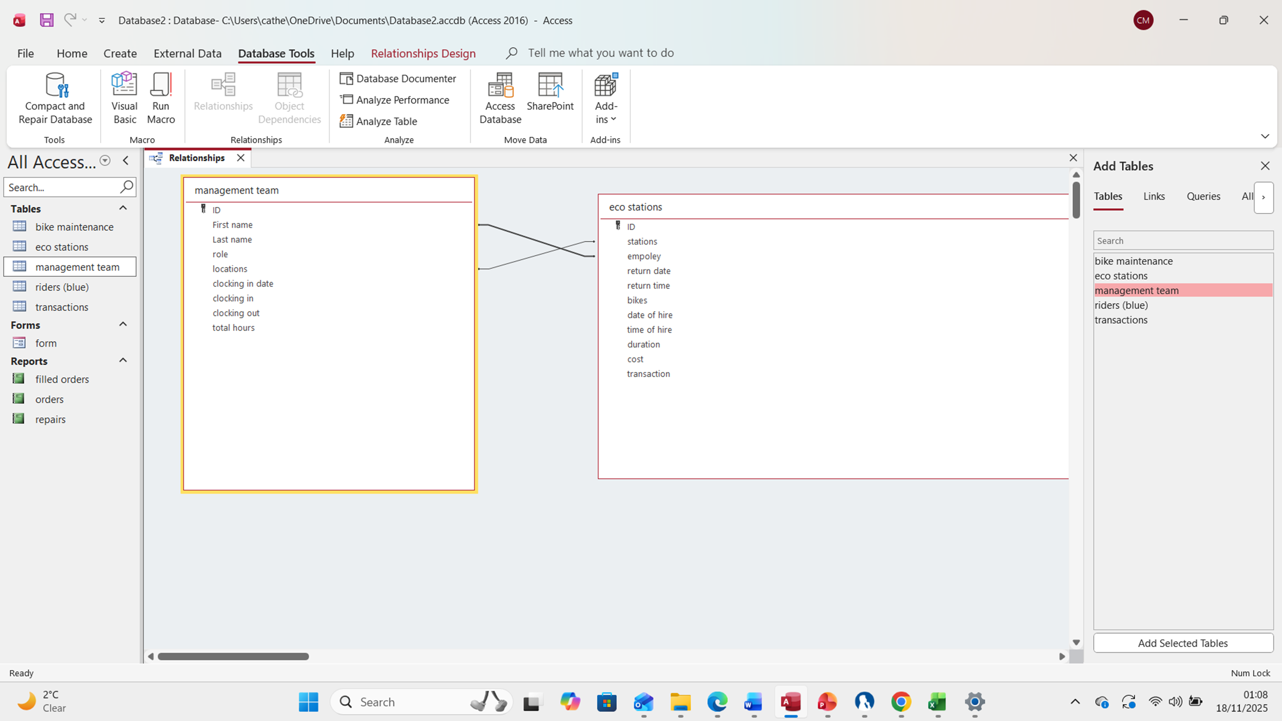
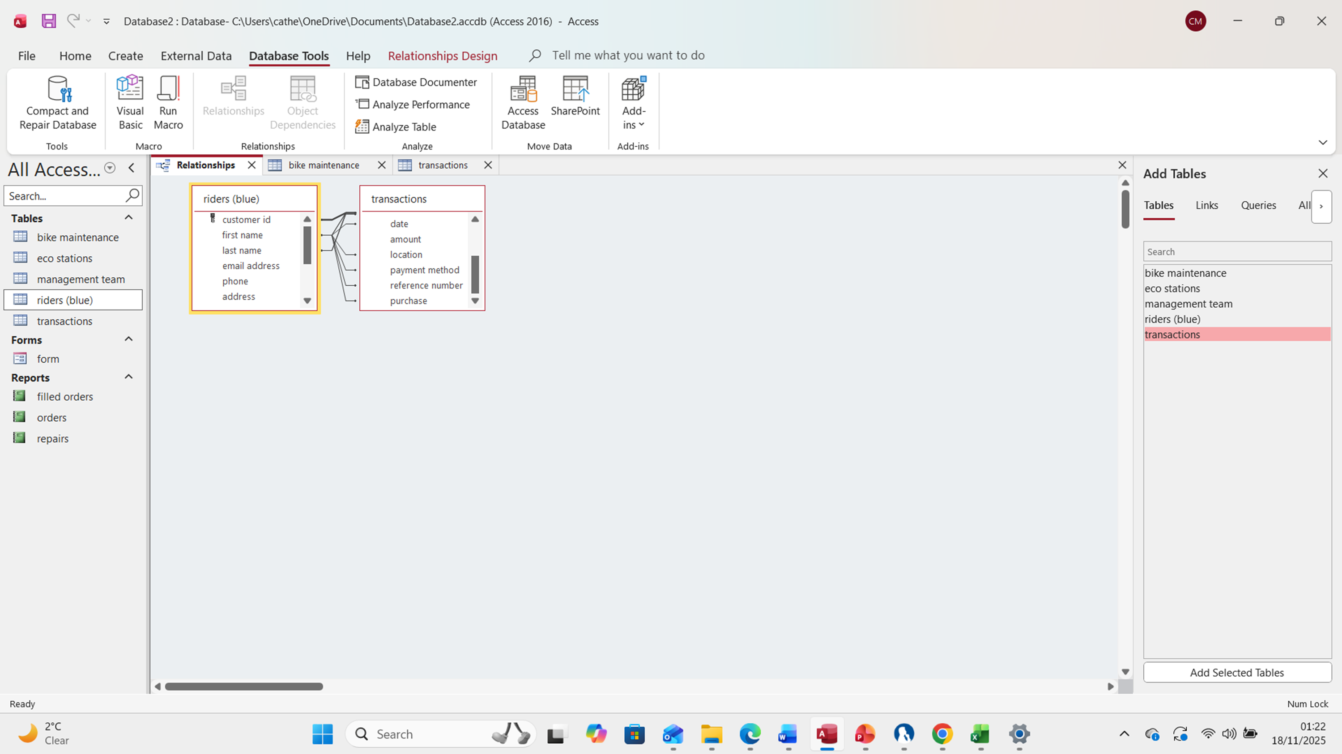
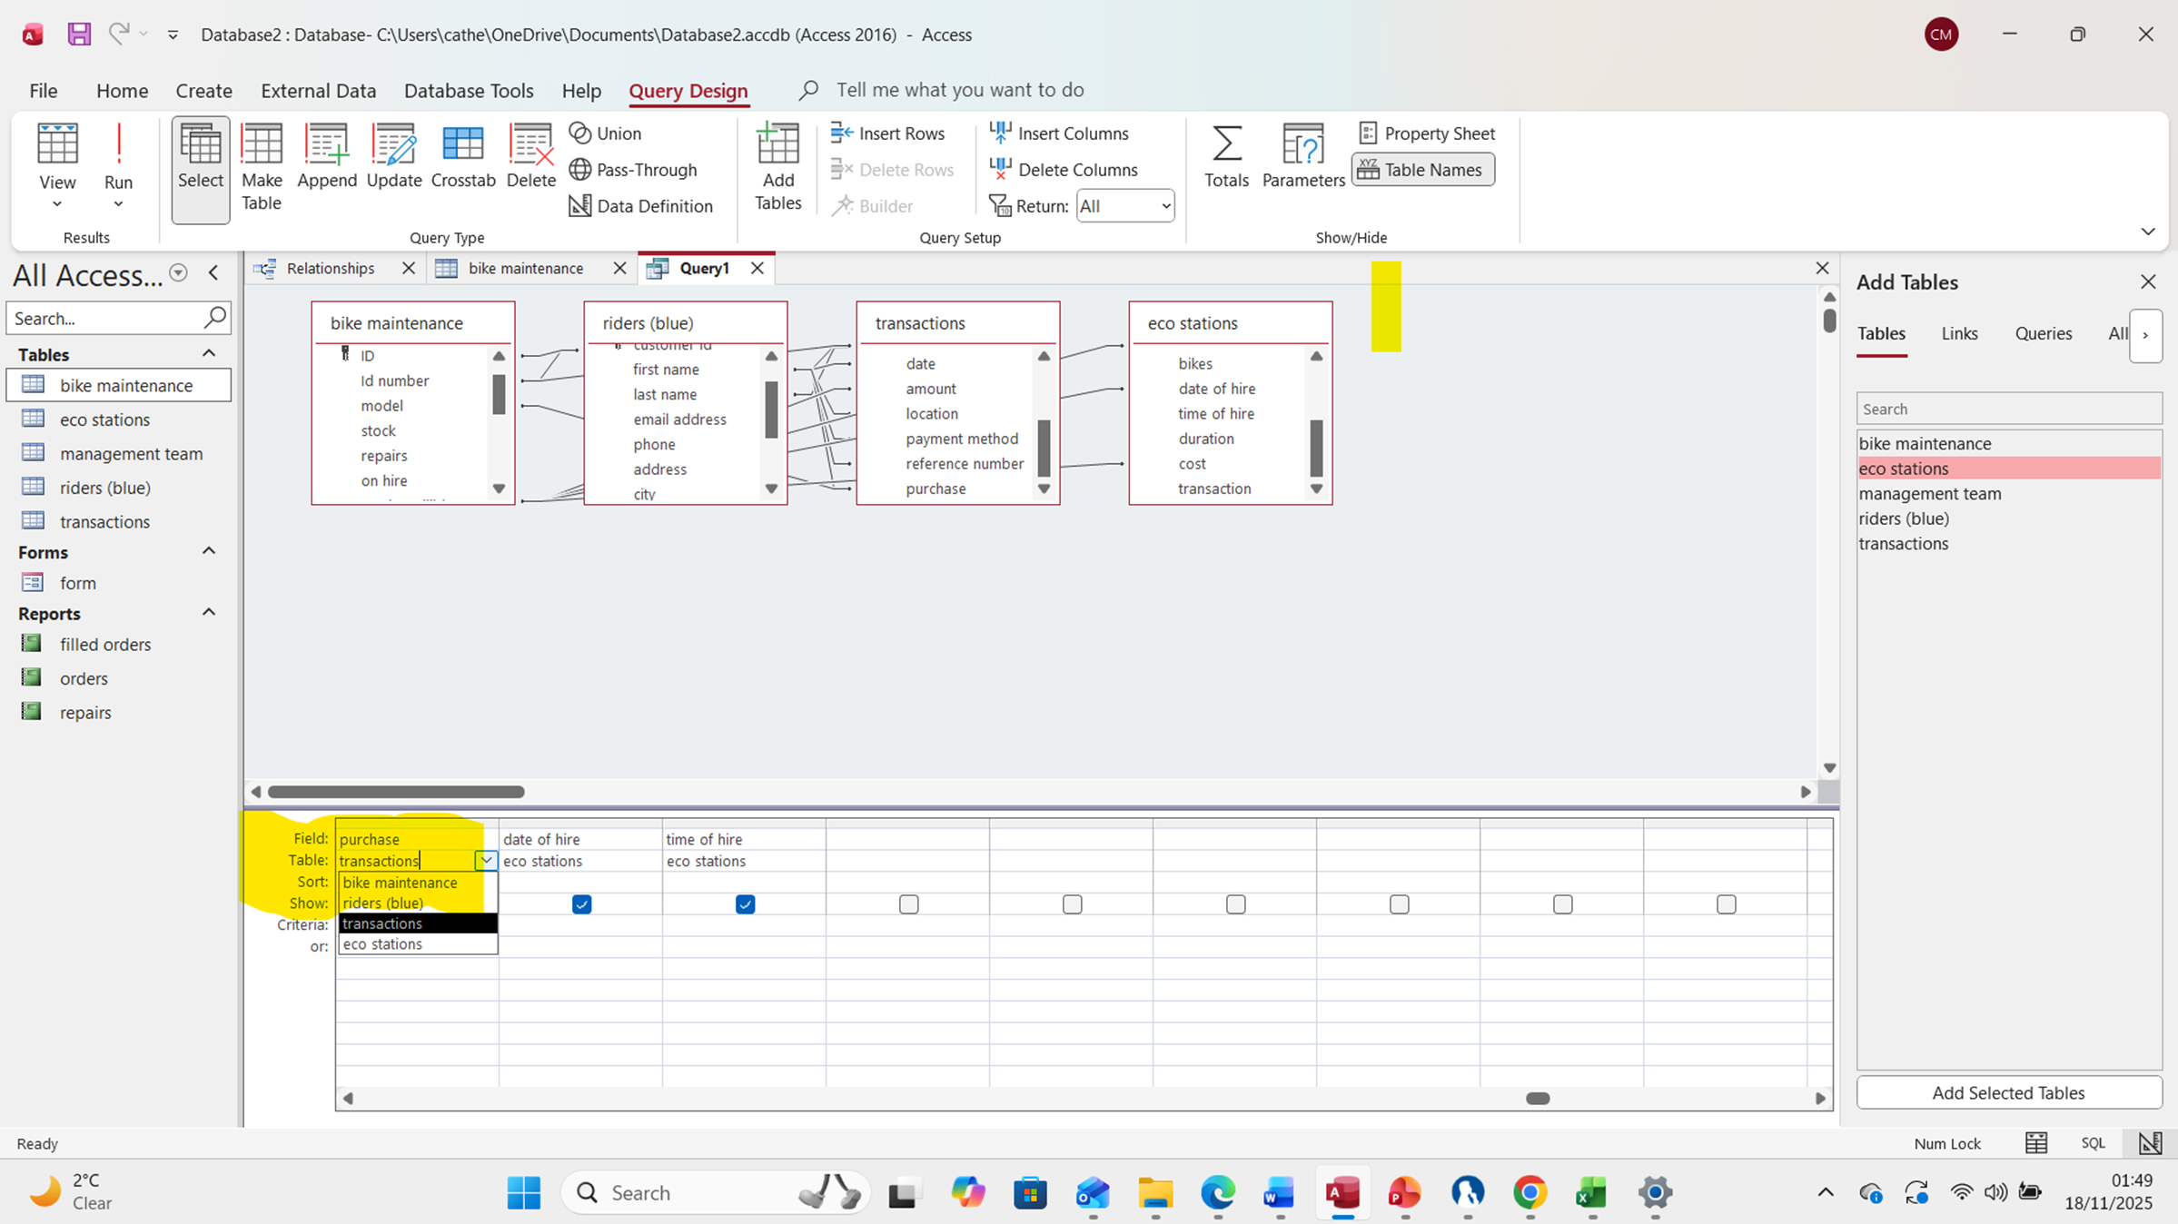

Part 3
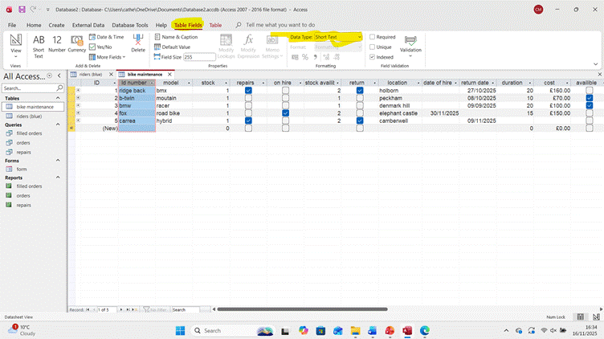
Here I can now see my order table listing what bikes are available, on hire or out for repair, location, and date of hire & off hire, etc. I've now finished saving my orders table. I now have two tables, so I can close the customer’s table.
Now I’ll explain how I changed the data type in my database, as I can see in the photo, I have 2 spots highlighted first one is (table fields), and the other highlighted spot says (data type) with a box that says short text.
To change the data type, I’d first want to click on the ribbon that says table fields, then make my way to click on the data type box. From here I
can change it to the intended data.
Part4

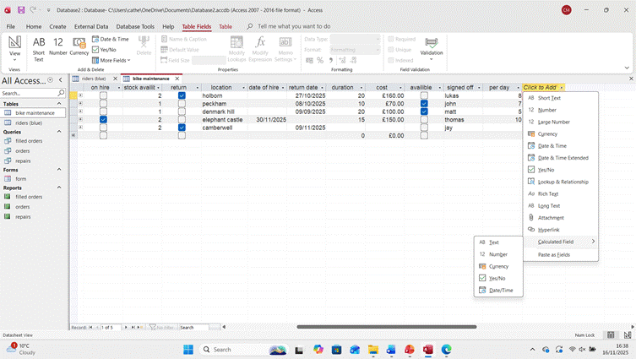
Now I'm going to explain how to use my database to do some calculations. Now going to go to the (click to add) mini tab shown above. After I’ve done that, I’d want to go all the way down to the calculated field. I’ve selected currency as I want it to calculate the price and how many orders are taking place for that customer as This field can calculate all the numbers as instructed.

Part 5
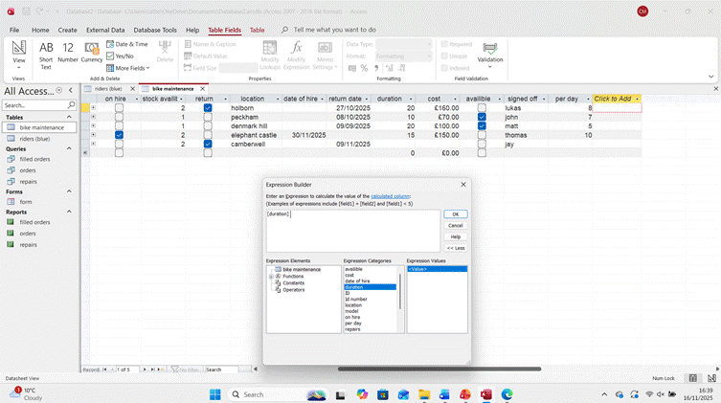
After I have selected the type of data I’m going to be using. I’ll now see a box that says (expression builder) here. I’ll put in my math Equation, for example, I’ll put in (duration/cost), and as I can see by my table, the customer is paying £8 per day.
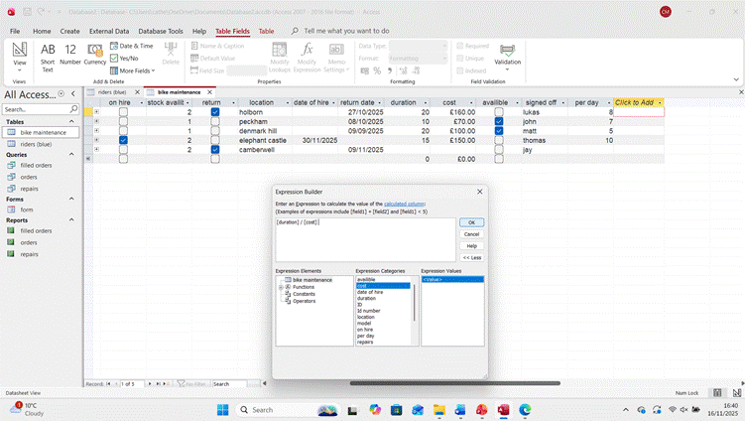
When selecting my attributes, I’ll come to my expression category and click on my intended attributes, and depending on the multiplication intended, I would use either one of these (*/+-) symbols to carry out my. My equation should look like this. [duration] / [cost]. And then click ok. Where I wanted to divide to, I used the division symbol.

Part 6
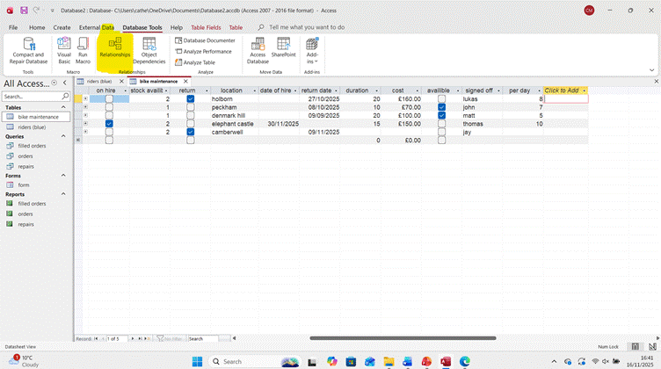
Now I'm going to show how I connected the two tables together using the relationship ribbon I'm going to go to the database tools then I should see a relationships icon where I've got highlighted.

After I’ve clicked on relationships, a tab will open saying relationships. Here is where I can create relationships between my tabs.
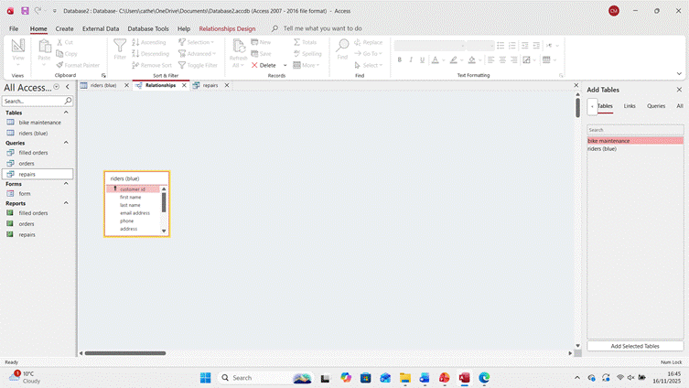
Now here you can see have opened one of my tabs that I want to create a relationship with and then I'm going to open my second tab together.
Now I can see I have both tabs open and I see the line that joins the two tabs.
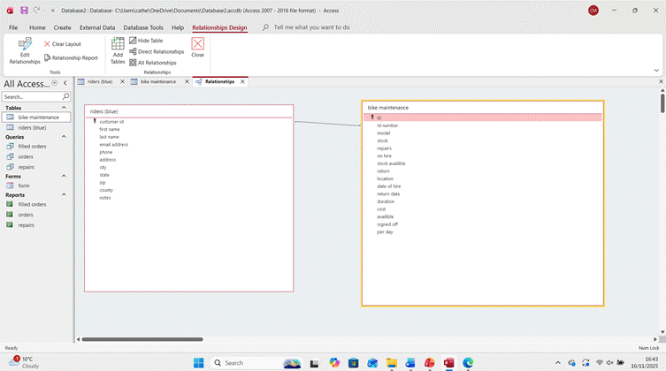 I have now just built a relationship between the two tabs. And to build a new relationship between the two tabs I drag one category 2 the training category that I wish. Then after I've done with that, I'd want to close the relationship tab.

Part7
Now I'm going to show how to set up a query. Now, if I look at the fur shown above, I can see on the top ribbon. I’ll come to the option create. I'm going to want to click on create, and then I can see where I got highlighted query design this is how I can make my query; they also have a query wizard.

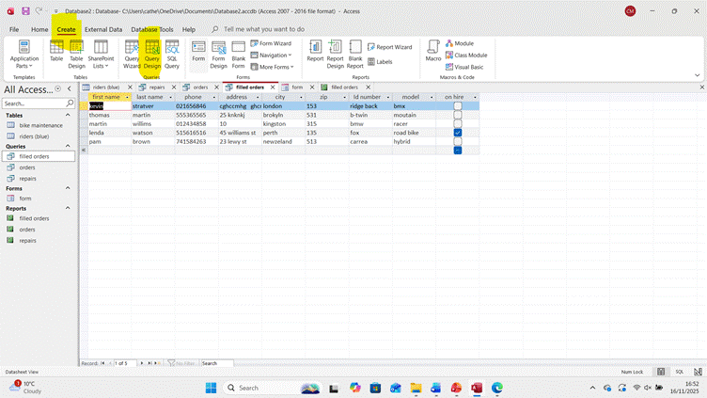
Now, if I look at the fur shown above, I can see on the top ribbon, the option creates. I’m going to want to click on create, and then I can see where I got highlighted query design this is how I can make my query; they also have a query wizard.

Here is my query.
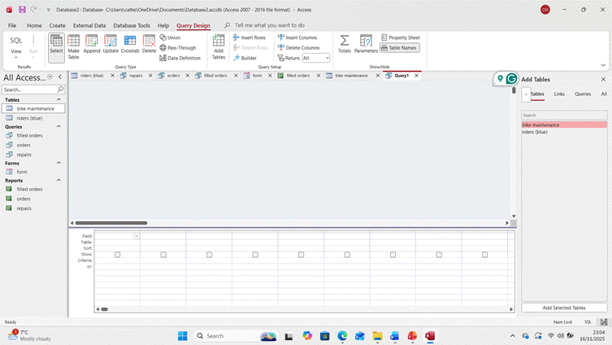
From here I can select what tables and information I want to show.

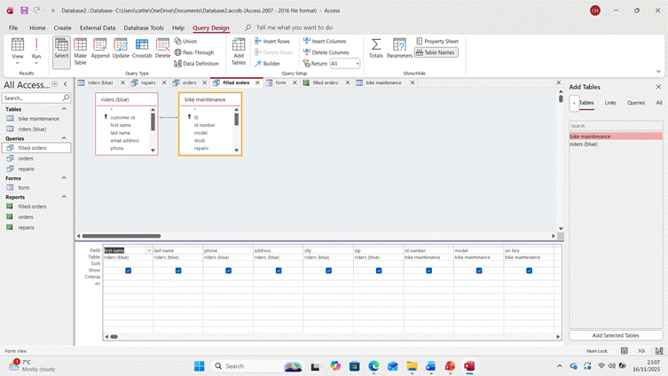
Here I can see which tables I have selected and the required fills with this I can track my filled orders, outstanding orders, and my repairs list.
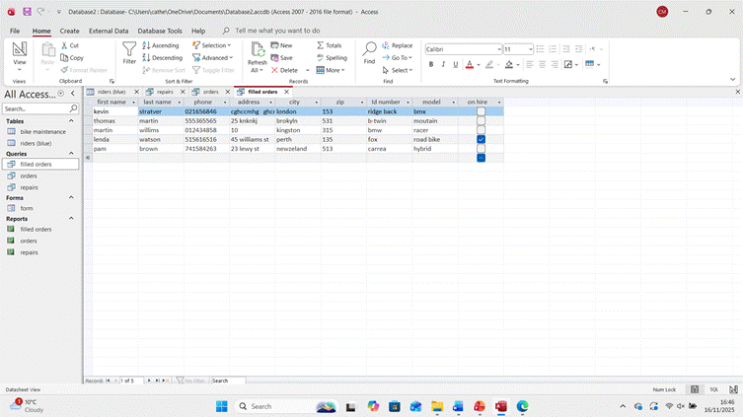
This is how my query looks after I’ve finished.
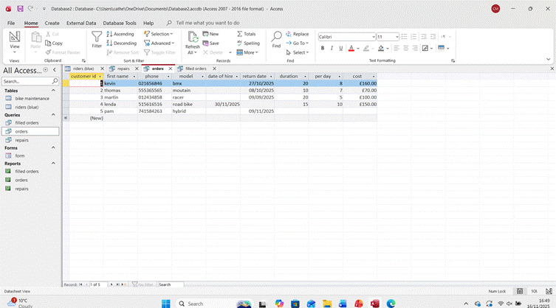
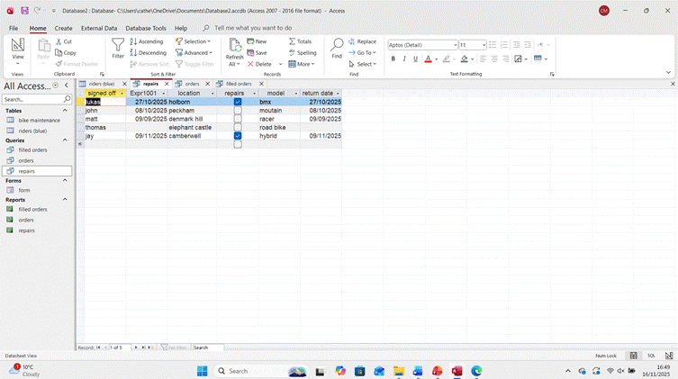

Part 8
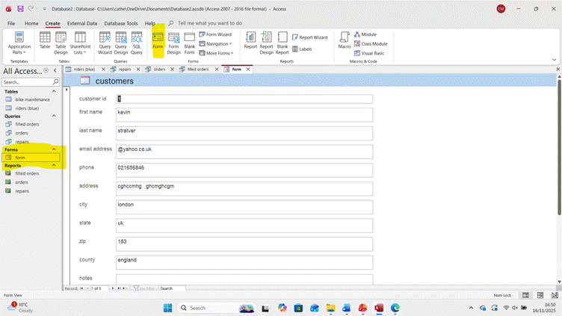
To create a form or a report. First, click on your first table, which contains all my customers' information. Then after I've done that, I'd want to click on the top ribbon that says create go to the bottom ribbon where it says form shown as highlighted and from there what happens is it converts all your customers information into a form which I can then save.
Now to make a new form. I’d want to go to the bottom of the page where I can see highlighted and click on the second arrow pain in left or if you want to see my customers forms individually, I can use the left and right arrow to go through
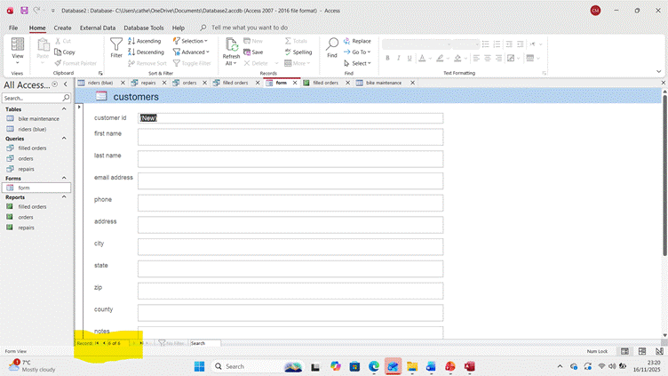

And it is the same process to create a report on my customer’s orders. Again, I’m going to want to go to the top ribbon, click on create, but instead of clicking on form, I'd want to click report, as I can see highlighted in the photo below
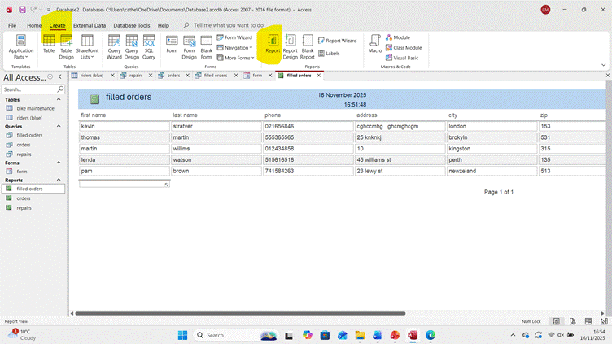

| Entities | Attributes | Relationships |
|--------------------|-------------------------------------------------|----------------------|
| Riders | rider name, rider contact information, rider ID | Scans at stations, Takes bikes |
| Bikes | bikeID, availability, repair_status | Rented by Riders |
| Rider Station | stationID, location | Has Bikes |
| Management Team | teamID, team_member_name, role | Oversees Operations |
| Rental Transactions | transactionID, start_time, end_time, cost | Records Rentals |
| Bike Maintenance | maintenanceID, bikeID, maintenance_date, notes | Maintains Bikes |
| Staff | staffID, staff_name, role | Assists Management |

### Relationships Explained:
- **Riders** can **Scan** their ID at various **Rider Stations** and **Take** bikes from those stations.
- **Bikes** are **Rented by** **Riders** during rental transactions.
- **Rider Stations** **Have Bikes** available for rental.
- The **Management Team** **Oversees** the entire operation, ensuring effective management of rentals and maintenance.
- **Rental Transactions** are **Recorded** for each bike rented by riders.
- **Bike Maintenance** ensures that bikes are kept in good working condition and keeps records of repairs associated with the **Bikes**.
- **Staff** **Assists** the **Management Team** in operations and maintenance tasks.

T |

Normalization Compliance
The data model should be normalized to Third Normal Form (3NF)
to minimize redundancy and dependency issues.

Sample Data Population
Populate the system with atleast 5 rows of sample data that reflects realistic use cases (e.g., a list of riders, bike records, rentals, maintenance logs).

Query Development
Design and run a series of practical queries to demonstrate how the system can be used. Example queries might include bikes currently out on rental, bikes due for service, most frequently used bikes or rentals by a particular rider The choice of relevant queries is left to your discretion, but some examples could be like reviewing bike availability, service needs, and user activity patterns

Validation and Testing
Evaluate your system against the functional requirements to confirm that it meets user needs. Document your testing process and outcomes.

Conclusion
Summarise overall with self-reflection:
- What you learned
- What limitations you faced
- Recommendations with further improvement

References
Include in-text citations throughout the report with a reference list alphabetically in IEEE referencing style.

c
Entities | Attributes | Relationships
Riders | rider name, rider_contact_information, and riderID | Scan, take
Bike
Rider Station
Management Team
Rental Transactions
Bike Maintenance
Staff

Normalization Compliance
minimize The data model should be normalized to Third Normal Form (3NF) to redundancy and dependency issues.

