UNIVERSITY OF WALES TRINITY SAINT DAVID
London Campus
────────────────────────────────────────
ACCA4023 – INTRODUCTION TO WEB AND DATABASE CONCEPTS
HTML & CSS WEB DEVELOPMENT
OZN COFFEE HOUSE WEBSITE
Student: Ozan Yakaryildirim
Student ID: 2530090
Lecturer: Anum Paracha
Programme: CertHE Computing Skills for Workplace
Submission date: 14 August 2026

Table of Contents
1. Introduction ................................................. 3
2. Requirements ................................................. 3
3. Implementation ............................................... 3
4. Validation ................................................... 6
4.1 Validation Evidence ..................................... 6
5. Evaluation ................................................... 8
5.1 Usefulness, Usability and Utility ....................... 8
5.2 Search Engine Optimisation (SEO) ........................ 8
5.3 Accessibility and WCAG 2.1 .............................. 9
5.4 Comparison of Two Live Websites ......................... 9
5.5 Mobile Responsiveness ................................... 10
5.6 Recommendations for Future Improvement .................. 10
6. Conclusion ................................................... 11
7. References ................................................... 11
Appendix A – HTML Source Code ................................... 13
Appendix A.1 – index.html ................................... 13
Appendix A.2 – menu.html .................................... 15
Appendix A.3 – about.html ................................... 17
Appendix A.4 – contact.html ................................. 19
Appendix B – CSS Source Code .................................... 21

1. Introduction
Abstract. This report documents the design, hand-coding, implementation and evaluation of Ozn Coffee House, a small responsive coffee-shop website developed for ACCA4023. The site provides information about products, the business and contact details through four connected pages: Home, Menu, About Us and Contact. The report evaluates the implementation against web standards, validation, usability, search engine optimisation (SEO), accessibility, mobile responsiveness and comparison with two established coffee websites.
The website was deliberately hand-coded using HTML5 and one custom CSS stylesheet rather than an external framework. This supports the requirement to demonstrate the student's own design and customisation. The final site uses semantic HTML, alternative text for images, labelled form controls, page-specific titles and descriptions, keyboard focus styles and responsive CSS.

2. Requirements
The assessment specification requires a responsive website with a minimum of three relevant pages, hand-coded using web standards and supplied as a stand-alone ZIP that can run by opening index.html on a normal PC. The report must document design decisions, implementation, screenshots, validation, evaluation, references and appendices [1].
Ozn Coffee House meets the page requirement with four pages. Home introduces the coffee shop; Menu presents six products with descriptions and prices; About Us explains the business idea; and Contact provides a message form and business information. The intended audience is local and potential customers who need quick access to menu and contact information.
The technical implementation uses HTML5 structure, a language declaration, responsive viewport settings and one shared stylesheet. CSS Grid, flexible widths, responsive images and media queries are used to adapt the layout. Internal links use relative paths so the website can operate without a development environment [1].

3. Implementation
The website is organised around four HTML pages and one shared style.css file. The shared stylesheet provides visual consistency while each page contains its own content. The header contains the Ozn Coffee House brand and navigation links. At widths up to 800 pixels, desktop navigation is replaced by a mobile menu button. The button changes aria-expanded and shows or hides the mobile navigation without a third-party framework.
The Home page uses a centred introduction followed by three cards containing an image, heading and description. The Menu page uses the same card pattern for six products and adds prices. The About Us page uses a three-column feature grid and a Contact Us call-to-action. The Contact page contains Name, Email, Subject and Message fields alongside business information.
Accessibility-aware implementation choices include descriptive alt attributes, associated form labels, accessible navigation labels and aria-current for the active page. Keyboard focus styles are provided for links and buttons. The stylesheet also includes responsive image sizing and a prefers-reduced-motion rule. These features support accessibility but do not by themselves guarantee complete WCAG conformance.
Figure 1 – Home page
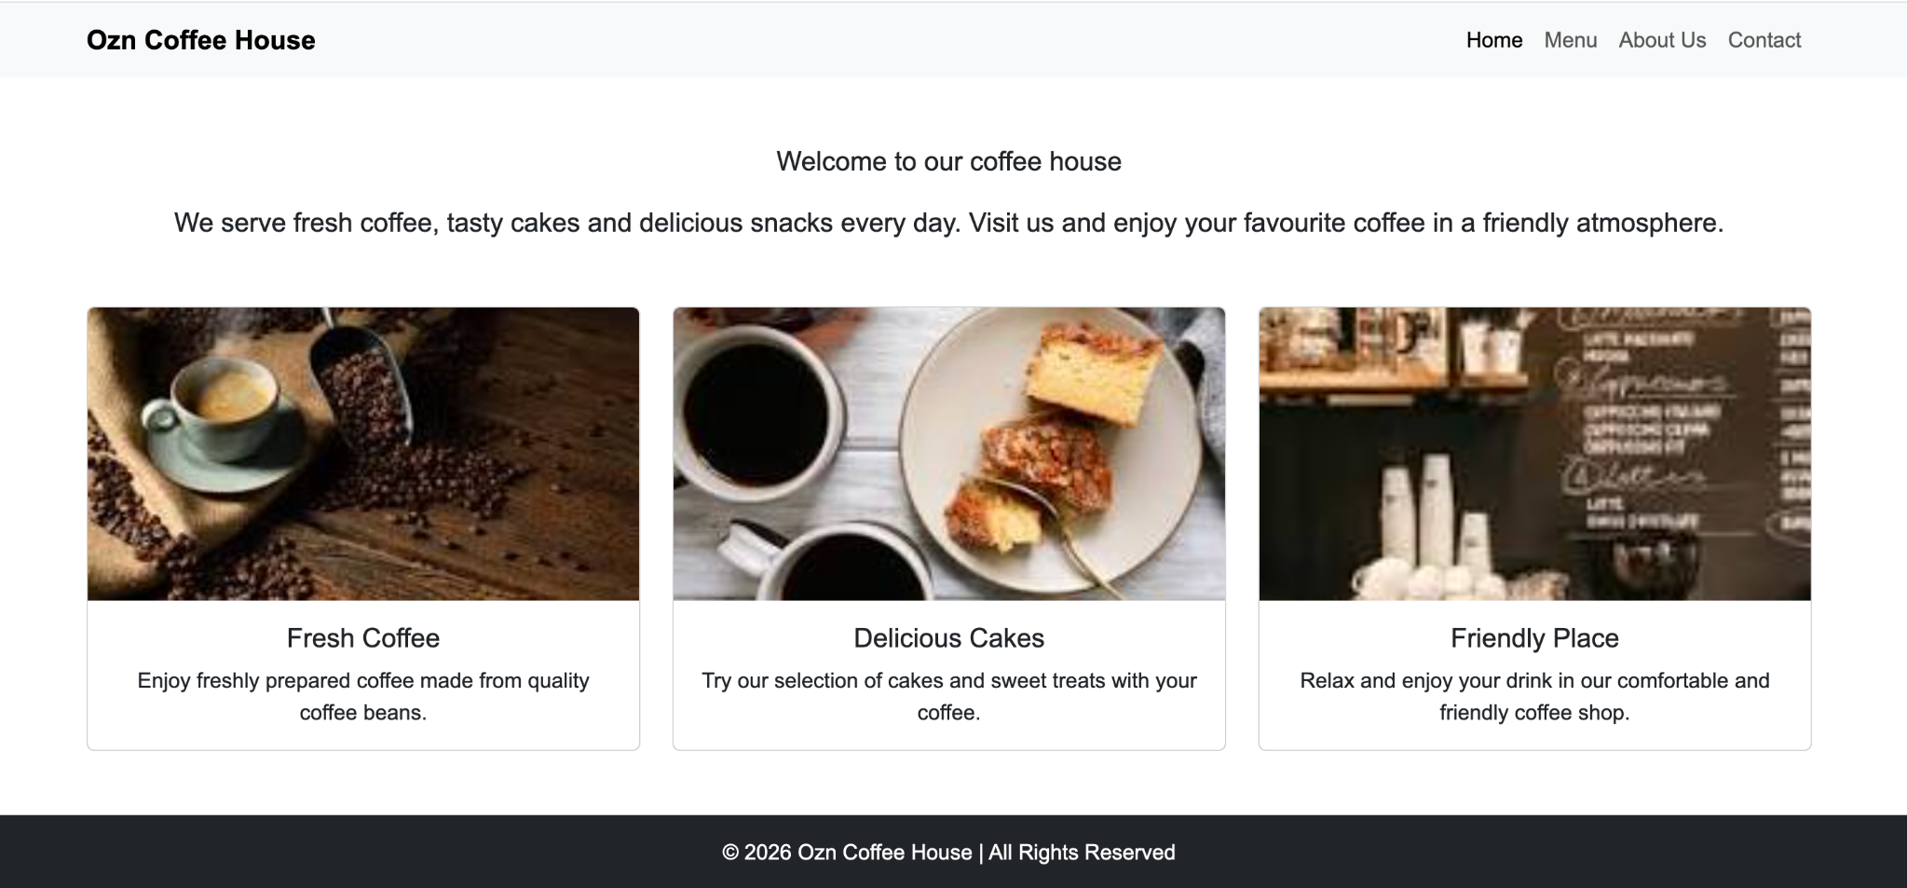
Figure 2 – Menu page
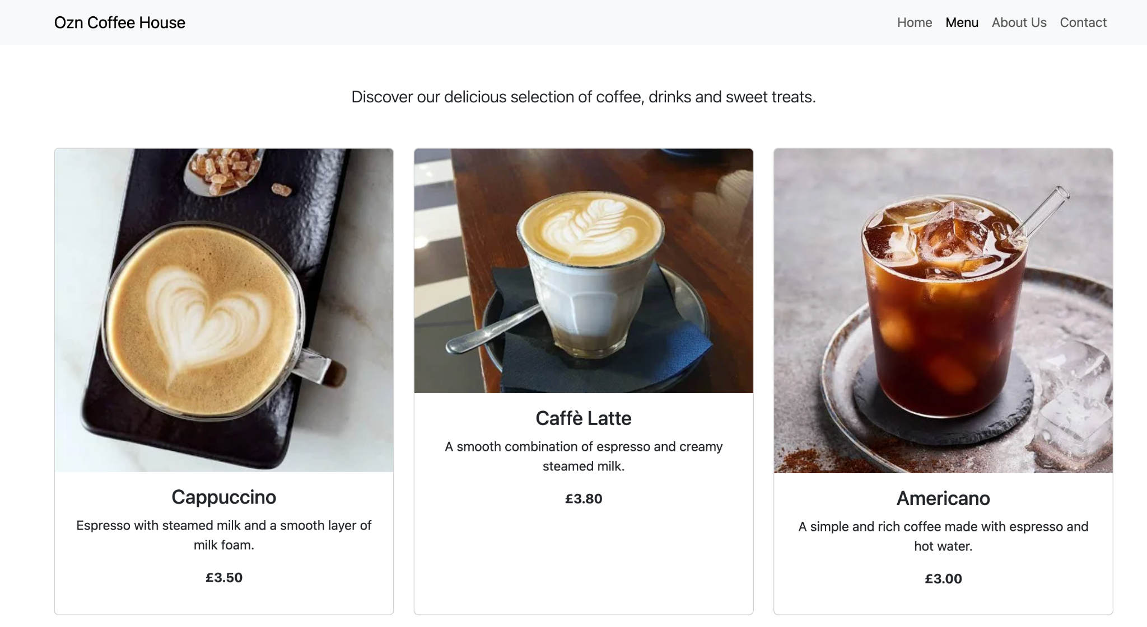
Figure 3 – About Us page
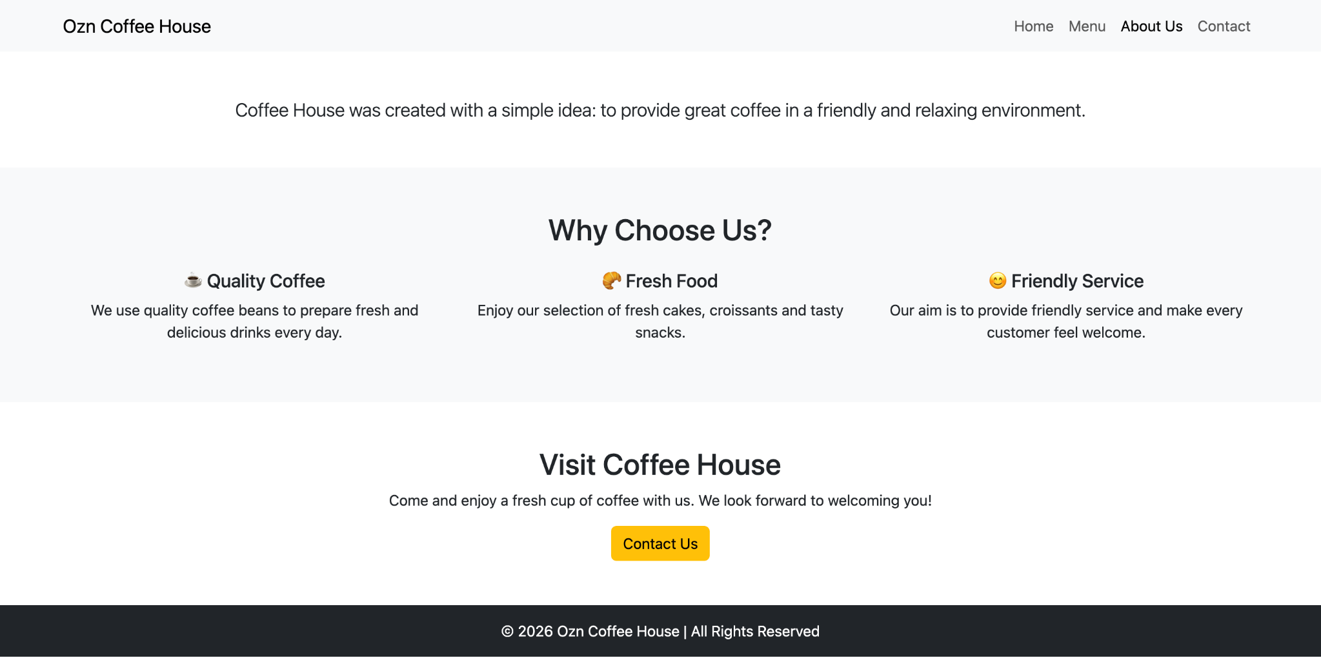
Figure 4 – Contact page
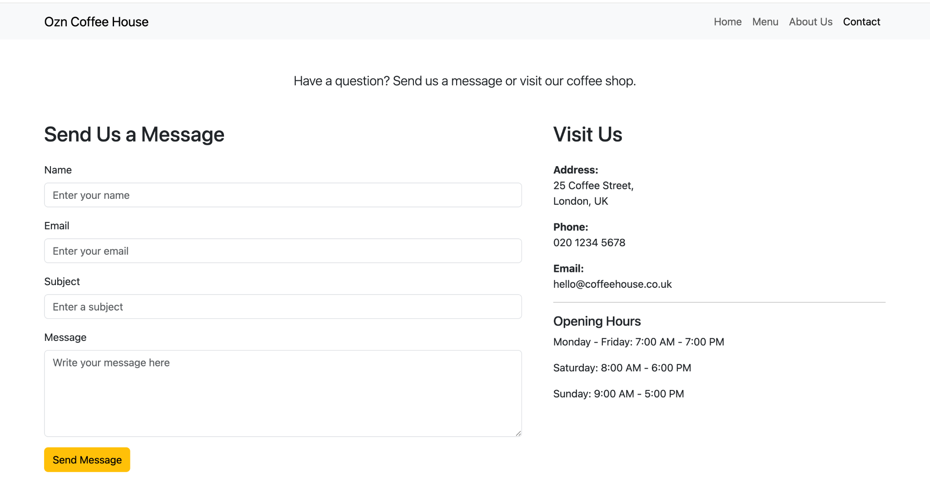

4. Validation
The assessment specification requires validation of the completed HTML and CSS. It specifically states that only the home-page HTML and the main CSS need to be validated [1]. Therefore, the formal validation scope is index.html and style.css.
A local pre-check confirmed the HTML5 doctype, lang="en", UTF-8 encoding, viewport metadata, descriptive title, meta description and one main H1 on the Home page. The three Home images have alt attributes and the stylesheet uses the relative path style.css. The CSS was also checked for unmatched blocks and invalid declaration structures.
Validation item | File | Pre-check | Comment
HTML5 structure | index.html | Pass | DOCTYPE, language, head and body structure present.
Viewport and metadata | index.html | Pass | Viewport, title and description are present.
Images | index.html | Pass | All three Home images have alt attributes.
CSS syntax structure | style.css | Pass | Braces and declarations were structurally checked.
Official W3C HTML validator | index.html | Final browser check required | Upload the exact final index.html to validator.w3.org and add the result screenshot.
Official W3C CSS validator | style.css | Final browser check required | Upload the exact final style.css to jigsaw.w3.org/css-validator/ and add the result screenshot.
Official validation evidence was captured from the final files. The W3C HTML validator reported no errors or warnings for index.html. The W3C CSS validator reported no errors and one warning. WAVE reported 0 errors and 0 contrast errors, with one redundant-link alert and an AIM score of 10/10. The redundant-link alert is not an accessibility error; it identifies links that lead to the same destination. These results provide useful evidence but do not replace human testing.

4.1 Validation Evidence
The validation process was treated as a final quality check rather than evidence that every possible problem had been eliminated. W3C validation checks conformance to HTML and CSS rules, while WAVE provides additional accessibility information. The screenshots document the results obtained from the submitted files. Future changes to navigation, forms or CSS should be followed by another validation cycle.
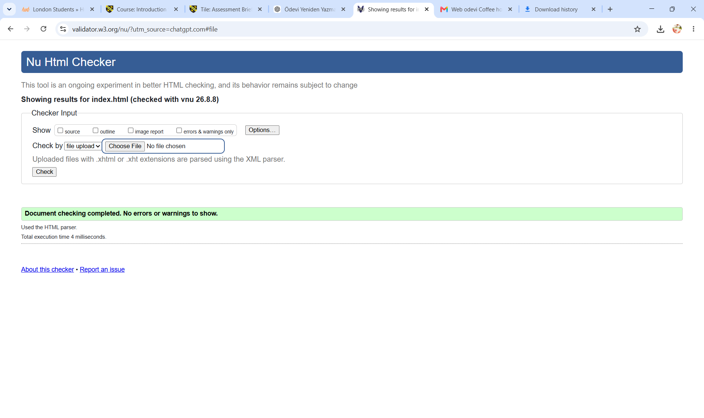
Figure 5 – W3C HTML validation result for index.html
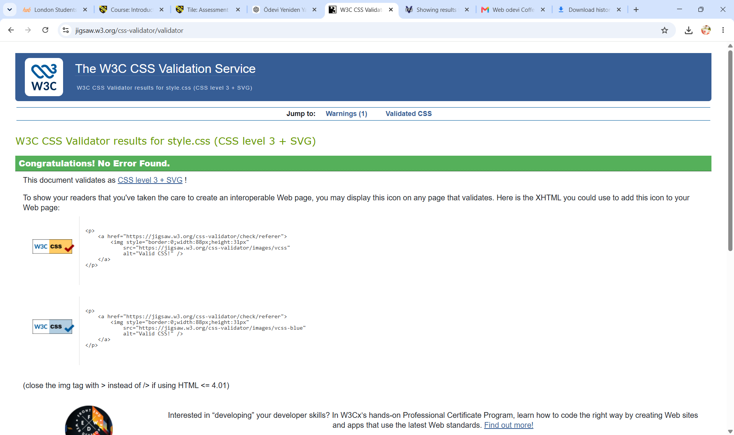
Figure 6 – W3C CSS validation result for style.css
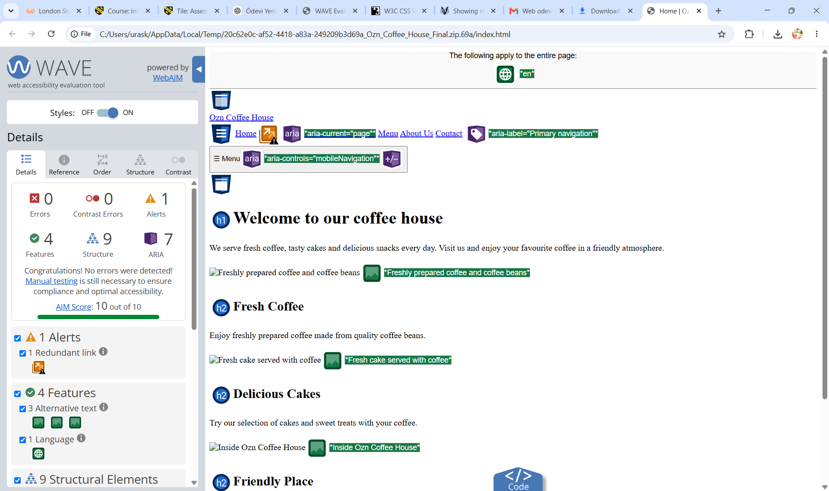
Figure 7 – WAVE accessibility evaluation result

5. Evaluation

5.1 Usefulness, Usability and Utility
Usefulness concerns whether the site provides the information required by its audience, while usability concerns how easily users can find and understand it. Ozn Coffee House performs its basic purpose well because Home, Menu, About Us and Contact are visible in the navigation. The Menu page groups product names, descriptions and prices consistently, while the Contact page provides practical details without requiring users to search other pages.
Research supports the importance of usability. Visser and Weideman found that usability attributes can positively affect conversion and argued that usability should be considered alongside SEO [2]. Research into responsive user experience also found that responsive design can maintain user experience and content readability, although information architecture still requires attention [3].
The main strengths are consistency, short navigation paths, readable headings and predictable card layouts. The main weakness is limited functionality. The site is an informational prototype rather than a commercial system: it has no online ordering, table booking, store search or customer accounts, and the contact form does not send a real message. A production version would need secure form processing, confirmation feedback, spam protection and privacy information.

5.2 Search Engine Optimisation (SEO)
The website applies basic on-page SEO techniques. Each page has a descriptive title, meta description and clear H1. The Home page title is 'Home | Ozn Coffee House' and its description identifies coffee, cakes and friendly service. Images have descriptive alt attributes and internal links connect the four pages. Meaningful headings also help users and search engines understand the content.
Research has identified a relationship between website usability and SEO, showing that both should be considered during commercial website design [4]. Hidayanto et al. also found an association between SEO configurations and increased website traffic [5]. The current SEO foundation is suitable for a small academic website but is not a complete SEO strategy. Future work could add a real domain, sitemap.xml, robots.txt, local-business structured data, local keywords, image optimisation and a Google Business Profile.
SEO should remain connected to content quality. Titles, descriptions and headings are useful when they accurately describe the page. The current site has a reasonable foundation because its four pages contain distinct content and meaningful headings. A real local business would need stronger location-based information and an established domain, with useful content preferred over excessive or unnatural keywords.

5.3 Accessibility and WCAG 2.1
WCAG 2.1 is based on four principles: Perceivable, Operable, Understandable and Robust. The site addresses these principles through alternative text, headings and readable content; visible keyboard focus styles and operable mobile navigation; consistent navigation and descriptive form labels; and standard HTML with ARIA attributes supporting the mobile menu.
Accessibility needs more than a visual inspection. Schmutz, Sonderegger and Sauer found that stronger web accessibility was associated with better task performance, usability and trustworthiness [6]. Rømen and Svanæs showed that guideline-based evaluation did not identify every problem found through testing with disabled users [7]. WAVE was therefore used as an automated accessibility check. The final result recorded 0 errors, 0 contrast errors, 4 features, 9 structural elements and 7 ARIA items, plus one redundant-link alert and an AIM score of 10/10 [8]. These results do not prove full WCAG conformance; human testing is still required.
The implementation includes several accessibility features at source-code level, but accessibility is an ongoing process. Keyboard testing should confirm logical focus through links, the mobile menu and form controls. Screen-reader testing should confirm that headings, labels and navigation communicate the intended structure. These manual activities would complement the automated WAVE result.

5.4 Comparison of Two Live Websites
Two established coffee websites, Starbucks UK and Costa Coffee UK, were selected because they provide similar broad services. The comparison considers usability, accessibility, SEO and mobile responsiveness. Both commercial websites offer much deeper customer journeys than Ozn Coffee House, while the student site is simpler and easier to understand at a glance.
Area | Ozn Coffee House | Starbucks UK | Costa Coffee UK
Usability | Simple four-page navigation; six-item menu; direct contact. | Large menu hierarchy and strong ordering paths; app, delivery and store options. | Large menu plus ordering, store locator and Click & Collect.
Accessibility | Alt text, labels, focus styles, ARIA mobile navigation. | Dedicated accessibility statement and ongoing accessibility programme. | Store locator identifies disability access; extensive customer information.
SEO | Basic titles, descriptions, headings, alt text and internal links. | Large content structure and many service/product pages create strong discoverability. | Large menu, nutrition/allergen pages and store pages provide rich searchable content.
Mobile | Responsive grid and collapsible mobile navigation. | Mobile ordering and app-oriented customer journey. | Mobile Click & Collect and Costa Club app support.
Starbucks provides order-ahead through its UK app, delivery and in-store options, together with store search [9]. Its menu has a much deeper information structure covering drinks, food, at-home products and merchandise [10]. Starbucks also publishes information about its digital accessibility work [11]. Costa similarly supports menu browsing, ordering through Costa Club and Click & Collect [12], while it provides nutrition and allergen information [14] and store information related to accessibility [15].
Overall, Starbucks and Costa are stronger for real transactions, store discovery and large-scale content. Ozn Coffee House is more limited but has a shorter navigation path and smaller information architecture. The comparison suggests that future development should focus on useful features rather than copying the complexity of large commercial sites.
The comparison also highlights project scale. Starbucks and Costa support large product catalogues, stores, ordering systems and customer services, so their information architecture is more complex. Ozn Coffee House does not need to reproduce all of these features. Instead, the comparison identifies transferable ideas such as clearer customer journeys, richer product information, store accessibility information and mobile-first services.

5.5 Mobile Responsiveness
Responsive design is important because users access websites on different screen sizes. The Ozn stylesheet uses a three-column grid on larger screens and changes to a single-column layout below 800 pixels. Desktop navigation is replaced by a menu button, the Contact layout becomes a single column, and images use max-width: 100% to reduce horizontal overflow.
Lestari, Hardianto and Hidayanto found that responsive design can maintain user experience and content readability, while information architecture still needs attention [3]. This supports the design used here: adapting the layout is useful, but navigation and content hierarchy must remain clear.

5.6 Recommendations for Future Improvement
- Future improvements should be prioritised according to the site's purpose. The contact form could be connected to a secure backend with clear success and error messages. A real location, map and opening-hours data could be added if the site represents a real business. Local SEO and structured data could improve discoverability. Further WAVE, keyboard and screen-reader testing should be recorded, and image files should be optimised for performance. Online ordering or Click & Collect could be considered only if the project expands beyond the academic prototype.
- These improvements should be implemented gradually. The highest priority would be reliable contact processing and clearer business information because these directly affect customer usefulness. Accessibility and performance testing should follow, while SEO enhancements can support discoverability once content and business details are stable. More advanced ordering features should only be added when the project has an appropriate backend, security controls and a clear business requirement.

6. Conclusion
The Ozn Coffee House website meets the main ACCA4023 design requirements through four related hand-coded pages, custom HTML/CSS, responsive layouts and a stand-alone file structure. The implementation demonstrates semantic structure, responsive CSS, alternative text, labelled forms and accessible navigation. The site is useful for its limited informational purpose, although it lacks production functions such as online ordering and real form processing.

7. References
[1] University of Wales Trinity Saint David, “ACCA4023 – Introduction to Web and Database Concepts: Level 4 Assessment Specification, HTML & CSS Web Development,” Appendix GA36a, 2026.
[2] E. B. Visser and M. Weideman, “An empirical study on website usability elements and how they affect search engine optimisation,” South African Journal of Information Management, vol. 13, no. 1, 2011.
[3] D. M. Lestari, D. Hardianto, and A. N. Hidayanto, “Analysis of user experience quality on responsive web design from its informative perspective,” International Journal of Software Engineering and Its Applications, vol. 8, no. 5, pp. 53–62, 2014, doi: 10.14257/ijseia.2014.8.5.06.
[4] E. B. Visser and M. Weideman, “Fusing website usability and search engine optimisation,” South African Journal of Information Management, vol. 16, no. 1, 2014, doi: 10.4102/sajim.v16i1.577.
[5] A. N. Hidayanto, M. S. Adha, M. A. Jiwanggi, and T. Melia, “A study of impact of search engine optimisation to internet marketing strategy,” peer-reviewed journal article, Universitas Indonesia research record.
[6] S. Schmutz, A. Sonderegger, and J. Sauer, “Implementing recommendations from web accessibility guidelines,” Human Factors, vol. 58, no. 1, 2016, doi: 10.1177/0018720816640962.
[7] D. Rømen and D. Svanæs, “Validating WCAG versions 1.0 and 2.0 through usability testing with disabled users,” Universal Access in the Information Society, vol. 11, no. 4, pp. 375–385, 2012, doi: 10.1007/s10209-011-0259-3.
[8] WebAIM, “WAVE Help,” Web Accessibility Evaluation Tools, 2026. [Online]. Available: https://wave.webaim.org/help.php. [Accessed: Aug. 11, 2026].
[9] Starbucks UK, “Ordering Starbucks,” 2026. [Online]. Available: https://www.starbucks.co.uk/order. [Accessed: Aug. 11, 2026].
[10] Starbucks UK, “Menu,” 2026. [Online]. Available: https://www.starbucks.co.uk/menu. [Accessed: Aug. 11, 2026].
[11] Starbucks UK, “Accessibility,” 2026. [Online]. Available: https://www.starbucks.co.uk/accessibility. [Accessed: Aug. 11, 2026].
[12] Costa Coffee UK, “Menu,” 2026. [Online]. Available: https://www.costa.co.uk/menu. [Accessed: Aug. 11, 2026].
[13] Costa Coffee UK, “Click & Collect,” 2026. [Online]. Available: https://www.costa.co.uk/order-online/click-and-collect. [Accessed: Aug. 11, 2026].
[14] Costa Coffee UK, “Allergen Information & Safety Guidance,” 2026. [Online]. Available: https://www.costa.co.uk/sustainability/nutrition/allergens. [Accessed: Aug. 11, 2026].
[15] Costa Coffee UK, “FAQs,” 2026. [Online]. Available: https://www.costa.co.uk/faqs. [Accessed: Aug. 11, 2026].

Appendix A – HTML Source Code
The following listings are copies of the final HTML files included in the website ZIP. They are included because the assessment specification requires text listings of all HTML and CSS at the end of the report.

Appendix A.1 – index.html
<!DOCTYPE html>
<html lang="en">
<head>
<meta charset="UTF-8">
<meta name="viewport" content="width=device-width, initial-scale=1.0">
<meta name="description" content="Home page for Ozn Coffee House, offering coffee, cakes and friendly service.">
<title>Home | Ozn Coffee House</title>
<link rel="stylesheet" href="style.css">
</head>
<body class="page-layout">
<header class="site-header">
<div class="nav-container">
<a class="brand" href="index.html">Ozn Coffee House</a>
<nav class="desktop-nav" aria-label="Primary navigation">
<a href="index.html" aria-current="page">Home</a>
<a href="menu.html">Menu</a>
<a href="about.html">About Us</a>
<a href="contact.html">Contact</a>
</nav>
<button class="menu-toggle" type="button" aria-expanded="false"
aria-controls="mobileNavigation" onclick="toggleMenu()">☰ <span class="visually-hidden">Menu</span></button>
</div>
<nav id="mobileNavigation" class="mobile-nav" aria-label="Mobile navigation" hidden>
<a href="index.html" aria-current="page">Home</a>
<a href="menu.html">Menu</a>
<a href="about.html">About Us</a>
<a href="contact.html">Contact</a>
</nav>
</header>
<main>
<section class="container intro">
<h1>Welcome to our coffee house</h1>
<p>We serve fresh coffee, tasty cakes and delicious snacks every day. Visit us and enjoy your favourite coffee in a friendly atmosphere.</p>
</section>
<section class="container card-grid" aria-label="Coffee house highlights">
<article class="card">
<img src="coffee.jpeg" alt="Freshly prepared coffee and coffee beans">
<div class="card-body">
<h2>Fresh Coffee</h2>
<p>Enjoy freshly prepared coffee made from quality coffee beans.</p>
</div>
</article>
<article class="card">
<img src="cake.jpeg" alt="Fresh cake served with coffee">
<div class="card-body">
<h2>Delicious Cakes</h2>
<p>Try our selection of cakes and sweet treats with your coffee.</p>
</div>
</article>
<article class="card">
<img src="shop.jpeg" alt="Inside Ozn Coffee House">
<div class="card-body">
<h2>Friendly Place</h2>
<p>Relax and enjoy your drink in our comfortable and friendly coffee shop.</p>
</div>
</article>
</section>
</main>
<footer class="footer">
<p>&copy; 2026 Ozn Coffee House | All Rights Reserved</p>
</footer>
<script>
function toggleMenu() {
const menu = document.getElementById('mobileNavigation');
const button = document.querySelector('.menu-toggle');
const isOpen = button.getAttribute('aria-expanded') === 'true';
button.setAttribute('aria-expanded', String(!isOpen));
menu.hidden = isOpen;
}
</script>
</body>
</html>

Appendix A.2 – menu.html
<!DOCTYPE html>
<html lang="en">
<head>
<meta charset="UTF-8">
<meta name="viewport" content="width=device-width, initial-scale=1.0">
<meta name="description" content="Menu page for Ozn Coffee House, offering coffee, cakes and friendly service.">
<title>Menu | Ozn Coffee House</title>
<link rel="stylesheet" href="style.css">
</head>
<body class="page-layout">
<header class="site-header">
<div class="nav-container">
<a class="brand" href="index.html">Ozn Coffee House</a>
<nav class="desktop-nav" aria-label="Primary navigation">
<a href="index.html">Home</a>
<a href="menu.html" aria-current="page">Menu</a>
<a href="about.html">About Us</a>
<a href="contact.html">Contact</a>
</nav>
<button class="menu-toggle" type="button" aria-expanded="false"
aria-controls="mobileNavigation" onclick="toggleMenu()">☰ <span class="visually-hidden">Menu</span></button>
</div>
<nav id="mobileNavigation" class="mobile-nav" aria-label="Mobile navigation" hidden>
<a href="index.html">Home</a>
<a href="menu.html" aria-current="page">Menu</a>
<a href="about.html">About Us</a>
<a href="contact.html">Contact</a>
</nav>
</header>
<main>
<section class="container intro">
<h1>Our Menu</h1>
<p>Discover our delicious selection of coffee, drinks and sweet treats.</p>
</section>
<section class="container card-grid" aria-label="Coffee house menu">
<article class="card">
<img src="cappuccino.webp" alt="Cappuccino">
<div class="card-body">
<h2>Cappuccino</h2>
<p>Espresso with steamed milk and a smooth layer of milk foam.</p>
<p class="price">£3.50</p>
</div>
</article>
<article class="card">
<img src="latte.webp" alt="Caffè Latte">
<div class="card-body">
<h2>Caffè Latte</h2>
<p>A smooth combination of espresso and creamy steamed milk.</p>
<p class="price">£3.80</p>
</div>
</article>
<article class="card">
<img src="americano.webp" alt="Americano">
<div class="card-body">
<h2>Americano</h2>
<p>A simple and rich coffee made with espresso and hot water.</p>
<p class="price">£3.00</p>
</div>
</article>
<article class="card">
<img src="hot-chocolate.jpeg" alt="Hot Chocolate">
<div class="card-body">
<h2>Hot Chocolate</h2>
<p>Rich chocolate combined with warm and creamy milk.</p>
<p class="price">£3.50</p>
</div>
</article>
<article class="card">
<img src="croissant.webp" alt="Croissant">
<div class="card-body">
<h2>Croissant</h2>
<p>A fresh and buttery croissant, perfect with your morning coffee.</p>
<p class="price">£2.50</p>
</div>
</article>
<article class="card">
<img src="chocolate-cake.webp" alt="Chocolate Cake">
<div class="card-body">
<h2>Chocolate Cake</h2>
<p>A delicious slice of chocolate cake for a sweet treat.</p>
<p class="price">£4.00</p>
</div>
</article>
</section>
</main>
<footer class="footer">
<p>&copy; 2026 Ozn Coffee House | All Rights Reserved</p>
</footer>
<script>
function toggleMenu() {
const menu = document.getElementById('mobileNavigation');
const button = document.querySelector('.menu-toggle');
const isOpen = button.getAttribute('aria-expanded') === 'true';
button.setAttribute('aria-expanded', String(!isOpen));
menu.hidden = isOpen;
}
</script>
</body>
</html>

Appendix A.3 – about.html
<!DOCTYPE html>
<html lang="en">
<head>
<meta charset="UTF-8">
<meta name="viewport" content="width=device-width, initial-scale=1.0">
<meta name="description" content="About Us page for Ozn Coffee House, offering coffee, cakes and friendly service.">
<title>About Us | Ozn Coffee House</title>
<link rel="stylesheet" href="style.css">
</head>
<body class="page-layout">
<header class="site-header">
<div class="nav-container">
<a class="brand" href="index.html">Ozn Coffee House</a>
<nav class="desktop-nav" aria-label="Primary navigation">
<a href="index.html">Home</a>
<a href="menu.html">Menu</a>
<a href="about.html" aria-current="page">About Us</a>
<a href="contact.html">Contact</a>
</nav>
<button class="menu-toggle" type="button" aria-expanded="false"
aria-controls="mobileNavigation" onclick="toggleMenu()">☰ <span class="visually-hidden">Menu</span></button>
</div>
<nav id="mobileNavigation" class="mobile-nav" aria-label="Mobile navigation" hidden>
<a href="index.html">Home</a>
<a href="menu.html">Menu</a>
<a href="about.html" aria-current="page">About Us</a>
<a href="contact.html">Contact</a>
</nav>
</header>
<main>
<section class="container intro">
<h1>About Ozn Coffee House</h1>
<p>Ozn Coffee House was created with a simple idea: to provide great coffee in a friendly and relaxing environment.</p>
</section>
<section class="section-light">
<div class="container">
<h2 class="section-title">Why Choose Us?</h2>
<div class="feature-grid">
<article class="feature">
<h2>☕ Quality Coffee</h2>
<p>We use quality coffee beans to prepare fresh and delicious drinks every day.</p>
</article>
<article class="feature">
<h2>🥐 Fresh Food</h2>
<p>Enjoy our selection of fresh cakes, croissants and tasty snacks.</p>
</article>
<article class="feature">
<h2>😊 Friendly Service</h2>
<p>Our aim is to provide friendly service and make every customer feel welcome.</p>
</article>
</div>
</div>
</section>
<section class="container cta">
<h2>Visit Ozn Coffee House</h2>
<p>Come and enjoy a fresh cup of coffee with us. We look forward to welcoming you!</p>
<a class="button" href="contact.html">Contact Us</a>
</section>
</main>
<footer class="footer">
<p>&copy; 2026 Ozn Coffee House | All Rights Reserved</p>
</footer>
<script>
function toggleMenu() {
const menu = document.getElementById('mobileNavigation');
const button = document.querySelector('.menu-toggle');
const isOpen = button.getAttribute('aria-expanded') === 'true';
button.setAttribute('aria-expanded', String(!isOpen));
menu.hidden = isOpen;
}
</script>
</body>
</html>

Appendix A.4 – contact.html
<!DOCTYPE html>
<html lang="en">
<head>
<meta charset="UTF-8">
<meta name="viewport" content="width=device-width, initial-scale=1.0">
<meta name="description" content="Contact page for Ozn Coffee House, offering coffee, cakes and friendly service.">
<title>Contact | Ozn Coffee House</title>
<link rel="stylesheet" href="style.css">
</head>
<body class="page-layout">
<header class="site-header">
<div class="nav-container">
<a class="brand" href="index.html">Ozn Coffee House</a>
<nav class="desktop-nav" aria-label="Primary navigation">
<a href="index.html">Home</a>
<a href="menu.html">Menu</a>
<a href="about.html">About Us</a>
<a href="contact.html" aria-current="page">Contact</a>
</nav>
<button class="menu-toggle" type="button" aria-expanded="false"
aria-controls="mobileNavigation" onclick="toggleMenu()">☰ <span class="visually-hidden">Menu</span></button>
</div>
<nav id="mobileNavigation" class="mobile-nav" aria-label="Mobile navigation" hidden>
<a href="index.html">Home</a>
<a href="menu.html">Menu</a>
<a href="about.html">About Us</a>
<a href="contact.html" aria-current="page">Contact</a>
</nav>
</header>
<main>
<section class="container intro">
<h1>Contact Ozn Coffee House</h1>
<p>Have a question? Send us a message or visit our coffee shop.</p>
</section>
<section class="container contact-grid">
<div>
<h2>Send Us a Message</h2>
<form action="#" method="post">
<div class="form-group">
<label for="name">Name</label>
<input class="form-control" type="text" id="name" name="name" autocomplete="name" placeholder="Enter your name" required>
</div>
<div class="form-group">
<label for="email">Email</label>
<input class="form-control" type="email" id="email" name="email" autocomplete="email" placeholder="Enter your email" required>
</div>
<div class="form-group">
<label for="subject">Subject</label>
<input class="form-control" type="text" id="subject" name="subject" placeholder="Enter a subject">
</div>
<div class="form-group">
<label for="message">Message</label>
<textarea class="form-control" id="message" name="message" rows="5" placeholder="Write your message here" required></textarea>
</div>
<button class="submit-button" type="submit">Send Message</button>
</form>
</div>
<aside class="info-box">
<h2>Visit Us</h2>
<p><strong>Address:</strong><br>25 Coffee Street,<br>London, UK</p>
<p><strong>Phone:</strong><br>020 1234 5678</p>
<p><strong>Email:</strong><br>hello@coffeehouse.co.uk</p>
<hr>
<h3>Opening Hours</h3>
<p>Monday - Friday: 7:00 AM - 7:00 PM</p>
<p>Saturday: 8:00 AM - 6:00 PM</p>
<p>Sunday: 9:00 AM - 5:00 PM</p>
</aside>
</section>
<section class="section-light">
<div class="container cta">
<h2>We Would Love to Hear From You</h2>
<p>Contact us with any questions, feedback or suggestions.</p>
</div>
</section>
</main>
<footer class="footer">
<p>&copy; 2026 Ozn Coffee House | All Rights Reserved</p>
</footer>
<script>
function toggleMenu() {
const menu = document.getElementById('mobileNavigation');
const button = document.querySelector('.menu-toggle');
const isOpen = button.getAttribute('aria-expanded') === 'true';
button.setAttribute('aria-expanded', String(!isOpen));
menu.hidden = isOpen;
}
</script>
</body>
</html>

Appendix B – CSS Source Code
/* Ozn Coffee House - custom responsive stylesheet */
* {
box-sizing: border-box;
}

html {
scroll-behavior: smooth;
}

body {
margin: 0;
font-family: Arial, Helvetica, sans-serif;
color: #212529;
background: #ffffff;
line-height: 1.6;
}

img {
max-width: 100%;
display: block;
}

a {
color: inherit;
}

.site-header {
background: #f8f9fa;
border-bottom: 1px solid #e5e7eb;
position: sticky;
top: 0;
z-index: 1000;
}

.nav-container {
max-width: 1200px;
margin: 0 auto;
padding: 0.9rem 1.25rem;
display: flex;
align-items: center;
justify-content: space-between;
gap: 1rem;
}

.brand {
font-size: 1.45rem;
font-weight: 700;
text-decoration: none;
white-space: nowrap;
}

.desktop-nav {
display: flex;
align-items: center;
gap: 0.25rem;
}

.desktop-nav a,
.mobile-nav a {
text-decoration: none;
padding: 0.55rem 0.75rem;
border-radius: 0.4rem;
}

.desktop-nav a:hover,
.desktop-nav a:focus-visible,
.mobile-nav a:hover,
.mobile-nav a:focus-visible {
background: #e9ecef;
outline: none;
}

.desktop-nav a[aria-current="page"],
.mobile-nav a[aria-current="page"] {
font-weight: 700;
color: #111;
}

.menu-toggle {
display: none;
}

.mobile-nav {
display: none;
}

.container {
width: min(1200px, calc(100% - 2rem));
margin-inline: auto;
}

.intro {
text-align: center;
padding: 3.2rem 0 2.2rem;
}

.intro h1 {
margin: 0 0 1rem;
font-size: clamp(1.8rem, 3vw, 2.5rem);
line-height: 1.2;
}

.intro p {
margin: 0 auto;
max-width: 1000px;
font-size: clamp(1.05rem, 2vw, 1.3rem);
}

.card-grid {
display: grid;
grid-template-columns: repeat(3, minmax(0, 1fr));
gap: 1.5rem;
padding-bottom: 3rem;
}

.card {
border: 1px solid #d7d7d7;
border-radius: 0.55rem;
overflow: hidden;
background: #fff;
text-align: center;
box-shadow: 0 1px 3px rgba(0, 0, 0, 0.04);
}

.card img {
width: 100%;
height: 230px;
object-fit: cover;
}

.card-body {
padding: 1.25rem 1.1rem;
}

.card h2,
.card h3 {
margin: 0 0 0.6rem;
font-size: 1.35rem;
}

.card p {
margin: 0;
}

.price {
margin-top: 0.8rem !important;
font-weight: 700;
font-size: 1.1rem;
}

.section-light {
background: #f8f9fa;
padding: 3rem 0;
}

.section-title {
text-align: center;
margin: 0 0 2rem;
font-size: clamp(1.7rem, 3vw, 2.2rem);
}

.feature-grid {
display: grid;
grid-template-columns: repeat(3, minmax(0, 1fr));
gap: 2rem;
text-align: center;
}

.feature h2 {
font-size: 1.3rem;
margin: 0 0 0.6rem;
}

.feature p {
margin: 0;
}

.cta {
text-align: center;
padding: 3rem 0;
}

.cta h2 {
margin-top: 0;
}

.button {
display: inline-block;
margin-top: 0.75rem;
padding: 0.7rem 1.2rem;
background: #ffbf00;
color: #111;
text-decoration: none;
border-radius: 0.45rem;
font-weight: 600;
border: 2px solid transparent;
}

.button:hover,
.button:focus-visible {
background: #e5a900;
outline: 2px solid #111;
outline-offset: 2px;
}

.contact-grid {
display: grid;
grid-template-columns: 1.4fr 0.9fr;
gap: 3.5rem;
padding-bottom: 3rem;
}

.contact-grid h2 {
margin-top: 0;
font-size: 2rem;
}

.form-group {
margin-bottom: 1rem;
}

.form-group label {
display: block;
margin-bottom: 0.35rem;
font-weight: 600;
}

.form-control {
width: 100%;
padding: 0.75rem 0.85rem;
border: 1px solid #cfd4da;
border-radius: 0.45rem;
font: inherit;
background: #fff;
}

.form-control:focus {
border-color: #555;
outline: 3px solid rgba(0, 0, 0, 0.12);
}

textarea.form-control {
min-height: 150px;
resize: vertical;
}

.submit-button {
padding: 0.7rem 1.2rem;
border: 0;
border-radius: 0.45rem;
background: #ffbf00;
color: #111;
font: inherit;
font-weight: 600;
cursor: pointer;
}

.submit-button:hover,
.submit-button:focus-visible {
background: #e5a900;
outline: 2px solid #111;
outline-offset: 2px;
}

.info-box p {
margin: 0 0 1rem;
}

.info-box hr {
border: 0;
border-top: 1px solid #cfcfcf;
margin: 1.5rem 0;
}

.footer {
margin-top: auto;
background: #212529;
color: #fff;
text-align: center;
padding: 1rem;
}

.page-layout {
min-height: 100vh;
display: flex;
flex-direction: column;
}

main {
flex: 1;
}

@media (max-width: 800px) {
.desktop-nav {
display: none;
}

.menu-toggle {
display: inline-flex;
align-items: center;
justify-content: center;
padding: 0.55rem 0.7rem;
border: 1px solid #bbb;
border-radius: 0.4rem;
background: #fff;
cursor: pointer;
font-size: 1.1rem;
}

.mobile-nav {
display: block;
max-width: 1200px;
margin: 0 auto;
padding: 0 1.25rem 0.8rem;
}

.mobile-nav[hidden] {
display: none;
}

.mobile-nav a {
display: block;
margin-top: 0.2rem;
}

.card-grid,
.feature-grid {
grid-template-columns: 1fr;
}

.contact-grid {
grid-template-columns: 1fr;
gap: 2rem;
}
}

@media (min-width: 801px) {
.mobile-nav {
display: none !important;
}
}

@media (prefers-reduced-motion: reduce) {
html {
scroll-behavior: auto;
}
}

.visually-hidden {
position: absolute;
width: 1px;
height: 1px;
padding: 0;
margin: -1px;
overflow: hidden;
clip: rect(0, 0, 0, 0);
white-space: nowrap;
border: 0;
}

