

Psychology in Health and Social Care (LCHS4010)



Date: 16/03/2026
Assignment 1 – Psychological Theory and Early Development
Student Name: Arzoo Anyis
Student ID: 2435268
Lecturer’s Name: Shepherd Ziko
Module Code: LCHS4010
Module Title: Psychology in Health and Social Care
Declaration: AI assistance was used to support the preparation of this presentation.



Slide 2-Introduction:

This presentation discusses the psychological development of Jenny using Attachment Theory.
The presentation will:
- Introduce Jenny’s situation
- Explain the key ideas of attachment theory
- Apply the theory to Jenny’s development
- Suggest strategies to support Jenny
- Evaluate the strengths and weaknesses of the theory
The aim is to understand how early relationships influence emotional and social development.

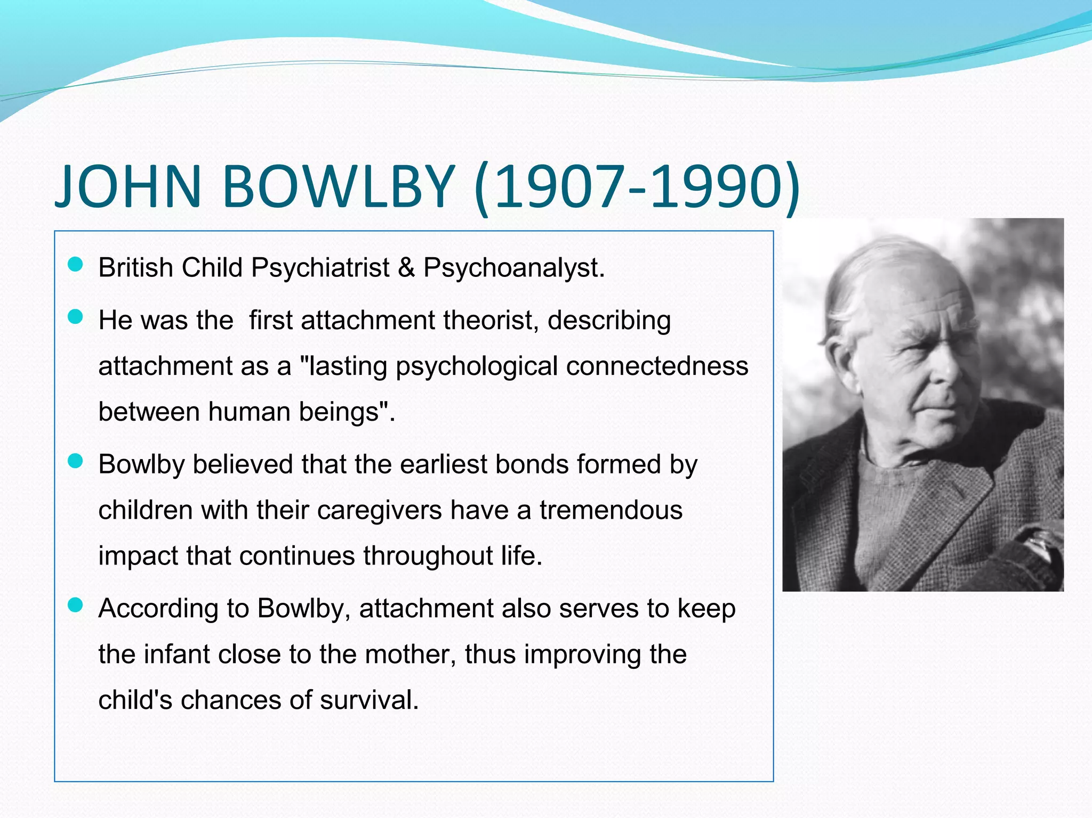
Slide 3 – Attachment Theory
Attachment Theory was developed by John Bowlby, a British psychologist.
The theory explains how early relationships between children and caregivers influence emotional development.
Key ideas include:
- Children form strong emotional bonds with caregivers
- These early bonds affect behaviour, confidence, and relationships later in life
- Secure attachment supports healthy development.

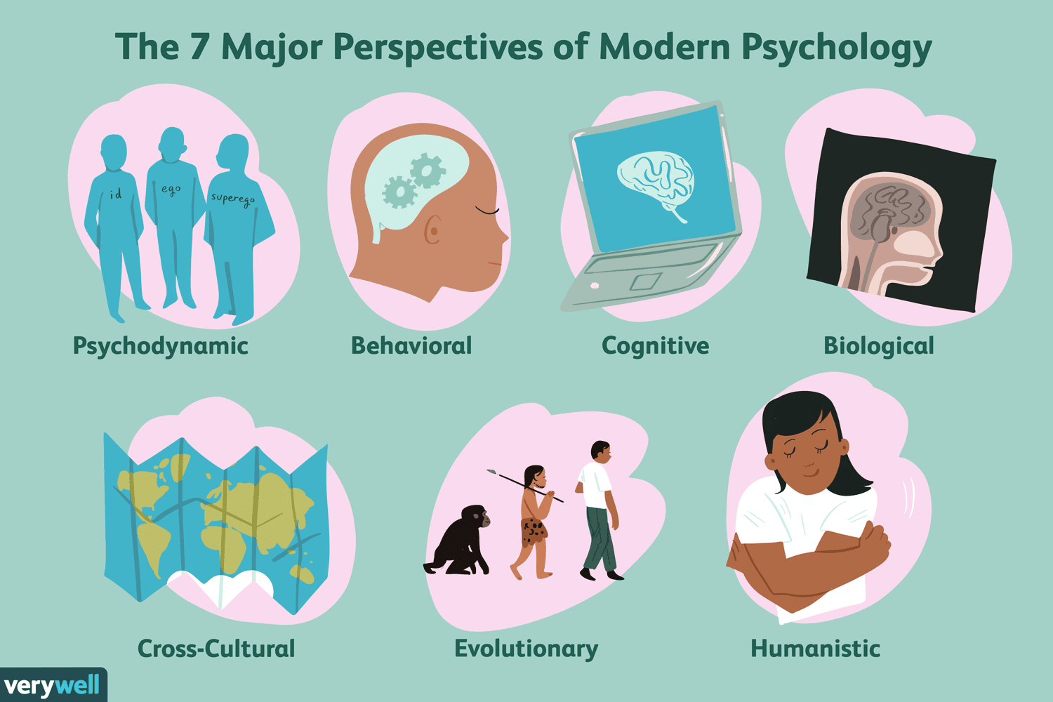

Slide 4 – Key Concepts of Attachment Theory
Attachment theory identifies diverse types of attachment.
Later research by Mary Ainsworth identified three main attachment styles:
- Secure attachment – child feels safe and supported
- Insecure-avoidant attachment – child avoids emotional closeness
- Insecure-ambivalent attachment – child becomes anxious and dependent
Secure attachment helps children develop:
- Confidence
- Emotional regulation
- Healthy relationships.

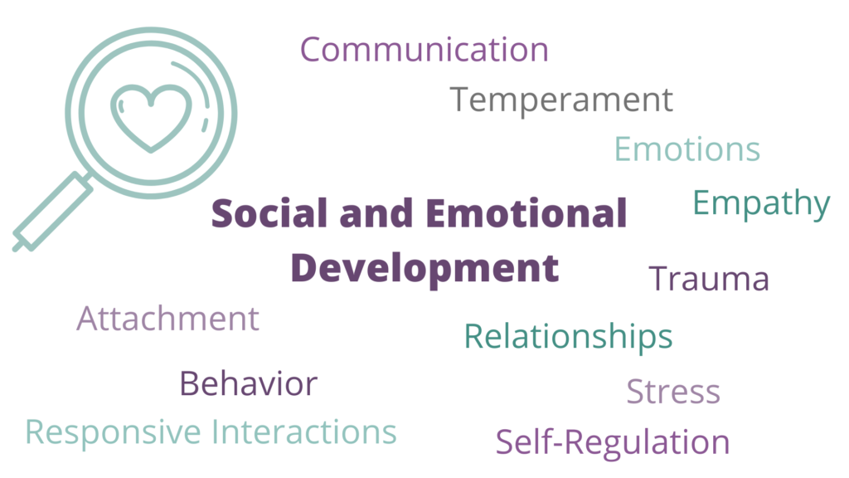

Slide 5 – Early Childhood Development
According to Bowlby, the first years of life are particularly important.
Children need:
- Consistent care
- Emotional warmth
- Reliable caregivers
If children experience instability, neglect, or inconsistent care, this may affect:
- Emotional development
- Behaviour
- Social relationships.

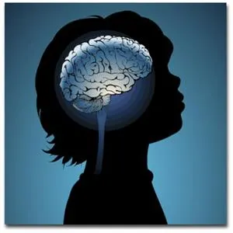
Slide 6 – Jenny’s Situation and Attachment Theory
Jenny’s situation can be understood using attachment theory.
If Jenny experienced:
- Lack of emotional support
- Inconsistent caregiving
- Family stress or instability
She may develop insecure attachment.
This could affect:
- Her confidence
- Her behaviour in school
- Her relationships with others.

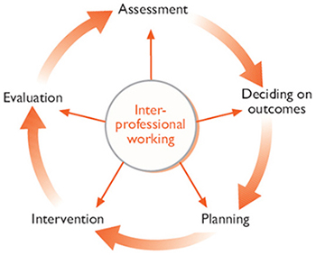

Slide 7 – Strategies to Support Jenny
Several interventions can support Jenny’s emotional development.
These include:
- Providing consistent and supportive caregiving
- Access to counselling or emotional support
- Building trusting relationships with teachers or carers
- Encouraging positive social interactions with peers.
These strategies help strengthen feelings of safety and trust.

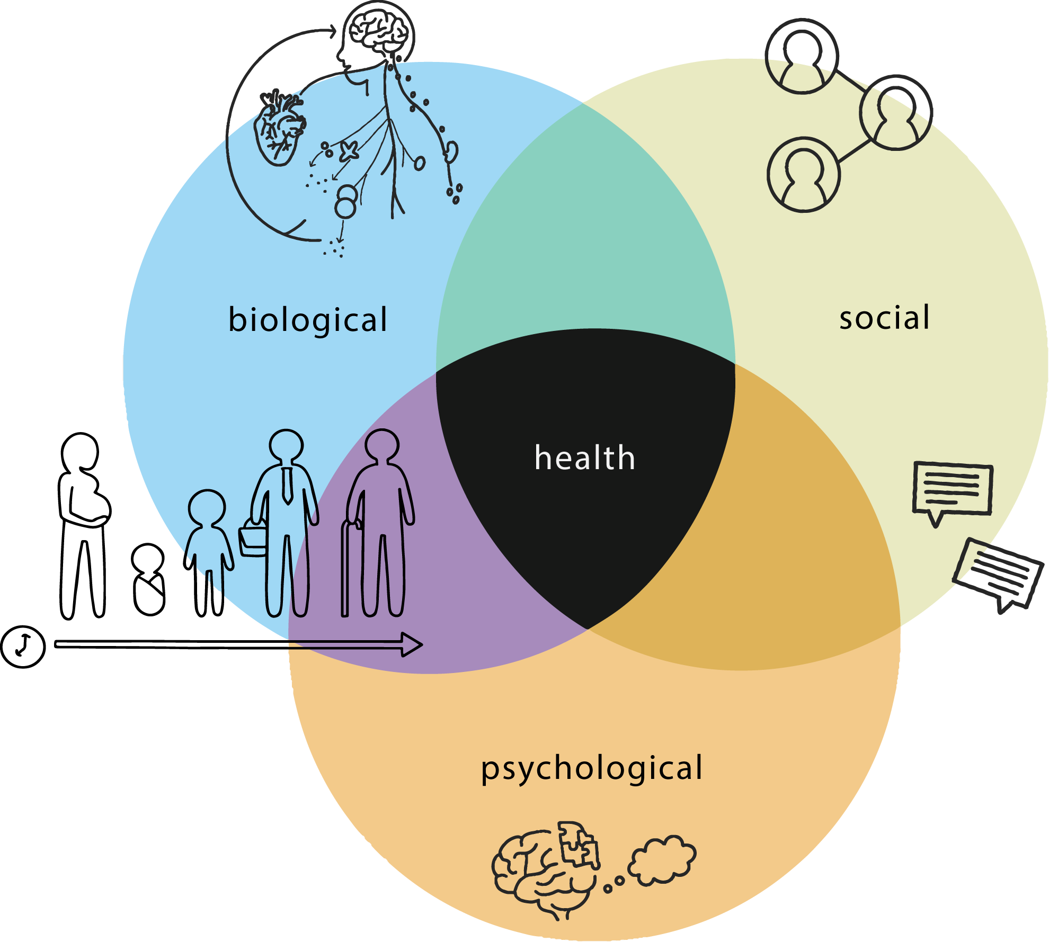

Slide 8 – Biological and Environmental Factors
Jenny’s development may be influenced by both biological and environmental factors.
Biological factors
- Genetics
- Brain development
- Emotional regulation abilities
Environmental factors
- Family relationships
- School environment
- Peer relationships
- Social support systems.
Both factors interact to shape a child’s development.



Slide 9 – Strengths of Attachment Theory
Attachment theory has several strengths.
- It highlights the importance of early childhood relationships
- It is supported by many psychological studies
- It helps professionals understand children's emotional needs
- It is widely used in healthcare, education, and social care.
This theory helps guide interventions that support child wellbeing.


Slide 10 – Weaknesses of Attachment Theory
Despite its strengths, attachment theory has some limitations.
- It may place too much emphasis on the mother-child relationship
- It may not fully consider cultural differences
- Other factors such as personality and social environment also influence development.
Therefore, attachment theory should be used alongside other psychological perspectives.


Slide 11 – Conclusion
This presentation discussed Jenny’s development using attachment theory.
Key points include:
- Early caregiver relationships are essential for emotional development
- Jenny’s experiences may influence her attachment style
- Supportive interventions can improve emotional wellbeing
- Attachment theory provides useful insights but also has limitations.
Understanding early relationships can help professionals better support children like Jenny.

Slide 12 – References (Example)
Bowlby, J. (1969). Attachment and Loss: Volume 1. Attachment. Basic Books.
Ainsworth, M. (1978). Patterns of Attachment. Lawrence Erlbaum Associates.
Howe, D. (2011). Attachment Across the Life course. Palgrave Macmillan.
Cassidy, J., & Shaver, P. (2016). Handbook of Attachment. Guilford Press.
Berk, L. (2018). Development Through the Lifespan. Pearson.
Prior, V., & Glaser, D. (2006). Understanding Attachment and Attachment Disorders. Jessica Kingsley.

