Research Proposal:

Project Clarity

Keefe Mark Ricafort Montebon 1702762

Research Methods ACDA5012

Wales Institute for Science and Art
University of Wales Trinity Saint David



Introduction
The proposed project will be under the name of Project Clarity and the outlined research is to see how viable it is to create a device that can aid the blind or partially impaired to regain a form of sight or detection of their environment.
In this project, it will cover a number of forms and alternatives to accurately measure the distance of an object as well as direction of said object for the user involved.
LiDAR
What is LiDAR?
LiDAR or light detecting and ranging is a remote sensing method used for measuring the distance of an object on the earth's surface. First used in the 1960s where laser scanners were mounted on aeroplanes. Now, the tech is popularly used and has become a great asset in accurate geospatial measurements. Most of this tech is still being used in mainly aviation, but now we are seeing it in phones, specifically in the iPhone 12 pro, or over military uses in high powered infantry mounted optics and unmanned drones, for battlefield visualisation and hazardous detection or weapon guidance.
Military applications include [1] detailed urban mapping and non-urban terrain which greatly benefit in military operations, both from air and semi-autonomous vehicles. Military operations depends on LiDAR technology to map exact terrain of the battlefield and use this to reference where enemy positions are exactly located. This includes, enemy weaponry, such as tanks and motorized depots of enemy combatants, helping in neutralizing the threat. Among other things, this is also specific to air defence, air traffic control, ground surveillance, navigation search and rescue, fire control radars and identification of moving targets. As outlined, it has many benefits of which this project will try to take advantage of these facets.
Types of LiDAR
Airborne: [2] [1]Airborne Topographic lidar systems are the most common and have been used on aeroplanes and notably helicopters for generating digital elevation models for large areas. The combination of an airborne platform allows for effective data collection of elevation across tens of thousands of miles.

Terrestrial: [2] [1]The main difference is that a sensor can either be mounted via tripod or it can be mounted on ground vehicles to provide data on smaller arrays of areas or where higher density is needed. This also includes water based vehicles that can similarly be mounted with a Lidar sensor. These mainly include the data collection of urban environments, or road networks.
Principles and Techniques of LiDAR
A laser is pulsed out from the sensor itself, [3]where upon impact of the object in question, measures the time it takes for the laser to bounce back at said sensor, thus determining the distance travelled, recording the laser and finally calculate where the reflecting object is then located in a three dimensional space. So, sensor, laser, determine distance, angle of laser and calculating for where the object is in 3D space.
How to apply this tech?
In terms of acquiring such an item, might be a little beyond current means, however the idea is there. In terms of commercially available LiDAR, there is the fact that iPhone has them inbuilt in their products. However, procurement was never the goal; it was the premise of its application. You could easily calculate and give accurate measurements of the space given to you, plus with the added capacity of it being augmented reality, we could have some real life changing use, such as the for the visually impaired, and with the rapid rate of technological improvement, I see this as another step in the aid of quality of life improvements.
Other uses other than LiDAR
In essence, even if the use of the tech is not available, we have other ways being able to measure such systems, such as LDR (Light Detecting Resistors) and though it not on the same scale, works on the same principal. One of the finer drawbacks would be light pollution from the natural environment, in which the system would be placed. Other workarounds could be the use of the same laser detecting systems, such as IR lasing, with an IR detecting sensor which essentially works around the same assumption of LiDAR.
Main Issues
The biggest issues in the current research is, as stated above, the expense of procuring one of these units and also the overall lack of skill set in being able to properly utilise this tech into any working prototype. From the outset, it was never to use this tech going forward, but it would be a viable upgrade to any working model. For all the pros, it has just as many costs to obtain components and modules for mass produced models to be cheaper for consumers.
An article written by NikkeiAsia outlines in its report that the cost of affordable LiDAR components are falling, however this article is in reference to automobiles and vehicular applications. [1] The article states that Luminar Technologies, a U.S. vehicle sensor and software start up- have developed a low priced lidar sensor priced at $500 to $1000. From those prices and reports, it seems to me that it’s non-viable at the early stages of this project.
Even looking into other components from reputable sites, the prices vary and that’s not taking into account the specifications for the applied project needs. Sites such as Digi-key [5], RS Component [5] and hobbyrc.co.uk [5] all provide a form of lidar.
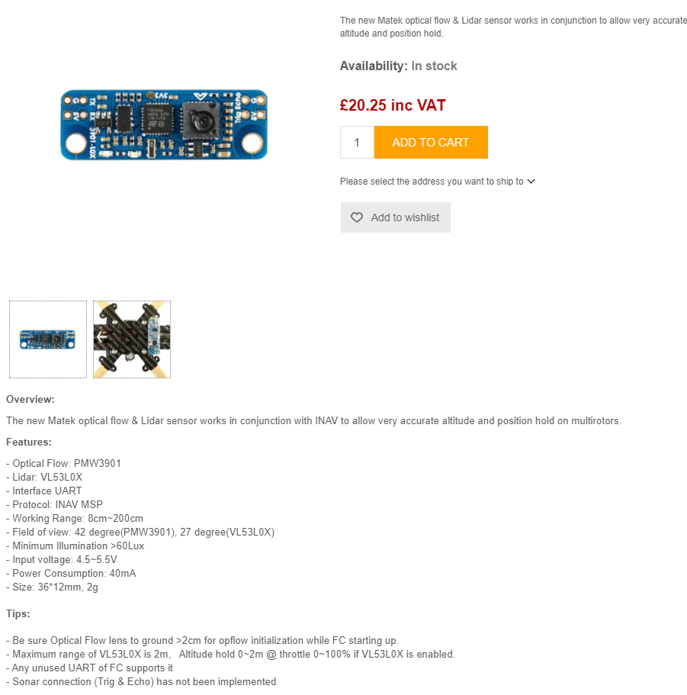
hobbyrc.co.uk [7]

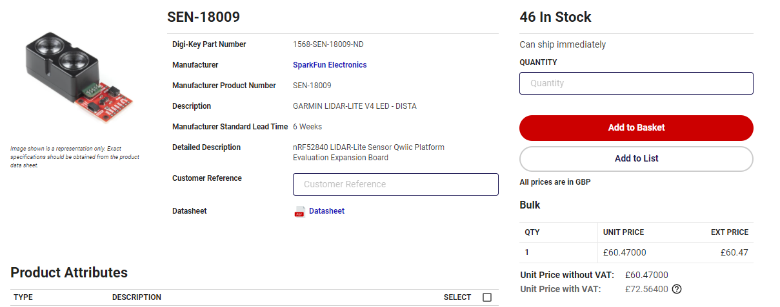
Digikey.co.uk [5]
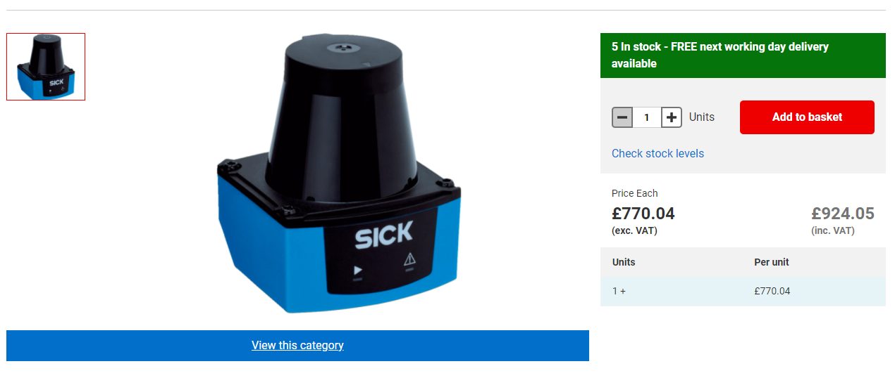
rs-online.com [6]

The alternative solution
The logical solution to try and work around some of the aforementioned problems is to find a substitute that could do the best for the job and one such solution was the use of Ultrasonic sensors or ultrasound transducers, with the advantage that the technology is widely used in many areas from search and rescue, to military means and better still affordable with many types of ultrasonic components and parts that have a range to the most simplest forms of detection to complicated error detection with a variety of applications.
Ultrasound and Ultrasonic Sensors
What is an ultrasonic sensor?
An Ultrasonic sensor [8] is an instrument or component that can measure the distance of an object using ultrasonic sound waves. An ultrasonic sensor uses a transducer to send and receive ultrasonic pulses that relay back information about an object’s proximity. These high-frequency sound waves reflect from surfaces of varying properties to produce distinct echoes of patterns.

Ultrasonic waves can be reflected off a number of surfaces, one such surface is glass or liquid surfaces which can return to the sensor head, where even transparent glass can be detected. [9] Detection isn’t hindered by accumulated dust and or dirt and can even detect complex objects such mesh trays and springs, which is another reason as to how useful it is a tech.

Ultrasonic sensors are primarily used in proximity sensors [10] which can be found in automobiles for autonomous parking technology and anti-collision safety systems in a number of car makes and models, such as Tesla and Hyndai to name one or two car brands. Ultrasonic sensors are also used in robotic obstacle detection systems, as well as manufacturing technology. In comparison to IR sensors; ultrasonic sensors aren’t as susceptible to interference of airborne particles, [9] such as dirt or dust. It can still detect unstable readings due to heat or atmospheric changes which is one downside to this technology.

As stated, it has been applied in a number of uses all throughout industry and medical industries around the globe, which is the reason for the shift in primary focus. Although Lidar has many advantages, it would mean nothing if it wasn’t accessible to the public.
Types of Ultrasonic sensors

Ultrasonic Proximity Sensors: These proximity sensors [11]are common in many manufacturing industries and automated applications. There main use, as the name indicates is to detect objects and measure the distance of said object. They’re main uses comes from food and beverage processing and various packaging applications.

The basic principle is that, the sensor sends out an ultrasonic pulse and receives a pulse back. Using that time difference between the sent and received signals, the distance to the object can be determined. [11]Due to the components properties to detect objects with the use of sound, it’s more versatile in cases where photoelectric sensors, such as IR would have difficulty. An example would be in packaging processes such as beer bottles or clear plastic surfaces. Highly reflective surfaces or even liquid levels can throw off optical sensors.

Ultrasonic 2 Point Proximity Switches: As the name suggests, [12]this type of sensor uses a dual output proximity sensor and works in the same principal as a ultrasonic proximity sensors, but in applications such as machining where they act as switches that output either an on or and off signal, which is based on whether they can detect metal within their parameters, as an example.

Conventional proximity sensors have fixed operating points, where the signal transmits an ‘on’ input for a certain amount of time, and then the sensor changes to receive that signal looking for an ‘off’ input. With these 2 point sensors, having two different operating points, each able to output a signal, they combine the on-off logic which enables it to sense four areas.

Ultrasonic Retro-reflective Sensors: Just like conventional proximity sensors, it basis itself of the same properties, however its main difference is that the distance between sensor and reflector is measured by time. The sensor functions when an object comes within the sensing distance, the propagation time changes and the sensor changes to the active state. This also allows detection of sound and sound deflecting objects.

Ultrasonic Through Beam Sensors: These sensors work on the basis [13] that there are always two separate components, which is the emitter and the receiver. The detection and switching output electronics are located in the receiver. The emitter and receiver are mounted directly opposite one another. As soon as the object in question interrupts the sound beam between the emitter and receiver, the sensor switching output activates. The receiver sensitivity can be adjusted for different distances between the emitter and receiver and or for different object sizes, via a potentiometer.

Addressing the previous issues
With the problems in financing such a large scale, ultrasonic sensors seem to be the go to, for moving forward in the project. It’s affordable with many options available for a variety of uses, not to mention the support the systems has had over lengthy usage. This might also viable if there was a LiPo battery to make it more portable and hopefully user friendly, however, that is becoming outside the scope of the current circumstances.

Project Design
Product Design

The intention of the product is to be as user friendly as possible, with an intuitive set of easy to understand functions, such as a set of wrist mounts for the small vibrating motors, which would indicate how close an object would be, while there would be a small wire frame or mount with the receiver and emitter unit would be located, with the intended use is that, as the user moves and sways their head, the receiver and emitter unit keeps lunching a set of pulses where then it would take those pulses and directly translate it back into the set of motorized wrist mounts, which would then vibrate up on picking up any objects.

In short:-
- User friendly and intuitive access.
- Wrists with vibration feature that’s strong enough to warn a user and weak enough so that it doesn’t discomfort the user for long periods of time.
- A wireframe head mount to place the receiver and transmitter unit, to detect nearby objects.
- User would then be able to intuitively understand that the closer the object is, the stronger the vibration to their wrists.
Shortcomings:-
- This won’t stop limbs from bumping into objects, such as legs and arm placement.
- Depending on design, it might not be easy to wear for s ingle user, and might require a second user to equip the device, on the first user.

Aims and Objectives

Prototype:-

Testing:
- Qualitative sets of results in terms of questions pertaining to usability and features that would benefit a system like this.
- Testing for ergonomic ability of a design like this, with scales of 1 to 10 for random users.
- Blind users would need to sign an ethical form so that we can get qualitative data and most importantly, user feedback for the intended user.
Procurement of components:
- Research onto different components.
- Usability and viability of different components via extra research
Market Research:
- Research into existing products similar to the proposed design
- Research into existing products similar to proposed idea
- Qualitative and quantitative data in relation to products with the same design
- Qualitative and quantitative data in relation to products with the same premise as the one proposed.
Digital Design:
- Working set of PIC commands
- Working circuit
- Viable communication between headset and wrist mounts.
- Working set of code for PIC commands
- Troubleshooting

References

[1] | R. Uppal, 6th November 2018. [Online]. Available: https://idstch.com/technology/photonics/military-applications-lidar/. [Accessed 06 01 2022].
[2] | “GeoSpatial World,” [Online]. Available: https://www.geospatialworld.net/blogs/what-is-lidar-technology-and-how-does-it-work/. [Accessed 06 01 2022].
[3] | K. S. K. W. L. B. B. H. R. M. a. J. H. Jamie Carter, “Lidar 101: An Introduction to Lidar technology, data and applications,” NOAA Coastal Services Center, 2012.
[4] | “NikkeiAsia,” [Online]. Available: https://asia.nikkei.com/Business/Automobiles/Cheaper-lidar-sensors-brighten-the-future-of-autonomous-cars#:~:text=Luminar%20Technologies%2C%20a%20U.S.%20vehicle,priced%20at%20%24500%20to%20%241%2C000.. [Accessed 1 05 2022].
[5] | “digikey.co.uk,” [Online]. Available: https://www.digikey.co.uk/en/products/detail/sparkfun-electronics/SEN-18009/14113835?utm_adgroup=Evaluation%20Boards%20-%20Expansion%20Boards%2C%20Daughter%20Cards&utm_source=google&utm_medium=cpc&utm_campaign=Shopping_Product_Development%20Boards%2C%20Ki. [Accessed 01 05 2022].
[6] | “rs-online.com,” [Online]. Available: https://uk.rs-online.com/web/p/light-detection-and-ranging/2133817?cm_mmc=UK-PLA-DS3A-_-google-_-CSS_UK_EN_Automation_%26_Control_Gear_Whoop-_-Light+Detection+and+Ranging_Whoop-_-2133817&matchtype=&pla-367332268536&gclid=Cj0KCQjwyMiTBhDKARIsAAJ-9Vv0HNrvvn. [Accessed 01 05 2022].
[7] | “www.hobbyrc.co.uk,” 2002-2014. [Online]. Available: https://www.hobbyrc.co.uk/matek-optical-flow-lidar-sensor?gclid=Cj0KCQjwyMiTBhDKARIsAAJ-9VsdMnno1jf6FEI_zd9DuN-dD29wGQyJACjKVHp7gYbwd-1aeFuUmPIaAmyrEALw_wcB. [Accessed 2 05 2022].
[8] | “www.maxbotix.com,” 2021. [Online]. Available: https://www.maxbotix.com/articles/how-ultrasonic-sensors-work.htm. [Accessed 02 05 2022].
[9] | “www.keyence.co.uk,” 2022, [Online]. Available: https://www.keyence.co.uk/ss/products/sensor/sensorbasics/ultrasonic/info/. [Accessed 02 05 2022].
[10] | “www.fierceelectronics.com,” 2022. [Online]. Available: https://www.fierceelectronics.com/sensors/what-ultrasonic-sensor. [Accessed 02 05 2022].
[11] | “www.motioncontroltips.com,” 2022. [Online]. Available: https://www.motioncontroltips.com/what-are-ultrasonic-proximity-sensors/#:~:text=Ultrasonic%20proximity%20sensors%20are%20a,processing%20and%20various%20packaging%20applications.. [Accessed 02 05 2022].
[12] | “drivesandcontrols.com,” DFA Manufacturing Media Ltd, 1999-2022. [Online]. Available: https://drivesncontrols.com/news/fullstory.php/aid/6304/Dual-output_proximity_sensor_saves_time.html. [Accessed 03 05 2022].
[13] | “www.pepperl-fuchs.com,” 2022. [Online]. Available: https://www.pepperl-fuchs.com/great_britain/en/classid_184.htm?view=productgroupoverview. [Accessed 03 05 2022].

Appendices

