Dissertation – Proposal
LCBB6000

BA (Hons) Business Management
University of Wales Trinity Saint David (London Campus)

Proposed research title: "IMPACT OF BUSINESS COMMUNICATION ON ORGANISATIONAL PERFORMANCE IN UK COMPANIES"

- Student name: Diana Roabis
- Student ID: 2028044

Table of Contents
Chapter 1: Introduction 3
Significance and Rationale of the study 3
Purpose of the research 3
Aims and objectives 3
Objectives: 3
Research questions: 4
Chapter 2: Literature review 4
The role of effective internal communication in the UK organisations 4
Implementation of strategies for effective business communication platform 5
Employee job satisfaction and retention rates in UK organisations relate to internal communication 6
Business communication affected by the remote working process 6
Literature gap 7
Chapter 3: Research Methodology 7
Research method: 7
Research philosophy 8
Research approach 8
Research strategy 9
Data collection 9
Data analysis 9
Ethical consideration 9
Chapter 4: Conclusion 10
References 12

Chapter 1: Introduction
Successful organisations rely on effective communication and cooperation aspects, which is essential for influencing business dynamics in the UK corporate environment. The capacity for effective communication is essential in today's fast-paced and evolving business landscape where the globally connected corporate world promotes teamwork, boost output, and guarantee overall organisational effectiveness (Li et al., 2021). The primary purpose of this research proposal is to examine the value of good communication and how it affects different aspects of UK businesses as well as helps the companies to achieve its sustainable goals.

Significance and Rationale of the study
The business organisations of the competitive world have been prioritising and mastering the art of communication that provides a better position to overcome challenges, adapt to changes, and thrive in the competitive market (Li et al., 2021). However, businesses can establish a great working culture, strengthen their relationships with stakeholders, and eventually achieve sustainable success by knowing the subtleties of communication in this setting.

Purpose of the research
The main purpose of this review is to evaluate the role of communication in the UK organisations to achieve its desired success as well as improve the employee morale. Further context also reveals the applicable process of business communication through effective strategies and models that can prevent the open communication challenges in the agile workplaces.

Aims and objectives.
This research proposal aims to examine the innovative communication strategies employed by successful UK companies which are completely aligned with organisational goals and values.

Objectives:
- To determine the role of effective communication in the business success of the UK brands.
- To examine the impact of internal communication that affects employee job satisfaction and retention rates in the UK companies.
- To analyse the current situation towards remote work which influenced business communication as well as the organisational outcomes in the UK corporate sector?

Research questions:
- How can employee morale and productivity in UK organisations get affected by communication practices?
- In the business world of the United Kingdom, what part does internal communication play in accomplishing organisational goals?
- How do employee job satisfaction and retention rates in UK organisations relate to internal communication?
- How have organisational outcomes and business communication in the UK corporate sector been affected by the shift towards remote work?

Chapter 2: Literature review

The role of effective internal communication in the UK organisations
A key component of any successful firm is effective internal communication, which promotes teamwork, alignment, and employee engagement (Li et al., 2021). Several crucial elements in the organisational framework of the United Kingdom emphasise the significance of efficient internal communication which are written below:
Compliance with Organisational Principles:
Employee awareness and alignment with the organisation's mission and fundamental values is ensured through internal communication (Li et al., 2021). Maintaining a cohesive and purpose-driven workforce amid the various business landscapes of the UK has depended on this alignment.
Employee Morale and Engagement:
An effective communication process and its impacts is a factor in excellent morale and fostering engagement among staff members. Regarding the UK organisational aspect, a wide diversity has been found in its workforce culture where inclusive communication practices have been considered to explore different perspectives that can enhance employee satisfaction and commitment for further improvement of both parties (Men and Yue, 2019).
Adjusting to Shifts:
The changing business climate in the United Kingdom necessitates quick adaptation from enterprises (Men and Yue, 2019). Change management is accelerated by internal communication, which lessens opposition among staff members and enables them to comprehend the reasoning behind changes.
Collaboration and Teamwork:
In the recent era, the international expansion approach of the brands has increased the collaborative and globally connected business environment. Thus, the internal communication is not only able to facilitate effective teamwork but also ensures updated knowledge of each team member which contributes to organizational success through improved performance of the workforce.
Innovation and Creativity:
Through the open communication channels, the UK business organisations foster a positive environment in the workplace where employees feel comfortable to share their diverse perspectives. It is particularly important in the UK, where innovation and sustainability have been defined as a key driver of business competitiveness.

Implementation of strategies for effective business communication platform
To reduce the chances of miscommunication and conflicting issues in the organisations, the UK business sectors have implemented several strategies to foster a positive workplace culture and business communication approach also. To implement the effective business communication in the companies, the UK brands mainly emphasis the following strategies:
Consumer-Centric communication Approach: In the UK business context, a multicultural and multigenerational workforce have been followed in the organisations, where its audience-centric approach ensures that communication resonates with various segments of the workforce (Villanueva Ferrer, 2021).
Two-Way Communication: The UK business platform needs a strong teamwork and collaboration for the two-way communication approach that emphasises reciprocal interaction (Kim, 2021). Through the implementation of digital tools and facilitating real-time interaction, the UK brands are being able to foster innovative internal business communication.
Clarity and Consistency: through the utilisation of a mix of communication channels such as email, instant messaging, video conferencing and many more not only ensures that messages are clear, concise, and consistent across various communication channels but also maintains a balance between formal and informal communication (Kim, 2021).

Employee job satisfaction and retention rates in UK organisations relate to internal communication.
Internal communication strategies and employee job satisfaction and retention rates are closely related in the UK firms. A company's work atmosphere, employee engagement, and employees' decision to stay or go are all greatly influenced by effective internal communication. The following are the effects of internal communication on retention rates and work satisfaction:
- Transparent internal communication about organisational decisions, several adaptations as well as the updated knowledge about the challenges and changes builds trust among the management and employees (Gara and La Porte, 2020). It fosters the feeling among the workforce that they are valued in the company which boosts their capability.
- Employees' comprehension of their duties is improved when corporate goals, expectations, and individual roles are communicated clearly which increases the likelihood of employee satisfaction and motivation in their employment (Gara and La Porte, 2020).
- An environment that is responsive and open to input fosters a culture of listening. Workers are more likely to be content with their workplace and have a sense of belonging if they believe that their thoughts are valued and heard.

Business communication affected by the remote working process
The business communication approach became more challenging during the remote working aspect of the recent era, especially when team members are in various time zones (Yang et al., 2022). One of the communication barriers that remote workers often encounter is the lack of non-verbal cues which create various issues in the effective communication process within the workplace. The potential issues are written below:
Poor collaboration:
Collaboration seems to be more difficult while working remotely, particularly when working on complicated projects that call for a high level of coordination. Businesses are still trying to figure out how to encourage cooperation and teamwork in a remote setting especially in the isolated condition of an employee.
Management: According to Morrison-Smith and Ruiz, (2020) compared to managing in-person teams, managing remote teams calls for a different set of abilities. In addition to being able to offer support and direction from a distance, managers must be able to trust their staff members to work independently.
High reliance on technology: during the remote working process, the entire organisation has been reliant on digital communication tools where the evolving nature of technology and lack of knowledge among the workers affects the organisational function and creates conflicting issues (Gkeredakis et al., 2021).

Literature gap
Regarding the gap within this review, it can be said that the researchers need to create a thorough analysis to find out the challenges in implementing effective strategies within the UK brands to foster effective internal business communication approach. The business organisations in the United Kingdom mainly prioritise diplomacy over direct contact where the above strategies help the organisations to enhance effective business conversation among the workforce for further expansion. However, the review explores that despite having high flexibility and popularity the remote working aspect also creates misunderstandings and workplace conflicts due to the lack of face-to-face communication as well as isolation issues among the employees.

Chapter 3: Research Methodology

Research method:
In order to assess the structure of a research study that can offer a proper outlook of the layers of steps that are necessary for the completion of the investigation, the research design compares an onion with several layers of skin (Wimalaratne and Kulatunga, 2022). In terms of the main components of this design, the study has selected an appropriate research philosophy, research technique, research strategy, and data collection and analysis procedure that will aid in finishing the project within the allotted time frame.

Research philosophy
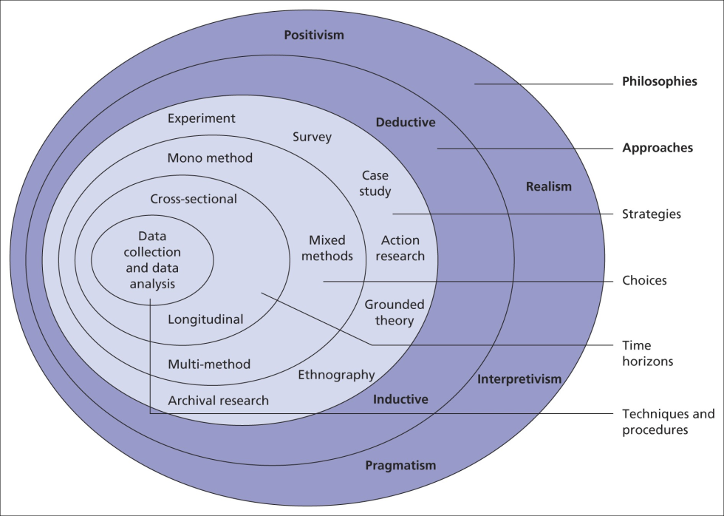

Figure: Layers of the Research Onion
Source: (Alharahsheh and Pius, 2020)

As per the best research philosophies, the study has included positivist philosophical elements that aim to employ the scientific process for project completion. Additionally, it aids in the collection of empirical data about the subject, which supports the conclusions drawn via methodical observation. The digital age claims that better decision-making is fuelled by the effective business communication in the workplace culture. Therefore, the positivist research philosophy will be able to give the research a strong foundation (Alharahsheh and Pius, 2020). As a result, the research study adopts a positivist stance in its effort to find out information regarding the influence of corporate communication on organisational effectiveness as well as analysed the gathered information to reject or accept the research hypothesis (Alharahsheh and Pius, 2020).

Research approach
Using a mixed-method approach, which combines quantitative and qualitative methodologies, can enable a thorough investigation. With this strategy, the researchers will be able to examine both numerical trends and the subtleties of human experiences, offering a comprehensive knowledge of the influence of business communication (Sahin and Öztürk, 2019).

Research strategy
One of the strategies in the qualitative research approach will be the analysis of secondary material that has already been collected from reliable sources in order to obtain new perspectives on the subject. This element states that the qualitative secondary analysis is an innovative approach in that it reviews qualitative works, such as published scholarly papers, environmental reports, and studies on the topic, in-depth and methodically (Sahin and Öztürk, 2019). In addition to this, the quantitative technique places a strong emphasis on the survey approach, which will entail a set of topic-related questions that can enable the researchers to collect a variety of viewpoints from managers and employees of UK companies.

Data collection
An effective survey will help the researchers to gather quantitative data on communication practices and their perceived impact in the UK organisations via online medium, Google Form. At the same time, it will be possible to gather qualitative insights about the experiences and perceptions of managers and employees of the UK professionals. To do so, face to face interview will be conducted. As per the qualitative secondary analysis, it is imperative to conduct a comprehensive and methodical examination of qualitative studies, including scholarly papers, environmental reports, and relevant studies (Sahin and Öztürk, 2019).
Sampling method:
This research will use the non-probability convenience sampling method, which is based on gathering data from participants. For the online survey, a sample size of 121 employees who are aware of business communication strategy implementation in their associated companies will be chosen. At the same time, qualitative interview will be conducted for 8 managers.

Data analysis
A set of 10 close ended questionnaire will be prepared for it. Survey data will be examined with statistical methods to find trends, and statistical significance. On the other hand, an open-ended questionnaire of 8 question will be prepared for this interview. For the qualitative information gleaned from the interviews, thematic analysis will be employed to provide a sophisticated knowledge of the experiences and views of participants, this entails locating themes and patterns in the qualitative data.

Ethical consideration
In order to conduct research in an ethical manner, investigators must implement fundamental research principles into their work, such as maintaining participant anonymity and identifying procedures for protecting acquired data through secure storage and controlled access. To adhere to the ethical standard, before involving participants in surveys and interviews, researchers should have their informed consent, making sure that the subjects are aware of the goal of the study and their rights.

Chapter 4: Conclusion
From the above study, it has been concluded that, to succeed in the diversified and dynamic organisational landscape of the United Kingdom, the management has depended critically on efficient internal business communication. Collaboration, employee engagement, and overall organisational performance can all be improved by utilising communication models and also helps the organisation to be aware of the particular communication requirements of the workforce. Because the research study requires conduction of survey, eight weeks will be required. And at a certain point in time, the time horizon of the study will be cross-sectional.

Planning

 | Week 1 | Week 2 | Week 3 | Week 4 | Week 5 | Week 6 | Week 7 | Week 8
Introduction
Literature review
Research methodology
Findings of the data from online survey and face to face interview
Analysing of the data
Conclusion
Recommendations
Formulation of the draft
Final submission

Reference list
Alharahsheh, H. and Pius, A. (2020). A Review of Key paradigms: Positivism VS Interpretivism. Global Academic Journal of Humanities and Social Sciences, [online] 2(3), pp.39–43. doi:https://doi.org/10.36348/gajhss.2020.v02i03.001.
Ferrer, V. (2021). Strengthening Communication Channels Between the EU and EU Citizens: An Audience-Centric Approach -Trabajo de Fin de Máster. [online] Available at: https://diposit.ub.edu/dspace/bitstream/2445/178907/1/TFM_Victor%20Villanueva_CEI.pdf.
Gara, G.L. and La Porte, J.M. (2020). Processes of building trust in organizations: internal communication, management, and recruiting. Church, Communication and Culture, [online] 5(3), pp.298–319. doi:https://doi.org/10.1080/23753234.2020.1824581.
Getchell, K.M., Carradini, S., Cardon, P.W., Fleischmann, C., Ma, H., Aritz, J. and Stapp, J. (2022). Artificial Intelligence in Business Communication: The Changing Landscape of Research and Teaching. Business and Professional Communication Quarterly, 85(1), p.232949062210743. doi:https://doi.org/10.1177/23294906221074311.
Gkeredakis, M., Lifshitz-Assaf, H. and Barrett, M. (2021). Crisis as opportunity, disruption and exposure: Exploring emergent responses to crisis through digital technology. Information and Organization, 31(1), p.100344. doi:https://doi.org/10.1016/j.infoandorg.2021.100344.
Kim, Y. (2021). Building Organizational Resilience Through Strategic Internal Building Organizational Resilience Through Strategic Internal Communication and Organization-Employee Relationships Communication and Organization-Employee Relationships. [online] Available at: https://epublications.marquette.edu/cgi/viewcontent.cgi?article=1566&context=comm_fac.
Li, J.-Y., Sun, R., Tao, W. and Lee, Y. (2021). Employee coping with organizational change in the face of a pandemic: The role of transparent internal communication. Public Relations Review, [online] 47(1), p.101984. doi:https://doi.org/10.1016/j.pubrev.2020.101984.
Men, L.R. and Yue, C.A. (2019). Creating a positive emotional culture: Effect of internal communication and impact on employee supportive behaviors. Public Relations Review, [online] 45(3), p.101764. doi:https://doi.org/10.1016/j.pubrev.2019.03.001.
ÖZTÜRK, G. and ŞAHİN, M.D. (2019). Mixed Method Research: Theoretical Foundations, Designs and Its Use in Educational Research. International Journal of Contemporary Educational Research, 6(2), pp.301–310. doi:https://doi.org/10.33200/ijcer.574002.
Smith, S.M. and Ruiz, J. (2020). Challenges and Barriers in Virtual teams: a Literature Review. SN Applied Sciences, [online] 2(6), pp.1–33. doi:https://doi.org/10.1007/s42452-020-2801-5.
Writers (2019). Understanding the Research Onion | Writing Guides | 15 Writers. [online] https://15writers.com/. Available at: https://15writers.com/research-onion.
Yang, L., Holtz, D., Jaffe, S., Suri, S., Sinha, S., Weston, J., Joyce, C., Shah, N., Sherman, K., Hecht, B. and Teevan, J. (2021). The Effects of Remote Work on Collaboration among Information Workers. Nature Human Behaviour, [online] 6(6). Available at: https://www.nature.com/articles/s41562-021-01196-4.

