Digital Skills and Research Methods
(BMSW4003)
The impact of Virtual Learning Environment (VLE) Use on Students’ Learning Experience

Module Leader: Joy Botu
Submitted by: Neli Todorova
Student ID: 1909068

Table of Contents
Introduction 3
Background 3
Aims and Objectives 5
Methodology 5
Results 6
Discussion 10
Conclusion 11
References 11
Appendix 12

Introduction
A VLE, or a Virtual Learning Environment ‘is an online system that allows teachers and trainers to share educational materials and communicate with their learners via the web’ (Gallacher, 2015). VLEs are used by many educational institutions, such as schools, colleges and universities. Although they are ‘not the most innovative technology, (...) they are one of the most pervasive in higher education’ (Weller, 2007, p.2). Often, they are the main medium between teachers and students for exchange of course materials, assessment information and submission. As the use of Virtual Learning Environments is a central part of the education experience of a lot of students, it is important to determine whether it is effective. Therefore, this report will aim to explore secondary research on the usefulness of VLEs and then, conduct primary research on how VLE use impacts students’ learning experience in the University of Wales Trinity Saint David (London Campus).

Background
As technology develops over time, the use of online tools for education is becoming more and more relevant. Virtual Learning Environments are already widely incorporated in a number of education institutions, so it is important to analyse their impact on student learning. In theory, VLEs are considered to have many advantages for both students and teachers. For example, Laister and Kober claim that VLEs provide benefits ‘such as flexibility (in time and place) and the possibility to give feedback through interactive media (Laister and Kober, 2005, p.1). In other words, they allow teachers and students to share and access learning materials anywhere and at any time, as well as provide a platform for collaborative feedback. These features make VLEs convenient as students can easily access educational sources outside of the classroom. In contrast, Virtual Learning Environments are also claimed to have disadvantages, such as ‘emphasis on self-learning’ and the problem that it is ‘difficult forming relationships’ (Jefferson and Arnold, 2009, p.63). Namely, VLEs have many available materials but students have all the responsibility of accessing them and learning, instead of being taught. Moreover, the nature of online platforms is impersonal, which can make it difficult for students to form a relationship with their teachers. There is a variety of previous research done on the different aspects of Virtual Learning Environment use. For example, in 2009, Maltby and Mackie reported that VLE use impacts students in various ways – for some, it ‘promotes a positive learning climate and thereby student engagement’ and for others it ‘promotes a negative learning climate and thereby student disengagement’ (Maltby and Mackie, 2009, p.60). This suggests that the impact of a Virtual Learning Environment is different, depending on the type of student who is using it and that customising it to suit different learners can possibly change that. In contrast, a 2013 study on sixth form students’ views reported that, ‘tasks on a VLE and the opportunity to learn at a personally defined place, time and pace (...) increases their independence and motivation to learn’ (Barker and Gossman, 2013, p.31). In other words, the results of that study suggest that the disconnectedness of VLE systems helps students by letting them study according to their abilities, without feeling pressured by time and other students. An important part of the use of VLE systems is how easy they are to use. Although the easiness of use depends on the student, if a Virtual Learning Environment is simple to use, it may be thought that more students will access it. However, previous research suggests the opposite. For example, a study done with British undergraduate students in 2017 found that ‘the ease of use of a system did not have a considerable effect on their intention to use’ (Kurt and Tingöy, 2017, p.12). However, as this study was done on a small sample of students, it is important to further investigate that topic. Another important aspect of VLE use is its impact on performance, which can be considered an indicator of effective learning. There are contrasting results of the research that has been done in this area. For instance, a study done at Loughborough University ‘found that the VLE has very little effect on students’ academic performance’ (Demian and Morrice, 2012, p.17). This can suggest that Virtual Learning Environments do not help students to improve their learning, but it can also be related to the sort of materials uploaded to that specific VLE or the type of course which was researched. In contrast, a study done in a different higher education institution found ‘a positive moderate correlation (0.6) between (...) student’ accesses to the VLE and the number of course units students passed’ (Alves et al., 2017, p.525). This suggests that there might be some relationship between the use of Virtual Learning Environments and whether students manage to pass their modules, or that VLEs help learning. Due to the variety of different findings on the topic of VLE use and learning, the different pieces of research cannot be generalised to all universities. Therefore, it is important to research within the University of Wales Trinity Saint David (London campus) in order to find out the impact of VLE use, specific to that university.

Aims and Objectives
The aim of the primary research in this report is to evaluate the impact of Virtual Learning Environment (VLE) use on student learning in the University of Wales Trinity Saint David, London Campus. The first objective is to find out if there is a relationship between how often students use the VLE and their learning experience. The second objective is to find out whether the structure of the VLE is benefitting students in their learning. The third objective is to determine whether there is a connection between age and the VLE learning experience of students. The last objective is to determine whether and how the VLE can be improved for a better learning experience.

Methodology
In order to do primary research on the impact of VLE use on student learning, it was necessary to ask students about their views. The population, significant for this research was students in the London Campus of the University of Wales Trinity Saint David. My sample was two classes of 20 people each – those classes were chosen because there was no chance to contact more people to get a larger sample. Moreover, originally, the research was planned to be conducted by handing out questionnaires at the university, but it is closed, so the whole research had to be done online. Therefore, the research tool used was an online questionnaire on Google Forms, to distribute to the classes that were picked. The questionnaire consisted of questions, which collected both quantitative and qualitative data. The main type of data collected was quantitative, through asking questions with a range of options to be selected. For example, the questionnaire asked students to rate (on a scale from 1 to 10) how easy they find using the VLE, and whether the VLE has met their learning needs (yes/ no answer). There was also one question in the questionnaire which required a longer answer (qualitative data). This was asking students how the VLE can be improved, allowing them to expand on their feedback. Out of the sample of 40 students, 12 students answered the questionnaire. In terms of ethical consideration, responses to the questionnaire were anonymous and did not require signing into Google, to respect privacy and anonymity. Moreover, the data was confidential as the researcher was the only person who had access to it. The full questionnaire is attached in the appendix.

Results
Question 1:
Figure 1: Number of times per week of students using VLE
Source: Author
Question 2:
Figure 2: Type of device used to access the VLE
Source: Author
Question 3:
Figure 3: On a scale from one to ten, how easy students find using the VLE
Source: Author
Question 4:
Figure 4: On a scale from one to ten, how structured the module pages are on the VLE
Source: Author
Question 5:
Figure 5: Whether the VLE has met the students’ learning needs
Source: Author
Question 6:
Figure 6: Themes in desired VLE improvements
Source: Author
Question 7:
Figure 7: Age groups of respondents
Source: Author
Relationship between age and number of visits to VLE per week:
Figure 8: How many times per week students use the VLE by age group
Source: Author

Discussion
As can be seen in Figure 1, 67% of respondents access the VLE of University of Wales Saint David (London Campus) 2-3 times per week, and 16% of students who responded access it 4-5 times a week. The fact that only 2.17% of students access it once a week and no students have responded that they access less than once a week, can suggest that the VLE is useful for student learning. In Figure 3, it can be observed that 9 out of 12 students (75%) rated the ease of using the VLE at 7 or more (on a scale from 1 to 10). The same applies to Figure 4, where the same percentage of students rated the structuredness of the VLE at 7 or above. The positive feedback related to easy access and the structure of the VLE is also supported in Figure 5, by 75% of students who reported that the VLE has met their learning needs. To also consider the negative feedback, it can be suggested that some students are not satisfied with the impact of the Virtual Learning Environment. For example, there are 25% of students who rated the easiness of using the VLE and how structured module pages are at 5 out of 10. This suggests that they are not receiving the intended benefit of the VLE system. Moreover, 25% of students have responded that the VLE has not met their learning needs as shown in Figure 5. In Figure 6, it can be seen that when asked, 42% per cent of students said that they would like more sources to be made available in the VLE. Moreover, 25% reported that they would like access to the VLE to be made easier. These statistics suggest that those are among the main problems which stop the VLE system from impacting student learning in a good way. Moreover, in Figure 8, one can observe the difference in the number of times students visit the VLE per week by age group. It can be observed that most of 20-29-year olds and 30-39-year olds use it 2-3 times per week, with some using it 4-5 times per week. In contrast, 50% of 40-49-year olds use it 2-3 times per week and the other 50%, only once a week. This suggests that the VLE is more useful for younger students, and that students above the age of 40 are finding it difficult to access or not useful for learning. Based on the data collected in this research, it is evident that the VLE has a good impact on the learning experience of the majority of students. However, there are areas for improvement. For instance, it is recommended that the university puts more resources on the VLE to help students with their learning, as a big percentage of them claimed that they need more resources for their assignments. The other important area of improvement is the ease of access of the VLE, as a quarter of students reported they would like to see this improvement. This is also vital because the age group of 40-49 is accessing the VLE less in comparison to other age groups, and that can be accounted for by the difficulty for them of accessing the system.

Conclusion
In conclusion, the use of a Virtual Learning Environment in University of Wales Trinity Saint David (London Campus) evidently has a good impact on the learning experience of a lot of students. There are some areas of improvement, such as ease of access and adding more sources to the module pages. As this research had a limited number of participants, there can be a problem of generalising the findings to all students in the university. This is why future research should be done on a larger scale in order to find a reliable sample of student opinions to be used to improve the VLE, which is a large part of education today.

References
Alves, P., Miranda, L. and Morais, C. (2017) ‘Influence of Virtual Learning Environments in Students’ Performance’, Universal Journal of Educational Research, 5(3), pp.517-527. Available at: http://www.hrpub.org/journals/article_info.php?aid=5705 (Accessed: 27th April 2020).
Barker, J. Gossman, P. (2013) ‘The Learning Impact of a Virtual Learning Environment: Students’ views’, Teacher Education Network Journal, 5(2), pp.19-38.
Demian, P. and Morrice, J. (2012) ‘The use of virtual learning environments and their impact on academic performance’, Engineering Education: A Journal of the Higher Education Academy, 7(1), pp.11-19. Available at: https://www.tandfonline.com/doi/full/10.11120/ened.2012.07010011 (Accessed: 20th April 2020).
Gallacher, C. (2015) What is a VLE (Virtual Learning Environment?). Available at: https://epale.ec.europa.eu/en/blog/what-vle-virtual-learning-environment (Accessed: 15th April 2020).
Jefferson, R. N. and Arnold, L. W. (2009) ‘Effects of virtual education on academic culture: Perceived advantages and disadvantages’, US-China Education Review, 6(3), pp.61-66. Available at: https://files.eric.ed.gov/fulltext/ED504959.pdf (Accessed: 16th April 2020).
Kurt, Ö. E., Tingöy, Ö. (2017) ‘The acceptance and use of a virtual learning environment in higher education: an empirical study in Turkey, and the UK’, International Journal of Educational Technology in Higher Education, 14:26. Available at: https://doi.org/10.1186/s41239-017-0064-z (Accessed: 17th April 2020).
Laister, J. and Kober, S. (2005) Social Aspects of Collaborative Learning in Virtual Learning Environments. Available at: http://citeseerx.ist.psu.edu/viewdoc/download?doi=10.1.1.462.3651&rep=rep1&type=pdf (Accessed: 16th April 2020).
Maltby, A. and Mackie, S. (2009) ‘Virtual learning environments – help or hindrance for the ‘disengaged’ student?’, Research in Learning Technology, 17(1), pp.49-62. Available at: https://journal.alt.ac.uk/index.php/rlt/article/view/897 (Accessed: 17th April 2020).
Weller, M. (2007) Virtual Learning Environments: Using, choosing and developing your VLE. London: Routledge.

Appendix
Questionnaire:
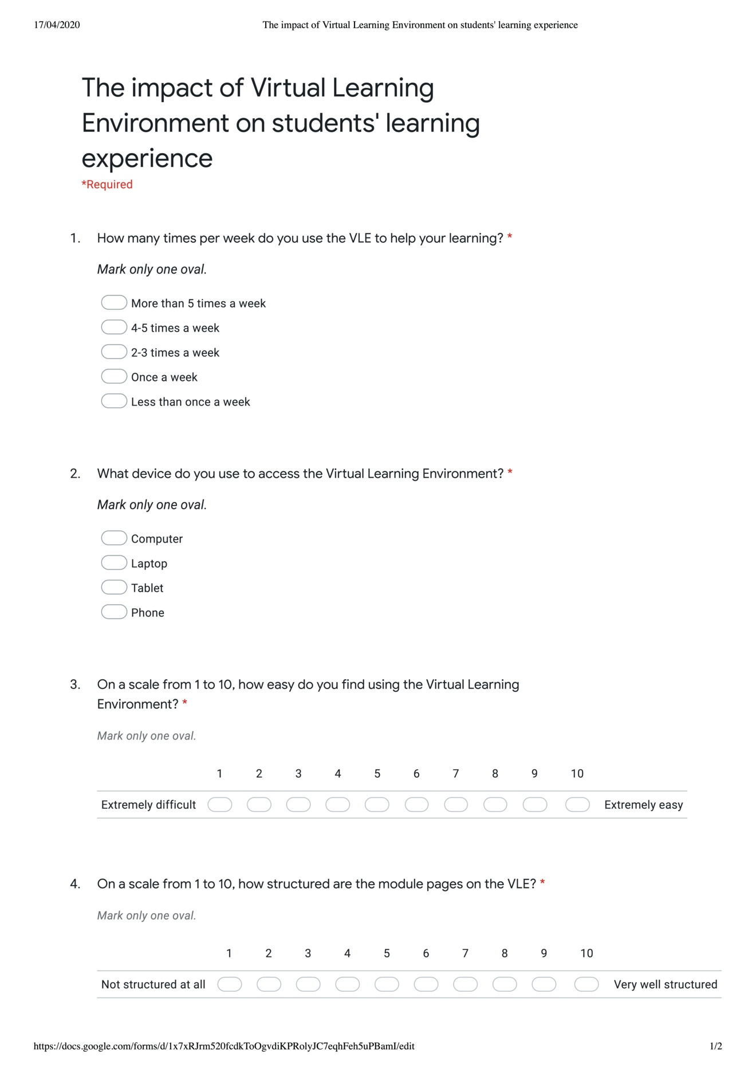
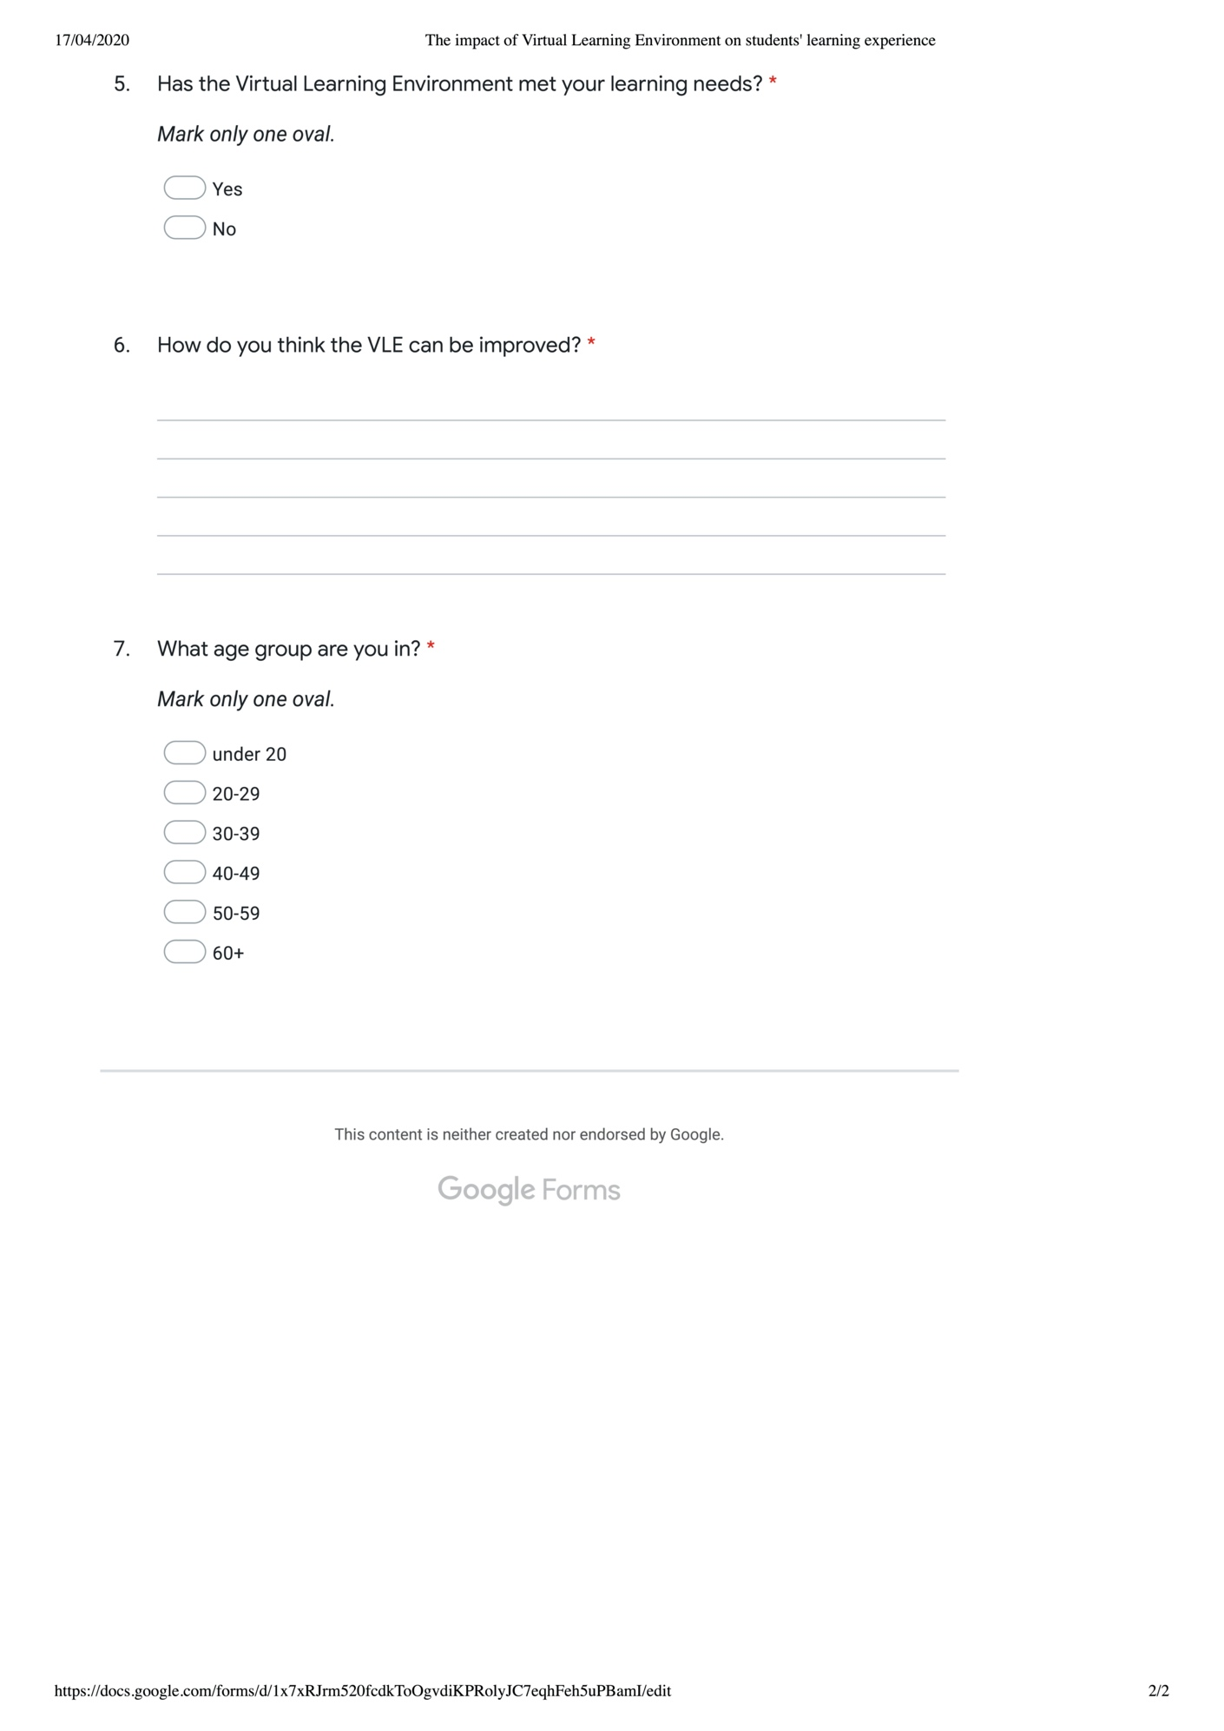
Source: Author.
Data collection
Question One
How many times per week do you use the VLE to help your learning? | Responses
More than 5 times a week | 0
4-5 times a week | 2
2-3 times a week | 8
Once a week | 2
Less than once a week | 0
 | 12
Question 1:
Question 2:
Question Two
What device do you use to access the Virtual Learning Environment? | Responses
Computer | 1
Laptop | 10
Tablet | 1
Phone | 0
 | 12
Question Three
On a scale from 1 to 10, how easy do you find using the Virtual Learning Environment? | Responses
One | 0
Two | 0
Three | 0
Four | 0
Five | 3
Six | 0
Seven | 2
Eight | 5
Nine | 2
Ten | 0
 | 12
Question 3:
Question 4:
Question Four
On a scale from 1 to 10, how structured are the module pages on the VLE? | Responses
One | 0
Two | 0
Three | 0
Four | 0
Five | 3
Six | 0
Seven | 1
Eight | 3
Nine | 5
Ten | 0
 | 12
Question Five
Has the Virtual Learning Environment met your learning needs? | Responses
Yes | 9
No | 3
 | 12
Question 5:
Question 6:
Question Six
How do you think the VLE can be improved?
Response | Theme
Nothing | No improvement
Nothing | No improvement
put everything in one place - easier access | Ease of access
I would like more research sources | More sources
I need more resources and readings | More sources
I would like to see more sources.. | More sources
Easier access from a mobile device | Ease of access
More resources for assignments | More sources
I cannot think of anything | No improvement
More learning resources | More sources
Make it easier to use | Ease of access
nothing | No improvement
There are three themes in the qualitative data: No improvement, Ease of access and More sources
Themes | Responses
No improvement | 4
Ease of access | 3
More sources | 5
 | 12
Question 7:
Question Seven
What age group are you in? | Responses
Under 20 | 0
From 20-29 | 6
From 30-39 | 4
From 40-49 | 2
From 50-59 | 0
60+ | 0
 | 12
Source: Author

