BMSW 4005
Reflective portfolio, Discursive Report
NAME: Shahida parbin
STUDENT NUMBER: 1814474
LECTURERS NAME: Domnan Freeman Miri

Contents
INTRODUCTION: 3
SELF-AWARENESS: 4
CAREER MOTIVATION TEST SUMMARY: 4
DOMINATE MOTIVATORS: 4
SECONDARY MOTIVATORS: 5
MINOR MOTIVATORS: 5
Altruism - 5
Learning- 5
PERSONALITY: 6
WHICH CAREER BEST FITS MY PERSONALITY TEST RESULTS: 6
SCAIER my personality type: 6
PROFESSIONS AND OCCUPATIONS: 7
MOTIVATION PROGRESSION: 7
HOW WILL THESE TEST AWARENESS DEVELOP IN MY CAREER? 7
HOW WILL THESE TEST AWARENESS IMPACT ON MY CAREER? 7
PART B 8
REFLECTIVE PORTFOLIO: 8
JOB DESCRIPTION: 8
PERSON SPECIFICATON: 8
PREPARATION OF APPLICATION DOCUMENTS: 9
PREPARATORY STEP BEFORE INTERVIEW: 9
REFLECTIVE REVIEW FROM INTERVIEW AND FEEDBACK FROM INTERVIEW: 10
Description: - 10
FEEDBACK: 10
Feelings/thoughts: 10
Evaluation: 10
ACTION PLAN: 11
CONCLUSION: 11
REFERENCE: 12
APPENDIX: 14

INTRODUCTION:
In this report I will be discussing the results which I have obtained from utilising two of the self-awareness test tools that I have completed in the class. One is what motivates me and the other one is which career suits me the best, I will write the important factors which stated on the test. These test shows me the personality of my career and the knowledge I gained for my career development; it also states how it will impact on my career inspiration. I am also going to be talking about what self-awareness means and the importance of having this attitude in a workplace environment.
Self-awareness is an important factor that is essential for an individual to succeed and improve. Importance of motivation to an individual is to improve on their strengths and weaknesses whilst also immensely improving their emotional intelligence. Having self-awareness will strongly improve your leadership skills as you will be able to create a growth mindset allowing you to work to the very best of your ability.
This report is also a reflective report which will focus on the importance of the job advert, job description, person specification and the application documents which is the cover letter and the curriculum vitae. I will be also reflecting on the preparation step that I engaged in before my interview and will be reflecting on what happened during the interview, how I felt, how was the experience and how I learnt from this interview by using the Gibb’s reflective tool.

SELF-AWARENESS:
Self-awareness is when you can look at your personal life and professional life with the ability to decide whether you have completed tasks correctly or incorrectly, understanding your strengths and weaknesses. Having self-awareness is an important attitude towards personal and professional life because it enables you to create a growth mindset and it helps you to improve from your previous mistakes, working harder to achieve the best of your ability. It is about knowing your personality, capabilities, interests and your values which will help you to understand your knowledge and control over what you do and how you do it. Self-awareness represents the capacity of becoming the objects of one’s own attention. In this state one actively identifies, processes, and stores information about them self (Alain Morin,2011)

CAREER MOTIVATION TEST SUMMARY:
I have carried out a career motivation test about self-awareness which reflected mostly on how my actions and capabilities reflect the career that I want to go for, new opportunities and individual growth. My results from the test I took was 83 out of 100 and I believe that I have performed well. After taking this test the results demonstrated to me that my personality type is a tycoon. Being a person with a tycoon personality means that I am destined to be overcome every problem that I face, gradually I will be reaching to the top. Being a tycoon personality means that I am willing to put all the hard work and efforts into the work. My test report also explains to me how I am as a person, I am motivated by financial reward and I want to see a reflection in the amount of work and energy level I put in and the amount that I get paid; I am a person who will enjoy the ability to afford a certain lifestyle that provides me with the will to succeed my way, a person who never gives up. After taking the self-awareness test it brings up my self-reflection and that really encourages me to think about myself and my current mind. It allows me the opportunity to work on my weaknesses.
This test summery is assessed in three categorized such as dominate, secondary and minor. Minors are not as essential as the dominate and secondary ones, but the minor ones still can have a slight impact on my level of motivation at work. After looking at the minor motivators it provided me with the awareness to work on these fields.
Down below I will show my scores for my motivators, in my opinion I feel that my dominant motivators are, status and financial reward whilst my weaknesses are altruism and learning, after this self-awareness test these results provides me to work on my weaknesses.
After the results of my weaknesses on altruism and learning I have developed an understanding on how to overcome these fields.

DOMINATE MOTIVATORS:

- Status -70% - I am destined to overcome every problem that I face, I have the power to reach to the top, and I am the person who will put all the hard work and effort into the work.

SECONDARY MOTIVATORS:
- Structure and order -58% - I am capable to achieve the goals of the organization.
- Creativity -50% - inclusion and joy in care and community settings.
- Financial Reward -60% -
- Identity and purpose -50%
- Independence -52%
- Inspiration -50%
- Mobility -63%
- Power -57%
- Social factor -56%
- Customer Orientation -50%
- Job-Hopping -58%

MINOR MOTIVATORS:
- Achievement -44%
- Balanced Lifestyle -48%
- Change and Variety -48%
- Altruism -37%
- Contribution -43%
- Responsibility -45%
- Learning -35%
- Recognition and Appreciation -42%
- Stability -43%
- Fun and enjoyment-45%

Altruism - Is very important in personal and professional lifestyle. It is a satisfaction you get in helping people, making a tremendous difference in their lives and personal satisfaction through your work. It also keeps you happy in your workplace and becomes easier to build good relationship between your work colleagues, can also significantly impact on their outlook. Helping a colleague or a member of staff for a task will show a strong motivation, building a strong team and good bonds with work colleagues can boost the level of self-worth and your motivation. Show more effort and look for more opportunities that you can offer to them. Good teamwork will achieve high level of results by helping each other and understand one another it allows you to work harder. To have a good development of positive work relationship focus on getting to know each other by having a team building activities such as
- Brainstorm-Allowing you to speak openly and freely
- Meetings – having discussion with one another and understanding one another
- Team dinner- Getting to know, spending time and building good relationship

Learning- It helps you to stay on top of things, having enough knowledge and understanding on what you do. Learning is good for your long-term progression. Learning is educating and guiding yourself on your weaknesses and will help you to develop and progress in life. After taking the self-awareness test I understood to try and set some goals for myself at work like learn to achieve specific promotions or change of career, give more time to myself to learn about a project, by doing this you can achieve your goals and feel satisfaction with your progression at work.(Future Learn,11 Nov 2018)

PERSONALITY:
Personality is defined as a characteristic way of thinking, behaviour, character, temptation, sensing, emotional patterns and attitudes. It is mostly expressing yourself and interacting with other people around you, this includes characteristic behavioural, the relationship and reputation with other people. (Holzman)
Personality awareness is very important in life, it can help people as an employee, employers, and political leaders. Personality awareness means managing your own responses to people, rather than others trying to change who you are. It helps you to make the right choices in your personal and professional life.

WHICH CAREER BEST FITS MY PERSONALITY TEST RESULTS:
After conducting a career aptitude test it has given me an insight of my career personality. In this test it has reflected on a characterisation of my personality in the term of Holland code, which is SCAIER personality types. This means I preferred social the most, followed by Conventional and Artistic. After taking this test I developed an awareness on what I prefer and what I don’t prefer in my career path, it provided me with my interest of career. Below I will show my percentage of my Holland code.

SCAIER my personality type:

Figure 1 personality type SCAIER

From this test I have learnt what kind of work environments and occupations suits me the best and what I prefer. Below I will provide a list of the professions and occupations that fits my Holland code SCAIER which is perfect for my career personality. My Holland code SCAIER presents an accurate description of my career personality and it also presents my capabilities at a workplace. This test was helpful because I understood which career will suit me the best. and overcome the problems and difficulties that I face, perfecting them to a great standard to reach my goal.
Down below I will list the jobs that fits my Holland code SCAIER, after taking the test these are the jobs which fits my personality.

PROFESSIONS AND OCCUPATIONS:
- Corporate trainer- 89%
- Tutor- 84%
- School teacher- 84%
- Podiatry assistant- 83%
- Occupational therapist- 81%
- speech and language therapist- 78%
- nurse responsible for general care- 73%

MOTIVATION PROGRESSION:
Motivation is when you have an aim for something and a desire to achieve your goal. It is reaching for the top and progressing at a work environment, it is the satisfaction or accomplishment of goals. ‘’Small wins’’ can boost people’s motivation and performance. (Amabile and Kramer. 2011)
“It is important that I am part of something that is bigger than myself. I seek out ways to contribute to important projects that provide me with a sense of ownership both in my own work and my overall work environment. Making an impact in this industry and in customer’s lives is motivating.” (Sejal Amin)

HOW WILL THESE TEST AWARENESS DEVELOP IN MY CAREER?
Taking these awareness test gave me a clear reflection on my personality and the motivations I have. This would help me to decide which career path I want to choose; and it also encourages me to identify where I will best fit and what companies will have interest on what I have to offer. The test helped me to identify the strength and the weaknesses of myself which I can work on, and overcome the problems and difficulties that I face, perfecting them to a great standard to reach my goal. It allows me to understand my weaknesses enable me to create a change for the better. I feel that the awareness test has provided me with an insight on my capabilities which I can work, improve, and change on. It also highlights the area I succeed at. Recognizing yourself allows you to work at a better quality as you understand your areas of strength and weaknesses. Furthermore, it will help me to figure out what I want to opt for in my future as I will be more knowledgeable on what I enjoy and what I am good at altogether.

HOW WILL THESE TEST AWARENESS IMPACT ON MY CAREER?
This Self-awareness test will allow me to progress on my work by understanding the weaknesses of myself in order to continue to grow professionally. Self-awareness test helped me to find my weakest point of myself which helped me to improve on it. Working on my weaknesses will motivate me to help myself to achieve my goals and will allow me to feel satisfied with my progression at working towards something better. (Lastovich, 2017) self-awareness will improves on your career and leads you to success in so many ways such as

- Knowing your strengths
- Knowing your weaknesses
- Have a better understanding
- Becoming a better leader
- Work better with others around you

self-awareness will lead you to self-responsibility, supporting positive attitudes and positive relationship. Developing a good self-awareness will have a fabulous impact on your professional and personal life.

PART B

REFLECTIVE PORTFOLIO:

JOB DESCRIPTION:
A job description is an information provided to job applicants explaining the main duties and responsibilities of the role that you will be needing to fulfil. A job description is normally created by a person in the organization who is responsible for selecting applicants for the role of the company. A job description is an accurate information about the job, so the organization can perform effectively. It is to identify the right task, duties, purpose, responsibilities and working conditions to be performed in the job role. A job description can also help the applicants to decide whether the job role fits in with their skills and experience, it is an information for the applicants to get an idea of the job role whether this is a suitable role for the candidate. (wikijob,2007)
Apollo home healthcare job advert interested me and persuaded me to apply for the job as I am a determined health carer who is dedicated and compassionate. This letter provides me with every detail that I need in order to complete the job and explains the attributes and the essential experience I need in order to get the part. It also gives me a clear description on what my client is like, what she suffers from, what she enjoys and gives a full description of the role which is extremely helpful because I am provided with the background knowledge before, I go in. it will also allow me to complete my work to the best of my ability making my client happy and satisfied. This job advert also includes the employer, location, the salary and the website which is essential information for me to know if I am in need for any help or require extra information about the job.

PERSON SPECIFICATON:
Person specification is necessary for the recruiter’s toolbox as it helps you to discuss the qualities you prefer in your ideal person for example has work experience, good education and important factors that are needed to fulfil this candidate role. Person specification enables the former to clearly understand how they want their desired employee and they recognize the strengths you need in order to complete the job they acquire. The former realises the necessities that is needed and the importance of fulfilling the role. It is a description of the knowledge, experience, skill, qualifications that the employee must obtain. It is a written description of the persons role of a job. (Ellington, Brannick, Levine. 2015)
After reading Apollo healthcare job description and person specification I discovered that the job that they needed fulfilling, paralleled my needs for becoming a better experienced health carer. This therefore pushed me to enhance my job application documents in order to fit in hand in hand with the job that I wanted to perform. Whilst editing my job application I kept the relevance of the former in mind and what they expected from an ideal employee.

PREPARATION OF APPLICATION DOCUMENTS:
After applying for a certain job advert the application may not be enough information to the employers, the employers may want you to provide some supporting documentation to complete the application. (Doyle,2019)
With the help of creating my desired job advert, I have discovered how to create my curriculum vitae and my coving letter. Showing the key skills and experience I must bring along with me to the company. Telling the company about myself, A support documentation can be a variety of things for example portfolios, reference list, letter of recommendation resume, cover letter and many more that are focused on the job posting. All this support documentation allows for the employee to present their skill and qualities for the job with actual proof.

PREPARATORY STEP BEFORE INTERVIEW:
The first thing I did to prepare myself for my interview was to research about the company that I was being interviewed by making sure that I was going to enter the interview with knowledge about the background. I then practiced answering questions and thinking of questions the interviewer could ask me providing me with confidence and reassurance. With research and practise being completed I made sure to be dressed formally wearing appropriate clothing. This will make it look like I am a smart and determined person who will fit perfectly into the job.
On the day for my interview I must make sure to be punctual as punctuality is the first impression the interviewer will have of me and therefore it is extremely vital and important. I was also practising my body posture and how to speak in a clear manner using hand gestures and facial expressions in front of the mirror to make sure my words flow fluently allowing the employer to understand me properly. The key steps for preparation of interview are

- Research company background – if they ask what you know about their company you can answer confidently.
- Practise interview questions – so you are ready to answer
- Dress appropriately – looking professional.
- Be on time and prepared – good impression of yourself.
- Don’t stress - staying calm and reminding yourself of your skills.

REFLECTIVE REVIEW FROM INTERVIEW AND FEEDBACK FROM INTERVIEW:
I would be using the Gibbs reflecting tool to review on my interview and the feedback I got from the interview.
Being at a work environment is very stressful and unfortunately I was late on the day of my interview, so I calmed myself down trying to focus on what skills I would talk about and why I have chosen this company which helped me calm myself down. Collected and confident, whilst waiting actively until I was called.
Description: - on the day of my interview my appointment was at 9.00, I was late due to an accident on the motorway even though I got out 2 hours before my interview unfortunately I still couldn’t make it on time, I had to phone and let them know, they were understanding and said they will still be able to interview me once I reach to the destination.
After I came in, I shook the both employers’ hands and apologised for being late, and then carried on with the interview. I was asked to speak about myself and give as much of information about myself such as my skills and experience. The both employers asked me questions, I was able to answer with the experience I have. I was asked to give my strength and my weak point of this job which I was able to explain in detail. I was also asked to ask any questions to the employers about the job, the interview was not for very long and everything seemed well to me.
FEEDBACK: It had been mentioned in my interview feedback that I should prepare myself for emergencies, be more prepared with some relevant questions to ask the employers, also on the feedback It was mentioned that my curriculum vitae needs to be tailored to the job in which I want to apply for. I was able to provide detailed answers which they said was good. I had a friendly approach to the interview, happy to hear I have talked them through my experience and how I this can help me in the role I have applied for.

Feelings/thoughts: - I was very nervous at the beginning because I was worried that my late arrival would affect the interview, but after shaking both the employers hands and apologising they both gave me a smile and said they were already got informed, this calmed me down and then went straight on with the interview. I was able to show my strongest point of the role as an employee from many years of experience on this field. I was very confident as I knew what to talk about and was prepared for the questions what they will ask me. After getting the feedback I was happy with the results from the both employers, yet I still need some improvements which I will work on to improve for my future.

Evaluation: - The bad experience I had was being late even though I prepared myself by getting out 2 hours earlier before my interview time, Me and the employers didn’t waste any more time and carried on with the interview. From this I have understood to prepare myself with more time for emergencies as this didn’t give them a good impression of myself. The good experience from this interview I have learnt to speak in a confident manner, I have also learnt how to think positively, entering things with a clear head so doubts and anxiety doesn’t create a bad effect on my performance. Although my interview was late, but everything went well and just the way I expected it to be. The feedback I got from the employers gave me a positive chance to alter my curriculum vitae and to prepare myself to think of more relevant questions to ask any employers in the future.

ACTION PLAN: - Attending an interview on time gives a very good impression to the employers, the feedback I have received from my employers explains how there is some improvement I need to make in order to improve myself for the future. After being late this time, it pushes me to prepare myself next time by getting out more earlier giving me more time in case for emergencies. I will also need to research to find out what are the most relevant questions you ask at an interview and have strong questions to ask the employers in the future. I have also understood to tailor my curriculum vitae and includes information about myself in the field I will be applying for.

CONCLUSION: this report is focused on how self-awareness is very important in our daily professional and personal life; emotional intelligence is first built with self – awareness. This is when you must be able to recognise and understand your own qualities and emotions. You can understand the effect you can have on others. Being self – aware will allow you to easily glide into other emotional competencies for example team leader, group working, social awareness. Also, self-improvement/personal development means when you improve and build on your character, your capabilities and your emotions. It is when you willingly decide to change around your lifestyle to improve and succeed. Self-awareness test such as career motivation and which career suits me best was tested on myself to become more self-aware on which I have came across of lots of things about myself in which I was not aware of, such as my weakest and strongest point, the career which suits my personality, what sort of person I am at an work environment and which field I need improvement on. This has given me a chance to improve on myself to achieve my career goals for the future. After taking the test I am fully aware of which path to choose for my career. After the feedback interview it pushed me to improve on my errors for my future career.

REFERENCE:

Morin, A.(2011) Social and Personality Psychology Compass available at: https://philpapers.org/rec/MORSP-2

S.J. Scott. (2019), habit development available at:
https://www.developgoodhabits.com/what-is-self-awareness/

Philip S.Holzman Cambridge, MA, United States, personality available at:https://www.britannica.com/topic/

Bill Eddy, LCSW, JD. (2018) personality awareness available at:
https://www.psychologytoday.com/us/blog/5-types-people-who-can-ruin-your-life/201804/is-personality-awareness-the-next-big-thing?amp

Marydel Mitch Flores Improve self-awareness available at: https://inspiringtips.com/12-tips-to-improve-self-awareness-and-develop-your-potential/

-Sejal Amin, VP of Corporate Tax Technology | Hoboken, NJ, USA, motivated by work available at:
https://www.thomsonreuters.com/en/careers/careers-blog/20-ways-employees-are-motivated-by-work.html

Amabile, T and Kramer, S. (2011) Motivation progression available at:
https://www.mindtools.com/pages/article/progress-theory.htm

Developing on altruism available at:
https://gethppy.com/company-culture/inspiring-employees-to-give-back

FutureLearn,(2018) learning at work available at:
https://about.futurelearn.com/blog/learning-at-work-2018

Lastovich, T (2017) Self-awareness available at:
https://www.payscale.com/career-news/2017/08/7-reasons-self-awareness-leads-success

Jay, C. (2019) Impact Employee Motivation available at:
https://www.m3ssolutions.com/article/top-9-factors-impact-employee-motivation/201

Job description available at: https://www.wikijob.co.uk/content/application-advice/job-applications/what-job-description

Person specification Volume 5. Human Resource Management
First published: 21 January 2015 available at:
J. Kemp Ellington Michael T. Brannick Edward L. Levine
https://doi.org/10.1002/9781118785317.weom050137

Alison Doyle, (2019).Supporting documents for a job application available at: https://www.thebalancecareers.com/documents-you-may-need-to-submit-with-a-job-application-2062110

By Angela De Schrijver,(2018) Preparatory steps before interview available at: https://work.chron.com/10-steps-good-interview-2019.html

Reflective review from interview, Gibbs Reflective Cycle by Graham Gibbs, (1998) available at:
https://my.cumbria.ac.uk/media/MyCumbria/Documents/ReflectiveCycleGibbs.pdf

APPENDIX:

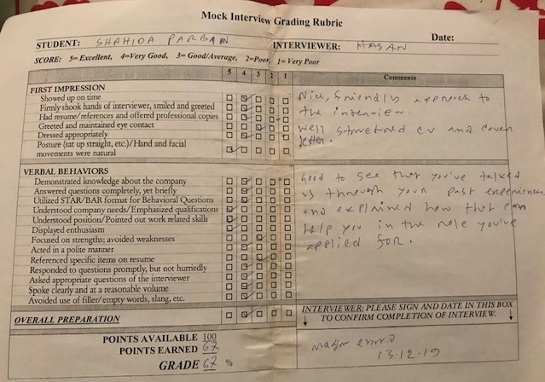
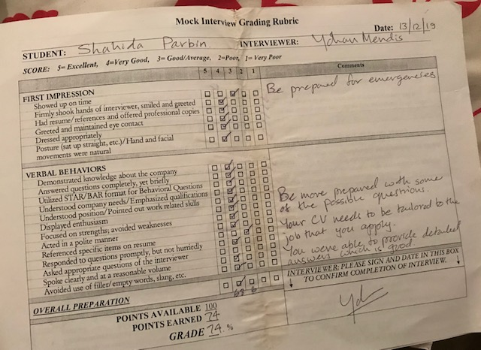

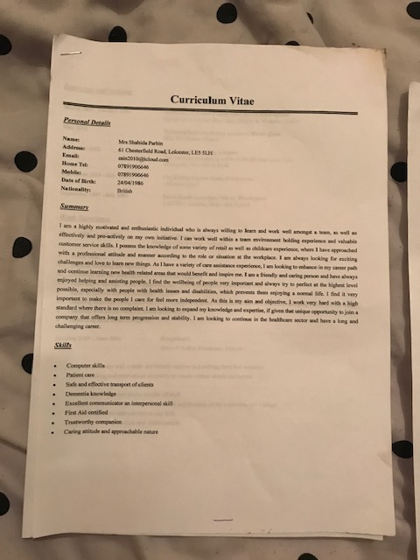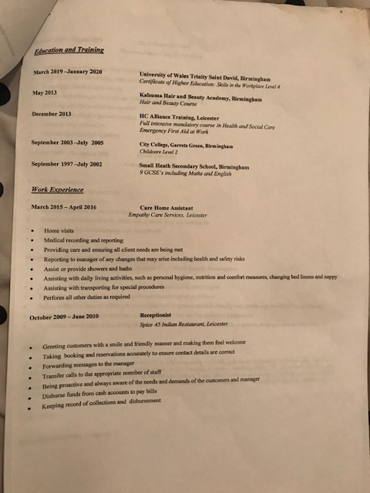

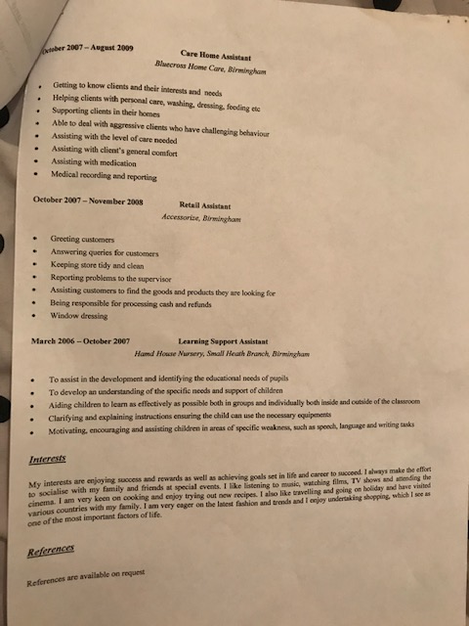

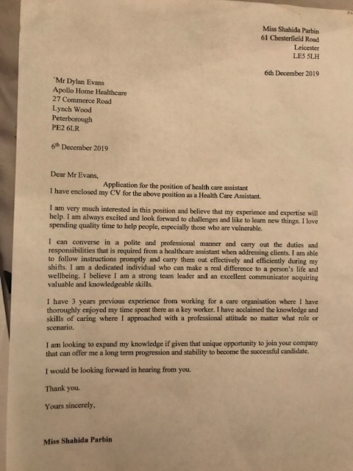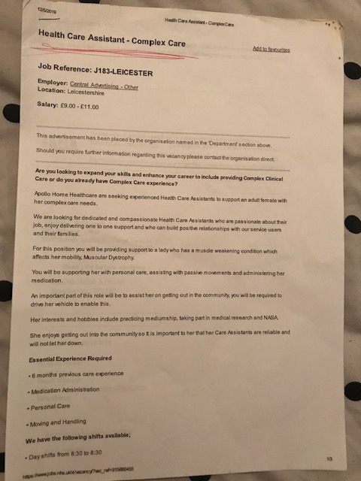

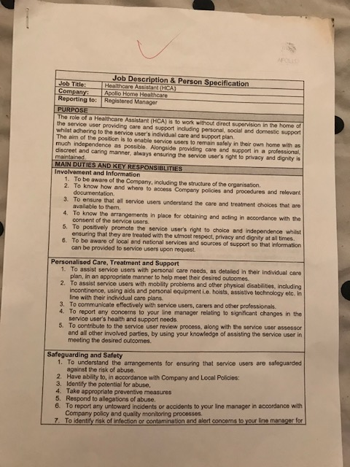

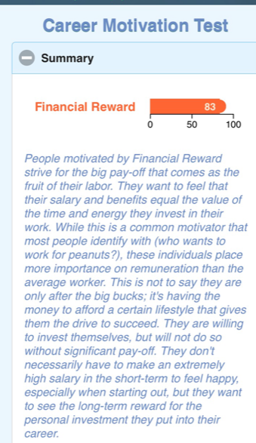
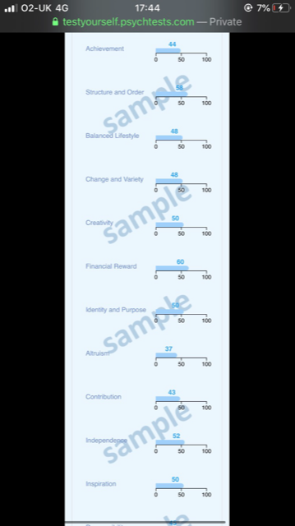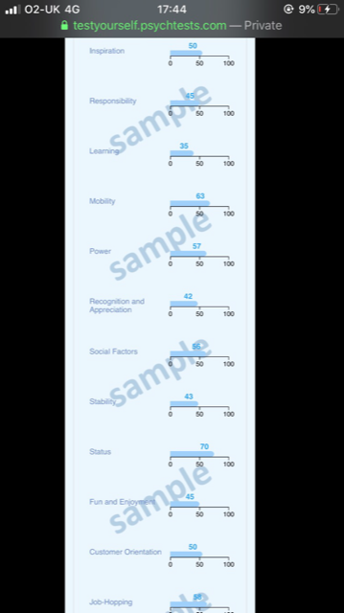

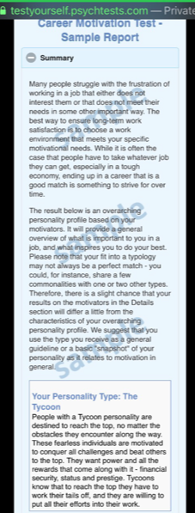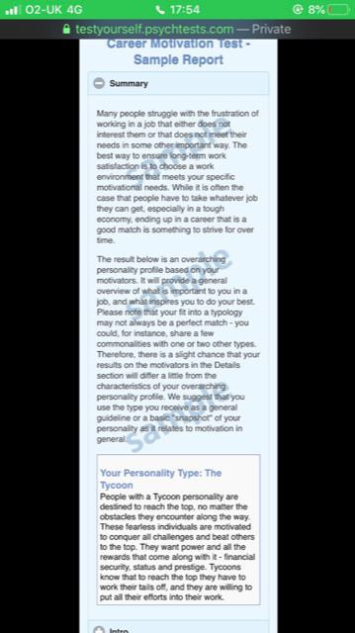
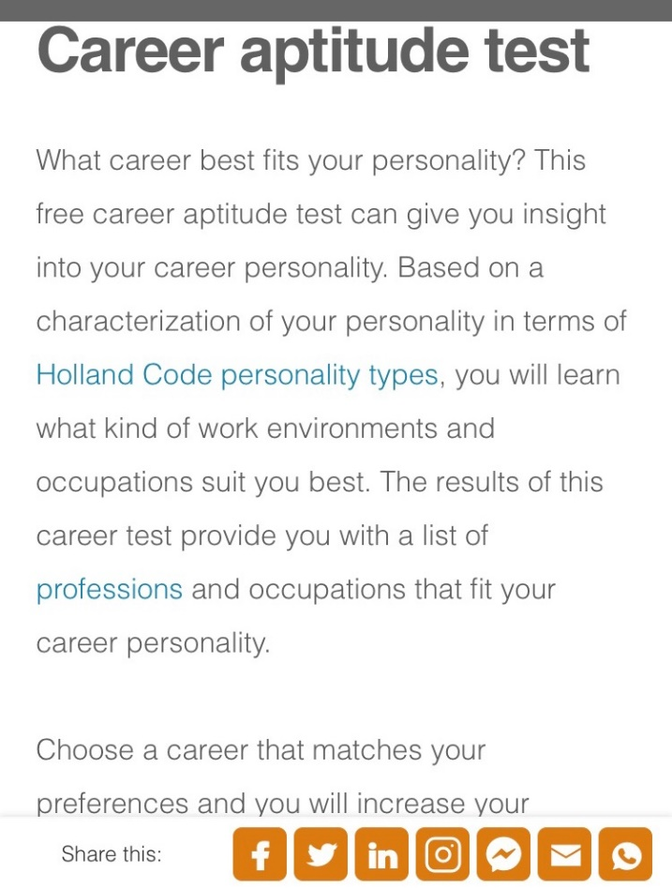
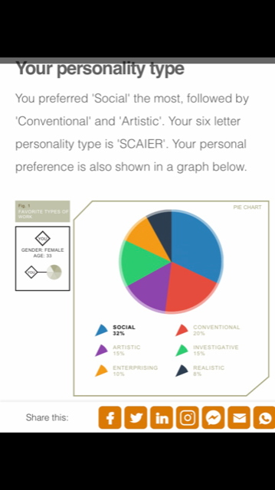
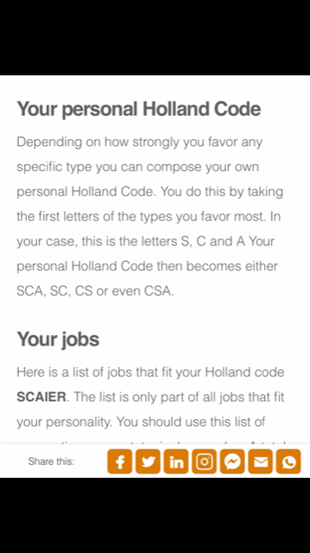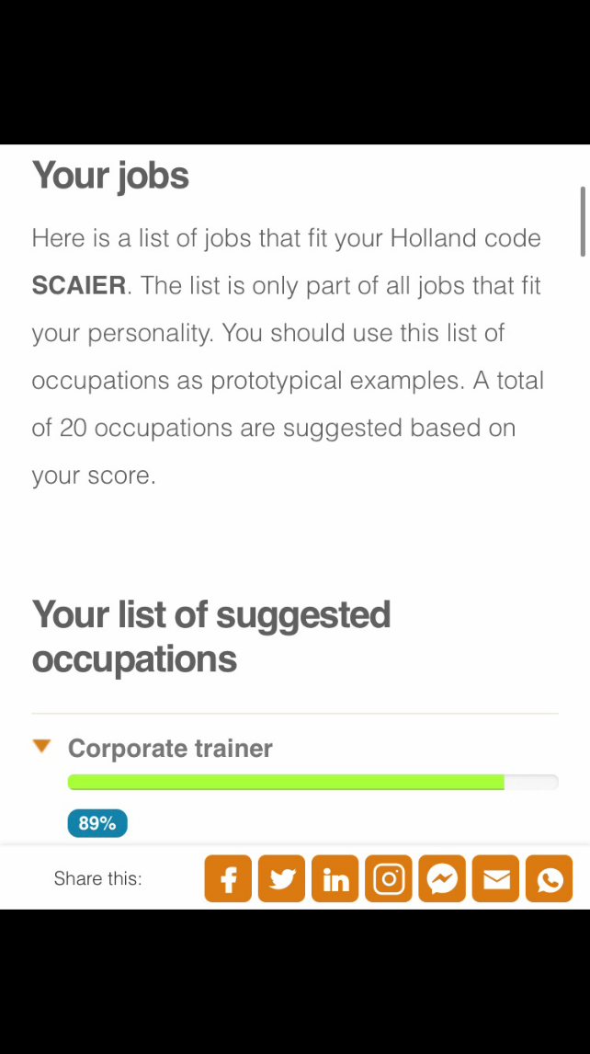
1


