ENTREPRENEURSHIP

University of Wales Trinity Saint David

Student name: Borislava Zlatanova

Student ID: 2013043

Lecturer: DR. Jonh-Paul-Okeoma-Okeke

Table of Contents :
Introduction 2
Discussion 2
Conclusion 7
Appendices 12
Appendix 1: Entrepreneurial traits and skills 12
Appendix 2: Opportunity recognition process 13

12

Introduction
Entrepreneurs are found to be crucial for market economies as entrepreneurs can act as a wheel of the country's economic growth. Thus, the following section is going to interpret the contribution of entrepreneurs to the development of a country's economic growth. In addition to this, the way entrepreneurs in the UK have been enhancing their market position and contributing to strengthening the country's economic stability in this present pandemic situation will be highlighted. PEST (Political, Economic, Social, and Technology) analysis will be made to analyse the UK's macro-environment based on which the opportunities of entrepreneurs along with the skills and traits that they should need to have to flourish their growth will be underlined briefly.
The thesis statement of the present study is to “analyse whether entrepreneurs in the UK have contributed to the growth and acceleration of the country's economic development in this competitive business world or not”.

Discussion
Theoretical knowledge of entrepreneurship
Introducing new businesses, services, and products, entrepreneurs have the potential to stimulate employment opportunities that in turn, accelerate the growth of economic development. It is identified that the creation of dynamism and wealth of a country is emphasised upon organisational competitiveness that directly and highly relied upon the capabilities of managers and entrepreneurs. As mentioned by Stoica et al. (2020), entrepreneurial function is found to refer to the exploitation, assessment, and discovery of opportunities that has the potential to impact directly upon economic development.
In this competitive and digitally advanced business world, being an entrepreneur is found to be easy to enhance business success and accomplish business goals by introducing new services and products across the target market. In the context of the UK, it is identified that about 64% of the UK workforce are showing their preference and interest to start their businesses (Jacimovic, 2021). In addition to this, it is identified that during the financial year 2020, about 726,000 new start-up businesses were created in the UK as compared to the value of 636,000 during 2019. After the outbreak of Covid-19, the UK is found to be one of the most affected countries in terms of economy, business disruptions, enforcement of strict government regulations, and others (Jones, 2021). However, despite the existing challenging situation, entrepreneurs are found to establish their strong presence across the UK market.
PEST Analysis
The microenvironment is found to be interlinked to the immediate periphery of any business entities that directly influence ongoing and future business performance. As mentioned by Vázquez et al. (2018), managers or entrepreneurs need to analyse and obtain a clear insight into the elements of macro environment such as political, technology, competitors, customers, economic and others within which it operates. This enhances the chance for the entrepreneurs to identify their business opportunities along with the product or services that can be introduced to drive business success in the future. In this context, PEST analysis can be considered as one of the effective tools that business entities along with entrepreneurs can be utilised to understand the external factors that influence business performance along with its growth. Thus, the following tables underline the elements within the UK external environment that can influence entrepreneurs in the way to accomplish their respective goals.

Factors | Impact | Descriptions
Political | High | - Persistence of political debates and uncertainties  - Enforcement of strict governmental regulations since the outbreak of Covid-19
Economic | High | - Economic growth has been increased by 7.5% in 2021 (Hotten, 2022)  - Increased in inflation rate by 5.5% in 2022 (ONS, 2022)
Social | High | - Rapid changes in customers' preferences and their demands  - Consumers are found to invest only in the required essential products instead of luxury products and services
Technology | High | - Growth of online shopping preference  - Growing usage of e-commerce by most of the business entrepreneurs to keep their survivability during the pandemic situation
Table 1: PEST analysis
(Source: Created by the learner)
In the context of the above table, it can be mentioned that each of the mentioned factors has the potential to influence the practices performed by entrepreneurs across the UK business environment. The key reason behind this statement is that uncertain political stability has been observed within the UK business environment. In addition to this, after the outbreak of Covid-19 along with its omicron variant, the UK government has imposed strict legislation that needs to be adhered to by each of the businesses across the UK. This might create complexity for entrepreneurs to strengthen their market position and accomplish their profitability goal (Belitski et al. 2022).
On the other hand, though the growing inflation rate minimises consumers' investment and influences their purchasing behaviour. In contrast, growing economic value could create opportunities for entrepreneurs to establish a strong market position (ONS, 2022).
Social and technological factors open up opportunities for entrepreneurs within the UK business environment. The key reason behind this statement is that in this digital age, entrepreneurs are found to utilise different digital and social media tools such as Facebook, Instagram, YouTube, and others to interact with their target audience. In addition to this, consumers are found to show their preferences towards online shopping and purchase their required items through e-commerce platforms (Prasanna et al. 2019⁾. This also creates opportunity for entrepreneurs to maximise their sales and productivity by adopting e-commerce business models. In order to gain opportunity across UK business environment, entrepreneur needs to have some specific skills and traits that are being underlined in the following adjacent section
Entrepreneurial traits and skills
Success and failure of business are found to have highly relied upon the way a manager or entrepreneur manages and tackles all its business operations. As mentioned by Kerr et al. (2018), entrepreneurial skills can encompass a wide range of different skill sets such as business management, leadership, technical skills, creative thinking skills, and others. As the skills of entrepreneurs can be incorporated into different industries and job roles, thus, improving entrepreneurial skills signifies developing a wide range of skills. For example, in the case of an individual who is willing to become a strong and efficient business owner, then he or she needs to have skills to manage business operations strategically (Mersha and Sriram, 2019).
Considering the news report published in 2022, it is identified that new British organisations or businesses are found to reach a record number during the financial year 2021. It is seen that the maximum number of adults during the first three months of introducing a new business are found to hit 12.6% with its young businesses. Despite the business declination rate to 7.8% from 9.3% due to the pandemic situation, the number of entrepreneurs in the UK has been increasing at a rapid pace (Tyler, 2022). In this regard, it can be mentioned that having strong entrepreneurial skills and traits UK entrepreneurs have been maximising their chance to gain success by introducing new products and services across the market.
In terms of entrepreneur traits, it is seen that most of the entrepreneurs portray a charismatic leadership style while they perform their activities. The key reason behind this statement is that charismatic leaders are those who always focus on motivating their employees and inspire them in such a way that positively enhances overall business productivity (Tittel and Terzidis, 2020) (Refer to appendix 1). In this regard, a news report published in 2020 underlines companies that are found to be accelerating their growth and prosperity are highly related to the creativity imposed by the creator. For example, with the rapidly changing and competitive business world, every entrepreneur is forced to introduce new and original ideas that make him or her different from the market competitors (Walker, 2020). Entrepreneurs are found to take new and innovative initiatives and they are found to be highly self-motivated, which helps them to grow and stabilise their position in the business world. Thus, it can be mentioned that with the help of entrepreneurs to identify skills and traits they have the potential to flourish professional growth along with enhancing business prosperity.
Opportunity recognition process
Opportunity recognition is considered as the systematic approach within which organisations and individuals' productivity seek out and perceive opportunities for new services and products. As mentioned by Aldawod (2022), opportunity recognition is found to influence innovation by encouraging businesses as well as industries to think and identify always about new services and products that are required across the target marketplace (Refer to appendix 2). On the other hand, it also helps to incorporate continuous improvement processes that enhance the chance for individuals or businesses to meet the demands of customers and markets that drive business success.
It is seen that entrepreneurs perceive and discover new opportunities while they try to establish a strong position within the existing market. This signifies that entrepreneurs perceive and consider social, economic, and technology trends of the markets within which they are willing to stabilise their position. Thus, it can be mentioned that the success of entrepreneurs highly relies upon the way they recognise market patterns and execute strategic plans that accelerate their growth. In this regard, opportunity evaluation or opportunity recognition plays a significant role for the entrepreneurs as it helps them to determine all the portable challenges that they might witness as well as helps to determine whether those identified challenges are worth the investment (Khin and Lim, 2018).
It is identified that opportunity recognition can be categorised into five specific stages such as opportunity identification, environmental scanning, team evaluation, opportunity evaluation, and opportunity development respectively. Each of the mentioned stages plays a significant role for the enterprise to accelerate its growth by forming a strong business with new products or services (Repository, 2022). Thus, it can be mentioned that the process of opportunity recognition is effective and appropriate for entrepreneurs to flourish their growth and stability.
Entrepreneurship and enterprise with focus on their importance to the economy
Entrepreneurship is considered as the “blanket term” in relation to the starting of a new business. As mentioned by Asante and Affum-Osei (2019), entrepreneurship can be considered as specific managerial functions or approaches instead of a particular time such as a business creation or a particular person such as a business founder. Entrepreneurs and innovation undeniably are found to contribute to economic growth and it is found to be a specific concern area for the policymakers. On the other hand, in countries that are in the middle or early stage of economic development, the growth of the economy is found to be negatively interlinked with entrepreneurship.
Considering the evidence from PEST analysis, it is identified that due to the enforcement of strict government regulation in the UK after the outbreak of Covid-19, business entities have been struggling hard for their sustainability and this directly influences upon the stability of the country's economy. On the other hand, the rate or number of entrepreneurs or start-up enterprises has been accelerating across the UK as they identify the opportunity for the digital business world (García-Jurado et al. 2021). Perceiving opportunities in the digital business world, entrepreneurs can also provide remote employment opportunities in this pandemic situation that also positively influence the accelerating country's economic growth. In this regard, it can be mentioned that entrepreneurs are the backbone of the British economy and despite identifying present business challenges; they have been flourishing their growth by identifying new opportunities, products, and services that meet the present market and consumer's needs efficiently. Entrepreneurs along with entrepreneurs generate employment opportunities for themselves as well as for others that positively influence economic activities by generating new methods, products, along the production process that strengthen competitiveness.

Conclusion
In the context of the above discussion, every business entity is found to be operating in a rapidly changing and competitive business environment. Entrepreneurs are found to serve as beneficial for strengthening a country's economic growth by introducing new ideas, products, services, employment opportunities, and others. The discussion has underlined that with the help of macro environment analysis, entrepreneurs can identify their market opportunities along with the probable risk that might directly influence their proposed business activities and growth. On the other hand, PEST analysis underlines that in the UK business environment, political, economic, social, and technology are found to have a high impact upon the growth of entrepreneurs. In addition to this, it is also identified that by addressing the technological factors, entrepreneurs can enhance their growth and establishes their market position effectively in the future. Other than this, the identified skills and traits are also required by the entrepreneurs to gain success in the present competitive business environment. Thus, the thesis statement can be restated as “entrepreneurs in the UK have contributed to the growth and acceleration of the country's economic development”.

References
Aldawod, A., 2022. A framework for the opportunity recognition process in UK entrepreneurial universities. Technological Forecasting and Social Change, 175, p.121386.
Asante, E.A. and Affum-Osei, E., 2019. Entrepreneurship as a career choice: The impact of locus of control on aspiring entrepreneurs' opportunity recognition. Journal of Business Research, 98, pp.227-235.
Belitski, M., Guenther, C., Kritikos, A.S. and Thurik, R., 2022. Economic effects of the COVID-19 pandemic on entrepreneurship and small businesses. Small Business Economics, 58(2), pp.593-609.
García-Jurado, A., Pérez-Barea, J.J. and Nova, R., 2021. A new approach to social entrepreneurship: A systematic review and meta-analysis. Sustainability, 13(5), p.2754.
Hotten, R., 2022. UK economy rebounds with fastest growth since WW2.[Online]. Available at: <https://www.bbc.com/news/business-60344573#:~:text=The%207.5%25%20growth%20the%20UK,those%20same%20economies%20in%202020. > [Accessed on 10 March 2022]
Jacimovic, D., 2021. 27 UK Entrepreneur Statistics To Inspire You. [Online]. Available at: <https://thecircularboard.com/entrepreneur-statistics/> [Accessed on 10 March 2022]
Jones, M., 2021. The number of new businesses started in the UK increased by 14% in the last year despite the impact of the Covid-19 pandemic, outpacing the global average of a 6% increase in business start-ups.. [Online]. Available at: <https://www.uhy-uk.com/insights/number-new-businesses-uk-increases-14-despite-impact-pandemic-outpacing-global-average#:~:text=There%20were%20almost%20726%2C000%20new,new%20business%20creation%20league%20table.> [Accessed on 10 March 2022]
Kerr, S.P., Kerr, W.R. and Xu, T., 2018. Personality traits of entrepreneurs: A review of recent literature. Foundations and Trends® in Entrepreneurship, 14(3), pp.279-356.
Khin, S. and Lim, T.H., 2018. Entrepreneurial opportunity recognition, exploitation and new venture success: moderating role of prior market and technology knowledge. International Journal of Entrepreneurship, 22(4), pp.1-6.
Mersha, T. and Sriram, V., 2019. Gender, entrepreneurial characteristics, and success: Evidence from Ethiopia. Thunderbird International Business Review, 61(2), pp.157-167.
ONS, 2022. Consumer price inflation, UK: January 2022. [Online]. Available at: <https://www.ons.gov.uk/economy/inflationandpriceindices/bulletins/consumerpriceinflation/january2022#:~:text=current%20inflation%20rates.-,The%20Consumer%20Prices%20Index%20(CPI)%20rose%20by%205.5%25%20in,when%20it%20stood%20at%207.1%25.> [Accessed on 10 March 2022]
Prasanna, R.P.I.R., Jayasundara, J.M.S.B., Naradda Gamage, S.K., Ekanayake, E.M.S., Rajapakshe, P.S.K. and Abeyrathne, G.A.K.N.J., 2019. Sustainability of SMEs in the competition: A systemic review on technological challenges and SME performance. Journal of Open Innovation: Technology, Market, and Complexity, 5(4), p.100.
Repository, (2022). Chapter 3: The entrepreneurship process. [Online]. Available at: <https://repository.up.ac.za/bitstream/handle/2263/24173/04chapter4.pdf?sequence=4#:~:text=The%20opportunity%20identification%20stage%20can,al%2C%202003%3A108).> [Accessed on 10 March 2022]
Stoica, O., Roman, A. and Rusu, V.D., 2020. The nexus between entrepreneurship and economic growth: A comparative analysis on groups of countries. Sustainability, 12(3), p.1186.
Tittel, A. and Terzidis, O., 2020. Entrepreneurial competences revised: developing a consolidated and categorized list of entrepreneurial competences. Entrepreneurship Education, 3(1), pp.1-35.
Tyler, R., 2022. New British businesses hit record numbers, according to Global Entrepreneurship Monitor. [Online]. Available at: <https://www.thetimes.co.uk/article/new-british-businesses-hit-record-numbers-according-to-global-entrepreneurship-monitor-gxk06t825> [Accessed on 10 March 2022]
Vázquez, M.L., Hernández, J.H., Hernández, N.B., Salvatierra, J.A.A. and Baryolo, O.G., 2018. A framework for PEST analysis based on fuzzy decision maps. Espacios, 39, p.13.
Walker, B., 2020. Six Personality Traits Of Successful Entrepreneurs. [Online]. Available at: <https://www.forbes.com/sites/theyec/2020/05/11/six-personality-traits-of-successful-entrepreneurs/?sh=23a3aaf770ba> [Accessed on 10 March 2022]

Appendices

Appendix 1: Entrepreneurial traits and skills
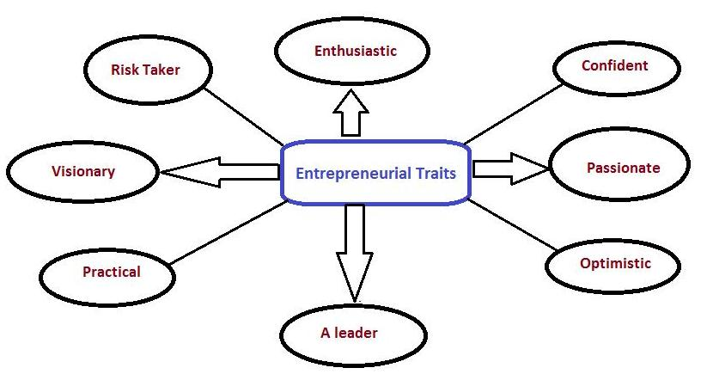
(Source: https://studiousguy.com/entrepreneurship-and-entrepreneurial-traits/)

Appendix 2: Opportunity recognition process
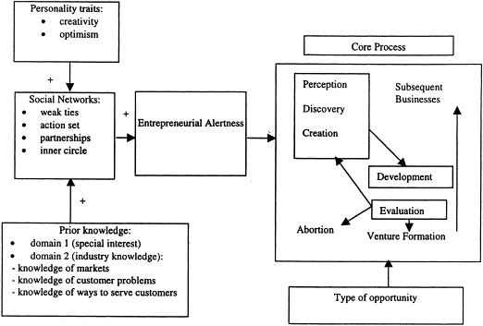
(Source: https://www.sciencedirect.com/science/article/abs/pii/S0883902601000684)

